# **Assignment(20-08-2025)**

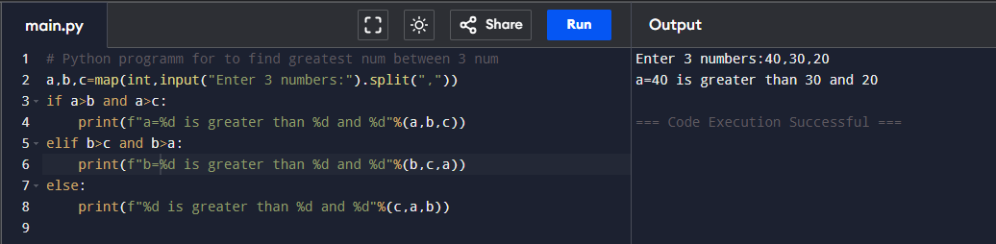**1.Greatest number between three numbers.**

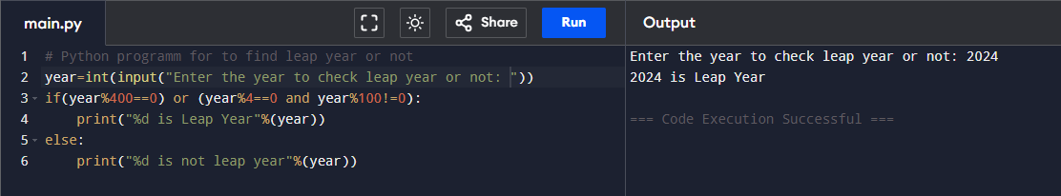**2. To check leap year or not.**

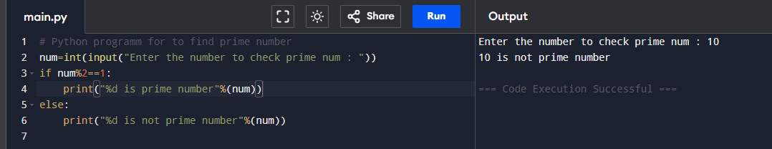**3. to check prime number**