# **ASSIGNMENT (21-08-2025)**

**Submitted by: Srividya Arul Raju**

**Roll number: 23KQ5A0206**

1. 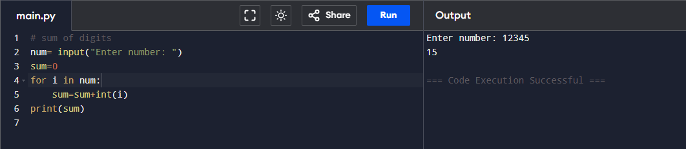**To write the program on python to find sum of digits in number**

**2.To check palindrome or not in Python**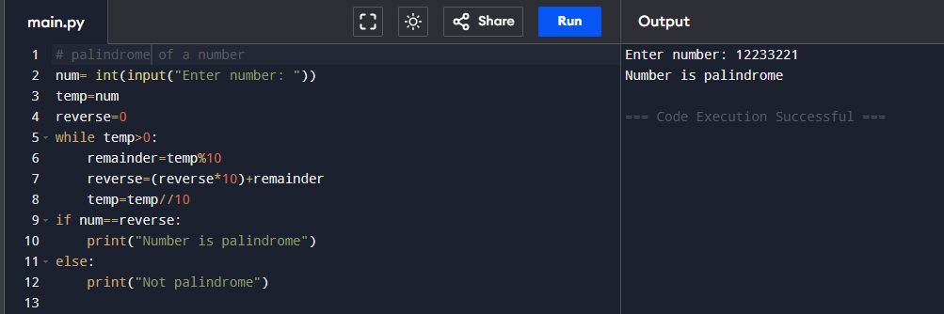

**3.To find reverse of a number.**

