

Business Requirements Document (BRD) for Samarthanam

Samarthanam

7th September 2018

Version 1.0

# Document Revisions

|  |  |  |
| --- | --- | --- |
| Date | Version Number | Document Changes |
| 07-09-2018 | 1.0 | Initial draft of business requirements |

# Approvals

|  |  |  |  |  |
| --- | --- | --- | --- | --- |
| **Role** | **Name** | **Title** | **Signature** | **Date** |
| Project Sponsor |  |  |  |  |
| Business Owner | Crecientech Infosystems Pvt Ltd |  |  | 07-09-18 |
| Project Manager/ Architect |  |  |  |  |
| Business Analyst |  |  |  |  |
| Development Lead |  |  |  |  |
| User Experience Lead |  |  |  |  |
| Quality Lead |  |  |  |  |
| Content Lead |  |  |  |  |

# Introduction

## Project Summary

This main aim of our project is to capture the details of the disabled persons from different districts of Karnataka. Initially, we are focusing on two districts; these districts are Dharwad and Gadag. The disability details of a person and their user specific details like the Type of disability, Education level and Annual income and so on, will be captured using a Tablet application. The person related information is stored in the database for the usage of Government schemes. The tablet application User Interface (UI) is supported in multiple languages such as Kannada and Hindi, apart from English language. The database is stored in English language only to maintain the integrity of data in the database.

### Objectives

* Capture the disability related information and store the details in the database.
* The user interface must support Kannada and Hindi language, apart from English language for the benefit of the user and enumerator.

### Background

Currently the disabled person’s details are captured using a User questionnaire sheet manually by the enumerator and this information is stored in files/books across various districts. This disability information must be captured using software and then stored in a database. The Advantages of our software is that, it will support various reports generation based on the input provided, these reports can be sent to the government for getting grants/approval of various schemes provided for disabled persons. These reports will also help disabled persons for getting a visibility into the government schemes supported for them.

#### Business Drivers

* Using our software we can ensure the disabled persons get timely help from government.
* Provide Livelihood for disabled persons so that they do not need to be depend on our family members by supporting them through grants and government schemes.

## Project Scope

The scope of samarthanam project is to capture disabled person information using a Questionnaire and storing this information in a database. This data is used to generate various reports for enabling disabled persons, with grants and government schemes, which are created specially to support the disabled persons and helping them to lead a better life. These schemes will help the disabled persons to lead a normal life, independent life and not depend on others for livelihood.

### In Scope Functionality

* To create a Login account for enumerators/users of our application.
* To capture Disability related information from various persons with disabilities.
* To provide a Dashboard, this can be used to search the details of disabled persons.
* To generate various reports for enabling disabled persons view their entitlements based on various Grants and Government schemes.

## System Perspective

**Technical Limitations**

Samarthanam project is primarily designed for Tablet applications and it supports iOS and Andriod operating systems. The User Interface and screens are specifically designed for tablets. The user interface or the menu options will be available in English, Kannada and Hindi languages.

**Operational Limitations**

Samarthanam project is primarily designed for tablets. The UI specifications are designed for tablet/mobile versions of iOS and Andriod operating systems.

For regular software fixes/software release updates, contact customersupport@crecientechinfosystem.com

### Assumptions

* Mainly for tablet users and mobile users.
* Application should capture user data, even when internet is offline and later on update the database, when internet is available.

### Constraints

* The UI should be available in three different languages like English, Kannada and Hindi.

### Risks

* Not Applicable to this project

### Issues

* Not Applicable to this project

# Business Process Overview

The Business requirements are captured directly from the client and are designed in par with the client requirements and standards.

## Current Business Process (As-Is)

The Disabled person’s information is captured through a Questionnaire sheet, which is currently a handwritten document. This information is captured by the enumerator using Questionnaire sheets and the handwritten document is filed for further usage.

## Proposed Business Process

The proposed business process is a software application designed for tablets and the user’s data is stored in the database. The application is started/resumed by providing the Email id and Password details. These login credentials are used to access/login to the tablet application.

### Login screen

The Enumerator/Admin provides the Email Id and Password required to Login to the application. The Login screen should perform the following validation criteria:

|  |  |
| --- | --- |
| Actions | Results |
| Email Id and Password is correct. | The login is successful and user can access the application. |
| Email id is wrong and Password is correct. | The login is unsuccessful and message should be displayed as “Wrong Email id. Please give correct Email Id”. |
| Email id is right and Password is wrong | The login is unsuccessful and message should be displayed as “Wrong Password. Please give correct Password”. |
| Email id and Password is wrong | The login is unsuccessful and message should be displayed as “Email id and Password both are wrong. Please enter again”. |
| Email id validation | Check if the Email id is valid, like Email id should contain @ symbol and must end with .com |
| Password validation | Password validation has to be done for characters and numbers combination and minimum number of characters required for password. |

The user should be given a maximum of 4 attempts to login to the application, after this the Email id should be blocked for security reasons. The screen shown below is the Login screen UI.

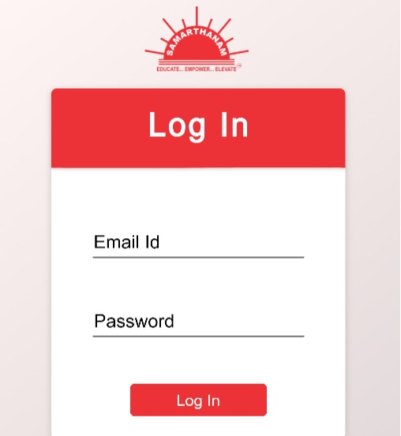

Figure : Login Screen

### Dashboard

On successful login, user moves to the Dashboard. The Dashboard will give a list of Disabled persons and the enumerator can perform a search based on the First Name of the disabled person. Based on the input given in the search field, the matching disabled person list is displayed in the dashboard.

The Dashboard screen is shown below.

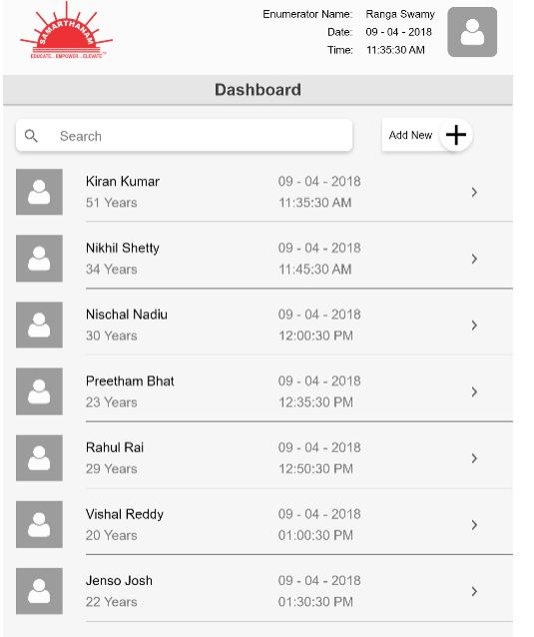

Figure : Dashboard

If the enumerator clicks on the disabled person information row which ends with ‘>’, an hand pointer symbol will appear and on selecting this, the user will be taken to the View Screen.

The Dashboard screen should perform the following validation criteria:

|  |  |
| --- | --- |
| Actions | Results |
| Based on the First Name information provided in the search field, the contents are displayed. | The First Name matching the search criteria are displayed. |
| The View Screen will display all the information matching the search criteria. | The user can only see or view the disabled person details; they cannot add or modify data in View Screen. All the fields in the View Screen are disabled from changes/modification. |
| The Add New + button is selected | The new disabled person details can be added with Add New + button. |

### View Screen

The View Screen is shown below.

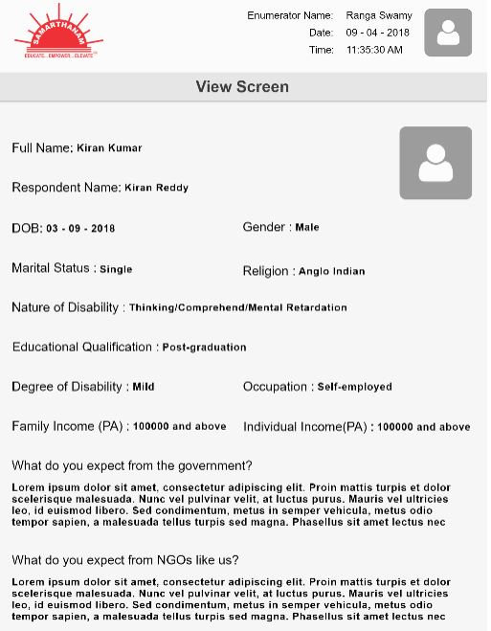

Figure 3 : View Screen

The View screen should perform the following validation criteria:

|  |  |
| --- | --- |
| Actions | Results |
| The View Screen will contain Enumerator Name, Date and Time. | The Enumerator Name, Date and Time details is displayed. |
| The Back button is selected by the user | The user is taken to the Dashboard screen. |
| The View Screen will display all the information matching the search criteria. | The user can only see or view the disabled person details; they cannot add or modify data in View Screen. All the fields in the View Screen are disabled from changes/modification. |

The Add New + Icon is used to add new disabled person to the database. When a user clicks on + Icon, the enumerator will be taken to the General Information screen.

### General Information

The General Information screen is given below. This screen will give the personal details of the disabled person.

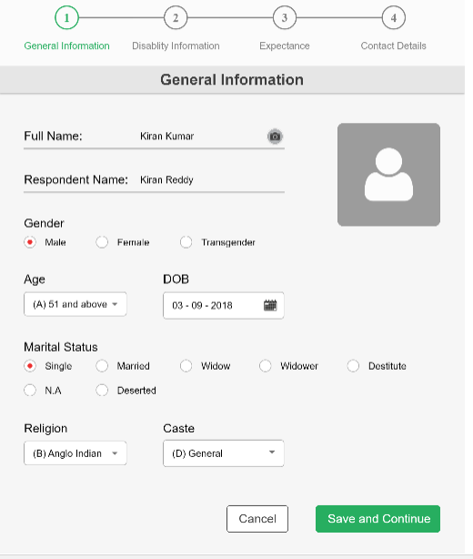

Figure : General Information screen

The General Information screen should perform the following validation criteria:

|  |  |
| --- | --- |
| Actions | Results |
| First Name, Respondent Name input | The First Name and Respondent Name fields should be a maximum of 30 characters length and cannot be blank. |
| Gender input | Gender must be selected from the Radio buttons provided. User can have only one option selected at a time. |
| Age input | Age information must be selected from the drop down list. |
| Date of Birth (DOB) | The Date of Birth (DOB) information must be provided. |
| Marital Status | The Marital Status must be selected from the radio buttons provided. User can have only one option selected at a point of time. |
| Religion | Religion must be selected from drop-down list. |
| Caste | Caste must be selected from drop-down list. |
| Save and Continue | Click on Save and Continue button to move to the next screen. |
| Cancel | Click on Cancel button to cancel the details provided. |

### Disability Information

User must select “Save and Continue” to move to the Disability Information screen. The Disability information details are captured in this screen. The Disability Information screen is shown below.

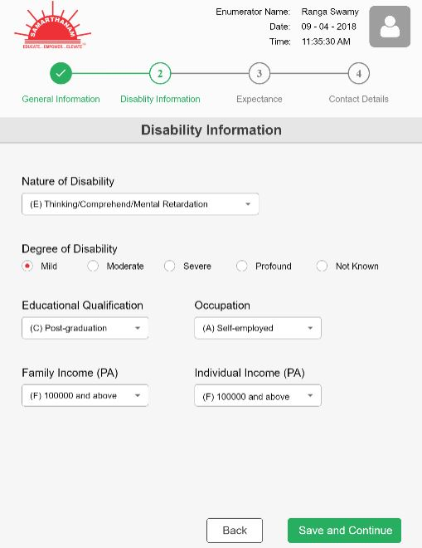

Figure : Disability Information

The Disability Information screen should perform the following validation criteria:

|  |  |
| --- | --- |
| Actions | Results |
| Nature of Disability input | Nature of Disability has to be selected from the drop-down list. |
| Degree of Disability input | Degree of Disability has to be selected from the  Radio Button list. Only one option can be selected at a time. |
| Educational Qualification | Educational Qualification must be selected from the drop down list. |
| Occupation | Occupation must be selected from the drop down list. |
| Family Income(PA) | The Family Income per Annum must be selected from drop down list. |
| Individual Income(PA) | The Individual Income per Annum must be selected from drop down list. |
| Save and Continue | Click on Save and Continue button to move to the next screen. |
| Back | Click on Back button to move to the previous screen. |

### Expectance

The Disabled person’s expectation from the government is captured in this screen. The screen shown below is the Expectance screen.

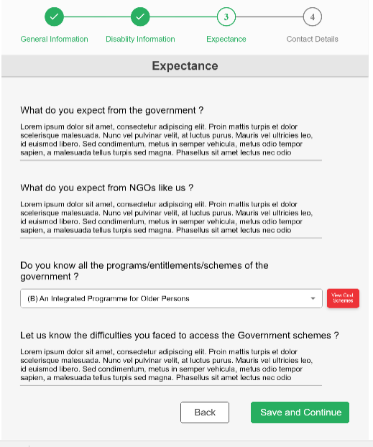

Figure : Expectance screen

The Expectance screen should perform the following validation criteria:

|  |  |
| --- | --- |
| Actions | Results |
| What do you expect from the government? | Disabled person expectations from government have to be gathered here. |
| What do you expect from NGOs like us? | Disabled person expectations from NGOs have to be gathered here. |
| Do you know all the programs/ entitlements/schemes of the government? | Disabled person knowledge on programs/entitlements/schemes has to be gathered here. |
| Let us know the difficulties you faced to access them? | Disabled person difficulties faced to access the government schemes information are stored here. |
| View Government schemes option | When user clicks on this option, the government schemes that are supported for the disabled persons are listed down. |
| Save and Continue | Save and Continue option is used to move to the next screen. |
| Back | Back option is used to move to previous screen. |

### Contact Details

The Contact details of the disabled person are captured in this screen. The screen for Contact details is shown below:

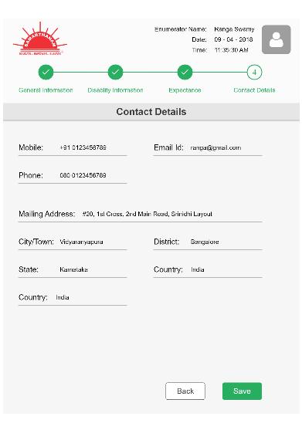

Figure : Contact Details screen

The Contact Details screen should perform the following validation criteria:

|  |  |
| --- | --- |
| Actions | Results |
| Mobile | Mobile number details are captured here. |
| Email Id | Email Id details are captured here. The Email Id validation must happen like it should have a @ sign and must end with .com |
| Mailing Address | Address of the Disabled person is captured here. |
| City | City information will be captured here. |
| District | District information will be captured here. |
| Pin Code | Pin code information will be captured here. |
| State | State information will be captured here. |
| Country | Country information will be captured here. |
| Save | Click on Save option to save the keyed in details. |
| View | Click on View option to display the keyed in details. The View option will take the user to the View Screen with a Edit option. |
| Edit | Click on Edit option, this will take the user to the General Information screen to make the required modifications. |

### Enumerator Profile details

The Enumerator Profile is captured, by clicking on the Profile image of the Enumerator. The Enumerator Name, Email Id and Mobile Number details are captured here.

The Enumerator Profile screen is shown below.

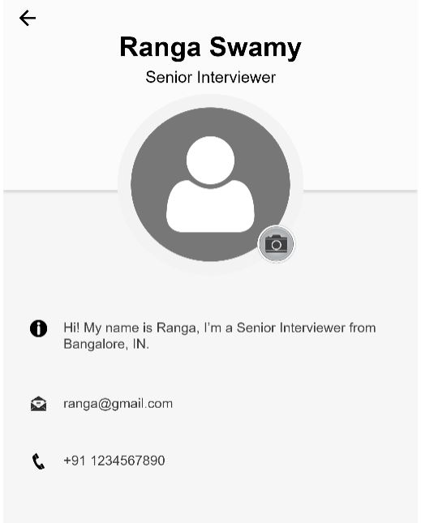

Figure : Enumerator profile screen

The Enumerator profile screen should perform the following validation criteria:

|  |  |
| --- | --- |
| Actions | Results |
| Information | Brief information about the Enumerator is captured here. |
| Email Id | Email Id details are captured here. The Email Id validation must happen like it should have a @ sign and must end with .com |
| Mobile/Phone No | The Mobile or Phone No is captured here. |

# Business Requirements

The requirements in this document are prioritized as follows:

|  |  |  |
| --- | --- | --- |
| **Value** | **Rating** | **Description** |
| 1 | Critical | This requirement is critical to the success of the project. The project will not be possible without this requirement. |
| 2 | High | This requirement is high priority, but the project can be implemented at a bare minimum without this requirement. |
| 3 | Medium | This requirement is somewhat important, as it provides some value but the project can proceed without it. |
| 4 | Low | This is a low priority requirement or a “nice to have” feature, if time and cost allow it. |
| 5 | Future | This requirement is out of scope for this project, and has been included here for a possible future release. |

## Functional Requirements

| **Req#** | **Priority** | **Description** | **Rationale** | **Use Case Reference** | **Impacted Stakeholders** |
| --- | --- | --- | --- | --- | --- |
| **General / Base Functionality** | | | | | |
| FR-G-001 | 1 | The Email Id and Password details have to be captured and based on this information access to should be provided to our application. | Access permissions will vary based on the Email id. |  |  |
| FR-G-002 | 2 | The View screen should allow the user to query on existing data. |  |  |  |
| FR-G-003 | 2 | The Add New screen should allow adding new person details and all the fields inputs will be validated based on the requirement criteria. |  |  |  |
| FR-G-004 |  |  |  |  |  |
| FR-G-005 |  |  |  |  |  |
| **Security Requirements** | | | | | |
| FR-S-001 | 1 | The login Email id and Password should define the access permissions to this application |  |  |  |
| **Reporting Requirements** | | | | | |
| FR-R-001 | 3 | The system shall generate reports based on the search criteria provided. |  |  |  |
| **Usability Requirements** | | | | | |
| FR-U-001 | 1 | User interface is specifically designed for tablets and mobile applications. |  |  |  |
|  | 1 | The User interface should support English, Kannada and Hindi Languages. |  |  |  |
| **Audit Requirements** | | | | | |
| FR-A-001 | 1 | Not applicable to this project. |  |  |  |

## Non-Functional Requirements

|  |  |
| --- | --- |
| **ID** | **Requirement** |
| NFR-001 |  |
| NFR-002 |  |
| NFR-003 |  |
| NFR-004 |  |
| NFR-005 |  |

# Appendices

## List of Acronyms

DOB: Date of birth

NGO: Non-Governmental Organization

PA : Per Annum

## Glossary of Terms

## Related Documents