**<LAMICO>**

**Business Requirements Document**

**Document History**

*<The document history is a log of changes that are made to the document, who made the changes, and when. For example, the initial creation of the document may contain the following: Version 0.1, Date 1/1/2004, Author Charlie Brown, Status Initial creation. Subsequent updates to the document will be Version 0.2, 0.3, etc. The first published version of the document should be Version 1.0.>*

|  |  |  |  |  |  |
| --- | --- | --- | --- | --- | --- |
|  |  |  |  |  |  |
| **Version** | **Date** | **Author** | **Status** | **Section** | **Revision Description** |
| 1.0 | 5-4-2019 | Srividya | Initial Draft |  |  |
|  |  |  |  |  |  |
|  |  |  |  |  |  |
|  |  |  |  |  |  |

**Approvals**

Your signature below indicates that this document meets its objectives and is acceptable.

|  |  |  |  |  |  |  |
| --- | --- | --- | --- | --- | --- | --- |
|  |  |  |  |  |  |  |
|  |  |  |  |  |  |  |
| Signature |  |  |  | Signature |  |  |
|  |  |  |  |  |  |  |
| <Name> | | |  | <Name> | | |
| <Date> | | |  | <Date> | | |
| <Title> | | |  | <Title> | | |
| <Role> | | |  | <Role> | | |

Table of Contents

1 Purpose 4

2 Glossary and Acronyms 5

3 Objectives 6

3.1 In Scope 6

3.2 Out of Scope 6

3.3 References/Inputs 6

4 Business Model 7

4.1 Organizational Profile 7

4.2 High Level ‘As-Is’ Process Flow 7

4.3 High Level ‘To-Be’ Process Flow 7

**4.3.1** **Submenu options screen** 7

**4.3.2** **User Management module** 8

**4.3.3** **Reference Data Management module** 9

**4.3.4** **Prospect module** 9

**4.3.5** **Inventory module** 14

**4.3.6** **Valuation module** 15

**4.3.7** **Vehicle Order** 18

**4.3.8** **Dashboards** 25

4.4 Gap Analysis 29

5 Requirements Definition 30

# Purpose

The purpose of the Business Requirements Document (BRD) is to lay the foundation for the design and development of a technical solution through definition of the business’ needs and achieve the goals and objectives of the *LAMICO* project. The BRD describes the high-level business process and outlines the business needs that will be fulfilled by the successful completion of the project.

The BRD establishes key requirements, objectives, and goals that drive all other subsequent lifecycle phases. In addition to key program level requirements, the requirements capture operational concepts and user interfaces. The BRD should be continuously referenced during the project lifecycle phases to ensure that the deliverables from the project meet the approved requirements.

Approval by the sponsor/client will ensure that, the requirements mainly support to achieve the project’s goals and objectives.

# Glossary and Acronyms

**Table: Terms and Acronyms Used in This Document**

| **Term/Acronym** | **Definition** |
| --- | --- |
| LPO | Loan Purchase Offer |
| CCV | Vehicle Identification Number |
| VIN | Vehicle Identification Number in India |
| BRD | Business Requirement Document |
| LTV | Loan To Vehicle |
| DL | Driving License |
| KYC | Know your Customer |
|  |  |
|  |  |
|  |  |
|  |  |
|  |  |
|  |  |
|  |  |
|  |  |
|  |  |
|  |  |
|  |  |
|  |  |
|  |  |
|  |  |
|  |  |
|  |  |
|  |  |
|  |  |
|  |  |
|  |  |
|  |  |
|  |  |
|  |  |
|  |  |
|  |  |

# Objectives

1. To address the requirements and project specific needs of Lamico.
2. To build efficient software platform so as to customize the Lamico project specifications.
3. To support/enhance the project on a regular basis to ensure its smooth functioning at the client side.
4. To properly build and test the application and make it user friendly and easy to use at the client location.
5. To maintain high performance and latest technology trends available in the market.

## In Scope

The following features are supported by this project. The supported modules/functions are listed below.

1. User Management module
2. Reference Data Management Module
3. Prospect Module
4. Inventory Module
5. Valuation Module
6. Vehicle Order
7. Dashboards

## Out of Scope

Any information/requirements that is not mentioned or discussed in the business requirement document (BRD) is out of scope of this project.

## References/Inputs

The Confluence data link to project requirements captured is given below.

<https://crecientech.atlassian.net/wiki/spaces/LAM/pages/edit/30539815?draftId=30572573&draftShareId=d133bd9b-dae5-4c7c-900b-6f12103e963a&>

# Business Model

* Our Software will identify the prospective customers and readily create opportunities that are best suitable for customer and dealership.
* Our software will interact with different banks and will identify the bank that best suits the customer interest.
* Our software will create a business intelligent software, which will interact with different entities and listed down the best of all choices and best of go to options for their clients.
* Our software will work internally with different software entities and give the best of Loan Purchase Offer from different banks.

## Organizational Profile

Our Software will be used by Sales Executives, Sales Manager, General Manager, Valuator, Bank user and Super Administrator. This software is specifically designed keeping our Lamico customer requirements in mind.

## High Level ‘As-Is’ Process Flow

The High Level ‘As-Is’ process flow is given in the Requirements Definition section link provided below.

Requirements Definition

## High Level ‘To-Be’ Process Flow

The High Level ‘To-Be’ Process Flow is captured in this section. The Process Flow should consist of following modules list below.

### **Submenu options screen**

The Submenu screen provides the options like Front desk and Valuator menu options. When the user selects any of these sub menu options, they will be taken to the Login screen to log into the application with their respective IDs such Front desk, Valuator, Customer, Sales manager and so on.

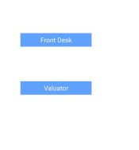

Figure : Submenu screen

### **User Management module**

Our objective is to capture the data related to user management module such as the user creation, user details and the functionalities of various kinds of users.

The User management module should have the following programs listed in this table.

|  |  |
| --- | --- |
| Actions | Results |
| User Management screen. | User Management module is the opening page of the auto application and it allows different kinds of users to access various functionalities based on their user permissions/user ids. |
| Sign up and Login functions for users | The Sign up screen is used by the user to access the application for the first time and for accessing the application regularly the user can use the login function. |
| Authentication and Authorization of users | The users have to authorize/authenticate based on their login ids which has to be one of these personas like sales executive, sales manager, general manager, bank user and super admin. |
| Change Password | The users should be provided with an option to change their password. |
| Forgot Password | The users should be provided with an option to change their password, if they have forgotten the existing password. |
| Profile updates for users | User profiles should be available for updates and removal. |

The User management screens are attached below and the various UI options available are shown in the screens.

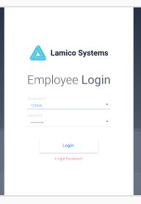

Figure : Employee Login screen

The user must enter the Employee Id and their Password and then click on Login button to enter the application. If the user has forgotten his/her password/Id, then they can click on Forgot Password/Change Password button, to modify/change the password/Ids.

The User Id and Password validations has to written for authorized and safety of the auto application.

### **Reference Data Management module**

Our objective is to capture the data related to the Reference Data Management module.

The Reference Data management screen should have the following programs listed in this table.

|  |  |
| --- | --- |
| Actions | Results |
| Addition of Bank details | Addition of Bank information and associate the banks with their Credit and Commission criteria. Define the Credit and Commission criteria. |
| Addition of Insurance companies | Add/Create the Insurance companies and to capture insurance related details. |
| Addition  of Dealer outlets | Add/Create the Dealer outlets and to capture the Dealer details. |
| Addition of Sales Manager and Sales executives | Add/Delete the Sales manager and Sales executives. |

The Reference management screens are attached below and the various UI options available are shown in the screens.

The Reference management screens have to be validated for different kinds of users like bank employees, Insurance company users, dealers, sales executive and managers.

### **Prospect module**

Our objective is to capture the data related to the prospect module.

The Prospect screen should have the following programs listed in this table.

|  |  |
| --- | --- |
| Actions | Results |
| Prospect Customer Details | To capture Prospect customer information |
| Opportunity Details | To capture Opportunity details based on prospective customer information. List of opportunities can be listed down |
| Opportunity Data table | The users should be able to edit / update/ close opportunities. |

The Prospect management screens are attached below and the various UI options available are shown in the screens.

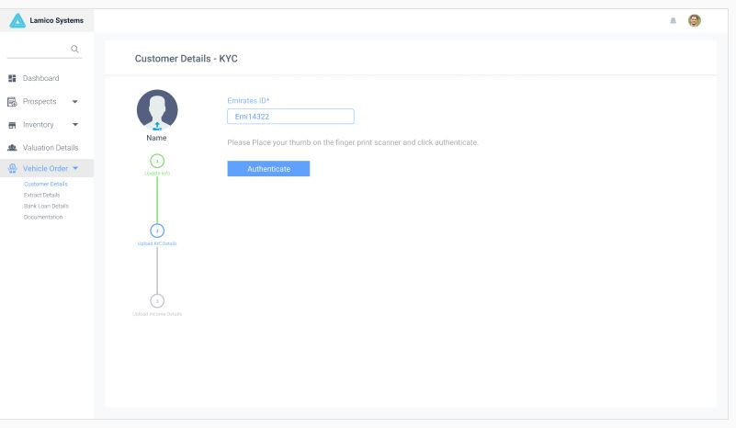

Figure : Customer Details screen

The customer details are captured here; the Emirates ID of the customer and customer’s thumb impression are captured. The customer details like their pay slips and other details are captured and uploaded into the system.

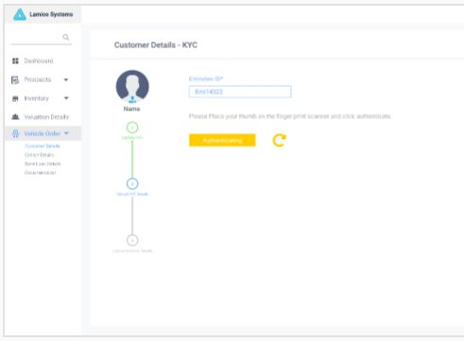

Figure : Customer Uploads screen

The opportunity details are captured in the screen. The Brand Name, Model, Sales Manager, Purchased Amt, Price Quoted, Start Date and Expected Close Date and Prospect Score. The Update button is used to update the opportunity and the Delete Button is used to delete the opportunity.

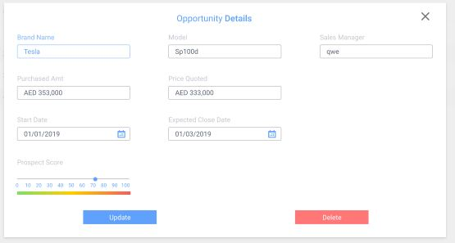

Figure : Opportunity details screen

The Opportunity score is calculated based on the customer feedback and the sales executive inputs and the Status is updated as open or closed based on the sales opportunity. Prospective customer information can be filtered based on Opportunity and Prospect score and Rating. Color codes are displayed based on the score generated.

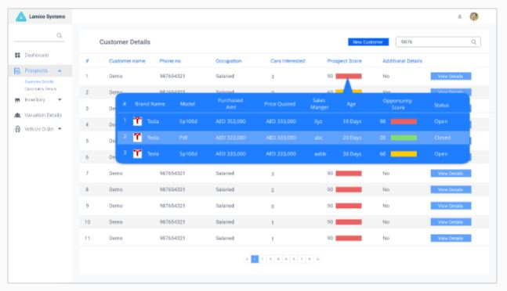

Figure : Prospective customer details screen

Customer details are captured in the screen below. The customer related information like their First Name, Middle Name, Last Name, Phone No, Gender, and Employment details, Prospect score information, Email Id and so on. The customer can be deleted only by the Manager and Super admin. Rest of the profiles should be able to view or add customer details.

The above fields like First Name, Last Name, Phone No, Employment details has to validated and stored in the table. The Gender and Occupation will be a drop-down list. The Prospect score is graded from 0 to 100. The Save Button is used to Save/Store the Customer Details in the Database.

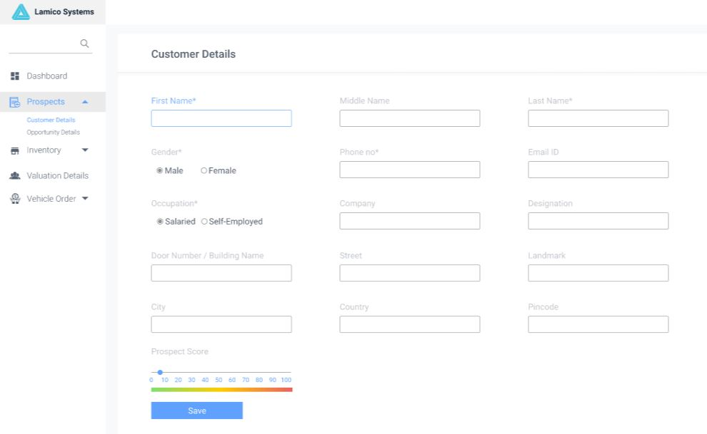

Figure : New Prospect screen

The Opportunity score for various brands liked by the customer are listed below. The Status is mapped as open or closed. Click on the Proceed Button to move ahead with the Car sales.

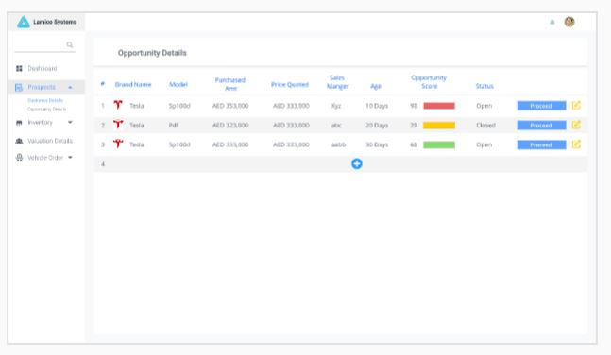

Figure : Existing opportunity Prospect screen

### **Inventory module**

Our objective is to capture the data related to the prospect module.

The Prospect screen should have the following programs listed in this table.

|  |  |
| --- | --- |
| Actions | Results |
| Create Inventory details | To capture New/Used inventory details |
| Edit/Delete/Update Inventory | To Edit/Delete/Update Inventory |
| Associate CCV with RC book and Insurance details | To Link the CCV Number with RC book and Insurance details. |

The Inventory management screens are attached below and the various UI options available are shown in the screens.

The Inventory details is captured in the screens below. The New and Used Cars information are captured in the corresponding tables. The Brand Name, Model, Type, Fuel type, Top Speed, Mileage and Status information is displayed. The View Details Button must be opted to view the additional information related to Inventory.  
 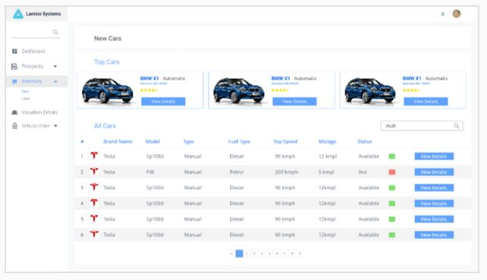

Figure : New Inventory screen

The Used Cars screen will display the listed of used cars available for sale. The Car details like the Model, Type, Year of Purchase, Distance Driven and the Vehicle Conditions are captured in this screen.

Click on “View Details” Button to view Additional details about this Vehicle/Car.

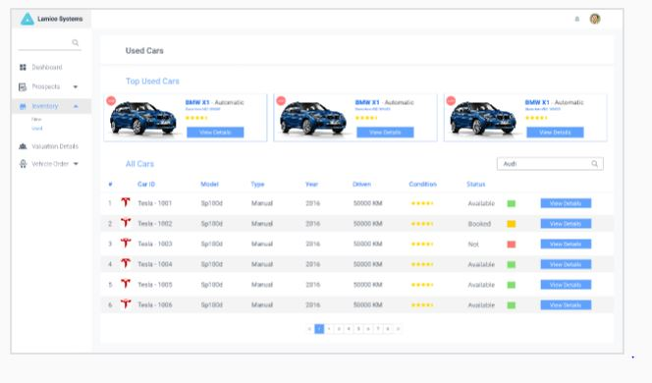

Figure : Used Inventory screen

### **Valuation module**

Our objective is to capture the data related to the Valuation module.

The Valuation screen should have the following programs listed in this table.

|  |  |
| --- | --- |
| Actions | Results |
| Select a Car details from the inventory and update valuation details such as Blue Book Value, Scrum Value and Valuator Value. | To capture Valuation details for the car and to update the blue book, scrum book and valuator value. |
| Create and Update Valuator module details. | Login and update the car value using Valuator login. |
| Sales Manager should also be able to update the Valuator value. | Login and update the car value using Sales manager Login. |
| Compute the Average Value of blue book, scrum book and Valuator value. | Column to display the computed values. Blue book value, scrum book value, Valuator value. |
| Compute the Market price, Proposed LTV would be defined by credit criteria as defined by individual bank and is not an input range. LTV is determined by the dealer | Column to display the computed values. Market value, Proposed LTV, LTV of dealer. |

The Valuation related screens are attached below and the various UI options available are shown in the screens. The Valuator Login details are required here to enter the application with Valuator credentials.

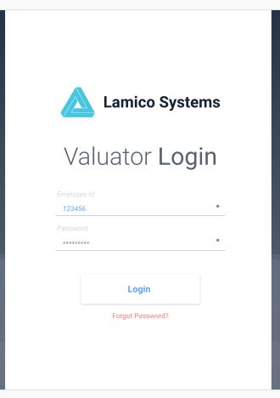

Figure : Valuator login screen

After the Valuator login, the vehicles that have to be evaluated are displayed in the valuation details screen. This evaluation will be done by the Valuator who is an external party, based on their technical expertise and their respective checklists and procedures. Valuator Price is given by the valuator and later on the valuator Price will be updated in the Database, the valuated car move to Completed status and will be displayed in the Completed screen. The Valuation of the vehicle is pending, and then the vehicle details are displayed in the Pending screen.

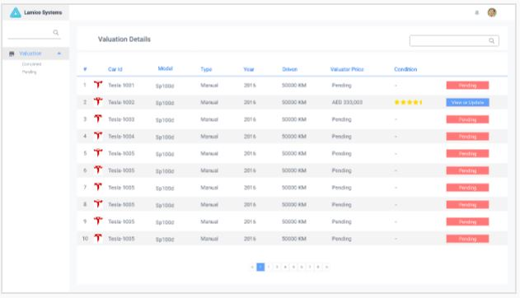

Figure : Valuation Details screen

The Car Details and Valuation Details are displayed together on this screen. The Additional Information related to car like the Insurance and other customer related documents can be stored under Additional Info section.

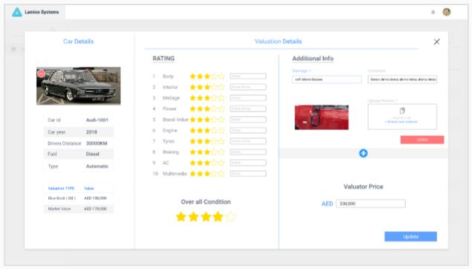

Figure : Valuator Price screen

The screen below displays the valuation details of the selected Vehicle.

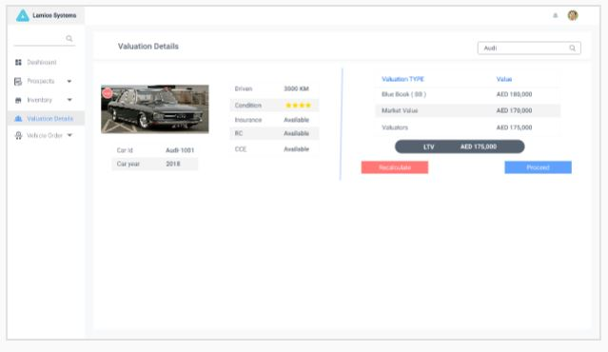

Figure : Valuation of selected car screen

### **Vehicle Order**

Our objective is to capture the data related to the Vehicle order module.

The Vehicle order screen should have the following programs listed in this table.

|  |  |
| --- | --- |
| Actions | Results/Steps |
| Sales Executive creates Vehicle Order package with the following data points. | * Fetch Customer details from the customer created in Prospect Module. * Capture KYC, Driving License and Income Details. If Salaried, 3 months’ salary slips, Salary Offer letter, 6 months bank statement. If Self-employed, 2 years bank statement, Source of income etc. * There should be an option to upload KYC, DL and Income related documents. Each of these documents type should be defined for upload in specific fields. * Fetch an opportunity created for the customer. Opportunity created will have car details. * Fetch CCV (Similar to VIN in India), RC book and Insurance Details. * Add the valuation details of the vehicle (all three valuation) * If customer has a choice of bank, indicate the choice of Bank. * Send above package to Sales Manager for sending it to bank. |
| Sales Manager adds these details to Vehicle Order package. | * Add proposed LTV (inferred) to the vehicle order packet. * Send the vehicle order packet to customer choose bank, otherwise the SM sends the packet to multiple banks of his choice. * Manager views Commission, Tier, and Probable Earning for the deal, Probability of getting the loan Approved based on Credit Criteria. * Once Manager gets the LPO from Banks, he will fill the LPO to Vehicle Order in the order of preference from Bank which dealer wants to close. |
| Sales Executive Completes the Vehicle Order | * Sales Executive discusses with Customer on the offer as preference proposed by Sales Manager * Closes the deal * Completes the documentation, Scans and Upload all the documents. * Required documentation is sent to Bank for further processing * Vehicle Order is completed and corresponding entities are updated. * Inventory Status, Opportunity Status updated while closing the deal. |

The Vehicle order screens are attached below and the various UI options available are shown in the screens. The customer documentation is captured and stored in the database; the customer documents are uploaded as doc or jpeg format and then uploaded into the repository. Customer salary slips and other documents like RC book, Insurance and so on are captured in the Documentation screen.

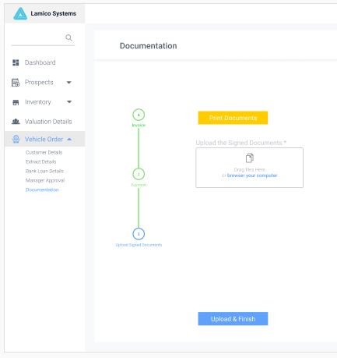

Figure : Documentation screen

Once the customer related information are captured, Select the Upload Documents button, Once the documents are uploaded, the button text automatically changes to Proceed.

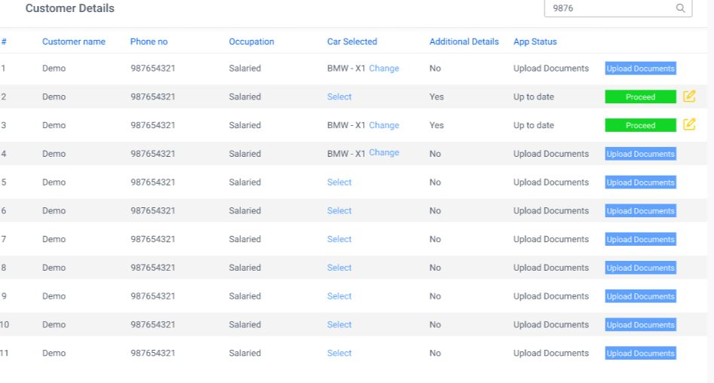

Figure : Customer details screen

The Customer Income details screen is shown below. The customer’s Income is capture here like the Company name, Designation, Company registration No, Company Address and so on. The customer balance sheet is prepared by capturing the Assets, Liabilities, owner Equity, and Balance sheet for the 2 years from the Current date.

The Bank Statement details like the Bank Name, Account No, Address, Account Type, IFSC and so on are captured here. The Bank Statement document as .doc or .pdf format is uploaded into the system.

Finally user clicks on “Upload & Finish” button to store the details in the database and proceed to next screen.

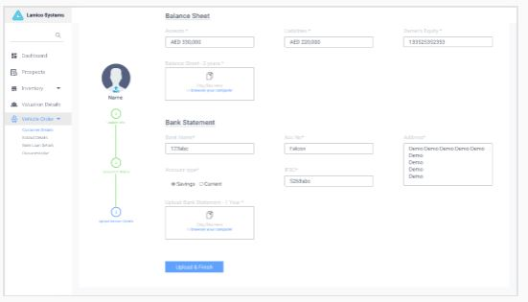

Figure : Customer Income details screen

The Extract Details customer screen will display the Customer Information like Name, Phone No, Email Id, Occupation, Address, Company, and Designation, Loan, Preferred Bank and so on.

The Vehicle details are also displayed on this screen like Brand Name, Selection, Year, Fuel, Gears, Drive, Mileage, Sports Mode, Doors, Wheels, Color, CLS, Height, Width, Capacity, and Torque.

The RC Details like Owner Name, Vehicle No, Engine No, Chassis No, Date of Issue, Purchase Date, Validity, Tax paid up to fields are displayed.

The Insurance Details like PolicyRef No, Area, Insured, Period, Party, Total Value, Contact No, and Insurance Price are displayed.

The CCE Details and Valuation Details like the different type of valuation such as Blue Book, Scrum Data, and Valuators Price are displayed.

The Documents Uploaded like the KYC and Income Details are also displayed in the Extract screen.

The user has to check the text box “I have verified the extracted Details” and then select the “Send details to SM” option to send the vehicle order package to the Sales Manager for his approval.

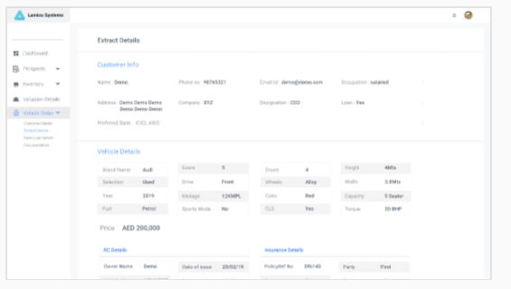

Figure : Extract details screen

The Customer Details are updated as shown in the screen below.

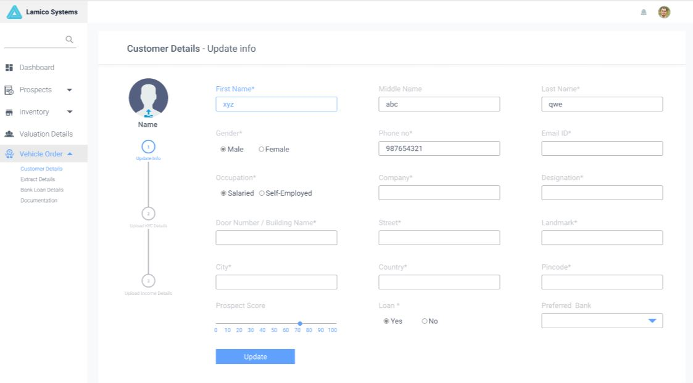

Figure : Customer Details – Update Info screen

The Bank Loan Details is shown below. The Customer Name, Phone No, Type, Car Selected, Bank Selected, LPO, App Status information is displayed in this screen. If any documents have not be Uploaded, the Upload Documents text will be displayed otherwise the Proceed text will be displayed.

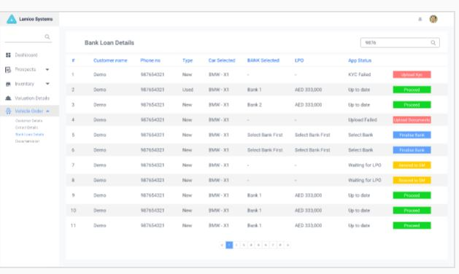

Figure : Vehicle Loan details screen

The Invoice is generated for the selected Car. The Invoice is distributed across 3 screens, The First screen has Company, Invoice to, along with Vehicle details and Loan details are displayed. Click on “Next” button to move to the 2nd Page in the Invoice.

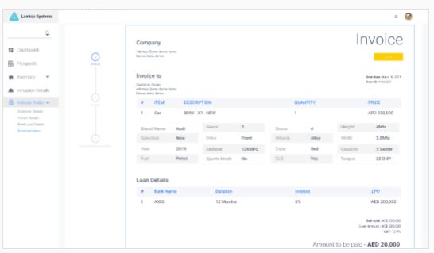

Figure : Documentation- Invoice page 1 screen

The Payment Mode can be one of these payment methods like Card, Cash, Cheque, Wallet, and Bank Transfer. The Transaction Number, Time and Date details are captured in this screen. Click on “Next” Button to move to 3rd page of the Invoice.

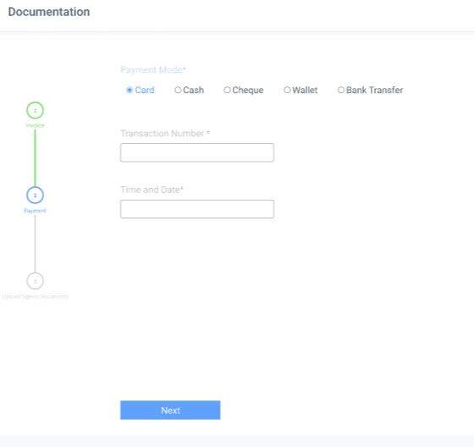

Figure : Documentation- Invoice page 2 screen

On Page 3 of Invoice there is a Print Documents Button to print the documentation. There is an option to Upload signed documents from the computer’s local drive. Click on “Upload and Finish” button to upload the documents into the Application.

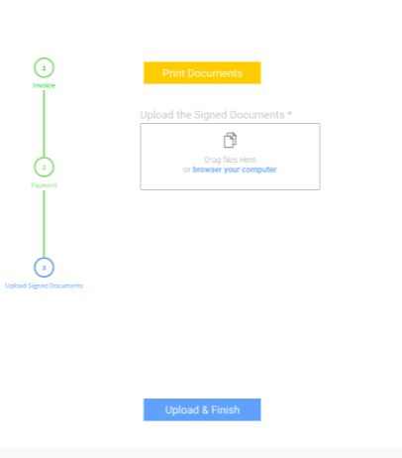

Figure : Documentation- Invoice page 3 screen

### **Dashboards**

Our objective is to display the data related to the Dashboard module.

The Dashboard should have the following programs listed in this table.

|  |  |
| --- | --- |
| Actions | Results |
| Sales Executive (Front Desk User) | * Opportunity Status (Filter based on criteria such as OEM, date range, status) * Opportunity Dashboard – Last 1/3/6/12 months, status on OEM and overall * Dashboard of Opportunity – Hot, Warm, Cold, Rejected on OEM and overall * Details on funded orders – Bank details, Loan Details (LTV/LPO) for last 1/3/6/12 months on OEM and overall |
| Sales Manager – Opportunity for his team | * Opportunity Status (Filter based on criteria such as date range, status) on OEM and overall * Opportunity Dashboard – Last 1/3/6/12 months, status on OEM and overall * Dashboard of Opportunity – Hot, Warm, Cold, Rejected on OEM and overall * Details on funded orders – Bank details, Loan Details (LTV/LPO) for last 1/3/6/12 months on OEM and overall |
| General Manager – For the Entire dealership | * Opportunity Status (Filter based on criteria such as date range, status) on OEM and overall * Opportunity Dashboard – Last 1/3/6/12 months, status on OEM and overall * Dashboard of Opportunity – Hot, Warm, Cold, Rejected on OEM and overall * Details on funded orders – Bank details, Loan Details (LTV/LPO) for last 1/3/6/12 months on OEM and overall |

#### Sales Executive Dashboard

The Dashboard will display the Sales in the form of linear graph. The Opportunity details based on, From and To Dates and Opportunity Score is filtered and displayed in the Dashboard using the Filter button. The Interrupted Transaction details and Customer details based on Opportunity score is displayed in the form of a table in the Dashboard. This dashboard is for users with Sales Executive Login. Click on “Continue” button to view the Customer details fully.

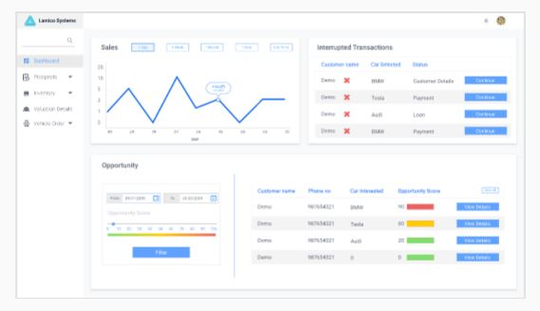

Figure : Dashboard for Sales Executive

#### Dashboard for the Sales Manager(SM)

The Sales Manager has two kinds of Dashboards. They are;

##### General

The overall Sales, Earnings, Loan approval Pending, Loan Approved, Number of Deals, Average Deal Value, Opportunities closing this month, Total Opportunity details data are displayed for the Sales Manager.

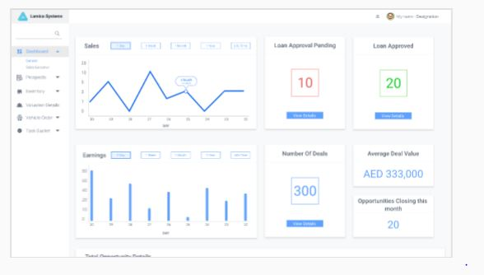

Figure : Sales Manager General view dashboard

##### Sales Executives based view for Sales Manager

Sales Executive wise Sales, Deals completed, Average Deal Value, Total Sales, Target Reach, Opportunities Details, The From and To Dates for filtering the Sales Executive Data is entered and the all the information on the Dashboard is filtered on this criteria.

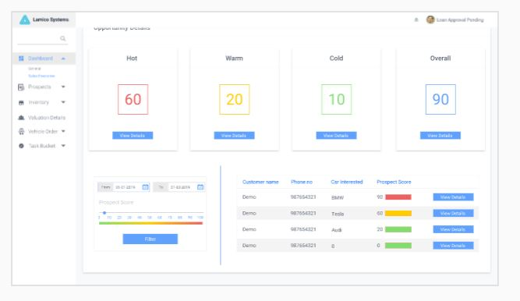

Figure : Sales Manager view Sales Executive wise Dashboard

### Task Bucket

The task bucket consists of list of tasks assigned to the sales executives. The task bucket consists of Pending, Waiting, and approved tasks details for all sales executives who report to the sales manager. The Salesman Id, Salesman No, Customer Name, Car Selected, Bank Selected, Status details are all displayed. The Task Bucket report is classified based on Pending, Waiting, and approved tasks.

#### Approval Pending

The Salesman Id, Salesman No, Customer Name, Car Selected, Bank Selected, Status, View Details option, Resend to Bank options are displayed on the screen. The Salesman Id, Salesman Name, From and To Dates is used to Filter this information. Based on the Status such as “Pending”, “Waiting”, “Approved”, the customer and sales executive data is filtered.

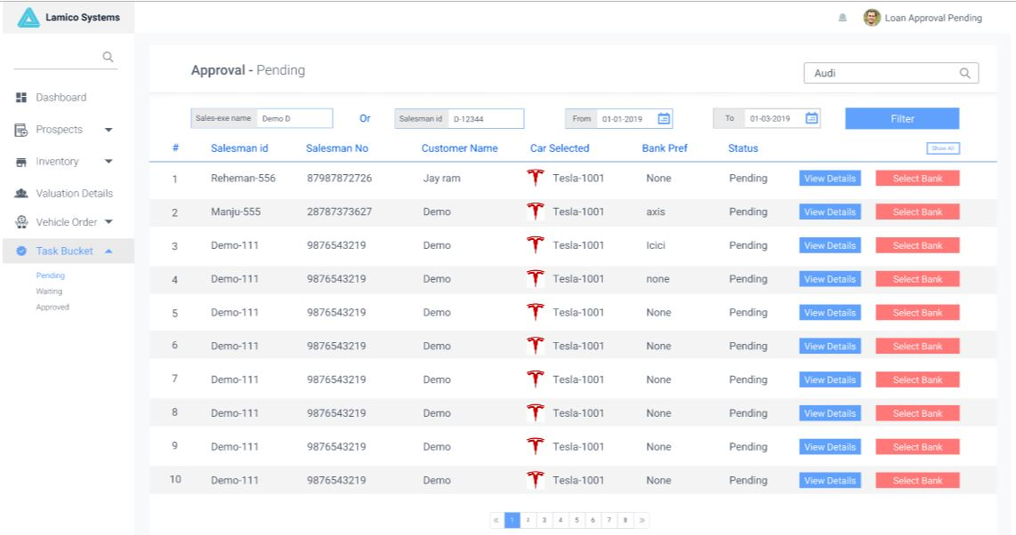

Figure : Approval - Pending

## Gap Analysis

To be done

# Requirements Definition

Requirements details captured for this project are listed below:

**High Level requirements for Lamico Auto Dealer project**

The following are the high level requirements for the project, provided by our client.

1. **User Management module:**
   * Sign-up and Login facility for Lamico Auto Dealer project are:
     1. Sales Executive (Front Desk User)
     2. Sales Manager
     3. General Manager
        1. Valuator (External)
     4. Bank User (External) - two types of user profiles are required here
        1. First one is a dashboard viewer
        2. and the other is a credit specialist who will trigger the Loan Purchase Offer from the bank (LPO) to the dealer
     5. Super Admin
   * Validate and Identification, Authentication or Authorization of users to the Auto Dealer Application.
   * Change Password, Forgot Password, Profile updates.
2. **Reference Data Management Module:**
   * Addition of Bank Details and associate them with Credit Criteria and Commission details
   * Define Bank Credit Criteria
   * Define Bank Commission Structure
   * For each of the Banks with which the dealer has a tie-up, Sales Manager will have some data points like Commission Structure (percentage commission), Tier Definition depending on Loan Value (Tier 1, 2, 3), Earning range for this Tier and so on. Proposed earning for this deal at a bank level depending on MTD deal done with the bank.
   * To add / create preferred Insurance Companies.
   * To add dealer outlets.
   * To add / create Sales Manager, Sales Executives.
3. **Prospect Module:**
   * Prospect Customer Details
     1. To Create Customer Details, Salaried/Self-employed and to define the Prospect Score (0 to 100 and Hot, Warm Cold parameters) – this will be both color coded and showing propensity of conversion.
     2. To List the Customer Details (Name, Phone No, Occupation, View details).
        1. To Edit / Update / Delete the Customers (deletion of customer details must only be with the manager and has to be cleared by the super admin).
   * Opportunity Details
     1. Create Opportunity Details (Customer Name, Product Details, Amount, Start Date (Created Date), Expected Close Date, Dealer Purchase Amount, Expected Amount (Average of Blue Book Value, Scrum Value and Valuator Value), Sales Executive, Sales Manager, Probability (Prospect Score (0 to 100 and Hot, Warm Cold parameters)).
     2. List of Opportunities.
     3. Edit / Update / Close the Opportunities.
4. **Inventory Module:**
   * Ability to create new and used car details.
   * Create Inventory (Car Summary, Purchase Date, Dealer Purchase Amount, Status (Available, Sold, Booked), Condition (if old), View Details.
   * Edit / Update / Delete Inventory.
   * Upload the Image, Video and so on for Inventory.
   * Associate CCV (Similar to VIN in India), RC book and Insurance Details.
5. **Valuation Module:**
   * Select a Car details from the inventory and update valuation details such as Blue Book Value, Scrum Value and Valuator Value.
   * Valuator Module – Provide a screen for Valuator to Login and Update the Valuator Value for a particular car.
   * If Valuator is not able to update, Sales Manager should be able to update this value.
   * Calculate Average Value considering values entered from Blue Book Value, Scrum Value and Valuator Value.
   * Calculate Market price, Proposed LTV would be defined by the credit criteria as defined by individual bank and is not an input range..LTV (Loan To Vehicle) as determined by the dealer.
6. **Vehicle Order:**

Sales Executive creates

Vehicle Order package with the following data points;

* + Fetch the Customer details from the customer created in the Prospect Module. (Please note that Customer and Opportunity has to be created first in the prospect module).
  + Capture KYC, Driving License and Income Details. If Salaried, then collect 3 months salary slips, Salary Offer letter, 6 months bank statement. If Self-employed, then collect 2 years bank statement, Source of income and so on.
  + There should be an option to upload KYC, DL and Income related documents. Each of these documents type should be defined for upload into specific fields. For eg, EID, Passport Copy, Visa Copy, DL, Traffic File Number, and so on.
  + Fetch an opportunity created for the customer. Opportunity created will have car details.
  + Fetch CCV (Similar to VIN in India), RC book and Insurance Details.
  + Add the valuation details of the vehicle (all three valuation).
  + If customer has a choice of bank, indicate the choice of Bank.
  + Send the above package to Sales Manager for forwarding  it to the bank.

Sales Manager adds the below details to the Vehicle Order package above.

* Along with the above details, add proposed LTV (inferred) to the vehicle order packet.
* If the customer has the preferred bank, the vehicle order packet has to be sent to that Bank only. Otherwise, Sales Manager can send the packet to multiple Banks of his choice.
* Manager views Commission, Tier, Probable Earning for the deal, Probability of getting the loan Approved based on Credit Criteria.
* With the above intelligence built in the system, Sales Manager will send the Vehicle Order packet to selected banks for getting LPO (Loan Proposed Offer).
* Once the Manager gets the LPO from Banks, he will fill the LPO to Vehicle Order in the order of preference from the Bank which the dealer wants to close.

Sales Executive Completes the Vehicle Order.

* Sales Executive discusses with Customer on the offer as preference proposed by the Sales Manager.
* Closes the deal.
* Completes the documentation, Scans and Uploads the documents.
* Required documentation is sent to the Bank for further processing.
* Vehicle Order is completed and corresponding entities are updated.
* Inventory Status, Opportunity Status are updated while closing the deal.

**7.  Dashboards :**

Sales Executive (Front Desk User) – Only his Opportunities.

* Opportunity Status (Filter based on criteria such as OEM, date range, status).
* Opportunity Dashboard – Last 1/3/6/12 months, status on OEM and overall.
* Dashboard of Opportunity – Hot, Warm, Cold, Rejected on OEM and overall.
* Details on funded orders – Bank details, Loan Details (LTV/LPO) for last 1/3/6/12 months on OEM and overall.

Sales Manager – Opportunity for his team

* Opportunity Status (Filter based on criteria such as date range, status) on OEM and overall.
* Opportunity Dashboard – Last 1/3/6/12 months, status on OEM and overall.
* Dashboard of Opportunity – Hot, Warm, Cold, Rejected on OEM and overall.
* Details on funded orders – Bank details, Loan Details (LTV/LPO) for last 1/3/6/12 months on OEM and overall.

General Manager – For the Entire dealership

* Opportunity Status (Filter based on criteria such as date range, status) on OEM and overall.
* Opportunity Dashboard – Last 1/3/6/12 months, status on OEM and overall.
* Dashboard of Opportunity – Hot, Warm, Cold, Rejected on OEM and overall.
* Details on funded orders – Bank details, Loan Details (LTV/LPO) for last 1/3/6/12 months on OEM and overall.

**Roles at Bank level**

**Sales Level**

* Dealers on-boarding to the system.
* Defining Commission Structure.
* Dashboard view of deals in pipeline.
* Status of LPOs.
* Status of documentation pre LPO and post LPO.

**Credit Level**

* Acceptance of deal
* Ability to download data in their native format, up-loadable into their scoring module.
* Defining Credit Criteria (this could be at a Car Level, dealer level or at Bank level).
* Blacklisting of dealers or stopping the dealer reference.