1. Getting the following error when running docker setup from command prompt.
2. This error information was not present in the getting started guide.

Command provided at the command prompt was:

docker run -d -p 80:80 docker/getting-started

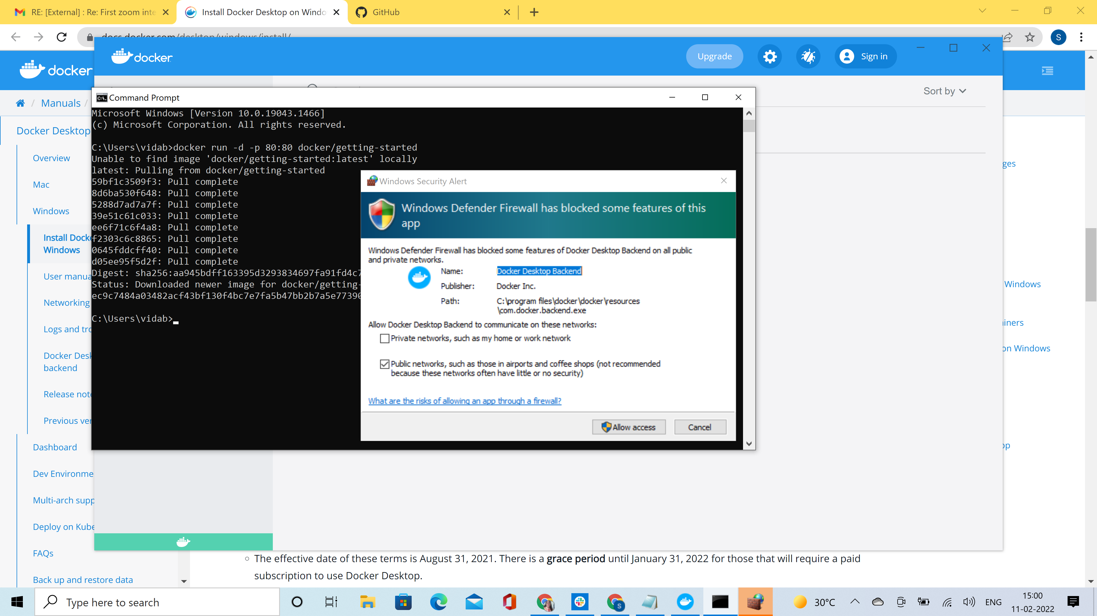

1. Docker Subscription Service Agreement window was not displayed. May be mine is not a paid subscription. So I could not verify this screen exists or not.
2. While running the sample program, lot of commands are there like

docker run -dp 3000:3000 getting-started

We should show in a window the output of these commands to know if the user is running them successfully then the output window contents should be similar.

1. I was not able to run the sample application, tried multiple times using github, docker and visual studio code also.
2. I have created a GitHub repository and sharing my GitHub repository details with you. It is created as a public repository so you can view it.

<https://github.com/SrividyaF506/docker_task>