ASSIGN 02 – Maverick Food Services

Link to application : <https://mavfoodservicevgopaluni.herokuapp.com/>

path in GIT : <https://github.com/SrividyaGopaluni/mfs.git>

Created an additional superuser in the application deployed to Heroku with the following credentials

Username: instructor

password: instructor 1a

Email: svlasnik@unomaha.edu

Screenshots of Maverick food services Application

1. Login

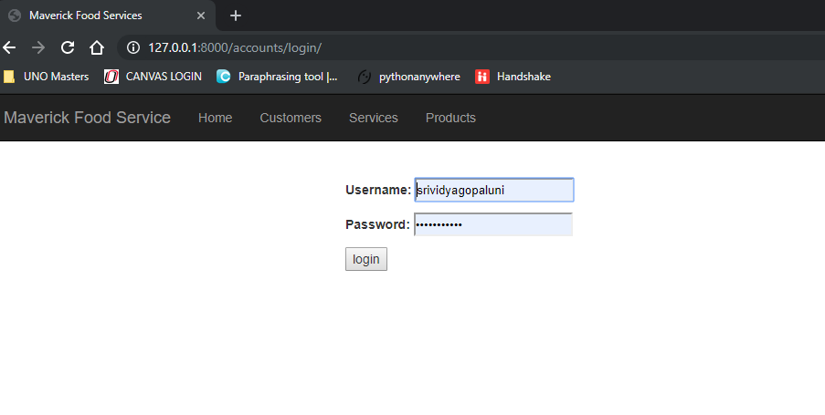

2. Home

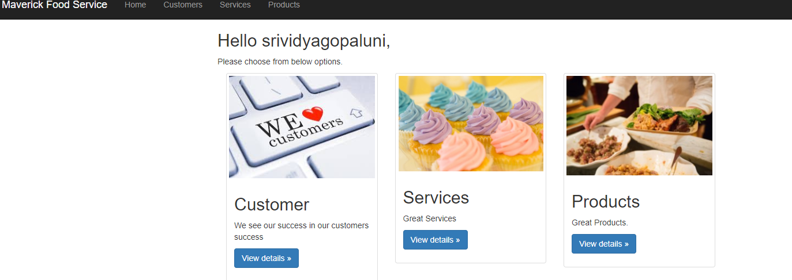

3. Adding a Customer

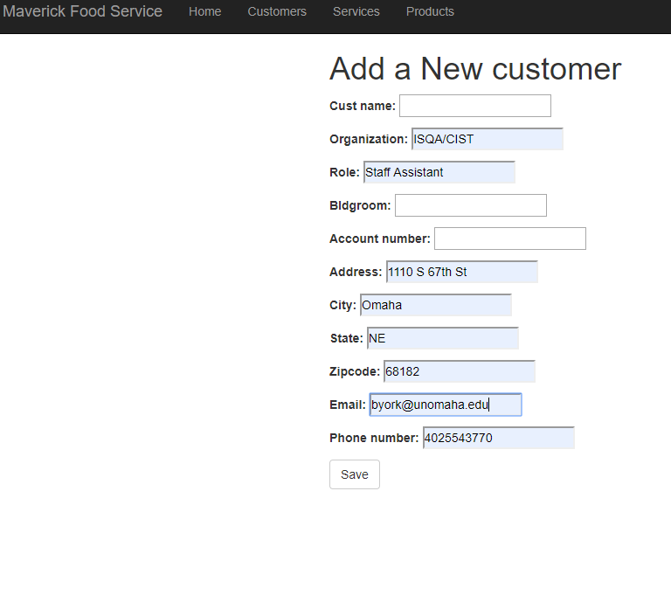

4. Customer information

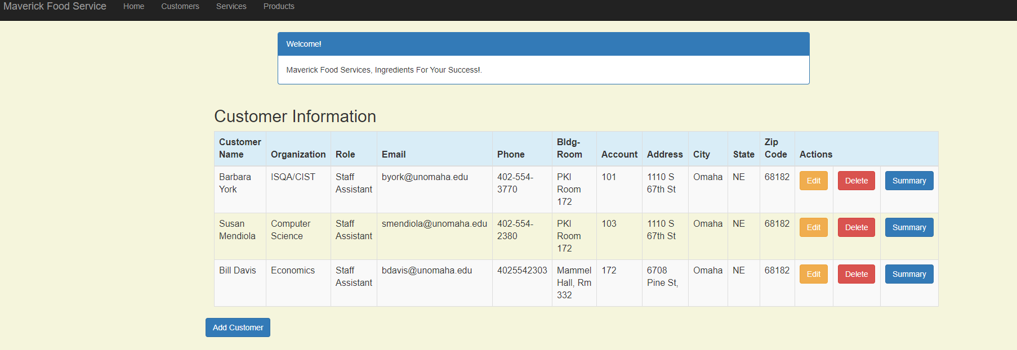

5. Editing a customer

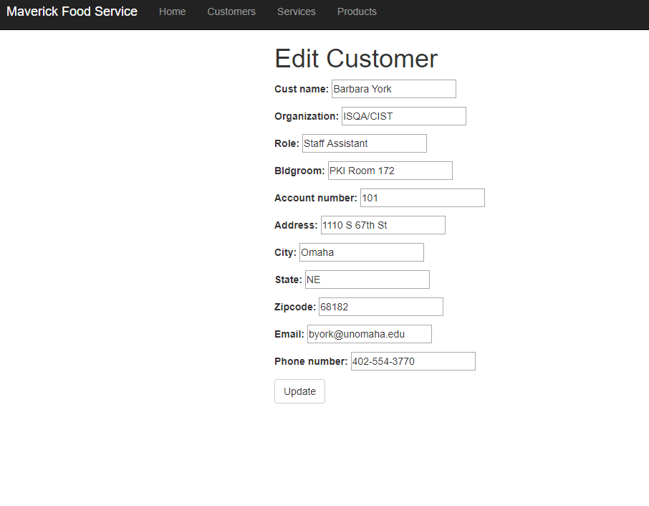

6. Deletion of customer

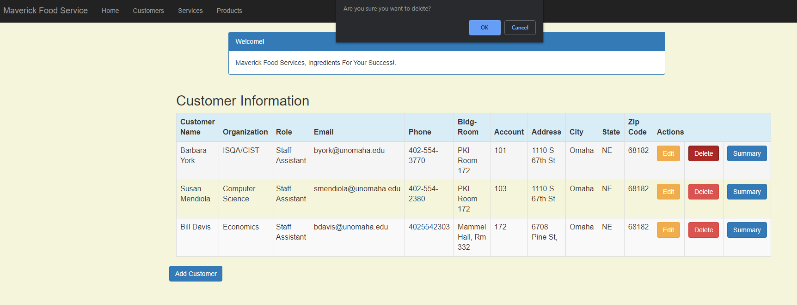

7. Adding a Product

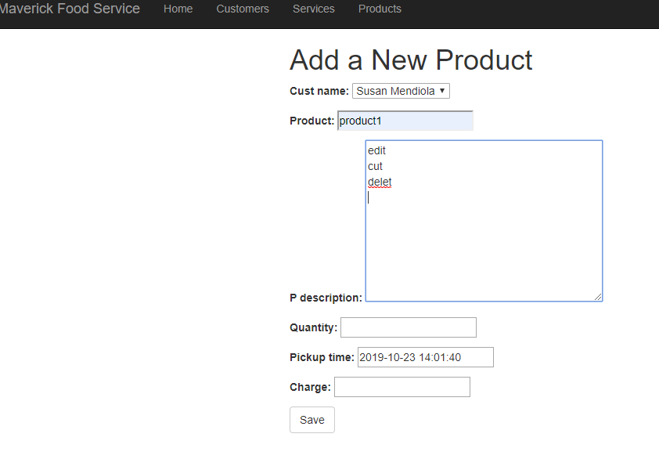

8. Product Information

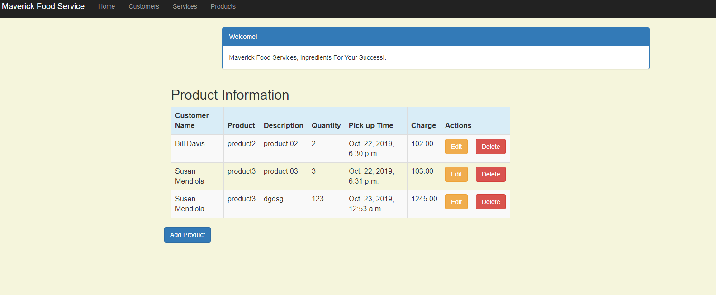

9. Editing Product

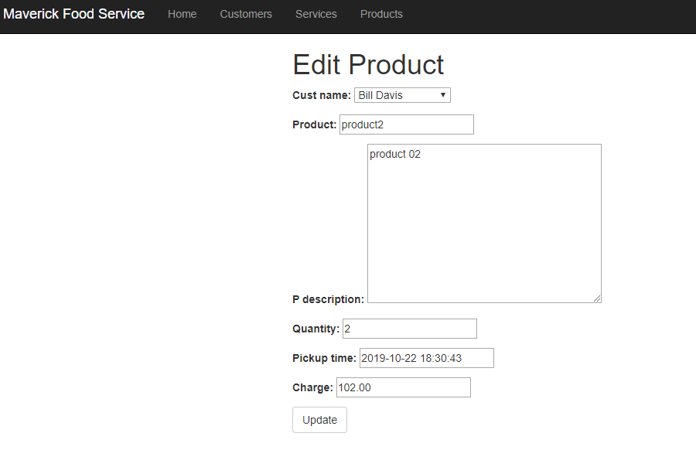

10.Deletion of services :

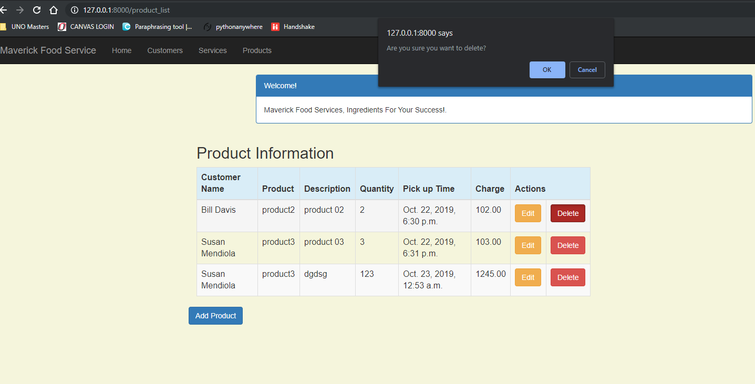

11. After Deletion of Services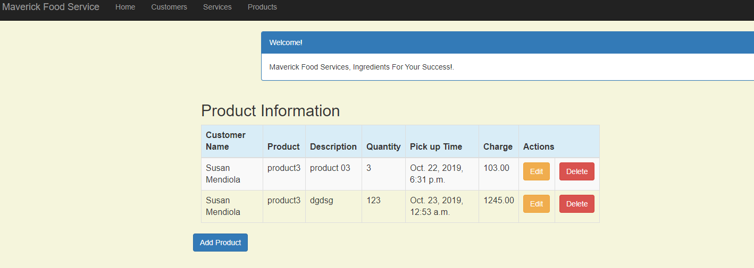

12. Service Information

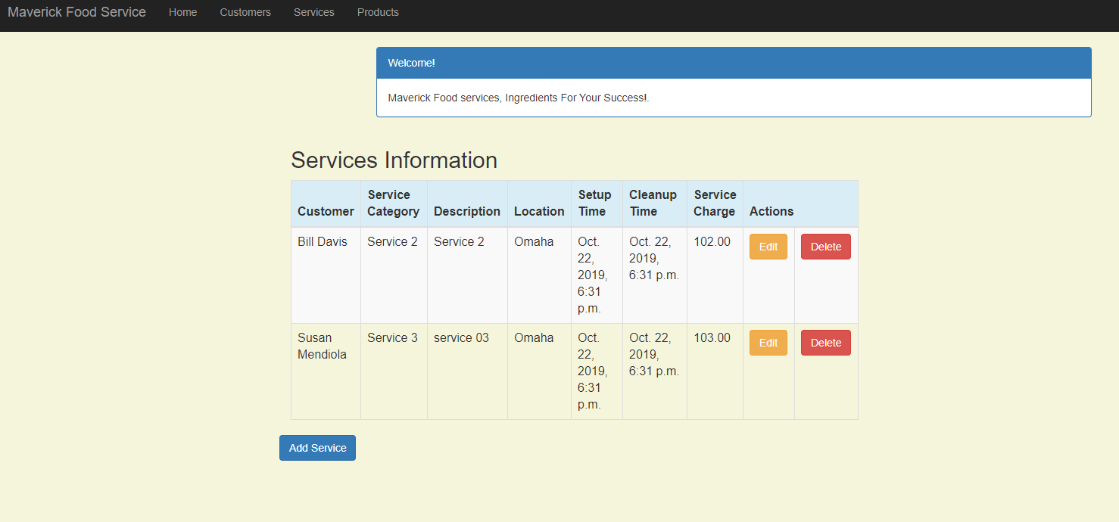

14. Edit Service

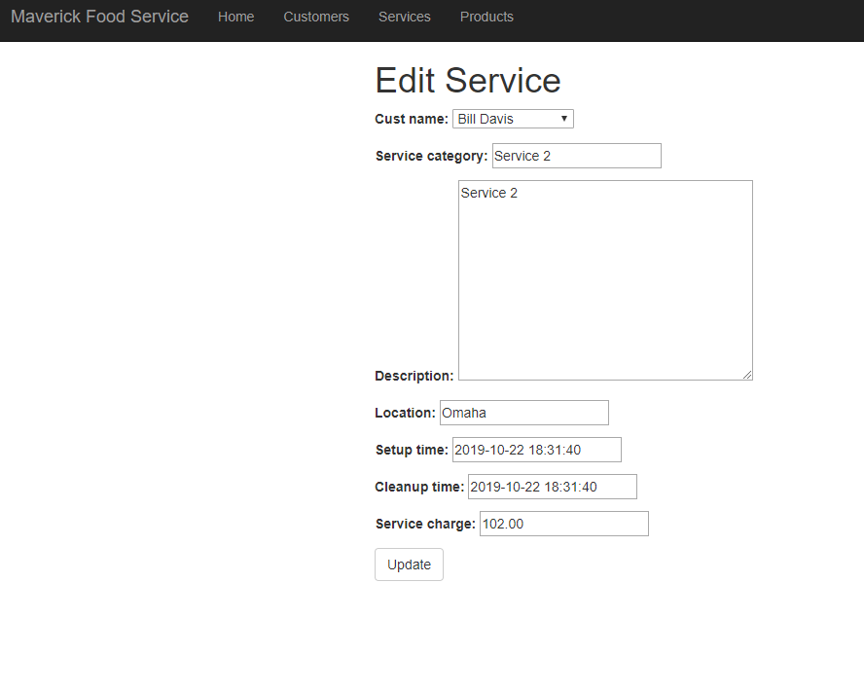

15. Delete Service

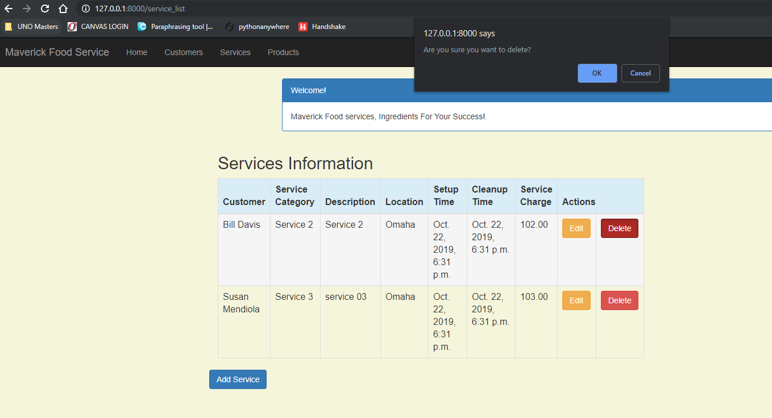

16. After Service Deletion

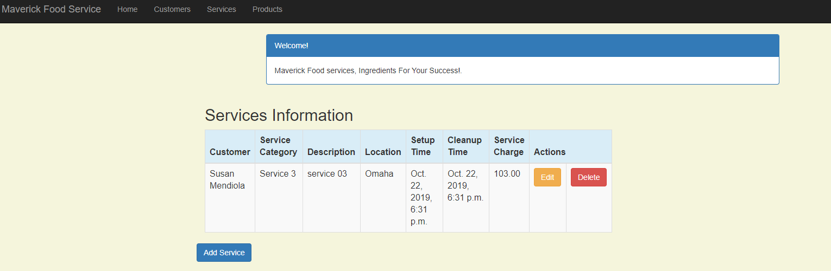

17. Customer Summary

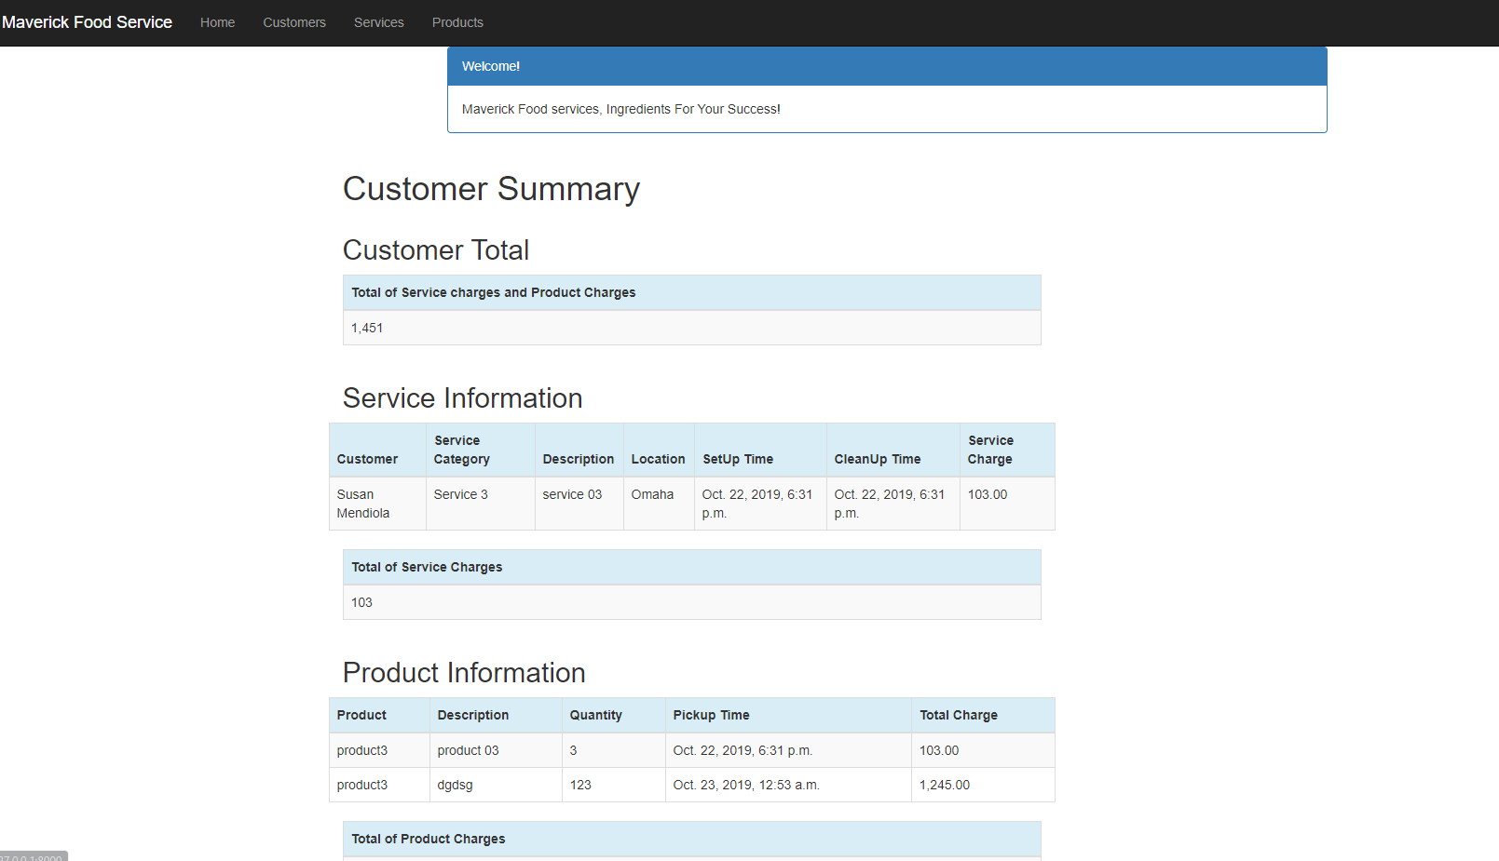

**Admin**

1. Admin page

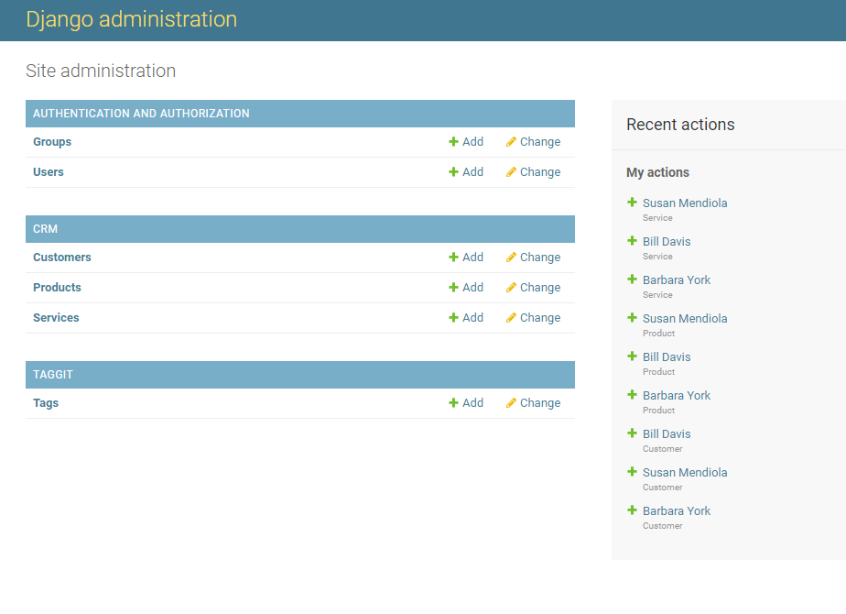

2. Adding Customer

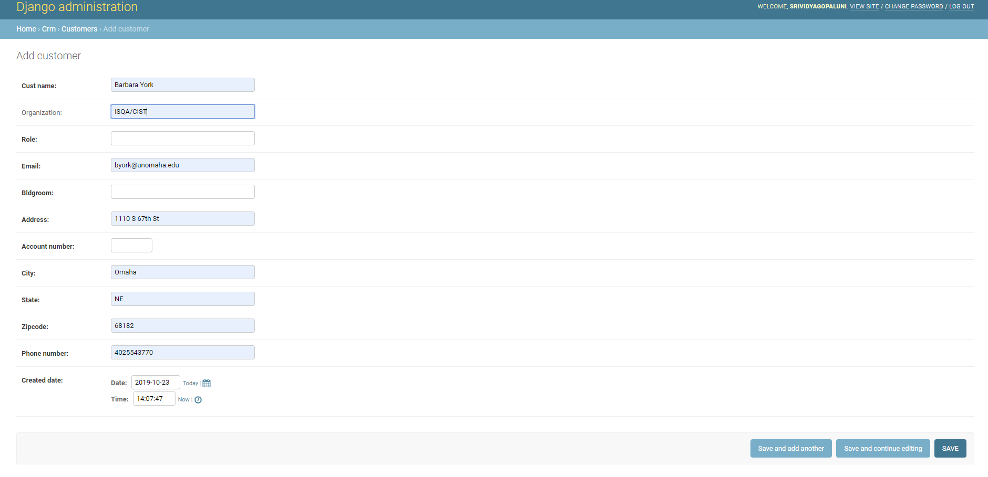

3. Adding Product

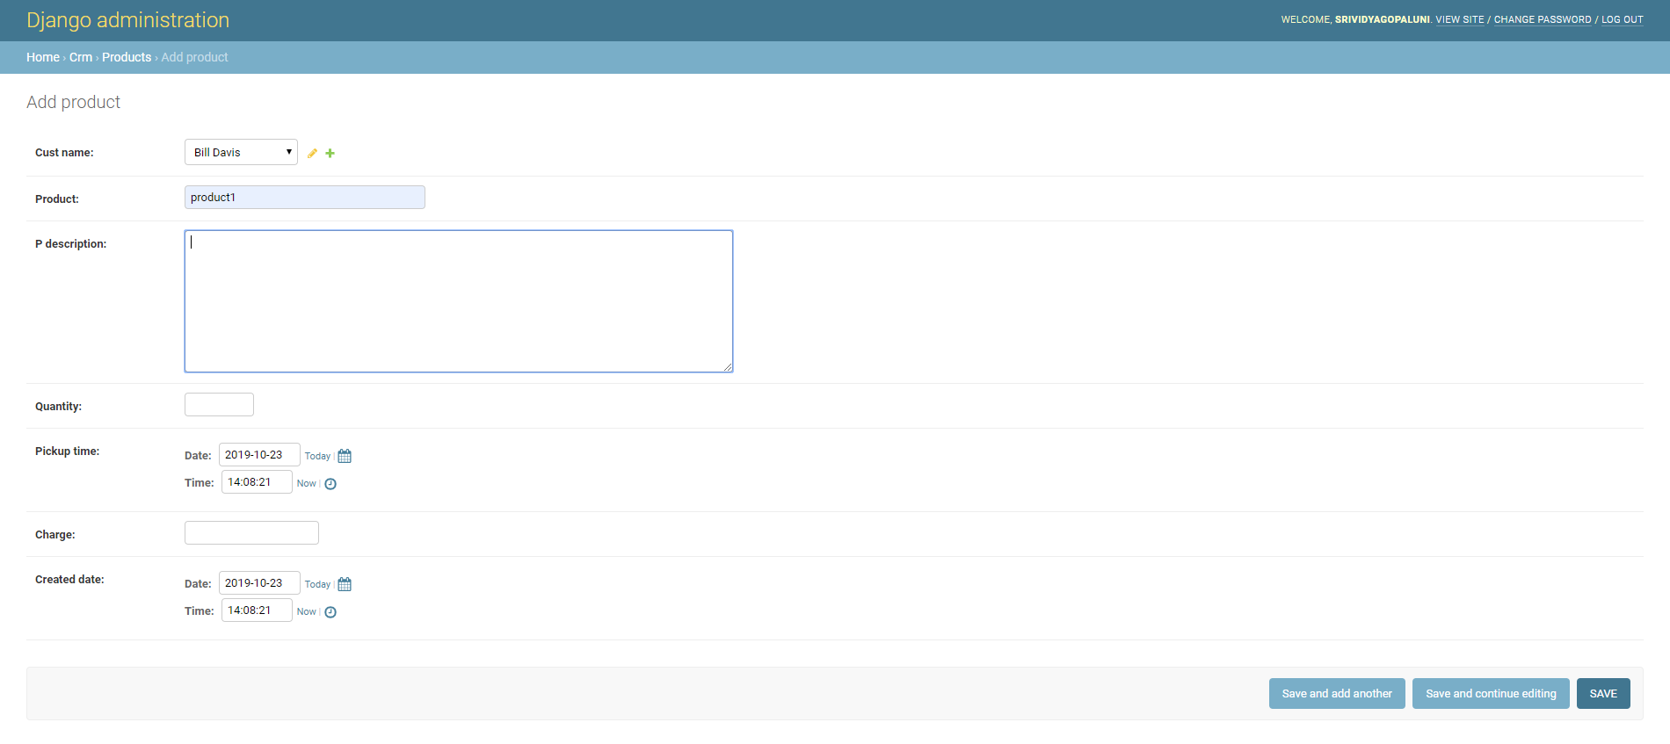

4. After Customer addition

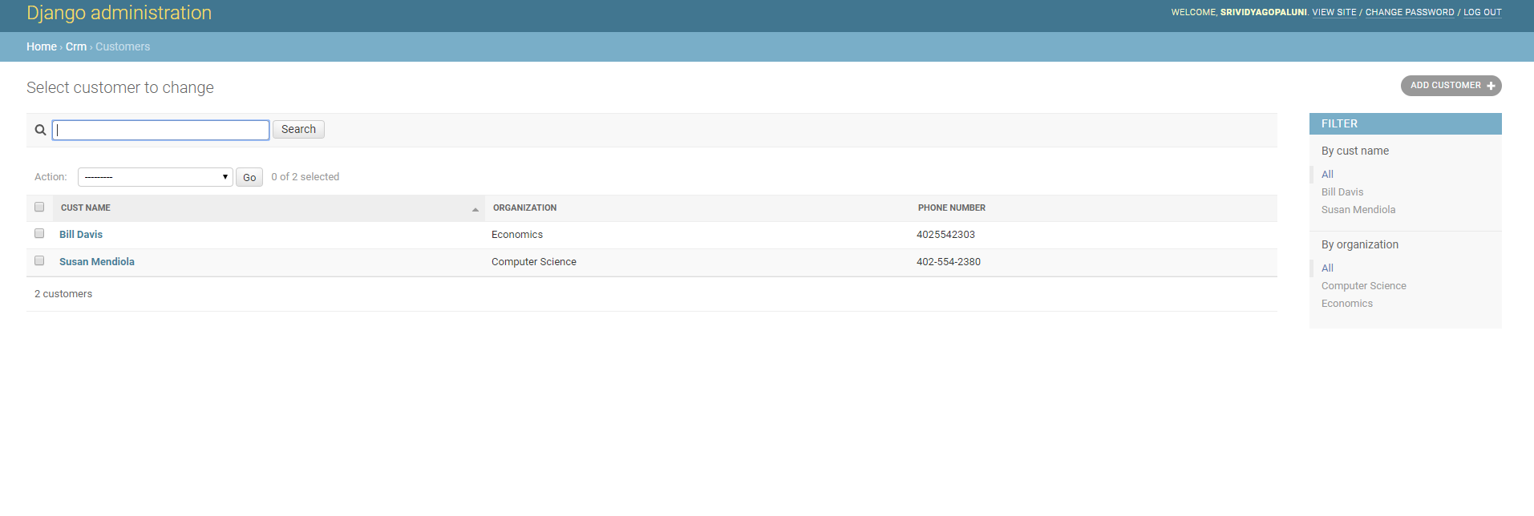

5. Editing Customer

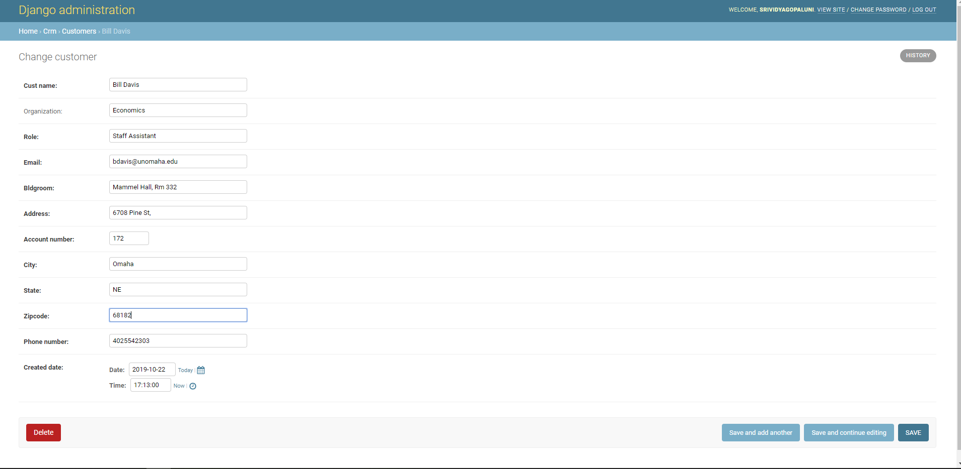

6. Adding Product

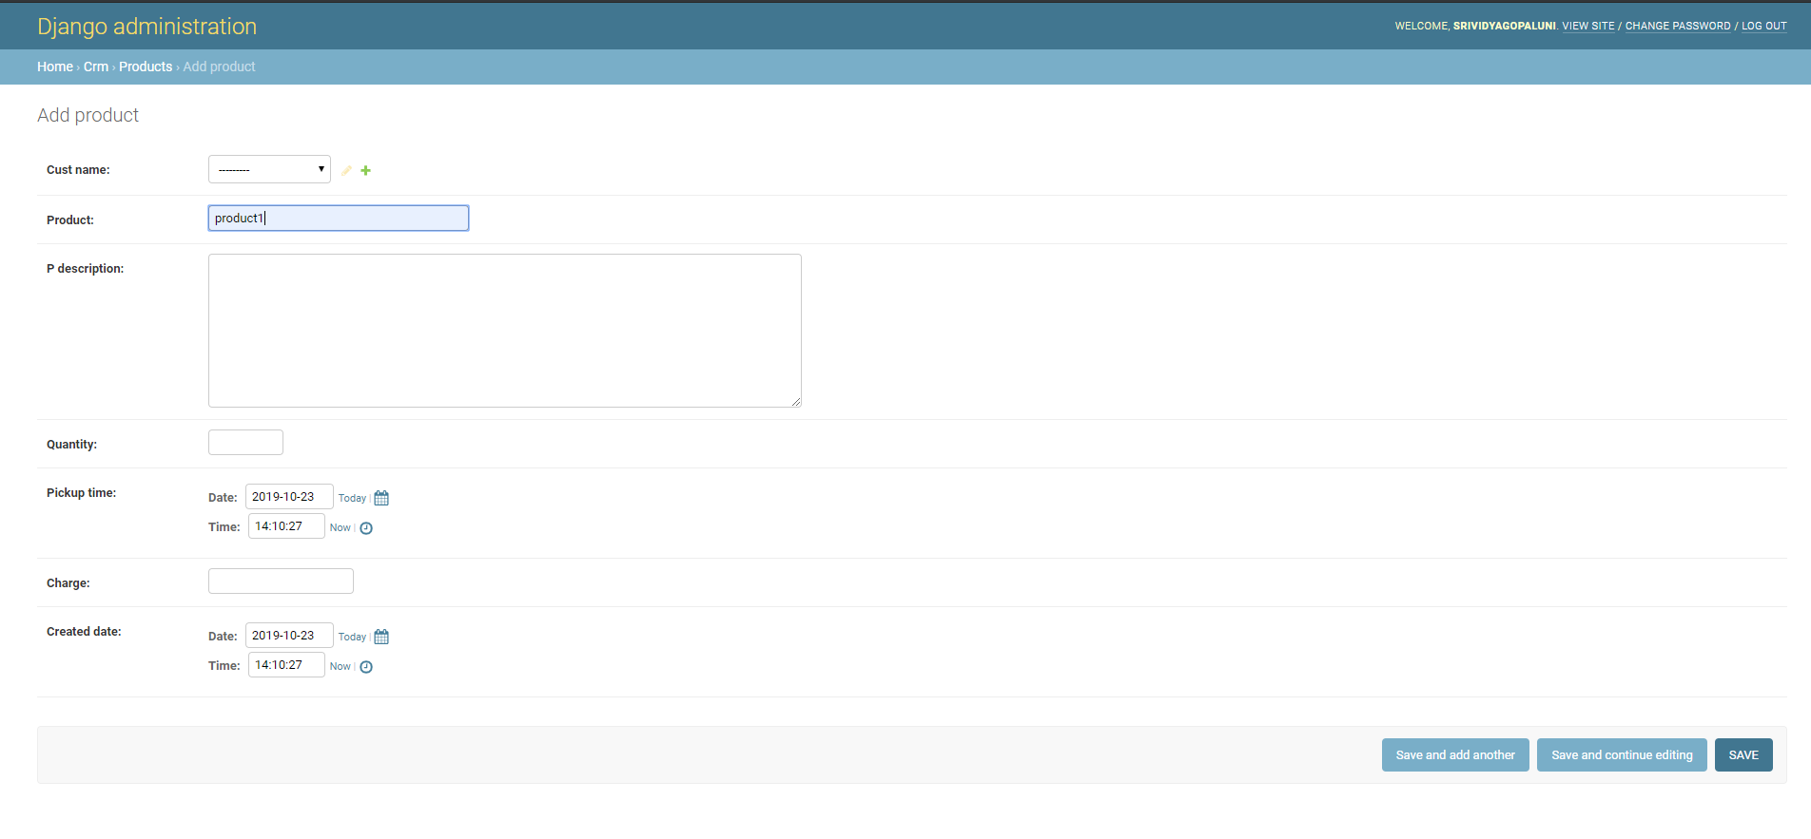

7. Edit Product

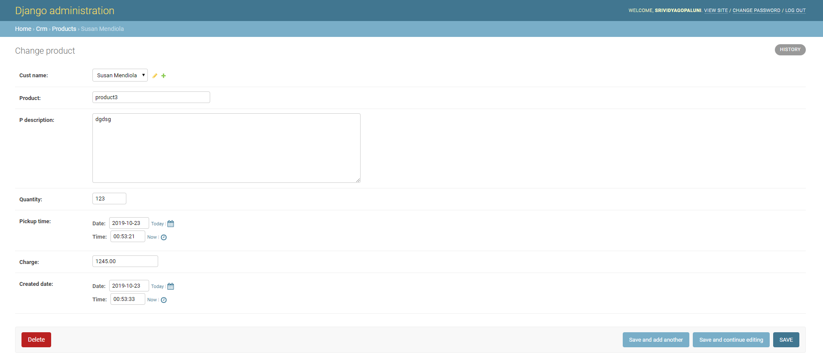

8. Adding Service

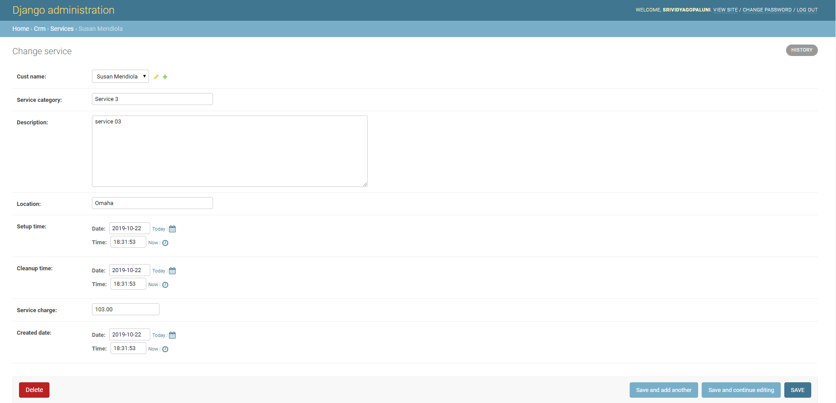

9. Edit Service

