ANP-C6540

Student ID: AF0342624

Name: Kallagunta Srividhya

Database Design for

Electricity Billing System

**ELECTRICITY BILLING SYSTEM**

**Introduction to Electricity Billing System**

Electricity Billing System is a software-based application.

1. This project aims at serving the department of electricity by computerizing the billing system.
2. It mainly focuses on the calculation of units consumed during the specified time and the money to be charged by the electricity offices.
3. This computerized system will make the overall billing system easy, accessible, comfortable, and effective for consumers.

**Various Entities**

**Bill:**

* **Meter_no**
* **Total_bill**
* **Month**
* **Unit**
* **Status**

**Tax:**

* **gst**
* **Service_tax**
* **Swachbharath_cess**

**Rent:**

* **Cost_per_unit**
* **Service_charges**
* **Meter_rent**

**Customer:**

* **name**
* **meter_no**
* **address**
* **phone_num**
* **e-mail**

**meter_info:**

* **bill_type**
* **meter_type**
* **phase_code**
* **days**
* **meter_location**

**Login:**

* **User_Name**
* **User**
* **Password**
* **Meter_no**

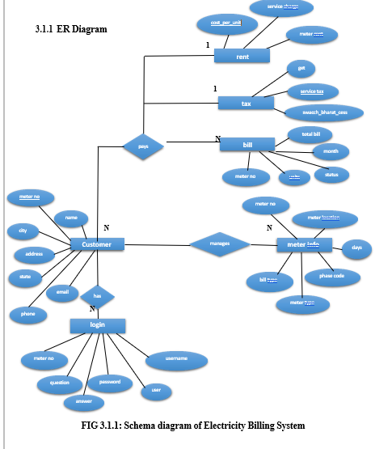

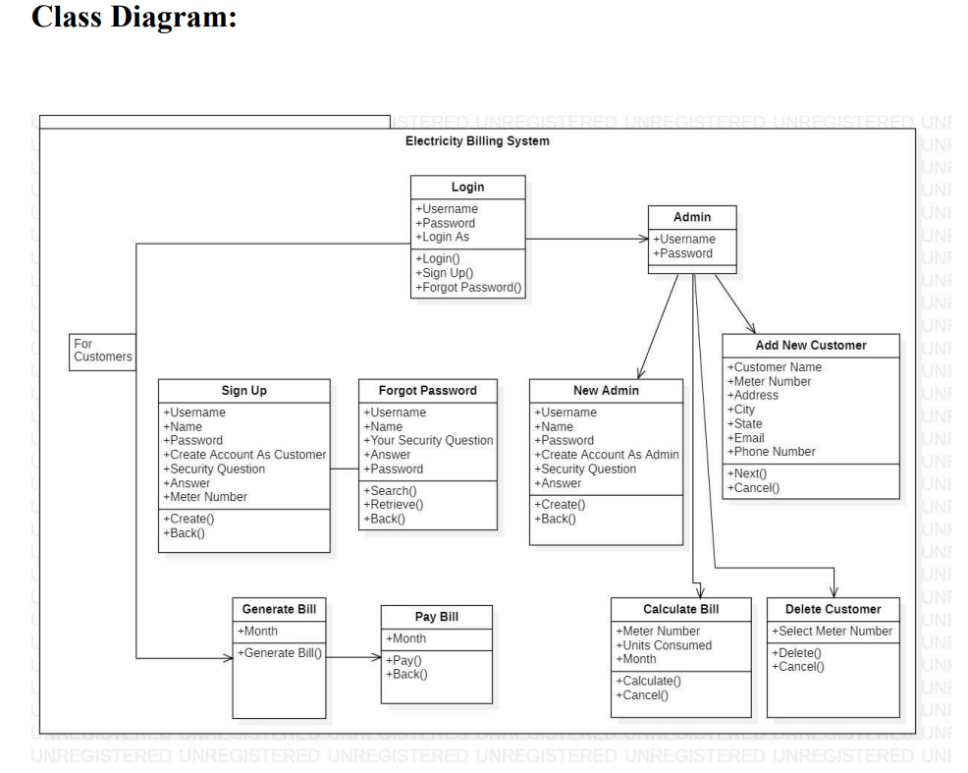

**Conclusion**

In conclusion, all the hard work is done for electricity bill management system is here. It is software which helps the user to work with the billing cycles, paying bills, managing different DETAILS under which are working etc.

This software reduces the amount of manual data entry and gives greater efficiency. The User Interface of it is very friendly and can be easily used by anyone.