Website Enhancement Suggestions
Website: www.prepxl.app
Purpose: UI/UX Audit & Improvement Proposal
Prepared by: Boddu Sri Vishnu

1. Introduction
This document presents a UI/UX analysis and enhancement suggestions for the website www.prepxl.app.
The objective of this audit is to identify usability issues, visual design gaps, and user experience improvements that can enhance engagement, clarity, and conversion.
The analysis is done from a user and student perspective, focusing on accessibility, readability, and intuitive navigation.

2. Overall Observations
After reviewing the website, the following general observations were made:
- The website contains valuable content, but the visual hierarchy is not very clear
- Some sections feel text-heavy, which may overwhelm first-time users
- Call-to-action (CTA) buttons are present but not visually prominent
- Spacing and alignment can be improved for better readability
- The website can benefit from improved mobile responsiveness

3. Section-Wise UI/UX Analysis & Suggestions
3.1 Homepage / Hero Section
Current Issues:
- The hero section contains too much text at first glance
- The main value proposition is not immediately clear
- Primary CTA buttons do not stand out enough
Suggested Improvements:
- Reduce text content and highlight one clear headline
- Add a short supporting tagline below the headline
- Use a single primary CTA button with a contrasting color
- Increase whitespace to improve visual clarity
Benefit:
- Users can quickly understand the purpose of the website
- Improved user engagement and conversion rate

3.2 Content Layout & Readability
Current Issues:
- Long paragraphs make scanning difficult
- Inconsistent spacing between sections
- Font sizes are similar across headings and body text
Suggested Improvements:
- Break long paragraphs into bullet points
- Use consistent spacing between sections
- Increase font size for headings and reduce body text size slightly
- Maintain consistent line height for better readability
Benefit:
- Improved readability
- Better content scanning for users

3.3 Call-to-Action (CTA) Buttons
Current Issues:
- CTA buttons blend with the background
- Multiple CTAs compete for user attention
Suggested Improvements:
- Use one primary CTA per section
- Apply a consistent accent color for all CTA buttons
- Add hover effects for better interaction feedback
Benefit:
- Clear user action guidance
- Increased click-through rate

3.4 Navigation & User Flow
Current Issues:
- Navigation options are not always intuitive
- Users may take extra time to find important sections
Suggested Improvements:
- Simplify navigation menu items
- Highlight important links such as “Courses”, “Practice”, or “Get Started”
- Add a sticky navigation bar for easier access
Benefit:
- Smoother user journey
- Reduced user confusion

3.5 Mobile Responsiveness
Current Issues:
- Some elements feel cramped on smaller screens
- Text and buttons may appear too close together
Suggested Improvements:
- Increase padding and margins for mobile layouts
- Ensure buttons are large enough for touch interaction
- Optimize font scaling for different screen sizes
Benefit:
- Improved experience for mobile users
- Better accessibility across devices

4. Visual Design Improvements
Suggested Enhancements:
- Use a consistent color palette across the website
- Improve contrast between text and background
- Introduce subtle animations or transitions for interactions
- Maintain consistent icon styles throughout the website
Benefit:
- More modern and professional appearance
- Better visual consistency

5. Accessibility Suggestions
Recommendations:
- Ensure sufficient color contrast for readability
- Add proper labels for buttons and form fields
- Improve keyboard navigation support
- Use clear and simple language for content
Benefit:
- Better accessibility for all users
- Compliance with basic accessibility standards

6. Screenshots & Annotations
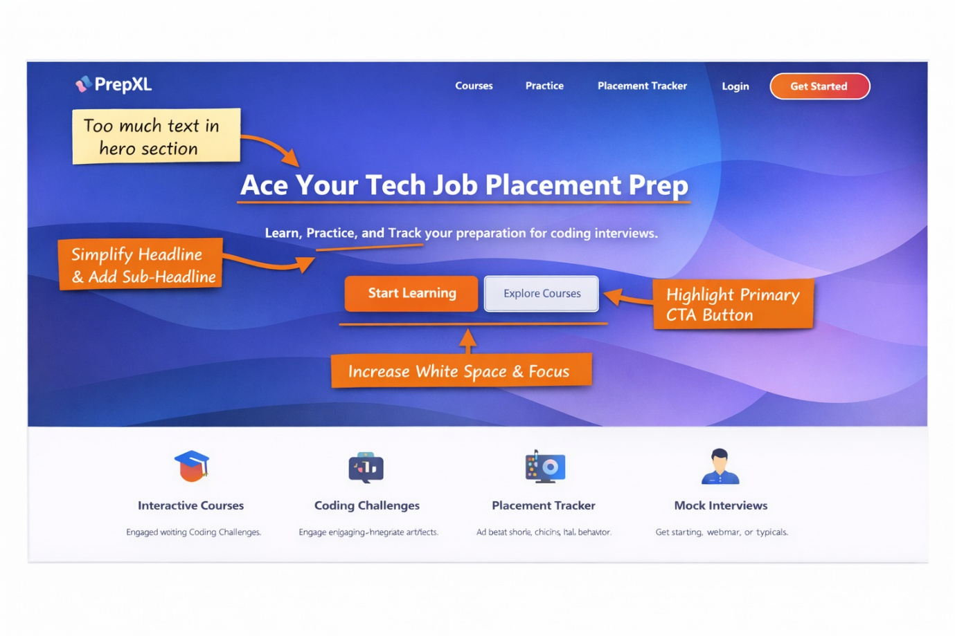
7. Conclusion
The website www.prepxl.app has a strong foundation in terms of content and purpose.
By improving visual hierarchy, spacing, CTA clarity, and mobile responsiveness, the overall user experience can be significantly enhanced.
These suggested improvements aim to make the website:
- More user-friendly
- Visually appealing
- Easier to navigate
- More engaging for students and first-time users

8. Final Note
The proposed enhancements are incremental and practical, meaning they can be implemented without major redesign efforts while still delivering noticeable improvements in usability and user satisfaction.

