## 2)Create 3 XML and Json files for department,year,student

<?xml version="1.0" encoding="UTF-8"?>

<department>

<department>

<deptid>1</deptid>

<deptname>IT</deptname>

</department>

<department>

<deptid>2</deptid>

<deptname>CSE</deptname>

</department>

<department>

<deptid>3</deptid>

<deptname>ECE</deptname>

</department>

</department>

YEAR.XML

<?xml version="1.0" encoding="UTF-8"?>

<year>

<year>

<id>1</id>

<name>firstyear</name>

</year>

<year>

<id>2</id>

<name>secondyear</name>

</year>

<year>

<id>3</id>

<name>thirdyear</name>

</year>

<year>

<id>4</id>

<name>fourthyear</name>

</year>

</year>

STUDENT.XML

<?xml version="1.0" encoding="UTF-8"?>

<student>

<student>

<id>1</id>

<name>Vyshnavi</name>

<dept>IT</dept>

</student>

<student>

<id>2</id>

<name>Kiran</name>

<dept>CSE</dept>

</student>

<student>

<id>3</id>

<name>Vennela</name>

<dept>ECE</dept>

</student>

</student>

DEPARTMENT.JSON

{

"departments": [

{

"id": 1,

"name": "Computer Science",

"location": "Building A"

},

{

"id": 2,

"name": "Electrical Engineering",

"location": "Building B"

}

]

}

Year JSON:

{

"years": [

{

"id": 1,

"name": "Freshman"

},

{

"id": 2,

"name": "Sophomore"

}

]

}

STUDENT.JSON

{

"students": [

{

"id": 1,

"name": "John Doe",

"department_id": 1,

"year_id": 3

},

{

"id": 2,

"name": "Jane Smith",

"department_id": 2,

"year_id": 2

}

/* Add more students here if needed */

]

}

## 3)Create a file with depertment as root,year as subroot and student as an element

<?xml version="1.0" encoding="UTF-8"?>

<department>

<year>

<id>1</id>

<name>firstyear</name>

<student>

<student>

<id>1</id>

<name>Vyshnavi</name>

<dept>IT</dept>

</student>

<student>

<id>2</id>

<name>Kiran</name>

<dept>CSE</dept>

</student>

</student>

</year>

<year>

<id>2</id>

<name>secondyear</name>

<student>

<student>

<id>1</id>

<name>Ruchitha</name>

<dept>IT</dept>

</student>

<student>

<id>2</id>

<name>prathyusha</name>

<dept>ECE</dept>

</student>

</student>

</year>

<year>

<id>3</id>

<name>thirdyear</name>

<student>

<student>

<id>1</id>

<name>Preethika</name>

<dept>IT</dept>

</student>

<student>

<id>2</id>

<name>Vennela</name>

<dept>ECE</dept>

</student>

</student>

</year>

<year>

<id>4</id>

<name>fourthyear</name>

<student>

<student>

<id>1</id>

<name>Sravan</name>

<dept>IT</dept>

</student>

<student>

<id>2</id>

<name>shanthi</name>

<dept>ECE</dept>

</student>

</student>

</year>

## 5)Create a Login Screen

<html>

<head>

<title> LOGIN</title>

</head>

<body>

<form>

<h3><b><center> LOGIN </center> </b></h3>

<table border="0" align="center">

<tr>

<td>Username : </td>

<td><input type ="text"></td>

</tr>

<tr>

<td>Password: </td>

<td><input type ="password"></td>

</tr>

<tr>

<td align="center" ><input type="Button" value="Submit"></td>

</tr>

<tr>

<td>If not a member Register</td>

</tr>

</form>

</body>

</html>

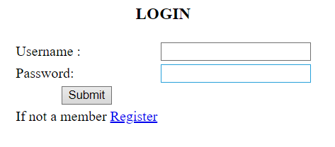

## 6)Create a User Creation Screen by using all elements in it(like List, Radio button, Drop down, CheckBox)

<html>

<head>

<title> Registration </title>

</head>

<body>

<form>

<h3><b><center> REGISTRATION FORM </center> </b></h3>

<table border="0" align="center">

<tr>

<td>First Name : </td>

<td><input type ="text"></td>

</tr>

<tr>

<td>Last Name : </td>

<td><input type ="text"></td>

</tr>

<tr>

<td>Phone number: </td>

<td><input type ="text"></td>

</tr>

<tr>

<td>Gender : </td>

<td><input type ="radio" name="g">Female

<input type ="radio" name="g">Male

<input type ="radio" name="g">Other</td>

</tr>

<tr>

<td>List of the subjects: </td>

</tr>

<tr>

<ul>

<li>Java</li>

<li>C</li>

<li>c++</li>

</ul>

</tr>

<tr>

<td>Email: </td>

<td><input type ="text"></td>

</tr>

<tr>

<td>branch: </td>

<td><select name="branch">

<option>--SELECT--</option>

<option>CSE</option>

<option>EEE</option>

<option>ECE</option>

</td>

</tr>

<tr>

<td>Address: </td>

<td> <textarea rows="5" cols="5"> </textarea> </td>

</tr>

<tr>

<td>DOB: </td>

<td><input type ="date"></td>

</tr>

<tr>

<td>HOBBIES</td>

<td><input type="checkbox" name="rcb">playing cricket</input>

<input type="checkbox" name="rcb">reading books</input></td>

</tr>

<tr>

<td>Landmark: </td>

<td><input type="text" name="input" placeholder="(optional)"></td>

</tr>

</form>

</body>

< /html>

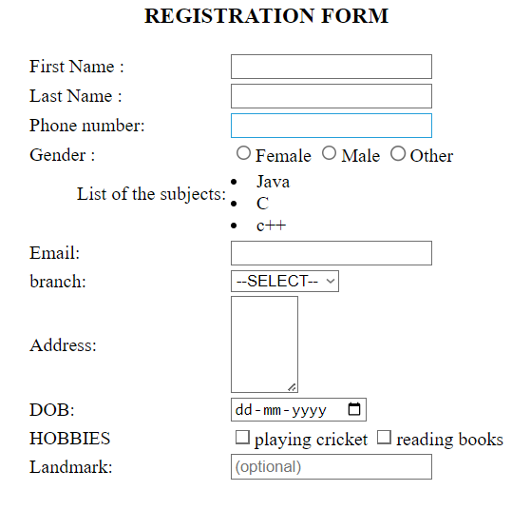

## 7)List all Users,Update user and Delete user(Popup for confirmation eg:Are you sure do you want to delete)

<html>

<head>

<script language="Javascript">

function de()

{

confirm("Are you sure you want to delete?");

}

</script>

</head>

<body>

<h1><b><center>List of users</center></b></h1>

<form>

<table border="1" align ="center"><br>

<br>

<br>

<tr>

<th>S.No.</th>

<th>Name:</th>

<th>Email:</th>

<th>Phone:</th>

<th>Edit</th>

</tr>

<tr>

<td> 1.</td>

<td> Kiran Dedavath </td>

<td> kiran56789@gmail.com </td>

<td>7892737387</td>

<td><input type="Button" value="Update">

<input type ="Button" value="Delete" onclick="de()"></td>

</tr>

<tr>

<td> 2.</td>

<td> Ruchitha </td>

<td> ruchi34789@gmail.com </td>

<td>7892732637</td>

<td><input type="Button" value="Update">

<input type ="Button" value="Delete" onclick="de()"></td>

</tr>

</body>

</html>

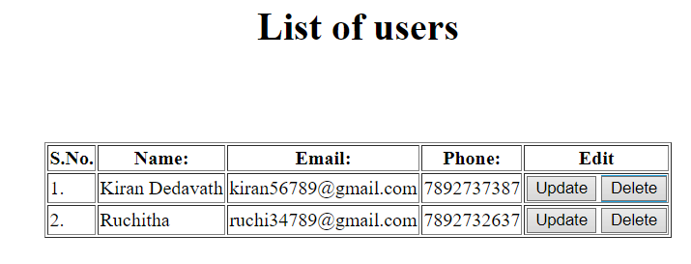

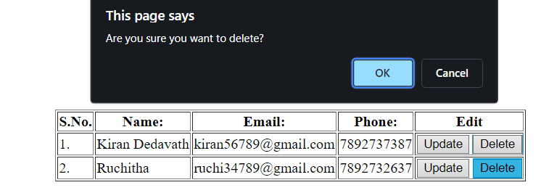

## 8)Create a HTML page with Google maps

<html>

<body align="center">

<iframe src="https://www.google.com/maps/embed?pb=!1m18!1m12!1m3!1d3807.1930794820496!2d78.65009197455531!3d17.40251930237024!2m3!1f0!2f0!3f0!3m2!1i1024!2i768!4f13.1!3m3!1m2!1s0x3bcb90cedb836e63%3A0xae409c5cd6f1ce0c!2sNalla%20Narasimha%20Reddy%20Education%20Society%E2%80%99s%20Group%20of%20Institutions!5e0!3m2!1sen!2sin!4v1716309882498!5m2!1sen!2sin" width="600" height="450" style="border:0;" allowfullscreen="" loading="lazy" referrerpolicy="no-referrer-when-downgrade"></iframe>

</body>

</html>

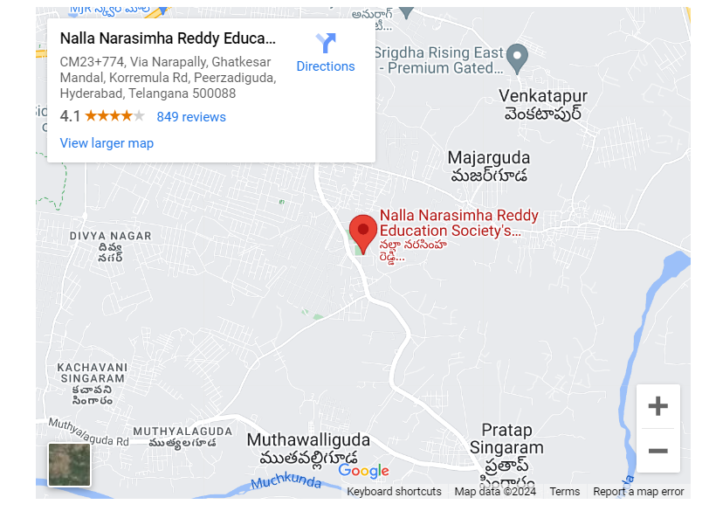

## 9)Create a HTML page with Video File

<html>

<head>

</head>

<body><center>

VIDEO<br>

<br>

<video width="400" controls>

<source src="C:/Users/srivy/Downloads/radhe.mp4" type="video/mp4">

</center>

</video>

</body>

</html>



## 10)Create a HTML page with Audio file

<html>

<body><center>

AUDIO<br>

<br>

<audio controls>

<source src="C:/Users/srivy/Downloads/aud.mp3" type="audio/mpeg"></center>

</audio>

</body>

</html>

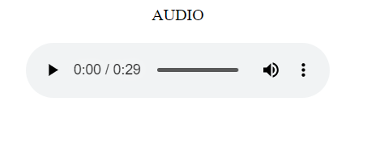

## 11)Create a HTML page to upload a file

<html>

<head>

<title> Selection of file </title>

</head>

<body>

<form>

<center>Select a file

<input type="file" id="myfile" name="myfile"><br>

<br>

<input type="button" value="Submit">

</center>

</form>

</body>

</html>

