AI-POWERED VENDOR WEBSITE BUILDER
An Intelligent E-Commerce Generation & Storefront Management Platform for Small Businesses
INTERNSHIP REPORT
Submitted in partial fulfillment of the requirements
For the award of the degree of
BACHELOR OF TECHNOLOGY
IN
INFORMATION TECHNOLOGY & COMPUTER APPLICATIONS
Submitted by:  ARAVAPALLI KARUNYA | Registration No:  323114611002
Under the Esteemed Guidance of
Dr. SURI BABU KORADA
ANDHRA UNIVERSITY
COLLEGE OF ENGINEERING FOR WOMEN
Visakhapatnam - 530017, Andhra Pradesh, India
Academic Years: 2023 - 2027

CERTIFICATE
ANDHRA UNIVERSITY COLLEGE OF ENGINEERING FOR WOMEN
VISAKHAPATNAM - 530017
DEPARTMENT OF INFORMATION TECHNOLOGY & COMPUTER APPLICATIONS
This is to certify that the project report entitled “AI-POWERED VENDOR WEBSITE BUILDER” is a bonafide record of the internship work carried out by ARAVAPALLI KARUNYA (Regd. No: 323114611002) in partial fulfillment of the requirements for the award of the Degree of Bachelor of Technology in Information Technology & Computer Applications from Andhra University College of Engineering for Women during the academic year 2025–2026.
The project demonstrates satisfactory performance, original software implementation, and diligent adherence to modern software engineering standards and full-stack development methodologies.
Dr. Suri Babu Korada  Project Guide & Mentor  Dept. of IT & CA, AUCEW | Prof. B. Prajna  Head of the Department  Dept. of IT & CA, AUCEW

INTERNSHIP COMPLETION CERTIFICATE
TO WHOMSOEVER IT MAY CONCERN
This is to certify that Ms. ARAVAPALLI KARUNYA, Reg. No. 323114611002, a student of B.Tech (Information Technology & Computer Applications) at Andhra University College of Engineering for Women, Visakhapatnam, has successfully completed her software engineering internship from May 2025 to June 2025.
During her internship tenure, she worked comprehensively on the design, architecture, and full-stack development of the project entitled “AI-Powered Vendor Website Builder”. Her work included developing responsive user interfaces in React.js, engineering RESTful microservices in Node.js/Express.js, integrating Google Gemini Generative AI for automated website layout generation, implementing automated background removal algorithms via external APIs, and establishing resilient database models in MongoDB.
During the period of her internship, her conduct was found to be exemplary, and she demonstrated commendable technical proficiency, problem-solving capabilities, and dedication to high software engineering standards.
Date: 30 June 2025  Place: Visakhapatnam | Technical Internship Director  Industry & Innovation Cell  Authorized Signatory

DECLARATION
I hereby declare that the internship project entitled “AI-POWERED VENDOR WEBSITE BUILDER” submitted in partial fulfillment of the requirements for the award of the degree of Bachelor of Technology in Information Technology & Computer Applications at ANDHRA UNIVERSITY COLLEGE OF ENGINEERING FOR WOMEN, Visakhapatnam, is an authentic record of the work carried out by me under the esteemed guidance of Dr. Suri Babu Korada.
I further declare that this project report is the result of my own independent effort, and that the matter embodied in this report has not been submitted previously, in part or in full, to any other university or institute for the award of any degree, diploma, or fellowship.
ARAVAPALLI KARUNYA
Regd. No: 323114611002
B.Tech (IT & CA)
AUCEW, Visakhapatnam

INDEX
S.No | Content | Page No.
 | Abstract | 6 - 7
 | List of Acronyms | 7
1. | Introduction | 8 - 10
1.1 | Objective of the Project | 8
1.2 | Purpose of the Project & Key Features | 8 - 10
1.3 | Scope of the Project | 10
2. | Problem Statement | 11 - 14
2.1 | Existing System & Traditional Bottlenecks | 11
2.2 | Proposed System Architecture & Workflow | 11 - 12
2.3 | Advantages of the Proposed Project | 12 - 13
2.4 | Special Functions & Intelligent Capabilities | 13 - 14
3. | Design and Methodology | 15 - 18
3.1 | Software & Hardware Requirements | 15 - 16
3.2 | System Architecture & Block Diagram | 16 - 18
4. | UML Diagrams & System Models | 19 - 28
4.1 | Use Case Diagram & Actor Specifications | 19 - 20
4.2 | Class Diagram & Domain Entities | 21 - 23
4.3 | Sequence Diagram & Operational Flows | 24 - 25
4.4 | State Chart Diagram & Lifecycle Transitions | 25 - 26
4.5 | Activity Diagram & Workflow Execution | 27 - 28
5. | Conclusion and Future Enhancements | 29
6. | Bibliography & Web References | 30

ABSTRACT
This project report documents the design, architecture, and full-stack implementation of the AI-Powered Vendor Website Builder, an intelligent zero-code e-commerce enablement platform engineered to bridge the digital divide for small vendors, local merchants, service providers, and emerging entrepreneurs. In the contemporary digital economy, establishing a polished online presence is critical for business longevity; however, traditional web development workflows demand substantial capital investment, deep technical expertise, and continuous maintenance. Micro and small businesses—such as neighbourhood tailors, restaurants, salons, grocery stores, bakeries, and freelance technicians—routinely struggle with complex platforms like WordPress or Shopify that require manual theme coding, plugin configuration, and steep learning curves.
The Vendor Website Builder eliminates these barriers by introducing an autonomous, AI-driven digital storefront generation engine powered by Google Gemini Generative AI, Cheerio web scraping, and a robust MERN (MongoDB, Express.js, React 18, Node.js) stack. The platform provides two distinct, frictionless paths to online deployment: (1) Single-Click AI Generation based on business category and profile inputs, and (2) Intelligent URL Scraping & Import, which crawls any existing website link, parses its structural DOM, extracts branding and catalog items, and reconstitutes the assets into a contemporary, mobile-first design within seconds.
Key Technical Capabilities Include:
- 1. Autonomous Store Generation: Translates business categories into full digital storefronts equipped with curated color palettes, hero sections, interactive service lists, testimonials, FAQ accordions, and Google Maps integration.
- 2. AI Web Scraper & Layout Reconstructor: Employs Axios and Cheerio to crawl existing merchant websites, extract core business metadata, copy, and product offerings, and reconstruct modern responsive layouts.
- 3. In-line AI Copilot: Context-aware generative text assistant embedded directly into the design panel, generating high-conversion sales headlines, promotional banners, product descriptions, and SEO meta tags.
- 4. Automated Product Image Optimization: Integrates the Remove.bg API with Multer multipart pipelines to automatically remove messy, cluttered photo backgrounds, producing studio-grade product imagery with zero graphic design effort.
- 5. Live Multi-Viewport Visual Customizer: Interactive WYSIWYG editor enabling instant real-time customization of layouts, typography, and themes across desktop, tablet, and mobile views.
- 6. Unified Operational Dashboard: Centralized back-office providing real-time order tracking (Pending to Dispatched via SMS notifications), inventory management, direct customer inquiry messaging, and analytics.
By replacing complex manual configurations with automated generative intelligence, the AI-Powered Vendor Website Builder dramatically reduces time-to-market from several weeks to under two minutes, while lowering upfront costs to zero. The resulting solution empowers non-technical business owners with enterprise-grade e-commerce capabilities, delivering measurable improvements in digital visibility, operational productivity, and commercial reach.

LIST OF ACRONYMS
Acronym | Expanded Definition
AI | Artificial Intelligence
API | Application Programming Interface
MERN | MongoDB, Express.js, React.js, Node.js
REST | Representational State Transfer
SPA | Single Page Application
DOM | Document Object Model
ODM | Object Data Modeling (Mongoose)
LLM | Large Language Model
OTP | One-Time Password
SMS | Short Message Service
JWT | JSON Web Token
JSON | JavaScript Object Notation
HTML5 | HyperText Markup Language (Version 5)
CSS3 | Cascading Style Sheets (Version 3)
UI / UX | User Interface / User Experience
SEO | Search Engine Optimization
HTTP / HTTPS | HyperText Transfer Protocol / Secure
URL | Uniform Resource Locator
CRUD | Create, Read, Update, Delete
MSME | Micro, Small, and Medium Enterprises

1. INTRODUCTION
1.1 OBJECTIVE OF THE PROJECT
The primary objective of the AI-Powered Vendor Website Builder is to conceptualize, design, and deploy a comprehensive, end-to-end e-commerce generation and business administration platform specifically tailored for micro-merchants, local shopkeepers, and independent service providers. The project seeks to eliminate the severe financial, design, and technical barriers that historically prevent small brick-and-mortar enterprises from participating effectively in the digital economy.
The core objectives of the platform encompass:
- Autonomous Store Creation: Enable non-technical vendors to generate fully structured, branded, responsive storefronts in under two minutes using AI-guided inputs.
- Zero-Code Customization: Provide an intuitive live visual editor enabling vendors to modify color schemes, typography, section visibility, and branding assets without editing a single line of code.
- Automated Asset Enhancement: Incorporate automated AI pipelines for studio-grade product image background removal, AI copywriting, and logo generation.
- Unified Commercial Management: Integrate catalog management, customer order dispatch tracking via SMS, customer inquiries handling, and real-time visitor analytics into a single dashboard.
- Mobile-First Responsiveness: Ensure all public storefronts and administrative consoles deliver seamless user experiences across mobile phones, tablets, and desktop computers.
1.2 PURPOSE OF THE PROJECT
In developing economies and emerging markets, local merchants—such as grocery stores, apparel tailors, hair salons, boutique bakers, and auto repair shops—form the backbone of the retail ecosystem. While large retail corporations invest heavily in bespoke e-commerce engineering, small vendors are compelled to rely on traditional, high-friction communication channels like paper logs, offline word-of-mouth, or disorganized WhatsApp chats. Existing website builders (e.g., Shopify, WordPress/WooCommerce, Wix) are fundamentally misaligned with the needs of small merchants due to exorbitant subscription costs, intricate setup procedures, overwhelming dashboard complexity, and the requirement for professional photography and marketing copy.
The purpose of this project is to address these pain points by engineering an autonomous, AI-augmented web platform that shifts the burden of web design, technical coding, and digital marketing from the business owner to intelligent algorithms.
Key Modules & System Features:
- 1. AI Website Generation Engine: Leverages Google Gemini models to synthesize comprehensive store schemas—including hero headlines, promotional banners, structured service menus, FAQ items, and company bios—from simple business category prompts.
- 2. AI Web Scraper & Content Importer: Crawls any existing web URL provided by a merchant using Axios and Cheerio, extracts semantic text and images, and restructures them into modern e-commerce layouts automatically.
- 3. AI Copilot Design Assistant: Provides real-time AI copywriting directly inside the storefront editor, allowing vendors to generate persuasive product descriptions, promotional slogans, and localized FAQs with one click.
- 4. Automated Background Removal Pipeline: Integrates Remove.bg API services directly into product intake forms, allowing merchants to photograph products against messy shop backgrounds and instantly obtain transparent, clean e-commerce photos.
- 5. 35+ Industry-Tailored Templates: Pre-configured, responsive layouts spanning 10 distinct commercial categories (Restaurant, Grocery, Tailor, Salon, Clinic, Auto Mechanic, Home Services, Tea Shop, Stationery, and General Retail).
- 6. Multi-Viewport Live Preview Editor: Allows vendors to preview and test their live store across mobile, tablet, and desktop display modes instantaneously while making adjustments.
- 7. Order Lifecycle & SMS Notification Suite: Complete order processing pipeline (Pending -> Confirmed -> Ready -> Dispatched -> Completed) with integrated customer SMS alerts via Message Central API.
- 8. Direct Inquiries & Messaging Hub: Captures visitor queries submitted through public storefront contact forms, routing them to the merchant's dashboard for prompt resolution.
- 9. Real-Time Analytics & Traffic Monitoring: Tracks daily store views, conversion metrics, popular products, and regional customer visits using reactive aggregation queries.
- 10. Super Admin Governance Console: PIN-authenticated administrative dashboard providing global platform oversight, vendor metrics, website statuses, and administrative controls.
1.3 SCOPE OF THE PROJECT
The operational scope of the AI-Powered Vendor Website Builder spans the entire lifecycle of digital storefront creation, customization, publishing, and ongoing e-commerce management. The system is architected as a cloud-ready, responsive web application supporting multiple distinct user roles: vendors, customers, and platform administrators.
The functional boundaries encompass vendor registration via passwordless OTP (SMS and email), multi-category store initialization, generative AI site compilation, responsive theme customization, product catalog CRUD operations with AI background processing, secure public URL publishing with custom slugs (e.g., `/store/:slug`), digital shopping cart checkout, order dispatching, and analytics visualization. The platform is designed for enterprise scalability, modular extensibility, and seamless integration with third-party payment gateways (Razorpay, UPI, Stripe) and localized logistics APIs.

2. PROBLEM STATEMENT
In the contemporary commercial landscape, transitioning from traditional offline commerce to digital channels is essential for business competitiveness. However, micro, small, and medium enterprises (MSMEs) face severe structural bottlenecks when attempting to establish an online storefront. The conventional website creation process is highly manual, technically demanding, time-consuming, and cost-prohibitive. To democratize digital commerce, an intelligent, zero-code, automated platform is required.
2.1 EXISTING SYSTEM & TRADITIONAL BOTTLENECKS
In the existing ecosystem, when a small business owner seeks to launch an e-commerce website, they are forced to choose between two unsatisfactory paradigms:
- 1. Commissioning Custom Web Development: Hiring digital agencies or freelance web developers entails substantial upfront capital investments ($500–$3,000+), multi-week development cycles, and continuous retainer fees for routine content edits.
- 2. Self-Hosted / Generic SaaS Builders: Platforms like WordPress/WooCommerce, Shopify, and Wix present steep technical learning curves. Users must manually configure domain DNS records, install database plugins, code CSS themes, source high-resolution imagery, and compose promotional text.
- 3. Low-Quality Product Imagery: Small shop owners lack professional photography gear and photo editing skills. Raw smartphone photos captured in crowded stores look unprofessional, resulting in poor customer trust and low conversion rates.
- 4. Disconnected Order Management: Merchants who attempt to sell online without specialized tools frequently receive orders via unorganized WhatsApp chats, phone calls, or physical notebooks, leading to missed orders, delayed dispatches, and inventory mismatches.
Drawbacks of the Existing System:
- • Prohibitive Setup Costs: High barrier to entry excludes micro-enterprises and solo entrepreneurs.
- • Severe Time Inefficiency: Average store launch cycles require several weeks of manual development and content curation.
- • High Error Susceptibility: Manual order logging and stock tracking lead to frequent discrepancies and customer friction.
- • Lack of Integrated Intelligence: Traditional platforms lack autonomous copywriting, instant scraping from legacy sites, or automated photo cleanup.
2.2 PROPOSED SYSTEM ARCHITECTURE & WORKFLOW
The proposed system, AI-Powered Vendor Website Builder, directly overcomes every bottleneck of the existing paradigm through an integrated MERN stack architecture augmented with Google Gemini Generative AI and automated computer vision microservices. The application provides an intuitive, web-based platform that transforms merchant inputs into fully functional, high-conversion online stores in seconds.
Upon logging in securely via OTP authentication, the merchant can either select their business category or submit an existing web URL. The system activates its generative AI engine to construct a fully populated storefront blueprint—complete with tailored color palettes, persuasive copy, product categories, and interactive sections. Merchants can fine-tune their storefront in a real-time WYSIWYG editor, upload product photos that are instantly cleaned of background clutter via AI, and publish the store to a dedicated public URL.
2.3 ADVANTAGES OF THE PROPOSED PROJECT
- 1. Instantaneous Time-to-Market: Reduces storefront deployment time from weeks to under two minutes through automated generative AI algorithms.
- 2. Zero Technical Barrier: Enables shop owners without coding or graphic design knowledge to launch and manage professional stores effortlessly.
- 3. Cost Elimination: Removes the recurring expense of professional web designers, copywriters, and expensive software plugins.
- 4. Studio-Grade Imagery: Automated background removal transforms ordinary smartphone photos into clean, catalog-ready product pictures automatically.
- 5. Real-Time Responsiveness: All public storefronts and management dashboards adapt seamlessly across mobile phones, tablets, and desktop devices.
- 6. Centralized Operations: Combines website design, product catalogs, order lifecycle tracking, customer inquiries, and live traffic analytics into one unified console.
- 7. High Reliability & Scalability: Engineered with Node.js non-blocking I/O and MongoDB NoSQL document architecture to comfortably handle high visitor traffic and concurrent transactions.
2.4 SPECIAL FUNCTIONS & INTELLIGENT CAPABILITIES
The AI-Powered Vendor Website Builder introduces several cutting-edge capabilities that distinguish it from conventional e-commerce tooling:
- • AI One-Click Store Synthesizer: Connects directly to the Google Generative AI API (`gemini-1.5-pro` / `gemini-pro`) to dynamically generate semantic store names, hero headlines, brand stories, FAQs, and recommended color schemes based on the vendor's chosen niche.
- • Intelligent Web Scraper & Reconstructor: Built with Axios and Cheerio, this engine crawls any existing website URL, strips away redundant scripts/styling, parses core body copy, extracts product offerings, and reconstitutes the assets into a modern responsive layout.
- • AI Copilot Content Assistant: A live floating assistant in the visual editor that generates captivating product titles, marketing copy, and promotional announcements on demand.
- • Automated Background Removal Pipeline: Integrates the Remove.bg API with Multer file storage, automatically isolating foreground products from background clutter in uploaded images.
- • Multi-Viewport Live Preview: Provides an interactive device viewport switcher (Desktop, Tablet, Mobile) with live state synchronization, allowing vendors to verify responsive fidelity in real time.
- • Automated Order Dispatch & SMS Alerts: Synchronizes with Message Central SMS gateways to dispatch automated tracking notifications to customers upon order status updates.
- • Super Admin PIN-Protected Console: A dedicated management dashboard allowing system administrators to oversee platform-wide metrics, monitor vendor registrations, and inspect active stores.

3. DESIGN AND METHODOLOGY
3.1 SOFTWARE & HARDWARE REQUIREMENTS
The Vendor Website Builder is engineered using modern full-stack web technologies to ensure exceptional performance, horizontal scalability, and intuitive user experiences.
Frontend Development Stack:
- • React 18: Component-based declarative JavaScript UI library enabling rapid rendering through the Virtual DOM and modular component architecture.
- • Vite: Next-generation frontend build tool providing near-instantaneous Hot Module Replacement (HMR) and optimized ES module bundling.
- • Tailwind CSS: Utility-first CSS framework employed for modern, responsive styling, dark mode support, and micro-interactions.
- • React Router DOM (v6): Handles client-side routing, protected dashboard paths, dynamic slug routes (`/store/:slug`), and navigation state.
- • React Icons & Lucide: Provides lightweight, responsive vector iconography for dashboard controls and storefront elements.
- • Axios: Promise-based HTTP client for asynchronous communication with backend REST endpoints.
Backend Development Stack:
- • Node.js (v18+): Asynchronous event-driven JavaScript runtime executing server-side logic with high I/O concurrency.
- • Express.js: Fast, unopinionated web framework for architecting RESTful API endpoints, middleware pipelines, and error handling.
- • Multer: Node.js multipart/form-data middleware handling binary file uploads, local storage, and mime-type verification.
- • Cheerio: Fast, flexible implementation of core jQuery designed specifically for server-side HTML scraping and DOM traversal.
- • Nodemailer: SMTP mail transport module utilized for sending transactional verification emails and order notifications.
Database & Cloud Storage:
- • MongoDB (v6.0+): Document-oriented NoSQL database providing flexible JSON-like schema structures, high write throughput, and horizontal scalability.
- • Mongoose ODM: Object Data Modeling library providing strict schema validation, type casting, relationships, and lifecycle hooks.
External APIs & Cloud Services:
- • Google Gemini API (`@google/generative-ai`): Generative Large Language Model API utilized for automated website generation, copywriting, and chatbot queries.
- • Remove.bg API: Computer vision cloud service employed for automated AI product image background removal.
- • Message Central API: SMS gateway service providing OTP verification and automated order dispatch notifications.
Development Environment & Tools:
- • Visual Studio Code: Primary Integrated Development Environment (IDE) with ESLint and Prettier extensions.
- • Git & GitHub: Distributed version control system for source code management, tracking branches, and collaborative development.
- • Postman: API testing tool for validating REST endpoints, request payloads, and response headers.
3.2 SYSTEM ARCHITECTURE & BLOCK DIAGRAM
The Vendor Website Builder follows a modular 3-Tier Client-Server Architecture, cleanly separating presentation concerns, business logic execution, and data persistence. This ensures system maintainability, high responsiveness, and independent scalability of each tier.
Architectural Layers:
- 1. Presentation Layer (Client Tier): The Single Page Application (SPA) executed on the user's browser, built with React 18, Vite, and Tailwind CSS. It encapsulates the Vendor Onboarding Wizard, Live Preview Visual Editor, Store Management Dashboard, and Public Storefront.
- 2. Application Layer (Logic Tier): The Express.js REST API server executing on Node.js. It handles request routing, OTP authentication, file upload processing via Multer, AI prompt construction, Cheerio web crawling, and business logic enforcement.
- 3. Data & Cloud Services Layer (Storage & External Tier): Comprises the MongoDB NoSQL database for structured document storage (Business profiles, Websites, Products, Orders, Inquiries), local media storage for processed imagery, and external cloud APIs (Google Gemini, Remove.bg, Message Central).
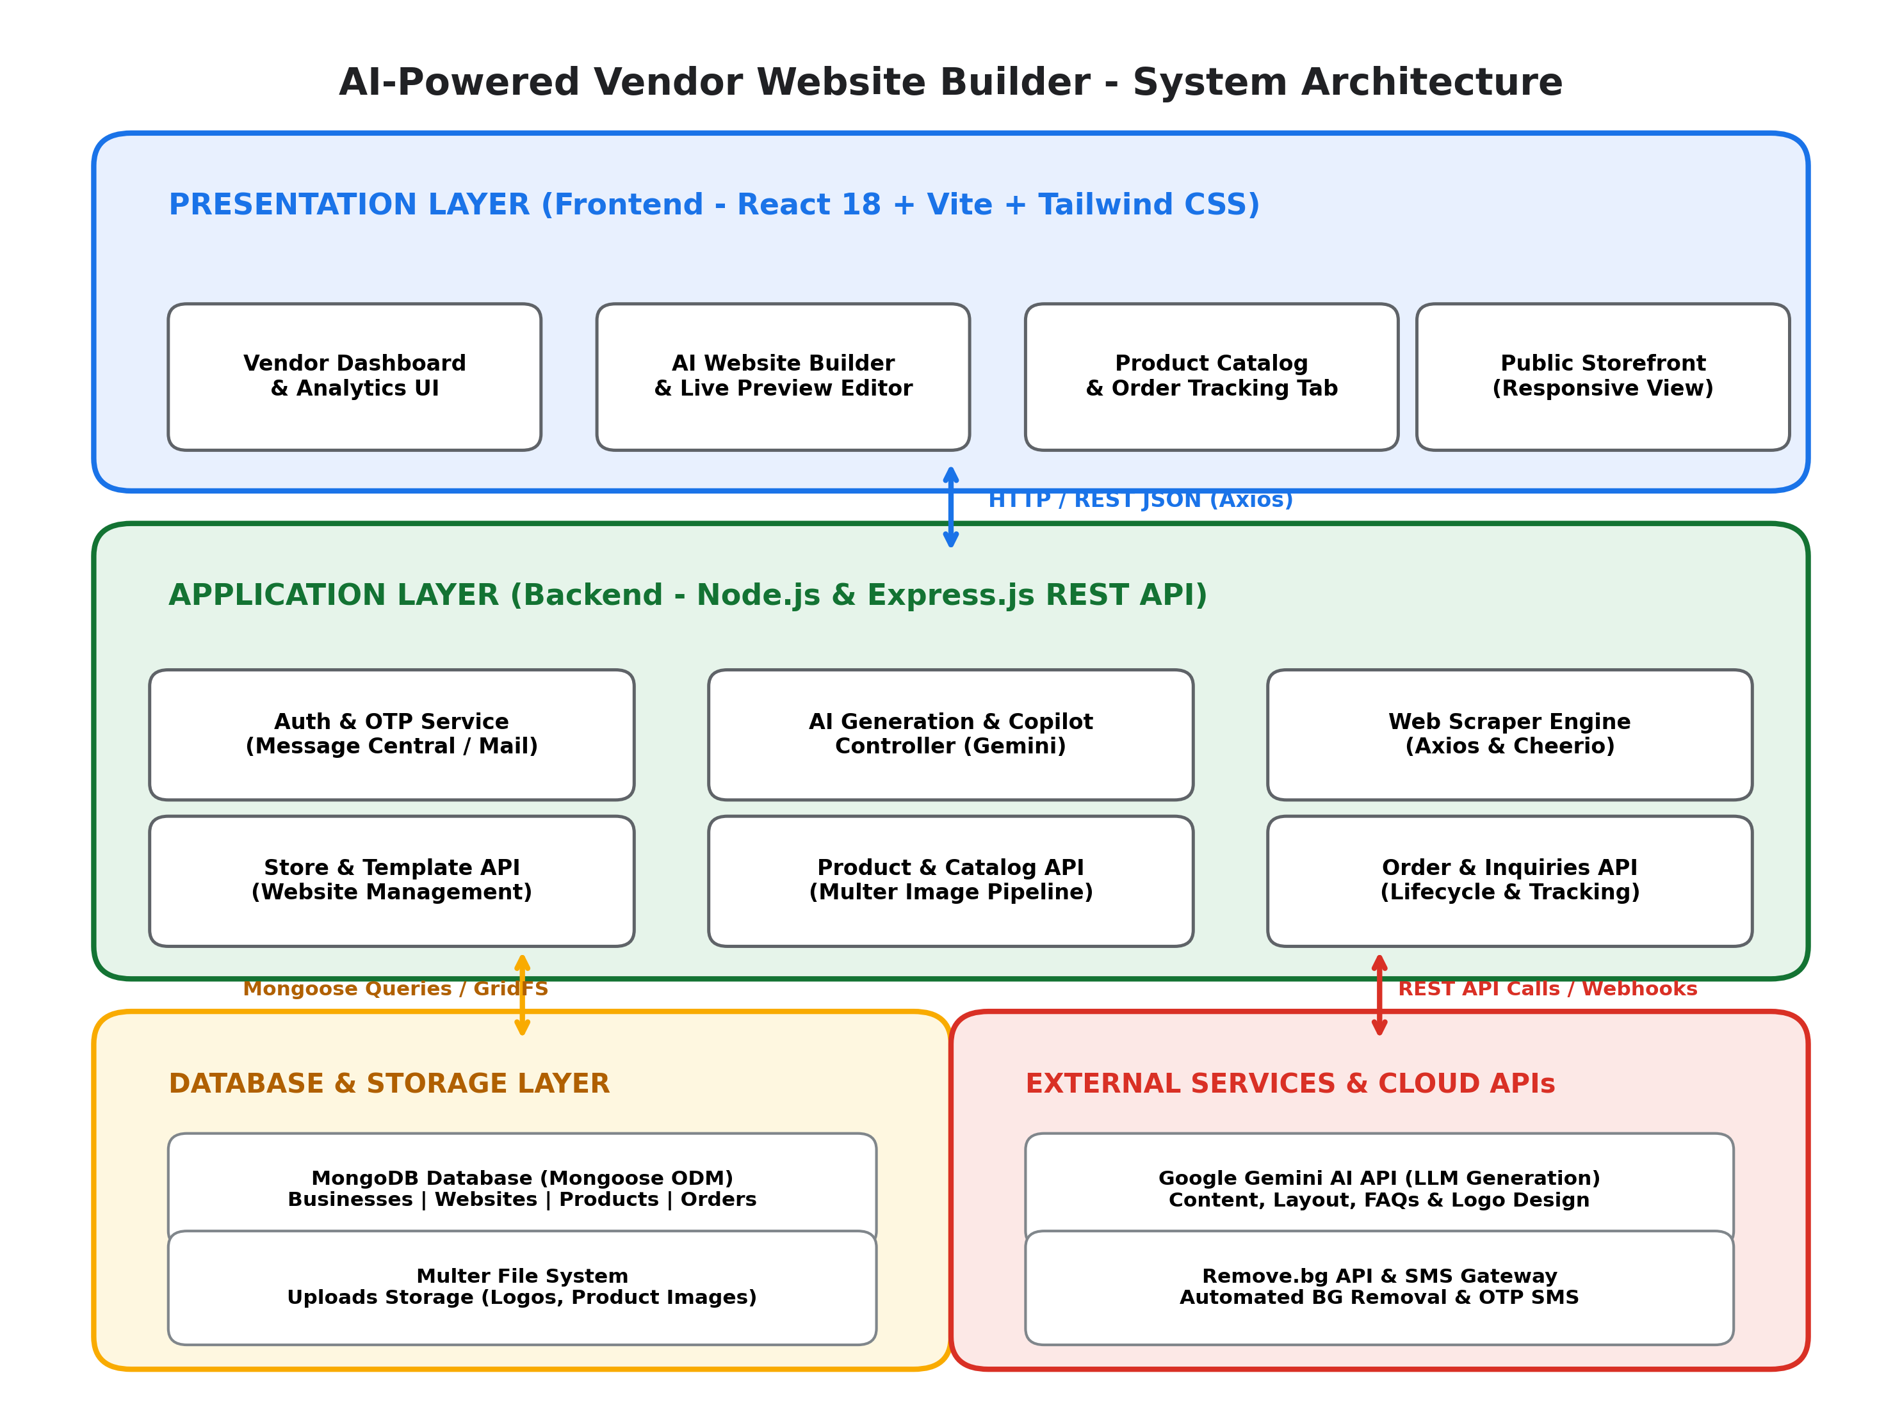
Figure 3.1: System Architecture and Modular Block Diagram of the Vendor Website Builder Platform
Communication between the Presentation Layer and Application Layer occurs entirely via asynchronous JSON REST APIs over HTTP/HTTPS. When an AI generation request is triggered, the Express server formats structured system instructions, queries the Google Gemini API, parses the resultant JSON response, and persists the new storefront document in MongoDB before returning the hydrated schema to the React client.

4. UML DIAGRAMS
4.1 USE CASE DIAGRAM
The Use Case Diagram captures the functional requirements and high-level behavioral interactions between external actors and the Vendor Website Builder platform. It delineates system boundaries and specifies user privileges.
Actor Descriptions:
- 1. Vendor (Store Owner): Primary administrative actor responsible for registering via OTP, inputting business parameters, generating storefronts via AI or URL scraping, customizing layouts in the visual editor, managing product catalogs with background removal, tracking orders, and responding to customer inquiries.
- 2. Customer (End-User / Buyer): Public consumer accessing published storefronts via unique slugs (`/store/:slug`). Responsibilities include searching product catalogs, reviewing service offerings, adding items to cart, completing checkout, and submitting contact inquiries.
- 3. Super Admin: System administrator accessing the pin-protected global dashboard to oversee registered businesses, inspect website statuses, monitor gross platform volume, and enforce platform governance.
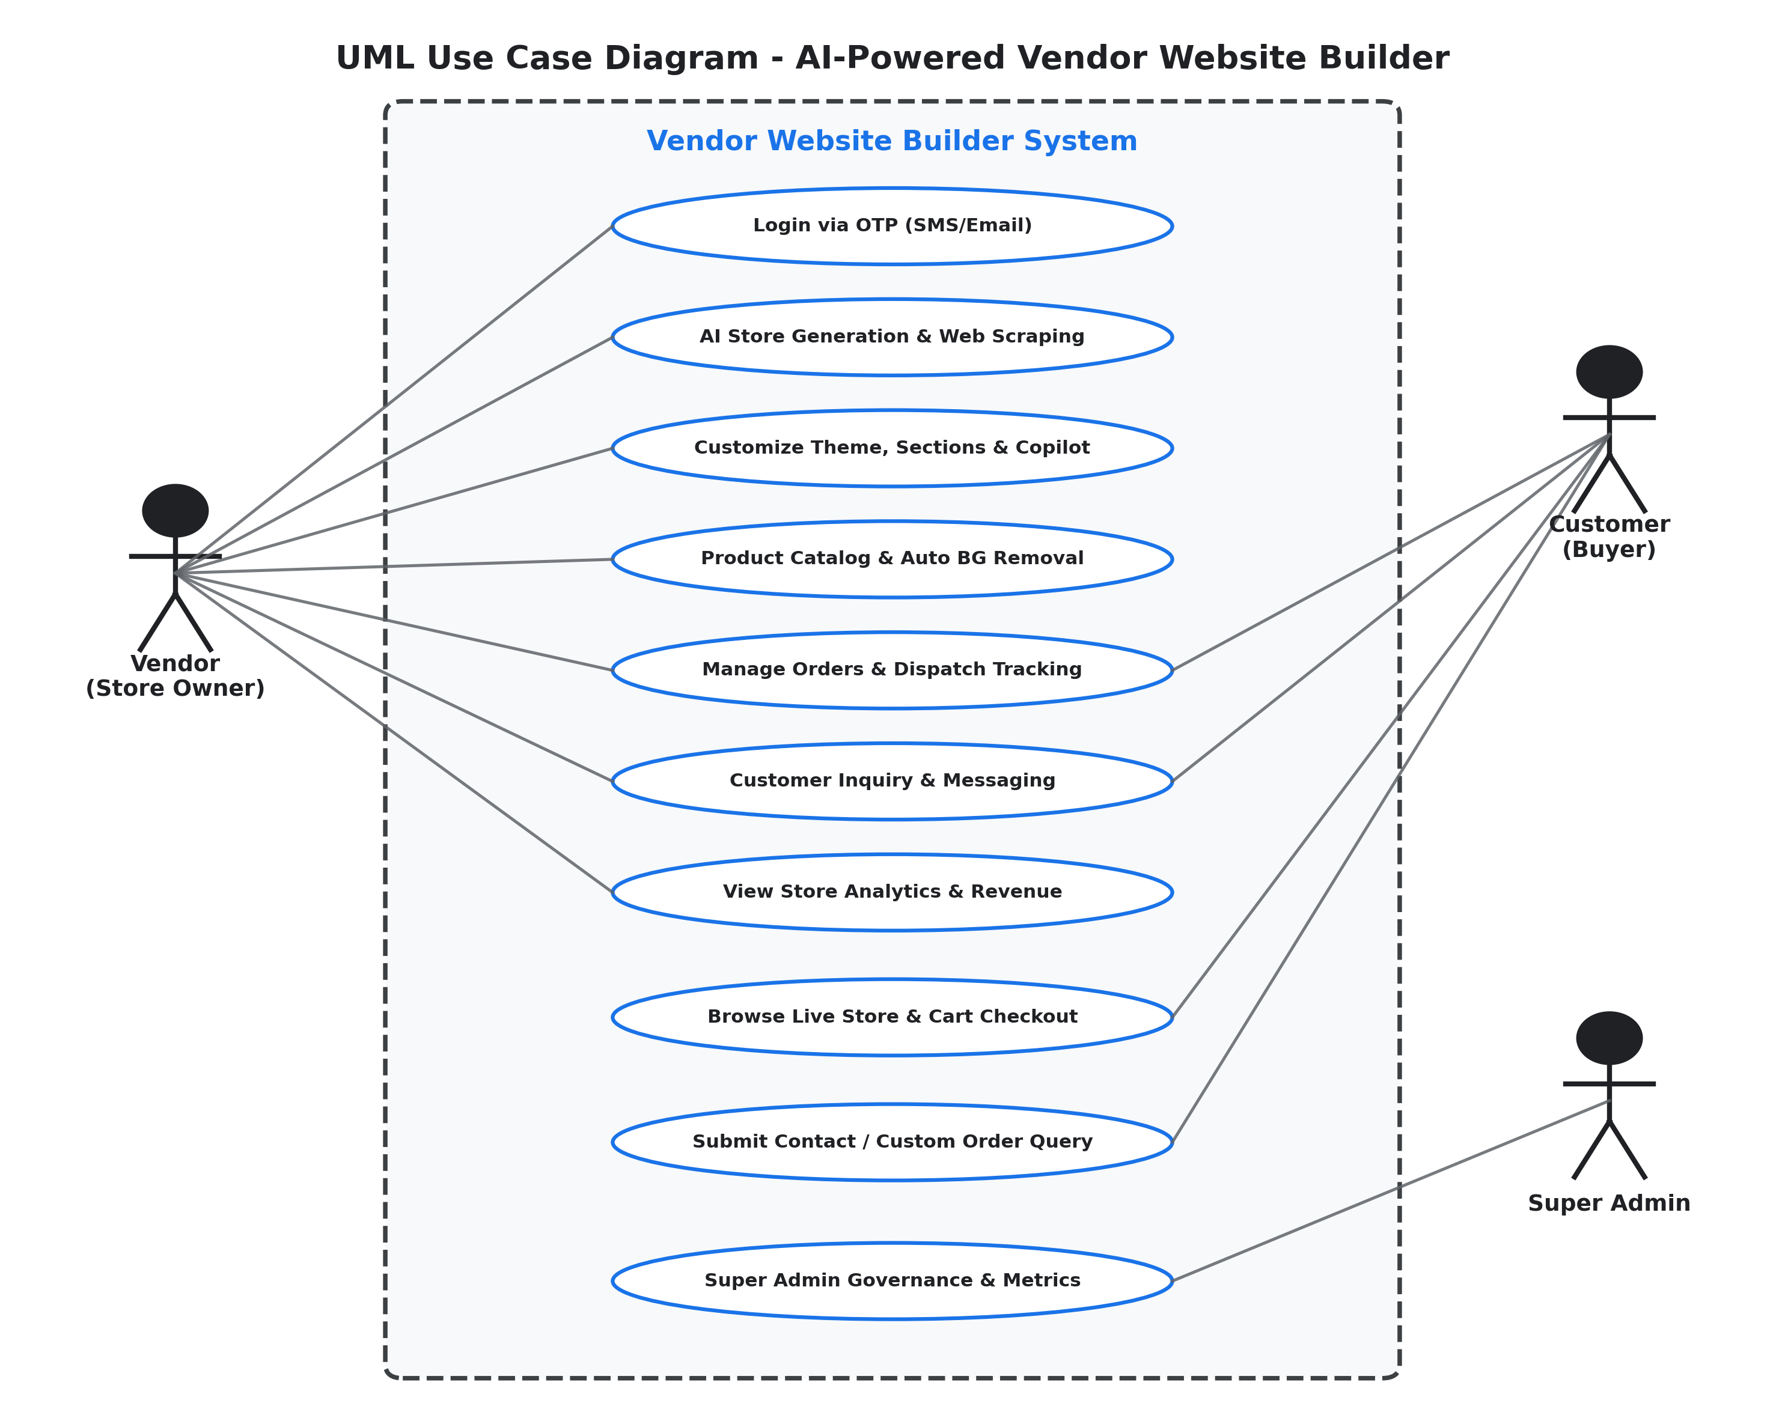
Figure 4.1: UML Use Case Diagram of the AI-Powered Vendor Website Builder System
4.2 CLASS DIAGRAM
The UML Class Diagram provides a static structural view of the core domain entities, data schemas, attributes, operations, and relationships that govern the Vendor Website Builder platform. The design maps directly to Mongoose ODM schemas in the backend database.
Core Domain Entities:
- 1. Business: Central vendor account container encapsulating authentication data (vendorPhone, vendorEmail, otp), profile metadata (businessName, category, location, contact, paymentInfo, socialMedia), and operational shop hours.
- 2. Website: Encapsulates the generated e-commerce storefront. Attributes include businessId reference, storeName, template key, theme colors, section toggles, unique slug, published status, visitor analytics (views, viewsByRegion), SEO metadata, and design configuration.
- 3. Product: Represents inventory catalog items belonging to a business and website. Attributes include name, price, category, description, imageUrl, inStock boolean, stockQuantity, sizes, dietary tags, and material specifications.
- 4. Order: Tracks customer e-commerce purchases. Attributes include businessId, websiteId, customerPhone, customerName, ordered items array, totalAmount, order status (pending, confirmed, ready, completed, cancelled), and payment method.
- 5. Inquiry: Stores customer inquiries submitted via storefront contact forms, capturing name, email, message body, and timestamps.
- 6. Asset / Image: Maintains metadata for user-uploaded brand assets, logos, and raw/processed product photography.
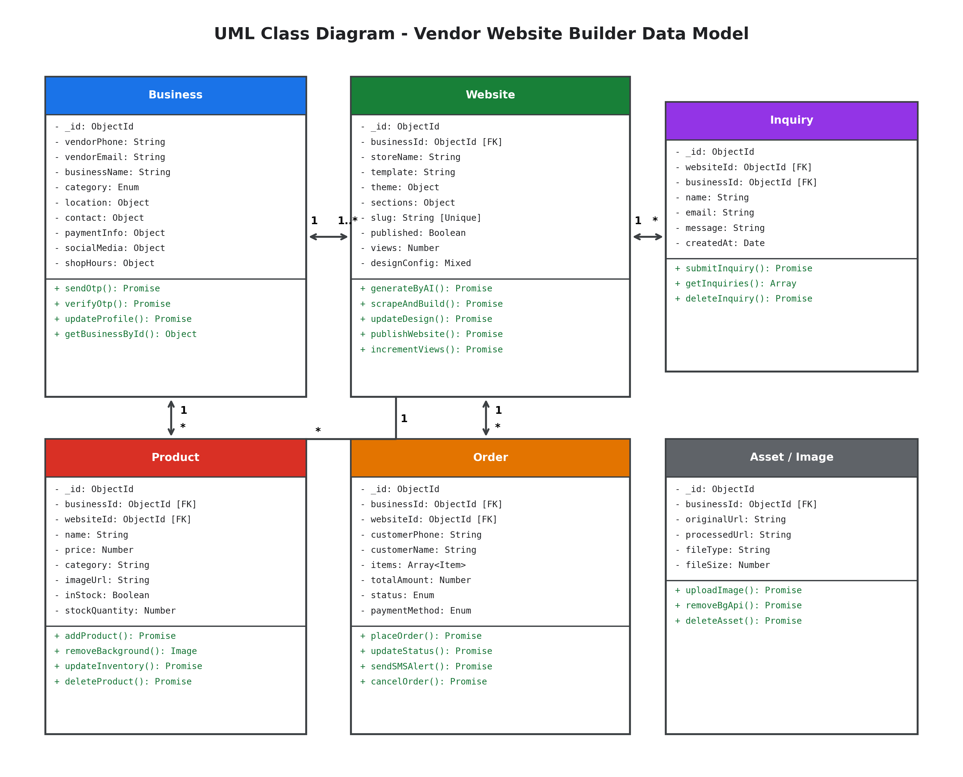
Figure 4.2: UML Class Diagram Illustrating Domain Entities, Attributes, Methods, and Associations

4.3 SEQUENCE DIAGRAM
The UML Sequence Diagram models the chronological message exchange between system components during the core workflow: AI Website Generation and Store Publishing. It details the synchronous and asynchronous interactions between the Vendor, React Client, Express Server, Google Gemini AI API, and MongoDB Database.
Workflow Execution Steps:
- 1. Initiation: The vendor inputs their business category or existing web URL into the React onboarding UI.
- 2. API Dispatch: The React frontend sends an HTTP POST request to `/api/ai/scrape-and-recommend` or `/api/ai/generate-website`.
- 3. AI Prompt Execution: The Express controller cleans incoming data, constructs a structured prompt specifying theme colors, copy, and layout schemas, and calls the Google Gemini AI API.
- 4. Schema Hydration: The Gemini model synthesizes a structured JSON response containing storefront copy, section arrangements, and suggested products.
- 5. Draft Persistence: The server constructs a Mongoose Website document linked to the vendor's Business ID and saves it to MongoDB with `published: false`.
- 6. Live Customization: The React client renders the generated layout inside the Live Preview Editor, allowing the vendor to adjust colors, edit text via AI Copilot, and upload products.
- 7. Storefront Publishing: The vendor clicks 'Publish Store'. The client sends a PUT request to update the database, setting `published: true` and finalizing the unique public slug (`/store/:slug`).
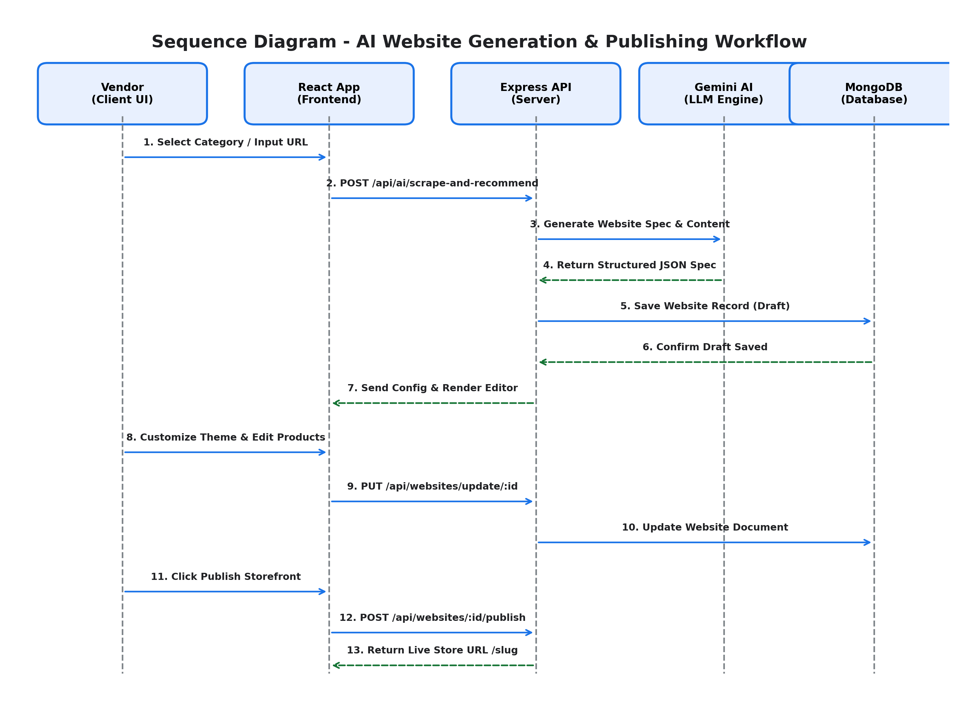
Figure 4.3: UML Sequence Diagram for AI Website Generation, Customization, and Publishing Workflow
4.4 STATE CHART DIAGRAM
The State Chart Diagram models the dynamic lifecycle of a digital storefront within the platform, showing all possible operational states and the event triggers that cause transitions from creation to archival.
Lifecycle States and Transitions:
- • Store Created (Initial State): The vendor completes OTP authentication and profile setup; a bare business container is initialized.
- • AI Draft Generated: Triggered when the AI generation engine or URL scraper synthesizes the initial layout schema, marketing text, and default section configurations.
- • Theme Customization: The vendor enters the interactive editor to modify palette colors, toggle sections (Hero, Services, Gallery, FAQ), and refine copy.
- • Catalog Loaded: The vendor uploads inventory items; the Remove.bg pipeline processes photos into transparent PNGs, populating the product catalog.
- • Store Published (Live State): The vendor activates the public URL. The store is publicly accessible at `/store/:slug` and indexed for discovery.
- • Active Operations: The store actively processes incoming customer purchases, updates order statuses, captures contact inquiries, and aggregates traffic analytics.
- • Archived / Inactive (Final State): The merchant temporarily pauses operations or permanently archives the storefront.
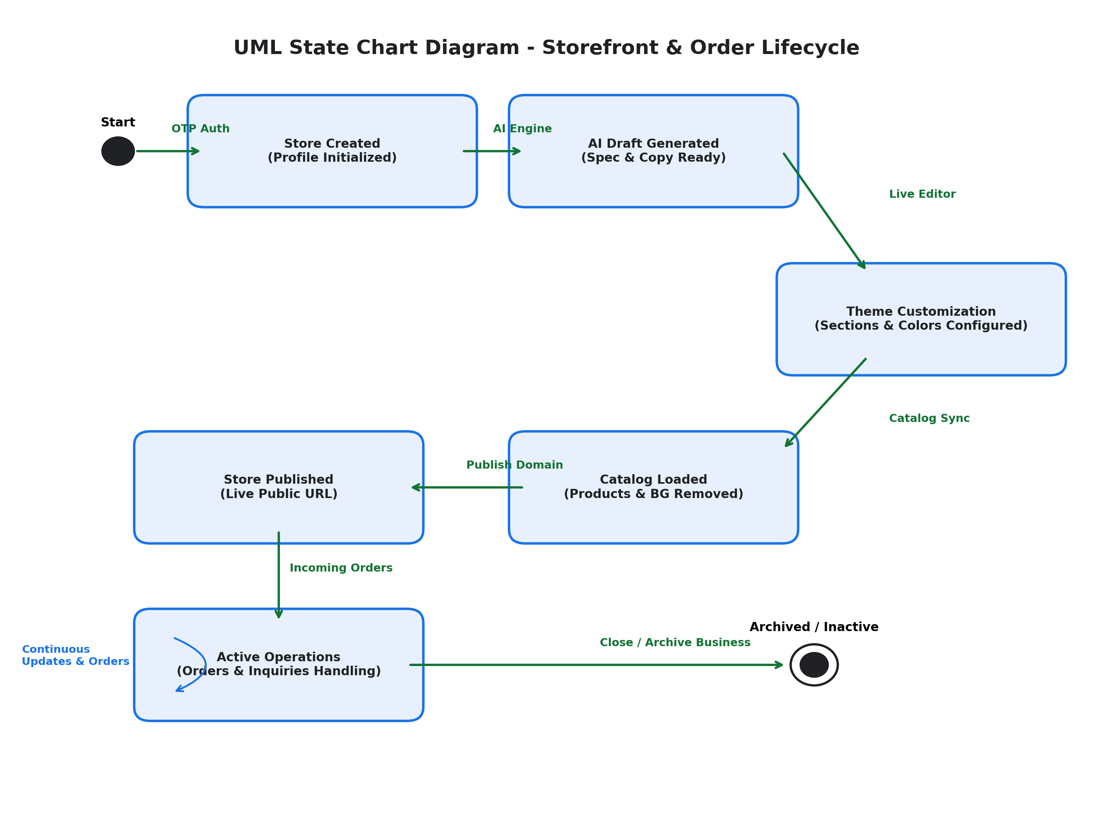
Figure 4.4: UML State Chart Diagram Modeling the Storefront Lifecycle States and Transitions

4.5 ACTIVITY DIAGRAM
The UML Activity Diagram illustrates the end-to-end operational workflow of the Vendor Website Builder, highlighting parallel control paths, decision branches, and system actions from initial vendor onboarding to customer order fulfillment.
Workflow Activities & Decision Nodes:
- 1. Vendor Authentication: Vendor enters their mobile phone or email; system issues an OTP via SMS/email; vendor enters OTP to authenticate.
- 2. Path Decision Branch: System queries whether the vendor has an existing website. If YES, the vendor supplies the URL and the Axios/Cheerio engine scrapes content. If NO, the vendor selects their business category from 35+ industry templates.
- 3. AI Synthesis Activity: The Google Gemini AI engine compiles complete layout structures, engaging promotional copy, color themes, and recommended service catalogs.
- 4. Live WYSIWYG Editing: The vendor customizes layouts in real-time, previewing changes across desktop, tablet, and mobile displays.
- 5. Product Intake & AI BG Removal: Vendor uploads inventory photos; the Multer and Remove.bg pipeline automatically strips backgrounds to create clean catalog assets.
- 6. Store Publishing & Deployment: System generates a unique URL slug and exposes the public storefront for e-commerce traffic.
- 7. Order Fulfillment & Notifications: Customers place orders; the vendor processes them through life-cycle stages with automated SMS dispatch updates.
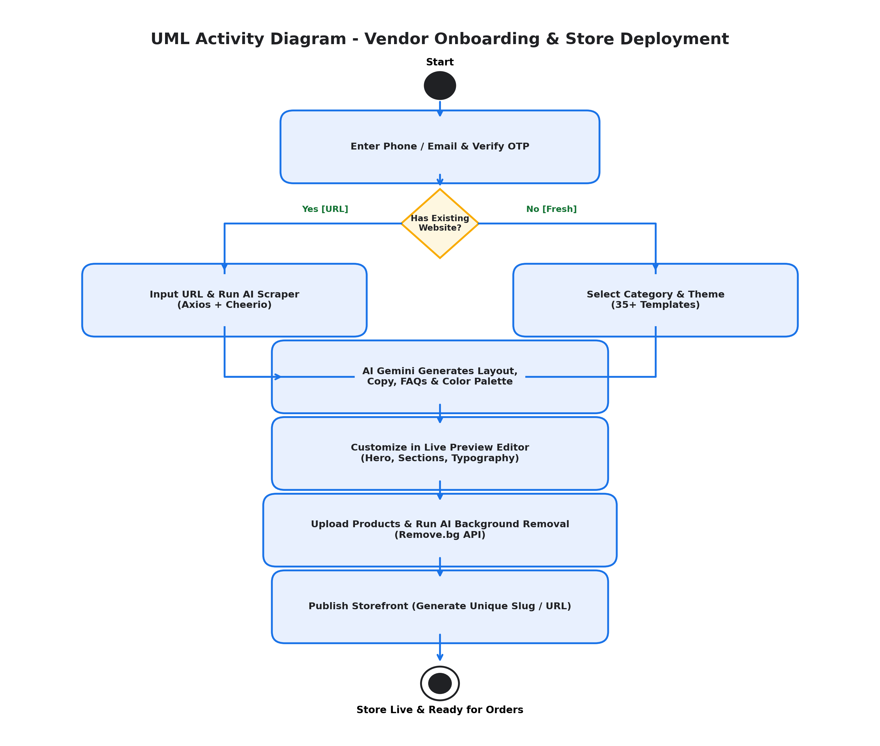
Figure 4.5: UML Activity Diagram Depicting the Complete Vendor Onboarding and Deployment Flow

5. CONCLUSION AND FUTURE ENHANCEMENTS
The AI-Powered Vendor Website Builder successfully demonstrates how modern full-stack engineering combined with state-of-the-art Generative AI can democratize e-commerce for micro, small, and medium businesses. By eliminating financial and technical barriers, the platform allows local merchants—who previously lacked the resources to hire web agencies—to establish professional digital storefronts in under two minutes.
Through the implementation of key architectural components—such as single-click AI website synthesis via Google Gemini, intelligent URL scraping and reconstruction via Cheerio, automated product background removal via Remove.bg, responsive multi-viewport customization in React, and unified order management with SMS notifications—the project establishes a resilient, end-to-end e-commerce operating system.
Future Scope & Enhancements:
- • Custom Domain DNS Automation: Implement automated CNAME/A-record DNS mapping allowing vendors to link custom domains (e.g., `www.myshop.com`) directly to their generated store.
- • Integrated Payment Gateways: Integrate direct checkout processing via Razorpay, Stripe, and dynamic UPI QR verification for instant automated payment settlement.
- • Automated WhatsApp Commerce Bot: Deploy an AI-powered conversational WhatsApp bot enabling end-users to browse catalogs and place orders directly inside WhatsApp.
- • Multilingual Localization via AI: Enable automatic real-time translation of store content into regional Indian languages (Telugu, Hindi, Tamil, etc.) to enhance vernacular reach.
- • AI Predictive Inventory Forecasting: Implement predictive analytics on order history to alert merchants about stock replenishment schedules and trending products.
In conclusion, the project met all designed engineering objectives, validating the practical application of software engineering principles, full-stack web architecture, and artificial intelligence in solving real-world economic challenges.

6. BIBLIOGRAPHY & WEB REFERENCES
• React Documentation: Official guide to React 18, Hooks, Virtual DOM, and component lifecycles.
URL: https://react.dev/
• Vite Next-Gen Frontend Tooling: Documentation on lightning-fast development servers and optimized ES module bundling.
URL: https://vitejs.dev/
• Tailwind CSS Framework: Comprehensive documentation on utility-first responsive styling and layout grids.
URL: https://tailwindcss.com/
• Node.js Runtime Environment: Official architectural documentation on asynchronous event-driven I/O execution.
URL: https://nodejs.org/
• Express.js Web Framework: Guide to routing, middleware architecture, and REST API design in Express.
URL: https://expressjs.com/
• MongoDB & Mongoose ODM: Documentation on document-oriented NoSQL databases and schema modeling.
URL: https://mongoosejs.com/
• Google Generative AI SDK: API references for integrating Gemini models (`@google/generative-ai`) in Node.js applications.
URL: https://ai.google.dev/
• Cheerio HTML Parser: Fast, flexible implementation of core jQuery for server-side scraping and DOM traversal.
URL: https://cheerio.js.org/
• Remove.bg REST API: Developer documentation for cloud-based automated image background removal.
URL: https://www.remove.bg/api
• Project Source Code Repository: Official GitHub repository containing frontend, backend, schemas, and AI controllers.
URL: https://github.com/Karunya-3/vendor-website-builder

