**Experiment 1**

**Name**: K.Sriya

**Roll No:** 2320090043

Creating a simple network between 2 PC’s using ping command

**Step by step procedure:**

**Step1:** Open cisco packet tracer. **Step 2:** Create a simple network.

**Step 3:** Add 2 PC’s and connect with copper straight through cable.

**Step 4**: Give IP address

PC1 → desktop → IP address PC1=192.168.1.1

PC2 → desktop → IP address PC2=192.168.1.2

**Step 5:** PC2 → desktop → Command prompt and write command

**Command**:

ping <IP address of PC1>

**Diagram:**

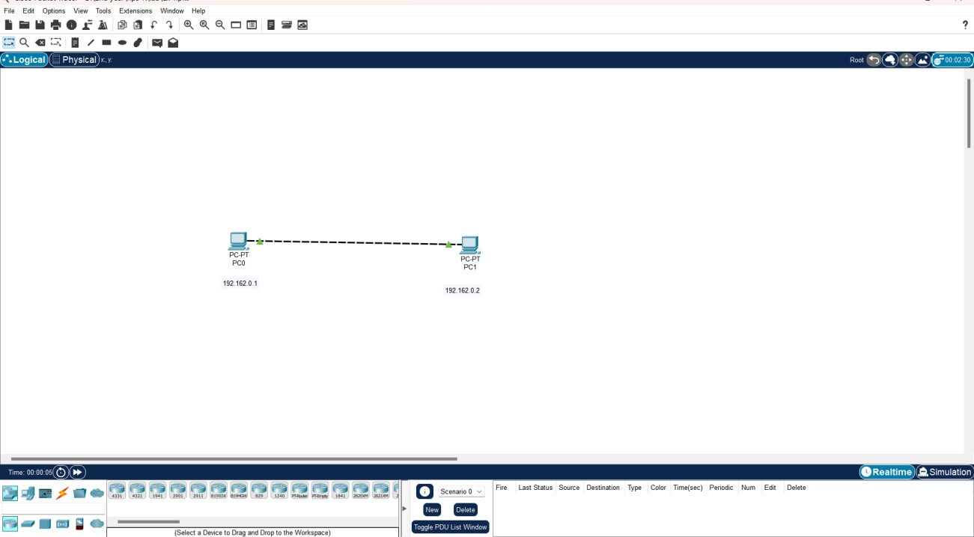

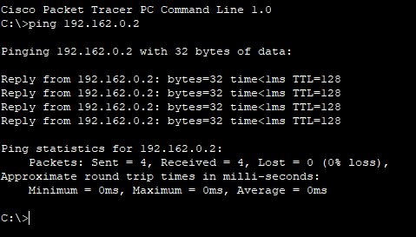

**Result:**

We have connected the 2 PC’s and now can send packets from one PC to another.