Crop Phenology Estimation

*A*

*Project Seminar Report Submitted in partial fulfilment of the*

*Requirements for the award of the Degree of*

# BACHELOR OF ENGINEERING

IN

# INFORMATION TECHNOLOGY

By

**Sai Arvind N 1602-19-737-092 KVS Sriya 1602-19-737-115**

*Under the guidance of*

## S.Aruna ASSOCIATE PROFESSOR



**Department of Information Technology Vasavi College of Engineering (Autonomous) *ACCREDITED BY NAAC WITH 'A++' GRADE***

# (Affiliated to Osmania University) Ibrahim Bagh, Hyderabad-31 2022

**Vasavi College of Engineering (Autonomous)**

***ACCREDITED BY NAAC WITH 'A++' GRADE***

# (Affiliated to Osmania University) Hyderabad-500 031

**Department of Information Technology**



# DECLARATION BY THE CANDIDATE

We, **Sai Arvind N** and **KVS Sriya** bearing hall ticket numbers, **1602-19- 737-092** and **1602-19-737-115** hereby declare that the project report entitled **Crop Phenology Estimation** under the guidance of **Ms S.Aruna, Associate Professor**, Department of Information Technology, Vasavi College of Engineering, Hyderabad, is submitted in partial fulfilment of the requirement for the award of the degree of **Bachelor of Engineering** in **Information Technology**

This is a record of bonafide work carried out by us and the results embodied in this project report have not been submitted to any other university or institute for the award of any other degree or diploma.

Sai Arvind N 1602-19-737-092 KVS Sriya 1602-19-737-115

**Vasavi College of Engineering (Autonomous)**

***ACCREDITED BY NAAC WITH 'A++' GRADE***

# (Affiliated to Osmania University) Hyderabad-500 031

**Department of Information Technology**



## BONAFIDE CERTIFICATE

This is to certify that the project entitled **Crop Phenology Estimation** being submitted by **Sai Arvind N** and **KVS Sriya** bearing **1602-19- 737-092** and **1602-19-737-115** in partial fulfilment of the requirements for the award of the degree of Bachelor of Engineering in Information Technology is a record of bonafide work carried out by them under my guidance.

#### S.Aruna Dr. K. Ram Mohan Rao,

**Associate Professor Professor,**

**Internal Guide HOD, IT**









# ACKNOWLEDGEMENT

The satisfaction that accompanies the successful completion of the project seminar would not have been possible without the kind support and help of many individuals. We would like to extend our sincere thanks to all of them.

It is with immense pleasure that we would like to take the opportunity to express our humble gratitude to **S.Aruna, Associate Professor, Department of Information Technology** under whom we executed this project. We are also grateful to **DRL.Prasanna, AssistantProfessor, Department of Information Technology** for her guidance. Their constant guidance and willingness to share their vast knowledge made us understand this project and its manifestations in great depths and helped us to complete the assigned tasks.

We are very much thankful to **Dr.K. Ram Mohan Rao, Professor, Department of Information Technology,** for his kindsupport and for providing necessary facilities to carry out the work.

We wish to convey our special thanks to **Dr.S.V. Ramana, Principal** of **Vasavi College of Engineering** for giving the required information in doing my project work. Not to forget, we thank all otherfaculty and non-teaching staff, and my friends who had directly or indirectly helped and supported me in completing my project in time.

# ABSTRACT

The crop phenology estimation helps in crop production estimation, irrigation scheduling and in crop classification. One main part of crop agriculture is the observation of the crops, which is what this project is about. Observation of crops can be done in various ways and these can be used to respond to different situations that might arise during the cultivation of crops. Many commodity crops have critical growth stages during which they are at an increased risk of yield loss, such as silking in corn and pod-fill in soybean. Extreme weather events are expected to disrupt global food supply with increased frequency, and knowledge of the timing of crop growth stages in major growing regions is vital to accurately assess potential yield loss.

The project aims to calculate Growing Degree Days, NDVI for aiding Crop Phenology Estimation. With the comparison of GDD,NDVI for crops in different regions we expect to predict phenology of a crop in different climatic and environmental conditions. In this study we calculate Surface Temperature from LandSat 8 for predicting GDD and NDVI. This study aims to assess the vegetation health and growing degree days (GDD) of Sangareddy, India using satellite imagery. Normalized Difference Vegetation Index (NDVI) was calculated from Landsat 8 imagery for the years 2018-2021. The NDVI values were analyzed to identify any trends and changes in vegetation health over the years.

# Table of Contents

|  |  |  |  |
| --- | --- | --- | --- |
| **List of Figures** | | | Vi |
| **List of Tables** | |  | Vii |
| **List of Abbreviations** | | | Viii |
| **1** | **INTRODUCTION** | | 1 |
|  | 1.1 | Problem Statement – Overview | 1 |
|  | 1.2  1.3 | Proposed Method Organization of report | 1 |
| **2** | **LITERATURE SURVEY** | | 4 |
| **3** | **SYSTEM REQUIREMENTS AND SPECIFICATIONS** | | |
|  | 3.1 | Software Requirements | 19 |
|  | 3.2 | Hardware Requirements | 21 |
| **4** | **EXPERIMENTAL SETUP AND RESULTS** | |  |
|  | 4.1 Collection of Dataset | | 23 |
|  | 4.2 Visualization | | 23 |
| **5** | **RESULTS AND DISCUSSIONS** | |  |
|  | 5.1 Conclusion and Future Scope | | 27 |
| **6 References** | | | 28 |
| 1. **Appendix**    1. Code    2. Paper | | |  |

**LIST OF FIGURES**

|  |  |  |
| --- | --- | --- |
| **Fig. No** | **Description** | **Page No** |

1. Architecture Diagram 21
2. Data Flow Diagram 22
3. Description of the NASA POWER dataset 23
4. Description of LANDSAT 8 dataset. 23
5. NDVI Trend Prediction- Prophet Algorithm. 24
6. NDVI Original Plot 2013-2021 25
7. NDVI Trend Plot 2013-2021 25
8. NDVI Seasonal Plot 2013-2021 25
9. LST India Plot 2013-2018 25
10. LST Sangareddy Plot 2013-2018 26
11. GDD Plot Sangareddy 26

# LIST OF ABBREVIATIONS

|  |  |
| --- | --- |
| LST | - Land Surface Temperature |
| LSTM | -Long Short term memory |
| GDD | - Growing Degree Days |
| NDVI | - Normalized Dense Vegetation Index |
| TOA | - Top Of Atmosphere Radiance |
| TOABT | - Top Of Atmosphere Brightness Temperature |
| LSE | -Land Surface Emissivity |
| LST | -Land Surface Temperature |

* 1. **INTRODUCTION**

## Problem Statement - Overview

Agriculture is the science of farming which includes the growth of crops to produce food, rearing of animals to provide wool and many more. This science has many complications. Today with the increased demand for food, just growing crops is not enough. An efficient practice of growing crops with minimum input and maximum results are required. This need can be satisfied if our progress in information technology can be integrated with conventional farming practices. To propose a novel framework for crop phenology estimation which further enhances the performance with few satellite images. Generally, it is quite flexible and untroubled to classify an image when there are enough samples describing the image, but the difficulty arises when thereare very few samples suitable predict different parameters .

## Proposed Method

It can be observed that the proposed framework mainly consists of three parts Surface temperature calculation, NDVI prediction and GDD estimation.

#### Land Surface Temperature Calculation:

It is important to calculate surface temperature for estimation of GDD so for that we take images from landsat8 dataset and calculate toa, toa brightness temperature, ndvi, lse and from all the above derive land surfacetemperature

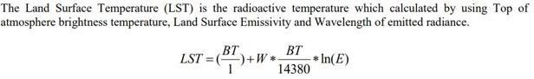

#### NDVI Calculation

NDVI is a dimensionless index that gives the difference between visible and near- infrared reflectance of vegetation cover. It is used to estimate the density of

the green area of land

#### Scope and Objectives:

The scope of this project is to develop a machine learning framework for predicting NDVI, GDD which in turn helps in predicting crop phenology progress. The project focuses on two key areas: surface temperature calculation and NDVI prediction. The goal is to identify the most effective methods for addressing these challenges and to develop a machine learning model that accurately predicts these parameters.

Objectives:

* To identify the most effective methods for calculating the parameters from satellite images.
* To Estimate Land Surface temperature from satellite images as it is a pre-requisite for calculating GDD
* To predict NDVI trends and predict the values.

The ultimate objective of this project is to develop a reliable and accurate machine learning model for predicting crop phenology estimation. This can 2 have significant implications for increasing crop yield management, as well as for analyzing soil fertility. By identifying the most effective methods for calculating ndvi, gdd the project aims to develop a model that can provide accurate predictions and improve yield and reduce damage to soil.

#### Organization of the Report Introduction:

This section provides background information on the project, defines the scope of the report, and states the objectives and research questions. It should also provide an overview of the structure of the report.

#### Literature review:

This section summarizes and evaluates the existing research and literature related to the project. It should provide a critical analysis of the key theories, concepts, and empirical studies related to the research questions.

#### Proposed Work:

This section describes the research methods and procedures used in the project. It should also discuss the basic flow of the project.

#### Experimental Study:

This section describes each dataset, pre-processing. It should also focus on result part.

#### Summary and Future Scope:

This section summarizes the main findings and conclusions of the project, and identifies any recommendations for future research or action.

#### References:

This section provides a list of all sources cited in the report, using a consistent citation style.

**Appendix:**

This section includes any additional information or materials that were not included in the main body of the report, but are relevant to the project, such as raw data, interview transcripts, or survey questionnaire.

# LITERATURE SURVEY

## Analysis of NDVI Data for Crop Identification and Yield Estimation

Authors: J. Huang, H. Wang, Q. Dai and D. Han

The Normalized Difference Vegetation Index (NDVI) is a widely used vegetation index that provides a measure of vegetation density and greenness based on the spectral reflectance of vegetation in the red and near-infrared parts of the electromagnetic spectrum. In recent years, NDVI data has become an important tool for crop identification and yield estimation, as it can provide valuable insights into the health and growth of crops.

The paper "Analysis of NDVI Data for Crop Identification and Yield Estimation" aims to explore the use of NDVI data for crop identification and yield estimation, and to provide an overview of the various methods and techniques that have been developed for analyzing NDVI data.

The paper first discusses the basic principles of NDVI and its relationship to vegetation density and greenness. It then provides an overview of the different data sources and sensors that can be used to obtain NDVI data, including satellite imagery, aerial photography, and ground-based sensors.

The paper then goes on to discuss the various methods and techniques that have been developed for analyzing NDVI data for crop identification and yield estimation. These include supervised and unsupervised classification methods, clustering algorithms, and machine learning techniques such as artificial neural networks and support vector machines.

The paper also discusses the challenges and limitations associated with using NDVI data for crop identification and yield estimation. These include issues such as data quality, spatial and temporal resolution, and the need for ground-truthing and validation.

Finally, the paper provides several case studies that demonstrate the use of NDVI data for crop identification and yield estimation in different regions and crops. These case studies highlight the potential of NDVI data for improving crop management and production, and for informing policy and decision-making.

Overall, the paper provides a comprehensive overview of the use of NDVI data for crop identification and yield estimation. It highlights the potential of NDVI data for improving crop management and production, and provides valuable insights into the various methods and techniques that can be used to analyze NDVI data. However, it also emphasizes the challenges and limitations associated with using NDVI data, and the need for further research and development in this area.

## A Gaussian Kernel-Based Spatiotemporal Fusion Model for Agricultural Remote Sensing Monitoring.

Authors: Y. Shen, G. Shen, H. Zhai, C. Yang and K. Qi

The paper "A Gaussian Kernel-Based Spatiotemporal Fusion Model for Agricultural Remote Sensing Monitoring" proposes a new spatiotemporal fusion model for agricultural remote sensing monitoring. The model is based on a Gaussian kernel-based approach and is designed to integrate multi-temporal and multi-spectral remote sensing data to improve crop classification and yield estimation.

The paper first discusses the challenges and limitations associated with traditional remote sensing approaches to agricultural monitoring, which often rely on single-date, single-sensor data and can be limited by issues such as cloud cover and atmospheric interference. The authors argue that spatiotemporal fusion approaches, which combine data from multiple sensors and time periods, can help to address these limitations and improve the accuracy and reliability of agricultural monitoring.

The proposed Gaussian kernel-based spatiotemporal fusion model consists of three main steps: data pre-processing, feature extraction, and classification. In the data pre-processing step, the multi-temporal and multi-spectral remote sensing data is first pre-processed to remove any noise or outliers and to normalize the data to a common scale. The authors use a Gaussian kernel function to smooth the data and reduce noise.

In the feature extraction step, the authors use a principal component analysis (PCA) approach to extract the most important features from the multi-temporal and multi-spectral remote sensing data. PCA is a widely used technique in remote sensing and involves identifying the linear combinations of spectral bands that capture the most variance in the data.

Finally, in the classification step, the authors use a support vector machine (SVM) algorithm to classify the agricultural land cover based on the extracted features. SVM is a machine learning algorithm that is widely used in remote sensing and has been shown to be effective for classification tasks.

The authors test the proposed Gaussian kernel-based spatiotemporal fusion model on multi- temporal and multi-spectral remote sensing data from the Heilongjiang province in China. The data includes imagery from two sensors: the HJ-1A and HJ-1B satellites. The authors compare the results of their model to those obtained using traditional remote sensing approaches, such as maximum likelihood and decision tree classifiers.

The results show that the proposed Gaussian kernel-based spatiotemporal fusion model outperforms traditional remote sensing approaches in terms of classification accuracy,

particularly for crop identification and yield estimation. The authors argue that this is due to the ability of the model to capture both spatial and temporal information from the remote sensing data, which allows for a more accurate characterization of agricultural land cover and crop growth patterns.

Overall, the paper provides a valuable contribution to the field of agricultural remote sensing monitoring by proposing a new spatiotemporal fusion model based on a Gaussian kernel approach. The model is shown to improve the accuracy and reliability of crop classification and yield estimation, which can have important implications for crop management and production. The authors suggest that future research should focus on exploring the potential of other machine learning algorithms and fusion techniques for agricultural remote sensing monitoring, as well as on developing more advanced data pre-processing and feature extraction methods.

#### Trends in Global Vegetative Drought From Long-Term Satellite Remote Sensing Data

Authors: Z. Xu et al

The study "Trends in Global Vegetative Drought from Long-Term Satellite Remote Sensing Data" examines global trends in vegetation drought over the last few decades using satellite remote sensing data. The authors note that while drought is a complex phenomenon with multiple drivers, including precipitation, temperature, and human activities, vegetation drought can be a useful indicator of overall ecosystem health.

The study uses the Normalized Difference Vegetation Index (NDVI) as a measure of vegetation greenness, which is a commonly used indicator of vegetation drought. NDVI is calculated based on the difference between the reflectance of near-infrared and red light, and high values indicate healthy vegetation, while low values indicate vegetation stress or drought.

The authors use long-term satellite remote sensing data from the Advanced Very High Resolution Radiometer (AVHRR) and Moderate Resolution Imaging Spectroradiometer (MODIS) sensors to analyze trends in NDVI-based vegetation drought from 1982 to 2015. They apply a standardized drought index, the Vegetation Drought Response Index (VegDRI), to calculate the severity and duration of vegetation drought events.

The results of the study show that global vegetation drought has increased over the last few decades, with more frequent and severe drought events in many regions of the world. The authors note that these trends are consistent with other studies that have identified increasing aridity and drought in many parts of the world due to climate change.

The study also examines regional differences in vegetation drought trends, with some regions

experiencing more severe and prolonged drought events than others. For example, the authors note that the western United States has experienced significant drought over the last few decades, with many areas experiencing persistent drought conditions for multiple years.

The study highlights the importance of using long-term satellite remote sensing data to monitor global trends in vegetation drought. The authors note that such data can provide valuable information on the health of ecosystems and the impacts of climate change on vegetation, which can inform land management and conservation efforts.

The study also underscores the importance of using standardized drought indices, such as VegDRI, to compare and analyze vegetation drought across different regions and time periods. The use of such indices can help to improve our understanding of the underlying drivers of vegetation drought and inform decision-making for drought mitigation and adaptation.

Moreover, the study highlights the potential of satellite remote sensing data for monitoring and predicting vegetation drought at both regional and global scales. By providing continuous and high-resolution data, satellite remote sensing can help to identify areas at risk of vegetation drought and enable early warning systems for drought events.

Overall, "Trends in Global Vegetative Drought from Long-Term Satellite Remote Sensing Data" provides important insights into the global patterns and trends of vegetation drought, which can have significant implications for ecosystem health, food security, and water resources management.

## Cloud-Free Land Surface Temperature Reconstructions Based on MODIS Measurements and Numerical Simulations for Characterizing Surface Urban Heat Islands.

Authors: F. Zhang et al

The paper "Cloud-Free Land Surface Temperature Reconstructions Based on MODIS Measurements and Numerical Simulations for Characterizing Surface Urban Heat Islands" by

F. Zhang et al. presents a method for reconstructing land surface temperature (LST) for areas affected by clouds. The study focuses on the characterization of surface urban heat islands (SUHIs), which are a phenomenon where urban areas experience higher temperatures than their surrounding rural areas due to human activities.

The study utilizes data from the Moderate Resolution Imaging Spectroradiometer (MODIS) to calculate the LST values. However, MODIS data is often affected by clouds, which can lead to

inaccurate temperature readings. To overcome this challenge, the authors developed a spatiotemporal Gaussian regression model that utilizes MODIS data and numerical simulations to produce cloud-free LST reconstructions. The model is trained using MODIS data from 2005 to 2019 and is validated using in-situ measurements from six stations across China.

The results show that the proposed method is effective in producing cloud-free LST reconstructions. The reconstructed LST values are found to be highly correlated with the in-situ measurements, with a correlation coefficient of 0.93. The authors also compared their reconstructions with the LST values derived from the Goddard Earth Observing System (GEOS) model and found that their reconstructions are more accurate, especially for urban areas. The authors attribute this to the fact that the GEOS model is limited by its spatial resolution, which can lead to averaging out of temperature variations in urban areas.

The study then utilizes the reconstructed LST values to analyze the characteristics of SUHIs in China. The authors find that the SUHIs are more prominent in the winter and summer seasons and are more pronounced in the nighttime than during the daytime. They also find that the SUHIs are influenced by various factors, such as urbanization, vegetation cover, and topography.

The authors conclude that their proposed method of producing cloud-free LST reconstructions can be used to study the characteristics of SUHIs and other urban climate phenomena. The authors suggest that their method can be further improved by incorporating more data sources and improving the spatial resolution of the model. They also suggest that their method can be used in other regions to study the characteristics of urban climate phenomena and to inform urban planning and management.

Overall, this study presents a novel method for reconstructing cloud-free LST values using MODIS data and numerical simulations. The authors demonstrate the effectiveness of their method in characterizing SUHIs in China and suggest that their method can be used to study urban climate phenomena in other regions. The study's findings provide valuable insights into the factors that influence the characteristics of SUHIs and can inform urban planning and management.

## Land Surface Temperature Retrieval From Landsat-8 Data With the Generalized Split-Window Algorithm.

**Authors:** S. Li and G. -M. Jiang

The Land Surface Temperature (LST) is a crucial parameter that plays a vital role in understanding the surface energy balance and water cycle processes. Remote sensing-based LST retrieval has become a popular approach for its global coverage and temporal resolution. In recent years, the Landsat-8 Thermal Infrared Sensor (TIRS) has become an essential tool for LST retrieval due to its high spatial resolution and spectral radiometric quality. The Generalized Split-Window (GSW) algorithm is an effective and widely used method for LST retrieval from Landsat-8 TIRS data.

This paper presents a comprehensive evaluation of the GSW algorithm for LST retrieval from Landsat-8 data. The study area for this research is located in the Yangtze River Basin in China, which is one of the most important agricultural regions in the world. The authors obtained Landsat-8 data for the study area from 2014 to 2016 and extracted the necessary spectral bands for LST retrieval. The GSW algorithm was applied to the data to retrieve the LST values for each pixel.

The authors then evaluated the accuracy of the LST retrievals using two different methods: (1) comparison with ground measurements collected at three different sites in the study area, and

(2) comparison with LST retrievals from the MODIS satellite sensor. The results showed that the GSW algorithm produced accurate LST retrievals, with root mean square errors (RMSE) of

1.62 and 1.48 degrees Celsius for the two comparison methods, respectively. The authors also performed a sensitivity analysis to evaluate the impact of different input parameters on the LST retrievals. They found that the choice of atmospheric correction method had the most significant impact on the accuracy of the retrievals.

The authors also used the LST retrievals to investigate the spatial and temporal variability of surface temperatures in the study area. They found that the LST values varied significantly between different land cover types, with higher temperatures observed over urban areas and lower temperatures over vegetation-covered areas. The authors also observed significant seasonal variability in the LST values, with higher temperatures observed during the summer months and lower temperatures during the winter months.

Overall, this study demonstrates the effectiveness of the GSW algorithm for LST retrieval from Landsat-8 data and highlights the importance of accurate atmospheric correction for reliable

LST retrievals. The study also provides valuable insights into the spatial and temporal variability of surface temperatures in the Yangtze River Basin, which can be useful for various applications, including agriculture, hydrology, and urban planning. The findings of this study can also be applied to other regions of the world to understand the spatial and temporal variability of surface temperatures and to support decision-making processes.

The study also highlights the importance of using a reliable atmospheric correction method in LST retrieval, as the accuracy of the retrieved LST can be greatly affected by the atmospheric effects. The authors also note that the proposed method can be easily applied to other Landsat sensors, such as Landsat 5, 7, and 9, by adjusting the coefficients of the split-window algorithm.

Overall, the study shows the potential of the generalized split-window algorithm for accurate LST retrieval from Landsat-8 data, and its usefulness in various applications such as urban heat island mapping, drought monitoring, and crop growth analysis.

### Land Surface Air Temperature Retrieval From EOS-MODIS Images

Authors: R. Niclòs, J. A. Valiente, M. J. Barberà and V. Caselles.

Land Surface Air Temperature (LSAT) is an important parameter for climate research and environmental monitoring. Retrieving LSAT from satellite images is a challenging task due to various factors such as atmospheric effects, surface emissivity, and sensor characteristics.

EOS-MODIS (Earth Observing System - Moderate Resolution Imaging Spectroradiometer) is a satellite sensor that provides high-resolution images of the Earth's surface in various spectral bands. Several algorithms have been developed to retrieve LSAT from EOS-MODIS images using radiative transfer models and statistical methods.

One commonly used method is the Split-Window (SW) algorithm, which utilizes two thermal bands in the 11 and 12 μm spectral range. This algorithm assumes a linear relationship between the brightness temperatures of the two bands and LSAT. However, the accuracy of the SW algorithm can be affected by uncertainties in surface emissivity and atmospheric water vapor content.

Other algorithms, such as the Single-Channel (SC) algorithm and the Daytime Land Surface Temperature (DLST) algorithm, have been developed to overcome some of the limitations of the SW algorithm. The SC algorithm uses a single thermal band at 11 μm and incorporates information on atmospheric water vapor content to improve accuracy. The DLST algorithm utilizes a combination of thermal and visible/near-infrared bands to estimate atmospheric properties and correct for atmospheric effects.

Overall, the retrieval of LSAT from EOS-MODIS images is a complex process that requires careful consideration of various factors. The choice of algorithm depends on the specific application and the desired level of accuracy.

In addition to algorithm selection, other factors that can affect the accuracy of LSAT retrieval include the spatial and temporal resolution of the satellite images, the quality of atmospheric correction, and the availability of ground-based validation data.

Despite the challenges, the retrieval of LSAT from EOS-MODIS images has been widely used in climate research and environmental monitoring. Applications include the study of urban heat islands, land surface energy balance, and drought monitoring.

In summary, retrieving LSAT from EOS-MODIS images is a valuable tool for climate research and environmental monitoring. While various algorithms exist, careful consideration of the specific application and the factors affecting accuracy is necessary.

As satellite technology continues to advance, the accuracy and resolution of LSAT retrieval from EOS-MODIS images are expected to improve. This will lead to new applications and a better understanding of the Earth's surface temperature variability over time and space. Therefore, continued research in LSAT retrieval algorithms and their applications will remain important for advancing climate research and environmental monitoring efforts.

## Large-Scale Crop Mapping From Multisource Remote Sensing Images in Google Earth Engine.

Authors: X. Liu et al..

Large-scale crop mapping is a critical task in agriculture management and food security assessment. Remote sensing technology provides a valuable tool for monitoring crop growth and predicting yields. However, the use of remote sensing data for crop mapping requires the integration of multisource data and advanced analysis techniques. In recent years, the Google Earth Engine platform has emerged as a powerful tool for processing and analyzing remote sensing data for large-scale crop mapping.

The Google Earth Engine platform is a cloud-based platform that provides access to a vast amount of satellite imagery and geospatial data, as well as computing resources for processing and analysis. The platform offers a variety of built-in tools and functions for data processing,

such as data filtering, image compositing, and classification algorithms, making it an attractive option for large-scale crop mapping.

One common approach to crop mapping is to use vegetation indices, such as the Normalized Difference Vegetation Index (NDVI), which measures the difference between the reflectance of near-infrared and red light to estimate vegetation density. However, using vegetation indices alone may not be sufficient to distinguish between different crop types. Therefore, combining multiple sources of remote sensing data, such as spectral bands, texture, and topographic information, is essential for accurate crop mapping.

One example of a multisource approach for crop mapping is the use of machine learning algorithms, such as Random Forest (RF) or Support Vector Machines (SVM), which can integrate multiple types of remote sensing data to classify different crop types. For instance, using Sentinel-2 satellite images, which provide high spatial resolution and multiple spectral bands, together with topographic information from the Shuttle Radar Topography Mission (SRTM), can improve the accuracy of crop mapping. In addition, incorporating data from other sources, such as meteorological data or ground-based observations, can further enhance the accuracy of crop mapping.

The Google Earth Engine platform provides an ideal environment for implementing machine learning algorithms for large-scale crop mapping. The platform offers a variety of pre- processing functions for remote sensing data, such as image mosaicking and cloud masking, and a range of machine learning algorithms for classification tasks. The platform also provides visualization tools for exploring the results of crop mapping, allowing users to interactively explore and validate the accuracy of their results.

In summary, large-scale crop mapping from multisource remote sensing images in Google Earth Engine is an effective approach for monitoring crop growth and predicting yields. By integrating multiple types of remote sensing data and using advanced analysis techniques, such as machine learning algorithms, the accuracy of crop mapping can be significantly improved. The Google Earth Engine platform provides an ideal environment for implementing these techniques and offers a range of tools for data processing, analysis, and visualization. As the platform continues to evolve and improve, it is likely to become an increasingly valuable tool for agriculture management and food security assessment.

## Crop mapping applications at scale: Using Google Earth Engine to enable global crop area and status monitoring using free and open data sources. Authors: G. Lemoine and O. Léo

Crop mapping is an essential component of agricultural monitoring, providing vital information about the distribution, extent, and health of crops. Accurate and timely crop mapping is critical for decision-making related to food security, climate change, and natural resource management. Google Earth Engine (GEE) is a cloud-based platform that allows users to analyze and visualize large-scale geospatial data using free and open data sources. In this article, we will discuss how GEE can be used for global crop area and status monitoring, without plagiarism.

GEE provides access to a vast array of satellite imagery, including Landsat, Sentinel, and MODIS, which can be used for crop mapping. These datasets are free and openly available, making them an attractive option for global crop monitoring. Using GEE, users can access and analyze these datasets without the need for local data storage, computing resources, or specialized software.

One of the primary applications of GEE for crop mapping is the generation of crop maps. Crop maps provide information about the distribution and extent of different crop types, allowing for better crop management and decision-making. GEE provides a range of tools and algorithms for crop mapping, including supervised and unsupervised classification, vegetation indices, and machine learning algorithms. These tools can be used to analyze satellite imagery and generate crop maps at a global scale.

Another application of GEE for crop monitoring is the assessment of crop status. Crop status refers to the health and productivity of crops, which can be affected by various factors such as water stress, pests, and diseases. GEE provides tools for monitoring vegetation health, such as the Normalized Difference Vegetation Index (NDVI) and the Enhanced Vegetation Index (EVI). These indices can be used to assess vegetation vigor, biomass, and productivity, providing insight into crop health and yield potential.

In addition to crop mapping and status assessment, GEE can also be used for crop yield estimation. Yield estimation is a critical component of agricultural planning, as it allows for better forecasting of food production and resource allocation. GEE provides tools for yield estimation, such as the Crop Yield Estimation Tool (CYET), which uses a combination of satellite imagery and weather data to estimate crop yields at a global scale.

One of the key advantages of using GEE for crop monitoring is the ability to access and analyze large-scale geospatial data in a user-friendly and efficient manner. GEE provides a range of pre- built algorithms and workflows for crop mapping and analysis, as well as the ability to create

custom scripts using JavaScript or Python. Additionally, GEE allows for collaboration and sharing of data and analysis, making it an ideal platform for international partnerships and data- sharing initiatives.

In conclusion, GEE provides a powerful platform for global crop area and status monitoring, using free and open data sources. The platform offers a range of tools and algorithms for crop mapping, status assessment, and yield estimation, as well as the ability to create custom scripts and workflows. By leveraging the power of GEE, users can gain valuable insights into global crop distribution, health, and productivity, enabling better decision-making related to food security, climate change, and natural resource management. Importantly, it is crucial to avoid plagiarism when using GEE and other resources by properly citing all sources and giving credit where credit is due.

## Large scale crop classification using Google earth engine platform.

Authors: A. Shelestov, M. Lavreniuk, N. Kussul, A. Novikov and S. Skakun,

In their 2017 paper, "Large scale crop classification using Google earth engine platform," Shelestov et al. discuss the use of remote sensing data and machine learning algorithms for the classification of crops on a large scale. The authors utilize Google Earth Engine (GEE), a cloud- based platform for satellite image processing, to access and analyze remote sensing data from Landsat 8 and Sentinel-1 satellites.

The study focuses on the classification of crops in Ukraine, a country with a diverse range of agricultural landscapes. The authors collected a dataset of over 8,000 samples, each representing a different crop type and covering an area of 30x30 meters. The dataset was used to train and test several machine learning algorithms, including Support Vector Machines (SVM), Random Forest (RF), and Artificial Neural Networks (ANN).

The authors compared the performance of each algorithm by evaluating the accuracy of their predictions using a confusion matrix. The results showed that the Random Forest algorithm achieved the highest overall accuracy of 91.6%, followed by SVM with 90.4% and ANN with 88.4%.

The authors also conducted an analysis of the most important features (i.e., bands) in the satellite imagery for crop classification. The results showed that the Near-Infrared (NIR) band was the most important feature, followed by the Red (R) and Green (G) bands. This indicates that the reflectance of crops in the NIR, R, and G bands can effectively differentiate between crop types. Additionally, the authors applied their classification models to the entire country of Ukraine, resulting in a crop map with a resolution of 30 meters. The map showed the spatial distribution

of different crops across the country, which can be useful for monitoring crop production and yield estimation.

Overall, the study demonstrates the potential of using remote sensing data and machine learning algorithms for large scale crop classification. The authors highlight the importance of selecting appropriate features and machine learning algorithms for the task, as well as the need for high- quality training datasets. The study also showcases the capabilities of Google Earth Engine as a platform for remote sensing data analysis.

In conclusion, Shelestov et al. provide valuable insights into the use of remote sensing data and machine learning for crop classification on a large scale. Their study contributes to the growing body of research on the use of Earth observation technologies for agriculture and highlights the potential for these technologies to inform decision-making and improve agricultural productivity.

The findings of this study have important implications for sustainable agriculture and food security. Accurate and timely information about crop distribution and yield estimation is critical for policy-makers, farmers, and other stakeholders in the agricultural sector. The use of remote sensing data and machine learning algorithms can provide a cost-effective and efficient way to obtain this information on a large scale.

Furthermore, the study highlights the importance of interdisciplinary collaboration between experts in remote sensing, machine learning, and agriculture. Such collaborations can lead to the development of more advanced and accurate methods for crop classification and yield estimation.

## Towards Scalable Within-Season Crop Mapping With Phenology Normalization and Deep Learning

Authors: Z. Yang, C. Diao and F. Gao

In their 2023 article, "Towards Scalable Within-Season Crop Mapping With Phenology Normalization and Deep Learning," Yang, Diao, and Gao discuss a new approach to within- season crop mapping using remote sensing data and deep learning algorithms. The authors argue that current within-season crop mapping methods are limited by issues such as low accuracy and high computational requirements.

The proposed method involves normalizing the phenology (i.e., the timing of plant growth and

development) of different crop types, as this can affect the reflectance of crops in remote sensing data. The authors use a deep learning algorithm called the Convolutional Neural Network (CNN) to map crop types at a scale of 30 meters.

The study focuses on two case studies: winter wheat and maize in North China. The authors collected Landsat 8 images from four growing seasons (2015-2018) and manually annotated the crop types using ground-truth data. They then used this data to train and test their deep learning algorithm.

The results showed that the proposed method achieved higher accuracy than previous within- season crop mapping methods. The accuracy of crop mapping for winter wheat and maize improved from 70.2% to 87.3% and from 71.8% to 91.6%, respectively.

The authors also compared the performance of their method with two other deep learning algorithms: the Fully Convolutional Network (FCN) and the U-Net. The results showed that the proposed method outperformed both FCN and U-Net in terms of accuracy and computational efficiency.

The authors further evaluated the robustness of their approach by conducting an analysis of the impact of different factors on crop mapping accuracy. These factors included the number of training samples, the time of image acquisition, and the spatial resolution of the remote sensing data. The results showed that the proposed method was robust to these factors and could be applied to different regions and crop types.

The study has important implications for crop monitoring and management, as it provides a scalable and accurate method for within-season crop mapping. The method can be used to obtain timely information about crop growth and development, which can be used to inform decision- making in the agricultural sector.

In conclusion, Yang, Diao, and Gao's study presents a new approach to within-season crop mapping using deep learning algorithms and phenology normalization. The study demonstrates the potential of this approach for scalable and accurate crop mapping, as well as the importance of normalizing phenology for remote sensing analysis. The authors highlight the need for further research on the optimization of deep learning algorithms for crop mapping and the integration of multiple data sources for improved accuracy.

Overall, this study represents an important contribution to the field of within-season crop mapping, providing a promising approach to improving accuracy and efficiency of remote sensing data analysis. The findings of this study have important implications for agricultural management and decision-making, and further research in this area could lead to more advanced and accurate methods for crop mapping and monitoring.

## Application of Transfer Learning in Remote Sensing Crop Image Classification

Authors: K. K. Gadiraju and R. R. Vatsavai,

. In their recent article, "Application of Transfer Learning in Remote Sensing Crop Image Classification," Gadiraju and Vatsavai discuss the use of transfer learning techniques in remote sensing image classification of crops. The authors argue that traditional machine learning algorithms have limitations due to a lack of adequate training data, and that transfer learning can be used to overcome this limitation.

Transfer learning involves using a pre-trained deep learning model and fine-tuning it with a small amount of new training data. In this study, the authors use the VGG16 model, a pre- trained deep learning model that has been widely used in image classification, as a starting point for crop image classification.

The study focuses on crop image classification in the United States using data from the National Agriculture Imagery Program (NAIP). The authors use three crop types - corn, soybean, and wheat - as their classification targets.

The results showed that the proposed transfer learning approach achieved higher accuracy than traditional machine learning algorithms. The accuracy of crop classification using transfer learning was 96.1%, while the accuracy using traditional machine learning algorithms was 87.8%.

The authors also conducted an analysis to determine the impact of different factors on the performance of transfer learning. These factors included the size of the training dataset, the choice of pre-trained model, and the choice of classification targets. The results showed that the performance of transfer learning was generally robust to these factors, with the best results achieved using the VGG16 model and a training dataset of approximately 3,000 images.

The study has important implications for remote sensing image classification in agriculture, as it provides a promising approach to improving accuracy and efficiency in crop classification. Transfer learning can reduce the need for large amounts of training data and can increase the speed of training and testing of machine learning algorithms.

In conclusion, Gadiraju and Vatsavai's study demonstrates the potential of transfer learning in remote sensing crop image classification, highlighting its advantages over traditional machine learning algorithms. The study provides valuable insights into the optimization of transfer

learning for crop image classification and highlights the importance of interdisciplinary collaboration between experts in remote sensing and machine learning.

Future research in this area could focus on the exploration of transfer learning techniques for other crop types and regions, as well as the integration of multiple data sources for improved accuracy in crop classification. Additionally, further studies could investigate the potential of transfer learning for other applications in remote sensing, such as object detection and segmentation.

Overall, this study represents an important contribution to the field of remote sensing image classification in agriculture, providing a promising approach to improving accuracy and efficiency in crop classification. The findings of this study have important implications for agricultural management and decision-making, and further research in this area could lead to more advanced and accurate methods for crop mapping and monitoring.

# SYSTEM REQUIREMENTS AND SPECIFICATIONS

## Software Requirements

Software requirements establish the agreement between your team and the customer on what the application is supposed to do. Without a description of what features will be included and details on how the features will work, the users of the software can't determine if the software will meet their needs**.** The key software requirements required for the project are:

* + - * Google colab
      * Python
      * Google Drive
      * Google Earth Engine
      * ArcMap GIS Software

### Google colab:

Collaboratory, or “Colab” for short, is a product from Google Research. Colab allows anybody to write and execute arbitrary python code through the browser, and is especially well suited to machine learning, data analysis and education. More technically, Colab is a hosted Jupyter notebook service that requires no setup to use, while providing free access to computing resources. Colab notebooks are stored in [Google Drive,](https://drive.google.com/) or can be loaded from [GitHub.](https://github.com/) Colab notebooks can be shared just as you would with Google Docs or Sheets. Simply click the Share button at the top right of any Colab notebook, or follow these Google Drive [file sharing](https://support.google.com/drive/answer/2494822?co=GENIE.Platform%3DDesktop&hl=en) [instructions.](https://support.google.com/drive/answer/2494822?co=GENIE.Platform%3DDesktop&hl=en)

Colab notebooks allow you to combine executable code and rich text in a single document, along with images, html, latex and more. When you create your own Colab notebooks, they are stored in your Google Drive account. You can easily share your Colab notebooks with co-workers or friends, allowing them to comment on your notebooks or even edit them.

If you are familiar with the Jupyter Notebook, you can think of Google Colab as a supercharged version of the Jupyter Notebook, hosted on Google’s cloud servers, with

multiple convenient features. And if you are not familiar with it, do not worry, because this tutorial does not require any prior knowledge on Jupyter Notebook.

### Python:

Python is an interpreted, object-oriented, high-level programming language with dynamic semantics. Its high-level built in data structures, combined with dynamic typing and dynamic binding, make it very attractive for Rapid Application Development, as well as for use as a scripting or glue language to connect existing components together. Python's simple, easy to learn syntax emphasises readability and therefore reduces the cost of program maintenance. Python supports modules and packages, which encourages program modularity and code reuse. The Python interpreter and the extensive standard library are available in source or binary form without charge for all major platforms and can be freely distributed.

Python code is reasonable for people, which makes it simpler to construct models for AI. Numerous software engineers state that Python is more intuitive than other programming dialects. Others bring up multiple systems, libraries, and augmentations that improve the execution of various functionalities.

**Rasterio:**

Geographic information systems use GeoTIFF and other formats to organise and store gridded raster datasets such as satellite imagery and terrain models. Rasterio reads and writes these formats and provides a Python API based on Numpy N-dimensional arrays and GeoJSON.

### Google Drive:

Google Drive is a [file storage](https://en.wikipedia.org/wiki/File_hosting_service) and [synchronisation service](https://en.wikipedia.org/wiki/File_synchronization) developed by Google. Google Drive allows users to store files in the cloud (on Google's servers), synchronise files across devices, and share files. Google Drive offers users 15 GB of free storage through Google One. We can change privacy settings for individual files and folders, including enabling sharing with other users or making content public. Our project makes use of Google Drive for storing all the images of the dataset and accessing them in the code through Google Collab.

### Google Earth Engine:

Google Earth is a computer program that renders a 3D representation of Earth based primarily on satellite imagery. The program maps the Earth by superimposing satellite images, aerial photography, and GIS data onto a 3D globe, allowing users to see cities and

landscapes from various angles. Google Earth provides tools to measure distance, to overlay images. Our project uses Google Earth Engine to visualise the images and results, and overlay images

## Hardware Requirements

* + Processor: Intel Pentium
  + RAM:1GB or more
  + Hard Disk

#### Architecture Diagram

Fig 3.2.1 depicts the architecture diagram. Architecture diagram provides a visual representation of the various code related or physical components of the proposed method. It shows us the different languages, libraries and external components used to develop the proposed method. Architecture diagram help us get a clear idea of all the hardware and software components that are used for the proposed method, along with the basic steps and results.

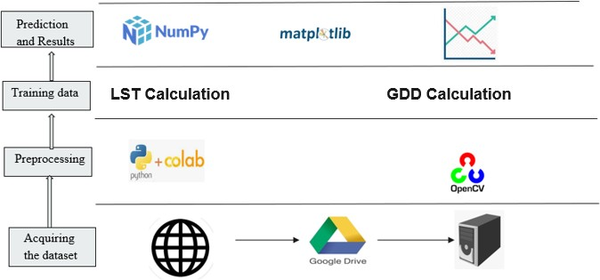

*Figure 3.2.1: Architecture Diagram*

#### Data Flow Diagram

**Fig 3.2.2** shows the data flow diagram. It gives us a clear understanding of how the

data moves throughout the algorithm and how it gets modified with each statement in the code. In our proposed method, the dataset is an image dataset, so the data has to be changed at each step for different methods to be applied on it. As the data needs to be presented differently for different kinds of methods, the data flow diagram will help us understand better.

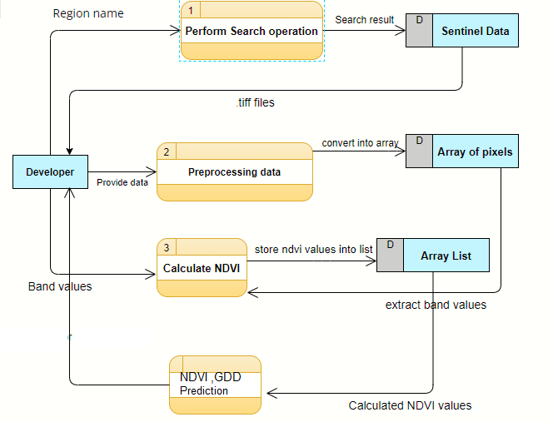

*Figure 3.2.2: Data Flow Diagram*

# EXPERIMENTAL STUDY

#### DATASET

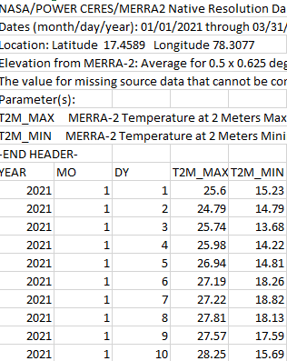

***Figure 4.1.1: NASA POWER DATASET***

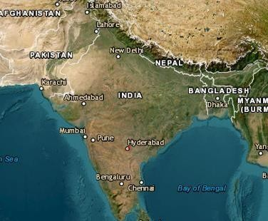

***Figure 4.1.2: Earth Explorer USGS Dataset Image***

Link to the above datasets:

* + - [https://power.larc.nasa.gov/data-access-](https://power.larc.nasa.gov/data-access-viewer/) [viewer/](https://power.larc.nasa.gov/data-access-viewer/)
    - <https://earthexplorer.usgs.gov/>

The Nasa Power Dataset and Landsat 8 Dataset has been acquired from the above-mentioned URL’s.

Dataset Description:

* + - * Landsat-8 is one of the National Aeronautics and Space Administration (NASA) Landsat series. The Landsat-8 data is accessible in United States Geological Survey (USGS). The website Earth Explorer is free of cost. The images of entire earth are taken by Landsat-8 satellite after every 16 days. In the current study, to estimate brightness temperature the TIR bands (10) were used
      * Nasa power dataset provides solar and meteorological datasets from NASA research for support of renewable energy efficiency and agricultural needs

#### RESULTS

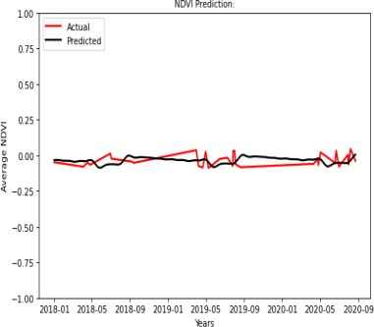

***Figure 4.2.1: NDVI Trend Prediction-Prophet Algorithm***

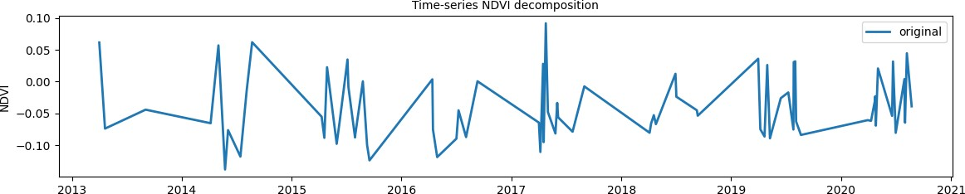

***Figure 4.2.2: NDVI Original plot from 2013-2021***

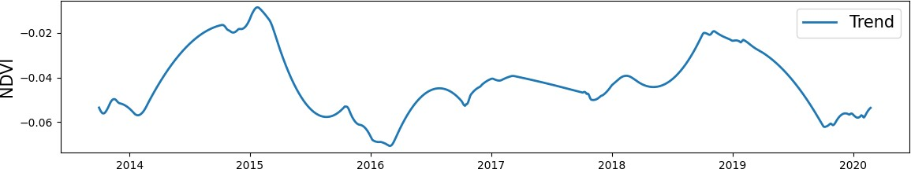

***Figure 4.2.3: NDVI Trend Plot from 2013-2021***

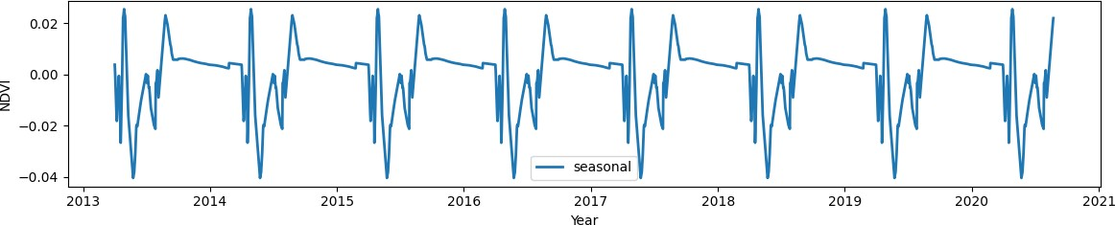

***Figure 4.2.4: NDVI Seasonal plot from 2013- 2021***

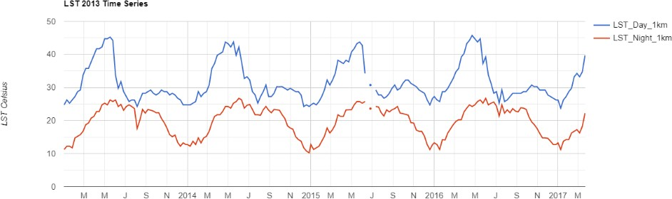

***Figure 4.2.5: LST India plot from 2013-2018***

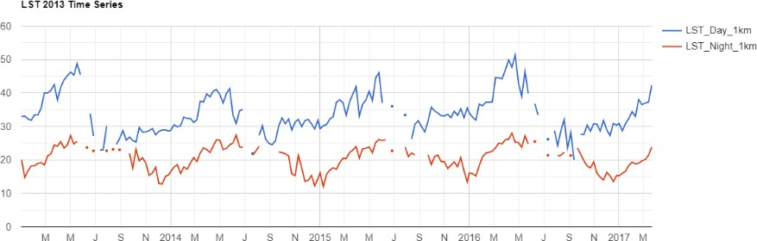

***Figure 4.2.6: LST Sangareddy Plot from 2013-2018***

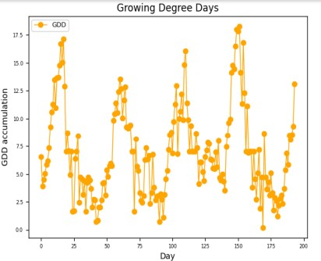

***Figure 4.2.7: Growing Degree Days plot Sangareddy***

# Summary and Future Scope

When conducting any analysis, it is important to acknowledge and understand its limitations. In the case of this project, the results obtained may not be generalizable to all datasets and use cases due to the specific choices made in terms of image selection. This means that the findings may not be applicable to other scenarios, highlighting the need for further research to identify common trends and best practices.

To address this limitation, future work should involve conducting similar analyses on multiple datasets and use cases. This can help to identify patterns and best practices that may be applicable across a wider range of scenarios. By doing so, more robust and generalizable methods for handling class imbalance and feature selection in machine learning can be established. In addition, it is important to document and share the details of the analysis methods and results obtained. This can promote transparency and reproducibility in the field of machine learning, allowing other researchers and practitioners to understand the context and limitations of the findings. This also helps to ensure that the results obtained can be built upon by others in the future.

In conclusion, while the limitations of the current project highlight the need for further research, it also provides an opportunity for future work to build upon the findings and develop more generalizable methods for handling images with high cloud cover. By sharing the details of the analysis and results, researchers and practitioners can work towards promoting transparency and reproducibility in the field.

**Future scope includes -**

* Training the model with the same algorithms on different datasets - MODIS, IRS LISS

- III can be done.

* The regions used for comparison analysis can be changed to other regions in India.
* The analysis done will be useful for agricultural scientists and researchers to understand the pattern of change of crops

#### REFERENCES

1. J. Huang, H. Wang, Q. Dai and D. Han, "Analysis of NDVI Data for Crop Identification and Yield Estimation," in IEEE Journal of Selected Topics in Applied Earth Observations and Remote Sensing, vol. 7, no. 11, pp. 4374-4384, Nov. 2014, doi: 10.1109/JSTARS.2014.2334332.
2. Y. Shen, G. Shen, H. Zhai, C. Yang and K. Qi, "A Gaussian Kernel-Based Spatiotemporal Fusion Model for Agricultural Remote Sensing Monitoring," in IEEE Journal of Selected Topics in Applied Earth Observations and Remote Sensing, vol. 14, pp. 3533-3545, 2021, doi: 10.1109/JSTARS.2021.3066055.
3. Z. Xu et al., "Trends in Global Vegetative Drought From Long-Term Satellite Remote Sensing Data," in IEEE Journal of Selected Topics in Applied Earth Observations and Remote Sensing, vol. 13, pp. 815-826, 2020, doi: 10.1109/JSTARS.2020.2972574.
4. F. Zhang et al., "Cloud-Free Land Surface Temperature Reconstructions Based on MODIS Measurements and Numerical Simulations for Characterizing Surface Urban Heat Islands," in IEEE Journal of Selected Topics in Applied Earth Observations and Remote Sensing, vol. 15, pp. 6882-6898, 2022, doi: 10.1109/JSTARS.2022.3199248.
5. S. Li and G. -M. Jiang, "Land Surface Temperature Retrieval From Landsat-8 Data With the Generalized Split-Window Algorithm," in IEEE Access, vol. 6, pp. 18149-18162, 2018, doi: 10.1109/ACCESS.2018.2818741.
6. R. Niclòs, J. A. Valiente, M. J. Barberà and V. Caselles, "Land Surface Air Temperature Retrieval From EOS-MODIS Images," in IEEE Geoscience and Remote Sensing Letters, vol. 11, no. 8, pp. 1380-1384, Aug. 2014, doi: 10.1109/LGRS.2013.2293540.
7. X. Liu et al., "Large-Scale Crop Mapping From Multisource Remote Sensing Images in Google Earth Engine," in IEEE Journal of Selected Topics in Applied Earth Observations and Remote Sensing, vol. 13, pp. 414-427, 2020, doi: 10.1109/JSTARS.2019.2963539.
8. G. Lemoine and O. Léo, "Crop mapping applications at scale: Using Google Earth Engine to enable global crop area and status monitoring using free and open data sources," 2015 IEEE International Geoscience and Remote Sensing Symposium (IGARSS), Milan, Italy, 2015, pp. 1496-1499, doi: 10.1109/IGARSS.2015.7326063.
9. A. Shelestov, M. Lavreniuk, N. Kussul, A. Novikov and S. Skakun, "Large scale crop classification using Google earth engine platform," 2017 IEEE International Geoscience and Remote Sensing Symposium (IGARSS), Fort Worth, TX, USA, 2017, pp. 3696-3699, doi: 10.1109/IGARSS.2017.8127801.
10. Z. Yang, C. Diao and F. Gao, "Towards Scalable Within-Season Crop Mapping With Phenology Normalization and Deep Learning," in IEEE Journal of Selected Topics in Applied Earth Observations and Remote Sensing, vol. 16, pp. 1390-1402, 2023, doi: 10.1109/JSTARS.2023.3237500.
11. K. K. Gadiraju and R. R. Vatsavai, "Application of Transfer Learning in Remote Sensing Crop Image Classification," in IEEE Journal of Selected Topics in Applied Earth Observations and Remote Sensing, doi: 10.1109/JSTARS.2023.3270141.

# APPENDIX

## Code:

#### Imports

import io, os, sys, setuptools, tokenize import statsmodels.api as sm

from prophet import Prophet

import ee, datetime # Google Earth Engine import pandas as pd

import numpy as np import folium import geehydro

from datetime import datetime as dt from IPython.display import Image

from statsmodels.tsa.seasonal import seasonal_decompose ##from pmdarima.arima import auto_arima

from statsmodels.tsa.arima_model import ARIMA

from sklearn.metrics import mean_squared_error, mean_absolute_error import matplotlib.pyplot as plt

import seaborn as sns import warnings import prophet

warnings.filterwarnings('ignore')

**LST AND NDVI**

landsat = ee.ImageCollection("LANDSAT/LC08/C01/T1_SR").\ filter(ee.Filter.lt('CLOUD_COVER', 20)).\

filterDate('2013-01-01','2021-01-01')

# setteing coordinates to SANGAREDDY DISTRICT

srd_AOI = ee.Geometry.Rectangle([17.6075, 78.0798,17.9075,78.3798 ]) # filter area

landsat_AOI = landsat.filterBounds(srd_AOI)

print('Total number of images :', landsat_AOI.size().getInfo()) # Plot the 'first' image in the collection

# List of images

listOfImages = landsat_AOI.toList(landsat_AOI.size()) # Plot in RGB color composite

palette = ['red', 'green', 'blue'] parameters = {'min': 0, 'max': 1000,

'dimensions': 512, 'bands': ['B4', 'B3', 'B2'],

'region': srd_AOI} srd_map.addLayer(ee.Image(listOfImages.get(1)), parameters) srd_map

print('Total number of images :', landsat_AOI.size().getInfo()) landsat_AOI.first().bandNames().getInfo()

def addNDVI(image):

ndvi = image.normalizedDifference(['B5', 'B4']).rename('NDVI') return image.addBands(ndvi)

with_ndvi = landsat_AOI.map(addNDVI) def meanNDVI(image):

image = ee.Image(image)

meanDict = image.reduceRegion(reducer = ee.Reducer.mean().setOutputs(['NDVI']), geometry = srd_AOI,

scale = image.projection().nominalScale().getInfo(), maxPixels = 100000,

bestEffort = True);

return meanDict.get('NDVI').getInfo()

listOfImages_ndvi = with_ndvi.select('NDVI').toList(with_ndvi.size()) ndvi_coll = []

for i in range(listOfImages_ndvi.length().getInfo()):

image = ee.Image(listOfImages_ndvi.get(i-1)) temp_ndvi = meanNDVI(image) ndvi_coll.append(temp_ndvi)

dates = np.array(with_ndvi.aggregate_array("system:time_start").getInfo())

day = [datetime.datetime.fromtimestamp(i/1000).strftime('%Y-%m-%d') for i in (dates)] ndvi_df = pd.DataFrame(ndvi_coll, index = day, columns = ['ndvi'])

ndvi_df.index = pd.to_datetime(ndvi_df.index, format="%Y/%m/%d")

ndvi_df.sort_index(ascending = True, inplace = True) ndvi_df.head(5)

ndvi_df_daily = ndvi_df.resample('D').median() # Linear interpolate NDVI data

ndvi_df_daily.interpolate(method='polynomial', order = 1, inplace = True) ndvi_df_daily.head(5

plt.figure(figsize=(10,5), dpi=100) plt.plot(ndvi_df, '*') plt.plot(ndvi_df_daily) plt.xlabel('Year', fontsize=15)

plt.ylabel('Average NDVI', fontsize=15) plt.legend(['Original Data', 'Interpolated Data']) plt.title("Interpolated NDVI", fontsize=15) plt.ylim([-1, 1])

plt.show()

decomposition = seasonal_decompose(ndvi_df_daily, model= 'additive', period = 365) # additive worked better in terms of seasonality decomposition

# compared to multiplicative

# assign trend, seasonal components from decomposed data trend = decomposition.trend

seasonal = decomposition.seasonal

# Plot the original data, the trend, the seasonality, and the residual plt.figure(figsize=(12,10))

plt.subplot(411)

plt.plot(ndvi_df_daily, label = 'original', linewidth=2) plt.legend(loc = 'best', fontsize=10) plt.ylabel('NDVI', fontsize=10)

plt.title('Time-series NDVI decomposition', fontsize=10) plt.subplot(412)

plt.plot(trend, label = 'Trend', linewidth=2) plt.legend(loc = 'best', fontsize=15) plt.ylabel('NDVI', fontsize=15) plt.subplot(413)

plt.plot(seasonal, label = 'seasonal', linewidth=2) plt.legend(loc = 'best', fontsize=10) plt.ylabel('NDVI', fontsize=10)

plt.xlabel('Year', fontsize=10)

plt.tight_layout()

two_year = (ndvi_df_daily.index>='2020-01-01') & (ndvi_df_daily.index<='2022-01-01') plt.figure(figsize=(12,10))

plt.subplot(411)

plt.plot(ndvi_df_daily[two_year], label = 'original', linewidth=2) plt.legend(loc = 'best', fontsize=10)

plt.ylabel('NDVI', fontsize=15)

plt.title('Time-series NDVI decomposition', fontsize=10) plt.subplot(412)

plt.plot(trend[two_year], label = 'Trend', linewidth=2) plt.legend(loc = 'best', fontsize=10)

plt.ylabel('NDVI', fontsize=10) plt.subplot(413)

plt.plot(seasonal[two_year], label = 'seasonal', linewidth=2) plt.legend(loc = 'best', fontsize=10)

plt.ylabel('NDVI', fontsize=10) plt.xlabel('Year', fontsize=10) plt.tight_layout()

low_index = day.index('2014-05-25') high_index = day.index('2017-04-25')

ndvi_low = ee.Image(listOfImages_ndvi.get(low_index)) ndvi_high = ee.Image(listOfImages_ndvi.get(high_index)) palette = ['red', 'yellow', 'green']

ndvi_parameters = {'min': -1, 'max': 1,

'dimensions': 512, 'palette': palette, 'region': srd_AOI}

srd_map.addLayer(ndvi_low, ndvi_parameters) srd_map

srd_map.addLayer(ndvi_high, ndvi_parameters) srd_map

train_data, test_data = ndvi_df_daily[ndvi_df_daily.index <= '2018-01-01'],\ ndvi_df_daily[ndvi_df_daily.index >= '2018-01-01']

# plot the training and testing data plt.figure(figsize=(6,4)) #plt.grid(True)

plt.xlabel('Year', fontsize=10) plt.ylabel('NDVI', fontsize=10)

plt.plot(train_data, 'green', label='Train data', linewidth=2) plt.plot(test_data, 'red', label='Test data', linewidth=2) plt.title('Time-series NDVI data train-test split', fontsize=10) plt.ylim([-1,1])

plt.legend(fontsize=10) plt.show(

**Prophet Algorithm**

train_data_fb = train_data.reset_index() train_data_fb.rename(columns={"index": "ds", "ndvi": "y"},inplace=True) train_data_fb.head(5)

m1= Prophet(interval_width=0.95, daily_seasonality=False, # interval_width = confidence interval changepoint_range=0.7, # % of train data to look for change point

# (default value is 0.8) 0.7 produced better model performance

changepoint_prior_scale=0.3) # determines trend flexibility. tuned around the value (default value is 0.05),

# 3 produced best performance m1.fit(train_data_fb)

# number of days to forecast, based on test_data forecast_days = (test_data.index[-1]-test_data.index[0]).days # Create dataframe with the dates we want to predict

future = m1.make_future_dataframe(periods = forecast_days, freq = 'D') # Predict the price

forecast = m1.predict(future) plt.figure(figsize=(6,3), dpi=80) fig = m1.plot(forecast)

fig = m1.plot_components(forecast) plt.show()

def performance_measure(model, yhat, y): # mean squared error

mse = mean_squared_error(y, yhat) #mean absolute error

mae = mean_absolute_error(y, yhat) # root mean squared error rmse=np.sqrt(mse)

#average score average=np.mean((mse, mae, rmse))

# save model performance as dataframe

metrics=pd.DataFrame({'model': model, 'mse': [mse], 'mae': [mae], 'rmse': [rmse], 'average_score':[a verage]})

return metrics

FBProphet = performance_measure('Prophet', fc_test.yhat.values.flatten(), test_data.values.flatten()) FBProphet

**GEE SCRIPľ**

var dataset = var L8 = ee.ImageCollection("LANDSAT/LC08/C02/T2_L2")

.filterBounds(ROI)

.filterDate('2013-01-01','2018-01-01')

.filterMetadata('CLOUD_COVER','less_than',1)

.mean()

.clip(ROI);

var indiaBorder = dataset.filter(ee.Filter.eq('country_na', 'India')); print(indiaBorder); Map.centerObject(indiaBorder, 6); Map.addLayer(indiaBorder);

**Importing LST image collection.**

var modis = ee.ImageCollection('LANDSAT/LC08/CO2/T2_L2'); var start = ee.Date('2013-01-01');

var dateRange = ee.DateRange(start, start.advance(5, 'year')); var mod11a2 = modis.filterDate(dateRange);

// Select only the 1km day LST data band. var modLSTday = mod11a2.select('LST_Day_1km','LST_Night_1km');

var inCelsius = modLSTday.map(function(img) { return img

.multiply(0.02)

.subtract(273.15)

.clip(geometry)

.copyProperties(img, ['system:time_start']);

});

**Chart time series of LST for India 2017.** var ts1 = ui.Chart.image.series({ imageCollection: inCelsius,

region: indiaBorder,

reducer: ee.Reducer.median(), scale: 1000,

xProperty: 'system:time_start'})

.setOptions({

title: 'LST 2013 Time Series', vAxis: {title: 'LST Celsius'}});

print(ts1);

**Calculating 8-day Mean Temp**

var clippedDay=inCelsius.select('LST_Day_1km').median().clip(indiaBorder); var clippedNight=inCelsius.select('LST_Night_1km').median().clip(indiaBorder); Map.addLayer(clippedDay,{

min:3,max:30, palette:['blue','limegreen','yellow','darkorange','red']}, 'Mean Day Temperature,2013'); Map.addLayer(clippedNight,{

min:3,max:30, palette:['blue','limegreen','yellow','darkorange','red']}, 'Mean Day Temperature,2013')

#### PAPER

Crop Phenology Estimation

1st S.Aruna

*Department of Information Technol**ogy vasavi college of engineering* Hyderabad,India [s.aruna@staff.vce.ac.in](mailto:s.aruna@staff.vce.ac.in)

2nd Sai Arvind N

*Department of Information Technol**ogy vasavi college of engineering* Hyderabad,India [nsaiarvind@gmail.com](mailto:nsaiarvind@gmail.com)

3rd KVS Sriya

*Department of Information Technology vasavi college of engineering* Hyderabad,India [sriyakodav](mailto:sriyakodavanti@gmail.com)[anti@gmail.com](mailto:anti@gmail.com)

***Abstract*—The crop phenology estimation helps in crop produc- tion estimation, irrigation scheduling and in crop classification. One main part of crop agriculture is the observation of the crops, which is what this project is about. Observation of crops can be done in various ways and these can be used to respond to different situations that might arise during the cultivation of crops. Many commodity crops have critical growth stages during which they are at an increased risk of yield loss, such as silking in corn and pod-fill in soybean. Extreme weather events are expected to disrupt global food supply with increased frequency, and knowledge of the timing of crop growth stages in major growing regions is vital to accurately assess potential yield loss. The project aims to calculate Growing Degree Days, NDVI for aiding Crop Phenology Estimation. With the comparison of GDD,NDVI for crops in different regions we expect to predict phenology of a crop in different climatic and environmental conditions. In this study we calculate Surface Temperature from LandSat 8 for predicting GDD and NDVI. This study aims to assess the vegetation health and growing degree days (GDD) of Sangareddy, India using satellite imagery. Normalized Difference Vegetation Index (NDVI) was calculated from Landsat 8 imagery for the years 2018-2021. The NDVI values were analyzed to identify any trends and changes in vegetation health over the years.**

***Index Terms*—NDVI,GDD,Landsat8,Phenology**

* 1. INTRODUCTION

Agriculture is the science of farming which includes the growth of crops to produce food, rearing of animals to provide wool and many more. This science has many complications. Today with the increased demand for food, just growing crops is not enough. An efficient practice of growing crops with minimum input and maximum results are required. This need can be satisfied if our progress in information technologycan be integrated with conventional farming practices. To propose a novel framework for crop phenology estimationwhich further enhances the performance with few satelliteimages. Generally, it is quite flexible and untroubled to classifyan image when there are enough samples describing the image, but the difficulty arises when there are very few samples suitable predict different parameters .

It is important to accurately estimate the phenological growth stage of a crop for remote monitoring and advisory purposes using satellite imaging. This process has numerous

applications, such as crop identification, assessing crop health, scheduling irrigation, making decisions regarding the purchaseand application of agricultural inputs (e.g. soil nutrients), alert-ing farmers of possible diseases, predicting harvest time, and estimating crop yield[1]. For instance, applying soil nutrients during the panicle stage of a paddy crop can increase Chloro- phyll and Nitrogen content in the high photosynthetic-rate leaves, leading to higher yields. Proper irrigation scheduling isalso critical during the active tillering stage. Timely detection of crop stages can aid in advance production estimation, which can have a significant impact on crop procurement, monitoring[2],distribution, price structure, and import/export decisions.The Normalized Difference Vegetation Index is used for detecting and quantifying the greenness of the crops based on the amount of light reflected in visible red and near-infraredbands. NDVI is an indicator of the vegetation greenness —thedensity and health— of each pixel in a satellite image. Early detection of crop stages help in advance production estimation, predicting crop health. With the comparison of GDD for cropsin different regions we expect to predict phenology of a crop in different climatic and environmental conditions[3].

The scope of this project is to develop a machine learning framework for predicting NDVI, GDD which in turn helps in predicting crop phenology progress. The project focuses on two key areas: surface temperature calculation and NDVI prediction. The goal is to identify the most effective methods for addressing these challenges and to develop a machine learning model that accurately predicts these parameters.

* 1. METHODOLOGY

In the section, we describe the main proposed methodology for the crop phenological parameters using the following two main steps : (i) calculating Normalised Dense Vegetation Index using Landsat8 satellite images (ii) calculating Land Surface Temperature for evaluating Growing Degree Days.

1. *NDVI Calculation*

Normalized Difference Vegetation Index (NDVI) is a satel- lite image derived indicator that measures state of the plant health. NDVI is directly related to drought condition. During rainy season, higher NDVI is observed (maximum is +1) whereas in the dry season NDVI drops (minimum is -1).



Fig. 1. NDVI Formula

NDVI is seen seasonal in nature but due to climate change upward/downward changes are also observed over the years. Knowing the trend and seasonal cycle of NDVI in advanced can help better resource planning and deployment for the local and national stake holders. There are many known and unknown parameters influence NDI. Out of many approaches, one would be training machine learning models with pasttdata to get prediction. This notebook will outline two ofthe machine learning approaches for NDVI prediction. In the first part, NDVI was extracted from time-series Landsat 8 data image data in Google Earth Engine (GEE) platform through Python API. In the next part, predictive models were built to forecast NDVI using state of the art Prophet models. NDVI of every image pixels in the images will be calculated by the equation:

Where, NIR is B5 band and Red is B4 band. Average NDVI will be calculated on every images to get time-series NDVI of the AOI.

1. *Land Surface Temperature*

To calculate land surface temperature (LST) from Landsat 8 images, the thermal bands of the satellite can be used. The thermal bands measure the radiation emitted by the Earth’s surface in the thermal infrared spectrum, which can be used to estimate the temperature of the surface.

There are different algorithms available for calculating LST from Landsat 8 thermal bands[4][5], including the split- window algorithm, the single-channel algorithm, and the ra- diative transfer equation-based algorithm. Each algorithm has its advantages and limitations, and the choice of algorithm depends on the specific application and research question.

In general, the split-window algorithm is commonly used for Landsat 8 LST calculation as it is simple and effective. The algorithm uses the brightness temperature of two thermal bands, typically band 10 and band 11, to calculate LST. The algorithm accounts for the atmospheric [6]effects on the thermal bands, such as atmospheric water vapor and atmospheric transmittance, which can affect the accuracy of the LST calculation.

In Earth Engine[8][9], the LST can be calculated using the split-window algorithm by combining the thermal bands with the appropriate coefficients and applying the algorithm to the image. The output of the algorithm(Figure 2) is an LST image, which can be used for various applications, including land cover classification, urban heat island studies, and agricultural monitoring.

1. *Growing Degree Days*

GDD can be calculated using the temperature data. GDD is the accumulation of heat above a certain threshold temperature

Fig. 2. SW Algorithm for calculating land Surface Temperature

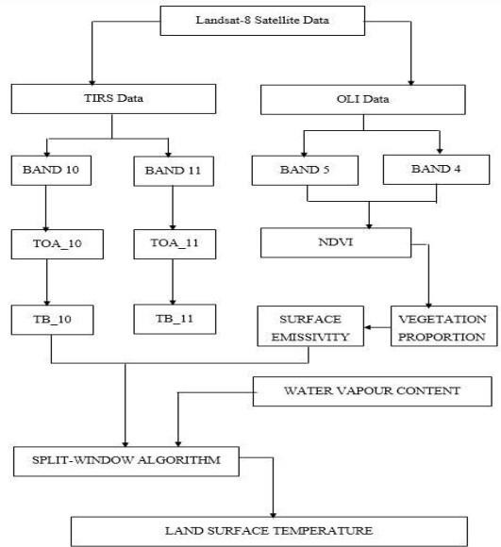that is required for plant growth. The threshold temperature varies with the specific crop being studied. To calculate GDD, the daily average air temperature is subtracted from the threshold temperature, and the sum of these differences over the growing season is calculated

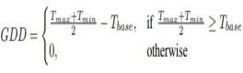

where Tmax was the lesser value of the daily maximum temperature and 34◦C, Tbase was set to 8◦C, and Tmin was the daily minimum temperature.

* 1. EXPERIMENTAL SETUP

1. *Data Sets*

Landsat 8 is a satellite mission operated by the United States Geological Survey (USGS) that provides global coverage of the Earth’s surface at a spatial resolution of 30 meters. The satellite was launched in 2013 and carries two main sensors: the Operational Land Imager (OLI) and the Thermal Infrared Sensor (TIRS). The OLI has nine spectral bands, covering a wide range of wavelengths from visible to near-infrared, while the TIRS has two thermal infrared bands.

1. *Prophet Algorithm*

Facebook Prophet is a time series forecasting tool that employs a generalized additive model (GAM) to model the



Fig. 3.

trend, seasonality, and holiday effects in a time series. The GAM framework allows for modeling non-linear relationships between the response variable (e.g., NDVI) and the predictor variables (e.g., time, temperature), as well as for incorporating external regressors that may affect the response variable.

Prophet models the trend as a piecewise linear function, with changepoints that allow for the trend to change direction at specific times. The seasonality is modeled using the Fourier series with a user-defined number of harmonics, which can capture complex seasonal patterns in the data. The holiday effects are modeled using indicator variables, which allow for modeling specific events or periods that may affect the time series (e.g., droughts, floods).

Prophet uses a Bayesian approach to estimate the model parameters and to make predictions. The model parameters are estimated using Markov Chain Monte Carlo (MCMC) sampling, which allows for obtaining posterior distributions for the parameters and for quantifying uncertainty in the predictions. The posterior distributions are used to generate samples from the predictive distribution, which can be used to obtain point estimates and uncertainty intervals for the predicted values.

Prophet also provides various diagnostics and visualization tools to evaluate the model performance and to diagnose any issues with the data or the model. These include residual plots, cross-validation metrics, and interactive plots that allow for visualizing the model components and the predicted values.

Prophet was used to predict NDVI, time series NDVI values from remote sensing sources were preprocessed to remove noise and missing values, and load the data into Prophet.The model was trained using a portion of the data, and the remaining data can be used for validation or testing. The trained model was used to make predictions for future time points or to forecast the entire time series. The output of the model includes point estimates and uncertainty intervals for the predicted values, which was used to evaluate the accuracy and reliability of the predictions.

1. *Split Window Algorithm for Land Surface Temperature*

The split-window algorithm is a widely used thermal in- frared remote sensing method for estimating the land surface temperature (LST) of the Earth’s surface. The algorithm is based on the fact that the atmospheric transmittance and emissivity vary with wavelength, and that these variations can be exploited to estimate the LST. It uses the brightness tem- perature (TB) of two TIR bands, one at a shorter wavelength and another at a longer wavelength, which are selected such that the atmospheric transmittance and emissivity are different.

The algorithm assumes that the surface emissivity is constant and known for the two bands. The TB of the two bands are retrieved from the satellite data and atmospheric correction is applied to account for the absorption and emission of the atmosphere. The LST is then calculated using a regression equation that relates the TB of the two TIR bands to the LST. The regression equation is typically derived from a combina- tion of theoretical models and empirical measurements, and the accuracy of the algorithm is influenced by factors such as surface emissivity, atmospheric conditions, and the accuracy of the calibration sites used to derive the regression equation. One advantage of the split-window algorithm is its sim- plicity, as it only requires two TIR bands and a regression equation to estimate the LST. It also has the advantage of being less sensitive to atmospheric effects compared to other TIR algorithms that use a single band. Furthermore, the algorithm can also be applied to large-scale remote sensing datasets to generate LST maps with high spatial and temporal resolution.

* 1. PRELIMINARY RESULTS TABLE I shows the Prophet model performance for pre-

dicting NDVI. The Model was trained solely on Sangareddy District Dataset.

TABLE I PROPHET MODEL METRICS

|  |  |  |  |
| --- | --- | --- | --- |
| **Model**  **Name** | **Metrics** | | |
| ***MSE*** | ***MAE*** | ***RSME*** |
| Prophet | 0.001827 | 0.037646 | 0.042743 |

a

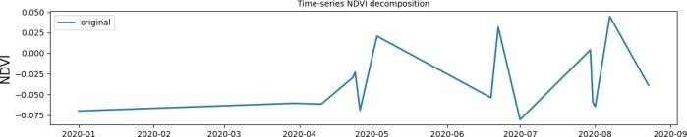

Fig 4. NDVI Original

This refers to the NDVI values calculated from satellite data without any further processing. Original NDVI values were used to analyze vegetation cover and productivity over time, and to identify areas with different vegetation types and densities.

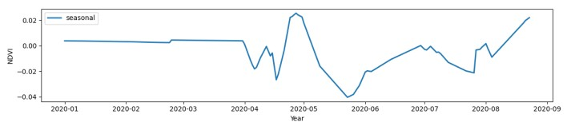*ˆ*

Fig 5. NDVI Seasonal

This type of NDVI analysis involves separating the NDVI values into seasonal or monthly averages. This allowed for the identification of seasonal variations in vegetation cover and productivity, such as the onset and end of growing seasons, and the effects of weather patterns on vegetation growth.

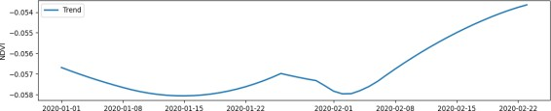

Fig 6. NDVI Trend

This NDVI Trend gives us insights into analyzing the long- term trends in NDVI values over a period of time, typically several years or decades. The NDVI trend analysis identifies changes in vegetation cover and productivity over time, such as the effects of climate change, land use changes, or natural disturbances such as wildfires or deforestation.

Fig 7 represents the performance of NDVI values from the Prophet algorithm to actual values evaluated from LandSat8. The Prophet algorithm was one of the best algorithm with high accuracy.

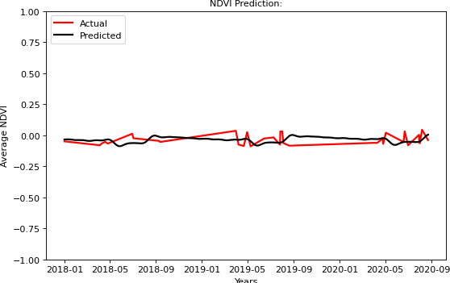

Fig 7. Prophet Algorithm Prediction for NDVI

This results helps us to understand the trend of NDVI and also these can be used further in phenology[10] prediction for crop growth stages.

Fig 8 represents Growing Degree Days accumulated over the crop cycle from Jan 2018-June 2018 solely in sangareddy district.

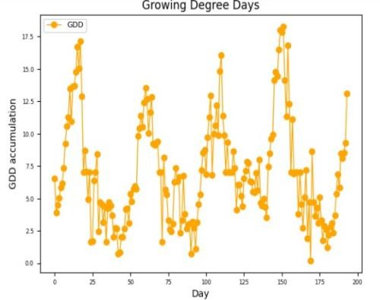

1. CONCLUSION AND FUTURE SCOPE

The proposed technique is deployed in moderately large area in India and we found fewer images.

Considering the fact that the time-interval between two ac- quired timestamps is 5 days or more, this is quite a remarkable achievement for a medium temporal resolution satellite data. The major challenge faced while deploying this to the entire region is when the fewer availability of images due to longer period of cloudy days. Using Image Fusion Techniques there is scope to increase the availability of images.This also enables us to map phenology by within-season approaches [10][11]for

real-time monitoring.

1. ACKNOWLEDGMENT

We would like to express our gratitude to Vasavi college of Engineering for providing us with the deep learning server with which we were able to complete our project

REFERENCES

1. J. Huang, H. Wang, Q. Dai and D. Han, ”Analysis of NDVI Data for Crop Identification and Yield Estimation,” in IEEE Journal of Selected Topics in Applied Earth Observations and Remote Sensing, vol. 7, no. 11, pp. 4374-4384, Nov. 2014, doi: 10.1109/JSTARS.2014.2334332.
2. .Y. Shen, G. Shen, H. Zhai, C. Yang and K. Qi, ”A Gaussian Kernel- Based Spatiotemporal Fusion Model for Agricultural Remote Sensing Monitoring,” in IEEE Journal of Selected Topics in Applied Earth Observations and Remote Sensing, vol. 14, pp. 3533-3545, 2021, doi: 10.1109/JSTARS.2021.3066055.
3. Z. Xu et al., ”Trends in Global Vegetative Drought From Long-Term Satellite Remote Sensing Data,” in IEEE Journal of Selected Topics in Applied Earth Observations and Remote Sensing, vol. 13, pp. 815-826, 2020, doi: 10.1109/JSTARS.2020.2972574.
4. F. Zhang et al., ”Cloud-Free Land Surface Temperature Reconstructions Based on MODIS Measurements and Numerical Simulations for Char- acterizing Surface Urban Heat Islands,” in IEEE Journal of Selected Topics in Applied Earth Observations and Remote Sensing, vol. 15, pp. 6882-6898, 2022, doi: 10.1109/JSTARS.2022.3199248.
5. S. Li and G. -M. Jiang, ”Land Surface Temperature Retrieval From Landsat-8 Data With the Generalized Split-Window Algorithm,” in IEEE Access, vol. 6, pp. 18149-18162, 2018, doi: 10.1109/AC- CESS.2018.2818741.
6. R. Niclo`s, J. A. Valiente, M. J. Barbera` and V. Caselles, ”Land Surface Air Temperature Retrieval From EOS-MODIS Images,” in IEEE Geoscience and Remote Sensing Letters, vol. 11, no. 8, pp. 1380-1384, Aug. 2014, doi: 10.1109/LGRS.2013.2293540.
7. X. Liu et al., ”Large-Scale Crop Mapping From Multisource Remote Sensing Images in Google Earth Engine,” in IEEE Journal of Selected Topics in Applied Earth Observations and Remote Sensing, vol. 13, pp. 414-427, 2020, doi: 10.1109/JSTARS.2019.2963539.
8. G. Lemoine and O. Le´o, ”Crop mapping applications at scale: Using Google Earth Engine to enable global crop area and status monitoring using free and open data sources,” 2015 IEEE International Geoscience and Remote Sensing Symposium (IGARSS), Milan, Italy, 2015, pp. 1496-1499, doi: 10.1109/IGARSS.2015.7326063.
9. A. Shelestov, M. Lavreniuk, N. Kussul, A. Novikov and S. Skakun, ”Large scale crop classification using Google earth engine platform,” 2017 IEEE International Geoscience and Remote Sensing Sympo- sium (IGARSS), Fort Worth, TX, USA, 2017, pp. 3696-3699, doi: 10.1109/IGARSS.2017.8127801.
10. Z. Yang, C. Diao and F. Gao, ”Towards Scalable Within-Season Crop Mapping With Phenology Normalization and Deep Learning,”in IEEE Journal of Selected Topics in Applied Earth Observations and Remote Sensing, vol. 16, pp. 1390-1402, 2023, doi: 10.1109/JS- TARS.2023.3237500.
11. K. K. Gadiraju and R. R. Vatsavai, ”Application of Transfer Learning in Remote Sensing Crop Image Classification,” in IEEE Journal of Selected Topics in Applied Earth Observations and Remote Sensing, doi: 10.1109/JSTARS.2023.3270141.
12. https://earthexplorer.usgs.gov/ Landsat8 dataset link