**DEPLOYING AND MANAGING MONITORING SYSTEMS USING NAGIOS IN DOCKER**

**BY ANGELENA-22BD1A0585**

**Step 1: Pulling the Nagios Image**

1. **Command to Pull Nagios**

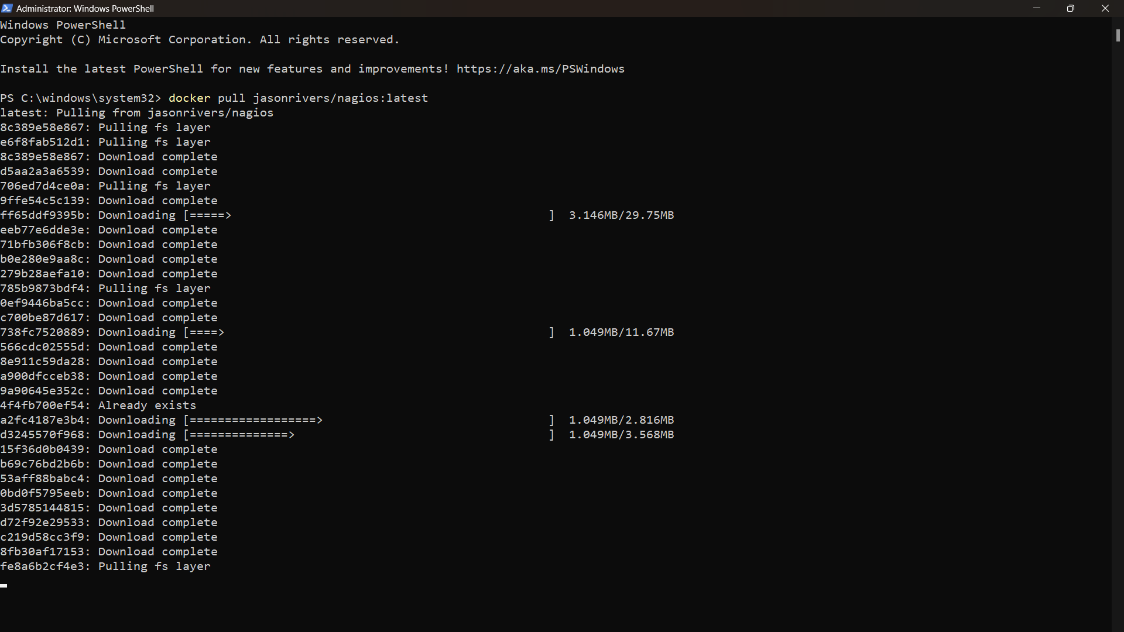

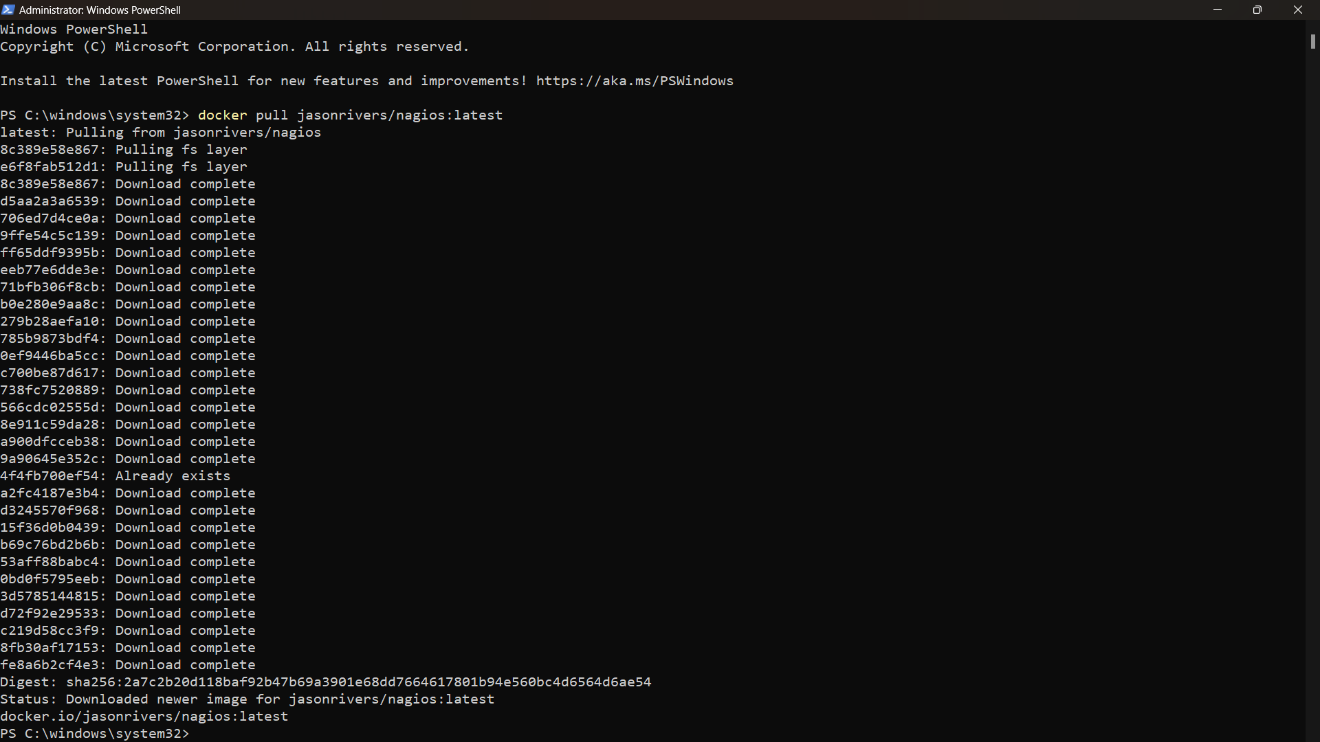

**Step 2: Running Nagios**

**1. Command to Run Nagios**

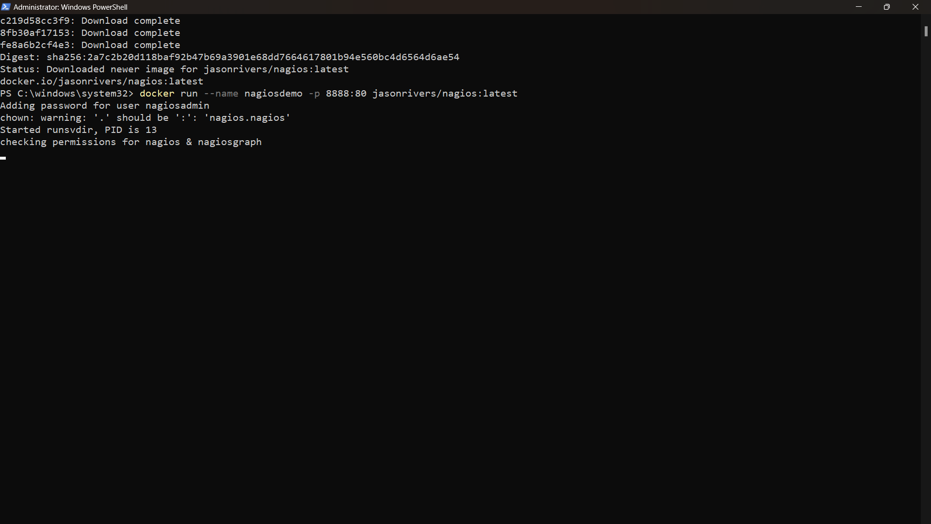

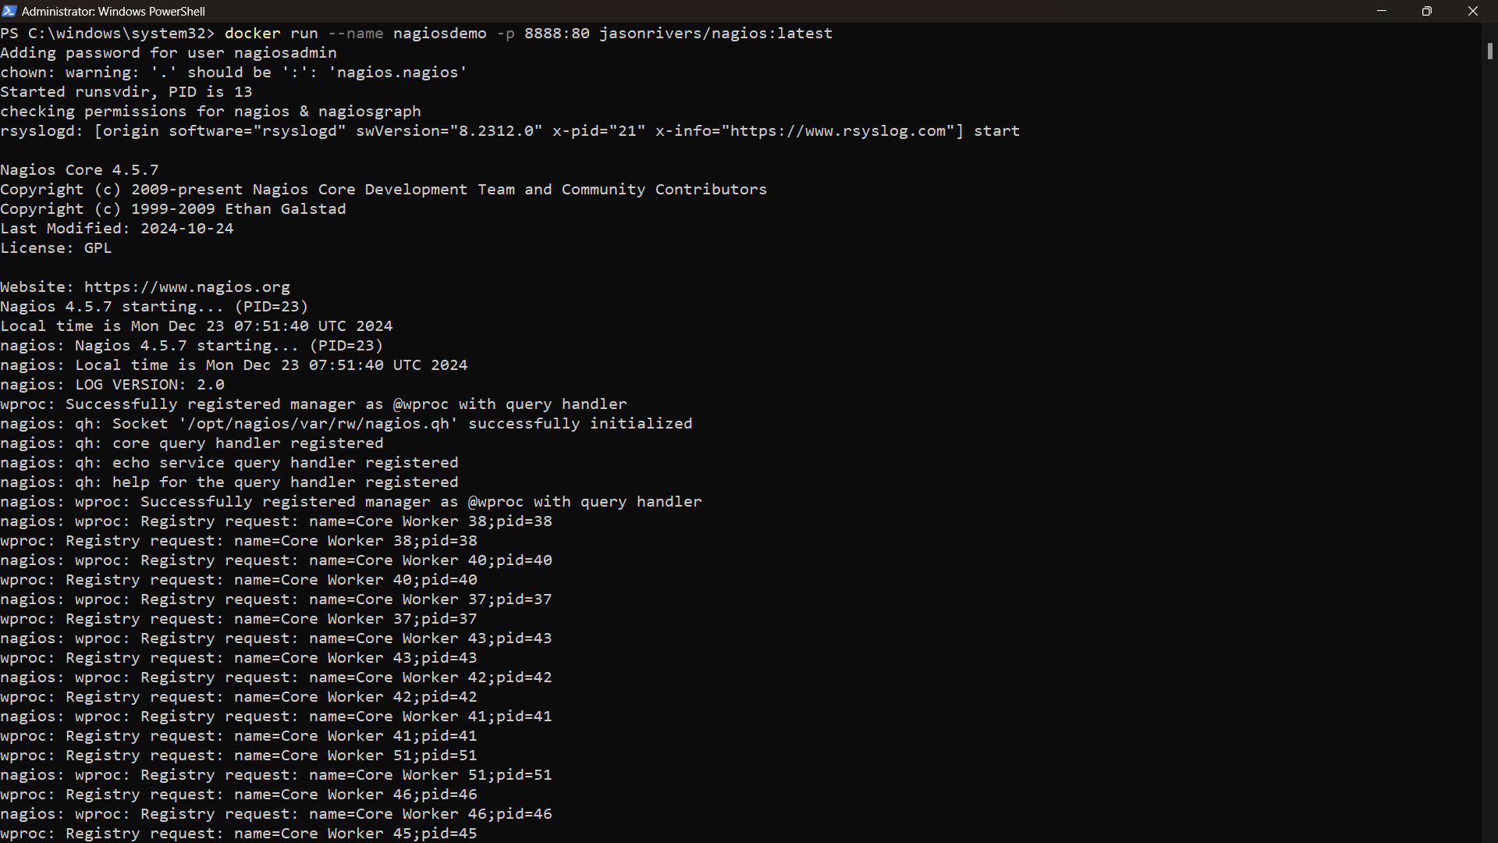

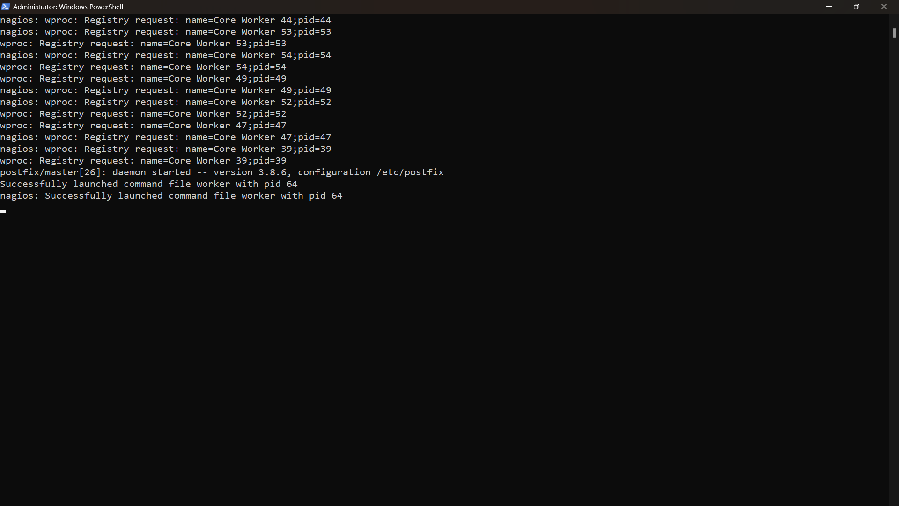

**Step 3: Accessing Nagios**

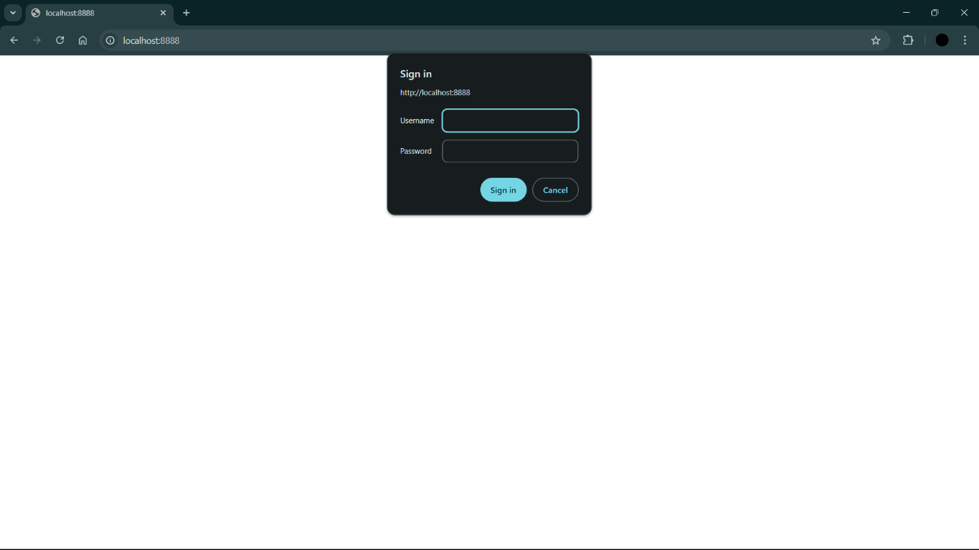

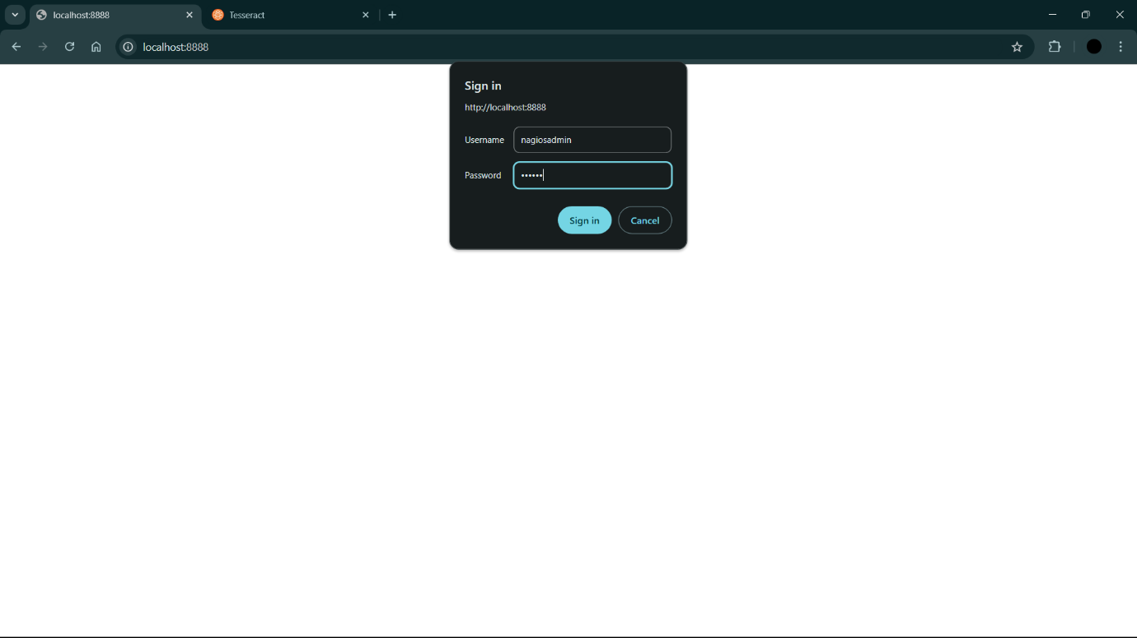

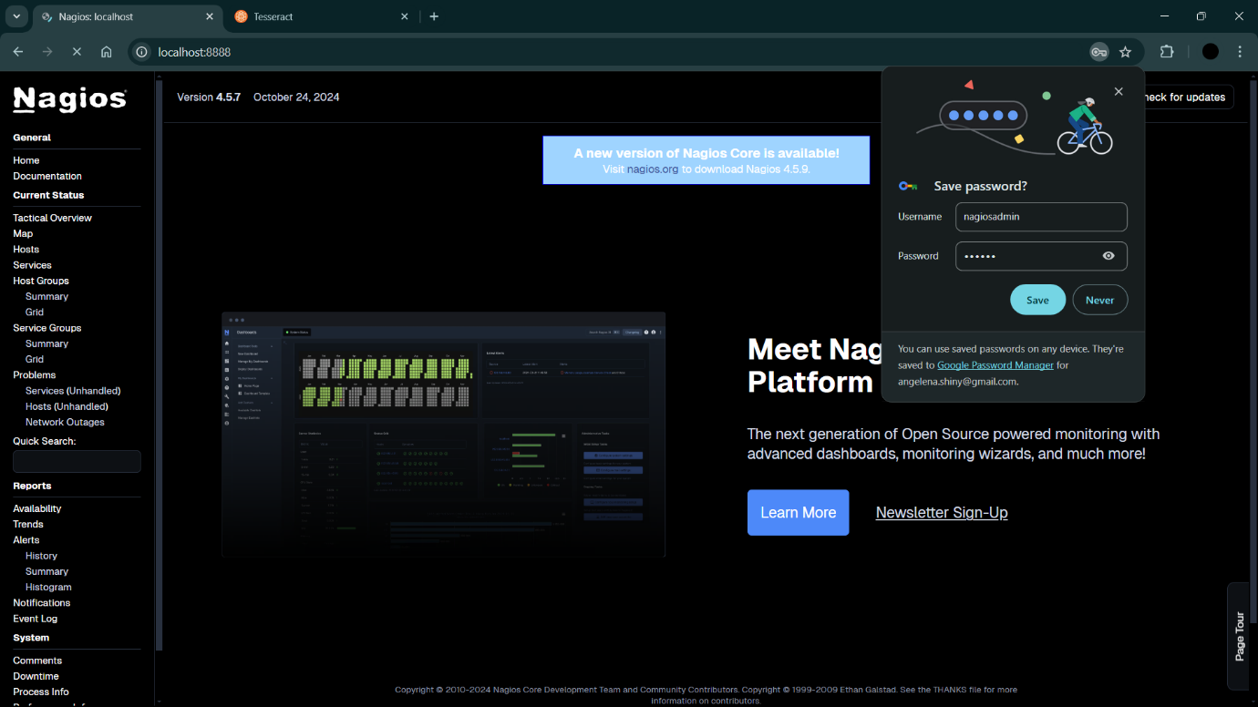

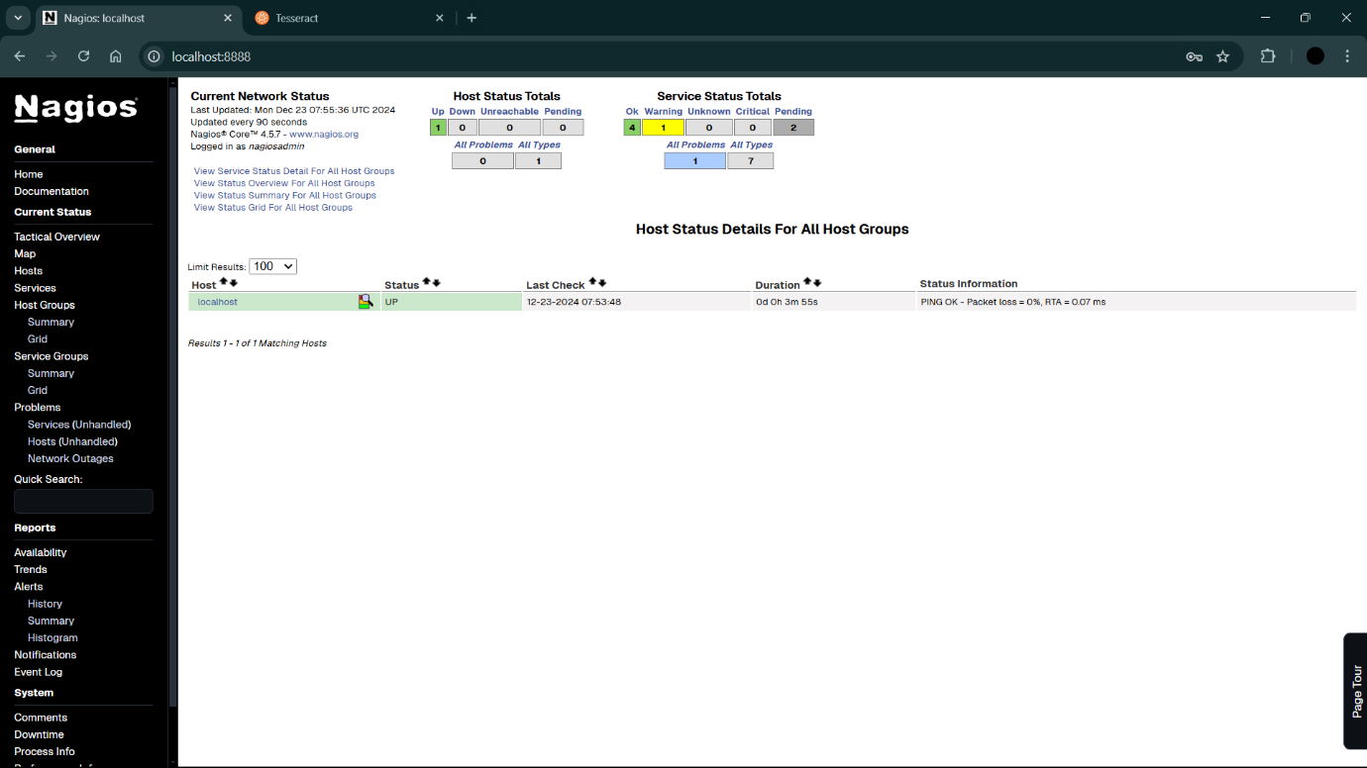

**Stopping Nagios:**

**1. Find the Container Name:**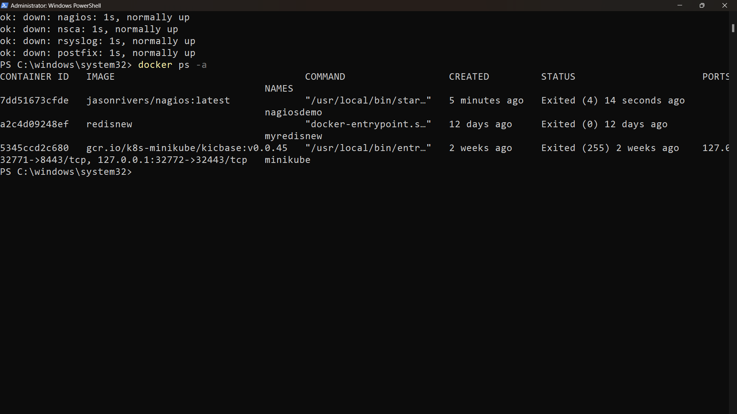

**2. Stop the Container:**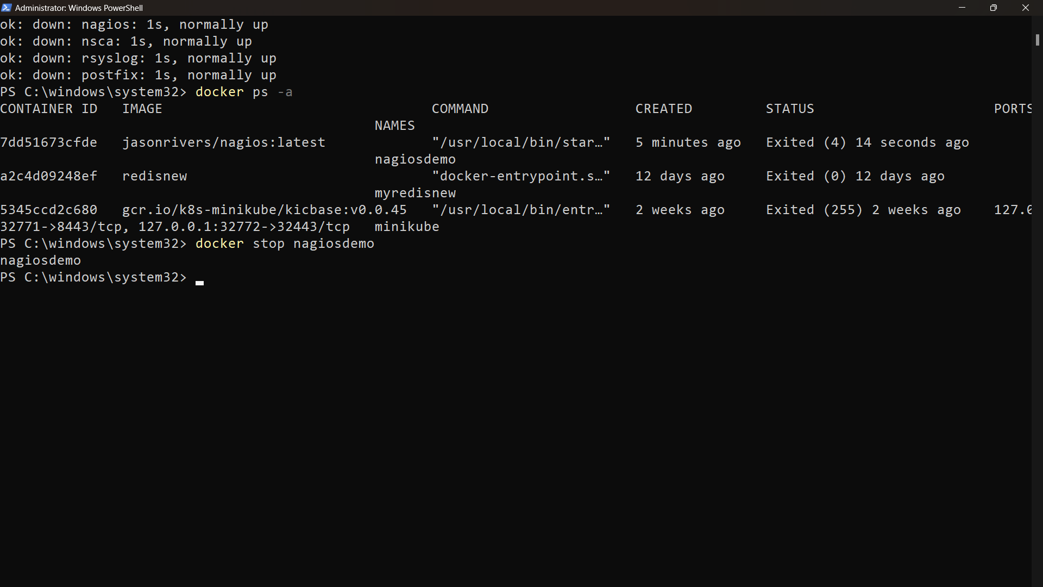

**Step 2: Deleting the Nagios Container**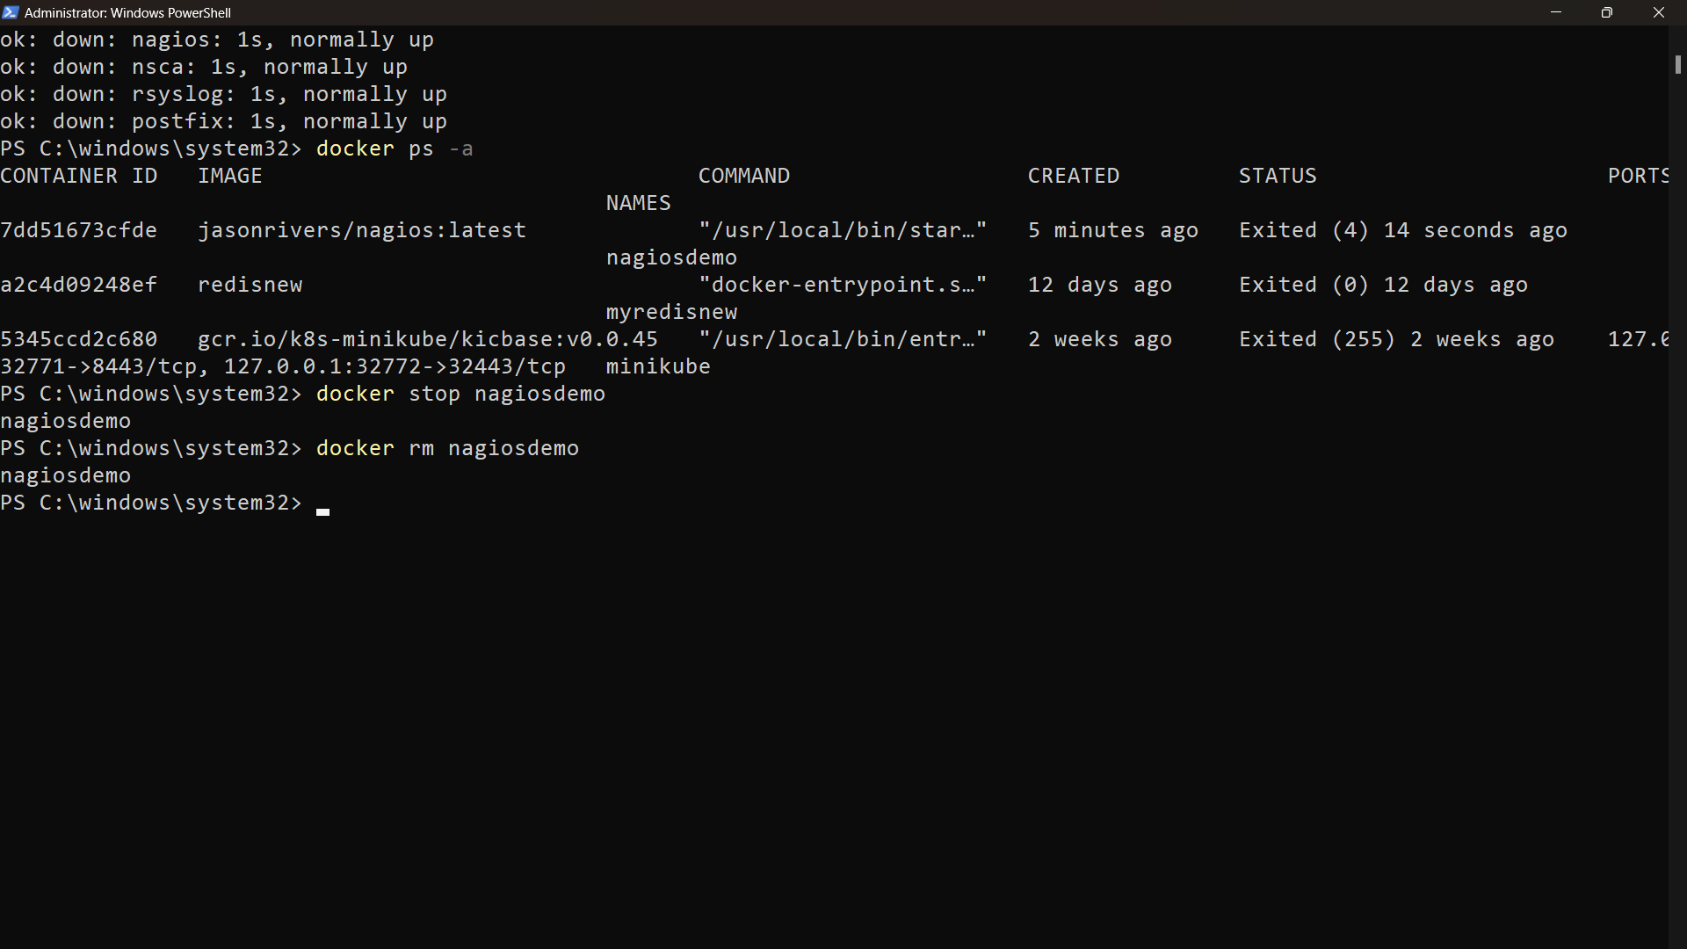

**Step 3: Deleting the Nagios Image**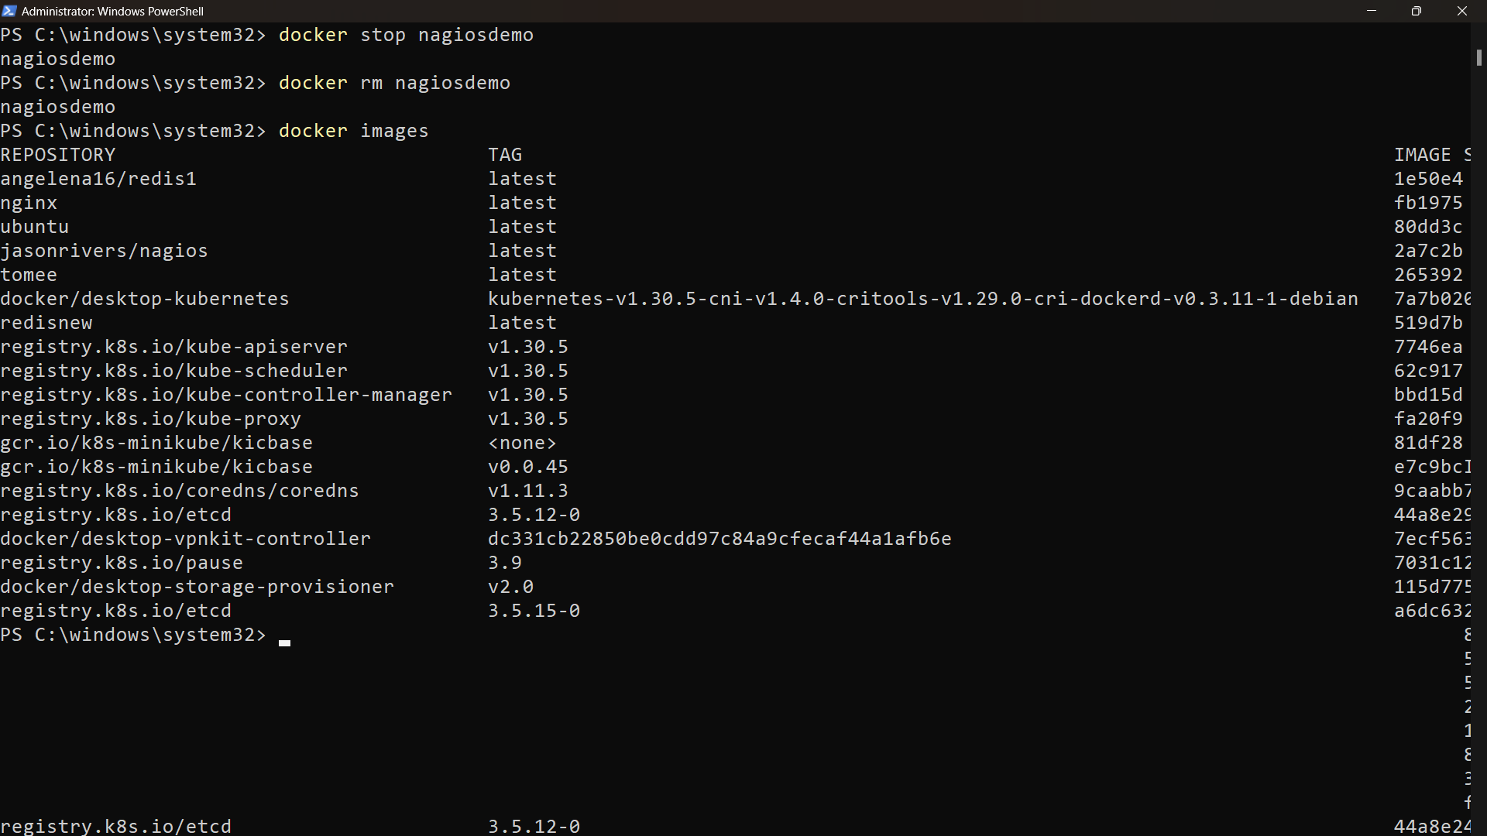

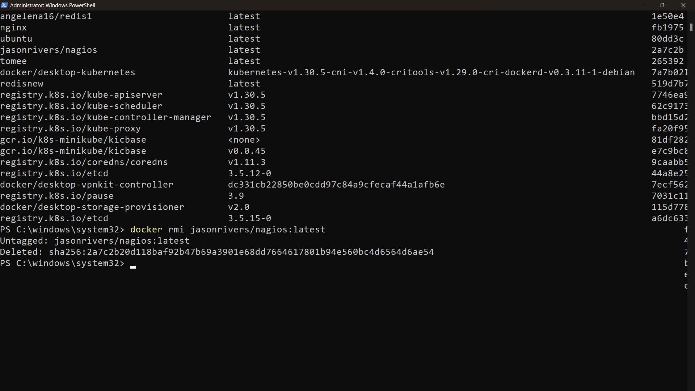

**AND THAT’S IT!!!!**