

A Mini Project Synopsis on
"BLOOD BANK MANAGEMENT SYSTEM"

Submitted
In partial fulfilment of the requirement for the VI Semester of Bachelor of Technology in Computer Science and Engineering of the academic year 2019-20

Submitted By

SNEHASISH BANIK (R17CS403)
TV POONAM (R17CS426)
SRIYANSH GHOSH (R17CS410)

Mini Project Group ID: G12
Section: G

Under the guidance of:

Prof. Laxmi Jayannavar

School of C & IT, REVA University

REVA UNIVERSITY
School of Computing and Information Technology
Bengaluru-560064

ABSTRACT

The purpose of blood bank management system is to automate the existing manual system by the help of computerized equipment and full fledged computer software, fulfilling their requirements so that their valuable data can be stored for a longer period with easy accessing and manipulation of the same. Blood bank management system can lead to error free, secure, reliable and fast management system. The organization can maintain computerized records without redundant entries. That means that one need not be distracted by information that is not relevant, while being able to reach the information. The aim is to automate its existing manual system by the help of computerized equipment.

Introduction:

The "Blood Bank Management System" has been developed to override the problems prevailing in the practicing manual system. This software is supported to eliminate and in some cases reduce the hardships faced by this existing system. Moreover this system is designed for the particular need of the company to carry out operations in a smooth and effective manner. The application is reduced as much as possible to avoid errors while entering the data. It also provides error message while entering invalid data. No formal knowledge is needed for the user to use this system. Thus by this all it proves it is user-friendly. Blood Bank Management System as described above, can lead to error free, secure, reliable and fast management system. It can assist the user to concentrate on their other activities rather to concentrate on the record keeping. Thus it will help organization in better utilization of resources.Every organization, whether big or small, has challenges to overcome and managing the information of Blood Group, Blood Bank, Blood Stock, Record, Blood Cell. Every Blood Bank Management System has different Blood Bank needs, therefore we design exclusive employee management systems that are adapted to your managerial requirements. This is designed to assist in strategic planning, and will help you ensure that your organization is equipped with the right level of information and details for your future goals. Also, for those busy executive who are always on the go, our systems come with remote access features, which will allow you to manage your workforce anytime, at all times. These systems will ultimately allow you to better manage resources.

LITERATURE SURVEY

There are three systems that have been selected as benchmark for the development of BBMS. They are the Blood Bank India(BBI) at http://www.bloodbankindia.net, Lions Blood Bank & Research Foundation(LBBRF) from http://www.lionsbloodbank.net/ and a previous BBMS standalone version. The website for Blood Bank India is a website that provides the facility for the donor to register by him or herself as a blood donor. Only citizen in India can register to the system. It also provides a feature where a person or hospital can request the blood bag or blood stock from the Blood Bank India.

OBJECTIVES

- Collecting blood group informations
Functionalities:

- It tracks all the information of Blood Group, Record, Blood Stock etc
- Manage the information of Blood Group
- Shows the information and description of the Blood Bank, Donor
- To increase efficiency of managing the Blood Bank, Blood Group
- It deals with monitoring the information and transactions of Blood Stock.
- Manage the information of Blood Bank
- Editing, adding and updating of Records is improved

SYSTEM REQUIREMENTS
.

Software Requirements | Hardware Requirements
Windows OS/linux | System : intel core i3
Microsoft visual studio.Net 2005 | Hard disc : 500GB
.NET / SQL server2000 | RAM : 8GB

EXPECTED IMPLEMENTATION METHOD
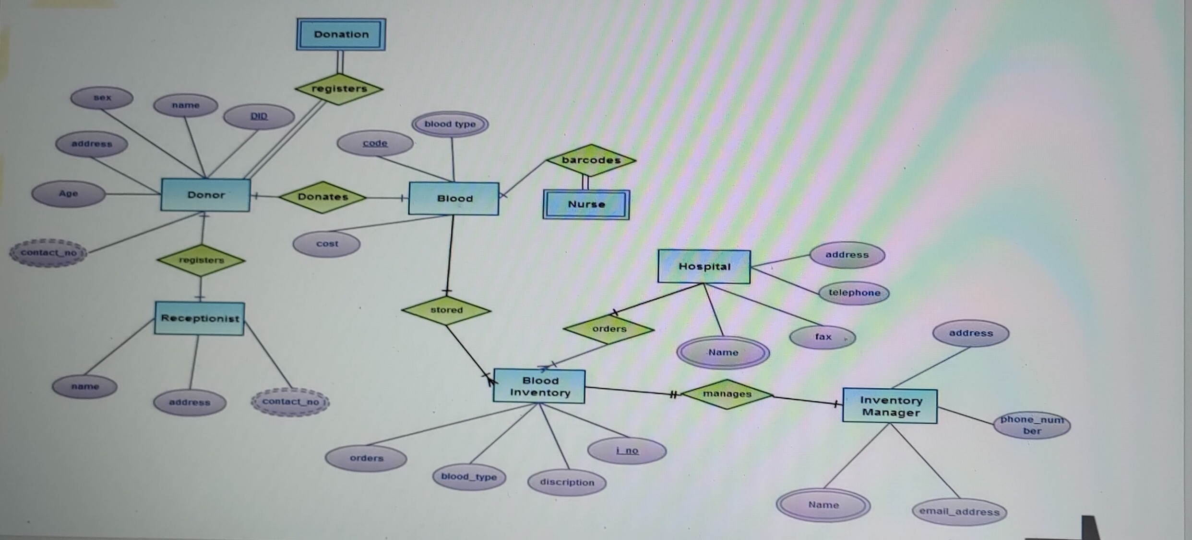
Figure: ER diagram

EXPECTED NEW APPLICATIONS

- Security of data
- Ensure data accuracy
- Better service
- User friendliness
- Interactive
- Minimum time required
- Minimize manual data entry

Features:
- Product and Component based
- Creating & Changing Issues at ease
- Query Issue List to any depth
- Reporting & Charting in more comprehensive way
- User Accounts to control the access and maintain security
- Simple Status & Resolutions
- Multi-level Priorities & Severities.
- Targets & Milestones for guiding the programmers
- Attachments & Additional Comments for more information
- Robust database back-end
- Various level of reports available with a lot of filter criteria’s
- It contain better storage capacity.
- Accuracy in work.
- Easy & fast retrieval of information.
- Well designed reports.
- Decrease the load of the person involve in existing manual system.
- Access of any information individually.
- Work becomes very speedy.
- Easy to update information

CONCLUSION

Our project is only a humble venture to satisfy the needs to manage their project work. Several user friendly coding have also adopted. This package shall prove to be a powerful package in satisfying all the requirements of the school. The objective of the software planning is to provide a framework that enables the manager to make reasonable estimates made within a limited time frame.

REFERENCE

Google for problem solving
Database Programming with PHP
https://www.tutorialspoint.com/
http://www.wampserver.com/en/
http://www.tutorialspoint.com/mysql/
IEEE papers

