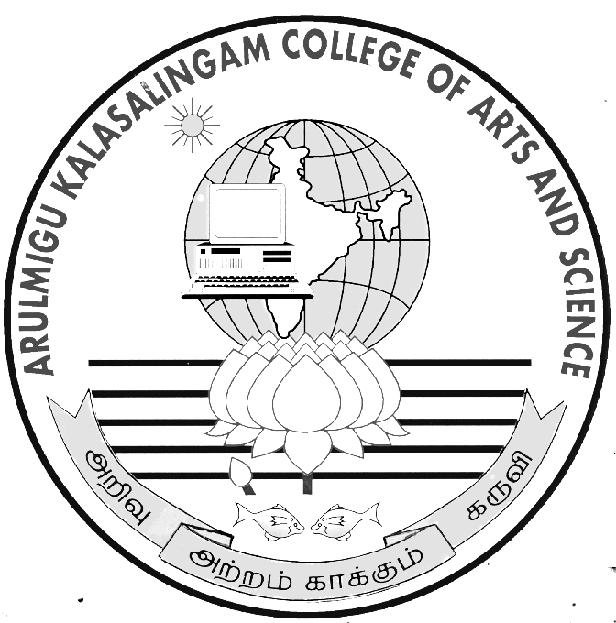
ARULMIGU
KALASALINGAM COLLEGE OF ARTS & SCIENCE
ANAND NAGAR,KRISHNANKOIL-626 126.
Srivilliputtur (Via), Virudhunagar District, Tamil Nadu.

Department Of ___________________________________

BONAFIDE CERTIFICATE

Bonafide record of work done by__________________________________

of_____________in ________________________________________

during in academic year 2022 - 2023.

Staff-incharge Head of the Department
Submitted to the Practical Examination held at A.K.College of Arts & Science, Krishnankoil on ------------------------------------

REGISTER NUMBER:

Internal Examiner External Examiner

