Project - High Level Design
on ProjectTitle
  - Course Name: DevOps Foundations

Institution Name: Medicaps University

Student Name(s) & Enrolment Number(s):
Sr no | Student Name | Enrolment Number
1. | Srijan Nigam | EN22CS301984
2. | Suhani Sharma | EN22CS301991
3. | Soumya Soni | EN22CS301979
4. | Sujal Ambeldkar | EN22CS301993
5. | Taha Millwala | EN22CS3011011

Group Name: D0-13
Project Number: 13D9
Industry Mentor Name: Mr. Vaibhav
University Mentor Name: Dr. Ritesh Joshi
Academic Year: 2026-2027

Table of Contents
- Introduction.
  - Scope of the document.
  - Intended Audience
  - System overview.
- System Design.
  - Application Design
  - Process Flow.
  - Information Flow.
  - Components Design
  - Key Design Considerations
  - API Catalogue.
- Data Design.
  - Data Model
  - Data Access Mechanism
  - Data Retention Policies
  - Data Migration
- Interfaces
- State and Session Management
- Caching
- Non-Functional Requirements
  - Security Aspects
  - Performance Aspects
- References

Introduction.
The Energy Consumption Tracker is a web-based application designed to monitor and analyze daily energy consumption patterns. Users can log appliance usage, track monthly consumption, and calculate electricity bills. The project demonstrates professional CI/CD pipeline implementation using GitHub Actions, Docker containerization, and AWS EC2 deployment with automated testing, security scanning, and multi-environment deployment strategies (Staging and Production).

Scope of the document.
This document provides high-level architectural design for the Energy Consumption Tracker application. It covers system architecture, component design, data models, API specifications, CI/CD pipeline implementation, deployment strategy, and non-functional requirements including security and performance aspects.

Intended Audience
This document is intended for development teams, DevOps engineers, system administrators, QA teams, project stakeholders, and academic faculty evaluating the project.

System overview.
The system implements a three-tier web application architecture with Flask backend, Jinja2 templating for frontend, and SQLite database. The application is containerized using Docker and deployed on a single AWS EC2 t2.micro instance hosting both staging (port 5001) and production (port 5000) environments. GitHub Actions automates the CI/CD pipeline including linting, security scanning, unit testing, Docker image building, and deployment with automated rollback capabilities.

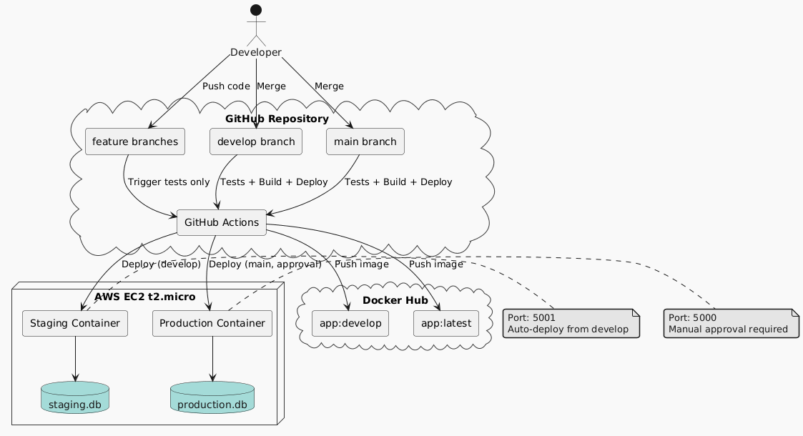

System Design.

Application Design
The application follows Model-View-Controller (MVC) pattern. The View layer uses Jinja2 templates for HTML rendering with CSS and JavaScript for styling and client-side validation. The Controller layer consists of Flask routes handling HTTP requests, form validation, and business logic orchestration. The Model layer uses SQLAlchemy ORM for database interactions with two main entities: energy_entries and billing_rates.
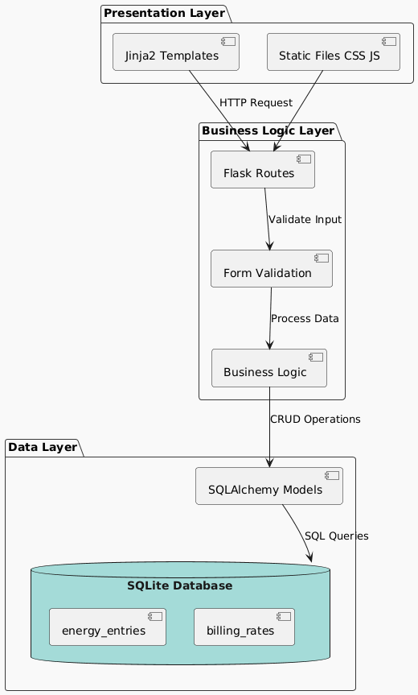

Process Flow.
User workflow: Access homepage → Display entry form → Enter appliance data (name, watts, hours) → Validate input → Calculate kWh → Save to database → Navigate to dashboard → Retrieve monthly data → Calculate total consumption and bill → Display results.
CI/CD workflow: Developer commits code → GitHub Actions triggers → Execute linting, security scan, unit tests → On develop branch: Build Docker image, push to registry, deploy to staging → On main branch: Require manual approval, deploy to production → Run health checks → Automatic rollback if health check fails.
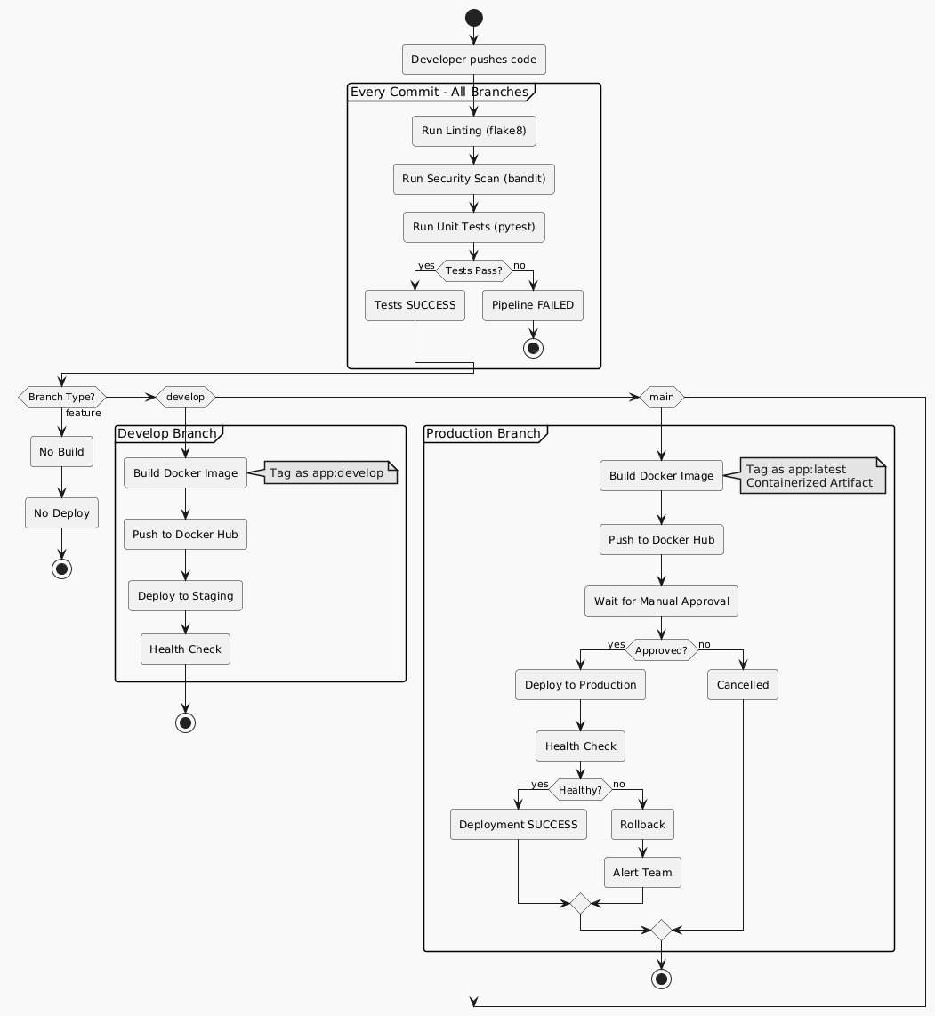

Information Flow.
Data Entry Flow: User Input → Form Validation → Energy Calculation (kWh = watts × hours ÷ 1000) → Database Storage → Confirmation Response

Dashboard Flow: User Request → Extract month/year parameters → Database Query with filters → Aggregate consumption → Calculate bill (Total kWh × rate_per_kwh) → Render template → HTML Response

Deployment Flow: Code Commit → GitHub → GitHub Actions → Docker Build → Docker Hub → EC2 SSH → Container Update → Health Check → User Traffic

Components Design
Frontend Components: Base template (Jinja2) provides header, footer, navigation. Entry form (HTML/CSS) handles appliance data input with validation. Dashboard view (Jinja2/JS) displays monthly data and calculations.

Backend Components: Flask application handles HTTP routing. SQLAlchemy models manage data persistence. WTForms provides input validation. Business logic layer performs calculations. Health check endpoint monitors application status.

Infrastructure Components: Docker Engine provides container runtime. Staging container (port 5001) for testing. Production container (port 5000) for live serving. GitHub Actions automates CI/CD. Docker Hub stores images. AWS EC2 t2.micro hosts both environments.

Key Design Considerations
Scalability: SQLAlchemy abstraction allows future database migration. Containerized architecture supports Kubernetes orchestration if scaling required.

Reliability: Automated health checks post-deployment. Failed deployments trigger automatic rollback. Staging environment reduces production failures. Database transactions ensure data consistency.

Maintainability: PEP 8 compliance enforced by linting. MVC separation facilitates parallel development. 80%+ test coverage enables confident refactoring. Docker ensures environment consistency.

Cost Optimization: Single EC2 t2.micro (free tier). Docker provides isolation without additional cost. GitHub Actions free for public repos. SQLite eliminates database hosting costs.

Security: Input validation prevents injection attacks. GitHub Secrets store credentials. SSH key authentication. Automated security scanning (bandit). Security Groups restrict network access.

API Catalogue.
The application exposes the following HTTP endpoints:

Endpoint | Method | Parameters | Response | Description
/ | GET | None | HTML form | Display daily entry form
/ | POST | appliance, watts, hours, date | Redirect | Save energy entry
/dashboard | GET | month, year | HTML dashboard | Display monthly data and bill
/health | GET | None | JSON status | Health check endpoint

Health Check Response Example:
{
"status": "healthy",
"timestamp": "2026-02-18T10:30:00Z",
"database": "connected"
}

Data Design.

Data Model
The system uses two primary database tables in SQLite:
Table: energy_entries
Column | Type | Constraints | Description
id | INTEGER | PRIMARY KEY | Unique identifier
appliance | TEXT | NOT NULL | Appliance name
watts | INTEGER | NOT NULL, > 0 | Power rating in watts
hours | FLOAT | NOT NULL, > 0 | Usage duration
date | DATE | NOT NULL | Entry date
created_at | TIMESTAMP | DEFAULT NOW | Creation timestamp

Table: billing_rates
Column | Type | Constraints | Description
id | INTEGER | PRIMARY KEY | Unique identifier
rate_per_kwh | FLOAT | NOT NULL, > 0 | Cost per kWh
updated_at | TIMESTAMP | DEFAULT NOW | Update timestamp

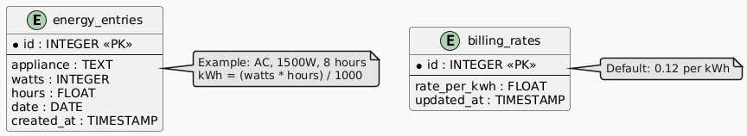

Data Access Mechanism

SQLAlchemy ORM provides abstraction between application and database. Features include automatic SQL generation, connection pooling, transaction management with commit/rollback, SQL injection protection through parameterized queries, and support for future database migration from SQLite to PostgreSQL/MySQL.

Data Retention Policies
Energy entries: Retained indefinitely for historical trend analysis. Application logs: Retained for 30 days for debugging and audit trail.

Data Migration
Database schema changes managed through Flask-Migrate (Alembic). Each migration includes upgrade and downgrade scripts. Migrations are version-controlled and applied automatically during deployment. Staging environment tests migrations before production application.

Interfaces
User Interface: Web-based responsive interface accessible via modern browsers. No authentication required. Mobile-responsive design.

External Interfaces: Docker Hub API (REST) for image push/pull. GitHub API (REST) for webhooks. AWS EC2 SSH for remote management.

Internal Interfaces: Application ↔ Database via SQLAlchemy ORM. GitHub Actions ↔ EC2 via SSH. Docker Engine ↔ Containers via Docker API.

State and Session Management
The application is stateless with no user sessions or authentication. Each HTTP request is independent. Form data validated and stored immediately without session dependency. This simplifies horizontal scaling and eliminates session synchronization complexity. Future enhancement: Add Flask-Login for multi-user support.

Caching
Current implementation has no caching layer due to small dataset size, frequently changing data, and sufficient SQLite query performance. Future enhancement: Implement Redis caching for monthly aggregations if user base grows significantly. Dashboard queries are candidates for caching with 1-hour TTL.

Non-Functional Requirements

Security Aspects
Aspect | Implementation | Tool
Credentials | GitHub Secrets | GitHub
Authentication | SSH keys only | OpenSSH
Network | Security Groups | AWS
Input Validation | Form sanitization | WTForms
Dependencies | Vulnerability scan | safety
Code Security | Static analysis | bandit
SQL Injection | Parameterized queries | SQLAlchemy
Container | Non-root user | Docker

Performance Aspects
Metric | Target | Method
Page Load | < 2 seconds | Browser DevTools
API Response | < 500ms | Flask logging
DB Query | < 100ms | SQLAlchemy
Docker Build | < 3 minutes | GitHub Actions
Deployment | < 5 minutes | GitHub Actions

Resource Utilization (EC2 t2.micro): RAM 1GB available, ~200MB used by both containers, ~800MB headroom. CPU 1 vCPU, ~10-20% used, ~80-90% headroom. Disk 20GB, ~5GB used, ~15GB headroom.

References
1. Flask Documentation: https://flask.palletsprojects.com/
2. Docker Documentation: https://docs.docker.com/
3. GitHub Actions: https://docs.github.com/actions
4. AWS EC2: https://docs.aws.amazon.com/ec2/
5. SQLAlchemy: https://docs.sqlalchemy.org/
6. Python PEP 8: https://peps.python.org/pep-0008/
7. OWASP Security: https://owasp.org/
8. DevOps Handbook
9. Continuous Delivery by Humble & Farley

