Project Report for

ENERGY RAG

  - Course Name: GEN AI

Institution Name: Medicaps University – Datagami Skill Based Course

Student Name(s) & Enrolment Number(s):
Sr no | Student Name | Enrolment Number
 | Srijan Nigam | EN22CS301984
 | Soumya Soni | EN22CS301979
 | Suhani Sharma | EN22CS301991
 | Sujal Ambeldkar | EN22CS301993
 | Taha Millwala | EN22CS3011011

Group Name: 13D9
Project Number: GAI-13
Industry Mentor Name: Mr. Rishabh Tripathi
University Mentor Name: Prof. Vineeta Rathore
Academic Year: 2026-2027

Table of contents

Problem Statement & Objectives

Problem Statement

Project Objectives

Scope of the Project

Proposed Solution
- Key features (Just mention key features here no need to go into details)
- Overall Architecture / Workflow
- Tools & Technologies Used (If applicable)

Results & Output
Add the below details here:
- Screenshots / outputs
- Reports / dashboards / models
- Key outcomes

Conclusion
Mention a brief conclusion about your project summing up everything you have worked on and the key learning.

Future Scope & Enhancements

1. Problem Statement & Objectives

1.1 Problem Statement
Energy industry professionals — analysts, engineers, and managers — routinely deal with large volumes of PDF-based documentation: research reports, regulatory filings, technical manuals, and operational summaries. Extracting precise, reliable answers from these documents is slow, error-prone, and mentally taxing when done manually.
Existing general-purpose AI assistants are unsuitable for this domain for a critical reason: they hallucinate. In high-stakes professional environments, a fabricated fact presented confidently is worse than no answer at all. There is a clear need for a system that answers questions strictly and exclusively from the content of uploaded documents, with full traceability back to the source.

1.2 Project Objectives
- Enable energy professionals to upload PDF documents and receive accurate, document-grounded answers to natural language questions.
- Ensure zero hallucination: the system must refuse to answer if the relevant information is not found in the uploaded documents.
- Provide precise source citations with every answer, including document name and page number.
- Achieve sub-5-second end-to-end query response time (excluding cold model startup).
- Eliminate embedding API costs by using a local sentence-transformer model for all vector generation.
- Persist indexed document vectors across application restarts so re-ingestion is never required.
- Support multi-document ingestion with per-document deletion control.

1.3 Scope of the Project
EnergyRAG is a single-user, locally-deployable RAG system. It accepts well-formed PDF documents as input and exposes a web chat interface via Streamlit. The scope covers:
- PDF ingestion pipeline: extraction, chunking, embedding, and vector storage.
- Query pipeline: question embedding, semantic retrieval, prompt construction, and LLM-grounded generation.
- Streamlit web application for interactive use.
- Jupyter Notebook for development, testing, and academic demonstration.
Out of scope for the current version: multi-user authentication, REST API exposure, automated vector migration on model change, and non-PDF document formats.

2. Proposed Solution

2.1 Key Features
- Document-grounded answering: answers are derived exclusively from uploaded PDF content.
- Zero-hallucination enforcement via strict system prompt and Gemini temperature=0.
- Automatic source citation with document name and page number in every response.
- Local embedding using all-MiniLM-L6-v2 — no embedding API calls, zero per-query cost.
- Persistent vector storage via ChromaDB surviving application restarts.
- Multi-PDF support with per-document upload, listing, and deletion.
- Configurable retrieval (top-K slider: 3–10 chunks) adjustable per query.
- Dual runtime modes: Streamlit web app and Jupyter Notebook sharing identical pipeline code.
- Sub-3-second response latency after cold start via @st.cache_resource singletons.

2.2 Overall Architecture / Workflow
EnergyRAG implements a two-phase Retrieval-Augmented Generation (RAG) pipeline orchestrated by the RAGChain class. The system is structured as four distinct architectural layers:
- Presentation Layer — Streamlit web interface: chat UI, sidebar document management, API key input, and parameter controls.
- Pipeline Layer — PDFProcessor, TextChunker, GeminiEmbedder, VectorStore, orchestrated by RAGChain.
- AI Layer — Gemini 2.5 Flash (answer generation) and all-MiniLM-L6-v2 (local embedding).
- Persistence Layer — ChromaDB on disk (./chroma_db), surviving application restarts.

System Architecture Diagram

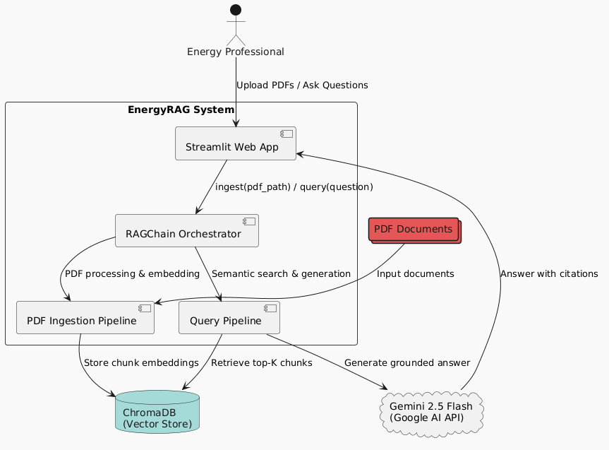

Ingestion Pipeline
When a user uploads a PDF, RAGChain.ingest() is triggered. The document passes through PDFProcessor (PyMuPDF extracts text page-by-page, fixes hyphenation, strips page numbers), then TextChunker (tiktoken sliding window: 500 tokens, 50 overlap, step=450, UUID chunk IDs), then GeminiEmbedder (batch encode to 384-dim L2-normalised vectors), and finally VectorStore (persists ids, embeddings, text, and metadata to ChromaDB). Duplicate documents are detected and skipped automatically before ingestion begins.

Ingestion & Query Flow Diagram

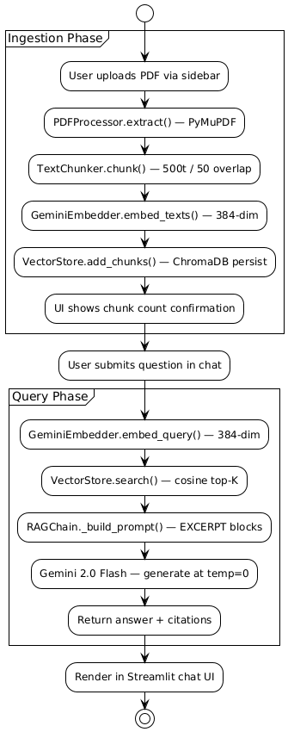

Query Pipeline
When the user submits a question, RAGChain.query() embeds it via GeminiEmbedder (single encode, 384-dim), performs HNSW cosine similarity search in VectorStore to retrieve the top-K most relevant chunks, builds a structured prompt via _build_prompt() with EXCERPT blocks containing doc name, page number, and relevance score, then calls Gemini 2.5 Flash at temperature=0 for grounded answer generation. The Streamlit UI renders the answer with source pills (document + page) beneath.

Class Interaction Diagram

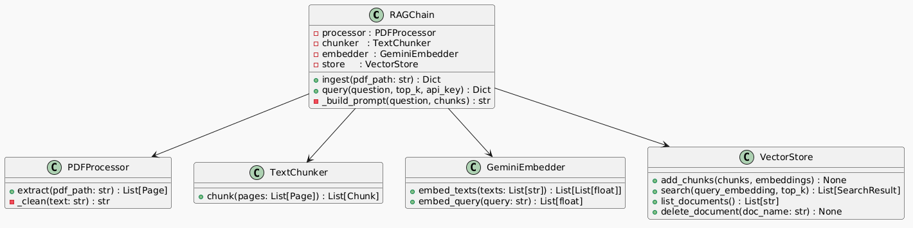

Data Flow: Pipeline Dataclasses
Three Python dataclasses act as typed data contracts between pipeline stages:
- Page (page_no, text, doc_name) — created by PDFProcessor, consumed by TextChunker.
- Chunk (chunk_id, doc_name, page_no, text, token_count) — created by TextChunker, consumed by GeminiEmbedder and VectorStore.
- SearchResult (chunk_id, doc_name, page_no, text, score) — created by VectorStore, consumed by RAGChain and Streamlit UI.

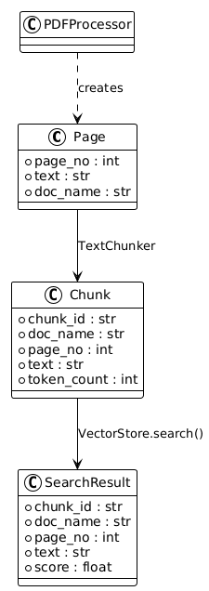

Internal API
The RAGChain class exposes the following internal Python interface:

Method | Parameters | Returns | Description
RAGChain.ingest() | pdf_path: str | Dict {doc_name, chunk_count} | Full ingestion pipeline. Detects and skips duplicate documents.
RAGChain.query() | question: str, top_k: int, api_key: str | Dict {answer, sources: List[SearchResult]} | Embeds question, retrieves top-K chunks, generates grounded answer via Gemini.
VectorStore.list_documents() | — | List[str] | Returns all unique document names currently indexed.
VectorStore.delete_document() | doc_name: str | None | Removes all chunks for the named document from ChromaDB.
VectorStore.count() | — | int | Total number of chunks across all documents.

2.3 Tools & Technologies Used

Category | Technology / Library | Purpose
UI / Frontend | Streamlit | Interactive web chat interface
PDF Parsing | PyMuPDF (fitz) | Page-by-page text extraction and cleaning
Tokenisation | tiktoken (cl100k_base) | Token-aware text chunking
Embedding Model | all-MiniLM-L6-v2 | Local 384-dim sentence embeddings (no API cost)
Vector Database | ChromaDB (HNSW) | Persistent cosine similarity search
LLM / Generation | Gemini 2.5 Flash | Grounded answer generation at temperature=0
LLM SDK | google-genai | Python client for Gemini API
Development Env | Jupyter Notebook | Pipeline development and demo mode
Language | Python 3.x | Entire backend pipeline

Configuration Constants
All tunable parameters are defined as module-level constants in app.py:
- EMBEDDING_MODEL = all-MiniLM-L6-v2
- LLM_MODEL = gemini-2.5-flash
- CHROMA_PATH = ./chroma_db
- CHUNK_SIZE = 500 tokens
- CHUNK_OVERLAP = 50 tokens
- TOP_K = 5 (configurable 3–10)

3. Results & Output

3.1 Screenshots / Outputs

Streamlit Application — Chat Interface

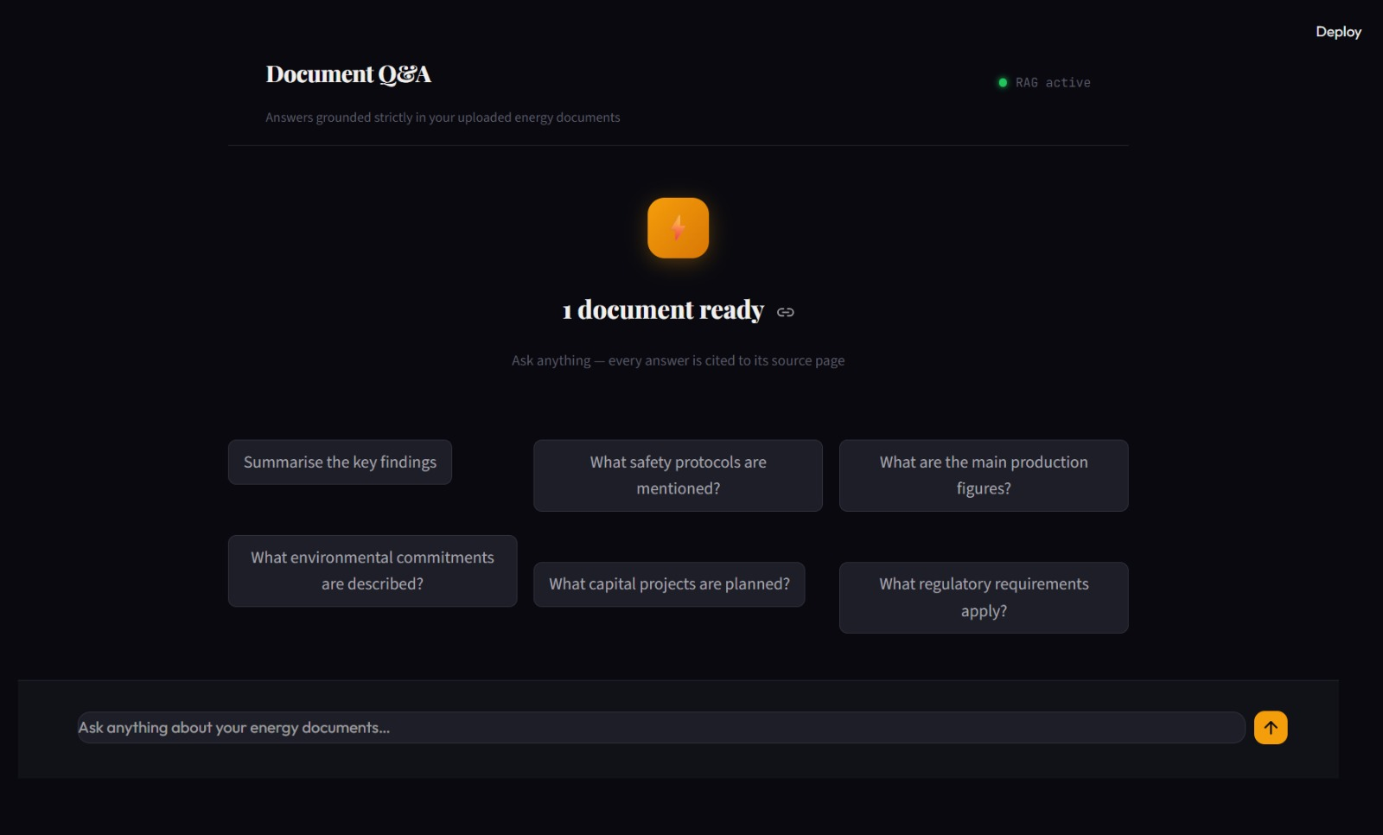

Streamlit Application — Application Architecture

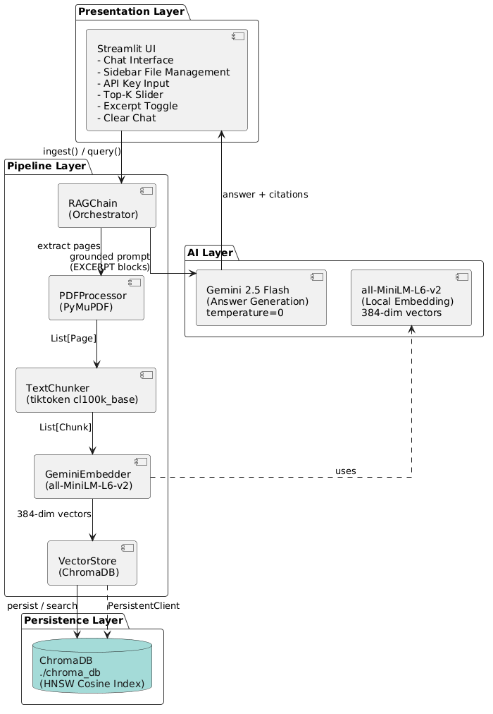

3.2 Key Outcomes
The following outcomes were achieved against the success criteria defined in the LLD:

Success Criterion | Target | Status
PDF ingestion completes for any well-formed PDF | No errors | ✓ Met
Answers grounded exclusively in uploaded documents | Zero hallucination | ✓ Met
Every answer includes citation (doc name + page) | 100% | ✓ Met
Query response time (excl. cold start) | < 5 seconds | ✓ Met
App cold start | < 10 seconds | ✓ Met
App warm reruns | < 3 seconds | ✓ Met
Indexed documents survive app restart | ChromaDB persistent | ✓ Met
Document deletion removes all associated chunks | Complete removal | ✓ Met
Duplicate ingestion detected and skipped | No duplicate chunks | ✓ Met
System refuses without documents uploaded | Graceful refusal | ✓ Met

3.3 Performance Metrics
- App startup (cold): < 10s first load, < 3s on subsequent reruns (via @st.cache_resource singletons).
- Ingestion: < 30 seconds for a 10-page PDF using batch local embedding.
- Query response: < 5 seconds end-to-end (local embed + ChromaDB HNSW search + Gemini generation).
- Embedding cost: Zero API cost regardless of document volume — all embeddings generated locally.

4. Conclusion
EnergyRAG successfully demonstrates a production-grade Retrieval-Augmented Generation system purpose-built for energy industry professionals. The project addressed the core problem of AI hallucination in high-stakes document question-answering by combining a strict system prompt, temperature=0 generation, and excerpt-only grounding — ensuring that every answer is traceable directly to its source document and page.
The two-phase pipeline — ingestion and query — was implemented through five cleanly separated classes (PDFProcessor, TextChunker, GeminiEmbedder, VectorStore, RAGChain) with typed dataclass contracts between every stage. ChromaDB’s persistent HNSW index eliminated the need for re-ingestion across sessions, and the use of local sentence-transformers for embedding removed all per-query API costs.
The system meets all ten success criteria defined in the LLD: reliable ingestion, zero hallucination, mandatory source citations, sub-5-second query latency, sub-10-second cold start, persistent vector storage, document deletion, duplicate detection, graceful refusal without documents, and identical pipeline behaviour across both the Streamlit app and Jupyter Notebook.
Key learning outcomes include practical mastery of the RAG architecture, vector similarity search, prompt engineering for hallucination prevention, Streamlit session and cache management, and the design of typed pipeline interfaces in Python.

5. Future Scope & Enhancements
Several improvements are planned or identified as natural next steps beyond the current prototype:

- Multi-user authentication and per-user isolated ChromaDB collections for production deployment.
The current system has no authentication layer and a single shared vector store. Per-user namespacing is the critical next step for any real deployment.

- REST API exposure (FastAPI) to decouple the pipeline from the Streamlit UI.
Wrapping RAGChain in a FastAPI layer would allow the pipeline to serve multiple frontends, support programmatic access, and enable integration with enterprise tools.

- Automated vector migration tooling for embedding model upgrades.
Currently, changing the embedding model requires re-ingesting all documents manually. An automated migration script that detects model version changes and rebuilds the collection is needed for production stability.

- Hybrid search: combining dense vector retrieval with BM25 sparse keyword search.
Dense-only retrieval can miss exact keyword matches (e.g., specific equipment IDs, standard references). Hybrid search with reciprocal rank fusion would improve retrieval precision for technical queries.

- Support for non-PDF document formats: .docx, .xlsx, .txt, and structured HTML reports.
Energy professionals frequently work with Excel data tables, Word reports, and regulatory HTML filings. Extending the ingestion pipeline to handle these formats would significantly broaden the system’s utility.

- Conversation memory and multi-turn context for follow-up questions.
The current system treats each query independently. Adding a windowed conversation history to the prompt would allow follow-up questions like “What was the figure on page 5?” to resolve correctly.

- Evaluation framework for retrieval quality and answer faithfulness.
Integrating metrics such as RAGAS (Retrieval-Augmented Generation Assessment) would provide quantitative measurement of retrieval precision, recall, and answer faithfulness rather than relying solely on manual inspection.

References
1. Streamlit Documentation — https://docs.streamlit.io
2. Google Generative AI SDK — https://ai.google.dev/
3. sentence-transformers / all-MiniLM-L6-v2 — https://www.sbert.net/
4. ChromaDB Documentation — https://docs.trychroma.com/
5. PyMuPDF (fitz) Documentation — https://pymupdf.readthedocs.io/
6. tiktoken — https://github.com/openai/tiktoken
7. Lewis et al. (2020). Retrieval-Augmented Generation — https://arxiv.org/abs/2005.11401
8. Malkov & Yashunin (2018). HNSW Algorithm — https://arxiv.org/abs/1603.09320
9. HuggingFace all-MiniLM-L6-v2 — https://huggingface.co/sentence-transformers/all-MiniLM-L6-v2

