Project - High Level Design
on EnergyRAG
  - Course Name: Gen AI

Institution Name: Medicaps University – Datagami Skill Based Course

Student Name(s) & Enrolment Number(s):
Sr no | Student Name | Enrolment Number
 | Srijan Nigam | EN22CS301984
 | Soumya Soni | EN22CS301979
 | Suhani Sharma | EN22CS301991
 | Sujal Ambeldkar | EN22CS301993
 | Taha Millwala | EN22CS3011011

Group Name: 13D9
Project Number: GAI-13
Industry Mentor Name: Mr. Rishabh Tripathi
University Mentor Name: Prof. Vineeta Rathore
Academic Year: 2026-2027

Table of Contents
- Introduction.
  - Scope of the document.
  - Intended Audience
  - System overview.
- System Design.
  - Application Design
  - Process Flow.
  - Information Flow.
  - Components Design
  - Key Design Considerations
  - API Catalogue.
- Data Design.
  - Data Model
  - Data Access Mechanism
  - Data Retention Policies
  - Data Migration
- Interfaces
- State and Session Management
- Caching
- Non-Functional Requirements
  - Security Aspects
  - Performance Aspects
- References

1. Introduction
EnergyRAG is a Retrieval-Augmented Generation (RAG) system designed for energy industry professionals — analysts, engineers, and managers. It enables users to upload PDF documents (reports, manuals, filings) and ask natural language questions, receiving accurate, document-grounded answers with full source citations. The system is strictly constrained: it never fabricates information outside the provided documents, ensuring reliability in high-stakes professional environments.
1.1 Scope of the Document
This document provides the high-level architectural design for EnergyRAG. It covers the two-phase pipeline (ingestion and query), component design, data flow, technology stack, non-functional requirements, and key design decisions. Both runtime modes — Streamlit web application and Jupyter Notebook — share the same core pipeline and are described within this document.
1.2 Intended Audience
This document is intended for the following audiences:
- ML Engineers and Backend Developers — for implementation and integration guidance
- Data Scientists — for understanding the embedding and retrieval pipeline
- DevOps Teams — for deployment and infrastructure planning
- System Architects — for architectural review and design decisions
- QA Teams — for test planning and non-functional requirement validation
- Project Stakeholders and Academic Faculty — for evaluating the system design

1.3 System Overview
EnergyRAG operates in two modes sharing identical pipeline code: an offline Jupyter Notebook for development and analysis, and a Streamlit web application for interactive use. The system implements a two-phase architecture — an Ingestion Phase where PDFs are processed, chunked, embedded, and persisted; and a Query Phase where user questions are embedded, matched via cosine similarity, and answered by a grounded LLM.

Figure 1 — System Architecture Overview

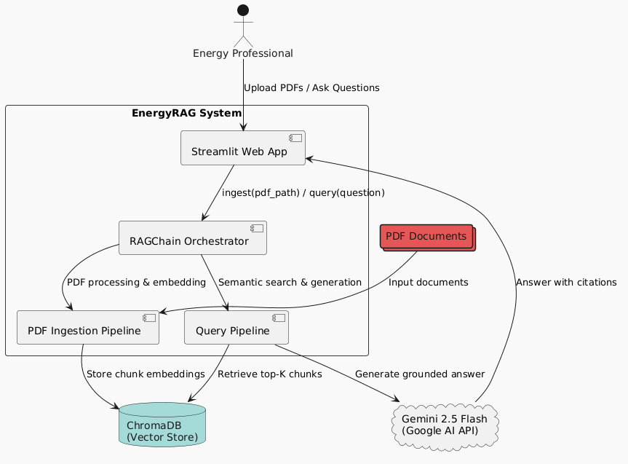

2. System Design
2.1 Application Design
EnergyRAG follows a layered pipeline architecture with four distinct layers:
- Presentation Layer: The Streamlit interface providing chat UI, sidebar file management, API key input, and configurable parameters.
- Pipeline Layer: Contains PDFProcessor, TextChunker, GeminiEmbedder, and VectorStore, orchestrated by RAGChain.
- AI Layer: Comprises Gemini 2.5 Flash for answer generation and all-MiniLM-L6-v2 for local embedding.
- Persistence Layer: ChromaDB on disk, surviving application restarts.

Figure 2 — Application Layer Design

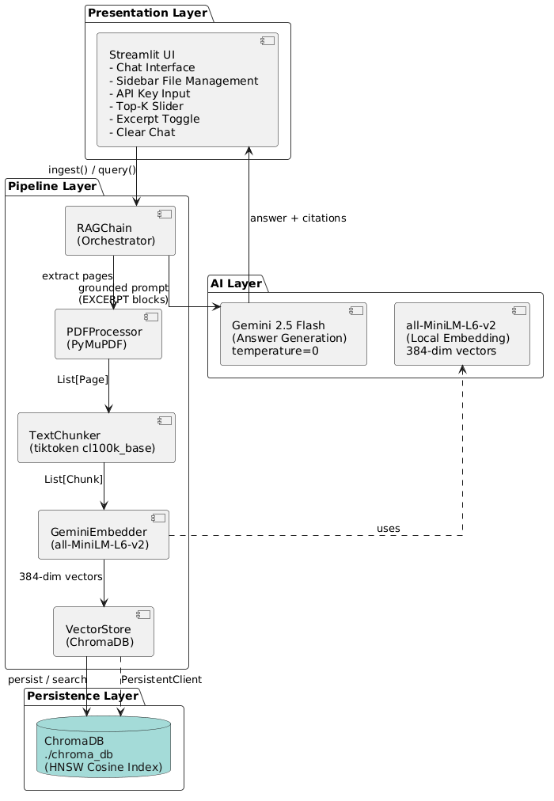

2.2 Process Flow
Ingestion
User uploads PDF → RAGChain.ingest() called → PDFProcessor extracts text page-by-page → TextChunker creates 500-token windows (50 overlap) → GeminiEmbedder generates 384-dim
L2-normalised vectors → VectorStore persists to ChromaDB → UI shows chunk count. Duplicate documents are skipped automatically.

Query
User types question → RAGChain.query() called → GeminiEmbedder embeds question (384-dim) → VectorStore cosine search returns top-K chunks → RAGChain._build_prompt() formats EXCERPT blocks with doc name, page, and relevance score → Gemini 2.5 Flash at temperature=0 generates cited answer → Streamlit renders answer with source pills.
Figure 3 — Ingestion and Query Process Flow
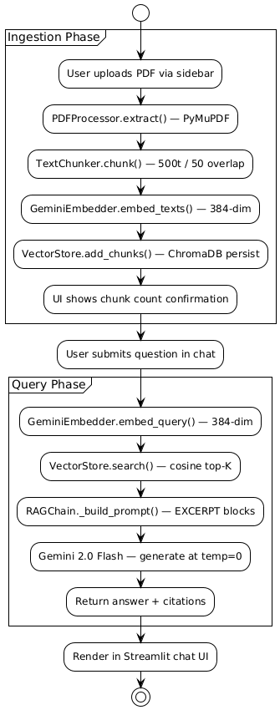

2.3 Information Flow
Ingestion:
PDF Upload → PyMuPDF extraction → token chunking → local embedding → ChromaDB storage → confirmation message.
Query:
User question → embedding (384 floats) → top-K SearchResult objects → grounded prompt string → Gemini generation → answer with citations.
Cache:
@st.cache_resource singletons for embedder (~3–8s cold), tokenizer (~0.5s), and vector store (~0.3s) — initialised once at startup, reused across all reruns.

2.4 Components Design
Pipeline Components
PDFProcessor
Uses PyMuPDF (fitz) for page-by-page text extraction. Cleans output by fixing hyphenation, collapsing whitespace, and stripping page numbers. Skips blank pages. Returns List[Page].
TextChunker
Loads tiktoken cl100k_base. Applies sliding window of 500 tokens with 50-token overlap (step = 450). Short pages become a single chunk. Generates UUID-based chunk IDs. Returns List[Chunk].
GeminiEmbedder
Wraps all-MiniLM-L6-v2 from sentence-transformers. Loaded once via @st.cache_resource. Supports batch encoding for ingestion and single encoding for queries. All vectors are L2-normalised to 384 dimensions.
VectorStore
Wraps ChromaDB PersistentClient with HNSW cosine index. Supports add_chunks, search, list_documents, delete_document, and count. Converts cosine distance to score (score = 1 − distance). Persists to ./chroma_db on disk.

RAGChain
The top-level orchestrator. Owns all four pipeline components. Checks for duplicate documents before ingestion. Builds structured prompts from retrieved excerpts annotated with doc name, page number, and relevance score.

Infrastructure Components
Streamlit UI
Sidebar houses API key (password field), multi-PDF uploader, document list with delete, top-K slider (3–10), excerpt toggle, and clear chat. Main area hosts suggestion pills, chat history, and chat input.
Cache Architecture
Three @st.cache_resource singletons (_load_embedder, _load_tokenizer, _load_vectorstore) initialised at startup. Zero re-loading on reruns. Shared across all class instances.

2.5 Key Design Considerations
Consideration | Approach | Benefit
Accuracy | temperature=0, strict system prompt, excerpt-only grounding | No hallucination — answers only from uploaded documents
Performance | @st.cache_resource singletons for all heavy models | Sub-3s startup after cold load, zero reload on reruns
Persistence | ChromaDB PersistentClient on disk | Indexed documents survive application restarts
Cost | Local sentence-transformers, no embedding API calls | Zero embedding cost regardless of document volume
Portability | Pure Python + requirements.txt, no external services except Gemini | Runs locally or on Streamlit Cloud unchanged
Scalability | ChromaDB collection supports multiple documents; per-user path planned | Multiple PDFs supported; future multi-user isolation

2.6 API Catalogue
EnergyRAG does not expose a REST API in its current form. The RAGChain class exposes the following internal Python interface consumed by both the Streamlit UI and Jupyter Notebook:

Method | Parameters | Returns | Description
ingest() | pdf_path: str | Dict | Full ingestion pipeline for a single PDF
query() | question, top_k, api_key | Dict | Full query pipeline, returns grounded answer
list_documents() | None | List[str] | All indexed document names from ChromaDB
delete_document() | doc_name: str | None | Removes all chunks for the given document

Query Response Example:
{
"answer": "Based on the Q3 report, North Sea output reached...",
"sources": [
{ "doc": "NorthSea_Q3.pdf", "page": 4, "score": 0.91 },
{ "doc": "NorthSea_Q3.pdf", "page": 7, "score": 0.87 }
]
}

3. Data Design
3.1 Data Model
Three Python dataclasses act as typed data contracts between pipeline stages:

Dataclass | Fields | Created By | Consumed By
Page | page_no: int, text: str, doc_name: str | PDFProcessor | TextChunker
Chunk | chunk_id: str, doc_name: str, page_no: int, text: str, token_count: int | TextChunker | GeminiEmbedder, VectorStore
SearchResult | chunk_id: str, doc_name: str, page_no: int, text: str, score: float | VectorStore | RAGChain, Streamlit UI

Figure 4 — Data Model: Pipeline Dataclasses

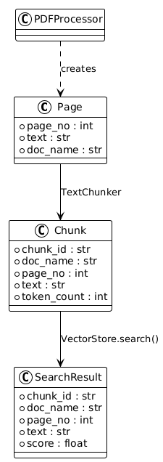

3.2 Data Access Mechanism
ChromaDB PersistentClient is the storage layer. Chunks are stored with:
- ids: UUID strings
- embeddings: 384-dim float vectors
- documents: raw text
- metadata: doc_name, page_no, chunk_id

All reads use HNSW cosine similarity search. Writes are batched per document during ingestion. The _load_vectorstore() singleton ensures a single shared client across all class instances.

3.3 Data Retention Policies
Indexed document chunks are retained indefinitely in ChromaDB until explicitly deleted via the sidebar delete control. Chat history is held in st.session_state and cleared on browser refresh or via Clear Chat. No server-side session state is persisted.

3.4 Data Migration
ChromaDB persists to ./chroma_db on disk. If the embedding model changes, existing vectors become incompatible and the collection must be rebuilt by re-ingesting all documents. No automated migration tooling is implemented in the current version. The chroma_db/ directory must be excluded from version control.

4. Interfaces
User Interface
Web-based chat interface via Streamlit. Accessible on any modern browser. No authentication layer in the current implementation. Sidebar provides document management, parameter controls, and API key input.

External Interfaces
Gemini 2.5 Flash API (Google AI) via REST, authenticated with an API key stored in the sidebar session variable. No external embedding API is called — all embedding is local.

Internal Interfaces
Streamlit UI calls RAGChain.ingest() and RAGChain.query(). RAGChain calls PDFProcessor, TextChunker, GeminiEmbedder, and VectorStore sequentially. GeminiEmbedder calls the locally loaded SentenceTransformer model. VectorStore calls the ChromaDB PersistentClient.

5. State and Session Management
EnergyRAG uses Streamlit's st.session_state for ephemeral per-session state:

Session Key | Type | Description
messages | List[Dict] | Full chat history — user and AI turns
pending_q | str | None | Pre-built suggestion question awaiting submission
api_key | str | Gemini API key entered via sidebar password field
Heavy models (embedder, tokenizer, vector store) are held in @st.cache_resource — not session state — making them global singletons shared across all sessions. Chat history does not persist across browser refreshes.

6. Caching
Three @st.cache_resource singletons are initialised at startup under a single 'Loading AI models...' spinner. All class instances reuse them — zero re-load on reruns.

Singleton Function | What It Loads | Cold Start | Scope
_load_embedder() | SentenceTransformer all-MiniLM-L6-v2 (~90MB) | ~3–8s | Global
_load_tokenizer() | tiktoken cl100k_base encoding | ~0.5s | Global
_load_vectorstore() | ChromaDB PersistentClient + collection | ~0.3s | Global

7. Non-Functional Requirements
7.1 Security Aspects

Aspect | Implementation | Tool / Method
API Key | Stored only in session variable — never logged or persisted | Streamlit password field
No Hallucination | Strict system prompt: answer only from excerpts; refuse if not found | Gemini temperature=0
Input Isolation | Each document stored in its own metadata namespace in ChromaDB | ChromaDB metadata filter
Local Embeddings | No document text sent to any external embedding API | sentence-transformers

7.2 Performance Aspects

Metric | Target | Method
App startup (cold) | < 10s first load, < 3s thereafter | @st.cache_resource singletons
Ingestion | < 30s per 10-page PDF | Batch embedding, local model
Query response | < 5s end-to-end | Local embed + ChromaDB HNSW search
Embedding cost | Zero API cost | Local sentence-transformers

8. References
- Streamlit Documentation — https://docs.streamlit.io/
- Google Generative AI SDK — https://ai.google.dev/
- sentence-transformers (all-MiniLM-L6-v2) — https://www.sbert.net/
- ChromaDB Documentation — https://docs.trychroma.com/
- PyMuPDF (fitz) Documentation — https://pymupdf.readthedocs.io/
- tiktoken — https://github.com/openai/tiktoken
- Lewis et al. (2020). Retrieval-Augmented Generation — https://arxiv.org/abs/2005.11401
- Malkov & Yashunin (2018). HNSW Algorithm — https://arxiv.org/abs/1603.09320

