Project - Low Level Design
on EnergyRAG
  - Course Name: Gen AI

Institution Name: Medicaps University – Datagami Skill Based Course

Student Name(s) & Enrolment Number(s):
Sr no | Student Name | Enrolment Number
 | Srijan Nigam | EN22CS301984
 | Taha Millwala | EN22CS3011011
 | Suhani Sharma | EN22CS301991
 | Soumya Soni | EN22CS301979
 | Sujal Ambeldkar | EN22CS301993

Group Name: Group 13D9
Project Number: GAI-13
Industry Mentor Name:
University Mentor Name: Mrs. Vineeta Rathore
Academic Year: 2026-2027

Table of Contents
- Introduction.
  - Scope of the document.
  - Intended Audience
  - System overview.
- System Design.
  - Application Design
  - Process Flow.
  - Information Flow.
  - Components Design
  - Key Design Considerations
  - API Catalogue.
- References

1. Introduction

1.1 Scope of the Document
This Low Level Design document provides the complete implementation reference for EnergyRAG — a Retrieval-Augmented Generation system built for energy industry professionals. It covers the internal architecture, class-level specifications, data models, caching strategy, prompt design, and UI component behaviour sufficient to implement the system from scratch.

EnergyRAG is considered successfully implemented when all of the following conditions are met:

- PDF ingestion completes without errors for any well-formed PDF document.
- All answers are grounded exclusively in uploaded document content — no hallucinated facts.
- Every answer includes at least one citation with document name and page number.
- Query response time is under 5 seconds end-to-end (excluding cold model start).
- App startup completes within 10 seconds on cold load; subsequent reruns within 3 seconds.
- Indexed documents survive Streamlit app restarts via ChromaDB persistence.
- Document deletion removes all associated chunks from the vector store.
- Duplicate document ingestion is detected and skipped without error.
- System refuses to answer when no documents are uploaded.
- Both Streamlit app and Jupyter Notebook produce identical pipeline results.

1.2 Intended Audience
This document is intended for the following stakeholders:

- Developers responsible for implementing or extending the EnergyRAG pipeline.
- Academic reviewers and university mentors evaluating the technical design.
- Industry mentors assessing architectural decisions and technology choices.
- QA engineers designing test cases against the specified component interfaces and error-handling behaviour.

1.3 System Overview
EnergyRAG is a Retrieval-Augmented Generation (RAG) system for energy industry professionals. Users upload PDF documents and ask natural language questions, receiving grounded answers with precise source citations. The system strictly prohibits fabrication — it answers only from the content of uploaded documents.
The system operates in two runtime modes sharing identical pipeline code: a Streamlit web application for interactive production use, and a Jupyter Notebook for development, analysis, and demos. The core pipeline consists of four components — PDFProcessor, TextChunker, GeminiEmbedder, and VectorStore — orchestrated by the RAGChain class.

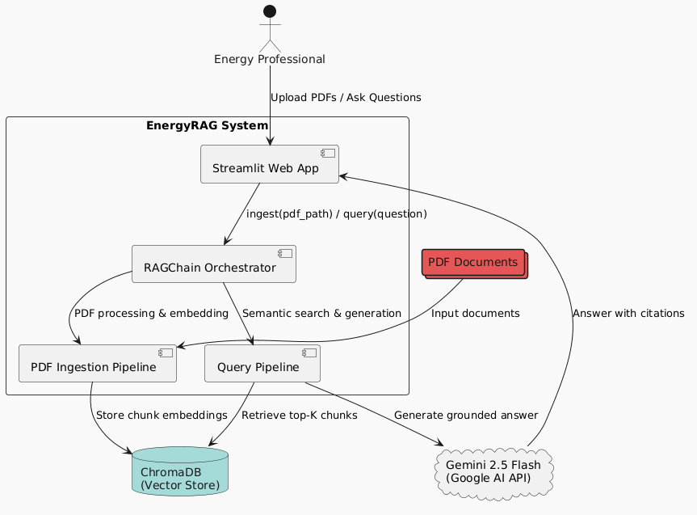
Figure 1 — System Context Diagram

2. System Design

2.1 Application Design
EnergyRAG is structured as a single-file application (app.py) intentionally. All pipeline classes and the Streamlit UI layer are co-located to reduce import complexity for a single-developer prototype. The Jupyter Notebook mirrors the identical pipeline for development and demo purposes.

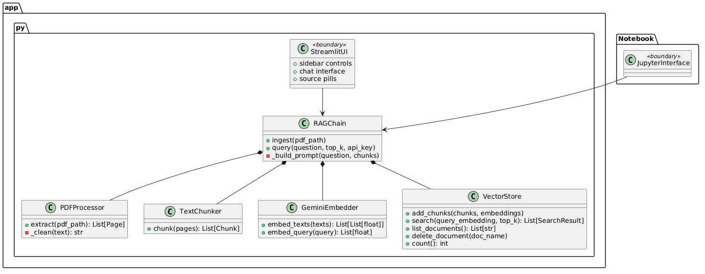
Figure 2 — Application Architecture Diagram

Project File Structure:

Path | Description
app.py | Streamlit app — all pipeline classes + UI in one file
RAG_Energy_Intelligence.ipynb | Jupyter notebook — same pipeline, HTML display layer
requirements.txt | streamlit, google-genai, sentence-transformers, chromadb, pymupdf, tiktoken
.streamlit/config.toml | Dark theme base colours for Streamlit
chroma_db/ | Auto-created — ChromaDB persistence directory (exclude from git)
NorthSea_Energy_Q3_Report.pdf | Sample test document — 6 pages, realistic energy data

2.2 Process Flow
The system operates across two distinct pipeline flows: the Ingestion Pipeline (triggered when a user uploads a PDF) and the Query Pipeline (triggered on every user question). Both flows are orchestrated by the RAGChain class.

2.2.1 Ingestion Pipeline
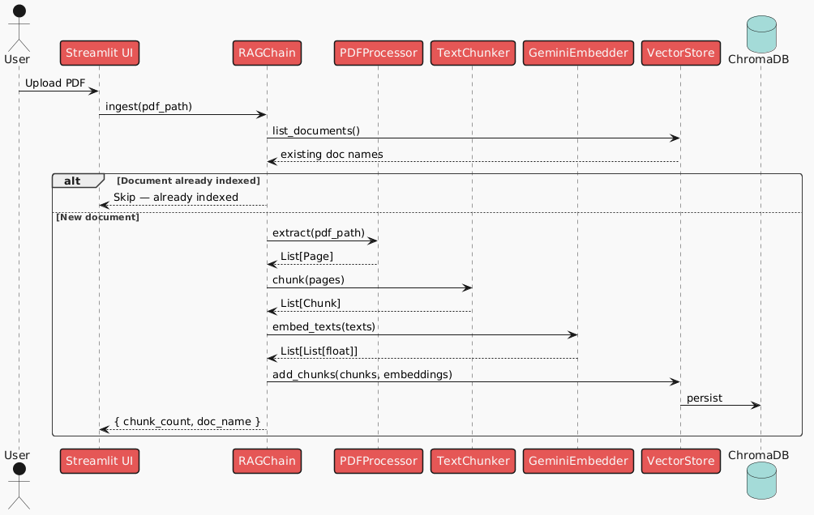

2.2.2 Query Pipeline

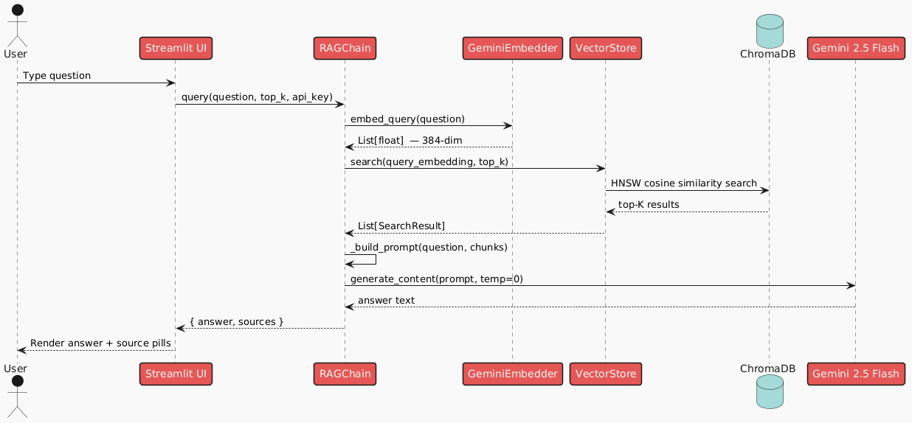

2.3 Information Flow
Three Python dataclasses act as typed data contracts between pipeline stages. They enforce a strict interface boundary — each component knows exactly what it receives and produces.

Dataclass | Fields | Created By | Consumed By
Page | page_no: int, text: str, doc_name: str | PDFProcessor | TextChunker
Chunk | chunk_id: str, doc_name: str, page_no: int, text: str, token_count: int | TextChunker | GeminiEmbedder, VectorStore
SearchResult | chunk_id: str, doc_name: str, page_no: int, text: str, score: float | VectorStore | RAGChain, Streamlit UI

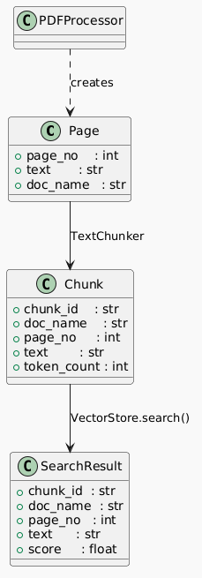

2.4 Components Design

2.4.1 PDFProcessor
Extracts and cleans raw text from PDF files using PyMuPDF. Handles the first stage of the ingestion pipeline.

Method | Signature | Returns | Notes
extract() | pdf_path: str | List[Page] | Opens with fitz, iterates all pages, skips blanks
_clean() | text: str | str | Fixes hyphenation, collapses whitespace, strips page numbers

2.4.2 TextChunker
Splits pages into overlapping token windows using tiktoken. The sliding-window approach preserves context across chunk boundaries.

Method | Signature | Returns | Notes
__init__() | chunk_size=500, overlap=50 | — | Loads cl100k_base via _load_tokenizer() cache
chunk() | pages: List[Page] | List[Chunk] | Step=450. Short pages=1 chunk. UUID chunk IDs

2.4.3 GeminiEmbedder
Generates vector embeddings locally via sentence-transformers. No API key required. Model loaded once and cached via @st.cache_resource — all subsequent embed calls are near-instant.

Method | Signature | Returns | Notes
__init__() | model=all-MiniLM-L6-v2 | — | Uses _load_embedder() singleton — loads once
embed_texts() | texts: List[str] | List[List[float]] | Batch encode, L2-normalised, 384-dim
embed_query() | query: str | List[float] | Single encode, L2-normalised, 384-dim

2.4.4 VectorStore
Wraps ChromaDB collection with cosine similarity via HNSW index. Handles all persistence, retrieval, and document management. Shares a single client instance via the _load_vectorstore() singleton.

Method | Signature | Returns | Notes
__init__() | persist_path=./chroma_db | — | Uses _load_vectorstore() singleton
add_chunks() | chunks, embeddings | None | Stores ids, vectors, documents, metadata
search() | query_embedding, top_k=5 | List[SearchResult] | cosine distance → score = 1 − distance
list_documents() | — | List[str] | Unique doc_name values from all metadata
delete_document() | doc_name: str | None | Deletes all chunks where doc_name == name
count() | — | int | Total chunks in collection

2.4.5 RAGChain
Top-level orchestrator. Owns all four pipeline components and is the single entry point for both the Streamlit UI and Jupyter Notebook. Handles duplicate detection during ingestion and prompt construction during queries.

Method | Signature | Returns | Steps
ingest() | pdf_path: str | Dict | extract → chunk → embed_texts → add_chunks. Skips if already indexed
query() | question, top_k, api_key | Dict | embed_query → search → _build_prompt → Gemini generate_content
_build_prompt() | question, chunks: List[SearchResult] | str | Formats EXCERPT blocks with doc/page/score, appends QUESTION

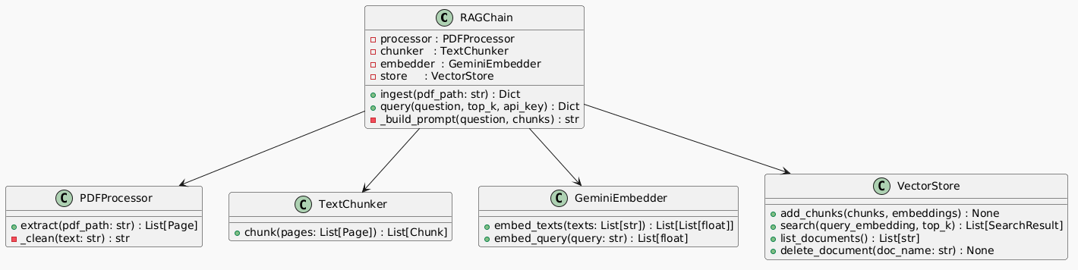
Figure 6 — Class Interaction Diagram

2.4.6 Cache Architecture
Three @st.cache_resource singletons are initialised at app startup under a single 'Loading AI models...' spinner. All class instances reuse these cached objects — zero re-loading on reruns. This is the primary mechanism for achieving sub-3s response latency after the initial cold start.

Singleton Function | What It Loads | Cold Start | Scope
_load_embedder() | SentenceTransformer all-MiniLM-L6-v2 (~90MB) | ~3–8s | Global
_load_tokenizer() | tiktoken cl100k_base encoding | ~0.5s | Global
_load_vectorstore() | ChromaDB PersistentClient + collection | ~0.3s | Global

2.4.7 Streamlit UI Components
Component | Location | Behaviour
API Key input | Sidebar | Password field — stored in session variable, never persisted
File uploader | Sidebar | Multi-PDF — calls rag.ingest() per file, shows chunk count on completion
Doc list + delete | Sidebar | list_documents() populates list; delete_document() on button click
Top-K slider | Sidebar | Range 3–10, default 5 — passed to rag.query() on each question
Excerpt toggle | Sidebar | Show/hide raw retrieved chunks displayed below each AI answer
Clear chat | Sidebar | Resets st.session_state.messages to empty list
Chat input | Main bottom | st.chat_input() — triggers rag.query() on submit
Suggestion pills | Main centre | Pre-built questions — sets pending_q in session state on click
Message history | Main scroll | User bubbles right, AI bubbles left, source pills with doc/page below

2.5 Key Design Considerations

2.5.1 Configuration Constants
All tunable parameters are defined as module-level constants in app.py — a single location for configuration changes without touching business logic.

Constant | Value | Description
EMBEDDING_MODEL | all-MiniLM-L6-v2 | Local sentence-transformers model name
LLM_MODEL | gemini-2.5-flash | Gemini generation model identifier
CHROMA_PATH | ./chroma_db | ChromaDB persistence directory — exclude from git
CHUNK_SIZE | 500 tokens | Maximum tokens per chunk (cl100k_base encoding)
CHUNK_OVERLAP | 50 tokens | Overlap between consecutive chunks (step = 450)
TOP_K | 5 | Default chunks retrieved per query (configurable 3–10)

2.5.2 Prompt Design
The prompt architecture is the primary control mechanism for accuracy and hallucination prevention. Every Gemini call follows a fixed two-part structure.

System Prompt (prepended to every query)
You are an expert assistant for energy industry professionals.

STRICT RULES:
(1) Answer ONLY from the provided excerpts.
(2) If not found, respond: 'I could not find this information in the uploaded documents.'
(3) Always cite sources as: [Doc Name, Page X].
(4) Never invent or infer facts outside the excerpts.

User Prompt Template
DOCUMENT EXCERPTS:

--- EXCERPT 1 ---
Document: {doc_name} | Page: {page_no} | Relevance: {score:.3f}
{chunk_text}

--- EXCERPT 2 ---
Document: {doc_name} | Page: {page_no} | Relevance: {score:.3f}
{chunk_text}

============================================================

QUESTION: {user_question}

ANSWER (cite your sources):

The EXCERPT format exposes doc_name, page_no, and relevance score per chunk, enabling precise inline citations. The Streamlit UI uses these fields to render clickable source pills beneath each answer.

2.5.3 Error Handling
Scenario | Handling | User Feedback
API key missing | Guard check before calling Gemini | Streamlit warning in sidebar
Duplicate document | list_documents() checked before ingest() | Info message: already indexed
Empty PDF / blank pages | PDFProcessor skips pages with no text after cleaning | Ingestion completes with lower chunk count
Answer not in documents | System prompt enforces refusal | "I could not find this information..."
Empty ChromaDB collection | search() returns empty list — prompt skips excerpts | Model instructed to refuse without excerpts
Gemini API error | Exception caught in query(), surfaced to UI | Streamlit error displayed in chat

2.6 API Catalogue
EnergyRAG does not expose a REST API. The public interface is defined by the RAGChain class methods, which serve as the internal API consumed by both the Streamlit UI and the Jupyter Notebook.

Method | Input Parameters | Return Type | Description
RAGChain.ingest() | pdf_path: str | Dict {doc_name, chunk_count} | Ingests a PDF into the vector store. Detects and skips duplicates.
RAGChain.query() | question: str, top_k: int, api_key: str | Dict {answer, sources: List[SearchResult]} | Embeds question, retrieves top-K chunks, generates grounded answer via Gemini.
VectorStore.list_documents() | — | List[str] | Returns unique document names currently indexed in the vector store.
VectorStore.delete_document() | doc_name: str | None | Removes all chunks associated with the named document from ChromaDB.
VectorStore.count() | — | int | Returns total number of chunks stored across all documents.

3. References

# | Reference | URL / Source
1 | ChromaDB Documentation | https://docs.trychroma.com
2 | Sentence Transformers — all-MiniLM-L6-v2 | https://huggingface.co/sentence-transformers/all-MiniLM-L6-v2
3 | Google Gemini API (google-genai SDK) | https://ai.google.dev/gemini-api/docs
4 | PyMuPDF (fitz) Documentation | https://pymupdf.readthedocs.io
5 | tiktoken — OpenAI Tokenizer | https://github.com/openai/tiktoken
6 | Streamlit Documentation | https://docs.streamlit.io
7 | Retrieval-Augmented Generation (RAG) — Lewis et al., 2020 | https://arxiv.org/abs/2005.11401

