Software Architecture and Design Specification
Project: Simple Unix-like Shell (Command-Line Interpreter)
Version: 1.0
Authors: Srotaswini Das, Sushanth Bhat, Tarsh Choudhary, SRK Akash
Date: 28-09-2026
Status: Draft

Revision History
Version | Date | Author | Change Summary
1.0 | 28-09-2026 | Srotaswini Das | Initial draft

Approvals
Role | Name | Signature/Date
QA Lead | Tarsh Choudhary
Dev Lead | Srotaswini Das
Product Owner | SRK Akash

1. Introduction

1.1 Purpose
This document specifies the architecture and design of the Unix-like Shell.

1.2 Scope
Covers the shell's core interactive services: command parsing, built-in commands, external command execution, I/O redirection, pipelines, background job control, environment variable handling, and signal handling.

1.3 Audience
Developers, QA engineers, security auditors, instructors, and maintenance teams.

1.4 Definitions
Shell, REPL, PID, PATH, stdin/stdout/stderr, EOF, SIGINT, SIGCHLD, ADR, fork/exec.

2. Document Overview

2.1 How to use this document
Provides architectural deliverables including UML diagrams, ADRs, and API/interface design for the shell's internal modules.

2.2 Related Documents
SRS, STP (Software Test Plan), RTM.

3. Architecture

3.1 Goals & Constraints
Goals: POSIX-like command-line compatibility, low latency (built-ins ≤ 50 ms), stability over long interactive sessions, portability across Linux and macOS.
Constraints: Must rely only on standard POSIX system calls (fork, execvp, pipe, dup2, waitpid, sigaction); no kernel modifications; single-process-tree model (no daemon).

3.2 Stakeholders & Concerns
- End users: responsiveness, familiar command behavior, clear error messages
- Developers: modularity, testability, ease of adding new built-ins
- QA / Security auditors: robustness against malformed input, no injection or memory-safety issues
- Instructors / Reviewers (course context): clear separation of parsing, execution, and job-control logic

3.3 Component (UML) Diagram
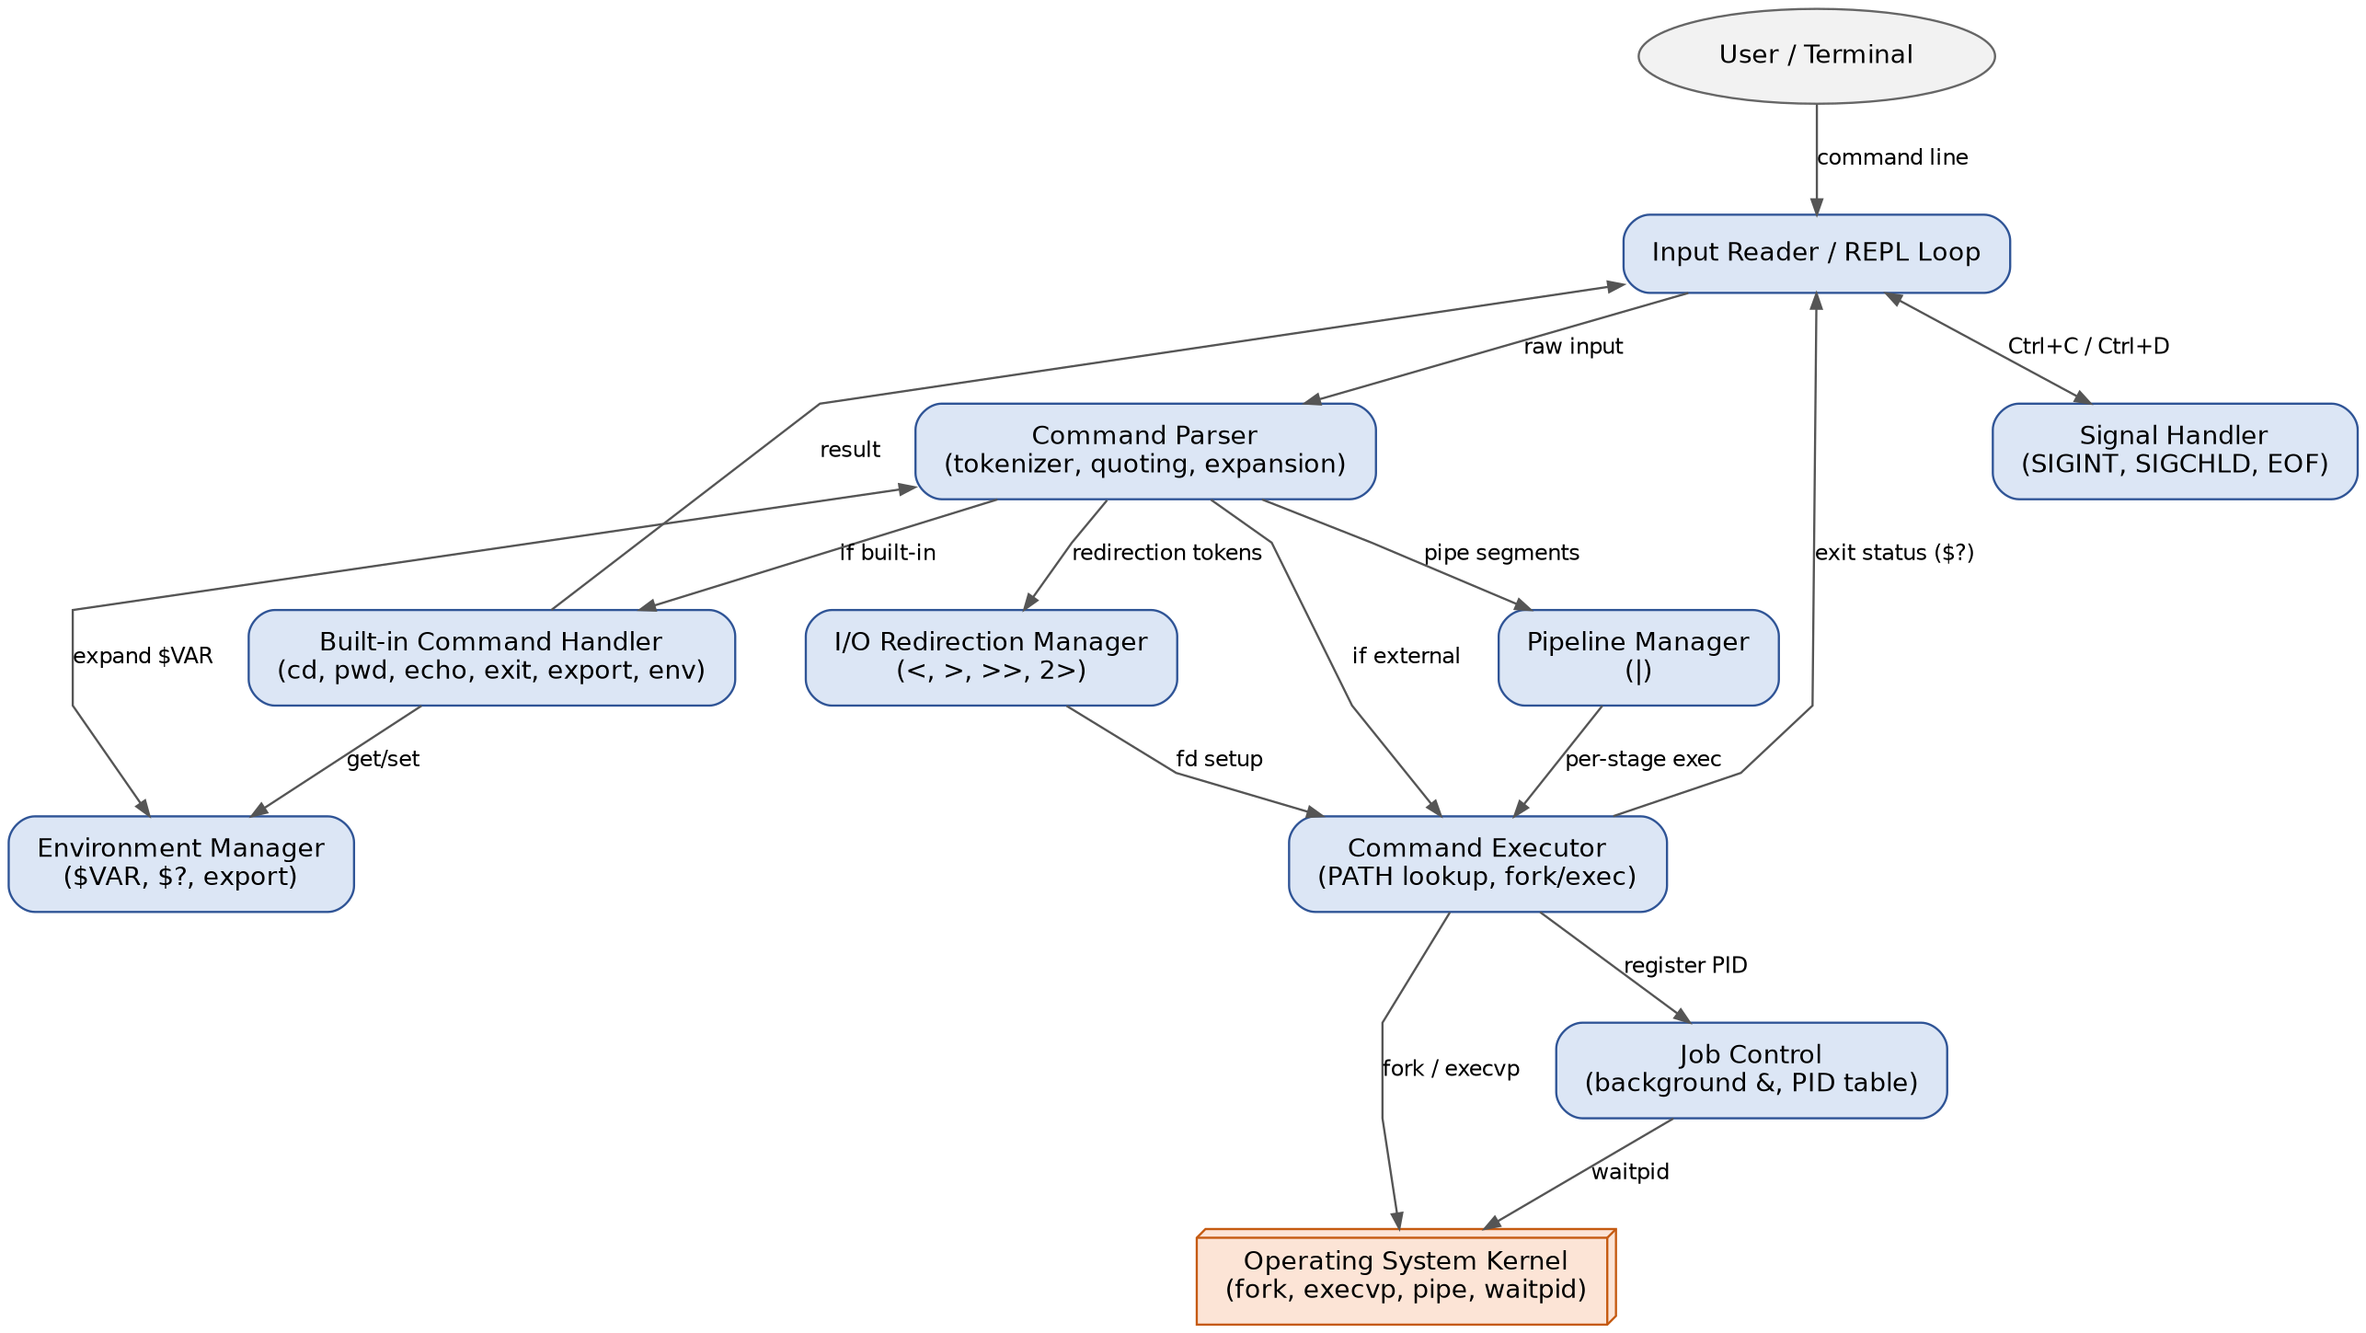
Figure 1 — Component diagram of the shell's internal modules

3.4 Component Descriptions
- Input Reader / REPL Loop: displays the prompt, reads a line of input, and drives the read-eval-print cycle.
- Command Parser: tokenizes raw input (handling quoting, escaping, and variable expansion) and classifies it into built-in, external, redirection, or pipeline segments.
- Built-in Command Handler: implements commands executed in the shell's own process (cd, pwd, echo, exit, export, env, history, help).
- Command Executor: resolves external commands via PATH and launches them using fork/execvp.
- I/O Redirection Manager: sets up file descriptors for <, >, >>, and 2> before a command runs.
- Pipeline Manager: wires stdout/stdin between consecutive commands in a pipeline using pipe() and dup2().
- Job Control: tracks process IDs for foreground and background (&) jobs and reaps terminated children.
- Environment Manager: stores and expands shell/environment variables ($VAR) and the last exit status ($?).
- Signal Handler: intercepts SIGINT (Ctrl+C) and EOF (Ctrl+D) so the shell survives interrupts to foreground jobs.
- Operating System Kernel: external dependency providing fork, execvp, pipe, dup2, and waitpid.

3.5 Chosen Architecture Pattern and Rationale
A layered, single-process architecture was chosen: a REPL layer, a parsing layer, and an execution layer, with cross-cutting modules (environment, job control, signals) accessible to all layers. This keeps the codebase simple and matches how real shells (sh, bash) are structured internally. A plugin-based or multi-process microkernel design was rejected as unnecessary complexity for a single-user, single-host command interpreter.

3.6 Technology Stack & Data Stores
Implementation language: C (POSIX system calls) or C++. Build system: Make/CMake. No persistent database; the shell holds state (environment variables, job table, command history) in memory for the session, with an optional history file (~/.shell_history) written to disk on exit.

3.7 Risks & Mitigations
Risk | Mitigation
Zombie processes from unreaped background jobs | SIGCHLD handler reaps children asynchronously; job table cleaned on each prompt cycle
Command injection via unsanitized arguments | Arguments passed as argv arrays to execvp (never via a shell string to system()), avoiding metacharacter injection
Deadlock or fd leaks in multi-stage pipelines | Close unused pipe ends immediately after dup2; automated fd-leak tests in CI
Platform differences between Linux and macOS | Limit calls to POSIX-standard APIs; test on both platforms in CI

3.8 Traceability to Requirements
- R1 (Command parsing & tokenization) → Command Parser
- R2 (External command execution) → Command Executor
- R3 (Built-in commands) → Built-in Command Handler
- R4 (I/O redirection) → I/O Redirection Manager
- R5 (Pipelines) → Pipeline Manager
- R6 (Background jobs) → Job Control
- R7 (Signal handling) → Signal Handler

3.9 Security Architecture
Threat Modeling (STRIDE):
- Spoofing: not directly applicable (single local user); PATH is resolved against a trusted, user-controlled variable only.
- Tampering: commands are executed via argv arrays, never through a string passed to a shell-interpreting system() call, preventing argument tampering/injection.
- Repudiation: optional command history log with timestamps for session audit.
- Information Disclosure: no sensitive data (passwords, tokens) is logged; error messages avoid leaking internal paths beyond what the user already provided.
- Denial of Service: input length limits and a cap on concurrent background jobs prevent resource exhaustion from malformed or runaway input.
- Elevation of Privilege: the shell runs with the invoking user's privileges only; it never escalates privileges or uses setuid.

4. Design

4.1 Design Overview
The shell is designed as a set of cooperating in-process modules (parser, executor, job control) layered around a single REPL loop, favoring clear separation of concerns and straightforward unit testing over raw performance, which is not a bottleneck for an interactive command interpreter.

4.2 UML Sequence Diagrams
Two representative flows are shown below: executing a single external command, and executing a two-stage pipeline.
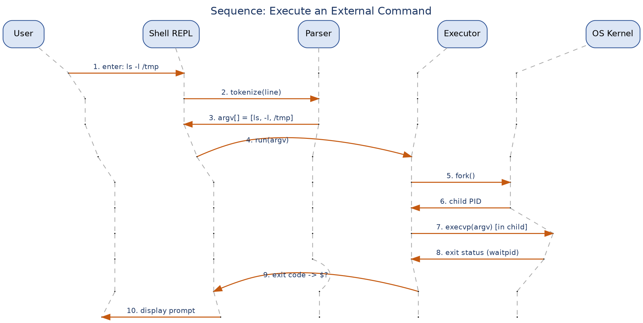
Figure 2 — Sequence: executing an external command (e.g., ls -l /tmp)
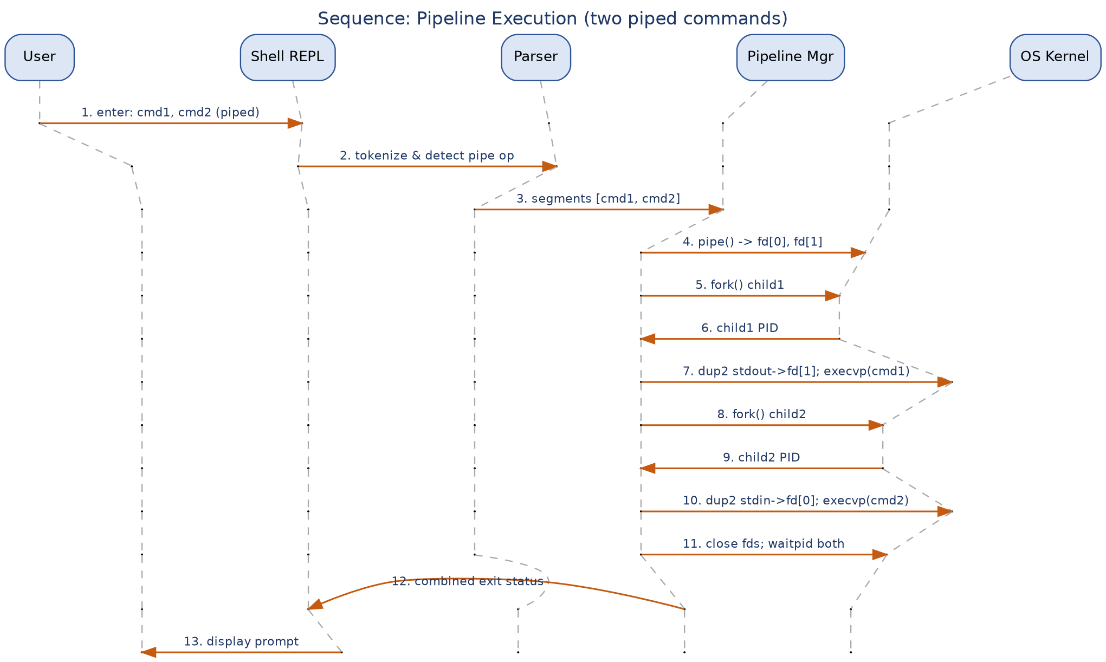
Figure 3 — Sequence: pipeline execution (cmd1 piped into cmd2)

4.3 API Design
Interface definitions for the two primary internal components:

Parser Interface
Function: parse(char *line) -> Command*
Input: raw input line (string)
Output: a Command structure: { argv[], input_file, output_file, append_flag, is_background, next_stage (for pipelines) }
Errors: returns NULL with a syntax error message on unmatched quotes or a trailing pipe/operator

Executor Interface
Function: execute(Command *cmd) -> int exit_status
Input: a parsed Command structure (possibly chained via next_stage for pipelines)
Output: process exit status, stored in the shell's $? variable
Errors: 127 (command not found), 126 (permission denied), 2 (bad redirection target)

4.4 Error Handling, Logging & Monitoring
Standardized, user-facing error messages (e.g., "shell: command not found: <name>") are printed to stderr without internal stack details. No sensitive environment values are logged. Monitoring during testing/CI includes: command failure rate, average built-in latency, and detection of leaked file descriptors or zombie processes via periodic /proc checks.

4.5 UX Design
The shell presents a minimal, configurable prompt (showing current directory), supports command history recall, and returns clear, single-line error messages. Output formatting defers to the invoked program; the shell itself adds no extraneous decoration to command output.

4.6 Open Issues & Next Steps
- Scripting constructs (if/while/for) and shell functions — out of scope for v1.0
- Command-line aliasing and tab-completion
- Globbing/wildcard expansion (*, ?)
- Command substitution ($(...))

5. Appendices

5.1 Glossary
Shell, REPL, PID, PATH, built-in, pipeline, job control, signal, STRIDE.

5.2 References
IEEE 42010, POSIX.1-2017 (IEEE Std 1003.1), OWASP, NIST SP 800-160.

5.3 Tools
Graphviz (architecture/sequence diagrams), draw.io (optional alternate diagramming), man pages for POSIX system calls.

