SOFTWARE REQUIREMENTS SPECIFICATION (SRS)
Problem Statement No. 18: Simple Shell (Command Line Interpreter)

Project | Simple Shell (Command Line Interpreter)
Version | 1.0
Authors | Srotaswini Das, Sushant Bhat, SRK Akash, Tarsh Choudhary
Date | 04-09-2026
Status | Draft / Submission Version
Course | Software Engineering
This SRS defines the functional, non-functional, security, interface and acceptance requirements for a Simple Shell that accepts commands from a user, interprets them and executes supported operations using the underlying operating system.

Revision History
Version | Date | Author | Change Summary | Approval
1.0 | 04-09-2026 | Instructor | Initial SRS for Simple Shell project | Pending

Approvals
Role | Name | Signature / Email | Date
Course Coordinator
Project Guide / Instructor

Table of Contents
1. Introduction
2. Overall Description
3. External Interface Requirements
4. System Features (Detailed Functional Requirements)
5. Non-Functional Requirements
5.1 Security Objectives
5.2 Security Requirements
6. Quality Attributes & Acceptance Tests
7. System Models and UML Use-Case Diagrams
8. Requirements Traceability Matrix (RTM)

1. Introduction

1.1 Purpose
This Software Requirements Specification (SRS) describes the requirements for a Simple Shell, also called a Command Line Interpreter. The system provides a text-based interface through which a user can enter commands. The shell parses the input, identifies supported commands, creates child processes where required, invokes operating-system services, and displays the command output or appropriate error messages. The purpose of this document is to provide a clear specification for development, testing and evaluation of the project.

1.2 Scope
The project covers an interactive command-line shell running on a Linux/Unix-like operating system. The shell will display a prompt, read user input, parse commands and arguments, execute external programs, support selected built-in commands, wait for foreground processes, handle invalid commands, and support basic input/output redirection and pipelines where implemented. The project does not attempt to replace a full production shell such as bash; advanced scripting, job-control features and complex shell syntax are outside the core scope unless explicitly added.

1.3 Audience
Developers, testers/QA students, course instructors, evaluators and end users familiar with basic command-line usage.

1.4 Definitions and Acronyms
Term | Definition
Shell / CLI | A command-line interface that accepts textual commands and requests the operating system to execute them.
Built-in Command | A command implemented directly inside the shell, such as cd, exit or help.
External Command | An executable program located and run by the operating system, for example ls or pwd.
Process | An executing instance of a program managed by the operating system.
PID | Process Identifier assigned by the operating system.
stdin / stdout / stderr | Standard input, standard output and standard error streams.
Redirection | Changing the source of input or destination of output for a command.
Pipe | A mechanism that passes the output of one command as input to another command.

2. Overall Description

2.1 Product Perspective
The Simple Shell is a standalone user-space program that acts as an intermediary between the user and the operating system. It repeatedly performs the following cycle: display a prompt, accept a command line, parse the input, execute the requested operation, wait for completion when appropriate, display results/errors, and return to the prompt.

2.2 Major Product Functions
- Display an interactive shell prompt.
- Read and validate user command input.
- Parse command names and arguments.
- Execute supported external programs.
- Provide built-in commands such as cd, pwd, help and exit.
- Maintain a command history for the current session.
- Support basic output/input redirection.
- Support basic command pipelines.
- Report invalid commands and execution failures.
- Handle interrupt/termination signals safely.

2.3 User Roles and Characteristics
User Role | Characteristics
End User | Has basic knowledge of command-line commands and uses the shell to execute programs and navigate directories.
Developer | Implements, debugs and extends shell functionality.
Tester / Evaluator | Executes functional, error-handling and performance test cases against the shell.

2.4 Operating Environment
The system shall run on a Linux/Unix-like operating system. It may be developed in C using standard POSIX APIs such as fork(), exec(), wait(), pipe(), dup2(), chdir() and signal handling functions. The shell is expected to run in a terminal emulator and use the operating system process and file systems.

2.5 Constraints
- The implementation shall use facilities available in the target Linux/Unix environment.
- The shell shall not require a graphical user interface.
- The core implementation should use standard POSIX process-management and file-descriptor mechanisms.
- The project is intended to be a simple educational shell and is not required to provide all features of bash/zsh.
- Unsupported syntax shall be rejected gracefully rather than causing the shell to terminate unexpectedly.

3. External Interface Requirements

3.1 User Interface
The primary user interface is a terminal. The shell shall display a clear prompt (for example, simple-shell>), accept commands as text, and display command output and error messages in the terminal.

3.2 Hardware Interfaces
No specialized hardware interfaces are required. The shell uses the standard computer keyboard and terminal/display provided by the operating system.

3.3 Software Interfaces
Interface | Purpose
Operating System / POSIX APIs | Process creation, program execution, waiting, directory operations, signals and file descriptor management.
File System | Access to executable files, directories and files used for input/output redirection.
Terminal Emulator | Receives user input and displays shell prompts, output and error messages.
System PATH | Used to locate external executable commands when a path is not explicitly specified.

3.4 Communications Interfaces
The core version of the Simple Shell does not require network communication. If future versions execute remote commands, network communication and authentication requirements must be specified separately.

4. System Features (Detailed Functional Requirements)
The following functional requirements use the identifier format SSH-F-###. The project contains more than the required 15 functional requirements.
Req ID | Feature | Requirement (shall...) | Type | Priority | Source/Stakeholder | Acceptance Criteria / Test | Dependencies
SSH-F-001 | Prompt Display | The system shall display a command prompt whenever it is ready to accept a new command. | Functional | High | End User | AC-F-001: A visible prompt is shown at startup and after each completed command. Test: TC-SH-01 | Terminal available
SSH-F-002 | Read Command | The system shall read a complete command line entered by the user. | Functional | High | End User | AC-F-002: Entered text is captured until the user presses Enter. Test: TC-SH-02 | stdin required
SSH-F-003 | Ignore Empty Input | The system shall ignore empty or whitespace-only input and return to the prompt without terminating. | Functional | Medium | End User | AC-F-003: Blank input produces a new prompt. Test: TC-SH-03 | Input parser
SSH-F-004 | Parse Arguments | The system shall parse a command name and its whitespace-separated arguments for supported command syntax. | Functional | High | Developer | AC-F-004: Command and arguments are passed correctly to execution logic. Test: TC-SH-04 | Parser module
SSH-F-005 | Execute External Commands | The system shall execute valid external commands using operating-system process creation and execution mechanisms. | Functional | High | End User | AC-F-005: A command such as ls executes and its output is displayed. Test: TC-SH-05 | fork/exec
SSH-F-006 | PATH Lookup | The system shall locate external commands using the operating system PATH when a full path is not supplied. | Functional | High | End User | AC-F-006: Standard commands execute without specifying absolute paths. Test: TC-SH-06 | Environment PATH
SSH-F-007 | Wait for Foreground Process | The system shall wait for a foreground child process to complete before accepting the next command. | Functional | High | End User | AC-F-007: Prompt returns after the foreground command completes. Test: TC-SH-07 | wait/waitpid
SSH-F-008 | Invalid Command Handling | The system shall display a clear error message when a command cannot be found or executed. | Functional | High | End User | AC-F-008: Invalid command produces an error and shell remains active. Test: TC-SH-08 | Error handling
SSH-F-009 | Built-in cd | The system shall provide a built-in cd command to change the shell's current working directory. | Functional | High | End User | AC-F-009: cd changes the working directory for subsequent commands. Test: TC-SH-09 | chdir()
SSH-F-010 | Built-in pwd | The system shall provide a built-in pwd command that displays the current working directory. | Functional | Medium | End User | AC-F-010: pwd displays the active directory. Test: TC-SH-10 | getcwd()
SSH-F-011 | Built-in help | The system shall provide a help command that lists supported commands and basic usage information. | Functional | Medium | End User | AC-F-011: help displays available built-ins and usage guidance. Test: TC-SH-11 | Built-in module
SSH-F-012 | Built-in exit | The system shall terminate cleanly when the user enters the exit command. | Functional | High | End User | AC-F-012: exit releases resources and ends the shell process. Test: TC-SH-12 | Cleanup logic
SSH-F-013 | Command History | The system shall maintain a history of commands entered during the current shell session. | Functional | Medium | End User | AC-F-013: Previously entered commands can be displayed through the supported history feature. Test: TC-SH-13 | Session memory
SSH-F-014 | Output Redirection | The system shall support basic stdout redirection using > for supported commands. | Functional | Medium | End User | AC-F-014: Command output is written to the specified file. Test: TC-SH-14 | File descriptors / dup2()
SSH-F-015 | Input Redirection | The system shall support basic stdin redirection using < for supported commands. | Functional | Medium | End User | AC-F-015: Command reads input from the specified file. Test: TC-SH-15 | File descriptors / dup2()
SSH-F-016 | Pipeline Support | The system shall support a basic pipeline using | to pass the output of one command to the input of another. | Functional | Medium | End User | AC-F-016: A two-command pipeline produces the expected result. Test: TC-SH-16 | pipe()
SSH-F-017 | Signal Handling | The system shall handle common terminal interrupts so that an interrupted command does not crash the shell. | Functional | High | End User | AC-F-017: After Ctrl+C during a supported foreground command, the shell remains usable. Test: TC-SH-17 | Signal handling
SSH-F-018 | Session Continuity | The system shall continue accepting commands after a recoverable command execution or parsing error. | Functional | High | End User | AC-F-018: Following an error, a subsequent valid command executes successfully. Test: TC-SH-18 | Robust error handling

5. Non-Functional Requirements
The following requirements use the identifier format SSH-NF-### and are measurable where possible.
Req ID | Requirement | Category | Priority | Acceptance Criteria / Measurement
SSH-NF-001 | The shell shall display the next prompt within 1 second after a lightweight command completes under normal system load. | Performance | High | 90% of tested lightweight commands return to the prompt in ≤1 second. Test: TC-PERF-01
SSH-NF-002 | The shell shall remain operational for at least 100 consecutive valid and invalid command executions without unexpected termination. | Reliability | High | 100-command stress test completes without shell crash. Test: TC-REL-01
SSH-NF-003 | The shell shall provide clear, concise error messages for invalid commands, missing files and unsupported syntax. | Usability | High | Error tests show understandable messages and the shell remains active. Test: TC-USAB-01
SSH-NF-004 | The source code shall be modular, readable and documented sufficiently for another student/developer to maintain the project. | Maintainability | Medium | Code review confirms meaningful module/function structure and comments. Test: TC-MAINT-01
SSH-NF-005 | The shell shall run on the specified Linux/Unix-like environment using standard supported POSIX interfaces. | Portability | High | Build and execution succeed on the target Linux environment. Test: TC-PORT-01

5.1 Security Objectives
- SO-1: Protect the stability and integrity of the shell process so that malformed or invalid user input does not cause unintended termination, memory corruption or uncontrolled behavior.
- SO-2: Prevent unintended exposure or corruption of user data by validating redirection targets and handling file/process errors safely.

5.2 Security Requirements
Req ID | Requirement (shall...) | Type | Priority | Acceptance Criteria / Test
SSH-SR-001 | The system shall validate command input length before processing it and shall reject or safely handle input exceeding the supported maximum length. | Security | High | TC-SEC-01: Overlength input does not crash or corrupt the shell.
SSH-SR-002 | The system shall use bounds-safe parsing and memory management so that command and argument buffers are not written beyond allocated limits. | Security | High | TC-SEC-02: Boundary-value tests complete without memory errors.
SSH-SR-003 | The system shall not execute malformed parsed commands when mandatory command information is missing. | Security | High | TC-SEC-03: Malformed commands are rejected safely.
SSH-SR-004 | The system shall report file redirection failures without replacing or corrupting the shell process state. | Security | Medium | TC-SEC-04: Invalid file paths generate an error and the shell continues.
SSH-SR-005 | The system shall release/close child-process and file resources after command execution where applicable to avoid uncontrolled resource exhaustion. | Security | High | TC-SEC-05: Repeated command tests do not show uncontrolled descriptor/process growth.

6. Quality Attributes & Acceptance Tests
The Simple Shell shall be evaluated using the following quality attributes:
- Correctness: valid commands produce the expected operating-system behavior.
- Reliability: recoverable errors do not terminate the shell.
- Usability: prompts and errors are understandable to a basic command-line user.
- Performance: normal lightweight commands return control to the user promptly.
- Maintainability: source code is modular and sufficiently documented.
- Portability: the program runs on the defined Linux/Unix-like target environment.
Acceptance exit criteria:
- All High-priority functional requirements are implemented and verified.
- All required test cases pass, with no critical failures.
- At least 15 functional requirements, 5 non-functional requirements, 2 security objectives and 5 security requirements are covered.
- The RTM demonstrates traceability from requirements to test cases.

7. System Models and Diagrams

7.1 UML Use-Case Diagram 1 – Core Shell Operations
This diagram shows the primary interaction between the user and the core command interpretation functions.
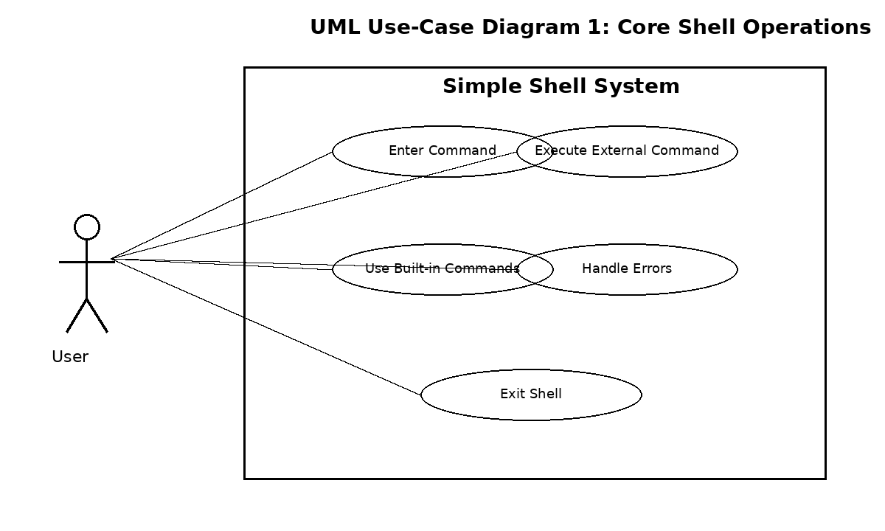

7.2 UML Use-Case Diagram 2 – Advanced I/O Features
This diagram shows the user interaction with history, redirection, pipelines and safe interruption features.
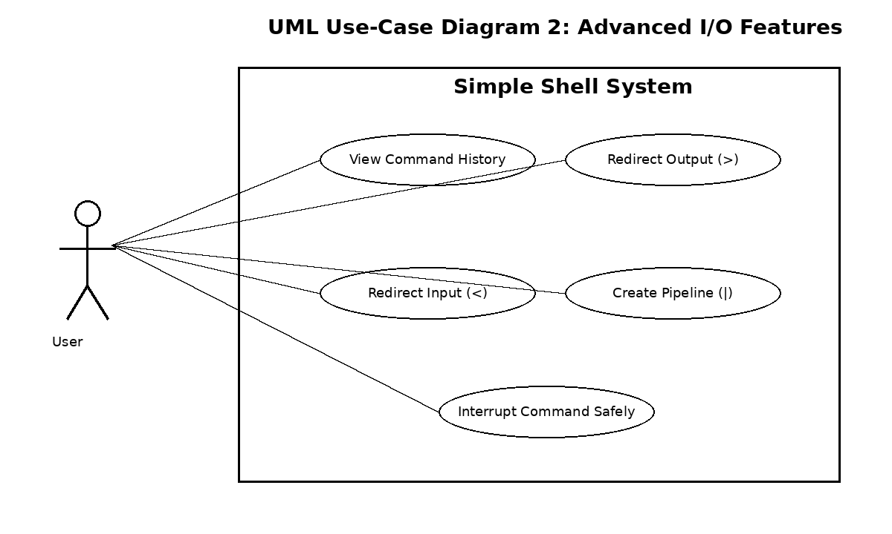

8. Requirements Traceability Matrix (RTM)
Req ID | Requirement Short | Section Ref / Design | Module | Test Case(s) | Status (N/P/A) | Comments
SSH-F-001 | Prompt display | 4 | UI Module | TC-SH-01 | N
SSH-F-002 | Read command | 4 | Input Module | TC-SH-02 | N
SSH-F-003 | Ignore empty input | 4 | Parser | TC-SH-03 | N
SSH-F-004 | Parse arguments | 4 | Parser | TC-SH-04 | N
SSH-F-005 | Execute external command | 4 | Execution Module | TC-SH-05 | N
SSH-F-006 | PATH lookup | 4 | Execution Module | TC-SH-06 | N
SSH-F-007 | Wait for process | 4 | Process Module | TC-SH-07 | N
SSH-F-008 | Invalid command handling | 4 | Error Module | TC-SH-08 | N
SSH-F-009 | cd built-in | 4 | Built-in Module | TC-SH-09 | N
SSH-F-010 | pwd built-in | 4 | Built-in Module | TC-SH-10 | N
SSH-F-011 | help built-in | 4 | Built-in Module | TC-SH-11 | N
SSH-F-012 | exit built-in | 4 | Built-in Module | TC-SH-12 | N
SSH-F-013 | Command history | 4 | History Module | TC-SH-13 | N
SSH-F-014 | Output redirection | 4 | I/O Module | TC-SH-14 | N
SSH-F-015 | Input redirection | 4 | I/O Module | TC-SH-15 | N
SSH-F-016 | Pipeline support | 4 | Pipe Module | TC-SH-16 | N
SSH-F-017 | Signal handling | 4 | Signal Module | TC-SH-17 | N
SSH-F-018 | Session continuity | 4 | Main Loop/Error Module | TC-SH-18 | N
SSH-NF-001 | Prompt response time | 5 | Main Loop | TC-PERF-01 | N
SSH-NF-002 | Reliability | 5 | All Modules | TC-REL-01 | N
SSH-NF-003 | Usable errors | 5 | Error Module | TC-USAB-01 | N
SSH-NF-004 | Maintainability | 5 | Codebase | TC-MAINT-01 | N
SSH-NF-005 | Portability | 5 | Build/System | TC-PORT-01 | N
SSH-SR-001 | Input length validation | 5.2 | Input Module | TC-SEC-01 | N
SSH-SR-002 | Bounds-safe parsing | 5.2 | Parser | TC-SEC-02 | N
SSH-SR-003 | Reject malformed commands | 5.2 | Parser | TC-SEC-03 | N
SSH-SR-004 | Safe redirection failures | 5.2 | I/O Module | TC-SEC-04 | N
SSH-SR-005 | Resource cleanup | 5.2 | Process/I-O Module | TC-SEC-05 | N

Status key: N = Not started, P = In progress, A = Approved/Implemented. Update the status column during development and testing.

