**Multi-Motor Unit Potential (Multi-MUP)**

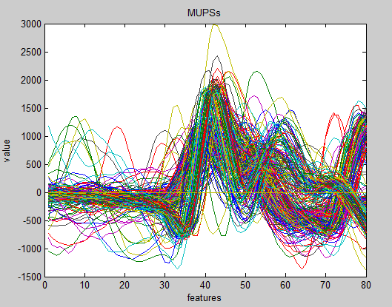

**Center of each cluster**

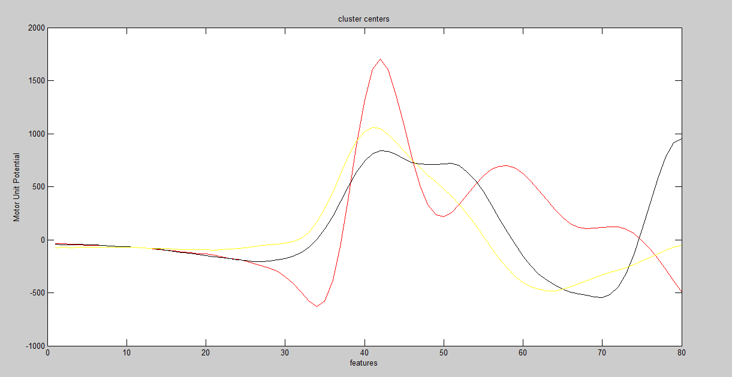

**MUPS RELATED TO CLUSTER #1**

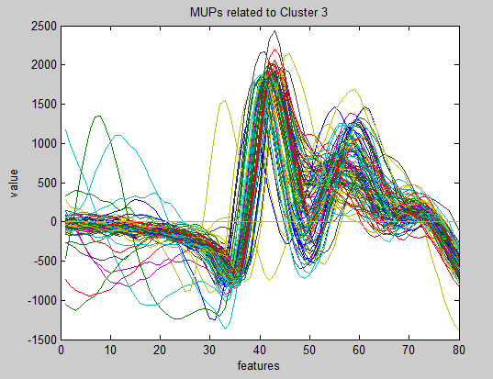

**MUPS RELATED TO CLUSTER #2**

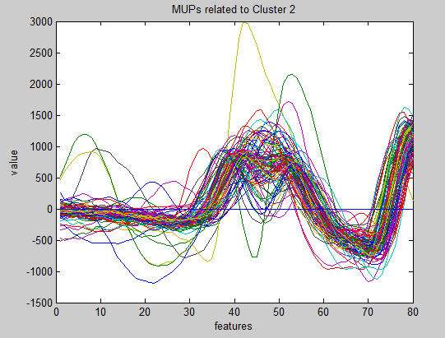

**MUPS RELATED TO CLUSTER #3**

