Report: Ethical Hacking Lab

Srushti Jabhinamath
251100690011

Activity 1 : Wi-Fi -hacking

- use the link: https://www.aircrack-ng.org/doku.php?id=wpa_capture , there download pacp file from there
- Open that file in the wireshark
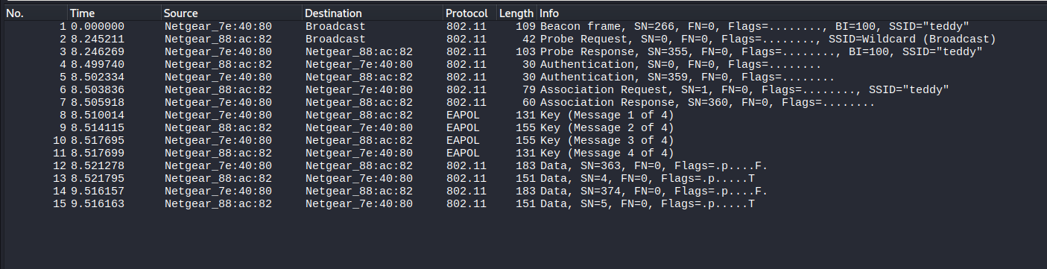
- We get a list of traffic captured
- Use the filter : wlan to know if there is any traffic under wifi
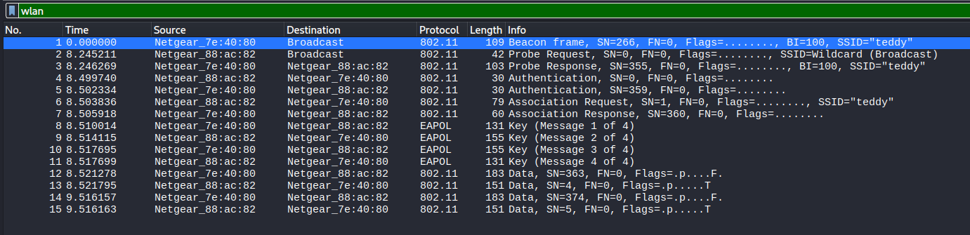
- Here we can see the SSID “teddy” which means it is the network SSID
- There we see the 2 MAC ADDRESS : Netgear_7e:40:80 && Netgear_88:ac:82 , this is the MAC of the communicating devices.
- Various WiFi frames such as Beacon, Probe, Authentication, Association, and Data frames were observed.
- It uses WPA-4 handshake, to check this use the filter : eapol
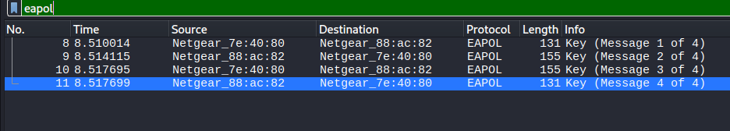
- A dictionary attack was performed using Aircrack-ng with the rockyou.txt wordlist
- aircrack-ng -w /usr/share/wordlists/rockyou.txt wpa.full.cap
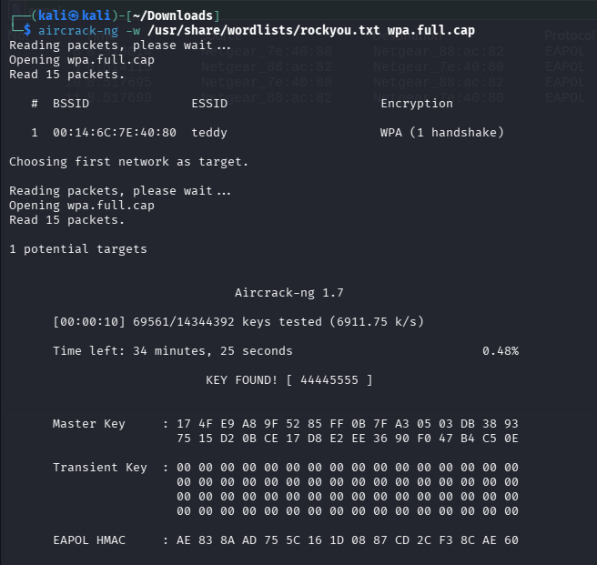
- There we found the KEY : 44445555
- This is the password
Activity 2 : Bluetooth hacking

- Download the pcap file, open it in the wireshark

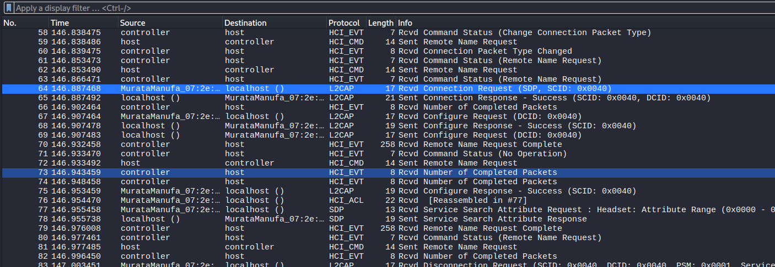
- Use the fiter : bthci_evt , we will get to see the Bluetooth discovery + connection process
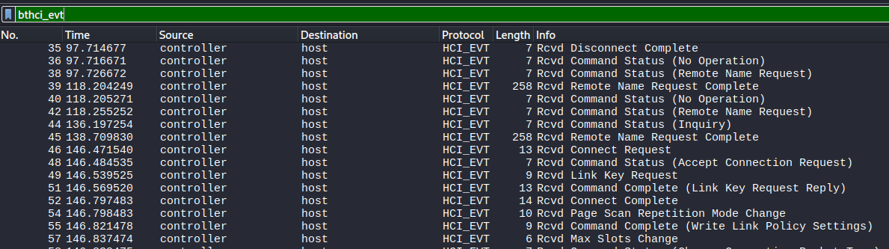
- Use the filter: bthci_acl, we will get to see the
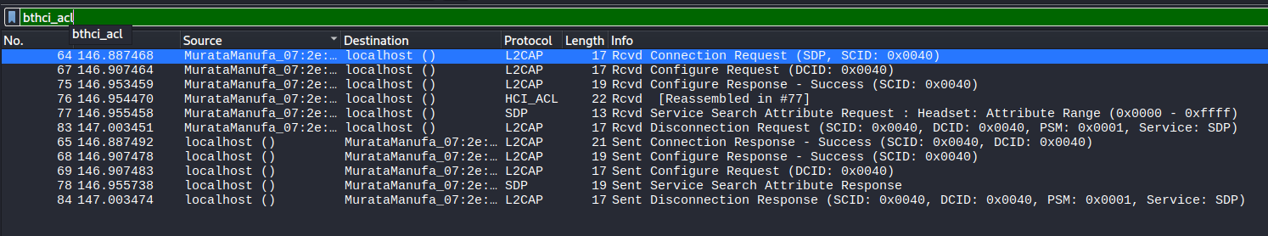
- In the filter : bthci_evt, we can see about inquiry, remote name request, connection request, pin request and connection complete.
- Under the filter : bthci_acl , we will see the L2CAP as protocol and info RcVD connection request.
- When we exapand this we will see the source BD_ADDR under the Blutooth HCI ACL packet.
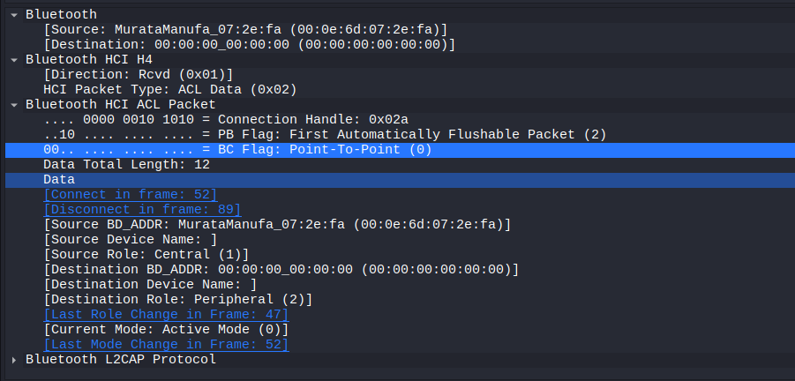
- This shows that actual Bluetooth connection ID at HCI level
- Source BD_ADDR: MurataManufa_07:2e:fa --- This is the device address
- Source Role: Central , Destination Role: Peripheral – The communication occurs between a Central device and a Peripheral device.

