Real-Time Financial Anomaly Detection Using Machine Learning and Streaming Simulation

Srudhan Eerla
MTech SCOPE
Vellore Institute of Technology
Chennai, INDIA
srudhaneerla@gmail.com

Dr. S. Deepa Nivethika
Professor
Vellore Institute of Technology
Chennai, INDIA
deepanivethika.s@vit.ac.in

Abstract— Financial anomaly detection involves identifying unusual patterns in transaction data that may indicate suspicious or irregular activities. By analyzing transaction behaviour, this work aims to detect deviations from normal patterns and highlight potentially risky operations. The proposed system focuses on identifying anomalous transactions in a near real-time environment and providing clear visualization of such events. By applying machine learning techniques, the system analyzes historical transaction data without relying on labeled information, using a dataset that contains both numerical and categorical attributes. A system is developed to process transactions sequentially and classify them as normal or anomalous based on their behavioural patterns. After preprocessing the data, feature transformation techniques are applied to prepare it for analysis, and the Isolation Forest algorithm is used to detect anomalies by learning the distribution of normal transactions. The model evaluates each transaction and assigns an anomaly score indicating the degree of abnormality, while a live dashboard displays detected anomalies and their trends over time. The results demonstrate that machine learning can effectively identify unusual financial activities in a continuous data environment, and the use of visualization improves interpretability and understanding of system behaviour, making this approach a practical solution for anomaly detection in financial systems.
Keywords—Anomaly Detection, Machine Learning, Isolation Forest, Financial Transactions, Real-Time Processing, Streaming Simulation, Data Preprocessing, Anomaly Score, Data Visualization, Streamlit Dashboard

Introduction
The rapid growth of digital financial services has led to a continuous increase in the volume of transaction data generated through activities such as online payments, banking operations, and digital transfers. While this expansion has improved convenience and accessibility, it has also introduced new challenges in monitoring and securing financial systems. Detecting unusual or suspicious transactions has become essential to prevent fraud and ensure system reliability. Traditional approaches, which rely on predefined rules or batch-based analysis, often struggle to identify complex patterns and may result in delayed detection.
Machine learning offers a more flexible and data-driven approach to handling such problems. In particular, anomaly detection techniques are well-suited for financial data, where labeled examples of fraud are often limited or unavailable. Unsupervised learning methods can learn normal transaction behaviour from the data itself and identify deviations without requiring prior labeling. This makes them effective in adapting to changing patterns and detecting previously unseen anomalies in dynamic environments.
In addition to accurate detection, there is a growing need for systems that can operate in real time. Delayed responses can lead to increased risks and reduced effectiveness of monitoring systems. This work focuses on developing a real-time anomaly detection framework using the Isolation Forest algorithm, combined with a streaming simulation approach. Transactions are processed sequentially, and detected anomalies are visualized through a live dashboard, enabling continuous monitoring and better understanding of system behaviour.

Related Work
Financial anomaly detection has gained significant attention in recent years due to the rapid increase in digital transactions and the need for secure financial systems. Researchers have explored various techniques ranging from traditional rule-based methods to advanced machine learning, deep learning, and real-time streaming frameworks. These studies aim to improve the accuracy and speed of detecting suspicious transactions while addressing challenges such as data imbalance, lack of labeled data, and scalability. With the availability of large financial datasets, it has become possible to develop systems that can analyze real-world transaction behaviour and support better decision-making in fraud detection.
Dumitrescu et al. [1] proposed a graph-based anomaly detection approach that combines egonet features with the Isolation Forest algorithm to identify suspicious accounts in financial networks. While the method effectively captures relationships between entities, it introduces additional complexity in handling large-scale data. Daksa et al. [2] focused on real-time fraud detection using streaming technologies such as Apache Kafka, Spark, and Flink. Their work demonstrated improved processing speed and scalability, but the system requires complex infrastructure for deployment. Stahmann et al. [3] provided a comprehensive review of anomaly detection techniques, categorizing them into statistical, clustering, and classification approaches, and highlighted the challenges in applying these methods to real-time environments.
Mandlik et al. [4] developed an AI-based fraud detection system using a combination of machine learning and deep learning techniques for UPI transactions. The system achieved good accuracy, but the reliance on labeled data limits its adaptability to new patterns. Gadimov and Birihanu [5] introduced an autoencoder-based approach for real-time anomaly detection using reconstruction error, which showed improved performance but required higher computational resources. Wang et al. [6] proposed a deep learning model for multivariate time-series anomaly detection, focusing on capturing temporal patterns, though the approach is resource-intensive and less suitable for lightweight systems.
Jain and Deshwal [7] explored traditional machine learning algorithms such as Support Vector Machines, Decision Trees, and Random Forest for fraud detection, emphasizing the importance of feature engineering. However, these methods often depend on labeled datasets and may not generalize well to unseen patterns. Li et al. [8] proposed a hybrid deep learning framework combining LSTM and autoencoders to analyze complex financial data, achieving improved accuracy but increasing model complexity and training time. Rahmati et al. [9] introduced a federated learning approach using Graph Neural Networks to enhance privacy and collaboration across institutions, though scalability remains a challenge.
Acharjee et al. [10] developed a streaming-based fraud detection system using machine learning techniques integrated with Kafka and Flink, demonstrating reduced detection latency and improved responsiveness. Similarly, Liu et al. [11] proposed a big data-driven fraud detection framework using distributed processing platforms such as Spark and cloud computing, which improved scalability but added system complexity.
Although these studies highlight the effectiveness of advanced techniques in anomaly detection, several challenges remain. Many approaches either focus on improving model accuracy without considering real-time implementation or emphasize streaming architectures without balancing detection performance. In contrast, the proposed work presents a lightweight and practical solution that combines unsupervised machine learning with a simulated real-time pipeline and a live dashboard, aiming to achieve both efficiency and usability in financial anomaly detection.

Methodology

Dataset Overview
The dataset used in this study consists of financial transaction records that include both numerical and categorical attributes representing different aspects of user activity. These features may include transaction amount, type of transaction, frequency, and other behavioral characteristics. The dataset reflects real-world transaction patterns where normal activities dominate and anomalies are relatively rare.

One important characteristic of the dataset is the absence of labeled outputs, meaning that transactions are not explicitly marked as normal or fraudulent. This makes the problem suitable for unsupervised learning techniques, where the model learns patterns directly from the data without prior labeling. The dataset is first explored to understand feature distributions, identify data types, and detect inconsistencies that may affect model performance.

Data preprocessing & Feature Selection
Data preprocessing is a critical step in preparing the transaction dataset for accurate analysis and anomaly detection. Real-world financial data often contains issues such as missing values, duplicate records, and inconsistencies in format, which can negatively impact model performance if not handled properly. Therefore, the dataset is carefully examined and cleaned to ensure that it is reliable and suitable for further processing. This stage focuses on improving data quality while preserving as much useful information as possible.
The first step involves handling missing values in both numerical and categorical features. For numerical attributes, missing values are replaced using the median of the respective column. This approach is preferred over mean imputation because financial data often contains extreme values, and the median provides a more robust representation without being influenced by outliers. For categorical features, missing entries are replaced with a default label such as “UNKNOWN,” ensuring that no records are discarded. This helps maintain dataset completeness and avoids unnecessary data loss, which is important in anomaly detection tasks.
In addition to handling missing data, duplicate records are identified and removed to prevent bias in model learning. Duplicate transactions can lead to repeated patterns that may distort the understanding of normal behavior. The dataset is also checked for data type consistency to ensure that each feature is in the correct format for further processing. These preprocessing steps collectively ensure that the dataset is clean, consistent, and well-structured, providing a strong foundation for feature transformation and anomaly detection in subsequent stages.
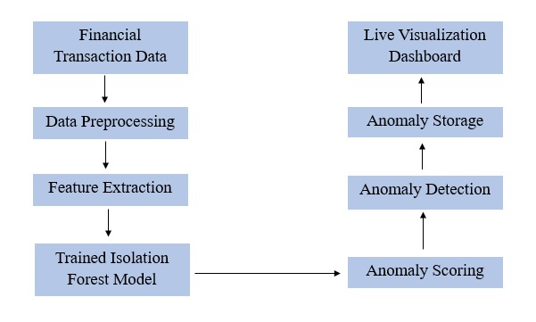
Fig. 1. System Architecture

Feature Selection
Feature selection is an important step that focuses on identifying the most relevant attributes from the transaction dataset that contribute to distinguishing normal and anomalous behaviour. Financial datasets often contain multiple features, but not all of them equally influence the detection process. Including irrelevant or noisy features can reduce model performance and increase computational complexity. Therefore, the selected features are those that capture meaningful transaction patterns such as amount, frequency, and behavioral characteristics. At this stage, categorical features are transformed into numerical representations using label encoding, where each unique category is assigned an integer value. This allows the model to process categorical data while maintaining the structure of the original information.

After selecting and encoding the features, scaling is applied to ensure uniformity across all input variables. In financial data, different features often exist on different scales—for example, transaction amounts may have large numerical values, while other attributes may have smaller ranges. If these differences are not addressed, features with higher magnitudes can dominate the model’s learning process, leading to biased results. To overcome this, standardization is used to normalize the data. The transformation is defined as:

$$z=\frac{X- }{}$$

Where 𝑋 represents the original feature value, μ is the mean of the feature, and σ is the standard deviation. This process converts all features into a standardized form with zero mean and unit variance.
The effect of standardization can also be understood in terms of statistical distribution. After scaling, each feature follows a normalized distribution where the variance is reduced to 1, ensuring consistency across all attributes. This is particularly important for algorithms like Isolation Forest, which rely on random feature selection and splitting. When features are properly scaled, the model treats all dimensions equally, improving its ability to isolate anomalies effectively. Overall, feature selection and scaling play a crucial role in enhancing model performance by reducing bias, improving stability, and ensuring that meaningful patterns in the data are accurately captured.

Models
Isolation Forest
The anomaly detection component of the proposed system is implemented using the Isolation Forest algorithm, which is well-suited for identifying rare and unusual patterns in large datasets. Unlike traditional machine learning models that attempt to learn the profile of normal data points, Isolation Forest is based on the principle of isolating observations. The key idea is that anomalous data points are fundamentally different from the majority and therefore can be separated more easily through random partitioning. This makes the algorithm particularly effective for financial datasets, where anomalies are rare and often do not follow a consistent pattern.
The algorithm operates by constructing an ensemble of decision trees, commonly referred to as isolation trees. Each tree is built using a random subset of the dataset. During the construction of a tree, a feature is selected randomly, and a split value is chosen randomly within the range of that feature. This recursive partitioning continues until the data point is isolated or a predefined tree height is reached. The number of splits required to isolate a data point is known as the path length. Data points that belong to dense regions of the dataset require more splits to be isolated, while outliers, being distinct and sparse, are isolated in fewer steps. This behaviour forms the foundation of anomaly detection in the Isolation Forest model.

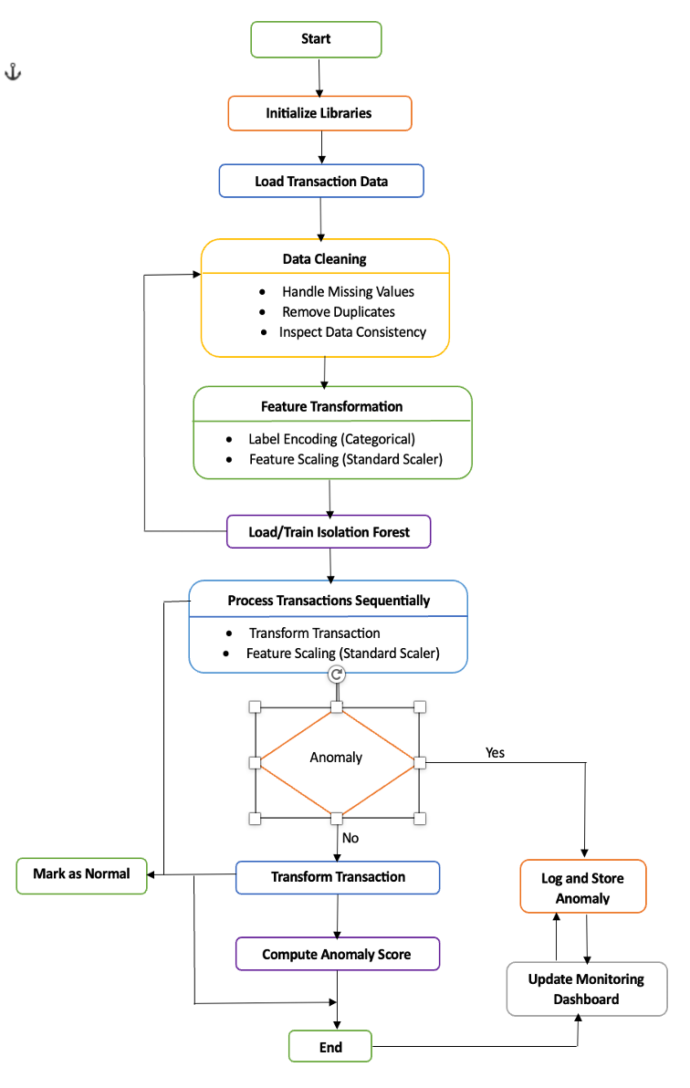
Fig. 2. Flowchart of Anomaly Detection Process

To quantify how anomalous a data point is, the algorithm computes an anomaly score based on the average path length across all trees in the forest. The score is given by:
$$Score\left(x\right)= 2^{-\frac{E(h\left(x\right))}{c(n)}}$$

where E(h(x)) represents the expected path length of a data point 𝑥 and 𝑐(𝑛) is the average path length of a binary search tree, which acts as a normalization factor for a dataset of size 𝑛. The value of 𝑐(𝑛) can be approximated as:

$$c\left(n\right)= 2H\left(n-1\right)-\frac{2(n-1)}{n}$$

where 𝐻(𝑛) is the harmonic number. This normalization ensures that anomaly scores are comparable across different dataset sizes. Transactions with shorter average path lengths produce higher anomaly scores, indicating a greater likelihood of being anomalous.
In practical implementation, the model is trained on the preprocessed dataset to learn the underlying distribution of normal transactions. Once trained, the model assigns a prediction label to each transaction, where typically “1” represents normal behaviour and “-1” indicates an anomaly. Additionally, the anomaly score provides a continuous measure of how unusual a transaction is, which can be useful for prioritizing suspicious activities.
One of the major advantages of Isolation Forest is its efficiency and scalability. Since it relies on random sampling and partitioning, it has a lower computational cost compared to many other anomaly detection techniques. It also performs well in high-dimensional spaces and does not require feature distribution assumptions. Moreover, it does not depend on labeled data, which makes it highly suitable for real-world financial systems where anomalies are often unknown or evolving.
In this system, the Isolation Forest model is integrated into a real-time simulation pipeline, where each incoming transaction is processed individually. The model evaluates each transaction based on learned patterns and determines whether it deviates significantly from normal behaviour. This enables continuous and efficient detection of anomalous transactions, making the approach practical for real-time financial monitoring applications.

Results and Discussions
The performance of the proposed anomaly detection system was evaluated using a financial transaction dataset processed in a simulated real-time environment. The system processes transactions sequentially and evaluates each entry using the trained Isolation Forest model to determine whether it deviates from normal behavior. The results obtained from this process demonstrate that the model is capable of identifying unusual transaction patterns effectively without relying on labeled data.
As the system runs, detected anomalies are recorded along with their corresponding anomaly scores and timestamps. These outputs provide both qualitative and quantitative insights into abnormal behavior. A sample of the detected anomalies is shown below, which includes transaction details along with their associated anomaly scores.
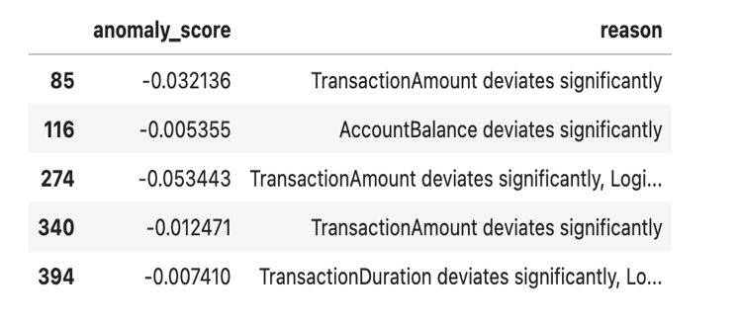Fig. 3. Sample of detected anomalous transactions
From the table, it can be observed that the model assigns different anomaly scores to transactions based on their level of deviation. Transactions with lower scores indicate stronger abnormality, suggesting that they are significantly different from the majority of the data. This confirms that the model is not only identifying anomalies but also providing a meaningful measure of how unusual each transaction is.

To monitor system activity, a dashboard is used to display key metrics such as the total number of anomalies detected, system status, and the most recent update time. These metrics are updated continuously as new transactions are processed, providing a real-time view of system performance.

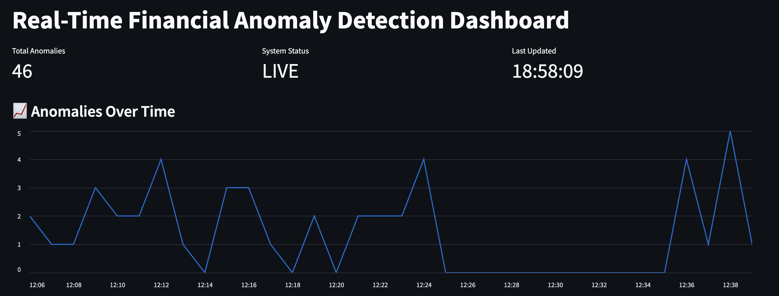Fig. 4. Dashboard showing Time-based visualization of anomaly occurrences
The continuous update of these values indicates that the system is functioning without interruption and is capable of handling sequential data efficiently. The live status indicator further confirms that the system is actively processing incoming transactions, which is essential for real-time applications.
A time-based analysis of anomalies was performed to understand how abnormal transactions are distributed over time. The anomalies were grouped based on their timestamps and visualized using a time-series graph.
The graph shows that anomalies are not evenly distributed but tend to occur in clusters. This behaviour suggests that certain periods may experience higher levels of abnormal activity, which could be indicative of suspicious patterns. Such temporal insights are valuable in real-world systems, as they help in identifying bursts of unusual behaviour that may require immediate attention.

In addition to temporal analysis, the system also provides a view of recently detected anomalies through a tabular representation. This allows users to quickly inspect the latest transactions flagged by the model and understand their characteristics.

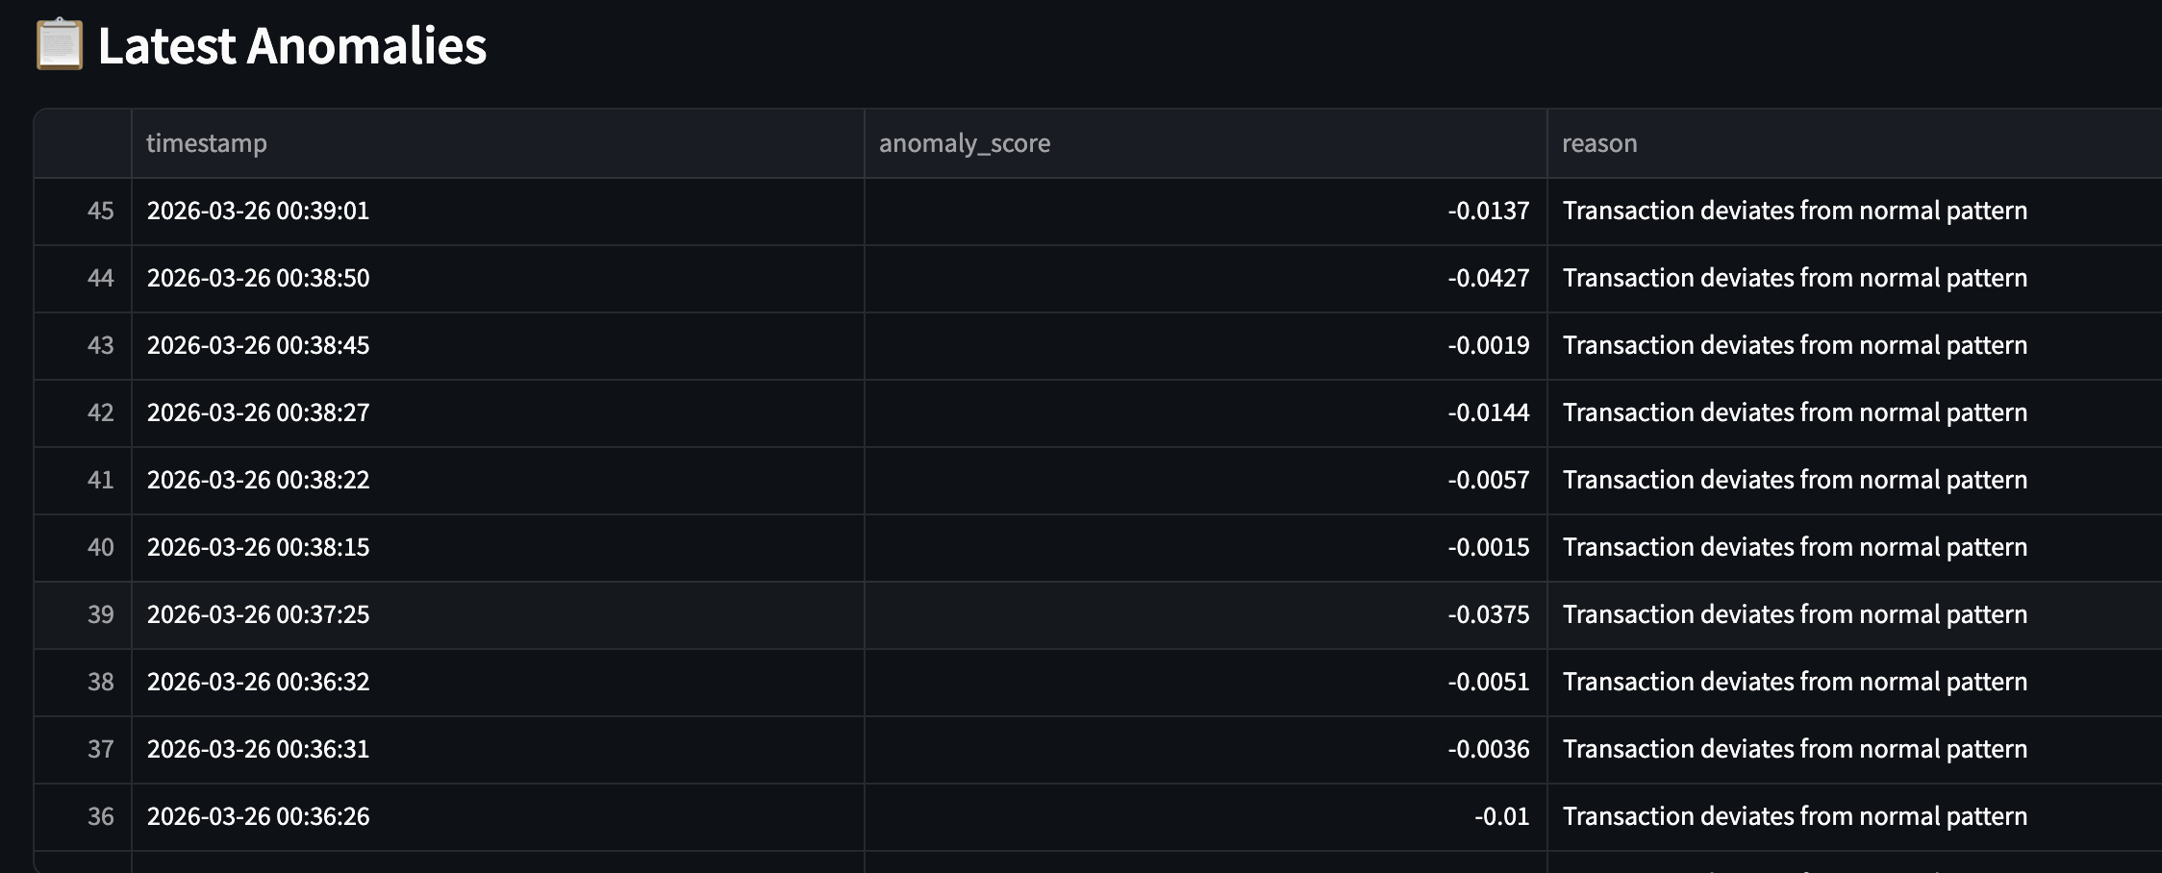
Fig. 5. Recent anomalies displayed in the dashboard

This representation improves usability by enabling quick access to relevant information without requiring manual data filtering. It also helps in tracking recent activity and understanding how frequently anomalies are being detected.
Another important aspect of the analysis is the distribution of anomaly scores, which provides insight into how strongly transactions deviate from normal patterns. This is visualized using a bar chart that represents the variation in anomaly scores across detected anomalies.
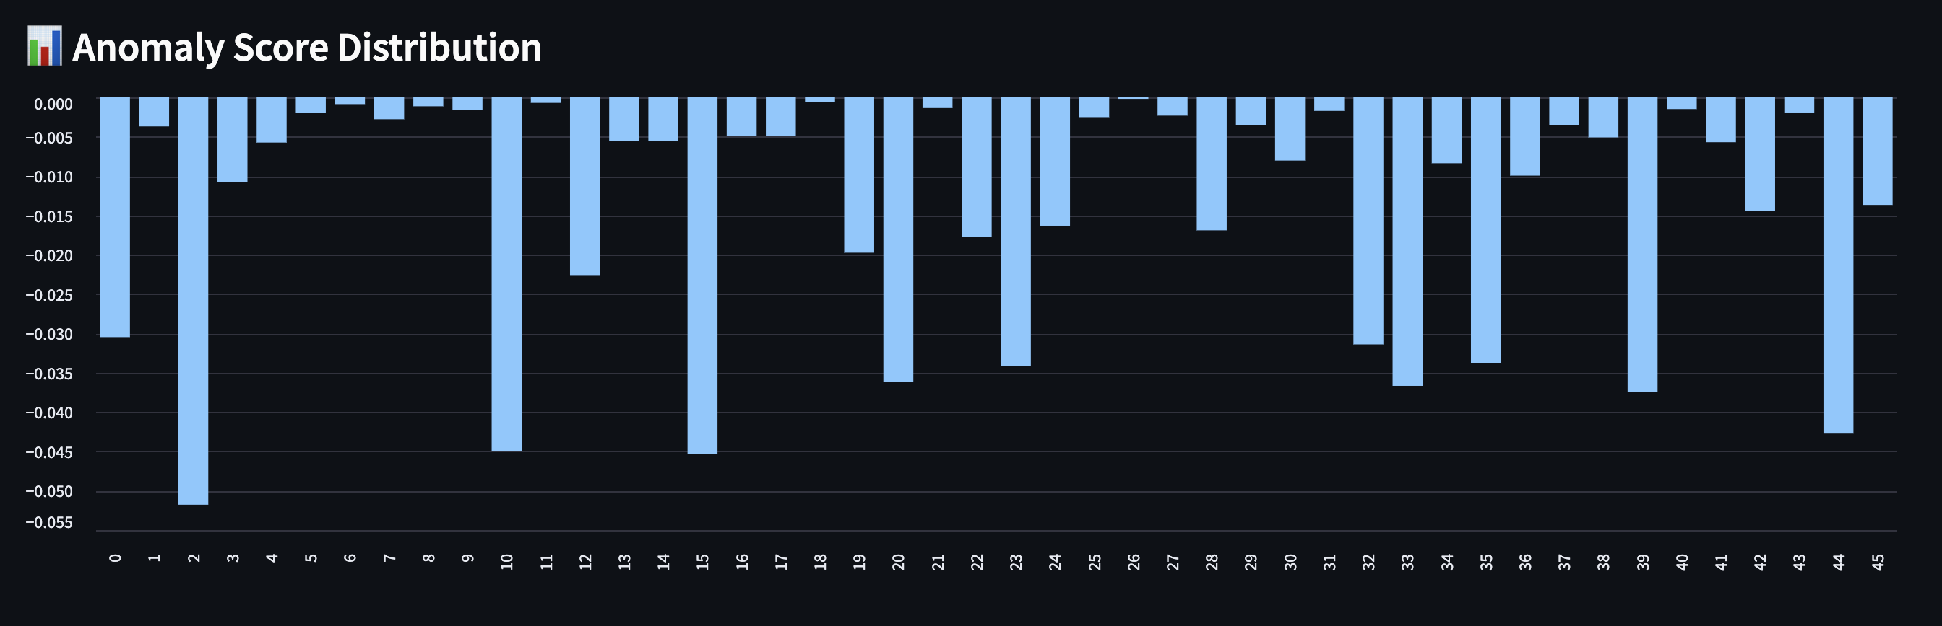
Fig. 6. Distribution of Anomaly Scores

he distribution indicates that anomalies vary in intensity, with some transactions being significantly more unusual than others. This variation is useful for prioritizing further investigation, as transactions with more extreme scores can be considered higher risk. It also demonstrates that the model captures subtle as well as strong deviations in the dataset.
Overall, the results demonstrate that the proposed system is effective in detecting anomalies in financial transactions within a near real-time setting. The combination of preprocessing, feature transformation, and the Isolation Forest algorithm enables accurate identification of unusual patterns. The simulated real-time processing approach ensures that transactions are evaluated continuously, while the dashboard provides clear and interactive visualization of system behaviour.
One of the key observations from the results is that anomaly detection is not only dependent on individual feature values but also on the overall pattern of the transaction. The model successfully identifies complex deviations that may not be captured by simple rule-based systems. At the same time, the system maintains simplicity and efficiency by avoiding the need for complex infrastructure.
Although the system performs well in detecting anomalies, it is important to note that unsupervised models may require further validation in certain cases where anomalies are less distinct. Despite this limitation, the overall performance indicates that the proposed approach provides a practical and scalable solution for financial anomaly detection, balancing accuracy, efficiency, and real-time responsiveness.

Conclusion
The proposed work presents a practical and efficient approach for detecting anomalous financial transactions using an unsupervised machine learning framework. The system combines essential stages such as data preprocessing, feature transformation, and anomaly detection to build a structured pipeline capable of identifying deviations from normal transaction behaviour. By utilizing the Isolation Forest algorithm, the model is able to detect rare and unusual patterns without requiring labeled data, which is particularly useful in real-world financial scenarios. The sequential processing of transactions enables a near real-time simulation, allowing the system to continuously evaluate incoming data. In addition, the integration of a live dashboard provides a clear and interactive visualization of detected anomalies, helping users understand system behaviour and monitor trends effectively.
The results demonstrate that the system performs reliably in identifying anomalous transactions while maintaining a balance between simplicity and effectiveness. The modular design ensures that different components of the system work seamlessly together, making it easy to maintain and extend for future enhancements. However, the current implementation is limited by its reliance on simulated streaming and the lack of detailed interpretability in anomaly detection decisions. Future work can focus on integrating real-time streaming technologies such as Kafka or Spark to handle large-scale data more efficiently, along with incorporating explainable AI techniques to provide better insights into model predictions. Overall, the proposed system offers a strong foundation for developing scalable and practical anomaly detection solutions in financial applications.

REFERENCES
[1] Dumitrescu, B., Băltoiu, A., & Budulan, Ş. (2022). Anomaly detection in graphs of bank transactions for anti money laundering applications. IEEE Access, 10, 47699-47714.
[2] Daksa, R. Procediaala, A. P. (2025). A Comparative Study On Real Time Data Streaming For Fraud Detection Using Kafka With Apache Flink And Apache Spark. Procedia Computer Science, 269, 192-199.
[3] Stahmann, P., Nebel, M., & Janiesch, C. (2025). AI-based real-time anomaly detection in industrial engineering: A structured literature review, taxonomy, and research agenda. Computers & Industrial Engineering, 111236.
[4] Mandlik, A. S., Ganeshpure, M. S., Kadadas, C. N., Korra, L., Kidav, J. U., & Lavadkar, M. A. (2025, August). AI-Driven Real-Time Threat Detection for UPI Transactions. In 2025 International Conference on Applications of Machine Intelligence and Data Analytics (ICAMIDA) (pp. 1-3). IEEE.
[5] Gadimov, E., & Birihanu, E. (2025). Real-time suspicious detection framework for financial data streams. International Journal of Information Technology, 1-17.
[6] Wang, F., Jiang, Y., Zhang, R., Wei, A., Xie, J., & Pang, X. (2025). A survey of deep anomaly detection in multivariate time series: taxonomy, applications, and directions. Sensors (Basel, Switzerland), 25(1), 190.
[7] Jain, R., & Deshwal, S. ‘Anomaly detection in bank transactions using machine learning. Tech. Rep.
[8] Li, Y., Wu, N., Tang, D., & Zhang, X. (2025, June). Research on Anomaly Detection Algorithm System for Financial Transaction Data Processing Based on Deep Learning. In 2025 IEEE 3rd International Conference on Image Processing and Computer Applications (ICIPCA) (pp. 1562-1566). IEEE.
[9] Rahmati, M. (2025). Real-Time Financial Fraud Detection Using Adaptive Graph Neural Networks and Federated Learning. Int. J. Management and Data Analytics, 5(1), 98-110.
[10] Acharjee, S., Bhattacharjee, P., Mondal, S., Goswami, S., Sadhukhan, S., Mukherjee, A., & Das, A. (2025, July). Streaming-Based Anomaly Detection for Real-Time Scalable Credit Card Fraud Prevention: A Comparative Study. In 2025 International Conference on Engineering Innovations and Technologies (ICoEIT) (pp. 736-740). IEEE.

