Step1: RawData_set in JSON (EAGLEEYE_OCC_CAMPAIGN_DETAILS):

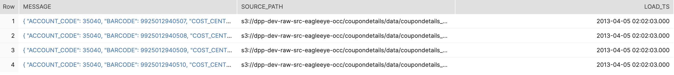

Step2: Parse Data Set (EAGLEEYE_OCC_CAMPAIGN_DETAILS_BATCH_LOAD)

Step3: data in View

Step4: Data in SAT

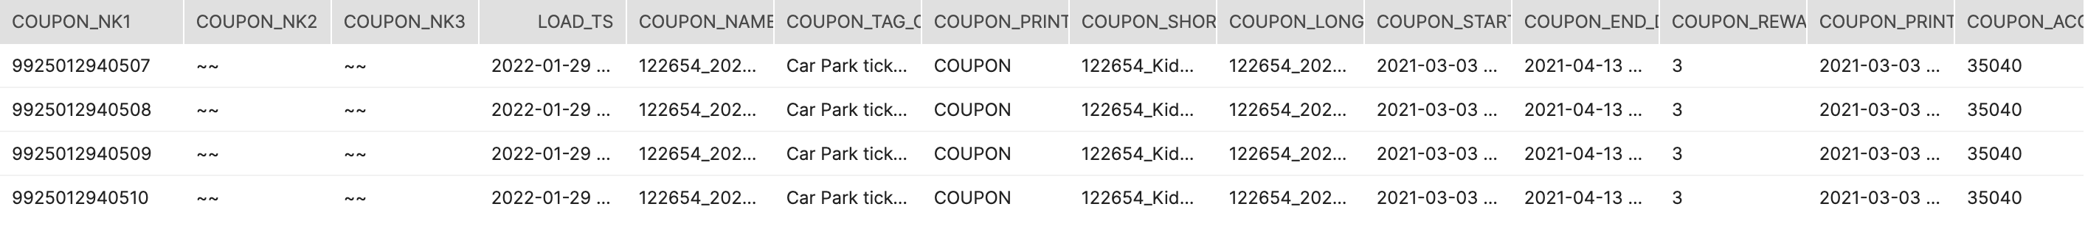

Step5: Data in BDV

