BMS COLLEGE OF ENGINEERING
(Autonomous College under VTU)
Bull Temple Road, Basavanagudi, Bangalore - 560019
A project report
on
“SENTINELGATE: BORDER SECURITY INTELLIGENCE &
PASSENGER COMPLIANCE PORTAL”
Submitted in partial fulfilment of the requirements for the award of degree
BACHELOR OF ENGINEERING IN
COMPUTER SCIENCE AND BUSINESS SYSTEMS
By
SRUJAN S (1BM22CS000)
SALMAN SHAIKH (1BM22CS000)
Faculty in Charge
Prof. Tejaswini K
Assistant Professor
Department of Computer Science and Business Systems
2025-2026

BMS COLLEGE OF ENGINEERING
(Autonomous College under VTU)
Bull Temple Road, Basavanagudi, Bangalore - 560019
Department of Computer Science and Business Systems
C E R T I F I C A T E
This is to certify that the project report on “SENTINELGATE: BORDER SECURITY INTELLIGENCE & PASSENGER COMPLIANCE PORTAL” is a bona-fide work carried out by SRUJAN S (1BM22CS000) & SALMAN SHAIKH (1BM22CS000) in partial fulfilment for the award of degree of Bachelor of Engineering in Computer Science and Business Systems from Visvesvaraya Technological University, Belgaum during the year 2025-2026. The report has been approved as it satisfies the academic requirements in respect of technical activity prescribed for the Bachelor of Engineering Degree.
Signature of the Faculty In charge  Prof. Tejaswini K  Assistant Professor  Dept of CSBS, BMSCE | Signature of the HoD  Dr. R. Ashok Kumar  Professor and HoD  Dept of CSBS, BMSCE

Table of Content
Sl. No | Topic | Page No.
1 | INTRODUCTION | 4
2 | OBJECTIVES | 6
3 | ER DIAGRAM | 7
4 | SCHEMA DESIGN | 8
5 | IMPLEMENTATION DETAILS | 12
6 | SCREENSHOTS OF OUTPUTS | 14

1. INTRODUCTION
SentinelGate Border Intelligence is a next-generation security compliance framework designed to automate and streamline border control operations. Modeled after modern contactless digital identity paradigms such as DigiYatra, the platform establishes a seamless passenger journey from registration to final flight boarding. SentinelGate integrates high-performance facial biometrics, automated passport optical character recognition (OCR), and border risk analysis to ensure secure, rapid processing. Additionally, the system provides immutable security audits using a synchronized blockchain-inspired ledger layout to prevent historical border record tampering.
In the current global climate, border checkpoints face dual challenges: escalating security threat risks and rising congestion due to outdated manual screening. SentinelGate addresses both challenges by shifting the verification burden onto decentralized automated nodes. Using a unified local database synchronization layer, it enables quick passenger onboarding and links legal passport documentation, face biometrics, and active airline boarding passes into a single tamper-proof token credentials package. Officers are provided with deep-search query consoles and reltional models to track traveler itineraries dynamically.
1.1 Software Architecture and Tech Stack
The application utilizes a robust, real-time technology stack structured as follows:
- Core Architecture: Next.js 16.x App Router featuring rapid Turbopack compilation processes.
- Frontend & Logic: TypeScript for strict type-safe UI modules, and modern JavaScript (ES6+).
- Database Management System: Supabase PostgreSQL, providing enterprise relational capabilities, transaction integrity, and foreign key validations.
- Biometrics Engine: face-api.js running client-side local neural network inference (SSD MobileNet V1 models) for face detection, landmark mapping, and descriptor comparison.
- Immigration Radar Map: React Simple Maps and World Atlas TopoJSON for rendering real-time geospatial travel crossing vector logs.
- Ledger Encryption: SHA-256 cryptographic chain blocks acting as an audit register to detect data manipulation.

2. OBJECTIVES
The primary objective of SentinelGate is to replace traditional, bottleneck-prone paper border clearances with an intelligent, paperless, and contactless digital framework. The key sub-objectives are:
- Automate Check-in Pipelines: Facilitate online passport OCR verification and biometric enrollment to eliminate manual airport desk verification queues.
- Execute Live Facial Matching: Deploy client-side browser neural networks to match traveler webcam feeds against registered descriptors, confirming identity at boarding gates in under 2 seconds.
- Implement Real-Time Risk Indexing: Formulate security profiles dynamically combining passport pattern checks, origin country geopolitical risk levels, and national watchlist databases.
- Deliver Decentralized Ledger Audits: Store all border check-in crossings in an immutable, cryptographically chained block ledger, making any unauthorized database manipulation instantly detectable.
- Ensure Unified Officer View: Equip security agents with visual map trackers, detailed dossier inspectors, threat flags, SQL database command inputs, and log ledgers in a single responsive command dashboard.

3. ER DIAGRAM
The SentinelGate database is designed around a relational schema containing five core tables. The relationships enforce strict database constraints (foreign keys, uniques, and cascade deletes) to ensure data integrity across immigration checkpoints:
- users ➔ passengers: A user account (identified by UUID) links to exactly one passenger profile. This represents a 1:1 relationship where users.id acts as a foreign key on passengers.user_id.
- passengers ➔ passport_verifications: Each passenger legal profile is associated with exactly one passport OCR record. This is a 1:1 unique relationship (passengers.id REFERENCES passport_verifications.passenger_id).
- passengers ➔ face_enrollments: Each passenger is linked to exactly one biometric face description model. This enforces a 1:1 constraint to prevent duplicate biometric registrations across accounts.
- passengers ➔ boarding_passes: Each passenger links to exactly one active flight boarding coupon (1:1 constraint mapping seat numbers, cabin class, booking PNR, and travel dates).
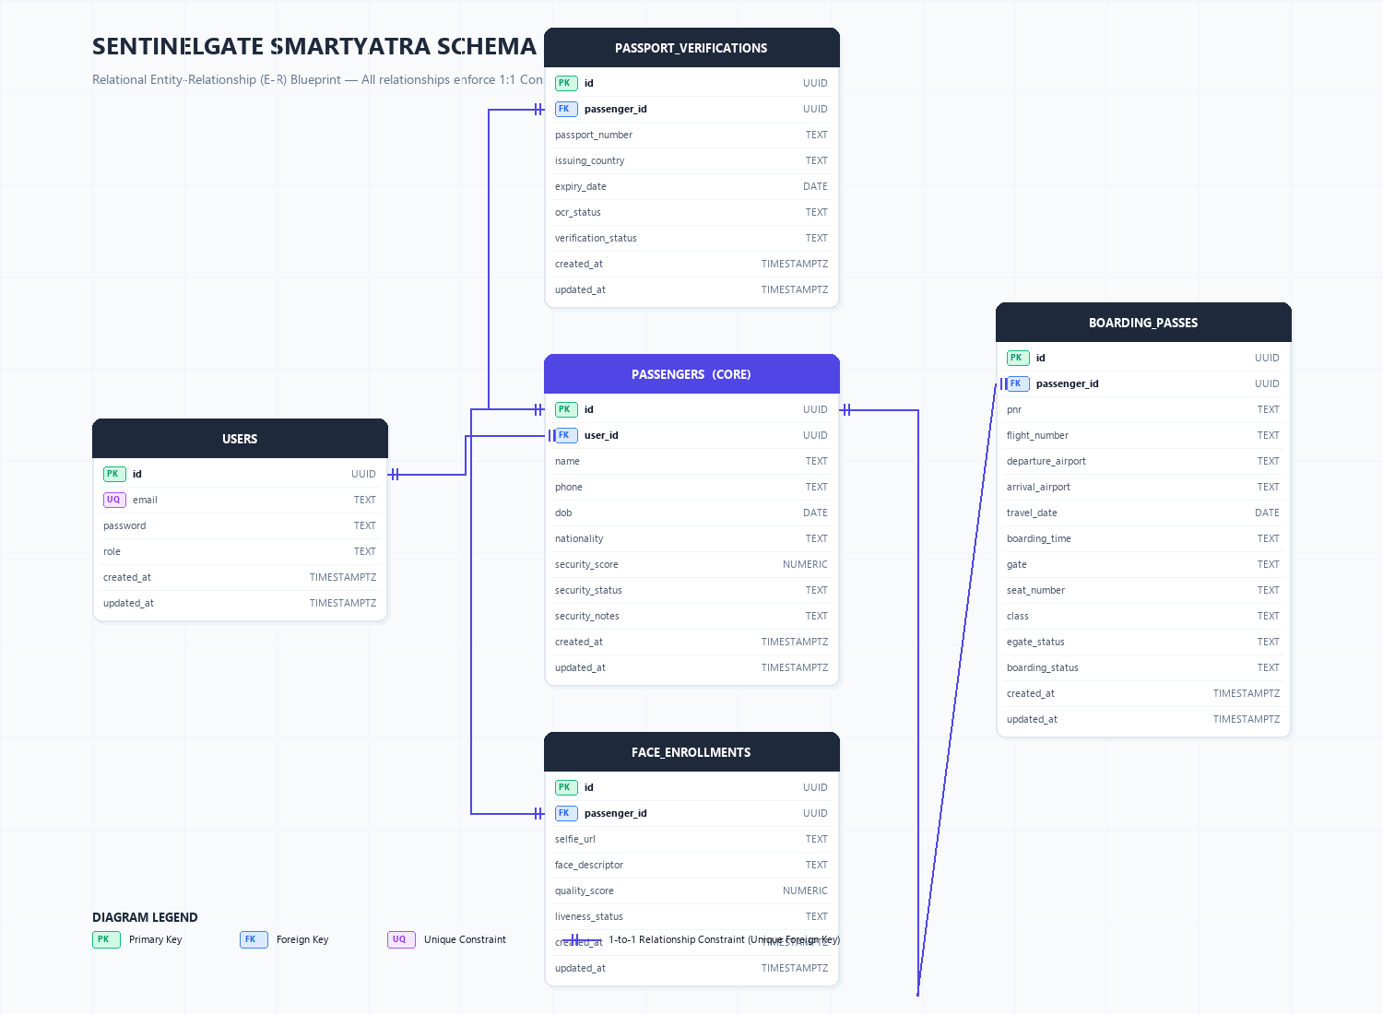

4. SCHEMA DESIGN (TABLE STRUCTURES)
4.1 Table: users
Stores authentication details and access roles.
Column Name | Data Type | Constraints & Description
id | UUID [PK] | PRIMARY KEY, auto-generated uuid_generate_v4()
email | TEXT | UNIQUE NOT NULL, user login identifier
password | TEXT | NOT NULL, hashed/plain credentials (default 'Pass123')
role | TEXT | NOT NULL, system access tier: 'passenger' or 'admin'
created_at | TIMESTAMP | Time of registration
updated_at | TIMESTAMP | Last update timestamp

4.2 Table: passengers
Maintains passenger legal profile details and computed security risk status.
Column Name | Data Type | Constraints & Description
id | UUID [PK] | PRIMARY KEY, auto-generated uuid_generate_v4()
user_id | UUID [FK] | REFERENCES users(id) ON DELETE SET NULL
name | TEXT | NOT NULL, full legal passenger name (upper-cased)
phone | TEXT | Contact mobile numbers
dob | DATE | Legal date of birth
nationality | TEXT | Citizenship nationality (default 'Indian')
security_score | NUMERIC | Computed risk percentage score (0-100, default 20)
security_status | TEXT | Status evaluation: 'SAFE', 'SECONDARY CHECK', 'HIGH RISK'
security_notes | TEXT | Security details or manual officer remarks
created_at | TIMESTAMP | Registration time
updated_at | TIMESTAMP | Last modification time

4.3 Table: passport_verifications
Maintains extracted passport OCR document credentials.
Column Name | Data Type | Constraints & Description
id | UUID [PK] | PRIMARY KEY, auto-generated uuid_generate_v4()
passenger_id | UUID [FK, UNIQUE] | UNIQUE, REFERENCES passengers(id) ON DELETE CASCADE
passport_number | TEXT | Passport document ID (uppercase)
issuing_country | TEXT | Country of passport authority
expiry_date | DATE | Document validity limit date
ocr_status | TEXT | OCR parsing outcome: 'PENDING', 'SUCCESS', 'FAILED'
verification_status | TEXT | Border verify: 'PENDING', 'VERIFIED', 'REJECTED'
created_at | TIMESTAMP | Time of scanning
updated_at | TIMESTAMP | Last update time

4.4 Table: face_enrollments
Holds facial biometric descriptors and liveness validation scores.
Column Name | Data Type | Constraints & Description
id | UUID [PK] | PRIMARY KEY, auto-generated uuid_generate_v4()
passenger_id | UUID [FK, UNIQUE] | UNIQUE, REFERENCES passengers(id) ON DELETE CASCADE
selfie_url | TEXT | Biometric selfie image reference payload
face_descriptor | TEXT | High-dimensional facial landmark feature vector string representation
quality_score | NUMERIC | biometric registration clarity score (0.0 - 1.0)
liveness_status | TEXT | Verification state: 'PENDING', 'VERIFIED', 'FAILED'
created_at | TIMESTAMP | Biometric registration time
updated_at | TIMESTAMP | Last modification time

4.5 Table: boarding_passes
Voyage boarding tickets and clearance milestones.
Column Name | Data Type | Constraints & Description
id | UUID [PK] | PRIMARY KEY, auto-generated uuid_generate_v4()
passenger_id | UUID [FK, UNIQUE] | UNIQUE, REFERENCES passengers(id) ON DELETE CASCADE
pnr | TEXT | PNR booking reservation code (6-character uppercase)
flight_number | TEXT | Flight identifier number
departure_airport | TEXT | Departure airport code (e.g. DEL, BOM)
arrival_airport | TEXT | Arrival destination airport code (e.g. JFK, LHR)
travel_date | DATE | Flight departure date
boarding_time | TEXT | Scheduled boarding time slot
gate | TEXT | Terminal gate code
seat_number | TEXT | Assigned seat string
class | TEXT | Cabin class: 'Economy', 'Business', 'First'
egate_status | TEXT | E-gate clearance state: 'PENDING', 'VERIFIED', 'DENIED'
boarding_status | TEXT | Final boarding state: 'PENDING', 'BOARDED', 'FAILED'
created_at | TIMESTAMP | Ticket link time
updated_at | TIMESTAMP | Last update time

4.6 Supabase PostgreSQL Database Initialisation DDL Script
Below is the complete Structured Query Language (SQL) Data Definition Language (DDL) code used to initialize the database tables, indices, and constraints on Supabase:
-- SentinelGate AI SmartYatra Database Schema (Supabase PostgreSQL - 5 Tables)
-- Copy and paste this code into your Supabase SQL Editor to build/rebuild the tables.
-- Enable UUID extension if not already enabled
CREATE EXTENSION IF NOT EXISTS "uuid-ossp";
-- Drop existing tables in reverse order of dependency to prevent constraint issues
DROP TABLE IF EXISTS boarding_passes CASCADE;
DROP TABLE IF EXISTS face_enrollments CASCADE;
DROP TABLE IF EXISTS passport_verifications CASCADE;
DROP TABLE IF EXISTS passengers CASCADE;
DROP TABLE IF EXISTS users CASCADE;
-- 1. users Table (handles authentication & user profiles)
CREATE TABLE users (
id UUID PRIMARY KEY DEFAULT uuid_generate_v4(),
email TEXT UNIQUE NOT NULL,
password TEXT NOT NULL DEFAULT 'Pass123',
role TEXT NOT NULL DEFAULT 'passenger', -- passenger or admin
created_at TIMESTAMP WITH TIME ZONE DEFAULT CURRENT_TIMESTAMP,
updated_at TIMESTAMP WITH TIME ZONE DEFAULT CURRENT_TIMESTAMP
);
-- Create index on user email
CREATE INDEX IF NOT EXISTS idx_users_email ON users(email);
-- 2. passengers Table (passenger legal details & security clearance status)
CREATE TABLE passengers (
id UUID PRIMARY KEY DEFAULT uuid_generate_v4(),
user_id UUID REFERENCES users(id) ON DELETE SET NULL,
name TEXT NOT NULL,
phone TEXT,
dob DATE,
nationality TEXT NOT NULL DEFAULT 'Indian',
security_score NUMERIC NOT NULL DEFAULT 20,
security_status TEXT NOT NULL DEFAULT 'SAFE', -- SAFE, SECONDARY CHECK, HIGH RISK
security_notes TEXT DEFAULT 'No threat flags identified.',
created_at TIMESTAMP WITH TIME ZONE DEFAULT CURRENT_TIMESTAMP,
updated_at TIMESTAMP WITH TIME ZONE DEFAULT CURRENT_TIMESTAMP
);
CREATE INDEX IF NOT EXISTS idx_passengers_user ON passengers(user_id);
-- 3. passport_verifications Table (OCR scanning validation details)
CREATE TABLE passport_verifications (
id UUID PRIMARY KEY DEFAULT uuid_generate_v4(),
passenger_id UUID UNIQUE REFERENCES passengers(id) ON DELETE CASCADE,
passport_number TEXT NOT NULL,
issuing_country TEXT NOT NULL,
expiry_date DATE NOT NULL,
ocr_status TEXT NOT NULL DEFAULT 'PENDING', -- PENDING, SUCCESS, FAILED
verification_status TEXT NOT NULL DEFAULT 'PENDING', -- PENDING, VERIFIED, REJECTED
created_at TIMESTAMP WITH TIME ZONE DEFAULT CURRENT_TIMESTAMP,
updated_at TIMESTAMP WITH TIME ZONE DEFAULT CURRENT_TIMESTAMP
);
CREATE INDEX IF NOT EXISTS idx_passports_number ON passport_verifications(passport_number);
-- 4. face_enrollments Table (passenger biometric enrollment & liveness check status)
CREATE TABLE face_enrollments (
id UUID PRIMARY KEY DEFAULT uuid_generate_v4(),
passenger_id UUID UNIQUE REFERENCES passengers(id) ON DELETE CASCADE,
selfie_url TEXT NOT NULL, -- Stored image payload reference
face_descriptor TEXT, -- Comma-separated Float32Array string representation
quality_score NUMERIC NOT NULL DEFAULT 0.0,
liveness_status TEXT NOT NULL DEFAULT 'PENDING', -- PENDING, VERIFIED, FAILED
created_at TIMESTAMP WITH TIME ZONE DEFAULT CURRENT_TIMESTAMP,
updated_at TIMESTAMP WITH TIME ZONE DEFAULT CURRENT_TIMESTAMP
);
-- 5. boarding_passes Table (passenger boarding passes, flight journey, E-gate and Boarding status)
CREATE TABLE boarding_passes (
id UUID PRIMARY KEY DEFAULT uuid_generate_v4(),
passenger_id UUID UNIQUE REFERENCES passengers(id) ON DELETE CASCADE,
pnr TEXT NOT NULL,
flight_number TEXT NOT NULL,
departure_airport TEXT NOT NULL,
arrival_airport TEXT NOT NULL,
travel_date DATE NOT NULL,
boarding_time TEXT NOT NULL,
gate TEXT NOT NULL,
seat_number TEXT NOT NULL,
class TEXT NOT NULL DEFAULT 'Economy', -- Economy, Business, First
egate_status TEXT NOT NULL DEFAULT 'PENDING', -- PENDING, VERIFIED, DENIED
boarding_status TEXT NOT NULL DEFAULT 'PENDING', -- PENDING, BOARDED, FAILED
created_at TIMESTAMP WITH TIME ZONE DEFAULT CURRENT_TIMESTAMP,
updated_at TIMESTAMP WITH TIME ZONE DEFAULT CURRENT_TIMESTAMP
);
CREATE INDEX IF NOT EXISTS idx_boarding_pnr ON boarding_passes(pnr);
CREATE INDEX IF NOT EXISTS idx_boarding_flight ON boarding_passes(flight_number);
-- POPULATE SEED PASSENGERS FOR OFFLINE/DEMO PURPOSES
-- Admin User
INSERT INTO users (id, email, password, role)
VALUES ('admin-uid-12345', 'admin@sentinelgate.gov', 'AdminSecurityTopRisk04822', 'admin')
ON CONFLICT (email) DO NOTHING;
-- Traveler 1 (Sarah Connor)
INSERT INTO users (id, email, password, role)
VALUES ('user-sarah-123', 'sarah@smarttravel.in', 'Pass123', 'passenger')
ON CONFLICT (email) DO NOTHING;
INSERT INTO passengers (id, user_id, name, phone, dob, nationality, security_score, security_status, security_notes)
VALUES ('passenger-sarah-123', 'user-sarah-123', 'SARAH CONNOR', '+91 9876543210', '1990-05-15', 'Indian', 20, 'SAFE', 'Clear background checks.')
ON CONFLICT (id) DO NOTHING;
INSERT INTO passport_verifications (id, passenger_id, passport_number, issuing_country, expiry_date, ocr_status, verification_status)
VALUES ('passport-sarah-123', 'passenger-sarah-123', 'J1234567', 'India', '2035-12-31', 'SUCCESS', 'VERIFIED')
ON CONFLICT (id) DO NOTHING;
INSERT INTO face_enrollments (id, passenger_id, selfie_url, quality_score, liveness_status)
VALUES ('face-sarah-123', 'passenger-sarah-123', '/mock_selfie.jpg', 0.98, 'VERIFIED')
ON CONFLICT (id) DO NOTHING;
INSERT INTO boarding_passes (id, passenger_id, pnr, flight_number, departure_airport, arrival_airport, travel_date, boarding_time, gate, seat_number, class, egate_status, boarding_status)
VALUES ('bp-sarah-123', 'passenger-sarah-123', 'PNR10293', 'SG-302', 'DEL', 'JFK', CURRENT_DATE, '19:30', 'Gate B12', 'Seat 12A', 'Economy', 'PENDING', 'PENDING')
ON CONFLICT (id) DO NOTHING;
-- Traveler 2 (Donald Trump)
INSERT INTO users (id, email, password, role)
VALUES ('user-trump-123', 'donald@trump.com', 'Pass123', 'passenger')
ON CONFLICT (email) DO NOTHING;
INSERT INTO passengers (id, user_id, name, phone, dob, nationality, security_score, security_status, security_notes)
VALUES ('passenger-trump-123', 'user-trump-123', 'DONALD TRUMP', '+1 555-0199', '1946-06-14', 'United States', 85, 'HIGH RISK', 'Flagged High-Risk VIP - Watchlist Interpol.')
ON CONFLICT (id) DO NOTHING;
INSERT INTO passport_verifications (id, passenger_id, passport_number, issuing_country, expiry_date, ocr_status, verification_status)
VALUES ('passport-trump-123', 'passenger-trump-123', 'W0000001', 'United States', '2032-06-14', 'SUCCESS', 'VERIFIED')
ON CONFLICT (id) DO NOTHING;
INSERT INTO face_enrollments (id, passenger_id, selfie_url, quality_score, liveness_status)
VALUES ('face-trump-123', 'passenger-trump-123', '/trump_target.jpg', 0.99, 'VERIFIED')
ON CONFLICT (id) DO NOTHING;
INSERT INTO boarding_passes (id, passenger_id, pnr, flight_number, departure_airport, arrival_airport, travel_date, boarding_time, gate, seat_number, class, egate_status, boarding_status)
VALUES ('bp-trump-123', 'passenger-trump-123', 'PNR29482', 'AI-101', 'BOM', 'LHR', CURRENT_DATE, '20:15', 'Gate C04', 'Seat 01F', 'First', 'PENDING', 'PENDING')
ON CONFLICT (id) DO NOTHING;

5. IMPLEMENTATION DETAILS
SentinelGate combines frontend logic modules and database integrations to achieve high-security compliance. The core technical features are implemented as follows:
Real-time Neural Biometrics (face-api.js)
Facial biometrics calculations execute locally on client machines. The webcam feed reads facial structures and compiles a 128-point feature float descriptor. The liveness model parses face landmark dimensions, ensuring a physical human is present before storing biometrics in the database.
Machine-Readable Passport OCR Parsing
When travelers upload a passport scan, the optical scanner extracts the passenger's given names, document numbers, nationalities, and document expiry dates. Standard validation expressions reject malformed credentials.
Geopolitical Risk Scoring Algorithm
Security checkpoints run a dynamic risk algorithm: Risk Score = (0.5 * Country Geopolitical Score) + (0.3 * Passport Format Check) + (0.2 * National Watchlist Match). Watchlist overlaps trigger alert codes, redirecting passengers for physical screening.
Cryptographic Ledger Auditing
To guarantee record immutability, check-in operations generate cryptographic blocks containing mined timestamps, actions, and SHA-256 hashes linked to the preceding block. If database entries are tampered with, the hash links break, signaling alarm flags on officer command screens.
Interactive Passenger Journey Roadmap
The portal utilizes a state-aware progress roadmap. The system hides admin menus for passengers, guiding them step-by-step through: Account registration ➔ Passport scanning ➔ Face enrollment ➔ Journey code linking ➔ E-Gate scanner clearance ➔ Boarding.

6. SCREENSHOTS OF OUTPUTS
This section contains visual output verification captures of the SentinelGate compliance portal. Each screenshot displays a specific check-in milestone or database ledger command console:
6.1 Passenger Portal Login Screen
The entry point for passenger account registrations and portal sessions.
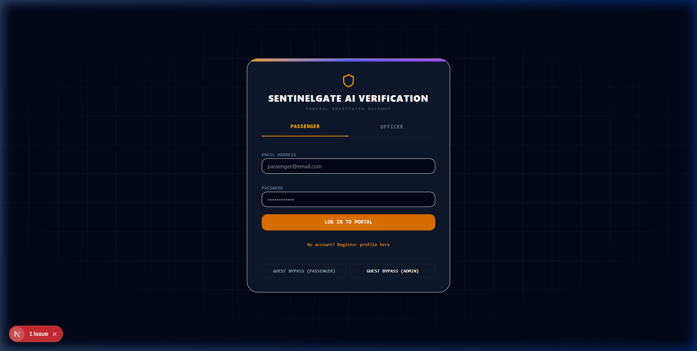

6.2 Passenger Digital ID Pass & Roadmap
Displays the traveler's digital credential card, verification status codes, and journey roadmap milestones.
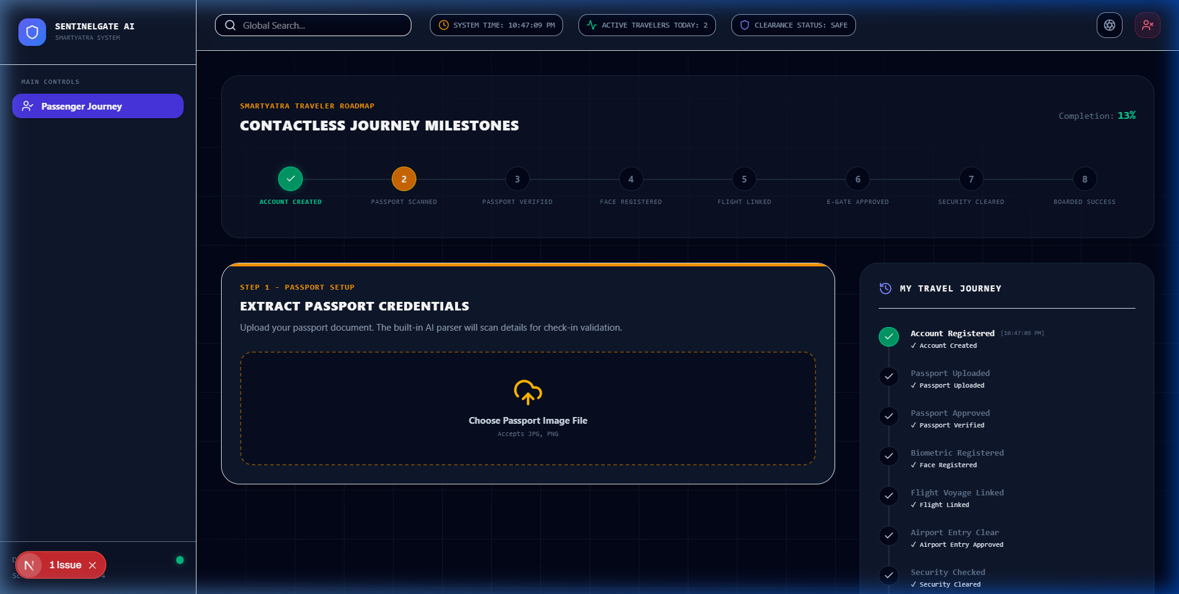

6.3 Passport OCR Scanning Interface
The side-by-side scan terminal displaying parsed passport document details.


6.4 Biometric Selfie Enrollment view
The biometric webcam registration layout displaying facial descriptor quality checking gauges.


6.5 Live border E-Gate simulation
Automated E-Gate webcam screen displaying face verification match confirmation logs.
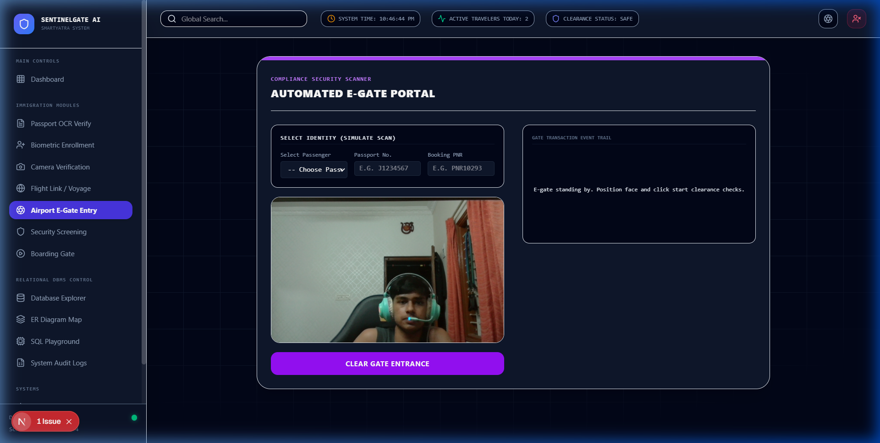

6.6 Border Command Officers Dashboard
The overview dashboard showing real-time geospatial flight paths, threat charts, and watchlist logs.
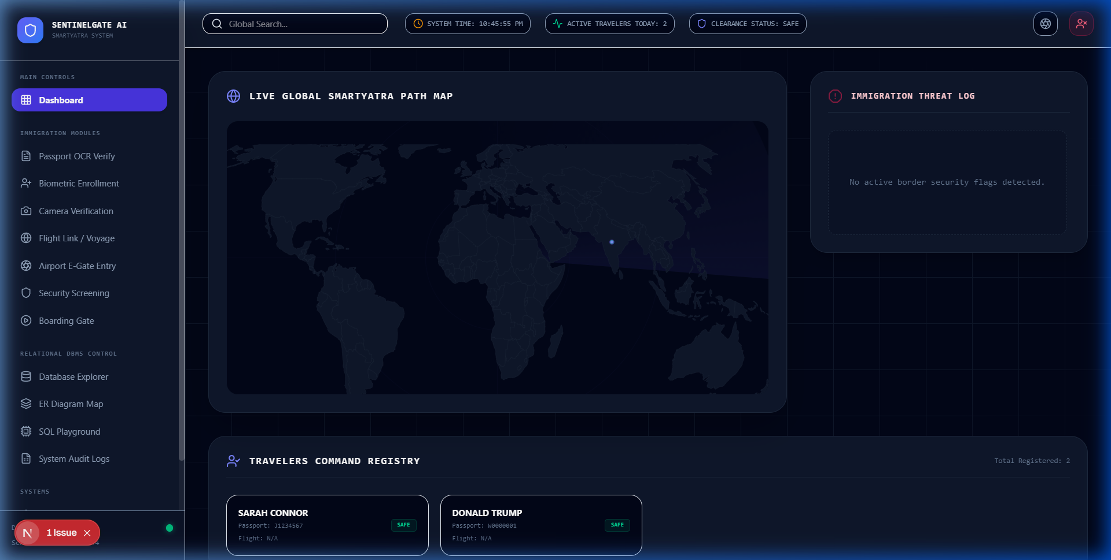

6.7 Travelers Command Directory Registry
The directory listing on the main dashboard showing registered passengers, including clicking a card to open the complete profile detail popup.


6.8 Relational ER Schema Relationships Map
Officer terminal section displaying SQL table foreign key linkages and dependencies.


6.9 Database Explorer Console
Command dashboard section to browse, query, and modify tables dynamically.
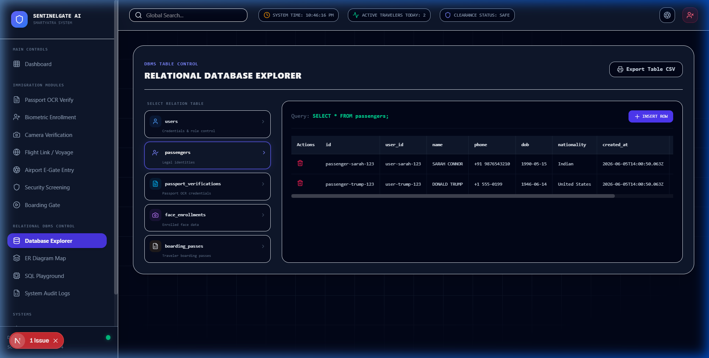

6.10 SQL Query Playground Terminal
Command line editor for executing structured read-only database queries.
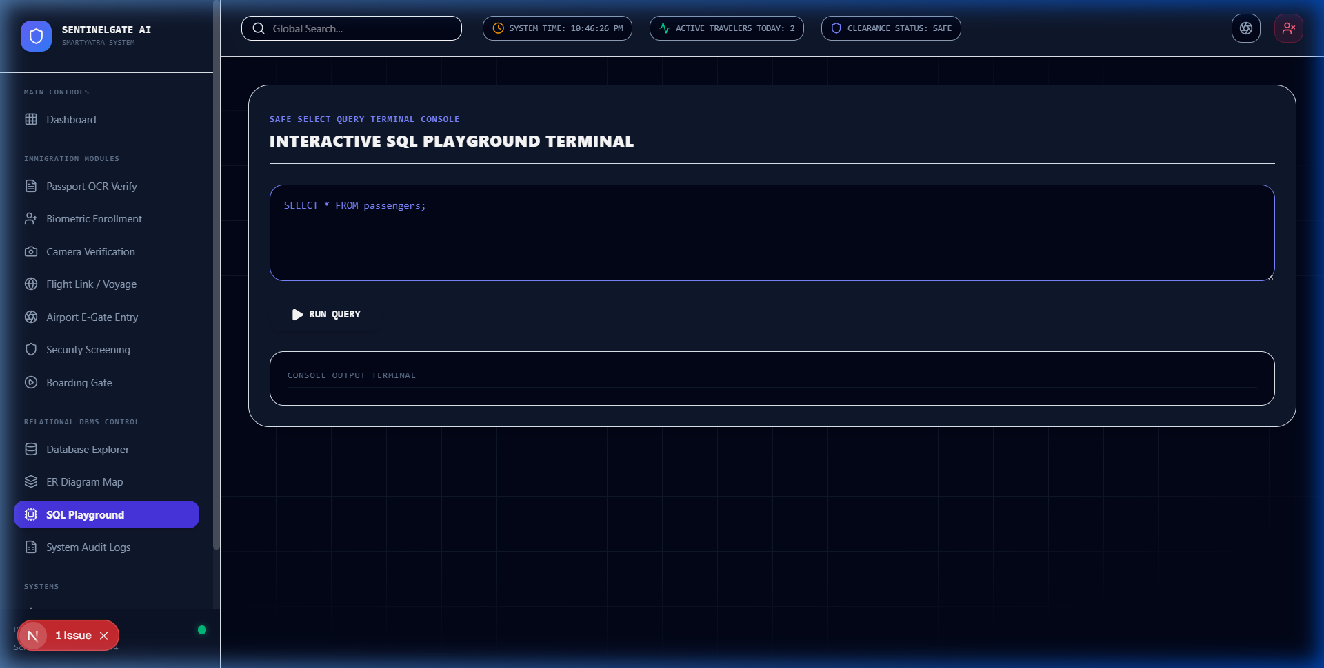

6.11 Immutable Audit Ledger records
Audit log viewer displaying sequential SHA-256 block ledger history logs.
