|  |  |  |  |  |  |
| --- | --- | --- | --- | --- | --- |
| **REVA H**   |  | | --- | | TECHNOLOGY BEYOND IMAGINA | | |  | | --- | |  |  |  | | --- | | **ACK 2023** |  |  | | --- | | TION | |
|  | |  |  |  | | --- | --- | --- | | |  | | --- | | Powered by: | |  | |

|  |  |
| --- | --- |
| |  | | --- | | GUIDELINES | |

|  |
| --- |
| Due to the limited capacity of the offline hackathon, only the top 50 teams will be selected. The |

selection will be based on the quality of your idea and the completeness and accuracy of your idea

|  |
| --- |
| submission. |

|  |
| --- |
| A two-step validation process will be followed to approve Offline Participants, Idea Pitch, and |

|  |
| --- |
| on-site verification. |

|  |
| --- |
| Your Idea Pitch will be evaluated based on the contents of this document only. So, please pay close |

|  |
| --- |
| attention while filling it out. |

|  |
| --- |
| Keep your pitch informative and concise, strictly stick to the number of allotted pages/slides(max |

|  |
| --- |
| 14 slides). Failure in doing so shall invalidate your idea pitch. |

|  |
| --- |
| Any inconsistencies found in the documents of the idea pitch shall be met with consequences. The |

|  |
| --- |
| organizers of the event shall hold the right to invalidate your pitch. |

|  |  |  |
| --- | --- | --- |
|  | |  | | --- | | PROJECT TITLE : | |

|  |
| --- |
| **TEAM NAME: Rudra** |

|  |
| --- |
|  |

|  |
| --- |
| TEAM LEAD: Deveesh Shetty | [deveeshshetty@gmail.com](mailto:deveeshshetty@gmail.com) | 9741268512 |

|  |
| --- |
| TEAM MEMBERS: |

|  |
| --- |
| Srujan Rai | [raisrujan@gmail.com](mailto:raisrujan@gmail.com) | 8861203688 |

|  |
| --- |
| Akkil M G | [akkilcharanmg@gmail.com](mailto:akkilcharanmg@gmail.com) | 8762205219 |

|  |
| --- |
| Varshaa Shetty | [varshaashetty275@gmail.com](mailto:varshaashetty275@gmail.com) | 9741409023 |

|  |  |
| --- | --- |
| Ananya P K | [ananyapk752@gmail.com](mailto:ananyapk752@gmail.com) | 8792435571  Powered by: |  |

|  |  |  |
| --- | --- | --- |
| |  | | --- | |  | | PROBLEM STATEMENT : |

|  |  |  |  |  |
| --- | --- | --- | --- | --- |
|  | |  | | --- | | **Automatic regulation of valves for release of water based upon soil moisture availability in the root zone of the crop, using artificial intelligence, in a piped and micro irrigation network of irrigation system :** |  |  | | --- | | The problem in modern agriculture is to manage water effectively in order to maximise agricultural productivity, preserve water, and safeguard the environment. Current irrigation techniques are not precise, which results in water waste and poor plant development. |   In piped and micro irrigation networks, when manual control cannot adjust to fluctuating soil moisture, this issue is particularly obvious. The main problem is the lack of real-time data-based automated water regulation. The agricultural yield and water conservation are harmed by this inconsistency.  In order to bridge the gap between water supply and crop demand, an AI-driven valve control system is needed that takes into account dynamic aspects, data integration, algorithm precision, valve control, flexibility, user interface, and economic feasibility. |  |
| |  |  |  | | --- | --- | --- | | |  | | --- | | Powered by: | |  | | | |

|  |  |  |
| --- | --- | --- |
| |  | | --- | |  | | Tracks available |

|  |  |  |  |  |
| --- | --- | --- | --- | --- |
| |  | | --- | | CHOICE OF TRACK: Cloud and IoT | | |  | | --- | | Powered by: Powered b: | |  |

|  |  |
| --- | --- |
| 1. 2. 3. 4. 5. 6. | GEN AI  BLOCKCHAIN  AR VR  CLOUD AND IOT  CYBER SECURITY  OPEN INNOVATION |

|  |
| --- |
|  |



|  |  |  |
| --- | --- | --- |
| |  | | --- | |  | | OPPORTUNITY |

|  |
| --- |
| **How different is it from existing ideas out there?** |

|  |
| --- |
| Current Irrigation system lacks precision which causes |

|  |
| --- |
| ❌ Water Wastage |

|  |
| --- |
| ❌ Suboptimal plant growth |

|  |
| --- |
| ❌ Environmental Degradation |

|  |  |
| --- | --- |
| Because, the current methods like piped and micro-irrigation fail to adapt with the dynamic and varying soil moisture, which harms the crops and results in wastage of water. . Our project's primary focus is on achieving accurate real-time precision while maintaining cost-efficiency. | |
| Powered by: |  |

|  |  |  |
| --- | --- | --- |
| |  | | --- | |  | | OPPORTUNITY |

|  |
| --- |
| **How will it be able to solve the problem?** |

|  |
| --- |
| We are using **Artificial Intelligence** for monitoring the soil moisture and to automate regulation of **valves** for water release. |

|  |
| --- |
| This will bridge the gap between water supply and crop demand, and optimize the **resource utilization** and **minimize environmental impact**. |

|  |  |
| --- | --- |
| We first survey the farmland and surroundings, then strategically place the sensors as required. Later onboard the farmer to our mobile app and website. AI will predict the crop requirement and regulate the valves. | |
| Powered by: |  |

|  |  |  |
| --- | --- | --- |
|  | SOLUTION | |
| |  | | --- | | Artificial intelligence is being used to automate the control of water release valves and monitor soil  moisture levels. The data is  collected via Sensors and sent to the Arduino, this data is used to predict the valve timings and flow, which is sent to the Database and reflects in the Web and App User Interface where the farmer can monitor and intervene it. | |  | |
| Powered by: |  |

|  |  |  |
| --- | --- | --- |
|  | |  | | --- | | SOLUTION | |

|  |  |  |  |  |  |
| --- | --- | --- | --- | --- | --- |
|  | |  | | --- | | **Data Fetching and Prediction:**The soil moisture, humidity and temperature sensors will be installed in the divided sectors of the farm. This will send **real-time data** to the AI Model for it to predict the**valve status**and timings. These predictions will then be updated in the **User-Interface**. |  |  | | --- | | **User Interface - Web / App:** A Web-based application in support of Android Mobile Software. This will enable farmers to monitor and intervene in the decisions made by the AI Model. The application will also feature a smooth onboarding process that gathers information about the farm area, location and surroundings interactively. |  |  | | --- | | **Valve Control Mechanism:** Data from the sectors is input into the AI model, which  determines whether to activate or deactivate the multiport valve. The valve is then adjusted to open the designated sector for the recommended duration enabling precise water regulation as directed by the AI. | |  |
|  |  |  |

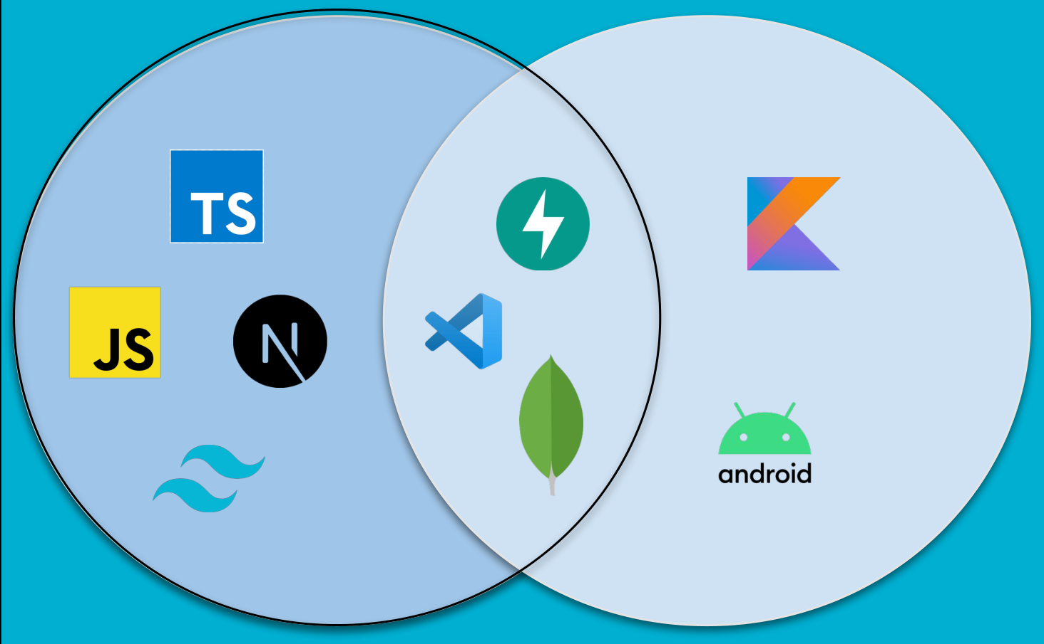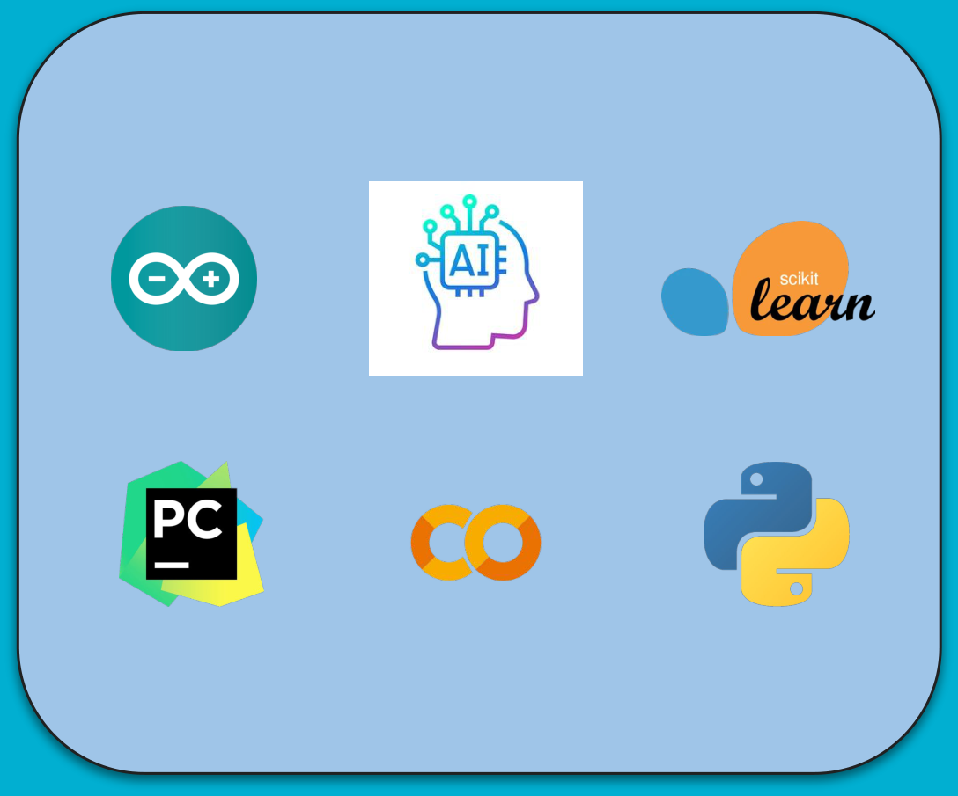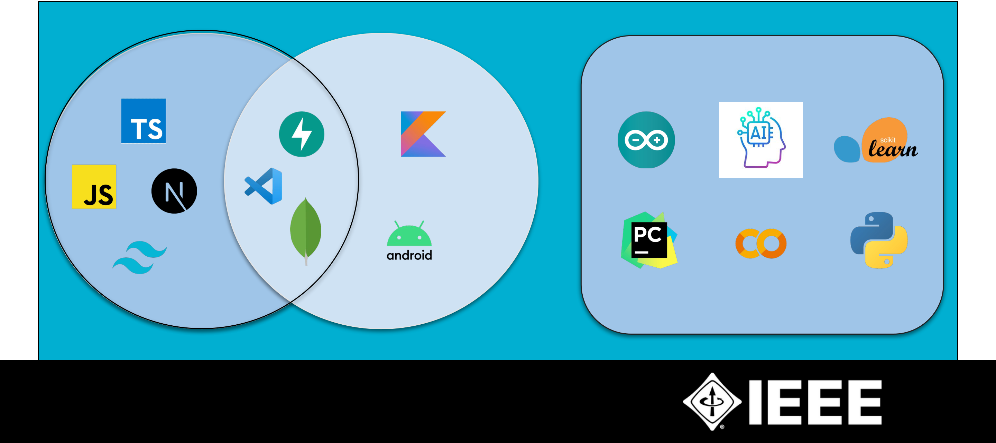

|  |  |  |  |
| --- | --- | --- | --- |
| |  | | --- | |  | | TECHNOLOGY USED |  |
| Web | App | IoT and AI |

Powered by:



|  |  |  |  |  |
| --- | --- | --- | --- | --- |
| |  | | --- | |  | | WHY SHOULD WE CHOOSE YOUR TEAM? | | |
| |  |  | | --- | --- | | |  | | --- | | We have a very strategic plan for addressing the issue with a strong concept for its  development and surely we can execute it successfully | | | | |  |  | | --- | --- | | |  | | --- | | Our team is very well versed in the tech stack like Web, App and also IoT. We have  collaborated on many projects that showcase our expertise. | | | |
| |  |  | | --- | --- | | |  | | --- | | We have done research in the field of agriculture and have  identified potential complexities that may arise during  development process | | | | |  |  | | --- | --- | | |  | | --- | | The team has been taking part in various hackathons, securing victories in several of them. This has fostered strong synergy  among our members.💡 | | | |
| Powered by: | | |  |

|  |  |  |
| --- | --- | --- |
| |  | | --- | |  | | THANK YOU |

|  |
| --- |
| Contact Us :**Ankit Kumar:** +91-90199 86049 |

|  |
| --- |
| **Shivam** : +91-88618 30388 |

|  |
| --- |
| We will get back to you by 2nd week of october. |

|  |  |  |  |
| --- | --- | --- | --- |
| Please keep checking your mails | | | |
| Follow us on: |  |  | |
| Powered by: | | |  |