# Phase 2: Org Setup & Configuration

This document provides Phase 2 details for the AI-Enhanced Human-AI Collaboration Platform project. The focus is on Org Setup & Configuration, ensuring the Salesforce environment is properly structured.

## Salesforce Editions

* Check your Salesforce edition under Setup → Company Information.
* Developer Edition is sufficient for MVP; Enterprise or Nonprofit editions provide advanced features like Einstein and Sandboxes.
* Ensure your edition supports Flows, Next Best Action, and Experience Cloud.

## Company Profile Setup

* Navigate to Setup → Company Information → Edit.
* Set Company Name (e.g., Uni-AI Collaboration Lab), Locale (English India/US), Time Zone (GMT+05:30 IST), and Currency (INR).
* Ensure these settings align with your team’s location and reporting needs

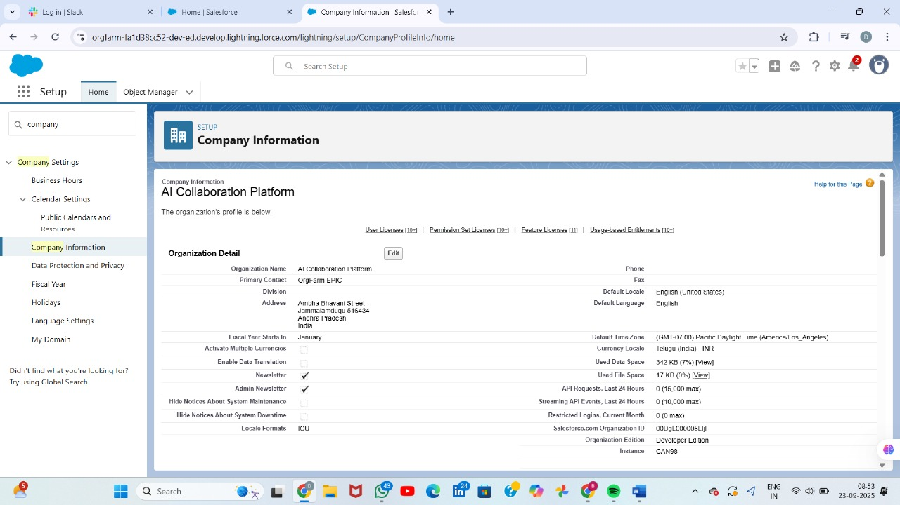

User license

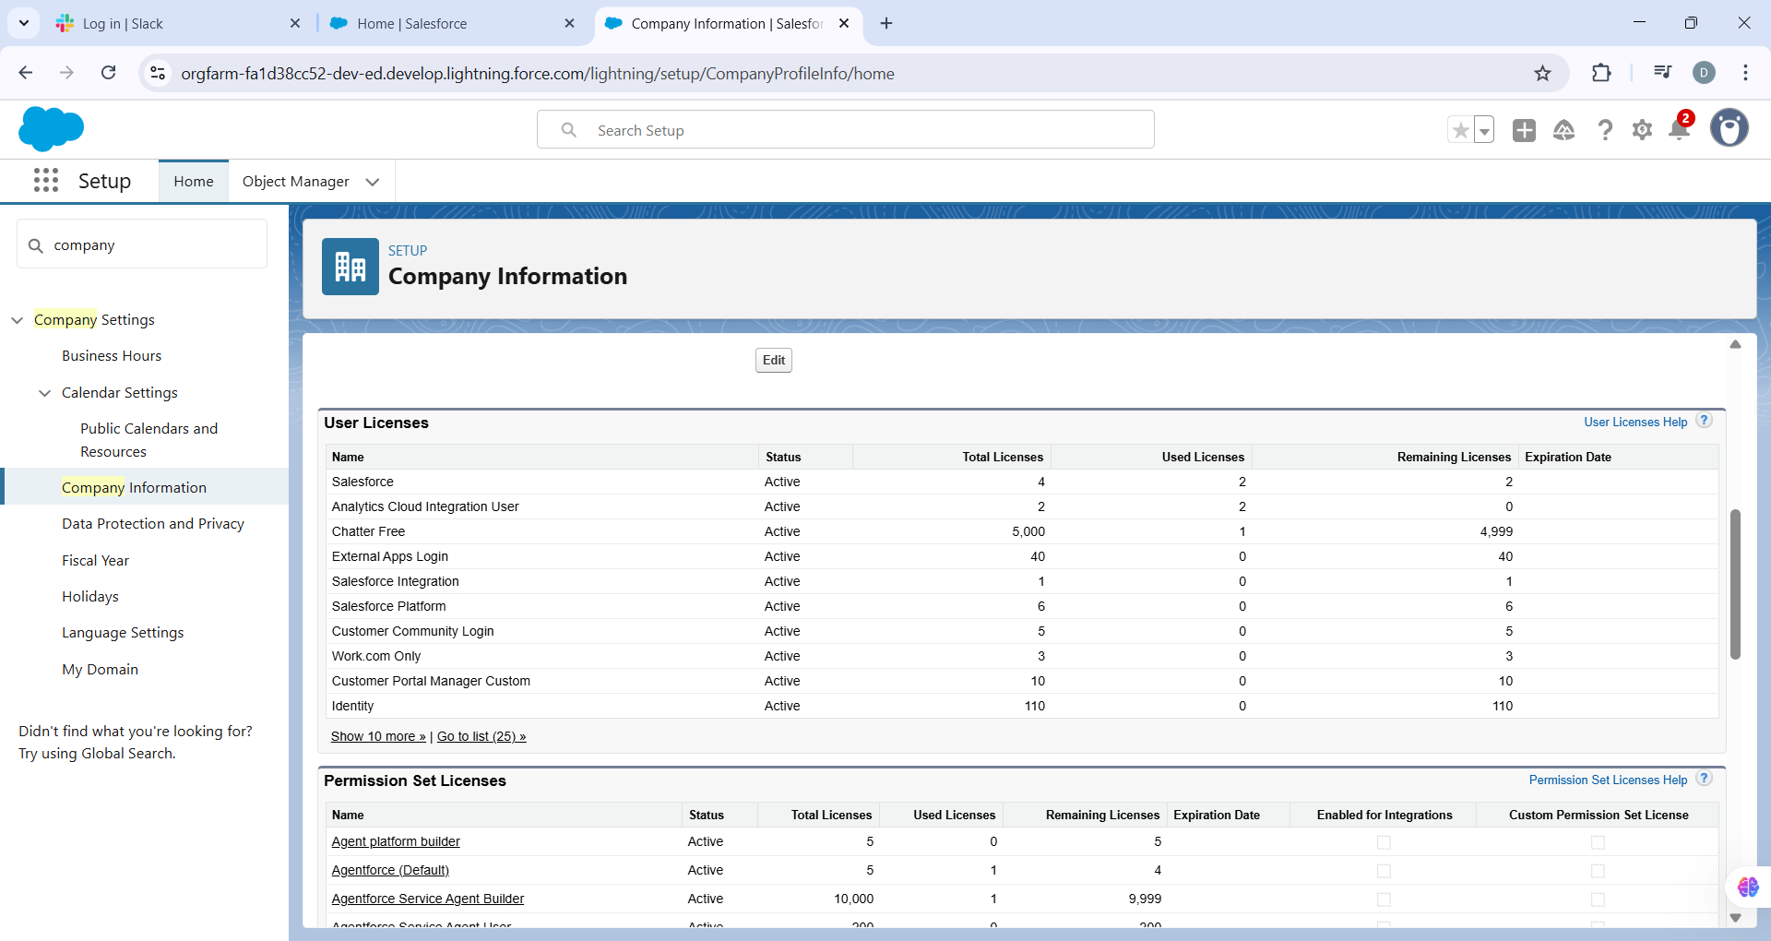

## Business Hours & Holidays

* Setup → Business Hours → New.
* Create ‘Support Business Hours’ (Mon–Fri, 9:00–18:00).
* Add Holidays under Setup → Holidays for non-working days (affects SLA calculations).  
    
    
  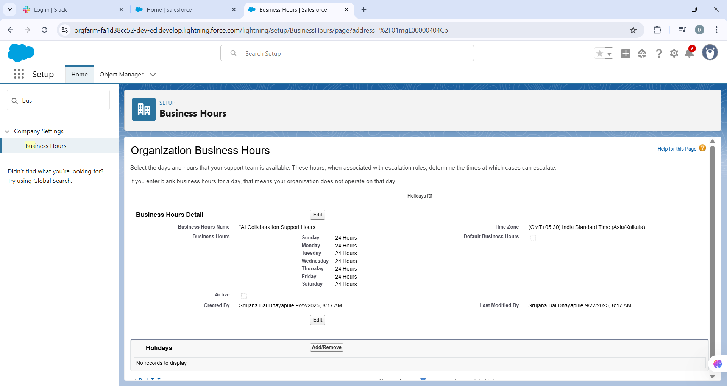

**Holidays**

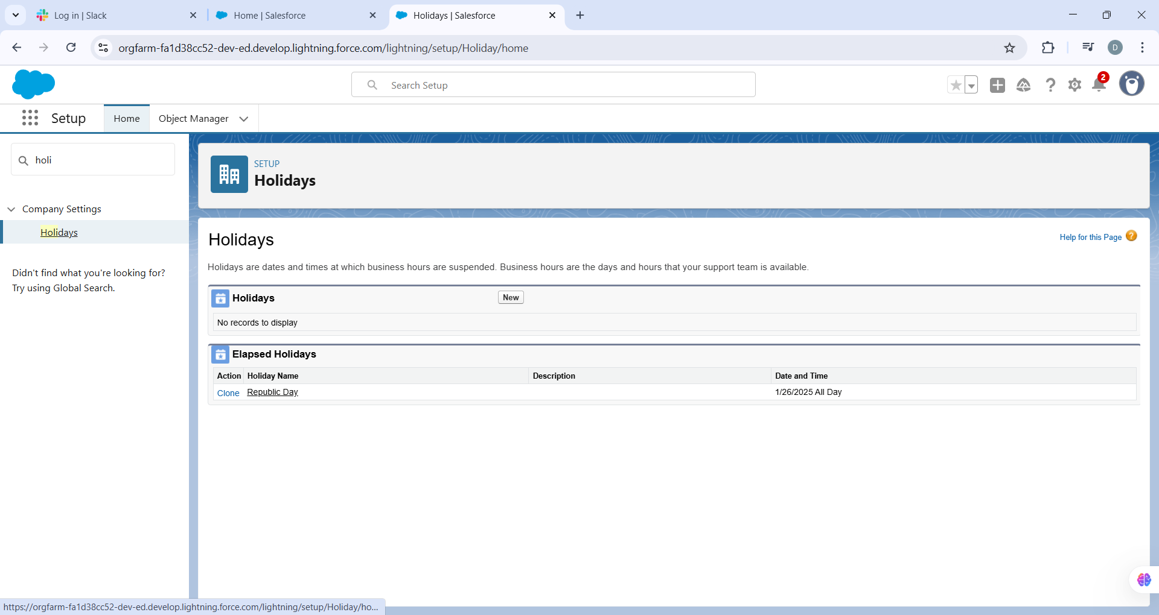

## Fiscal Year Settings

* Setup → Fiscal Year → Select Standard Fiscal Year unless custom is needed.
* Define start month/quarter for reporting and dashboards.

## User Setup & Licenses

* Setup → Users → New User.
* Create users for Agent, Supervisor, and Admin roles.
* Assign proper licenses: Salesforce/Platform for Agents, Admin license for System Administrator.
* Ensure each user has correct profiles and permissions.

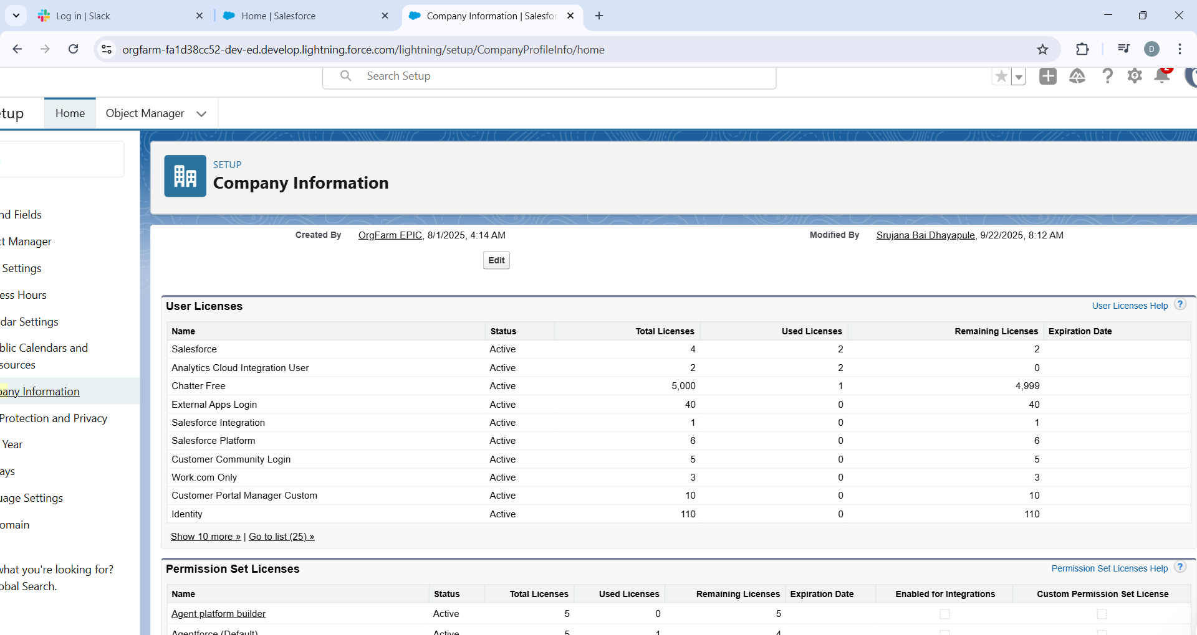

## Profiles

* Clone Standard User profile → rename to Agent Profile.
* Set object permissions: Read/Create/Edit on Task, AI Suggestion, and Feedback objects.
* Create Supervisor Profile with added access to reports and dashboards.
* System Administrator retains full permissions.
* 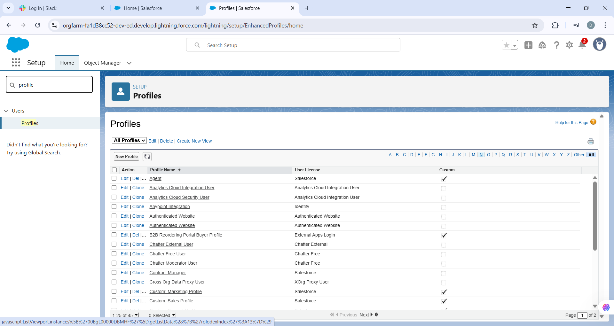

## Roles

* Setup → Roles → Set Up Roles.
* Create hierarchy: System Admin → Supervisor → Agent.
* Assign users to roles for data visibility and escalation.

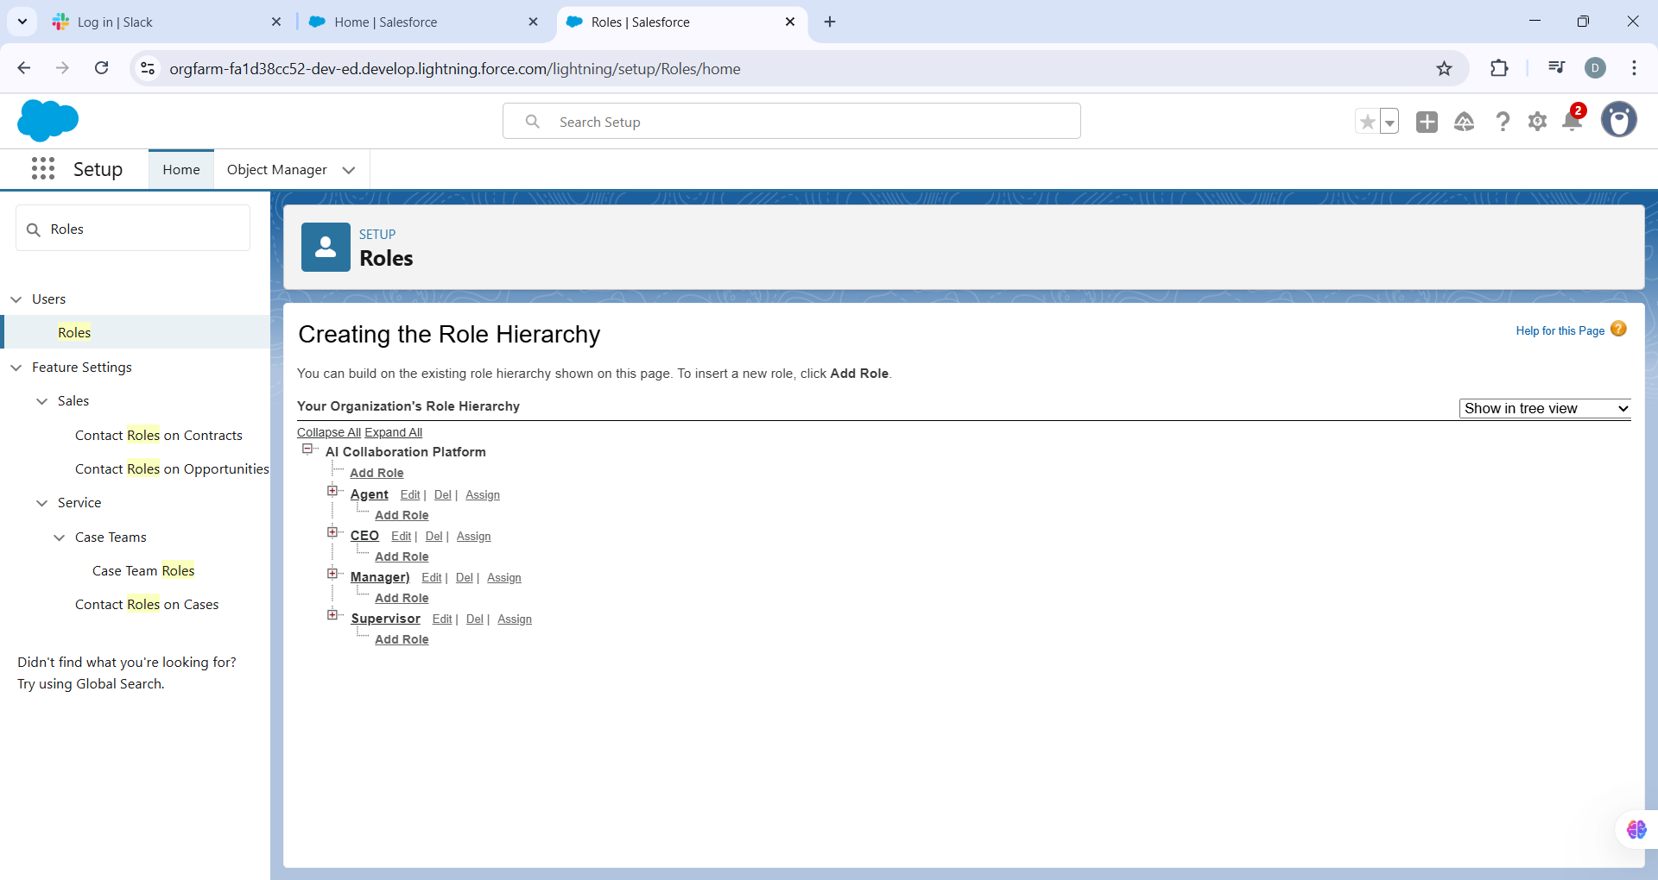

## Permission Sets

* Setup → Permission Sets → New.
* Create ‘Einstein Access’ for AI tools and Flows.

Assign permission sets to specific users for temporary or extra privileges.  
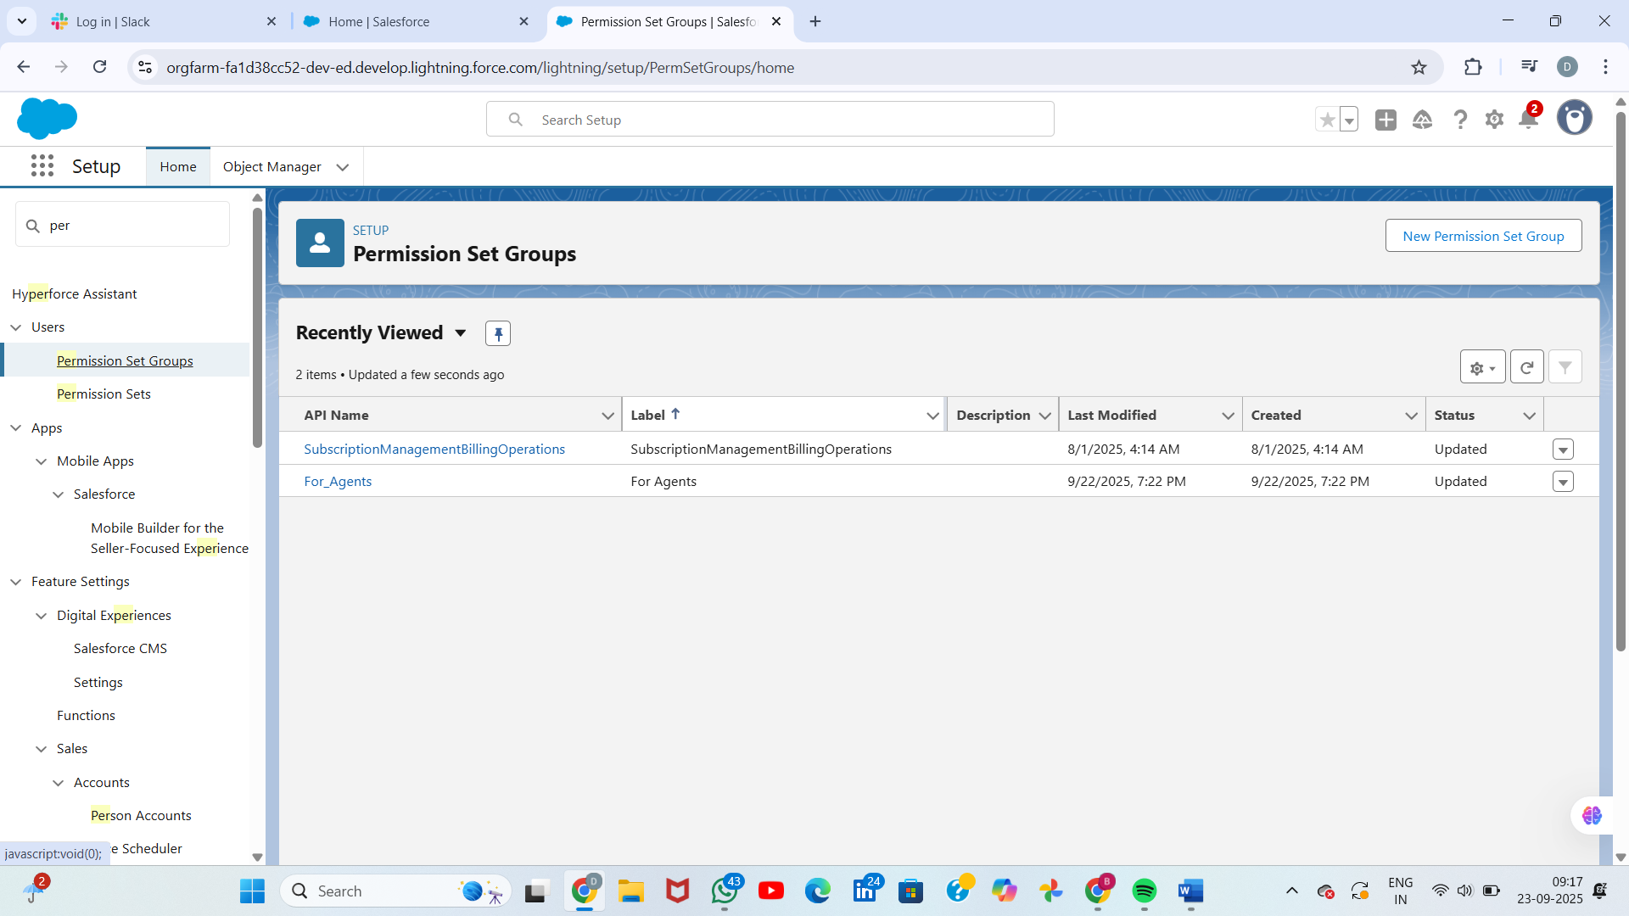

## OWD (Organization-Wide Defaults)

* Setup → Sharing Settings.
* Set Task, AI Suggestion, and Feedback objects to Private.
* This ensures only owners can see their records unless shared.  
  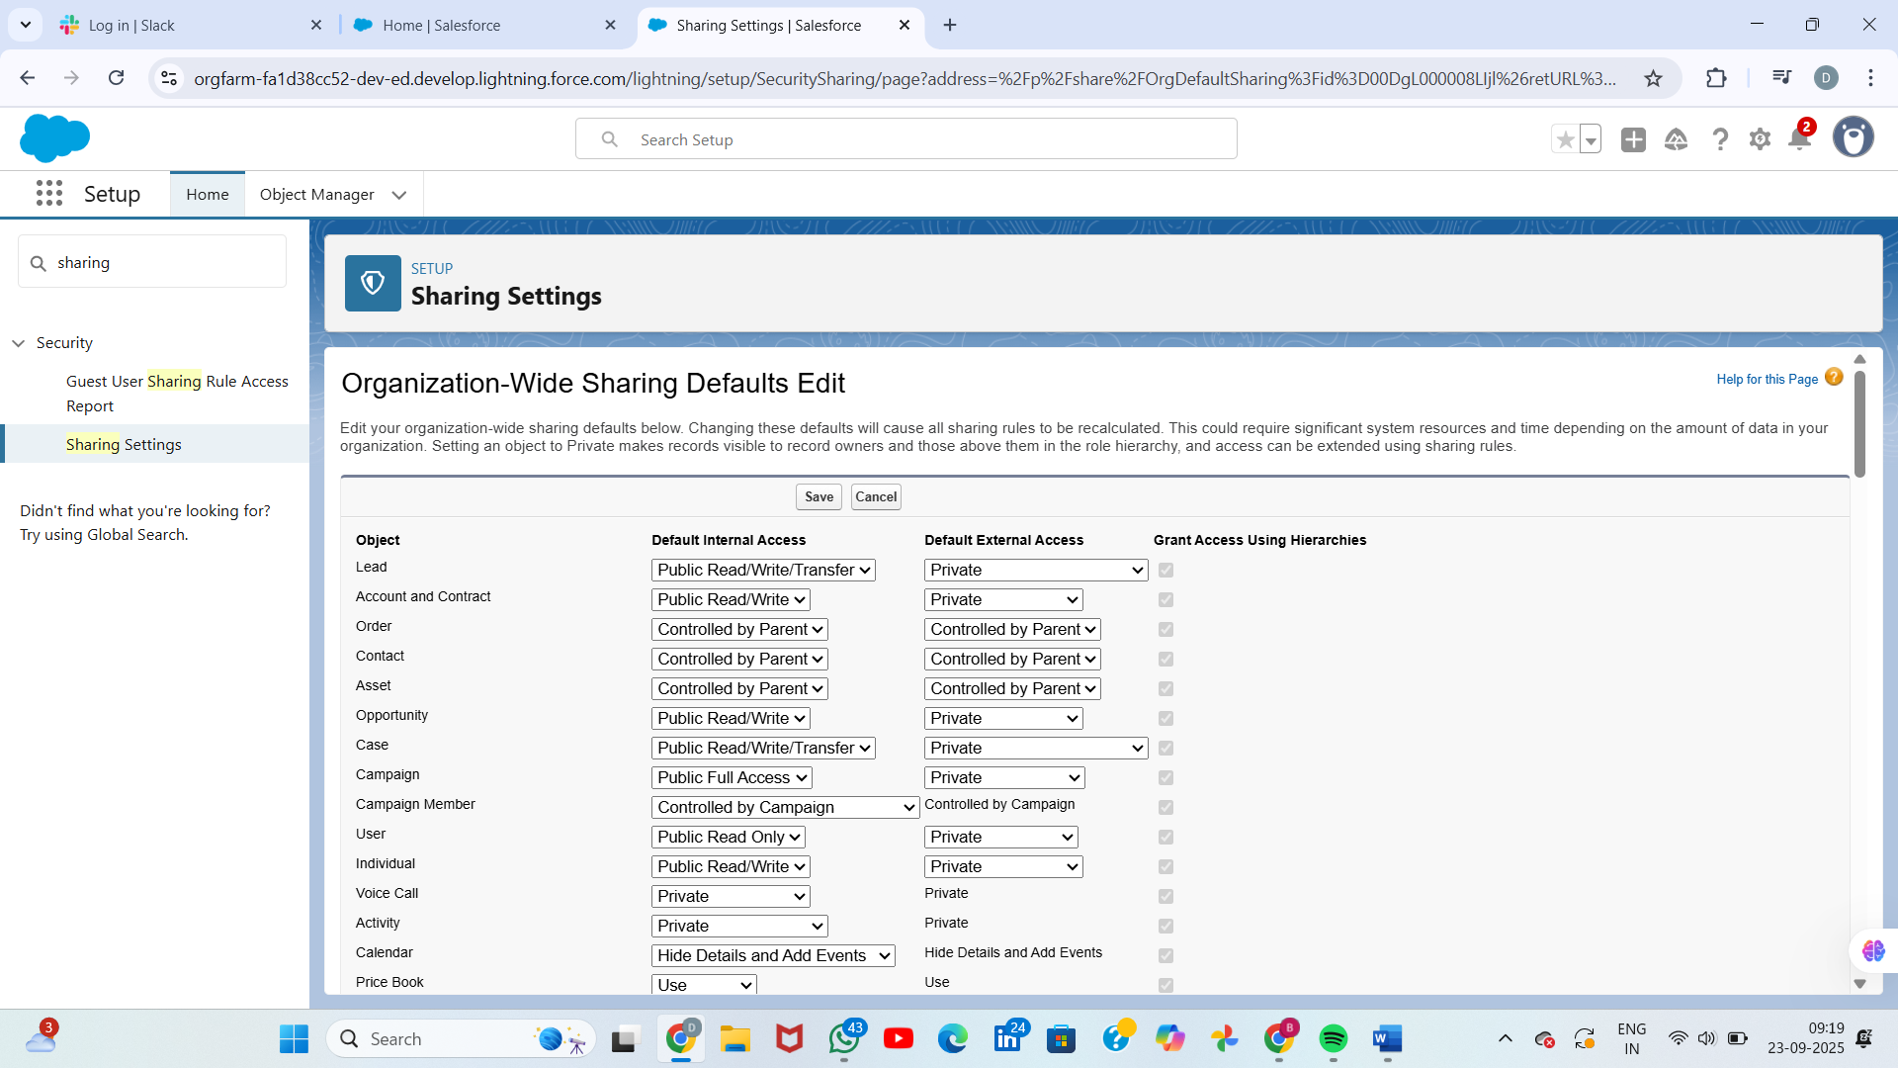

## Sharing Rules

* Setup → Sharing Settings → New Rule.
* Example 1: Share Tasks owned by Agents to Supervisors (Read/Write).
* Example 2: Criteria-based rule to share AI Suggestions with low confidence (<70%) with Supervisors.

## Login Access Policies

* Setup → Security → Session Settings.
* Set Session Timeout to 30 minutes for Agents, enable 2FA for Admins.
* Setup → Network Access → add trusted IP ranges for secure access.
* 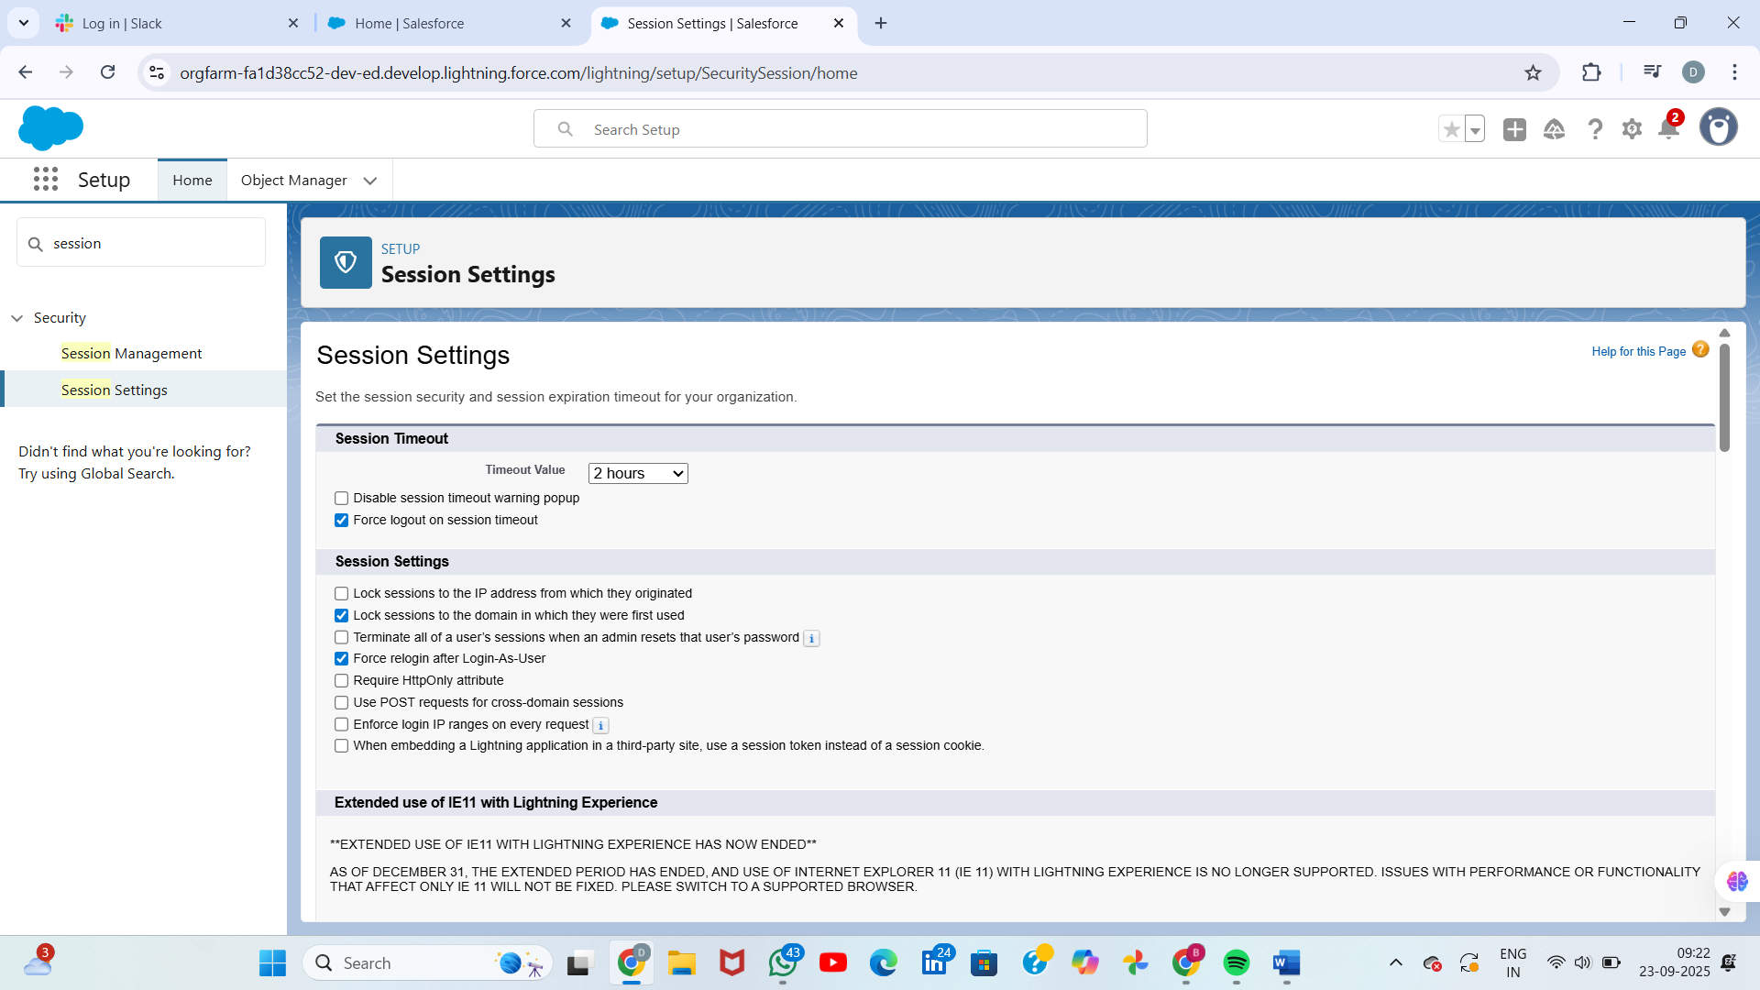

## Dev Org Setup

* Sign up for free Developer Edition at developer.salesforce.com.
* Enable My Domain (required for Lightning).
* Create test users (Agent, Supervisor, Admin).
* Optional: Enable Dev Hub if using SFDX.

## Sandbox Usage

* Setup → Sandboxes → New Sandbox.
* Create Developer Sandbox for testing flows and objects.
* Use Partial Copy or Full Sandbox for larger-scale testing if available.

## Deployment Basics

* Use Change Sets or SFDX to move changes from Dev → Test → Production.
* Steps: Build in Sandbox → Outbound Change Set → Upload to target → Validate → Deploy.
* Ensure all Apex tests pass (if used) and profiles/permissions are included.
* Run smoke tests post-deployment to confirm flows and automations work correctly.