# Phase 6 – User Interface Development

## Purpose

The purpose of Phase 6 is to design and implement an intuitive user interface within Salesforce that allows users to submit tasks, review AI-generated suggestions, and provide feedback. This phase bridges the backend processing with the end-user experience by leveraging both declarative Salesforce tools and programmatic customizations through Lightning Web Components (LWC) and Apex. The goal is to ensure seamless interaction, scalability, and adoption by end users.

## Overview

User Interface Development is a critical phase because it defines how users interact with the AI-enhanced system. The design must focus on accessibility, responsiveness, and simplicity while enabling powerful backend logic to surface seamlessly. Key tools include Lightning App Builder, Home Page Layouts, Record Pages, Tabs, Utility Bar, Lightning Web Components, and advanced LWC capabilities such as events, wire adapters, imperative Apex calls, and navigation service. Each step ensures a modular, interactive, and secure front-end that is consistent across different devices and user profiles..

## Step 1 – Lightning App Builder

* • Navigate to Setup → App Manager → New Lightning App.
* • Define app details (Label, Description, Primary Branding).
* • Choose supported form factors: Desktop, Phone, or Both.
* • Add Navigation Items: Task, AI Suggestions, Feedback, Reports, Dashboards.
* • Configure Utility Bar for global actions (e.g., New Task flow, Quick Access to Suggestions).

• Finalize visibility: Assign app to specific profiles.  
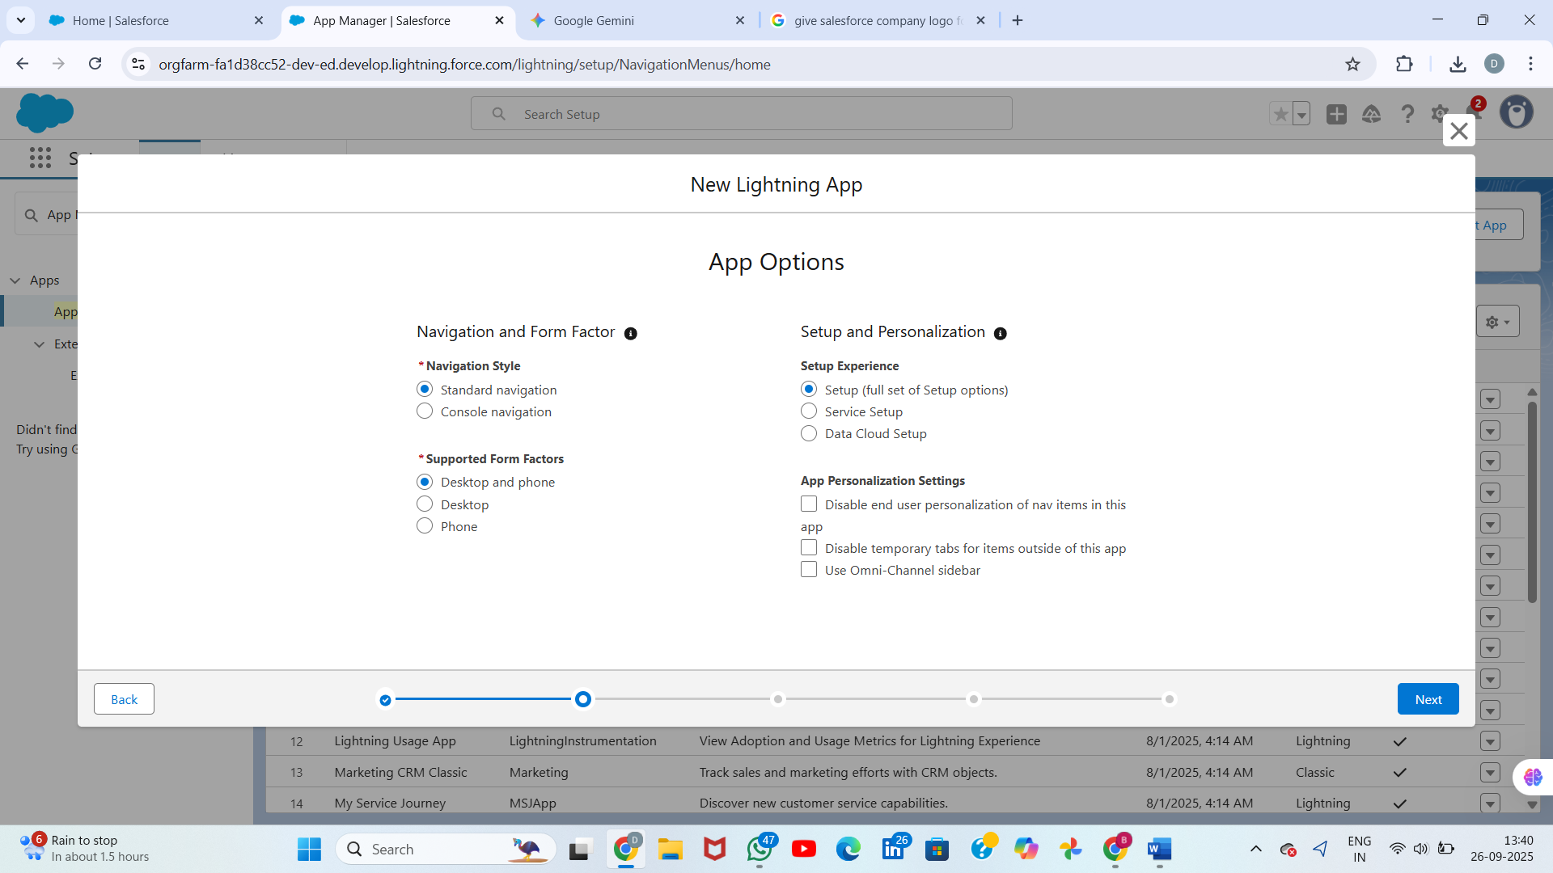

## 

## 

## Step 2 – Record Pages

* • Navigate to Object Manager → Task → Lightning Record Pages → New.
* • Use Record Page template: Header, Tabs, and Related lists.
* • Place core details in main region, related lists below.
* • Add a custom LWC 'aiSuggestionsList' to show AI suggestions in context of a task.
* • Add a Flow component if you want to capture approvals or guided input.
* • Save, then Activate and assign for profiles or default app.  
  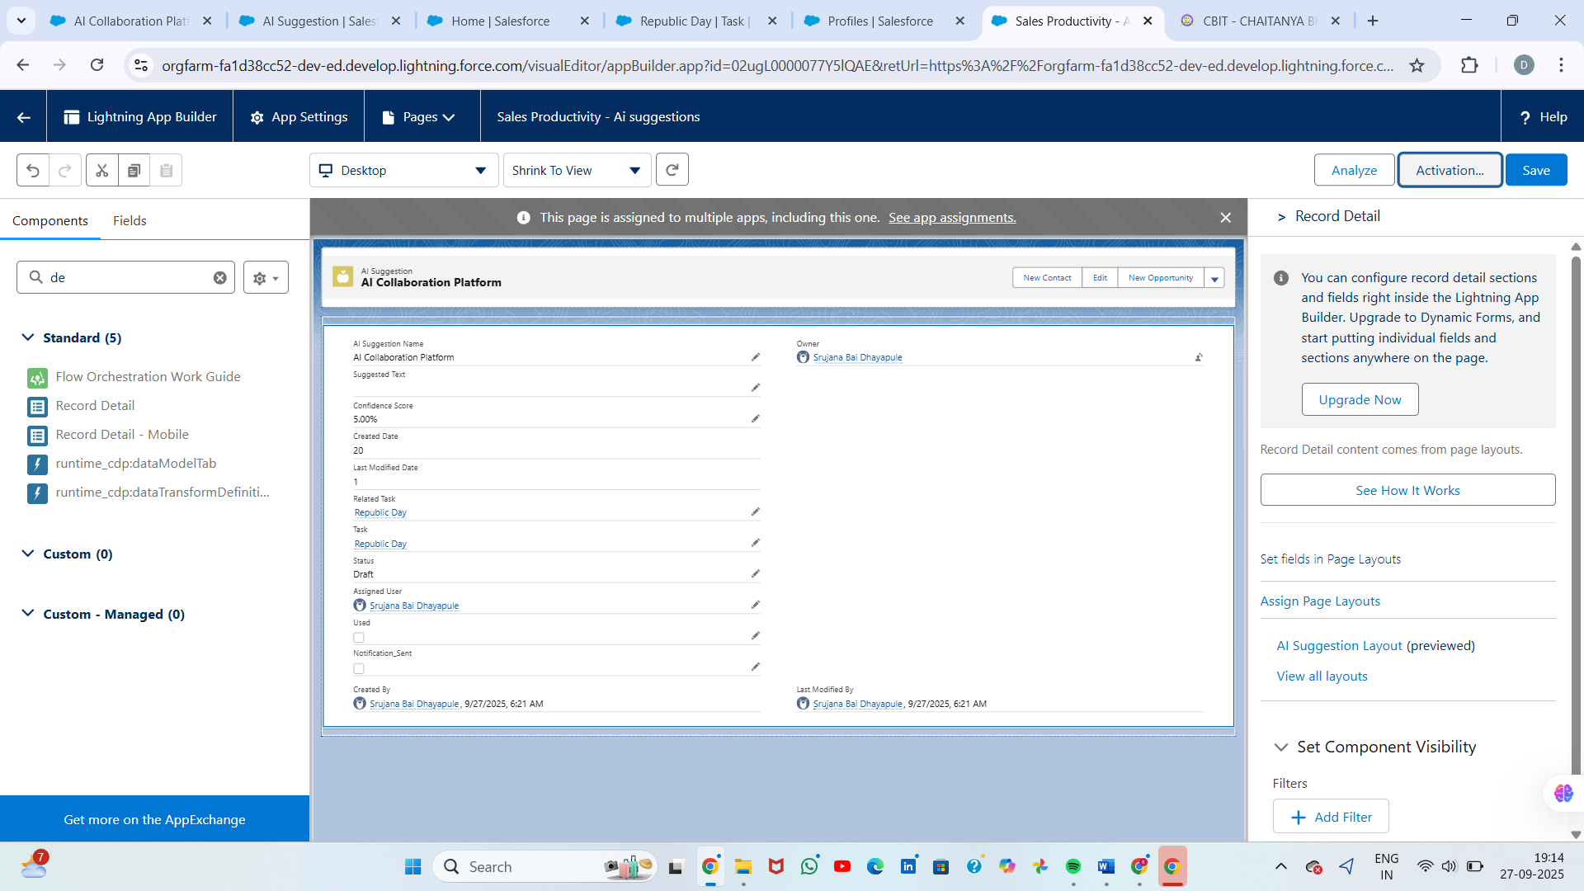

## Open ****Lightning Record Pages**** and create a new page

1. In the object menu (left column) click **Lightning Record Pages**.
2. Click **New** (top right). Choose **Record Page** when prompted and click **Next**.
3. Give the page a **Label** (e.g., Task — AI Suggestions Page) and select a **template** (Header + One Column, Two Regions, etc.), then **Finish**. The page opens in the **Lightning App Builder** canvas.

* 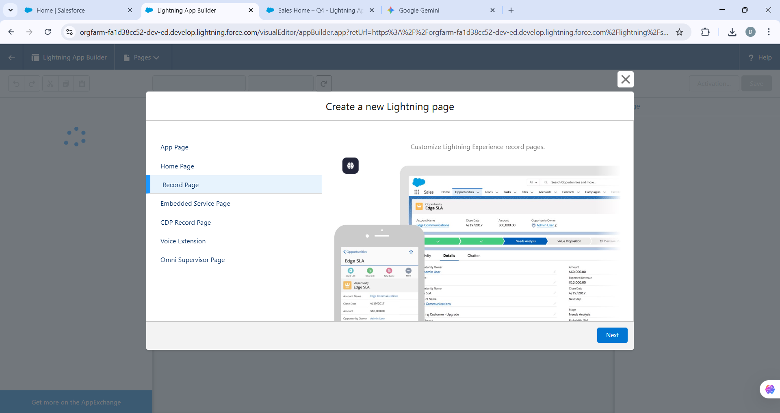

Task — AI Suggestions Page

* 

## Step 3 – Tabs

* • Setup → Tabs → New → Lightning Component Tab.
* • Select your LWC (exposed with lightning__Tab target).
* • Provide Tab Label, Icon, and Style for easy identification.
* • Add Tab to Lightning App navigation menu in App Manager.
* • Users can now access LWC-based functionality directly from navigation bar

.Create a new **Lightning Component Tab**

1. Click **New** under **Lightning Component Tabs**.
2. From the **Lightning Component** dropdown, select the **LWC** or **Aura**
3. **Component** you want to expose as a tab.
   * **Important:** For LWCs, ensure the component’s .js-meta.xml file includes the <target>lightning__Tab</target> entry. Example:

* 
 