**Phase 7 – Integration & External Access**

# Purpose:

Enable your Salesforce platform to securely connect with external systems, APIs, or services to fetch or push data. This allows your AI-enhanced human-AI collaboration platform to leverage external tools and keep data synchronized. Integration ensures real-time data consistency, automation, and access to external intelligence.

---

## Step 1: Understand Integration Types

1. Callouts (REST/SOAP): Send or receive data from external APIs.  
2. External Services: Simplified integration for pre-defined APIs.  
3. Platform Events & Change Data Capture: Real-time notifications within Salesforce or external systems.  
4. Salesforce Connect: Access external data in real-time without storing it in Salesforce.  
5. Authentication & Security: OAuth, Named Credentials, Remote Site Settings.  
6. API Limits: Ensure integrations respect Salesforce governor limits.  
7. Consider asynchronous vs synchronous callouts for performance and limits.

| **Field** | **Example Value** |
| --- | --- |
| Remote Site Name | GoogleGeminiAPI |
| Remote Site URL | https://api.google.com/gemini |
| Description | Allows Salesforce to access Google Gemini API. |
| Active | ☑ Checked |

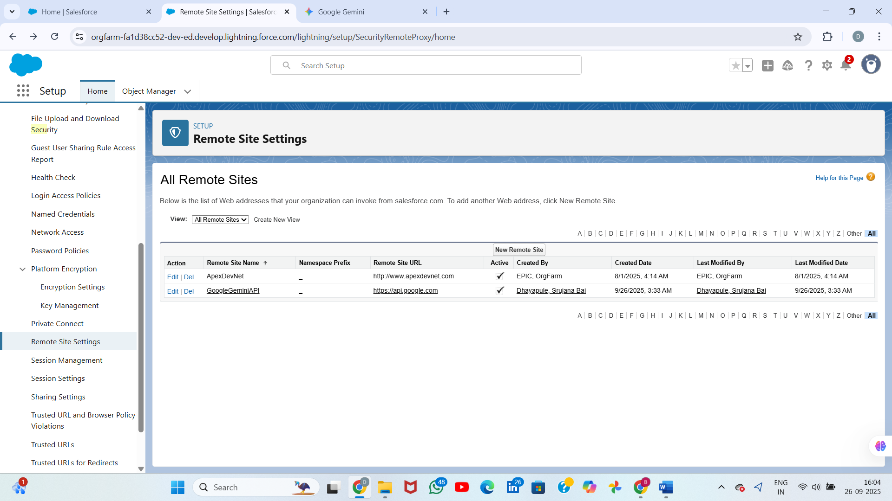

Create an Apex Class for Callout

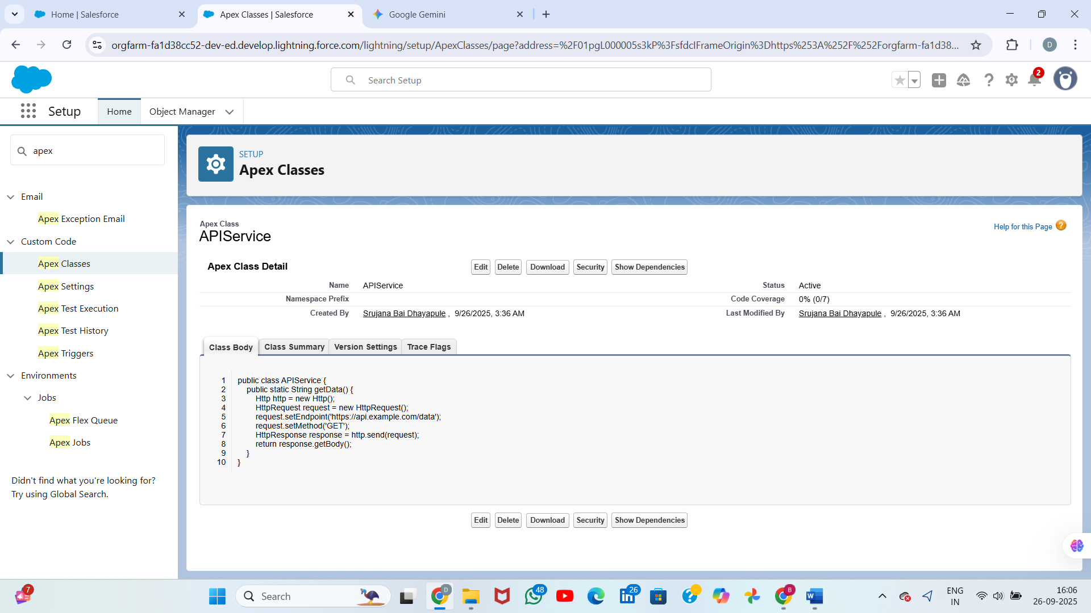

---

## Step 2: Set Up Named Credentials

Go to Setup → Named Credentials.  
Click New Named Credential.  
Fill in details: Label & Name (e.g., External_AI_API), URL (API base URL), Identity Type (Named Principal or Per User), Authentication Protocol (OAuth 2.0, Password, or No Authentication).  
If OAuth, configure the Auth Provider (see Step 4).  
Save.  
  
Example Apex usage:  
HttpRequest req = new HttpRequest();  
req.setEndpoint('callout:External_AI_API/v1/suggestions');  
req.setMethod('GET');  
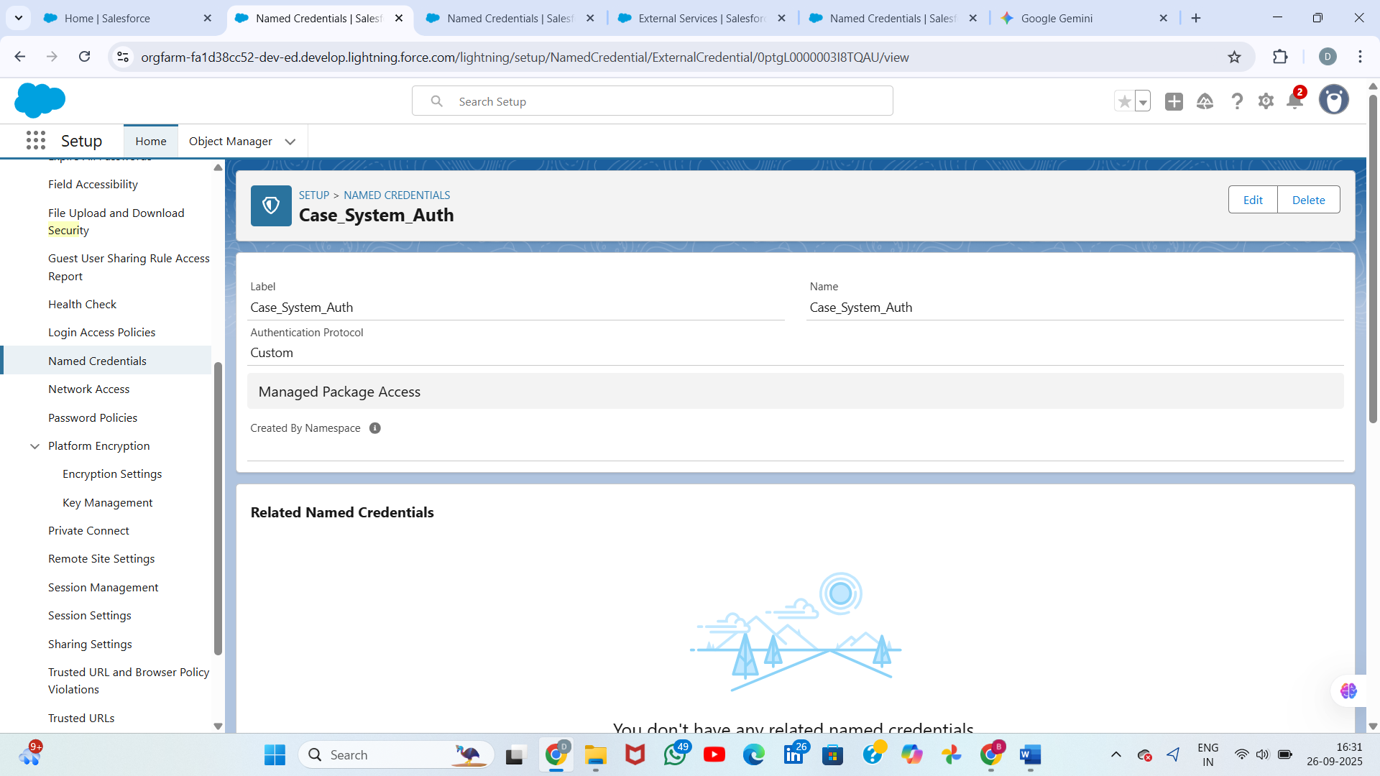

---

## Step 3: Set Up Remote Site Settings

Go to Setup → Remote Site Settings.  
Click New Remote Site.  
Fill in Name (e.g., AI_API_Remote) and Remote Site URL (matches API domain).  
Save.  
  
Note: Named Credentials often bypass this step, but it is required for standard callouts.

---

## Step 4: Configure OAuth & Authentication

Go to Setup → Auth. Providers.  
Choose provider type (Google, Salesforce, Custom, etc.).  
Fill Name, URL, Consumer Key & Secret.  
Save and note the callback URL.  
In Named Credentials, select this Auth Provider for OAuth authentication.  
  
Note: OAuth ensures secure and standard authentication between Salesforce and external services.

---

## Step 5: Create External Services

Go to Setup → External Services → New External Service.  
Fill in Name (e.g., AIService), Named Credential, and API schema (Swagger/OpenAPI JSON URL).  
Save. Salesforce auto-generates Apex actions for the API.  
These actions can now be used in Flow Builder or Apex.  
  
Note: External Services reduce manual coding and allow declarative API integration.

---

## Step 6: Make Web Service Callouts (REST/SOAP)

REST Example:  
public class AIIntegration {  
 public static String getSuggestions() {  
 HttpRequest req = new HttpRequest();  
 req.setEndpoint('callout:External_AI_API/v1/suggestions');  
 req.setMethod('GET');  
 Http http = new Http();  
 HttpResponse res = http.send(req);  
 return res.getBody();  
 }  
}  
  
SOAP: Use WSDL → Generate Apex classes.  
Always test callouts using `@IsTest(SeeAllData=false)` and mock responses.  
Implement proper exception handling to manage errors or timeouts in external requests.

---

## Step 7: Use Platform Events

Go to Setup → Platform Events → New Platform Event.  
Define fields (e.g., Task_ID, AI_Suggestion).  
In Apex or Flow, publish events when a task is created.  
External systems can subscribe via CometD or Change Data Capture.  
  
Note: Platform Events support event-driven architecture and asynchronous processing.

---

## Step 8: Enable Change Data Capture

Go to Setup → Change Data Capture.  
Select objects (e.g., AI_Suggestion__c).  
External subscribers can listen to updates using Streaming API.  
  
Note: Useful for keeping external systems synchronized with Salesforce records.

---

## Step 9: Salesforce Connect

Go to Setup → External Data Sources → New External Data Source.  
Select type: OData 2.0 / 4.0.  
Configure URL, authentication, and object mappings.  
Salesforce creates External Objects that behave like standard objects.  
  
Note: Enables real-time access to external data without storing it in Salesforce, reducing storage costs.

---

## Step 10: Monitor API Limits

Go to Setup → System Overview → API Usage.  
Track daily API calls.  
Optimize callouts and batch requests to stay under limits.  
  
Note: Consider combining data calls or using batch APIs for efficiency.

---

## Tips & Best Practices:

- Always use Named Credentials instead of hardcoding credentials.  
- Test callouts with mock responses before production.  
- Use Platform Events for near-real-time updates instead of frequent polling.  
- Monitor API usage and set alerts to avoid hitting limits.  
- Implement proper error handling and retries for callouts.  
- Document all integration points clearly for maintenance and auditing.  
- Follow Salesforce security guidelines when accessing external systems.  
- Optimize callout frequency and batch processing to manage governor limits.