**Phase 3 – Data Modeling & Relationships (Step-by-Step Implementation)**

# Objects Overview

I have create three main custom objects:

• Task – Represents the task or request created by the user (e.g., draft request).

• AI Suggestion – Stores AI-generated suggestions for a task.

• Feedback – Captures the user’s feedback on the AI suggestion.

# Concepts Covered in Phase 3

• Standard & Custom Objects

• Fields

• Record Types

• Page Layouts

• Compact Layouts

• Schema Builder

• Lookup vs Master-Detail vs Hierarchical Relationships

• Junction Objects

• External Objects

# Step 3.1 – Create the “Task” Object

Purpose: Store task requests where users provide descriptions that AI will process.

Steps:  
Go to Setup → Object Manager → Create → Custom Object  
Enter:

Label = Task  
Plural Label = Tasks  
Object Name = Task  
Record Name = Task Name (Auto Number or Text)  
Check “Allow Reports”, “Track Activities”  
Save.

## 

## Fields for Task Object

|  |  |  |  |
| --- | --- | --- | --- |
| Field Label | Field Name | Data Type | Description |
| Task Name | Task_Name | Text | The title or name of the task |
| Description | Description | Long Text Area (500) | Details of the task for AI to analyze |
| Status | Status | Picklist | Track task’s stage – options: New, In Progress, Completed |
| Assigned User | Assigned_User | Lookup(User) | Links task to the agent handling it |
| Created Date | CreatedDate | Auto-Number/Standard | Automatically tracks when the task is created |
| Last Modified Date | LastModifiedDate | Auto-Number/Standard | Automatically updates when task is edited |

Steps to Create Fields:  
Inside the Task object → click Fields & Relationships → New  
Select the appropriate data type  
Enter the field label and field name  
Set field-level security if needed (visible for agents/admins)  
Add the field to the page layout

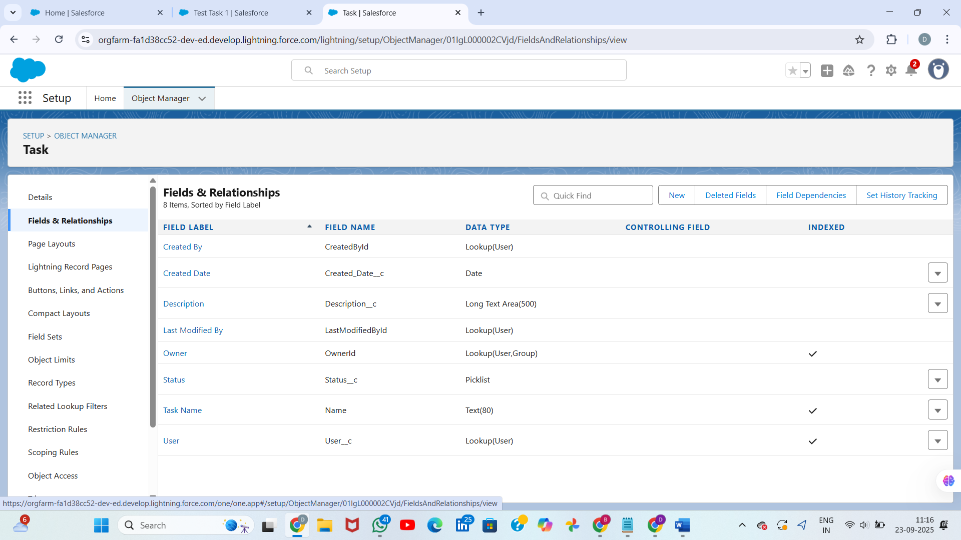

# Step 3.2 – Create the “AI Suggestion” Object

Purpose: Store AI-generated suggestions for each task.

Steps:  
Go to Setup → Object Manager → Create → Custom Object  
Enter:

Label = AI Suggestion  
Plural Label = AI Suggestions  
Object Name = AI_Suggestion  
Record Name = Suggestion ID (Auto Number or Text)  
Check “Allow Reports”  
Save.

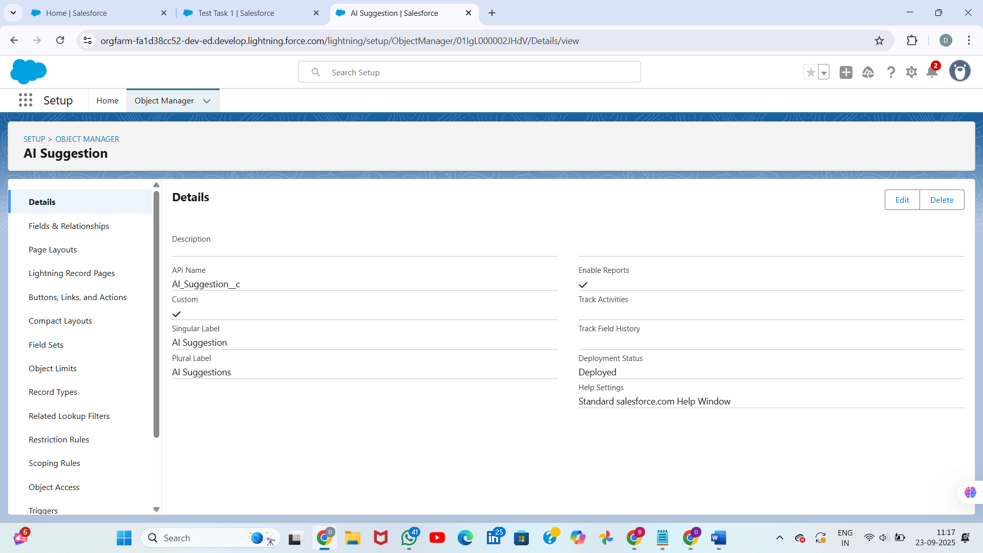

## Fields for AI Suggestion Object

|  |  |  |  |
| --- | --- | --- | --- |
| Field Label | Field Name | Data Type | Description |
| Suggested Text | Suggested_Text | Long Text Area (1000) | The AI’s recommended content |
| Confidence Score | Confidence_Score | Percent (3, 2) | AI’s confidence in suggestion accuracy |
| Related Task | Related_Task | Lookup(Task) | Connects this suggestion to a specific task |
| Created Date | CreatedDate | Auto-Number/Standard | Timestamp when suggestion is created |
| Last Modified Date | LastModifiedDate | Auto-Number/Standard | Timestamp when edited |

# Step 3.3 – Create the “Feedback” Object

Purpose: Track user approval, rejection, and comments regarding each AI suggestion.

Steps:  
Go to Setup → Object Manager → Create → Custom Object  
Enter:

Label = Feedback  
Plural Label = Feedbacks  
Object Name = Feedback  
Record Name = Feedback ID (Auto Number or Text)  
Check “Allow Reports”  
Save.

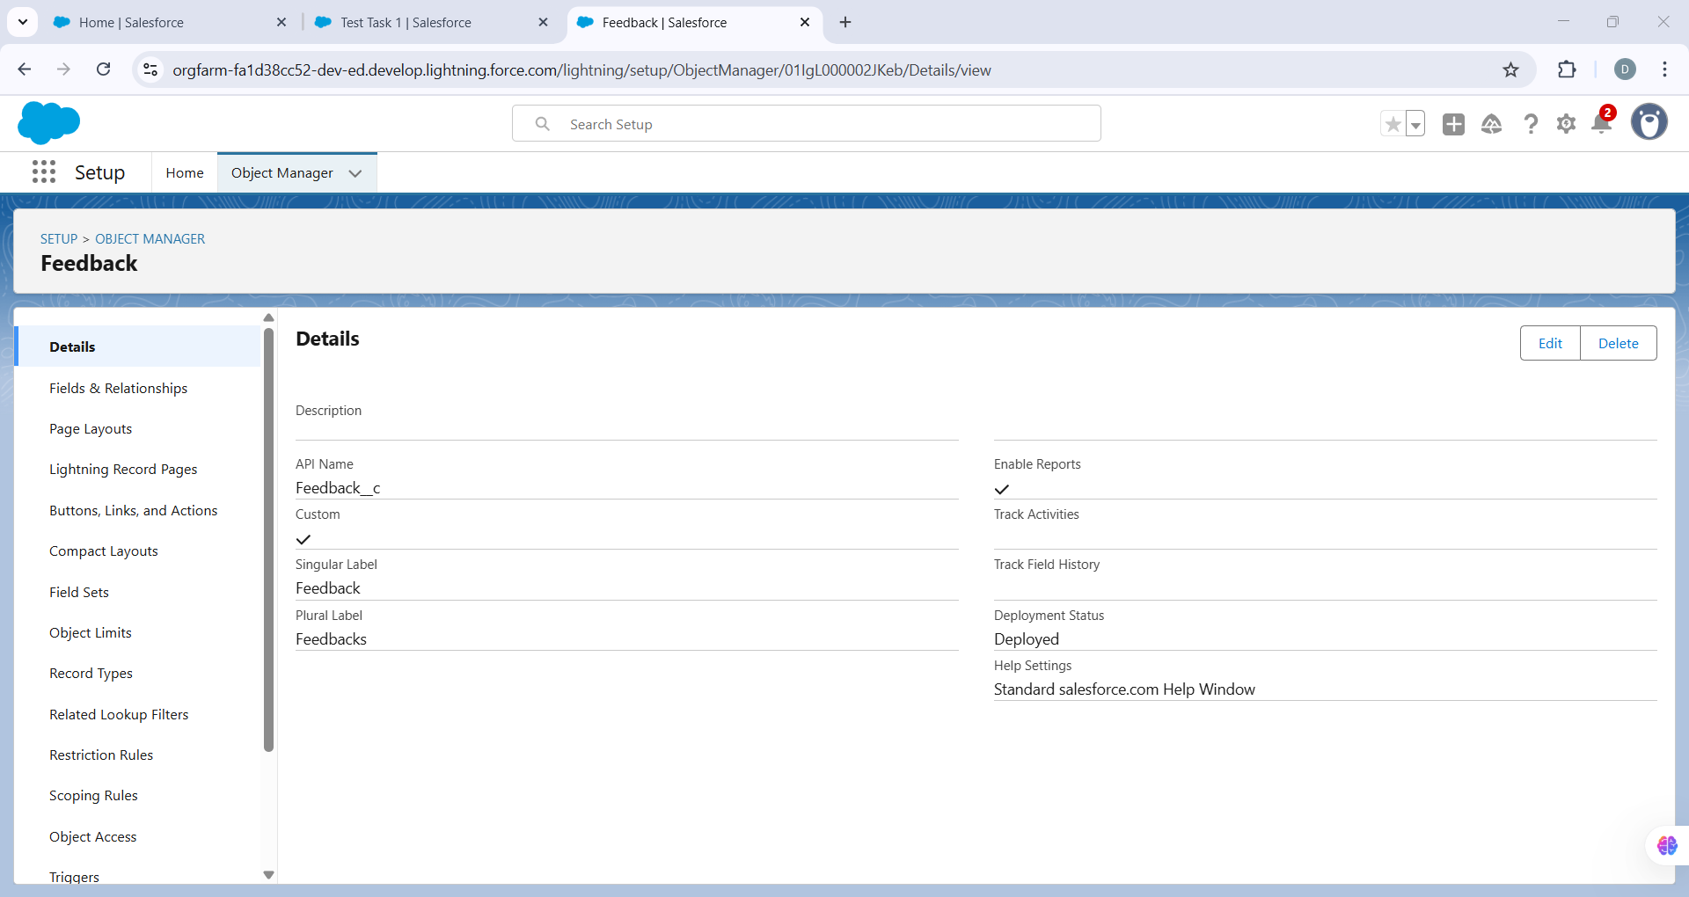

## Fields for Feedback Object

|  |  |  |  |
| --- | --- | --- | --- |
| Field Label | Field Name | Data Type | Description |
| Approved | Approved | Checkbox | Indicates if suggestion was accepted |
| Comments | Comments | Long Text Area (500) | Additional remarks from user |
| Related Suggestion | Related_Suggestion | Lookup(AI Suggestion) | Connects feedback to the suggestion |
| Created Date | CreatedDate | Auto-Number/Standard | Automatically set when feedback is created |
| Last Modified Date | LastModifiedDate | Auto-Number/Standard | Updates when feedback is edited |

# Step 3.4 – Define Relationships

Task → AI Suggestion (1-to-many)  
Each task can have multiple suggestions  
Create lookup field → Related Task in AI Suggestion

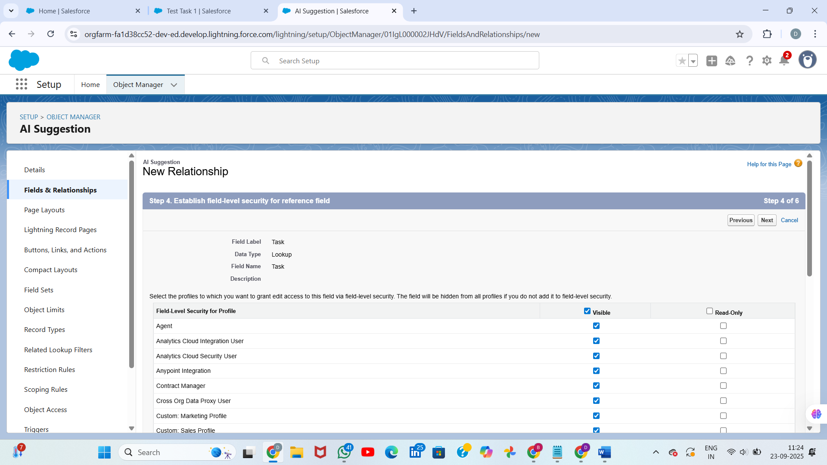

AI Suggestion → Feedback (1-to-many)  
Each suggestion can have multiple feedback entries  
Create lookup field → Related Suggestion in Feedback  
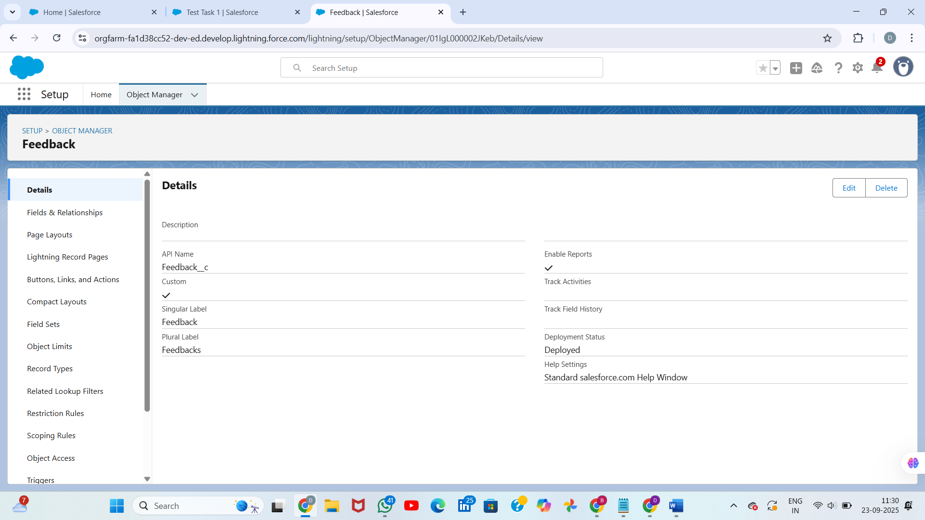

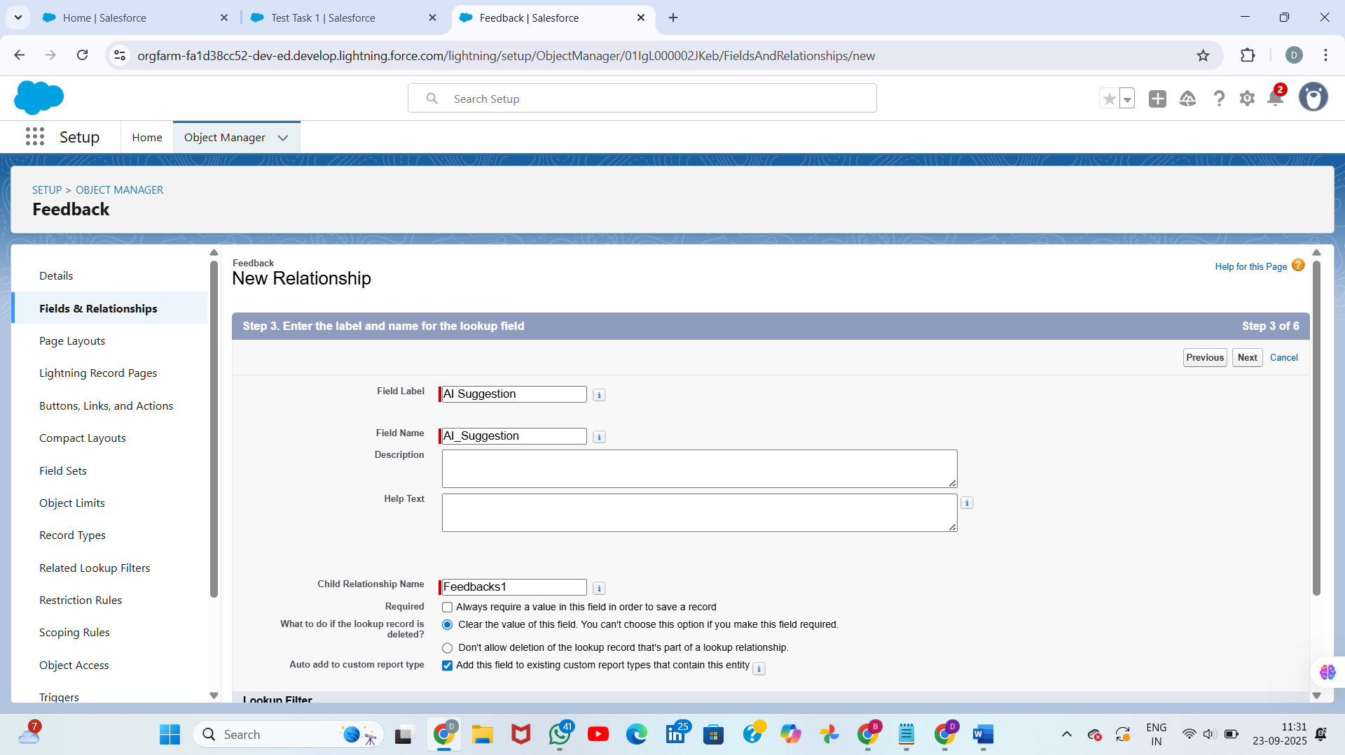

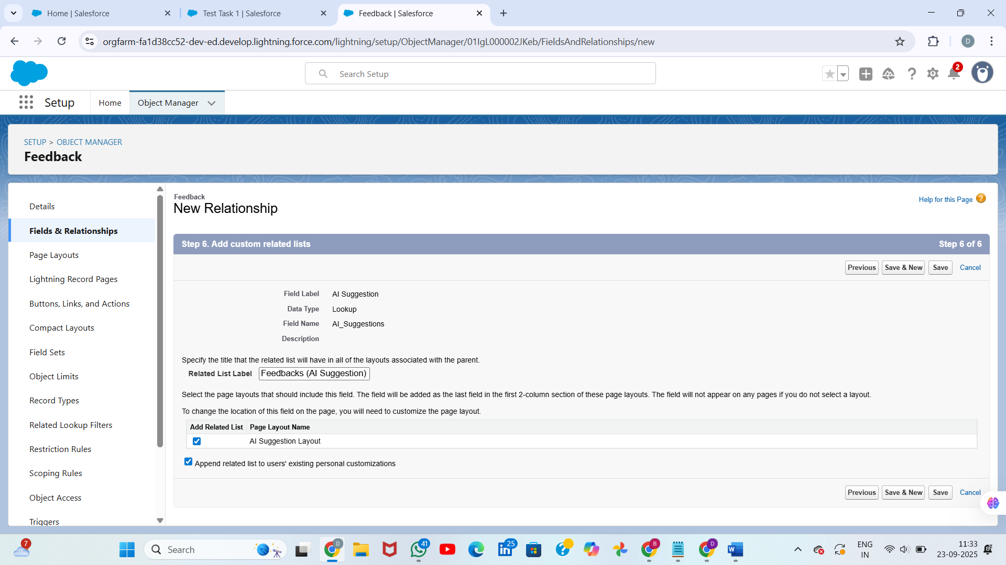

# Step 3.5 – Customize Page Layouts

For each object:  
Go to Page Layouts inside the object settings  
Drag and drop fields logically:

• Task layout → Task Name, Description, Status, Assigned User

• AI Suggestion layout → Suggested Text, Confidence Score, Related Task

• Feedback layout → Approved, Comments, Related Suggestion

Add sections like “Details”, “Related Lists”  
Include buttons like “Edit”, “New Suggestion”, “Add Feedback”

# Step 3.6 – Create Compact Layouts (Optional but recommended)

✔ Create compact views to display key information at the top  
✔ Example: Show Task Name and Status prominently

# Step 3.7 – Test the Data Model

Create a sample Task  
Create a linked AI Suggestion for that task  
Create feedback connected to that suggestion  
Validate data flows correctly

**3.8. Schema Builder in Salesforce**

Schema Builder is a visual tool in Salesforce where you can create, view, and modify objects & relationships.

Navigate: Setup → Schema Builder

(search "Schema Builder" in Quick Find).

we’ll see all your objects (Standard & Custom) with fields and relationships visually connected.

## 3.9 Relationships in Salesforce

**(a) Lookup Relationship**

**Definition:** Loose relationship between two objects. One record can be linked but not tightly dependent.

### Example for project:

A Task may have a Lookup to AI Suggestion object.

(Task can exist even if the AI Suggestion is deleted).

### Steps in Schema Builder / Object Manager:

- Go to Object Manager → Your Object → Fields & Relationships → New.

- Choose Lookup Relationship.

- Select the related object.

- Save and add to page layout.

**(b) Master-Detail Relationship**

Definition: Strong relationship (child depends fully on parent). If parent is deleted, child records are also deleted. Child inherits parent’s sharing & ownership.

Example: AI Suggestion Detail object (child) related to AI Suggestion (parent).

(If AI Suggestion is deleted, its detail records also delete).

Steps: Same as lookup, but choose Master-Detail instead of Lookup.

(**c) Hierarchical Relationship**

Definition: Special type of relationship available only on User object to link one user to another (like manager → subordinate).

Example: You can set up "Reviewer User" field on User object to assign a user as reviewer/approver of tasks.

Steps:

- Go to Object Manager → User → Fields & Relationships → New.

- Select Lookup Relationship, it will show option Hierarchical.

- Choose User as the target.

## 3. 10 Junction Objects

## Definition: Custom object used to create many-to-many relationships.

## Example for project:

A Task can have many AI Suggestions, and one AI Suggestion can be linked to many Task

**Steps:**

Create a new custom object (e.g., Task_Suggestion_Link__c).

- Add two Master-Detail fields:

• Task (Master)

• AI Suggestion (Master)

- Salesforce automatically creates a many-to-many relationship via this junction.

**3.11. External Objects**

Definition: Used when data is stored outside Salesforce (like in an external system, database, or API). Instead of copying data into Salesforce, you access it virtually.

### Example:

If your AI engine is running outside Salesforce (say on AWS or external DB) and you want to show AI Results inside Salesforce without storing them.

### Steps:

- Setup → External Data Sources.

- Choose type (OData, Salesforce Connect, etc.).

- Define connection to your external system.

- Sync tables → Salesforce will create External Objects.

- Use these like normal objects (but data is fetched real-time from external source).