Phase 8 – Data Management & Deployment (Customized Implementation)

# Purpose

The purpose of this phase is to ensure that data can be imported, exported, and managed safely within Salesforce, while enabling smooth deployment of metadata and automation between environments. In this implementation, we focused on two key aspects:  
1. Importing sample Task data using the Data Import Wizard.  
2. Loading AI Suggestions using the Data Loader.  
  
This ensures that business users can quickly add and manage tasks, while administrators and developers can bulk-load suggestion data for testing and deployment.

# Step 1 – Importing Task Data using Data Import Wizard

The Data Import Wizard is a Salesforce tool for quickly importing smaller volumes of data through a simple UI.  
Process followed:  
1. Navigate to Setup → Data Import Wizard.  
2. Select the standard object 'Tasks'.  
3. Choose operation type: 'Add new records'.  
4. Upload CSV file containing sample Task data (columns: Subject, Due Date, Status, Assigned To).  
5. Map fields from CSV to Salesforce Task fields.  
6. Start Import and verify results from the Tasks tab.  
  
Outcome: Task records were successfully created in Salesforce for testing and demonstration.  
  
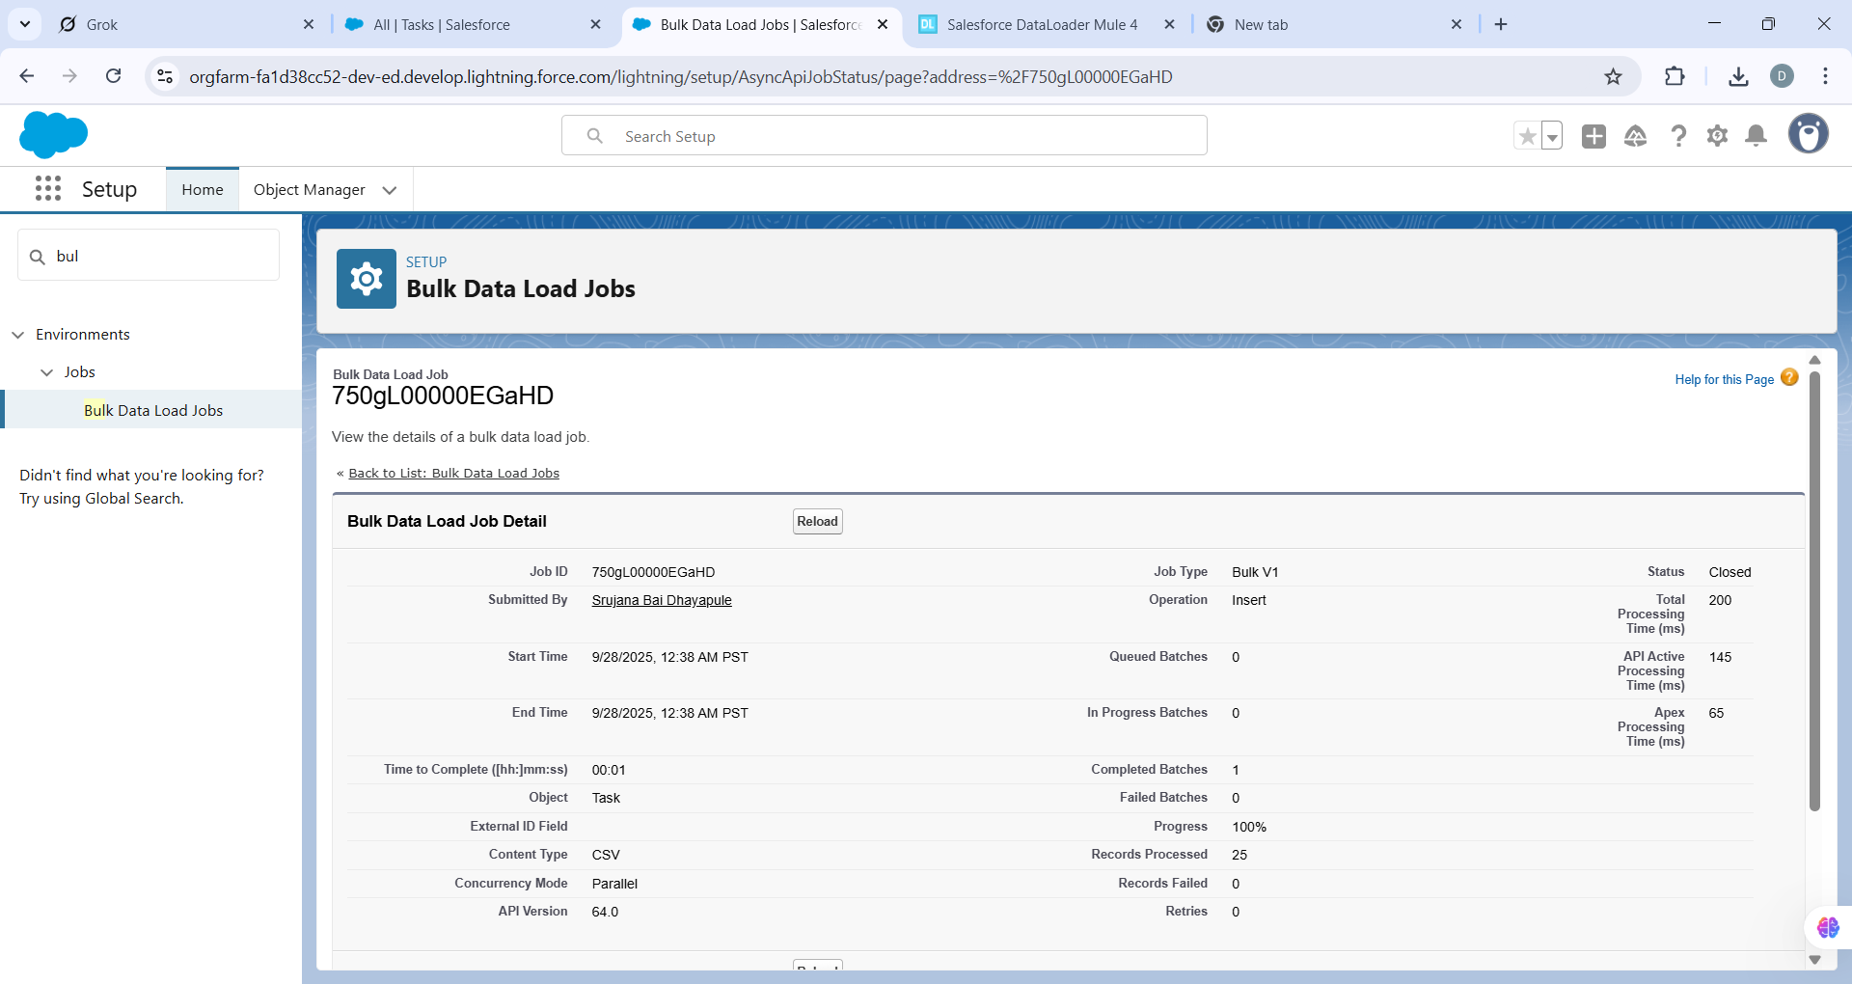

# Step 2 – Importing Suggestions using Data Loader

The Salesforce Data Loader is a client application that allows bulk import, update, export, and delete operations.  
Process followed:  
1. Launch Data Loader application on desktop.  
2. Login using OAuth (recommended) or Username + Password + Security Token.  
3. Choose 'Insert' operation.  
4. Select the custom object 'AI Suggestions'.  
5. Upload CSV file with sample suggestion data (columns: Suggestion Text, Category, Priority).  
6. Map CSV columns to Salesforce object fields.  
7. Run Import, check success and error files.  
8. Verify imported records in Salesforce under Suggestions tab.  
  
Outcome: Suggestions were successfully imported, enabling demo scenarios for AI-driven recommendations.  
  
• Setup → Matching Rules → Create/Enable rules (e.g., match by Email).  
• Setup → Duplicate Rules → Configure object rules (Allow/Block/Report).  
• Test with sample imports.  
Tip: For large migrations, sometimes set to Report first.  
  
  
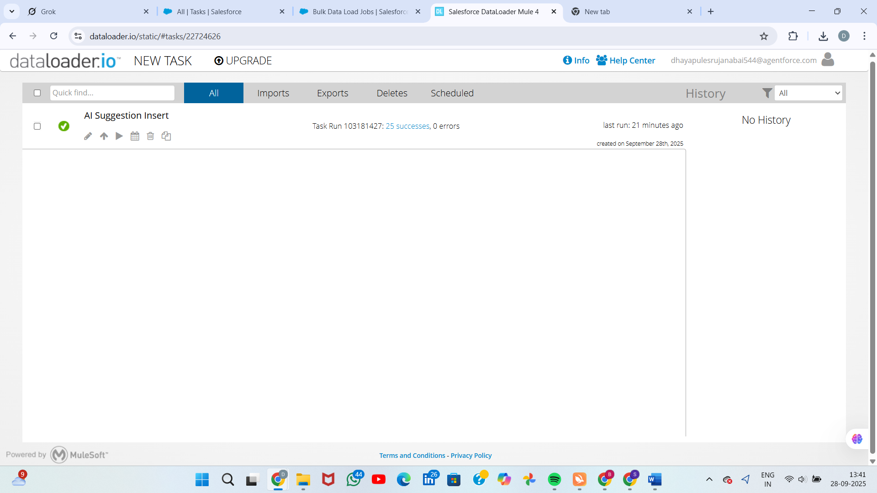  
  
Step 3 – Matching and Duplicate Rules

• **Start New Rule:**

* Click the **New Rule** button.
* Select **Task** as the object, and click **Next**.

• **Define Rule Details:**

* **Rule Name:** Enter Task_Subject_Who_Date_Exact.

• **Set Matching Criteria (All Exact Matches):**

* **Criterion 1 (Subject):**
  + **Field:** Select **Subject**.
  + **Matching Method:** Select **Exact**.
  + **Match Blank Fields:** Uncheck.
* **Criterion 2 (WhoId):**
  + Click **Add Mapping**.
  + **Field:** Select **WhoId** (The Contact/Lead lookup field).
  + **Matching Method:** Select **Exact**.
  + **Match Blank Fields:** Uncheck.
* **Criterion 3 (ActivityDate):**
  + Click **Add Mapping**.
  + **Field:** Select **ActivityDate**.
  + **Matching Method:** Select **Exact**.
  + **Match Blank Fields:** Uncheck.

• **Set Matching Logic:**

* The default logic will be **(1 AND 2 AND 3)**, which is correct.

• **Save and Activate:**

* Click **Save**.
* On the detail page for the new rule, click **Activate**.

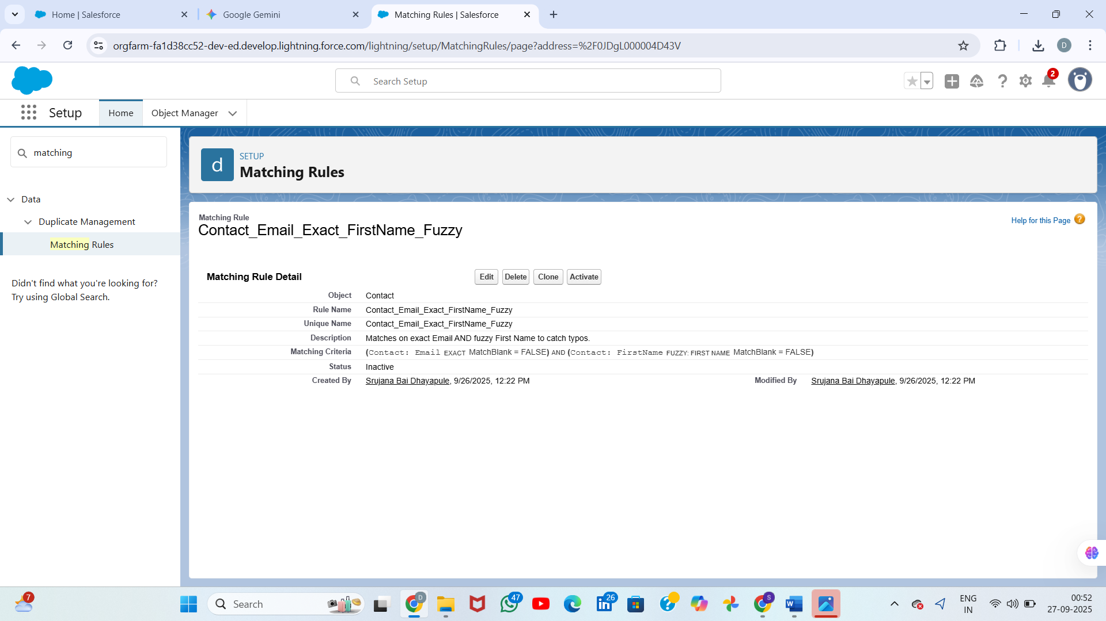

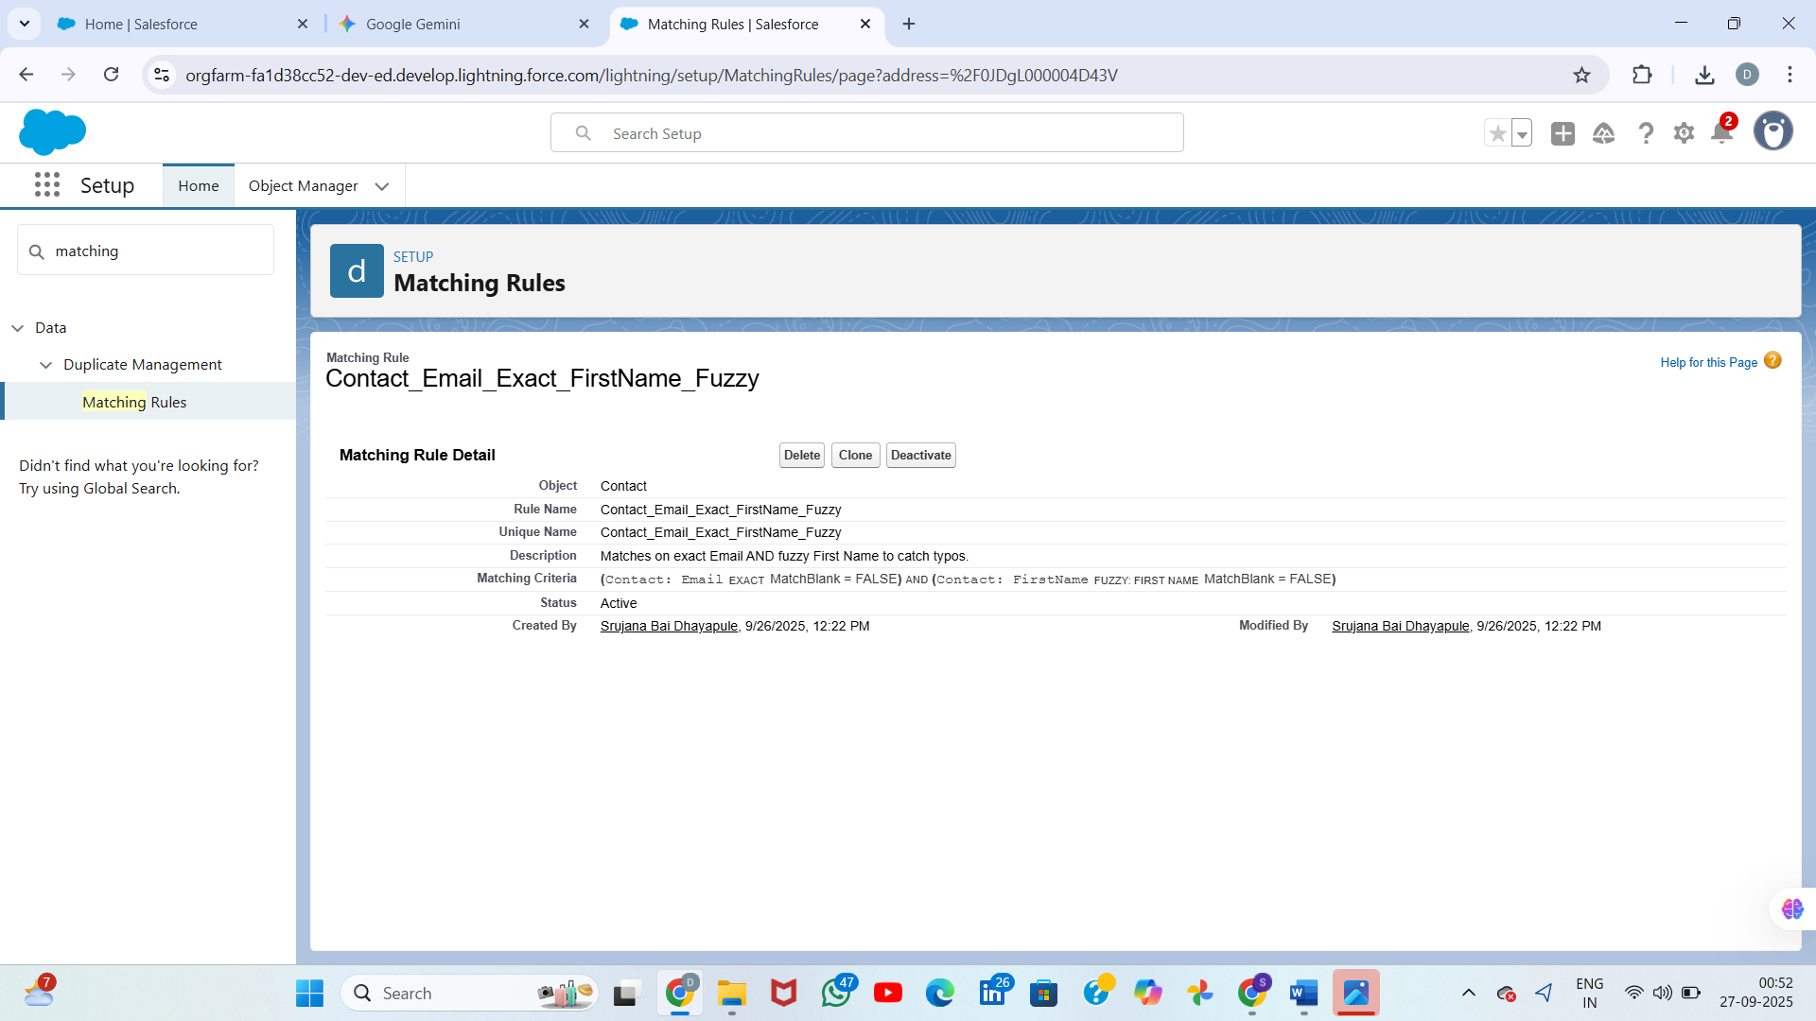

**Setting Up the Duplicate Rule**

A **Duplicate Rule** defines *what happens* when a record matches an **Active Matching Rule** (e.g., alert the user, block the save).

**Steps to Create a Duplicate Rule**

1. **Navigate to Setup:** (If you left the screen)
   * Click the **gear icon** (⚙) and select **Setup**.
2. **Find Duplicate Rules:**
   * In the **Quick Find** box, type Duplicate Rules and select the result.
3. **Create a New Rule for Your Object:**
   * Click **New Rule**.
   * Select the **Object** (must be the same object as your Matching Rule, e.g., Contact).
4. **Configure the Rule Details:**

| Section | Setting | Explanation |
| --- | --- | --- |
| **Rule Name** | Choose a descriptive name (e.g., Block Duplicate Contacts). |  |
| **Action on Create** | Defines the action when a new record is created. |  |
| **Action on Update** | Defines the action when an existing record is edited. |  |
| **Security** | Select **Bypass sharing rules** if you want the rule to check against ALL records, regardless of user access. | Recommended for data quality. |

1. Export to Sheets
2. **Configure Actions:**
   * Under **Actions**, you have three choices for both **On Create** and **On Edit**:
     + **Allow:** Permits the record to be created/updated but reports the duplicate (recommended for initial setup or large migrations).
     + **Alert:** Shows a warning message to the user but allows them to save the record.
     + **Block:** Prevents the record from being created/updated (use only if you are certain about your matching logic).
   * **Recommended Action for Data Import Preparation:** Set **Action on Create** and **Action on Update** to **Allow** and ensure the **Report** checkbox is selected. This logs duplicates without stopping the import.
3. **Select the Matching Rule:**
   * Scroll down to the **Matching Rules** section.
   * Click **Add Rule** and select the **Active Matching Rule** you created in Step 1 (e.g., Contact_Email_Match).
   * **Optional: Set Action on Create/Update for Records That Match:** This is where you specify the **Alert** or **Block** actions.
4. **Activate the Rule:**
   * Click **Save**.
   * Click **Activate** next to the rule name.
   * *A Duplicate Rule must be* ***Active*** *to check for duplicates.*

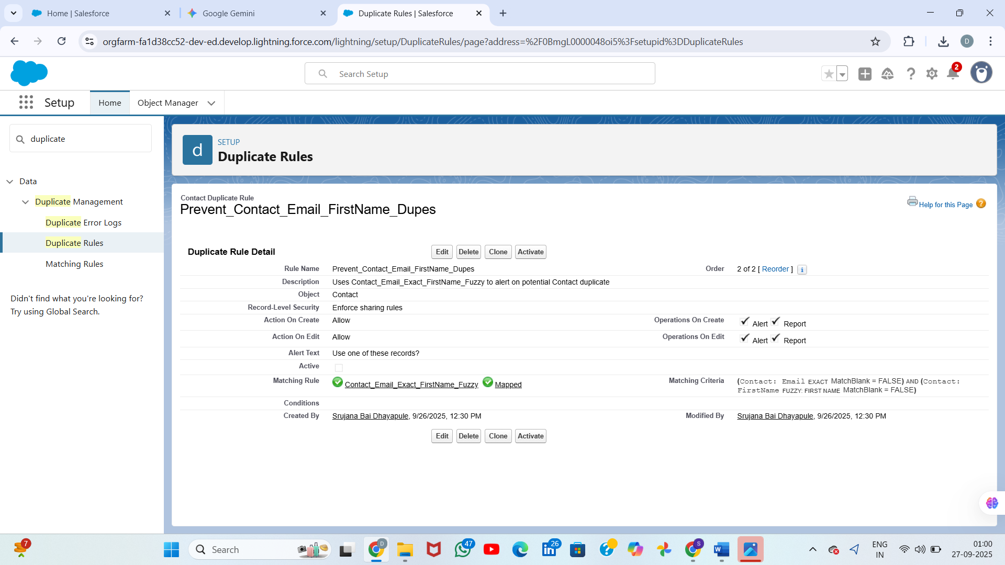

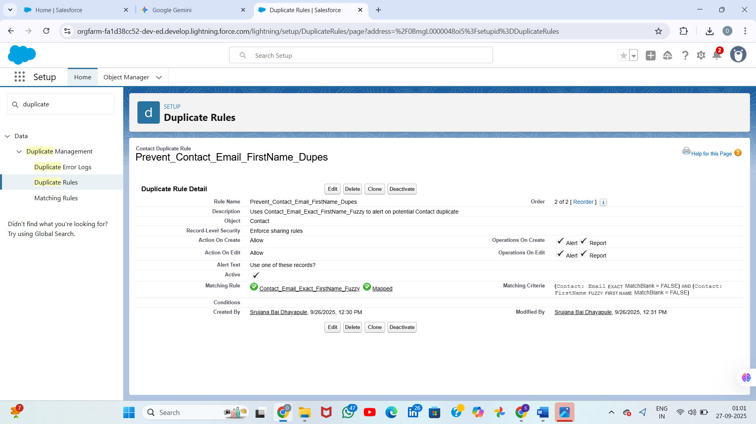  
**reate the Duplicate Rule**

Once these **Matching Rules** are active, they are ready to be used by a **Duplicate Rule**. You must create a **Duplicate Rule** for each object (Contact and Task) and point it to the respective new **Matching Rule** to enforce the duplicate prevention logic.

**Example for Contacts:**

1. Go to **Setup** → **Duplicate Rules**.
2. Click **New Rule** → **Contact**.
3. Set **Action on Create/Update** to **Allow** and ensure **Alert** and **Report** are checked.
4. Under **Matching Rules**, add your new rule: Contact_Email_Exact_FirstName_Fuzzy.
5. **Save and Activate** the Duplicate Rule.

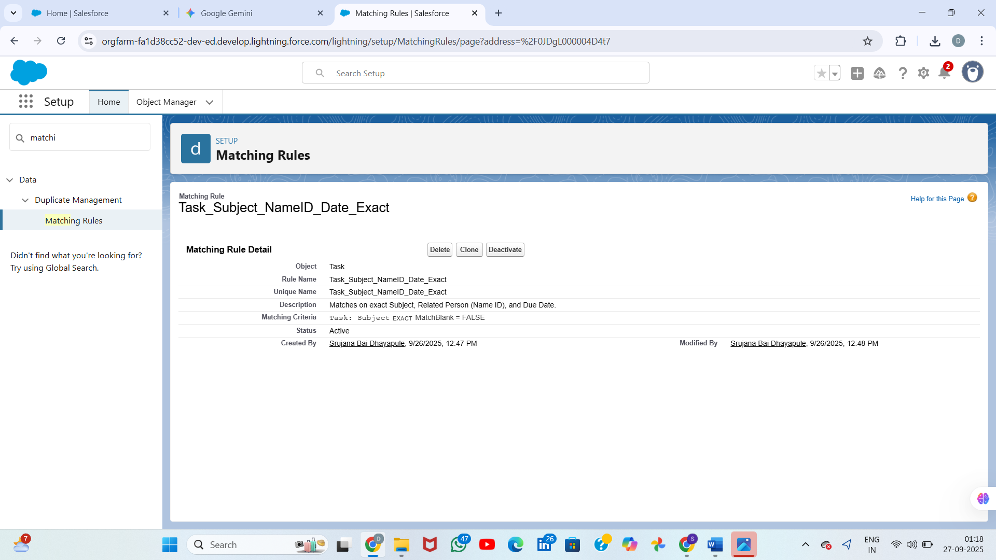

# Phase Outcome

By implementing Task imports via Data Import Wizard and Suggestion imports via Data Loader, we achieved:  
• Quick setup of sample task data for demonstrations.  
• Bulk loading of AI Suggestions for testing recommendation features.  
• Validation of Salesforce’s ability to manage both small-scale and large-scale imports.  
  
This phase sets the foundation for future deployments, reporting, and demonstrations.