# Neural Network Assignment – 2

# Srujana Konda

# 700740479

**Program 1**: Write a program that takes two strings from the user: first_name, last_name. Pass these variables to fullname function that should return the (full name).

For example: ▪ First_name = “your first name”, last_name = “your last name” ▪ Full_name = “your full name”

Write function named “string_alternative” that returns every other char in the full_name string. Str = “Good evening” Output: Go vnn

Note: You need to create a function named “string_alternative” for this program and call it from main function.

**Output screenshot**:

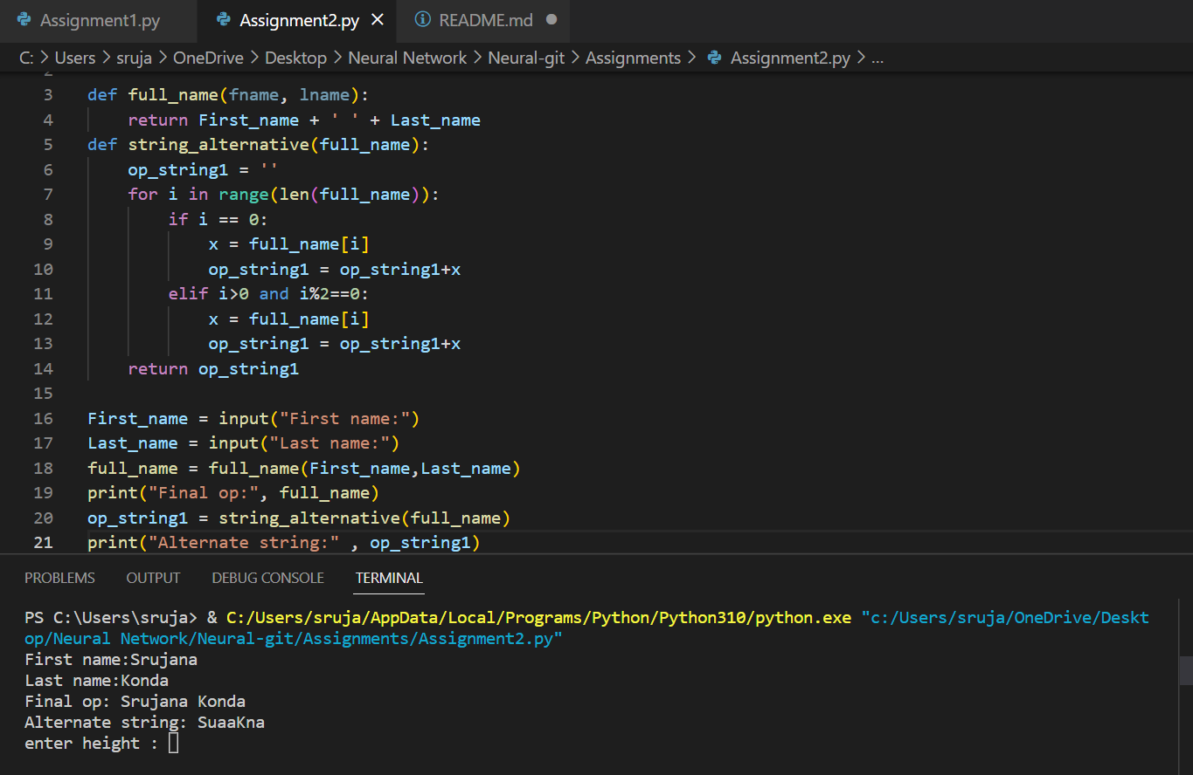

**Program 2:** Write a python program to find the wordcount in a file (input.txt) for each line and then print the output. o Finally store the output in output.txt file.

Example:

Input: a file includes two lines: Python Course Deep Learning Course

Output: Python Course Deep Learning Course

Word_Count: Python: 1 Course: 2 Deep: 1 Learning: 1

**Output Screenshot:**

**Program 3:**

Write a program, which reads heights (inches.) customers into a list and convert these heights to centimeters in a separate list using: 1) Nested Interactive loop. 2) List comprehensions

**Output screenshot:**

**Github link : https://github.com/Srujana-Konda/Assignment-2**