Neural Network Assignment-1

Srujana Konda

700740479

Program 1:

Write a python program for the following: – Input the string “Python” as a list of characters from console, delete at least 2 characters, reverse the resultant string, and print it

Output screenshots:

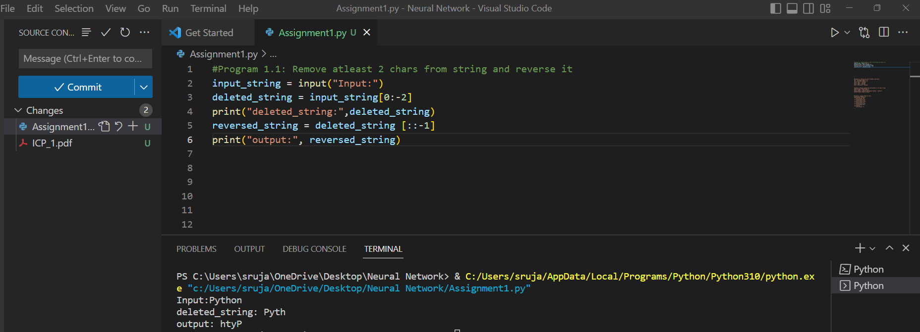

Program 1.1:

Take two numbers from user and perform at least 4 arithmetic operations on them.

Output Screenshots:

Program 2:

Write a program that accepts a sentence and replace each occurrence of ‘python’ with ‘pythons’.

Output Screenshot:

Program 3:

Use the if statement conditions to write a program to print the letter grade based on an input class score. Use the grading scheme we are using in this class.

Output Screenshot:

