Metro Interstate Prediction

HIGH-LEVEL DOCUMENT

Aditi Pagey

Srujana Gundam

8 MAY, 2022

iNeuron

Contents

1.Introduction................................................................................................................................3

1.1. What is a High-Level design document..................................................................................3

1.2.Scope......................................................................................................................................3

2.General Desciption.....................................................................................................................4

2.1 Product Prespective................................................................................................................4

2.2.Problem Statement..................................................................................................................4

2.3.Proposed Solution...................................................................................................................4

2.4. Future Improvements.............................................................................................................4

2.5. Data Description……………...................................................................................................4

2.6.Tools Used...............................................................................................................................5

2.7.Assumptions……….................................................................................................................6

3 Design Details…………………………………………………………………………………………..6

4. Performance……………………………………………………………………………………..……..7

5.Resuabilty……………………………………………………………………………………………….7

6.Conclusion………………………………………………………………………………………..……..8

ABSTRACT

Nowadays, traffic is a major issue for everyone, and it is a source of stress for anyone who has to deal with it on a daily basis. The growth of the population delays traffic and makes it worse day by day. The settlement of modern civilization looks at it, but it is unable to act in such a way as to protect people. We can watch traffic, collect data, and anticipate the next and subsequent observations using a variety of approaches and patterns. The observation agency then makes observations, which are then required out and predictions are made. Being stuck in a cosmopolitan city's traffic is the most common occurrence in one's life.

1. Introduction

1.1. Why this High-Level Design Document?

The purpose of this High-Level Design (HLD) document is to add the necessary detail to the current project description to represent a suitable model for coding. This document is also intended to help detect contradictions prior to coding and can be used as a reference manual for how the modules interact at a high level.

* The HLD will present all of the design aspects and define them in detail Describe the user interface being implemented
* Describe the hardware and software interfaces Describe the performance requirements
* Include design features and the architecture of the project
* List and describe the non-functional attributes like:

1. Security
2. Reliability
3. Maintainability
4. Portability
5. Reusability
6. Application compatibility
7. Resource utilization
8. Serviceability

1.2 Scope

The HLD documentation presents the structure of the system, such as the database architecture, application architecture (layers), application flow (Navigation), and technology architecture. The HLD uses non-technical to mildly-technical terms which should be understandable to the administrators of the system.

1. General Description

2.1. Product Perspective

The Metro Interstate Prediction is a machine learning-based regression model which will help us predict traffic volume based on various factors.

2.2.Problem Statement

The goal of this project is to build a regressive prediction model using multiple machine learning techniques and to use a template to document the end-to-end stages. We're trying to forecast the value of a continuous variable with the Metro Interstate Traffic Volume dataset, which is a regression issue.

2.3. Proposed Solution

A model is created which will take few important parameters on which traffic

in that given area is significantly depended.Training on those parameters will provide tentative traffic on the given time and day date.

The entire model will be used by the user with the help of a front end frame which will improve the UX.

2.4. Further Improvements

This model can be further enhanced with real time data set values with regular updation to increase it prediction accuracy (currently 93%) .More features can be added to the user interface to track previous start to end destination travel time, date, day etc so that user can plan their day better, section to add the recent journey experience details so that they can be updated to the dataset and model will be trained against more varied dataset and will be up to date daily.

2.5. Dataset Description

The dataset is provided with the following variables:

1. temp -Numeric Average temp in kelvin
2. rain_1h -Numeric Amount in mm of rain that occurred in the hour
3. snow_1h -Numeric Amount in mm of snow that occurred in the hour
4. clouds_all- Numeric Percentage of cloud cover
5. weather_main-Categorical Short textual description of the current weather
6. weather_description-Categorical Longer textual description of the current weather
7. date_time -DateTime Hour of the data collected in local CST time
8. traffic_volume -Numeric Hourly traffic volume

2.6. Tools used

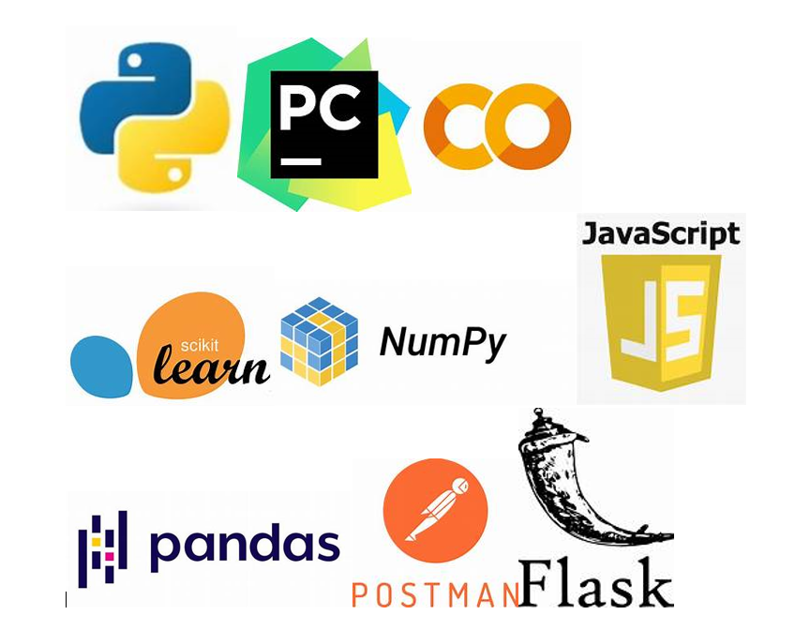

1. PyCharm
2. Jupyter Notebook
3. VS Code
4. Google Collab
5. GitHub
6. Python
7. Postman

Tools for web framework:

1. HTML
2. CSS
3. JavaScript
4. Flask

2.7.Assumptions:

It is assumed that the parameters provided are sufficient enough for the prediction and would be the only affecting parameters to the volume of the traffic.It is also assumed that the volume of data provided for training is enough and covers all the extreme cases as well as there is no bias in the categorical data which is used by the model.

3. Design Details

Proposed Methodology

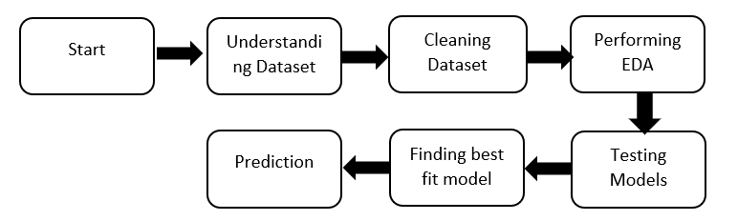

3.1. Model Training and evaluation

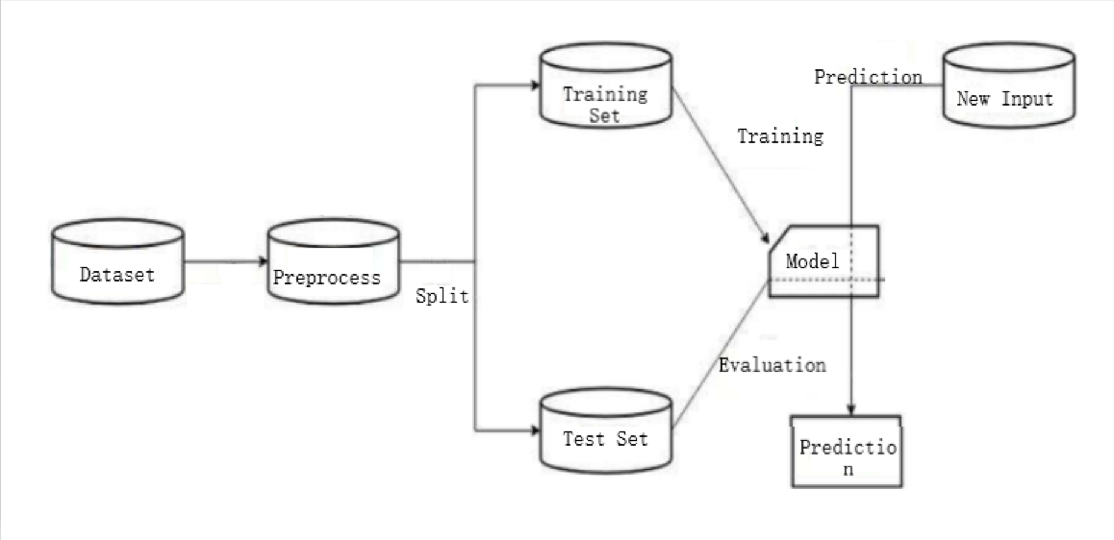

3.2. Deployment Process

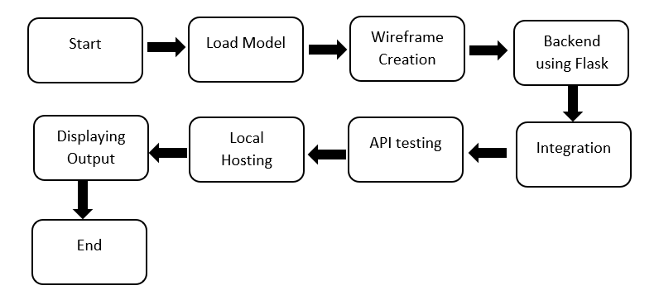

4. Performance

The accuracy of the model is 95% which gives a really good performance for the final application .

5. Reusability

The code is written in such a fashion that every chunk of code is easily reusable without need for any alterations or tweaking.

6. Conclusion

The model was built successfully and predicts output as expected.We can identify the parameters which affected the traffic volume at a place and can simply eliminate the non-significant parameters and factors for improved efficiency of the final model.

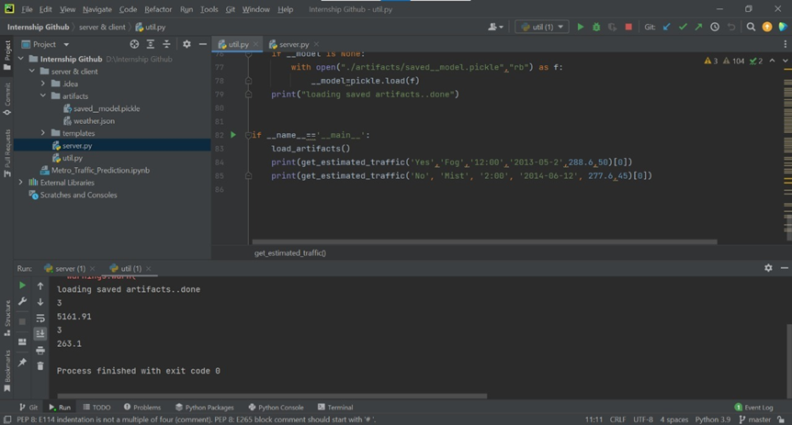

*Fig.1. Backend using Flask*

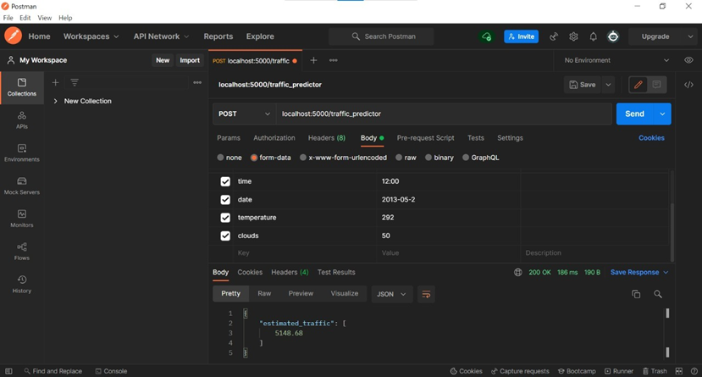

*Fig.2. API testing using Postman*

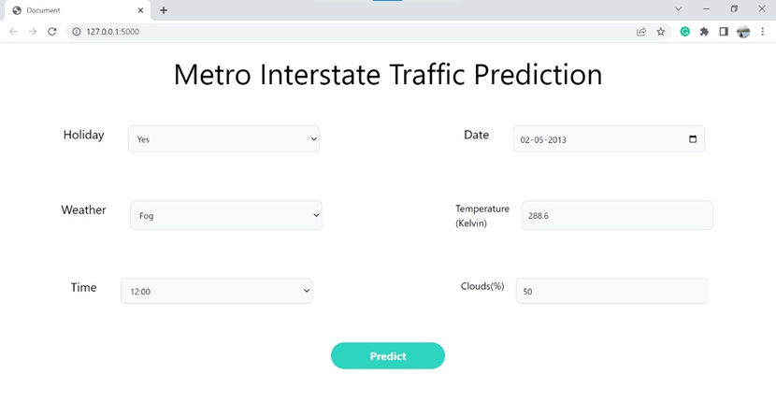

*Fig.3. Frontend using HTML & CSS.*