Metro Interstate Prediction

LOW-LEVEL DOCUMENT

Aditi Pagey

Srujana Gundam

8 MAY, 2022

iNeuron

Contents

1.Introduction................................................................................................................................1

1.1. What is a Low-Level design document..................................................................................1

1.2.Scope......................................................................................................................................1

2.Architecture................................................................................................................................2

3.ArchitectureDescription..............................................................................................................3

3.1. Data Description.....................................................................................................................3

3.2. Web Scrapping.......................................................................................................................3

3.3. Data Transformation...............................................................................................................3

3.4. Data Insertion into Database..................................................................................................3

3.5. Export Data from Database....................................................................................................3

3.6. Data Pre-processing...............................................................................................................3

3.7. Data Clustering

1. Introduction

1.1. What is a Low-Level design document?

The goal of LLD or a low-level design document (LLDD) is to give the internal logical design of the actual program code for Metro Interstate Prediction. LLD describes the class diagrams with the methods and relations between classes and program specs. It describes the modules so that the programmer can directly code the program from the document.

1.2. Scope

Low-level design (LLD) is a component-level design process that follows a step-by-step refinement process. This process can be used for designing data structures, required software architecture, source code and ultimately, performance algorithms. Overall, the data organization may be defined during requirement analysis and then refined during data design work

1. Architecture

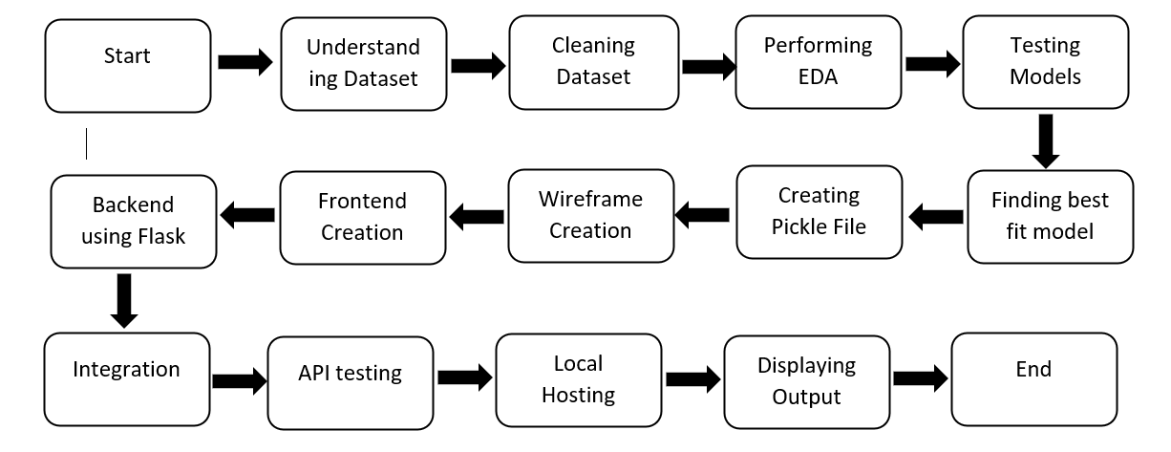

1. Architecture Description

3.1.**Understanding the Dataset**: Load the dataset and understand the various parameters given in it and what is their significance and units of the various parameters.

3.2. **Cleaning the dataset**: Clean the dataset and checked if it has any null values or rows which are not complete or have any garbage values.

3.3.**Exploratory Data Analysis (EDA):** to find out which parameters provide insights to understand the data better.

3.3.1. Change the data columns to categorical and numerical values for the better training and performance of the model

3.3.2. Pre-processing – analyse which columns aren’t useful for the output dependent parameter (as the model is a regressive model)

3.3.3. Drop the columns which aren’t providing many insights for understanding the dependency of the output variable on it.

3.4. **Testing Models:** Testing on various regression models to find the best fit for the dataset by seeing the accuracy of each model after training.

3.5.**Creating a pickle file**: It serializes the object first before writing it to file. Pickling is a way to convert a python object (list, dict, etc.) into a character stream. The idea is that this character stream contains all the information necessary to reconstruct the object in another python script.

3.6.**Wireframe Creation**: It is a schematic or blueprint that is useful for helping you think and communicate about the structure of the software or website you're building.

3.7.**Frontend Creation:** This is the software program or website that the user uses to interact. Create the front end by using tools according to convenience.

3.8.**Backend Creation:** The backend is the server-side of the website. It stores and arranges data, and also makes sure everything on the client-side of the website works fine. Create the front end by using tools according to convenience.

3.9.**Integrating of backend and frontend**: Write functions in the backend that take the model as input from the pickle file and give the predicted output.