**UNIT-5**

**CONGESTION:**Congestion in a network may occur if the load on the network—the number of packets sent to the network—is greater than the capacity of the network—the number of packets a network can handle. Congestion control refers to the mechanisms and techniques to control the congestion and keep the load below the capacity.

***Queues in a router***

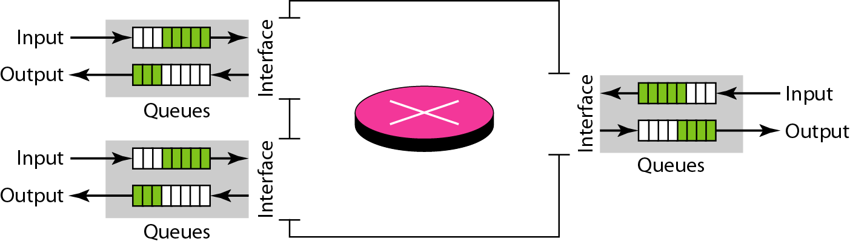

***Packet delay and throughput as functions of load***

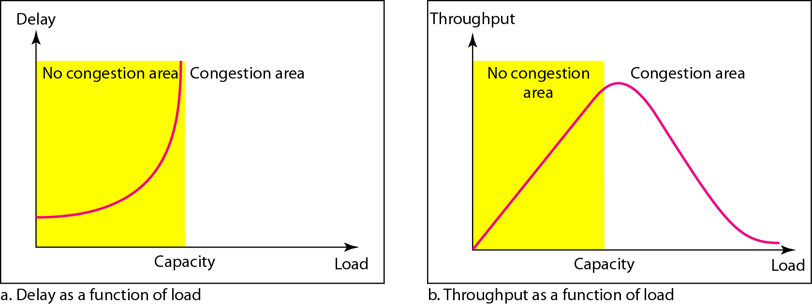

**CONGESTION CONTROL:**Congestion control refers to techniques and mechanisms that can either prevent congestion, before it happens, or remove congestion, after it has happened. In general, we can divide congestion control mechanisms into two broad categories: open-loop congestion control (prevention) and closed-loop congestion control (removal).

***Fig: Congestion control categories***

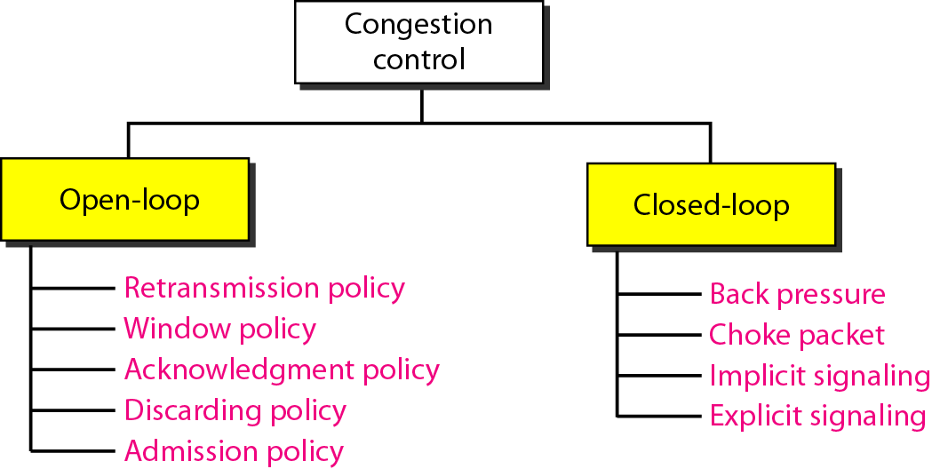

**Fig: Backpressure method for alleviating congestion**

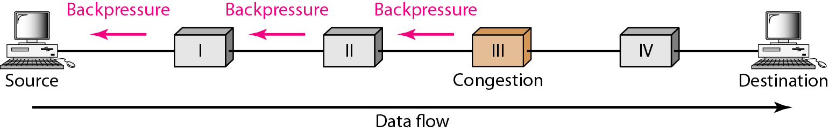

**Fig: Choke packet**

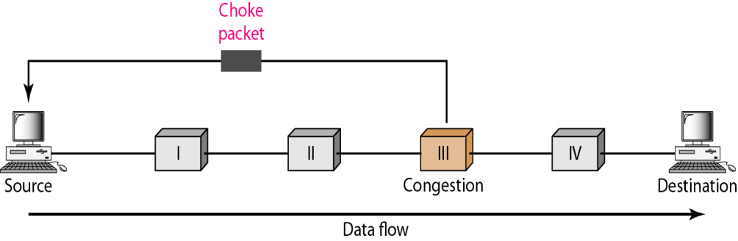

**TWO EXAMPLES**

To better understand the concept of congestion control, let us give two examples: one in TCP and the other in Frame Relay.

**Fig: Slow start, exponential increase**

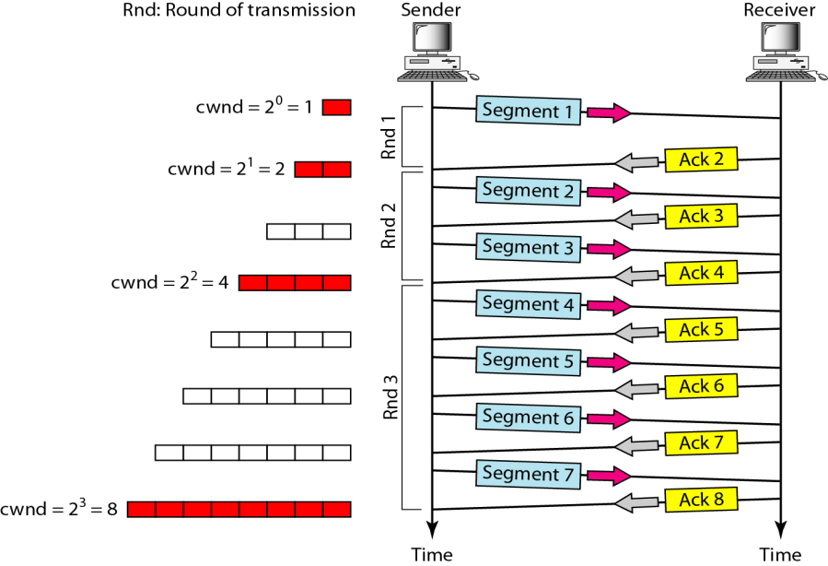

**Note:** In the slow-start algorithm, the size of the congestion window increases exponentially until it reaches a threshold.

**Fig: Congestion avoidance, additive increase**

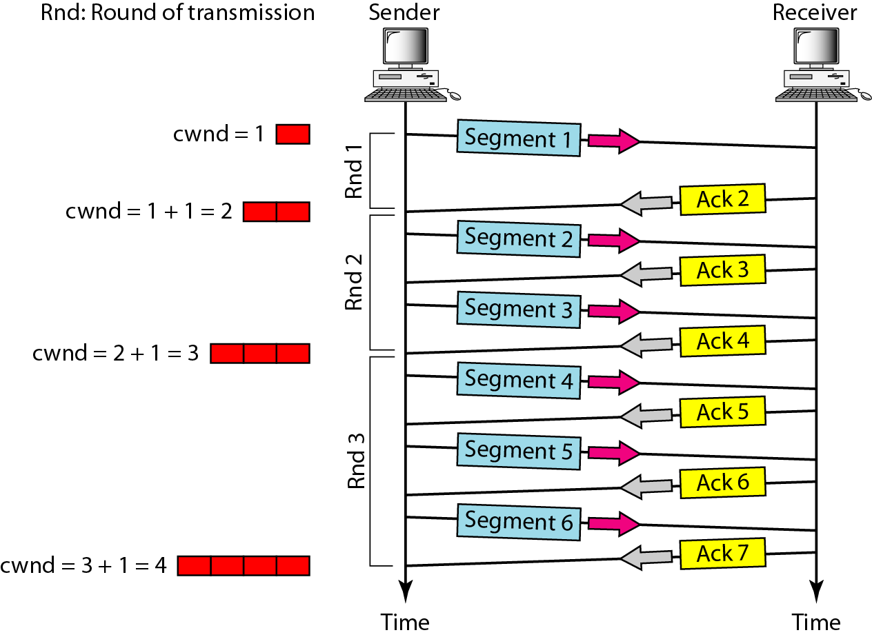

**Note:** In the congestion avoidance algorithm, the size of the congestion window increases additively until congestion is detected.

**Note:** An implementation reacts to congestion detection in one of the following ways:

* If detection is by time-out, a new slow start phase starts.
* If detection is by three ACKs, a new congestion avoidance phase starts.

**Fig: TCP congestion policy summary**

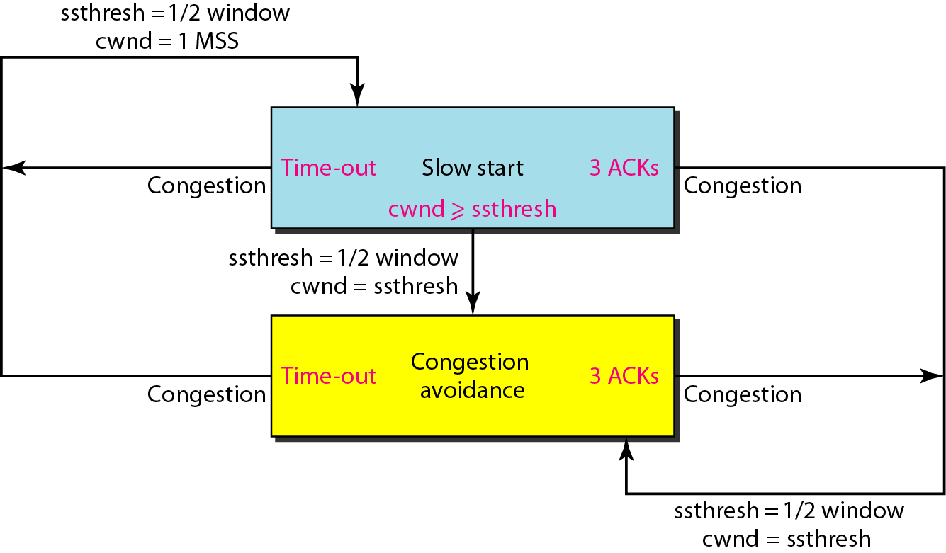

**Fig: Congestion example**

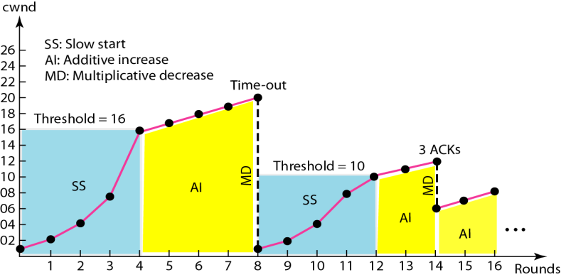

***Fig: BECN***

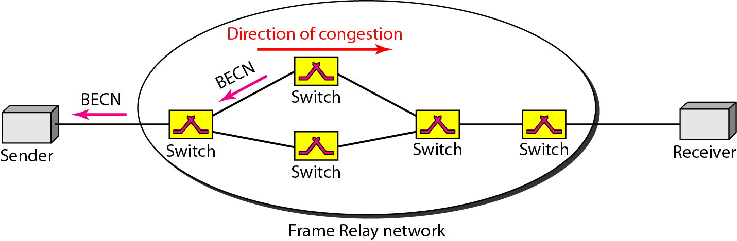

***Fig: FECN***

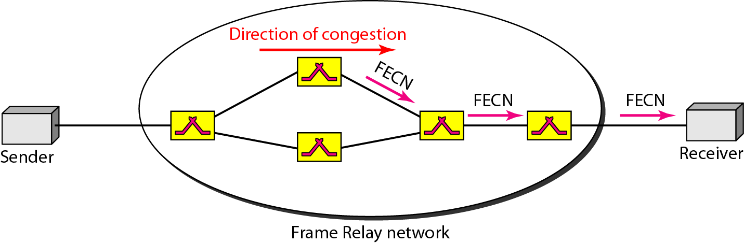

***Fig: Four cases of congestion***

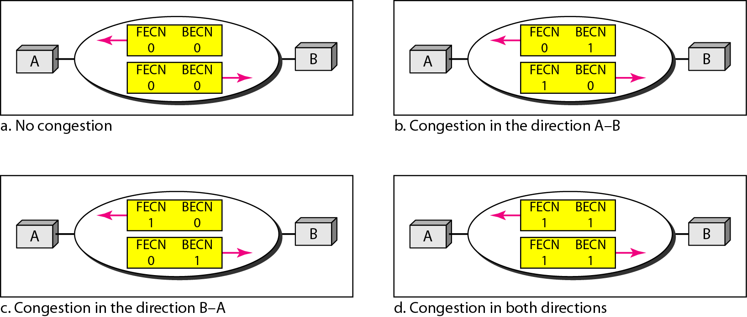

**QUALITY OF SERVICE**

Quality of service (QoS) is an internetworking issue that has been discussed more than defined. We can informally define quality of service as something a flow seeks to attain.

***Fig: Flow characteristics***

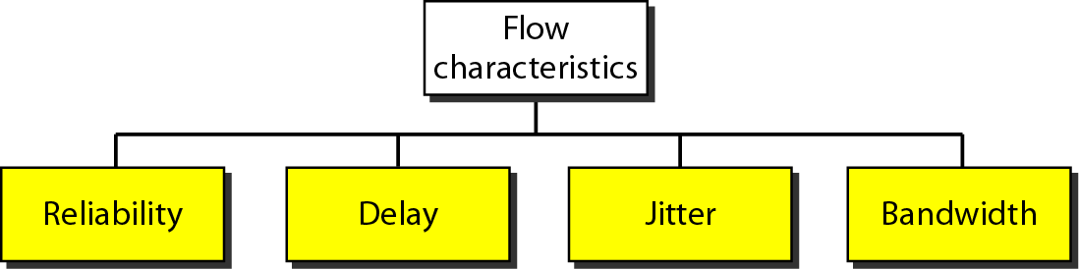

**TECHNIQUES TO IMPROVE QoS**

In Section we tried to define QoS in terms of its characteristics. In this section, we discuss some techniques that can be used to improve the quality of service. We briefly discuss four common methods: scheduling, traffic shaping, admission control, and resource reservation.

**Fig: FIFO queue**

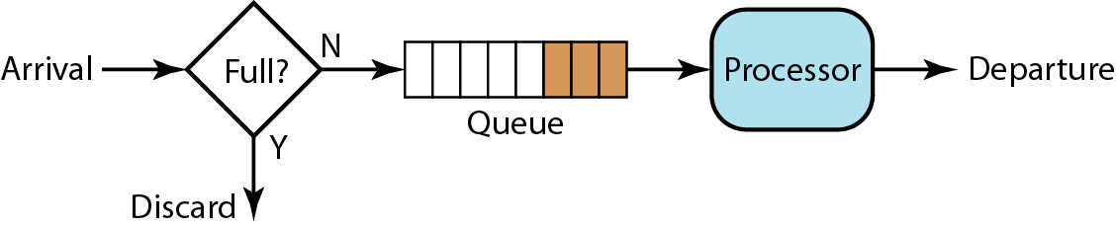

**Fig: Priority queuing**

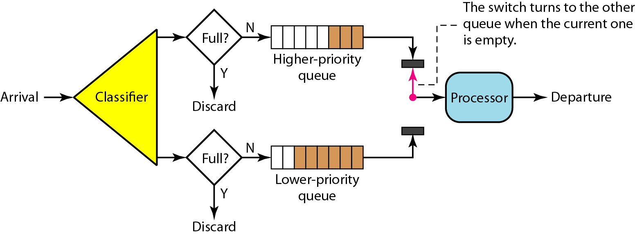

**Fig: Weighted fair queuing**

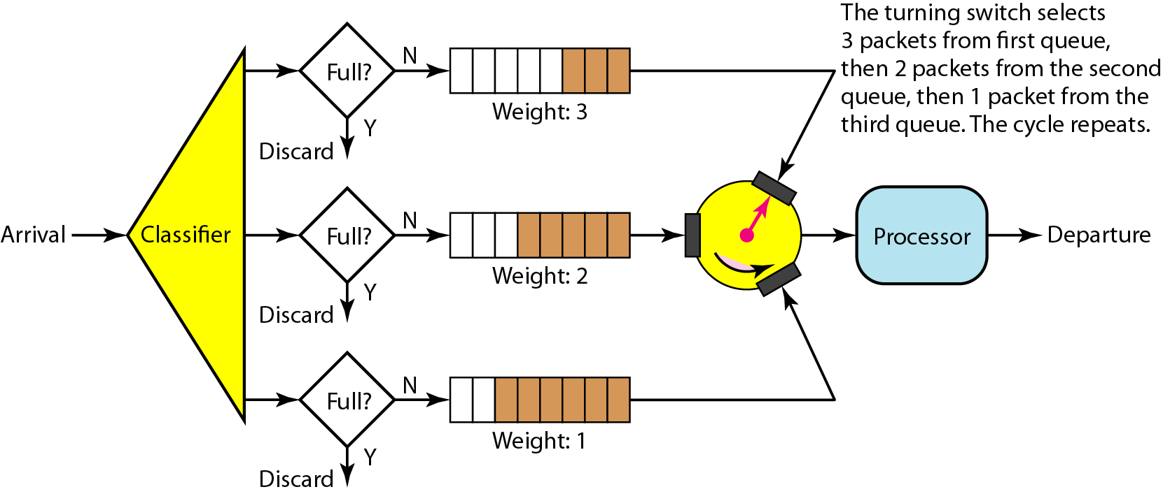

**Fig: Leaky bucket**

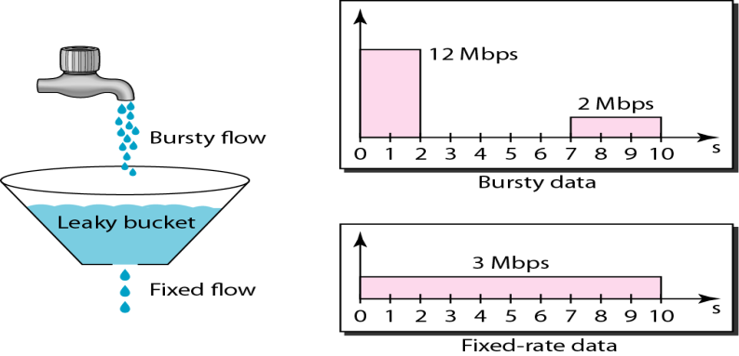

**Fig: Leaky bucket implementation**

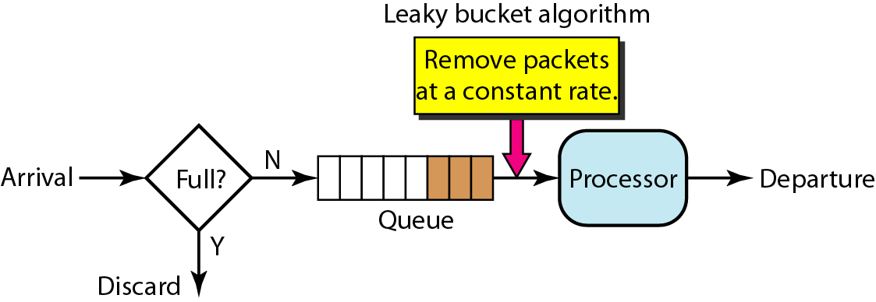

**Note:** A leaky bucket algorithm shapes bursty traffic into fixed-rate traffic by averaging the data rate. It may drop the packets if the bucket is full.

**Note:** The token bucket allows bursty traffic at a regulated maximum rate.

**Fig: Token bucket**

