CO_3 Programs(FEDF)
1.
function Product(props) {
return <h2>{props.name}</h2>;
}

function App() {
return <Product name="Srujana's iPhone 15" />;
}
export default App;

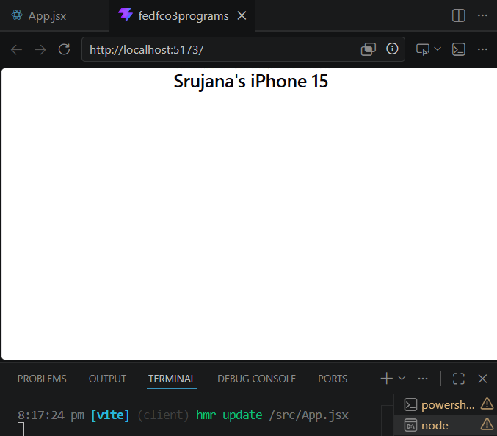
2.
function Product(props) {
return (
<div>
<h2>{props.name}</h2>
<p>Price: ₹{props.price}</p>
</div>
);
}

function App() {
return (
<Product name="Srujana's Laptop" price="55000" />
);
}
export default App;

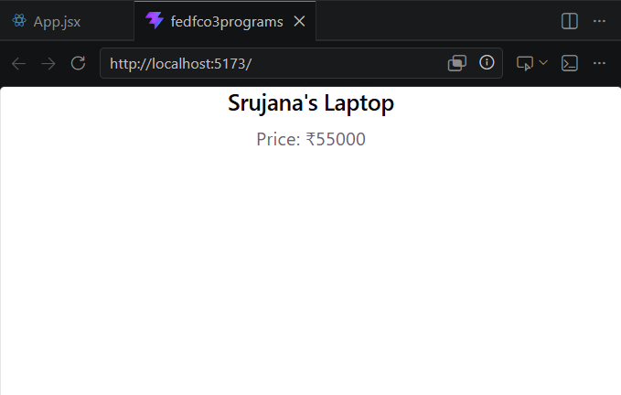
3.
import { useState } from "react";

function Cart() {
const [quantity, setQuantity] = useState(1);

return (
<div>
<h2>Srujana's Quantity: {quantity}</h2>

<button onClick={() => setQuantity(quantity + 1)}>
Add More
</button>
</div>
);
}

export default Cart;

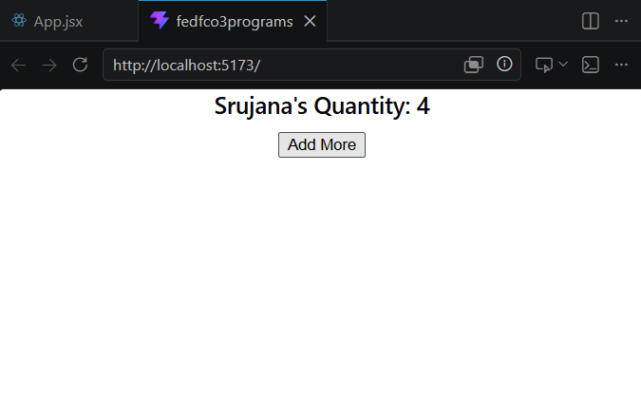

4.
import { useState } from "react";

function Product(props) {
const [likes, setLikes] = useState(0);

return (
<div>
<h2>{props.name}</h2>

<p>Likes: {likes}</p>

<button onClick={() => setLikes(likes + 1)}>
Like Product
</button>
</div>
);
}

function App() {
return <Product name="Srujana's Headphones" />;
}
export default App;

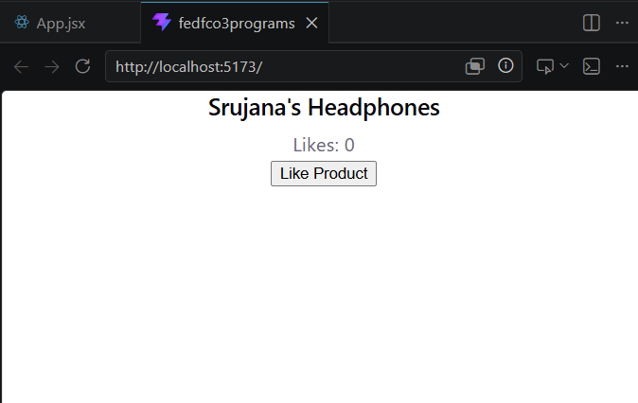
5.
import { useEffect } from "react";

function ProductPage() {

useEffect(() => {
console.log("Fetching Product Details...");
}, []);

return <h1>Srujana check Product Details</h1>;
}

export default ProductPage;

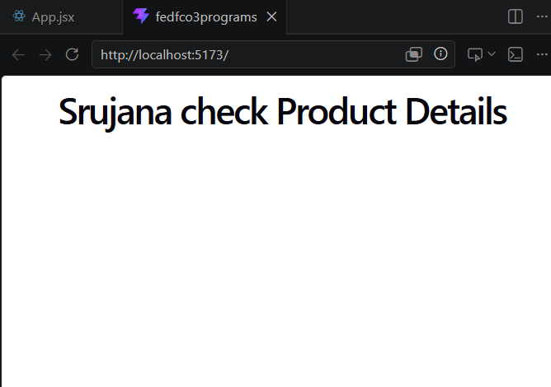

6.
import { useEffect, useState } from "react";

function Product() {

const [views, setViews] = useState(0);

useEffect(() => {
setViews(views + 1);
}, []);

return <h2>Srujana Check Views: {views}</h2>;
}
export default Product;

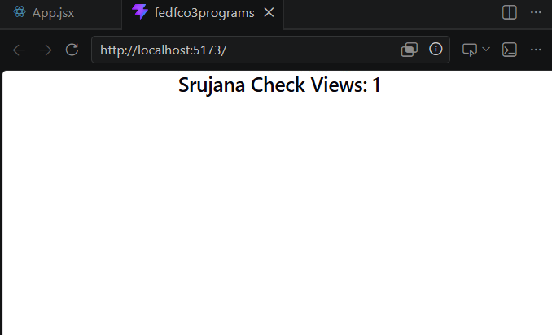
7.
import { useState } from "react";

function Cart() {

const [total, setTotal] = useState(1000);

return (
<div>
<h2>Total: ₹{total}</h2>

<button onClick={() => setTotal(total + 500)}>
Srujana-Add Item
</button>
</div>
);
}

export default Cart;

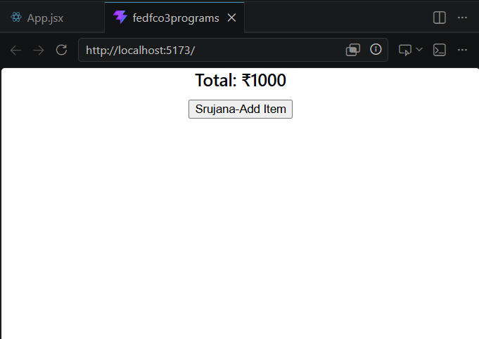
8.
import { useState } from "react";

function Search() {

const [text, setText] = useState("");

return (
<div>
<input
type="text"
value={text}
onChange={(e) => setText(e.target.value)}
placeholder="Search Product"
/>

<p>srujana searched: {text}</p>
</div>
);
}

export default Search;

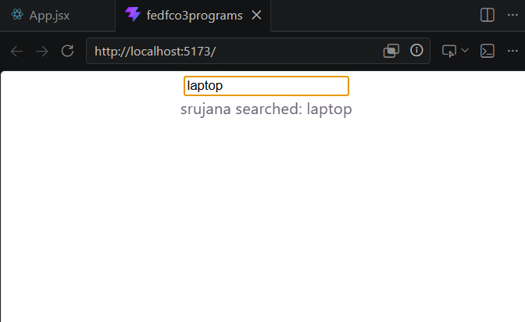
9.
import { useRef } from "react";

function Coupon() {

const inputRef = useRef();

function applyCoupon() {
alert(inputRef.current.value);
}

return (
<div>
<input type="text" ref={inputRef} />

<button onClick={applyCoupon}>
Srujana--Apply Coupon
</button>
</div>
);
}

export default Coupon;

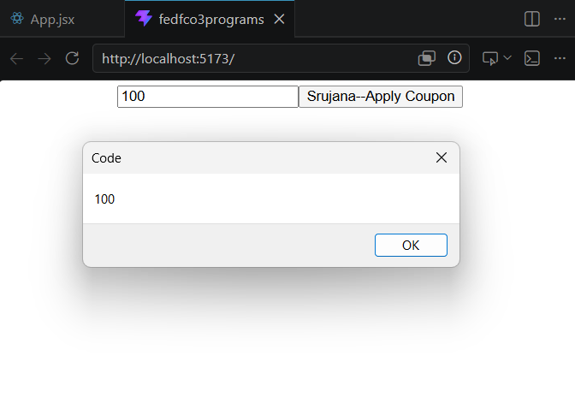
10.
function ProductName() {
return <h2>Srujana's Smart Watch</h2>;
}

function ProductPrice() {
return <p>₹3000</p>;
}

function ProductCard() {
return (
<div>
<ProductName />
<ProductPrice />
</div>
);
}

export default ProductCard;

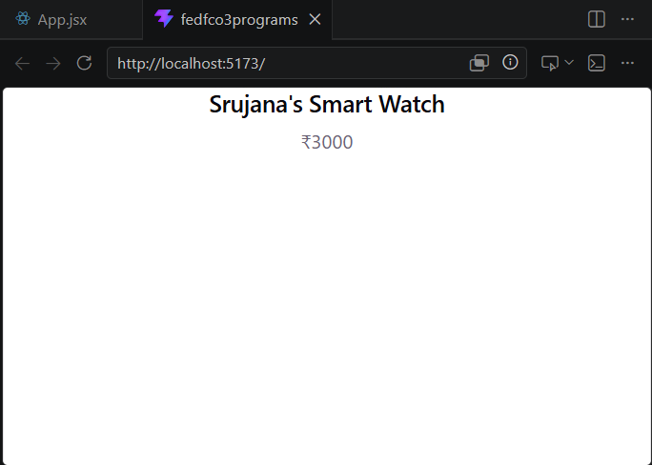
11. function Button(props) {
return (
<button>
{props.label}
</button>
);
}

function App() {
return (
<div>
<Button label="Buy Now" />
<Button label="Add to Srujana's Cart" />
</div>
);
}
export default App;

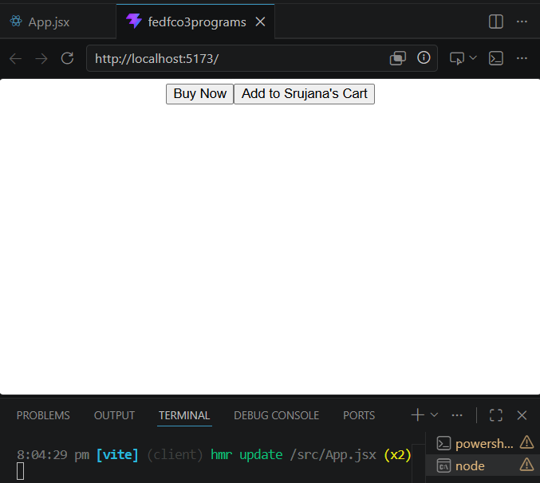

12.
function Product() {

function addToCart() {
alert("Product Added to Cart");
}

return (
<button onClick={addToCart}>
Add to srujana Cart
</button>
);
}

export default Product;

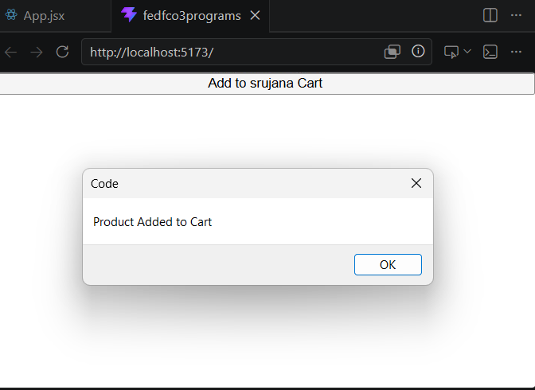
13.
function Card(props) {
return (
<div style={{border:"1px solid black", padding:"10px"}}>
{props.children}
</div>
);
}

function App() {
return (
<Card>
<h2>Srujana's Shoes</h2>
<p>₹2000</p>
</Card>
);
}
export default App;

