Fedf co4 programs
- Lift state
- import React, { useState } from "react";

- function App() {

- // Cart state in parent component
- const [cart, setCart] = useState([]);

- // Function to add product to cart
- function addToCart(product) {
- setCart([...cart, product]);
- }

- return (
- <div style={{ padding: "20px" }}>
- <h1>Simple E-Commerce App</h1>

- <h2>Products</h2>

- {/* Child Components */}
- <Product
- name="Laptop"
- price={50000}
- addToCart={addToCart}
- />

- <Product
- name="Mobile"
- price={20000}
- addToCart={addToCart}
- />

- <Product
- name="Headphones"
- price={3000}
- addToCart={addToCart}
- />

- <Cart cart={cart} />
- </div>
- );
- }

- // Product Component
- function Product(props) {

- return (
- <div
- style={{
- border: "1px solid black",
- padding: "10px",
- margin: "10px",
- width: "200px"
- }}
- >
- <h3>{props.name}</h3>

- <p>Price: ₹{props.price}</p>

- <button
- onClick={() =>
- props.addToCart({
- name: props.name,
- price: props.price
- })
- }
- >
- Add to Cart
- </button>
- </div>
- );
- }

- // Cart Component
- function Cart(props) {

- return (
- <div>
- <h2>Cart Items</h2>

- {props.cart.length === 0 ? (
- <p>Cart is Empty</p>
- ) : (
- props.cart.map((item, index) => (
- <div key={index}>
- {item.name} - ₹{item.price}
- </div>
- ))
- )}
- </div>
- );
- }

- export default App;

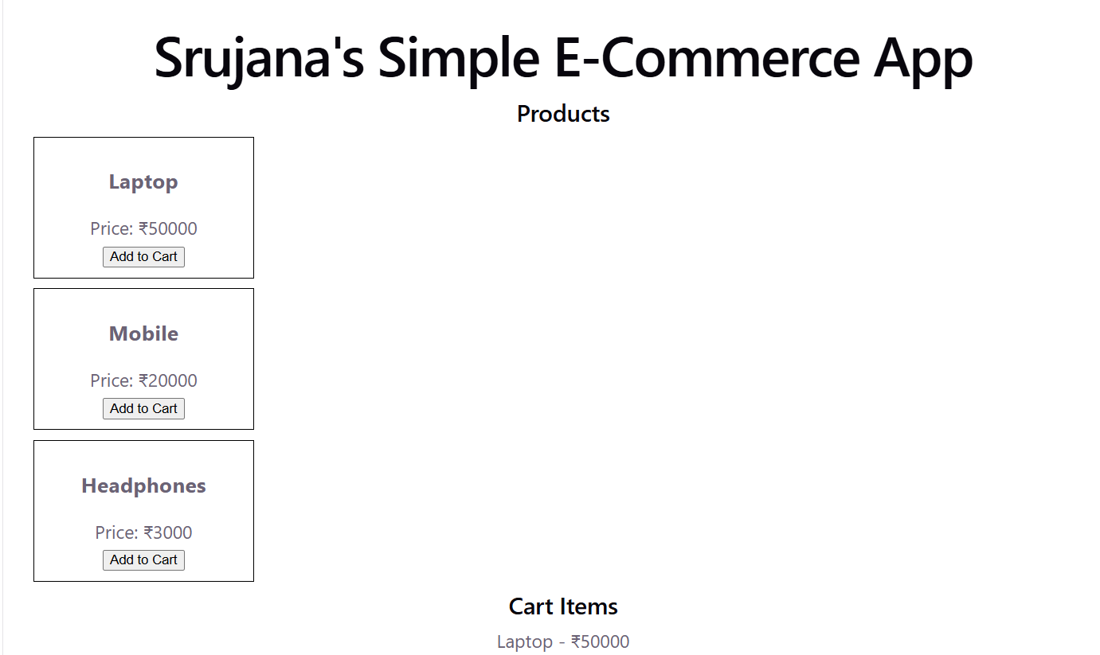

2. props drilling

function App() {
const username = "Srujana";

return (
<div>
<Parent username={username} />
</div>
);
}

// Parent Component
function Parent({ username }) {
return (
<div>
<Child username={username} />
</div>
);
}

// Child Component
function Child({ username }) {
return (
<div>
<GrandChild username={username} />
</div>
);
}

// GrandChild Component
function GrandChild({ username }) {
return (
<h2>Welcome {username}</h2>
);
}

export default App;


3. Raise condition

import { useState } from "react";

function App() {
const [message, setMessage] = useState("");

function startRace() {
// Request 1
setTimeout(() => {
setMessage("First Request");
}, 3000);

// Request 2
setTimeout(() => {
setMessage("Second Request");
}, 1000);
}

return (
<div>
<h2>Race Condition Example</h2>

<button onClick={startRace}>
Start
</button>

<h3>{message}</h3>
</div>
);
}

export default App;

4. Async Flow

import { useEffect, useState } from "react";

function App() {
const [user, setUser] = useState(null);
const [posts, setPosts] = useState([]);

useEffect(() => {
async function loadData() {
// Step 1: Get user
const userResponse = await fetch(
"https://jsonplaceholder.typicode.com/users/1"
);
const userData = await userResponse.json();

setUser(userData);

// Step 2: Get posts of that user
const postResponse = await fetch(
`https://jsonplaceholder.typicode.com/posts?userId=${userData.id}`
);
const postData = await postResponse.json();

setPosts(postData);
}

loadData();
}, []);

return (
<div>
<h2>User Details</h2>

{user && <p>Name: {user.name}</p>}

<h2>Posts</h2>

<ul>
{posts.map((post) => (
<li key={post.id}>{post.title}</li>
))}
</ul>
</div>
);
}

export default App;

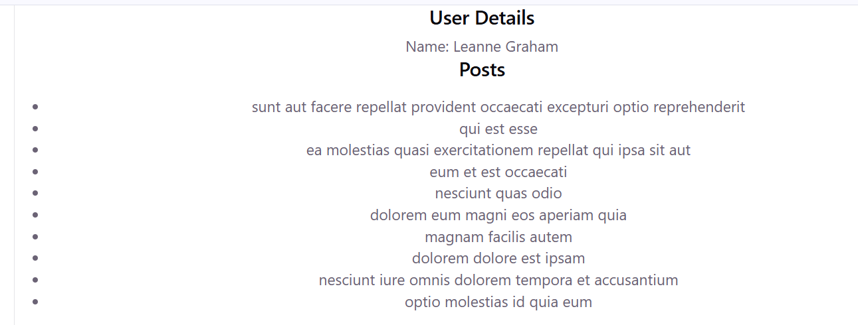
5 . Data caching

import { useState } from "react";

function App() {
const [message, setMessage] = useState("");

function loadData() {

const cachedData =
localStorage.getItem("message");

if (cachedData) {
console.log("Loaded from Cache");
setMessage(cachedData);
return;
}

console.log("Fetching Data...");

const data = "Welcome to React";

localStorage.setItem(
"message",
data
);

setMessage(data);
}

return (
<div>
<h2>{message}</h2>

<button onClick={loadData}>
Load Data
</button>
</div>
);
}

export default App;
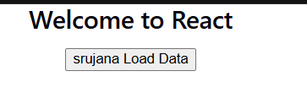
6. Raise condition
import { useState } from "react";

function App() {
const [message, setMessage] = useState("");

function startRace() {
// Request 1
setTimeout(() => {
setMessage("First Request");
}, 3000);

// Request 2
setTimeout(() => {
setMessage("Second Request");
}, 1000);
}

return (
<div>
<h1>Srujana</h1>
<h2>Race Condition Example</h2>

<button onClick={startRace}>
Start
</button>

<h3>{message}</h3>
</div>
);
}

export default App;
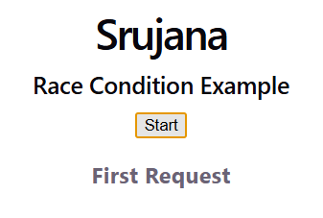
7. Skeleton UI
import { useEffect, useState } from "react";

function App() {
const [products, setProducts] = useState([]);
const [loading, setLoading] = useState(true);

useEffect(() => {
setTimeout(() => {
setProducts([
"Srujana Laptop",
"Mobile",
"Headphones"
]);

setLoading(false);
}, 3000);
}, []);

if (loading) {
return (
<div>
<h2>Loading Products...</h2>

<div>████████████</div>
<div>████████████</div>
<div>████████████</div>
</div>
);
}

return (
<div>
<h2>Products</h2>

{products.map((product, index) => (
<p key={index}>{product}</p>
))}
</div>
);
}

export default App;
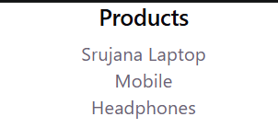
8. stale state
import { useState } from "react";

function App() {
const [cartCount, setCartCount] = useState(0);

function addTwoItems() {
setCartCount(cartCount + 1); //1
setCartCount(cartCount + 1); //0+1=1 but we expect 2
// for that we use
// setCartCount((prevCount) => prevCount + 1);
// setCartCount((prevCount) => prevCount + 1);
}

return (
<div>
<h2>Srujana’s Cart Items: {cartCount}</h2>

<button onClick={addTwoItems}>
Add 2 Products
</button>
</div>
);
}

export default App;
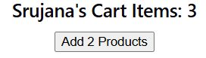
9. staleColocation
import { useState } from "react";

function App() {
return (
<div>
<h1>Amazon Store</h1>

<SearchBox />
</div>
);
}

function SearchBox() {
// State kept close to where it is used
const [search, setSearch] = useState("");

return (
<div>
<input
type="text"
placeholder="Search products"
value={search}
onChange={(e) => setSearch(e.target.value)}
/>

<p>Srujana Searching for: {search}</p>
</div>
);
}

export default App;
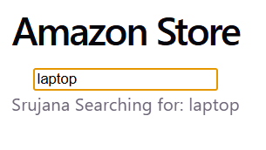
10. without lift state
import React, { useState } from "react";

function App() {

return (
<div>
<h1>E-Commerce Store</h1>

<Product name="Laptop" />
<Product name="Mobile" />
</div>
);
}

function Product(props) {

// Separate state inside each product
const [count, setCount] = useState(0);

return (
<div>
<h3>{props.name}</h3>

<p>Srujana Cart Count: {count}</p>

<button onClick={() => setCount(count + 1)}>
Add to Cart
</button>

<hr />
</div>
);
}

export default App;
