A PROJECT REPORT ON

SOFT ACTOR-CRITIC-BASED SEMANTIC-AWARE POWER
AND TIME ALLOCATION FOR HYBRID NOMA–OFDMA NETWORKS

Submitted in partial fulfilment of the requirements for the course
MACHINE LEARNING
25SC2107E
A.Y.: 2026–27

Submitted by
B.Sri.Srujana | 2520040005
S.Tejitha | 2520040008
M. Gnaneshwari | 2520040020

Under the esteemed guidance of
N. Lava Prasad
Assistant Professor, Department of ECE
Koneru Lakshmaiah Education Foundation (KLEF)
Department of Electronics & Communication Engineering


ABSTRACT
The increasing demand for reliable and energy-efficient wireless communication has made resource allocation an important challenge in modern communication networks. Wireless systems must distribute limited transmission power and airtime among users with different channel conditions, data requirements, and task priorities. Hybrid Non-Orthogonal Multiple Access (NOMA) and Orthogonal Frequency Division Multiple Access (OFDMA) networks provide a way to support multiple users through power-domain sharing and orthogonal subchannels. However, jointly allocating transmission power and airtime while considering task importance, transmission deadlines, and energy consumption remains a challenging optimization problem. This project implements a Soft Actor-Critic (SAC)-based semantic-aware power and time allocation framework for hybrid NOMA-OFDMA networks using a simulation-based reinforcement learning approach.
The implemented system simulates eight wireless users grouped into four fixed NOMA pairs operating over two OFDMA subchannels. A log-distance path-loss model and independently regenerated Rayleigh fading are used to represent wireless channel conditions. Each user receives a synthetic communication task described by data demand, a deadline, and a semantic-importance weight. Semantic importance is represented by a priority-weighted task-progress utility measure; the project does not implement a neural semantic encoder or a text/image understanding model. The SAC agent observes channel and task information and generates continuous actions controlling pair-level power utilization, NOMA power splitting, and airtime allocation. Analytical action transformations enforce the configured power and airtime constraints. The trained policy is evaluated against equal-allocation, semantic-priority, and random-allocation baselines across 20 held-out test scenarios.
In the saved 20,000-timestep experiment, SAC achieved mean semantic utility of 0.2561, goodput of approximately 2.02 Mbps, and energy efficiency of approximately 3.92 million useful bits per joule. Its average energy use was 0.2572 J per episode, compared with 0.5000 J for equal allocation. This corresponds to approximately 48.6% lower energy consumption and 79.8% higher energy efficiency relative to equal allocation. However, equal allocation achieved higher semantic utility and goodput, a higher task-completion rate, and a lower deadline-miss rate. No power or airtime violations were recorded for any evaluated policy. The results therefore demonstrate a trade-off between service performance and energy use rather than universal superiority of SAC. The project provides a reproducible simulation baseline for further study of adaptive resource allocation under task priorities and deadline constraints.
Keywords: Soft Actor-Critic, semantic-aware resource allocation, NOMA, OFDMA, deep reinforcement learning, power allocation, airtime scheduling, energy efficiency.

INDEX
Section | Page
Abstract | ii
1. INTRODUCTION | 1
1.1 Background | 1
1.2 Problem Statement | 1
1.3 Aim and Objectives | 1
1.4 Scope and Significance | 2
2. SYSTEM MODEL | 3
2.1 Simulation Configuration | 3
2.2 Synthetic User Profile and Input-Data Inspection | 3
2.3 Wireless Channel, NOMA and OFDMA Model | 4
2.4 Semantic Task Model and Reward | 5
2.5 Proposed System Architecture | 6
3. PROPOSED METHODOLOGY | 7
3.1 Environment State and Observation Construction | 7
3.2 Continuous Action Mapping and Feasibility | 7
3.3 SAC Training Configuration | 8
3.4 Baseline Policies | 8
3.5 Evaluation Metrics | 9
3.6 Software and Hardware Requirements | 9
4. RESULTS AND DISCUSSION | 10
4.1 Experimental Setup | 10
4.2 Training Behaviour | 10
4.3 Comparative Performance Across Held-Out Test Scenarios | 11
4.4 Energy Efficiency, Latency and Fairness | 12
4.5 Allocation Dynamics and Constraint Feasibility | 14
4.6 Discussion and Limitations | 15
5. CONCLUSION AND FUTURE SCOPE | 17
5.1 Conclusion | 17
5.2 Future Scope | 17
REFERENCES | 18

1. INTRODUCTION

1.1 Background
Wireless networks serve applications with different traffic volumes, channel conditions, and deadlines. Resource allocation determines how much transmission power and time are assigned to each user or user group. A scheme optimized only for aggregate transmission rate may spend energy on low-value or already-satisfied tasks, while an urgency-only heuristic may fail to account for longer-term consequences.
OFDMA divides spectrum into orthogonal subchannels, limiting interference between different subchannels. NOMA allows two users to share a frequency resource through power-domain multiplexing and successive interference cancellation (SIC). A hybrid NOMA-OFDMA architecture combines these ideas: each OFDMA subchannel can serve a NOMA pair, while additional candidate pairs share that subchannel over separate airtime intervals. Power and airtime must be coordinated under a common resource budget.
Task-oriented or semantic-aware communication motivates treating delivered information according to task significance rather than counting all bits as equally valuable [1], [2], [4]. Reinforcement learning is attractive for this problem because a policy can learn continuous allocation controls through repeated interaction with a simulated wireless environment. Soft Actor-Critic (SAC) is an off-policy, maximum-entropy actor-critic method designed for continuous action spaces [5].

1.2 Problem Statement
The problem addressed in this project is to learn a resource-allocation policy for a simulated hybrid NOMA-OFDMA network that jointly controls power utilization, the power split between weak- and strong-channel users within each NOMA pair, and airtime assigned to candidate pairs sharing each subchannel. The policy must account for channel quality, remaining task demand, semantic-importance weights, and deadlines, while respecting configured transmission-power and airtime limits.
This is a constrained sequential decision problem. Higher power can increase achievable service but also increases energy consumption. More airtime may improve task completion but must be shared among pairs. Prioritizing urgent or important tasks can improve targeted service but may affect goodput, fairness, and energy efficiency. The project evaluates these trade-offs in simulation rather than claiming deployment on a physical wireless testbed.

1.3 Aim and Objectives
Aim: To implement and evaluate a Soft Actor-Critic framework for semantic-priority-aware power and airtime allocation in a simulated hybrid NOMA-OFDMA network.
- Build a reproducible wireless simulation containing eight users, four fixed NOMA pairs, and two OFDMA subchannels.
- Model path loss, frame-by-frame Rayleigh fading, receiver noise, NOMA SINR, achievable rates, delivered service, and transmission energy.
- Represent heterogeneous tasks using synthetic demand, deadlines, and semantic-importance weights.
- Formulate a 49-dimensional observation space, a 12-dimensional continuous action space, and a reward that balances semantic utility, energy use, and deadline misses.
- Implement feasibility-preserving transformations for power utilization, NOMA power split, and subchannel airtime allocation.
- Train SAC with a configured 20,000 environment-timestep budget and compare its best validation checkpoint with equal, semantic-priority, and random feasible policies.
- Evaluate semantic utility, goodput, sum rate, task completion, deadline-miss rate, latency, energy, energy efficiency, fairness, and constraint violations across held-out seeds.

1.4 Scope and Significance
The scope is a CPU-based simulation and software prototype. It uses synthetic task arrivals and a mathematical channel model, not an external measured wireless dataset. The task-importance weight is a proxy for semantic value; the system does not encode or decode natural-language text, images, or learned semantic representations. SIC is idealized, user pairing and subchannel mappings are fixed, and fading is independently resampled each frame. The significance of the implementation is its transparent allocation formulation, explicit resource-feasibility mapping, reproducible test protocol, and multi-metric comparison of policies.

2. SYSTEM MODEL

2.1 Simulation Configuration
The simulated cell contains eight users grouped into four fixed NOMA pairs. Two OFDMA subchannels operate orthogonally. Pair 0 and Pair 1 time-share subchannel 0; Pair 2 and Pair 3 time-share subchannel 1. Each frame lasts 10 ms, and each episode contains 50 frames, representing 0.5 seconds of simulated time. These are configurable simulation assumptions rather than measurements from a real radio network.
Parameter | Configured value | Description
Number of users (K) | 8 | Four two-user NOMA pairs
NOMA pairs (G) | 4 | Fixed pair membership
OFDMA subchannels (M) | 2 | Pairs 0/1 share subchannel 0; pairs 2/3 share subchannel 1
Total transmit-power cap | 1.0 W | At most 0.5 W per active pair/subchannel allocation
Subchannel bandwidth | 180 kHz | Used in Shannon-style achievable-rate calculation
Frame duration | 0.01 s | 10 ms per frame
Episode length | 50 frames | 0.5 s simulated time
Carrier frequency | 3.5 GHz | Mid-band channel-model setting
Path-loss exponent | 3.5 | Log-distance path-loss model
User distance range | 30–250 m | Eight deterministic distance positions across the configured interval
Receiver noise figure | 7 dB | Added to thermal-noise density
Thermal noise density | −174 dBm/Hz | Converted to watts over the subchannel bandwidth
Task demand range | 2,000–10,000 bits | Synthetic task generation
Task deadline range | 2–6 frames | 20–60 ms
Semantic-importance range | 0.2–1.0 | Synthetic scalar weight

2.2 Synthetic User Profile and Input-Data Inspection
The project does not rely on a third-party or measured dataset. The file data/users_dataset.csv contains eight configured example user records with user ID, fixed NOMA-pair and subchannel assignments, illustrative NOMA roles, distance, path loss, a sample channel gain, task demand, deadline, and semantic-importance weight. During experiments, the task manager generates new demands, deadlines, and importance values from the configured ranges using reproducible random seeds; channel fading is resampled across frames. Therefore, the CSV is best treated as a synthetic scenario snapshot, not as an independent supervised-learning dataset.
User | Pair | Subch. | Distance (m) | Demand (bits) | Deadline | Importance
0 | 0 | 0 | 30.00 | 2714 | 5 (50 ms) | 0.551
1 | 0 | 0 | 61.43 | 5464 | 6 (60 ms) | 0.758
2 | 1 | 0 | 92.86 | 3611 | 2 (20 ms) | 0.980
3 | 1 | 0 | 124.29 | 7886 | 5 (50 ms) | 0.829
4 | 2 | 1 | 155.71 | 6106 | 2 (20 ms) | 0.560
5 | 2 | 1 | 187.14 | 6003 | 3 (30 ms) | 0.941
6 | 3 | 1 | 218.57 | 8253 | 5 (50 ms) | 0.858
7 | 3 | 1 | 250.00 | 6363 | 4 (40 ms) | 0.382

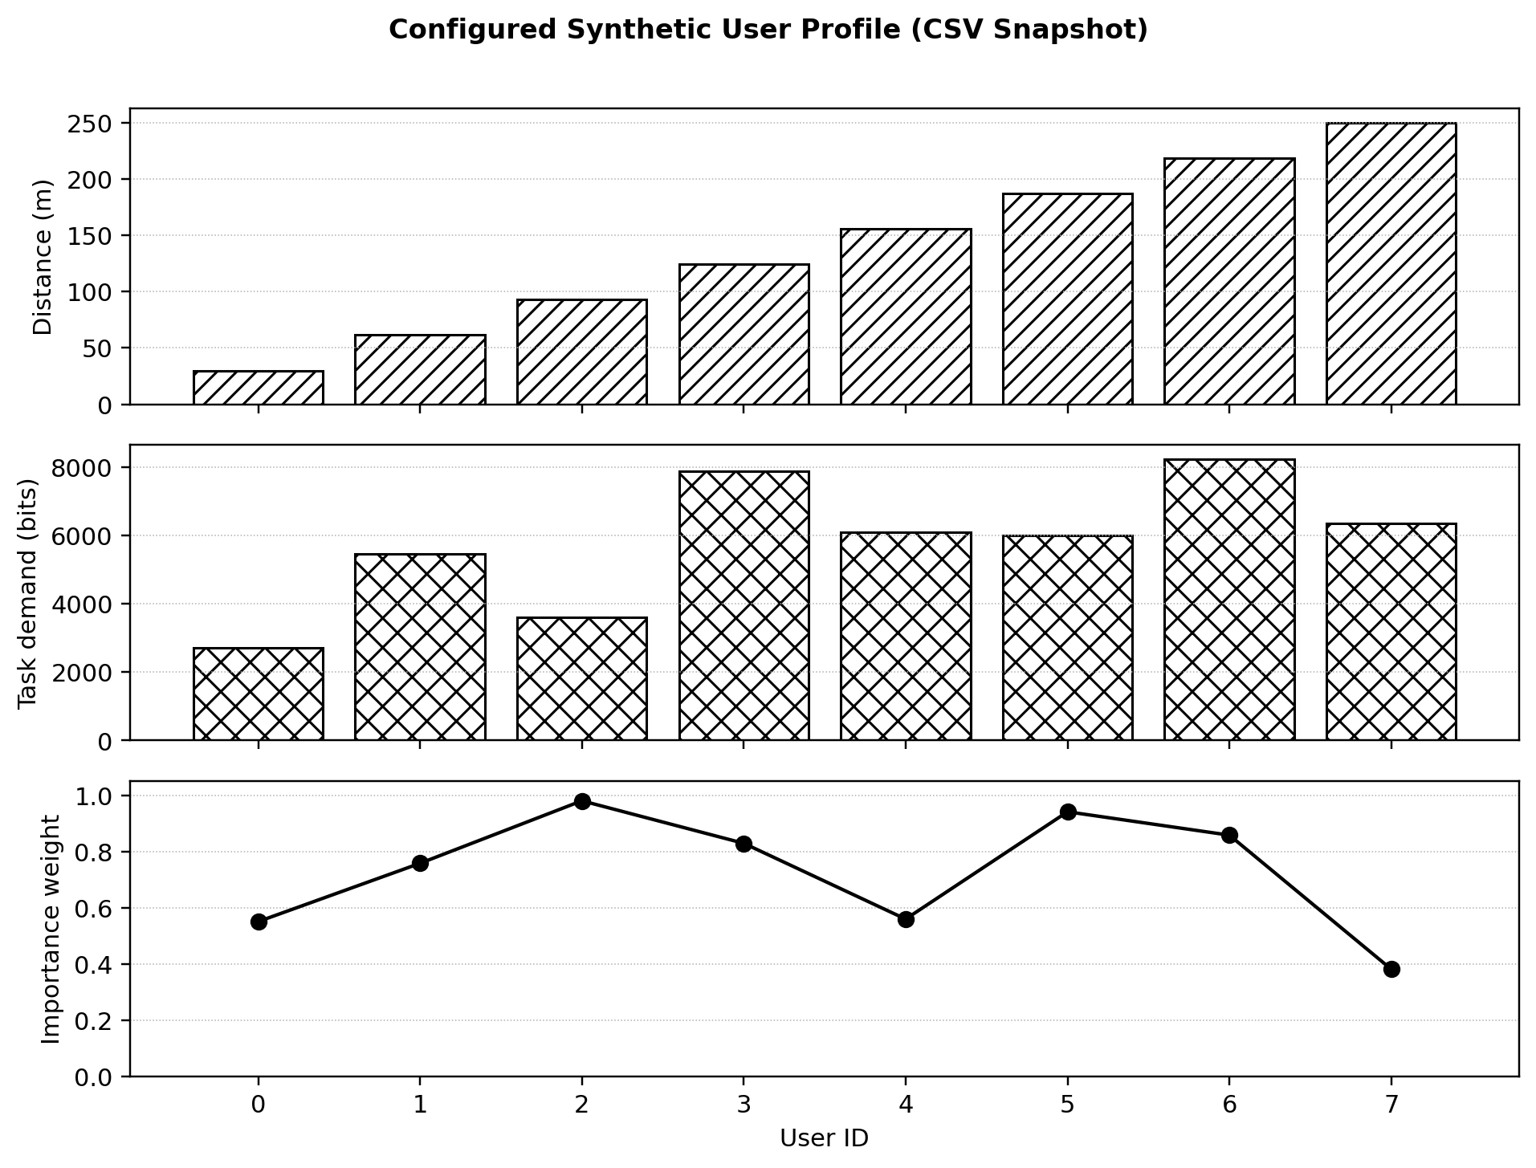
Figure 2.1. Distance, sample task demand, and importance weight in the configured synthetic user-profile CSV.
A descriptive inspection of the eight CSV rows gives a mean distance of 140 m (range 30–250 m), mean sample task demand of 5,800 bits (range 2,714–8,253 bits), mean configured importance weight of 0.732 (range 0.382–0.980), and sample deadlines from 2 to 6 frames. This small profile is used to document the simulation inputs; it is not a population sample and no train/validation/test split is applied to this CSV. The SAC policy is trained through environment interaction instead.

2.3 Wireless Channel, NOMA and OFDMA Model
Large-scale path loss is calculated from a free-space reference loss and a log-distance term:
PL₀ = 20 log₁₀(4πd₀f_c / c), PLᵢ = PL₀ + 10n log₁₀(dᵢ/d₀).
Here d₀ = 1 m, carrier frequency f_c = 3.5 GHz, c = 3 × 10⁸ m/s, path-loss exponent n = 3.5, and dᵢ is the fixed user distance. Instantaneous channel power gain is gᵢ(t) = 10^(−PLᵢ/10)|hᵢ(t)|², where Rayleigh fading power |hᵢ(t)|² is generated from an exponential distribution with mean one. Fading is independently regenerated from frame to frame in the present implementation.
The receiver noise power for each subchannel is Nₘ = 10^((N₀−30)/10) Bₘ 10^(NF/10), where N₀ = −174 dBm/Hz, Bₘ = 180,000 Hz, and NF = 7 dB. The allocator orders the users in each fixed pair by their current channel gains to identify the weak- and strong-channel user for that frame.
For pair g, the power is P_g = η_g P_max/M. The weak- and strong-user powers are p_w,g = β_gP_g and p_s,g = (1−β_g)P_g, respectively. The modeled SINRs are γ_w = p_wg_w/(p_sg_w+Nₘ), γ_(w→s) = p_wg_s/(p_sg_s+Nₘ), and γ_s = p_sg_s/Nₘ under ideal SIC. The weak-user rate is limited by both direct decoding and decoding at the strong receiver: R_w = Bₘ min{log₂(1+γ_w), log₂(1+γ_(w→s))}; the strong-user rate is R_s = Bₘ log₂(1+γ_s). These Shannon-style rates are a simplified physical-layer model and do not include coding errors, imperfect SIC, or link adaptation.
For a pair with airtime fraction τ_g, service delivered to user i during a frame is c_i(t) = τ_g T_f R_i(t). Useful service is capped by remaining task demand: s_i(t) = min(q_i(t), c_i(t)). Frame energy is E_t = T_f Σ_g τ_gP_g, and normalized energy is E_norm = E_t/(P_max T_f).

2.4 Semantic Task Model and Reward
Each user has one active synthetic task at a time. A task contains an original demand Dᵢ, remaining demand qᵢ, importance weight wᵢ, arrival frame, and deadline. Following service, remaining demand is reduced; completed tasks are recorded, while incomplete tasks lose one frame of deadline. An incomplete task whose deadline expires is recorded as missed, and a replacement task is generated for the next frame.
The implemented semantic utility is a weighted task-progress proxy: U_sem(t) = (1/K) Σᵢ wᵢ sᵢ(t)/Dᵢ. The deadline-miss term M_t weights remaining undelivered demand at expiry by the importance weight and averages over users. The reward implemented in environment.py is:
r_t = U_sem(t) − λ_E E_norm(t) − λ_D M_t, λ_E = 0.01, λ_D = 0.5.
This scalar utility encourages delivery of important tasks but is not a semantic similarity score or task-classification accuracy. It is deliberately described as a proxy to avoid implying that the prototype contains a neural language, image, or semantic encoder.

2.5 Proposed System Architecture
The implementation connects a seeded channel model and task manager to a Gymnasium environment. The SAC policy receives the observation and produces a continuous action. The resource allocator maps actions into feasible physical controls, calculates rates, service, and energy, and returns metrics used to compute the reward. Training and evaluation use separate code modules, with three baselines evaluated under the same environment and test seeds.
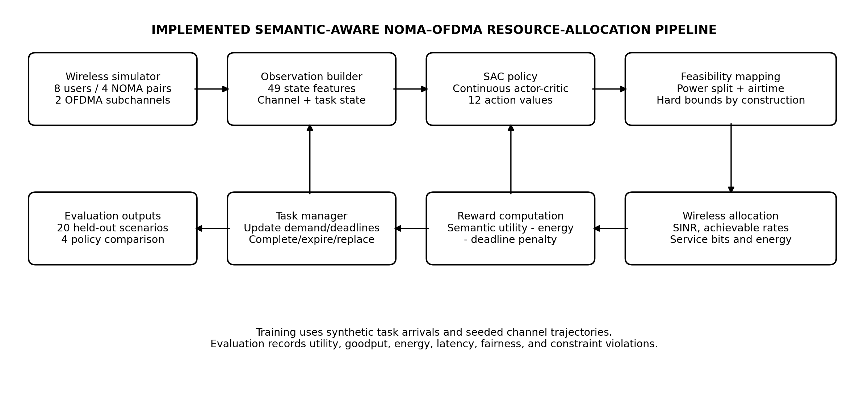
Figure 2.2. Implemented architecture derived from the project source modules.
At each frame, the environment constructs the current channel and task observation, receives one allocation action from the policy, calculates NOMA signal-to-interference-plus-noise ratios and achievable rates, and delivers service subject to each task’s remaining demand. The environment then updates task completion and deadline status, computes semantic utility and energy, and returns the next state and reward to the learning algorithm.
For evaluation, the same channel, service, task, and metric definitions are used for SAC and all three baseline policies. Test seeds are kept separate from training and validation seeds. This common environment makes the comparison reproducible while leaving the conclusions limited to the assumptions of the current simulation model.

3. PROPOSED METHODOLOGY

3.1 Environment State and Observation Construction
The environment exposes a 49-element observation vector. For each of the eight users, six values are encoded: normalized log channel gain, normalized distance, remaining-demand ratio, normalized original demand, semantic-importance weight, and normalized remaining deadline. One additional global value is the remaining fraction of the episode. The code clips/normalizes features to keep observations within the configured observation space.
State component | Per-user features | Total dimensions
Channel | Log-normalized instantaneous channel gain | 8
Location | Normalized distance in the configured 30–250 m interval | 8
Task progress | Remaining demand divided by original demand | 8
Task size | Original demand normalized by maximum configured demand | 8
Priority | Semantic-importance weight in [0.2, 1.0] | 8
Urgency | Remaining deadline ratio | 8
Episode state | Remaining fraction of the current episode | 1
Total |  | 49

3.2 Continuous Action Mapping and Feasibility
The SAC action space is Box(−1,1) with 12 continuous values, three for each of four NOMA pairs: power-utilization control a_η,g, weak-user power-split control a_β,g, and airtime-preference control a_τ,g. The code clips raw actions to the allowed domain and maps them using the following relations:
- η_g = (a_η,g + 1)/2, so 0 ≤ η_g ≤ 1.
- β_g = 0.5 + 0.45(a_β,g + 1)/2, so 0.5 ≤ β_g ≤ 0.95.
- z_g = (a_τ,g + 1)/2; for each subchannel m, τ_g = z_g / max(1, Σ_{j∈G_m} z_j).
- P_g = η_g P_max/M with P_max = 1 W and M = 2; p_w,g = β_gP_g and p_s,g = (1−β_g)P_g.
The transformations maintain 0 ≤ P_g ≤ 0.5 W per candidate pair/subchannel allocation and Σ_{g∈G_m}τ_g ≤ 1 on each subchannel. This feasibility-by-construction approach means the learner does not have to discover the constraints solely from reward penalties. Evaluation logs nevertheless monitor maximum power and airtime violations as a verification measure.

3.3 SAC Training Configuration
The project uses the SAC implementation from Stable-Baselines3 with an MLP policy. The saved standard run completed all 20,000 requested environment timesteps in approximately 62.89 seconds without reaching the 600-second runtime limit. The training seed is 42. Validation uses seeds 1000–1004 for checkpoint selection; held-out test seeds 2000–2019 are used only for final policy comparison.
Parameter | Configured / saved value
Algorithm | Soft Actor-Critic (SAC)
Policy network | MlpPolicy; two fully connected hidden layers [128, 128]
Learning rate | 0.0003
Discount factor γ | 0.99
Replay buffer | 25,000 transitions
Learning starts | 500 environment steps
Batch size | 128
Training frequency | Every 4 environment steps
Gradient steps | 1 per train trigger
Training budget | 20,000 timesteps; 600 s configured wall-clock limit
Hardware execution | CPU-only; maximum 2 numerical threads
Random seed | 42
Validation | 5 seeds, evaluated every 2,000 timesteps
Held-out testing | 20 seeds, 2000–2019; best validation checkpoint

The best validation checkpoint is stored as checkpoints/best_model.zip and the final checkpoint as checkpoints/final_model.zip. The report uses the evaluation results recorded in runs/run_20261014_194752/evaluation_summary.csv, associated with the 20,000-timestep run. The training plots are included as descriptive diagnostics; noisy episode rewards are not taken as proof of mathematical convergence.

3.4 Baseline Policies
Policy | Power and airtime strategy | Purpose
SAC (proposed) | Learns η_g, β_g, and τ_g through continuous actions; deterministic inference for evaluation. | Evaluate learned, energy-aware sequential allocation.
Equal Allocation | η_g = 1; β_g = 0.75; τ_g = 0.5 for the two candidate pairs sharing each subchannel. | Simple full-power fixed-allocation benchmark.
Semantic Priority | Heuristic based on importance weight, remaining demand, and urgency; maps priorities to pair power and airtime preferences. | Test whether a simple priority rule can approach learned behaviour.
Random Allocation | Seeded random actions sampled in the feasible continuous action domain. | Uncoordinated reference policy.

Every policy is evaluated in the same configured simulation on the same 20 held-out test seeds. Random allocation uses an independent seeded generator. The semantic-priority method is a deterministic heuristic, not a trained machine-learning model.

3.5 Evaluation Metrics
Metric | Definition / interpretation
Semantic utility | Frame-averaged importance-weighted useful progress, using the synthetic task proxy.
Goodput | Total useful delivered bits divided by 0.5 s simulated episode duration.
Sum rate | Mean sum of the modeled achievable user rates over frames.
Task completion rate | Completed tasks divided by total generated tasks.
Deadline-miss rate | Expired incomplete tasks divided by total generated tasks.
Average latency | Mean arrival-to-completion delay for completed tasks, reported in frames.
Energy and energy efficiency | Cumulative transmit energy and useful delivered bits per joule.
Jain fairness index | Uniformity of useful service across 8 users; 1 is perfectly equal service.
Power/airtime violations | Maximum observed excess over the power cap or subchannel airtime budget.

Accuracy, precision, recall, and F1-score are not the principal model metrics for this project because SAC outputs continuous resource-allocation controls rather than a class label. The report therefore evaluates the downstream control outcomes and physical constraint compliance, rather than introducing classification metrics that do not match the implemented task.

3.6 Software and Hardware Requirements
Component | Requirement / tool
Operating system | Windows 10/11 64-bit (the supplied run configuration is Windows-oriented)
Language | Python 3.11 or 3.12
Deep learning | PyTorch CPU build; Stable-Baselines3 SAC
RL environment | Gymnasium custom environment API
Data processing | NumPy and Pandas
Visualization | Matplotlib
Testing | pytest; nine test modules are included
Optional dashboard | Streamlit, installed from requirements-dashboard.txt
Hardware | CPU execution configured to use no more than two numerical threads; GPU not required

4. RESULTS AND DISCUSSION

4.1 Experimental Setup
The report uses the standard saved run in runs/run_20261014_194752. The model completed 20,000 environment timesteps in 62.89 s; the training configuration allowed up to 600 s and set the maximum CPU-thread count to two. The network uses eight users, four fixed pairs, two 180 kHz subchannels, 10 ms frames, and 50-frame episodes. All four policies were evaluated across 20 held-out seeds (2000–2019), yielding 80 policy-episode evaluations. Results below are means and standard deviations over these 20 scenarios.
The saved training run uses seed 42; validation seeds are 1000–1004 and test seeds 2000–2019. The best model checkpoint is selected by validation reward and then evaluated on the held-out seeds. No external dataset split is used because the simulation generates synthetic tasks rather than fitting a supervised classifier to labeled data.

4.2 Training Behaviour
The training reward plot shows substantial episode-to-episode variability throughout the 20,000 timesteps. The rolling average fluctuates in a relatively narrow band and rises modestly over parts of training, rather than following a smooth monotonic curve. This is expected in a stochastic wireless environment with changing fading and task arrivals. The plot should be interpreted as an exploratory training diagnostic, not as proof of asymptotic convergence.
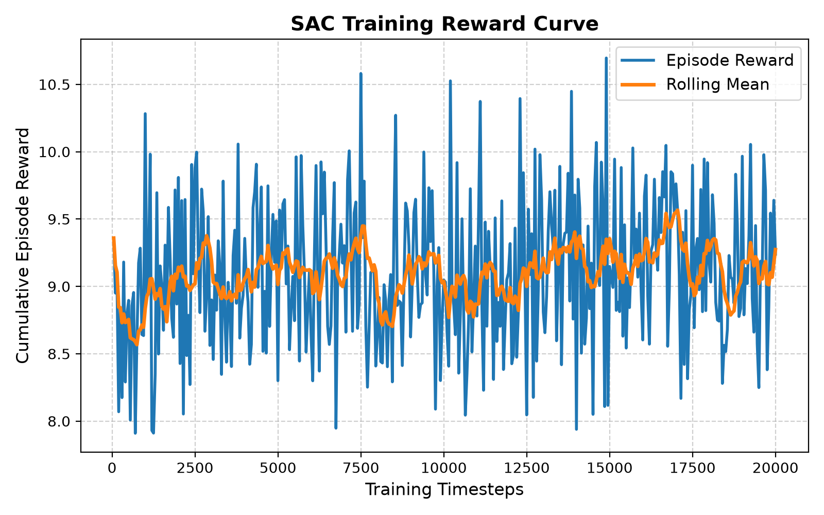
Figure 4.1. Episode reward and rolling mean during the 20,000-timestep SAC training run.
The reward combines semantic progress with energy and deadline-miss penalties. The saved component plot provides a qualitative view of these contributions during learning. The raw semantic-utility and penalty magnitudes are logged independently, which helps make the reward formulation more transparent than reporting only a single total reward.
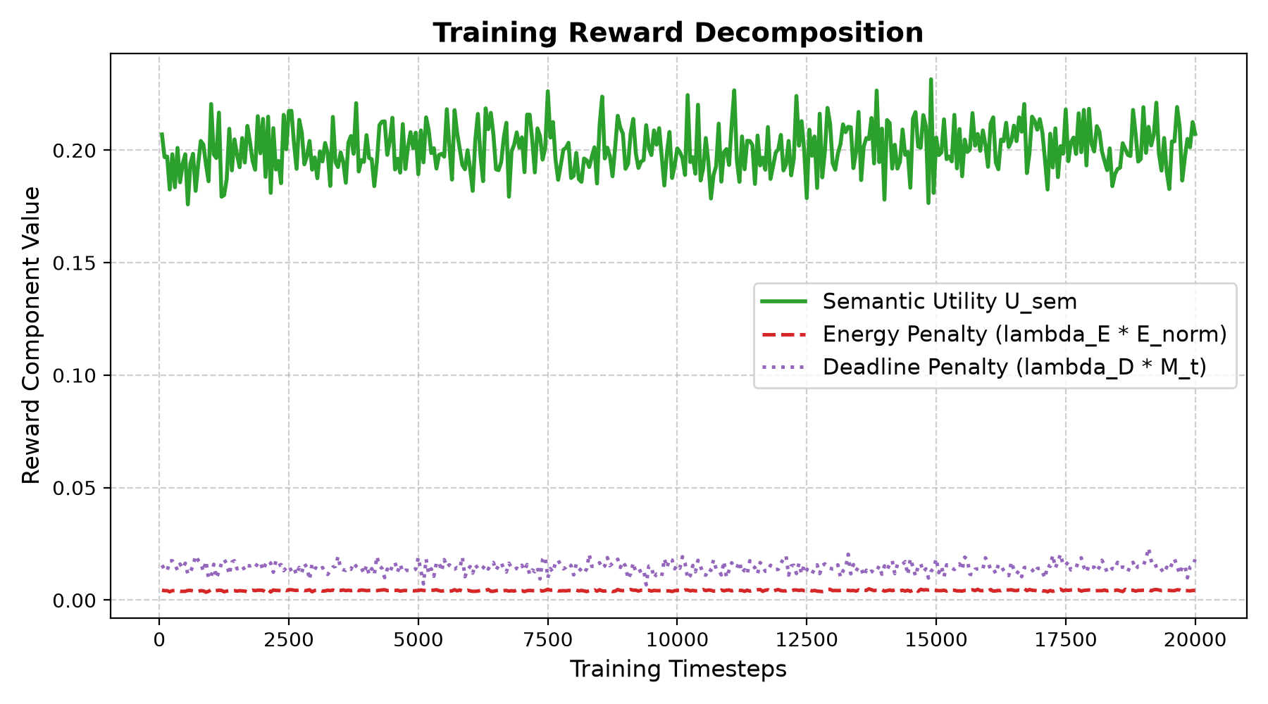
Figure 4.2. Logged semantic-utility, energy-penalty, and deadline-penalty components during training.

4.3 Comparative Performance Across Held-Out Test Scenarios
Table 4.1 reports the primary service and reward outcomes from the saved evaluation_summary.csv. Equal allocation has the highest mean semantic utility (0.2760) and goodput (approximately 2.18 Mbps), followed by SAC in goodput. The semantic-priority heuristic achieves a similar semantic utility to SAC and a slightly higher completion rate, while random allocation performs worst on these service metrics.
Policy | Reward | Semantic utility | Goodput (Mbps) | Sum rate (Mbps) | Completion | Deadline miss
SAC | 12.145 ± 0.354 | 0.2561 ± 0.0064 | 2.015 ± 0.043 | 5.756 ± 0.061 | 78.78% ± 2.31% | 16.94% ± 2.34%
Equal Allocation | 12.998 ± 0.364 | 0.2760 ± 0.0073 | 2.180 ± 0.052 | 6.463 ± 0.062 | 82.46% ± 3.16% | 13.47% ± 3.20%
Semantic Priority | 12.234 ± 0.340 | 0.2555 ± 0.0072 | 1.999 ± 0.052 | 6.012 ± 0.065 | 81.91% ± 2.44% | 13.64% ± 2.45%
Random Allocation | 8.963 ± 0.373 | 0.1990 ± 0.0070 | 1.537 ± 0.053 | 5.388 ± 0.102 | 65.10% ± 2.70% | 29.85% ± 2.73%

Table 4.1. Mean ± standard deviation over 20 held-out test seeds (2000–2019).
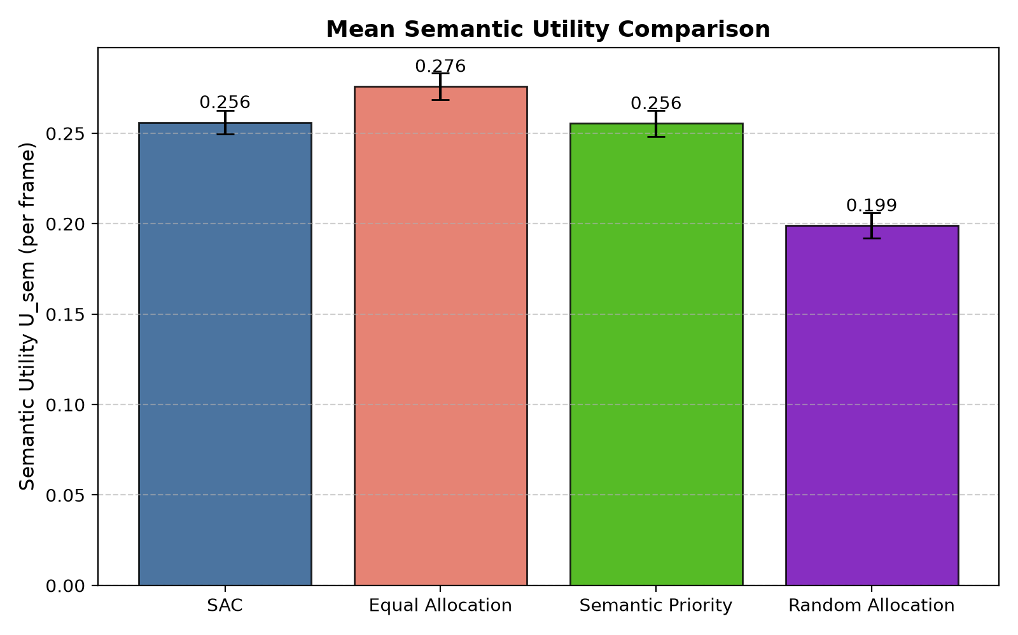
Figure 4.3. Mean semantic-utility proxy for SAC and the three baselines.
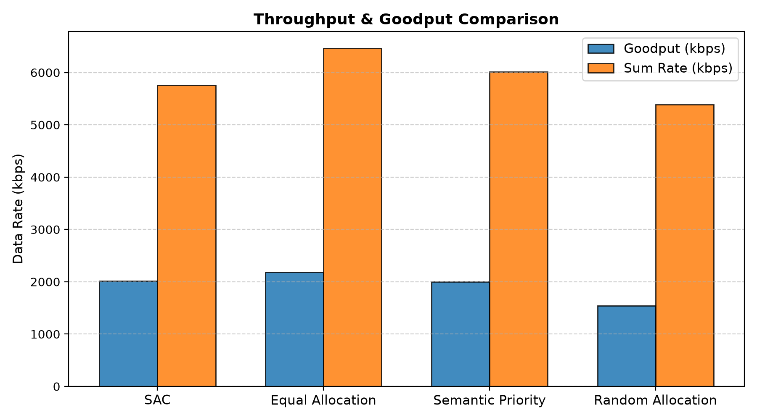
Figure 4.4. Goodput and modeled sum-rate comparison across evaluated policies.
SAC's mean utility (0.2561) is close to the semantic-priority baseline (0.2555), but below equal allocation (0.2760). Its goodput is approximately 92.5% of equal allocation's measured goodput. SAC's mean task completion rate is 78.78%, compared with 82.46% for equal allocation and 81.91% for semantic priority. Therefore, the results do not support a claim that SAC maximizes every service metric in the current configuration.

4.4 Energy Efficiency, Latency and Fairness
The strongest measured advantage for SAC is energy efficiency. Mean energy use is 0.2572 J per 50-frame episode, compared with 0.5000 J for equal allocation. This is approximately a 48.6% reduction. Energy efficiency is approximately 3.92 × 10⁶ useful bits/J for SAC and 2.18 × 10⁶ bits/J for equal allocation, a relative increase of approximately 79.8%. The semantic-priority policy consumes 0.3663 J and achieves approximately 2.73 × 10⁶ bits/J. Random allocation has low energy use, but its lower useful delivery means its energy efficiency remains below SAC.
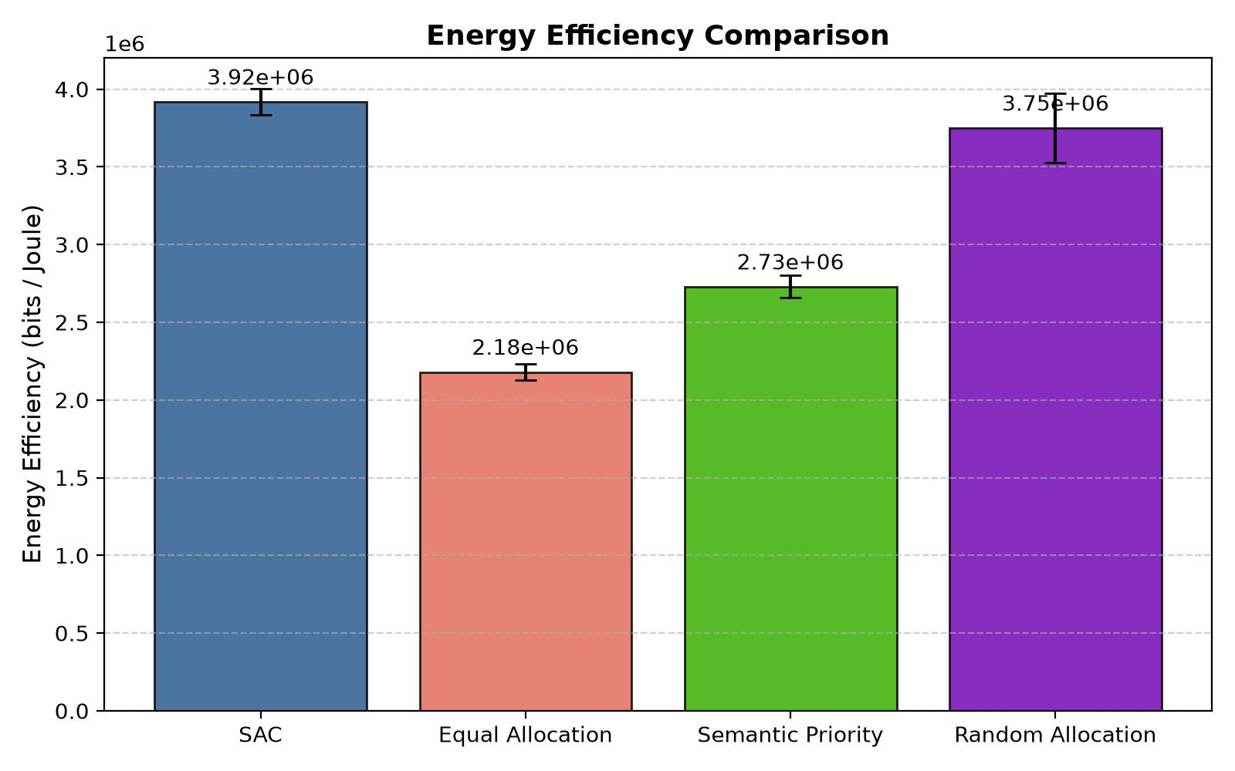
Figure 4.5. Useful bits delivered per joule across the four policies.
Mean completed-task latency is 2.06 frames for SAC and 1.98 frames for equal allocation; semantic priority averages 2.11 frames and random allocation 2.29 frames. SAC's deadline-miss rate is 16.94%, above the 13.47% observed for equal allocation and 13.64% for semantic priority. In the present reward weighting, the energy penalty improves the energy profile but does not fully compensate for the loss in deadline/service metrics against fixed equal allocation.
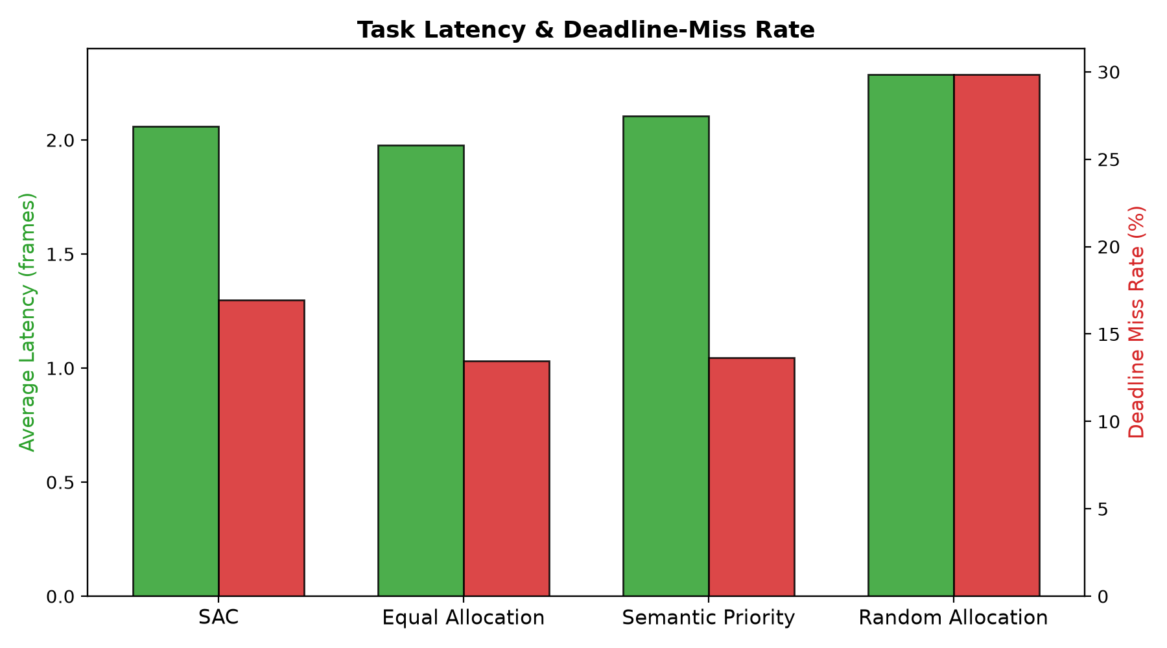
Figure 4.6. Mean completed-task latency and deadline-miss rate.
Jain's fairness index is 0.7944 for SAC, 0.8330 for equal allocation, 0.8236 for semantic priority, and 0.8137 for random allocation. All values indicate some variation in useful service among users, with equal allocation showing the highest fairness in this experiment. These values are simulator-derived and depend on the task, channel, and reward settings.
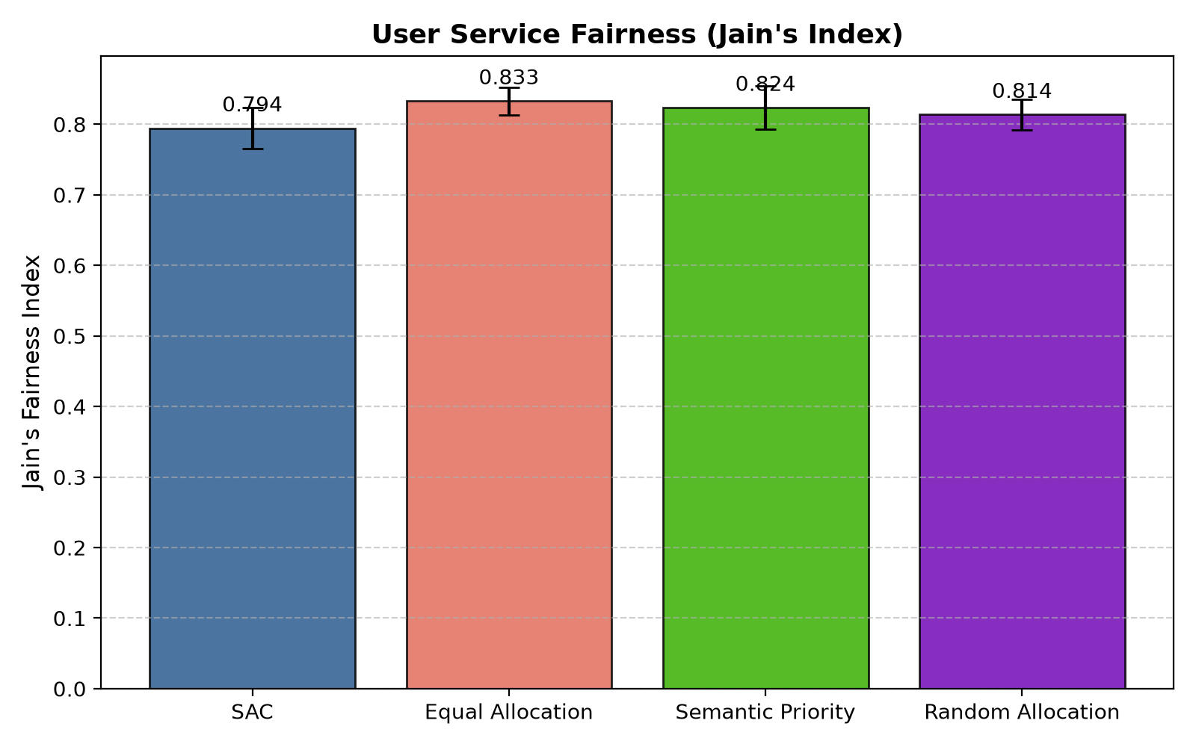
Figure 4.7. Jain's fairness index computed from cumulative useful service per user.

4.5 Allocation Dynamics and Constraint Feasibility
The saved example allocation plots illustrate one deterministic SAC rollout over 50 transmission frames. Pair-level power utilization varies across frames, remaining within the configured cap, while the airtime preferences are normalized within each subchannel. The plots are illustrative trajectories for the first test seed; they should not be read as average trajectories over all 20 held-out seeds.
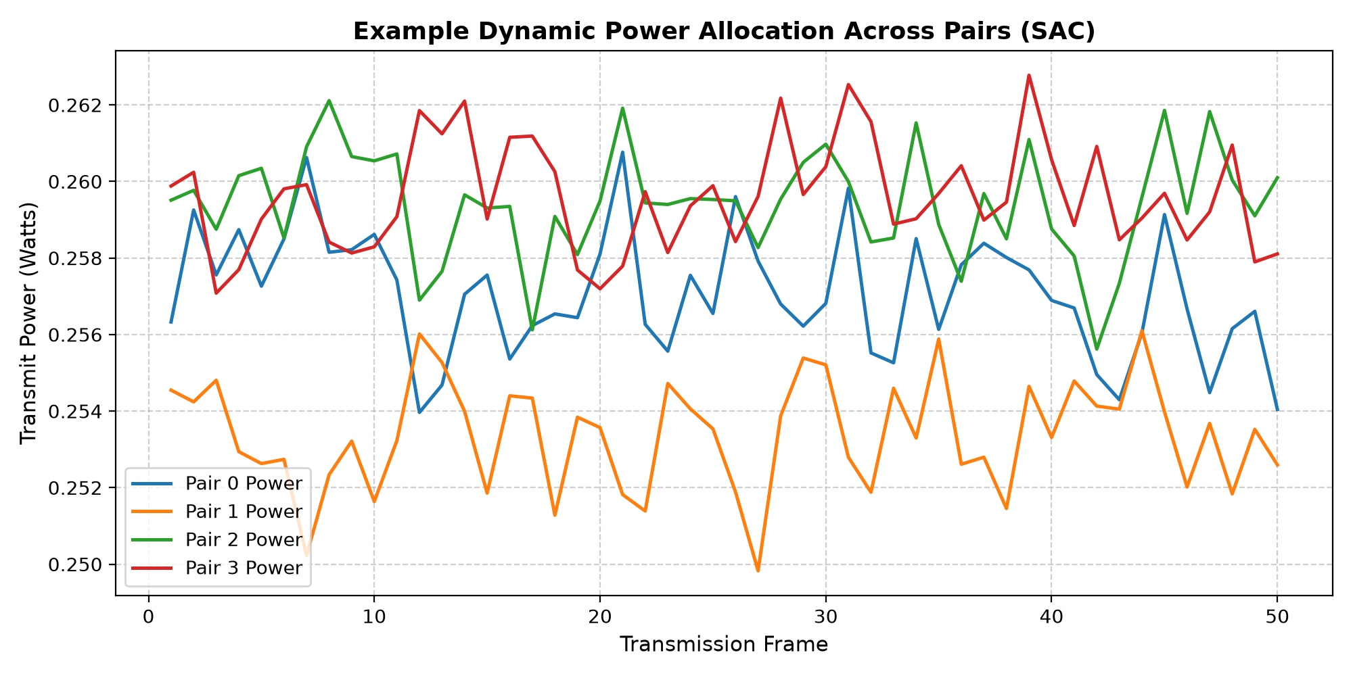
Figure 4.8. Example dynamic transmit-power allocation across the four NOMA pairs for one SAC episode.
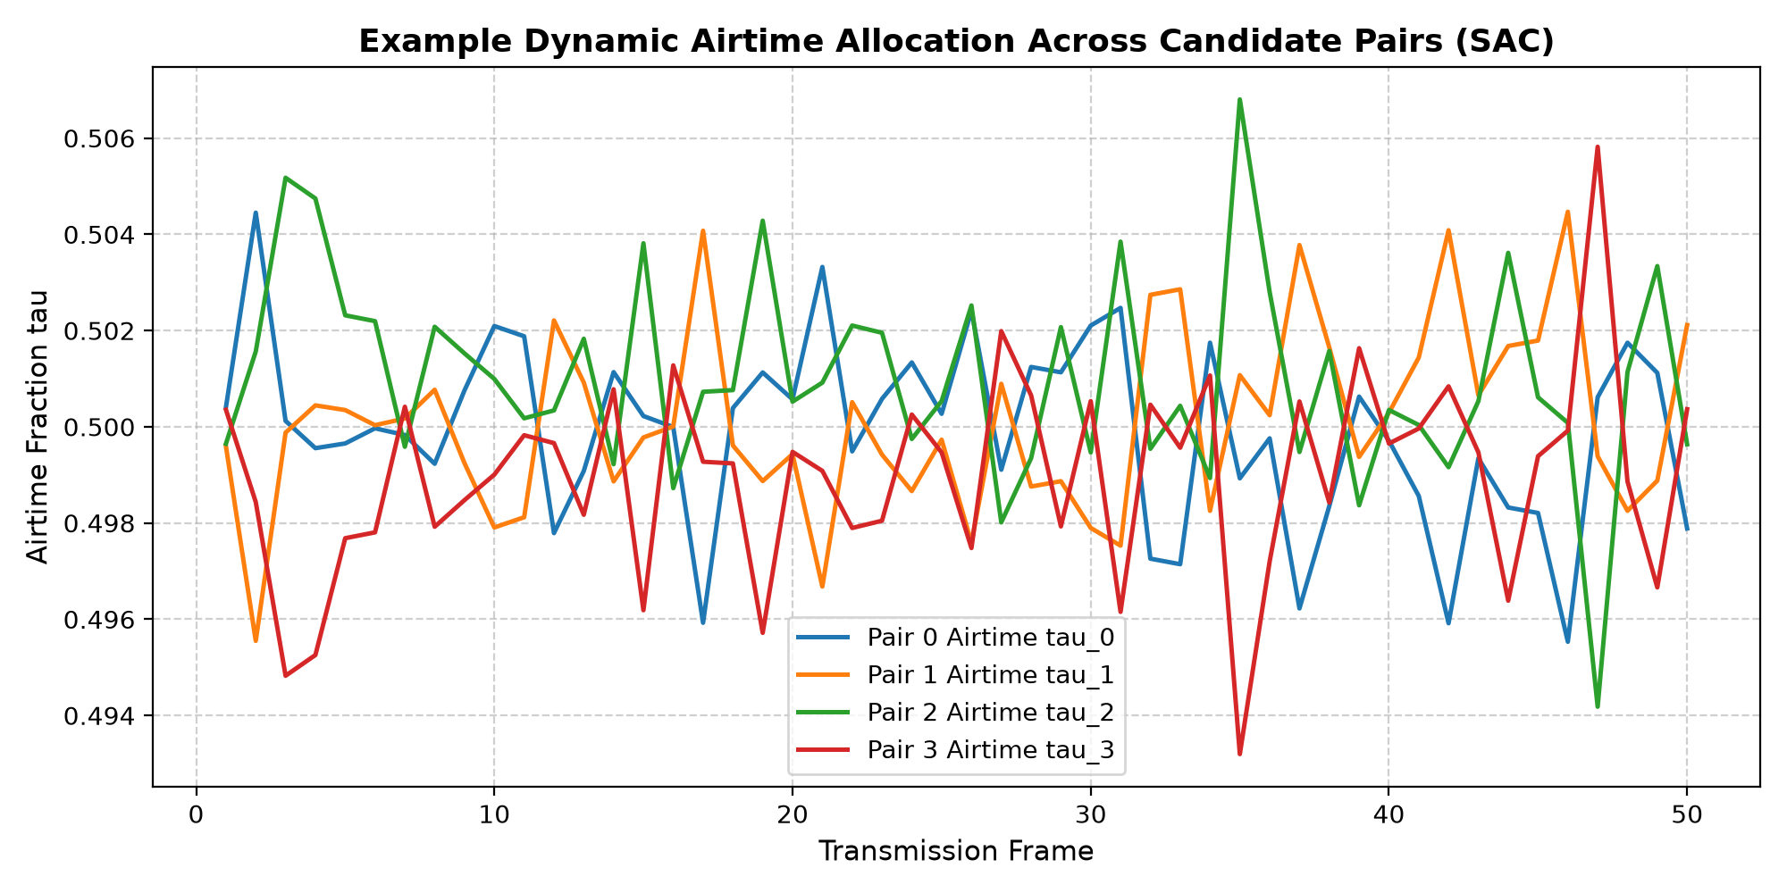
Figure 4.9. Example airtime fractions across the four candidate pairs for one SAC episode.
Across all 80 policy-episode evaluations, the recorded maximum power violation and maximum airtime violation are both 0.000000. This is consistent with the analytical transformation layer in resource_allocator.py. The result verifies constraint compliance in the configured simulator, not in a deployed RF system with hardware imperfections or measurement error.

4.6 Discussion and Limitations
- Service-versus-energy trade-off: equal allocation achieves higher semantic utility, goodput, task completion, and fairness in this particular configuration; SAC uses substantially less energy and has better energy efficiency.
- The results come from a stochastic mathematical simulator. Channel fading, traffic arrivals, noise, achievable rates, and task utility are simplified representations rather than measurements from a physical network.
- The semantic-importance term is a synthetic scalar weighting of delivered task progress. No text/image semantic encoder or semantic-similarity network is implemented.
- The current model assumes ideal SIC, fixed user-pair membership and fixed OFDMA-subchannel mapping, independent frame-to-frame fading, and a simplified Shannon-rate model.
- The 20,000-timestep budget is a small exploratory CPU training run. The observed reward curve is noisy; longer training and hyperparameter sensitivity analysis would be needed to make stronger learning claims.
- The held-out test results are based on 20 seeds for this model/configuration only. Performance could change with different user counts, reward weights, channel assumptions, task deadlines, or power budgets.
The project does not claim novelty from simply combining SAC, semantic task priorities, NOMA, and OFDMA; these ideas overlap with related literature [1]–[4]. The implementation's contribution is a reproducible software experiment that explicitly maps continuous actions to feasible power and airtime controls, reports multiple trade-off metrics, and documents the current limitations.

5. CONCLUSION AND FUTURE SCOPE

5.1 Conclusion
This project implemented a SAC-based control framework for joint power utilization, NOMA power splitting, and airtime allocation in a simulated hybrid NOMA-OFDMA network. The environment combines a log-distance path-loss model, frame-by-frame Rayleigh fading, simplified NOMA rate equations, synthetic user tasks, and a reward based on priority-weighted useful progress, normalized energy, and missed-deadline demand. The SAC agent observes 49 state features and generates 12 continuous control values, which are transformed to maintain the configured physical limits.
Across 20 held-out test scenarios, SAC achieved mean energy efficiency of approximately 3.92 × 10⁶ useful bits/J and mean energy use of 0.2572 J per episode, reducing energy by about 48.6% relative to equal allocation. However, equal allocation obtained greater mean semantic utility, goodput, completion rate, and fairness, and a smaller deadline-miss rate. No power or airtime constraint violations were recorded. The main conclusion is therefore a measured trade-off: the current SAC policy is more energy-efficient, but it does not dominate fixed equal allocation across all service objectives. Further tuning and broader evaluation are needed before claiming a generally superior resource-allocation strategy.

5.2 Future Scope
- Run multiple independent SAC training seeds and longer training schedules; report confidence intervals and sensitivity to hyperparameters.
- Tune energy and deadline reward weights using validation scenarios only, then freeze the configuration before held-out testing.
- Add dynamic NOMA pairing and adaptive subchannel assignment rather than keeping both mappings fixed.
- Include imperfect SIC, channel-estimation error, temporally correlated fading, adjacent-cell interference, and more realistic link-adaptation models.
- Replace the synthetic semantic utility proxy with a task-level semantic communication component that provides validated semantic-quality measurements.
- Evaluate generalization for larger user counts, different task arrival patterns, bandwidth/power settings, and different channel conditions.
- Expand the dashboard to display seed-level metrics and uncertainty, and publish the configuration, run summaries, and software test results with the source repository.

REFERENCES
[1] H. Zhang, J. Ni, X. Liu, Y. Ren, Z. Wu, and V. C. M. Leung, “DRL-Driven Resource Allocation for Hybrid NOMA-Assisted Semantic Communication Networks,” IEEE Transactions on Wireless Communications, vol. 25, pp. 15791–15802, 2026. doi: 10.1109/TWC.2026.3686618.
[2] Y. Zhang, L. Yan, and G. Li, “Reinforcement Learning-Based Resource Allocation for Multi-Task Multi-Codebook Semantic Communications,” Physical Communication, vol. 75, article 102982, 2026. doi: 10.1016/j.phycom.2025.102982.
[3] P. Pi and G. Ren, “Soft Actor-Critic Optimization for Efficient NOMA Uplink in Intelligent Vehicular Networks,” Physical Communication, vol. 68, article 102581, 2025. doi: 10.1016/j.phycom.2024.102581.
[4] H. Zhang, H. Wang, Y. Li, K. Long, and A. Nallanathan, “DRL-Driven Dynamic Resource Allocation for Task-Oriented Semantic Communication,” IEEE Transactions on Communications, vol. 71, no. 7, pp. 3992–4004, 2023. doi: 10.1109/TCOMM.2023.3274145.
[5] T. Haarnoja, A. Zhou, P. Abbeel, and S. Levine, “Soft Actor-Critic: Off-Policy Maximum Entropy Deep Reinforcement Learning with a Stochastic Actor,” in Proceedings of the 35th International Conference on Machine Learning, PMLR, vol. 80, pp. 1861–1870, 2018.
[6] Stable-Baselines3 contributors, “SAC — Soft Actor-Critic,” Stable-Baselines3 documentation. Available: https://stable-baselines3.readthedocs.io/en/master/modules/sac.html (accessed October 2026).
[7] Gymnasium contributors, “Gymnasium: An API standard for single-agent reinforcement learning environments.” Available: https://gymnasium.farama.org/ (accessed October 2026).

