Internship Report
Python Full-Stack Internship
DLithe Consultancy Services Pvt. Ltd.

Internship Report
Intern Name: Srujan Bangera
Reg. no: NNM23CS205
Period: 2 Months
Job Assignment: Internship Project, Real Estate Listing Platform (HomeFind)
Organization: DLithe Consultancy Services Pvt. Ltd.
Supervisor's Name: Ms. Dhanlakshmi S Jangalekar
Observations:
Submitted to
Signature of Training Supervisor Signature of Co-ordinator
Date: Date:

Letter of Transmittal
To,
Program Co-ordinator
DLithe Consultancy Services
Bengaluru
Dear Sir/Madam,
I am writing to submit my report on the Python Full Stack Internship Program that I recently completed. The training program was an invaluable learning experience, and I am grateful for the opportunity to participate.
The training program covered various key technologies in web development, including HTML, CSS, JavaScript, React, Python, SQL databases, and version control using GitHub. I gained a comprehensive understanding of building responsive user interfaces, designing backend logic, querying relational databases, and managing source code collaboratively. The training highlighted the potential of modern full-stack engineering to build scalable, interactive applications.
The report includes a detailed overview of the training program, including the topics covered, the learning objectives, and the outcomes achieved through my internship project, “HomeFind” — a full-stack real estate listing and property discovery platform. It also provides observations and insights into the potential benefits and challenges of developing full-stack applications.
I believe that the knowledge and skills that I acquired during the training program will be valuable to our organization. Expertise in full-stack web technologies and version control tools like GitHub is increasingly essential, and the ability to build secure, end-to-end solutions will contribute significantly to our organization's success.
I hope that the report provides useful insights into the benefits of on-job training and the potential of Python full-stack development.
Sincerely,
Name: Srujan Bangera
Reg. no: NNM23CS205

Table of Contents
Sl. No | Content | Page No
1 | Introduction | 4
2 | Background | 4
3 | Project Overview | 5
4 | Problem Statement | 5
5 | Solution Methodology | 5
6 | System Requirements | 6
7 | Hardware Requirements | 7
8 | Software Requirements | 7
9 | Schematics and Code | 8
10 | Results | 16
11 | Applications | 17
12 | Literature Survey | 17
13 | Training Experience | 18
14 | Key Learnings | 18
15 | Challenges | 18

1. Introduction
HomeFind is a full-stack real estate listing web application designed to let buyers, tenants, and property owners search, list, and manage residential and commercial properties through a single, responsive interface. Built during this internship, the project addresses common shortcomings of basic listing sites — rigid location search, unverified listing ownership, and no structured way to track buyer interest — by combining a modern React single-page frontend with a secure FastAPI backend.
The application allows visitors to browse and filter property listings by city, price, property type, and number of bedrooms; registered sellers to create, edit, and delete their own listings through a guided multi-step form; buyers to save favorite properties and send inquiries directly to a seller; and both buyers and sellers to manage their activity from a dedicated dashboard.
On the technical side, HomeFind's frontend is built with React 18 and Vite, styled with Tailwind CSS, and uses TanStack Query for server-state caching alongside React Hook Form and Zod for validated multi-step forms. The backend is a FastAPI (Python) service using the SQLAlchemy ORM over a SQLite database, with bcrypt password hashing and JWT (python-jose) based authentication protecting every owner-only operation.
This report documents the end-to-end design, implementation, system architecture, key learnings, and challenges encountered while engineering the HomeFind platform.

2. Background
Property search in India has increasingly moved online, but a large share of listing platforms still rely on rigid, exact-match location filters and offer no real accountability for who owns or can edit a listing. This creates friction for buyers, who must manually reconcile city aliases and colloquial names (Bangalore vs. Bengaluru, Gurgaon/Noida as part of Delhi NCR), and for sellers, who have no reliable channel to track and respond to genuine buyer interest.
Modern web architectures solve this by separating a reactive, component-based frontend from a stateless, token-authenticated backend API. The client manages UI state, filters, and optimistic caching, while the server independently enforces validation, ownership rules, and persistence. This decoupling makes it straightforward to add features — a dashboard, an inquiry inbox, saved listings — without rewriting the core data layer.
Project HomeFind was engineered during the Python Full Stack Internship Program at DLithe Consultancy Services to apply these principles to a real-world domain. By combining HTML, CSS, JavaScript, and React for the interface with a Python (FastAPI) backend for authentication and business rules, and SQL (SQLAlchemy over SQLite) for persistence — all version-controlled with Git and GitHub — HomeFind demonstrates a complete, extensible foundation for a property-listing marketplace.

3. Project Overview
HomeFind is an interactive full-stack web application built as part of the Python Full Stack Internship. It provides a public-facing marketplace — a home page with hero search and featured listings, a filterable and sortable search page, and a detailed property page with an image gallery, amenities, and a “contact seller” inquiry form — alongside an authenticated area where sellers manage their own listings and buyers manage saved properties.
At the core of HomeFind is a role-aware account system: every user registers as either a buyer or a seller. Sellers get a dashboard with summary cards and recent listings, a “My Listings” page to publish, edit, and delete their properties through a 4-step creation form (basic info → location → images → preview), and an inquiries inbox scoped strictly to properties they own. Buyers can save properties to a favorites list and submit inquiries to sellers without needing an account, since inquiries are public-write but owner-read only.
Search is powered by a city-alias engine ported directly from the frontend's original offline data, so a query for “Bangalore” also matches listings stored under “Bengaluru”, and “Gurgaon” / “Noida” both resolve to “Delhi NCR” — alongside standard filters for listing type (Buy/Rent), property type, price range, and minimum bedrooms, with sorting by newest, price, or area.
The application relies on a modern software stack combining client-side reactivity with a validated server API. The frontend is built using React 18, Vite, Tailwind CSS, React Router v6, TanStack Query, React Hook Form with Zod schemas, and Axios. The backend is a FastAPI microservice using SQLAlchemy ORM, bcrypt for password hashing, and python-jose for JWT issuing and verification, backed by a SQLite database. The entire codebase is version-controlled using Git and GitHub.

4. Problem Statement
Traditional or minimal property-listing tools face recurring issues: location search that only matches exact city-name strings, no server-side enforcement of who is allowed to edit or delete a listing, buyer interest expressed only through an exposed phone number with no record kept, and a frontend that becomes unusable the moment its backend is unreachable.
HomeFind addresses these issues by building a role-based single-page application backed by a REST API that (a) normalizes city names through an alias map for forgiving search, (b) enforces listing ownership on every write and inquiry-view endpoint via JWT-derived user identity, (c) records every buyer inquiry against the specific property and exposes it only to that property's owner, and (d) keeps the frontend fully clickable — browsing, search, login, saving, listing management — through a local mock-data and localStorage fallback whenever the API is unreachable, so demoing or developing the UI never blocks on backend availability.

5. Solution Methodology
The solution methodology for HomeFind relies on a decoupled full-stack architecture that separates frontend presentation and client-state from backend business rules and persistence. The client layer is a Single Page Application built with React 18 and Vite, styled with Tailwind CSS, routed with React Router v6 (a PublicLayout for marketplace pages and a protected DashboardLayout for seller/buyer account pages), using TanStack Query for server-state caching and mutations, and React Hook Form with Zod for validated forms. All network access is centralized through a thin services layer (api.js, authService, propertyService, favoriteService, inquiryService) so pages never call Axios directly.
The backend is a FastAPI (Python) service exposing a versioned REST API under /api, organized into four routers — auth, properties, favorites, inquiries — registered against a shared SQLAlchemy session dependency. Passwords are hashed with bcrypt (input capped at 72 bytes, per the algorithm's limit); a signed JWT (HS256, 7-day expiry, via python-jose) is issued on login/register and required as a bearer token for any owner-scoped operation, resolved by a get_current_user dependency that returns 401 for a missing or invalid token and 403 when the resolved user does not own the resource. Property search combines SQL-level filtering (listing type, property type, price range, bedrooms) with a Python-side city-alias match, so results stay correct even when a user searches with a colloquial city name. Data is persisted using SQLAlchemy ORM models (User, Property, Favorite, Inquiry) over SQLite (app.db, created automatically on first run), with the entire codebase version-controlled on GitHub.

6. System Requirements
Functionally, the application must handle secure user registration and login, listing creation and ownership-scoped editing, forgiving location search with filters and sorting, favoriting, and a private inquiry channel between buyer and seller — without exposing one user's data to another. Key system capabilities include:
- Functional Requirements: Secure registration/login with role selection (buyer/seller), property search with city-alias matching, listing type / property type / price / bedroom filters and sort, listing creation, edit and delete restricted to the owning seller, a favorites list per user, and an inquiry system where only the listing owner can read messages sent to them.
- Non-Functional Requirements: Sub-second API responses for typical filtered searches against a local SQLite dataset, a mobile-responsive UI down to phone widths, ownership and authentication enforced server-side on every protected endpoint (never trusted from the client alone), and a frontend that degrades gracefully to offline sample data instead of showing a blank page when the API is unreachable.
Operationally, the application relies on a well-defined hardware and software environment to run smoothly across development and client environments. The environment includes:
- Hardware & Network: Any machine capable of running Node.js and Python 3.10+ comfortably — a dual/quad-core processor, minimum 4 GB RAM, a few hundred MB of free storage for dependencies and the SQLite file, and a standard internet connection for real deployment. No specialized hardware is required, since the application does no media processing or heavy computation.
- Software Stack: Python 3.10+ with FastAPI & Uvicorn, Node.js (v18+) with React 18, Vite, and Tailwind CSS, backed by SQLite (via SQLAlchemy) for the database, with Git and GitHub for version control.

7. Hardware Requirements
To develop, run, and demo the HomeFind platform efficiently, the system requires the following baseline hardware configuration for both the development environment and the end-user client device:
- Processor (CPU): Any modern dual-core CPU (Intel Core i3 / AMD Ryzen 3 or better) is sufficient for running the Vite dev server and the Uvicorn backend simultaneously during development.
- Random Access Memory (RAM): Minimum 4 GB RAM (8 GB recommended for comfortably running the FastAPI server, the Vite frontend, a browser, and an editor together).
- Storage: Under 1 GB for node_modules, the Python virtual environment, and the SQLite database file (app.db); a few GB of free space is a practical minimum on a typical development machine.
- Display & Graphics: Any standard laptop or desktop display, 1280 × 720 or higher — the UI is fully responsive down to mobile widths.
- Network Interface: A standard broadband or Wi-Fi connection is sufficient, since the application only makes ordinary REST API calls with no real-time or high-bandwidth requirement.

8. Software Requirements
The HomeFind application requires the following software tools, runtimes, frameworks, and services across the frontend, backend, database, and development environments:
- Operating System: Windows 10/11, macOS, or Linux (64-bit).
- Programming Languages: Python (v3.10+), JavaScript (ES6+), HTML5, CSS3, and SQL.
- Frontend Framework & Libraries: Node.js (v18+), React 18, Vite, Tailwind CSS, React Router v6, TanStack Query v5, React Hook Form, Zod, Axios, and lucide-react.
- Backend Framework & Libraries: FastAPI (v0.115.0), Uvicorn (v0.31.0, [standard] extras), SQLAlchemy (v2.0.35), Pydantic (v2.9.2, email validation), python-jose (v3.3.0, cryptography backend) for JWT, passlib + bcrypt (v4.0.1) for password hashing, and python-multipart for the form-encoded login endpoint.
- Database: SQLite (app.db), accessed exclusively through the SQLAlchemy ORM layer — the schema (User, Property, Favorite, Inquiry) is portable to PostgreSQL with a connection-string change should the project move to a managed database for deployment.
- Development Tools & Version Control: Visual Studio Code, Git, GitHub (https://github.com/Srujanb2004/RealEstateListing.git), and modern web browsers (Google Chrome, Microsoft Edge, or Mozilla Firefox).

9. Schematics and Code

9.1 System Architecture Schematic
The HomeFind application follows a decoupled three-tier client-server architecture. The React single-page application handles routing, UI state, and optimistic caching; the FastAPI service handles authentication, ownership enforcement, and business rules; and SQLite (accessed via SQLAlchemy) persists users, properties, favorites, and inquiries. Every request from the client carries a JSON payload and, where required, a bearer JWT; the frontend falls back to bundled mock data and localStorage whenever the API is unreachable, so the interface remains usable offline.
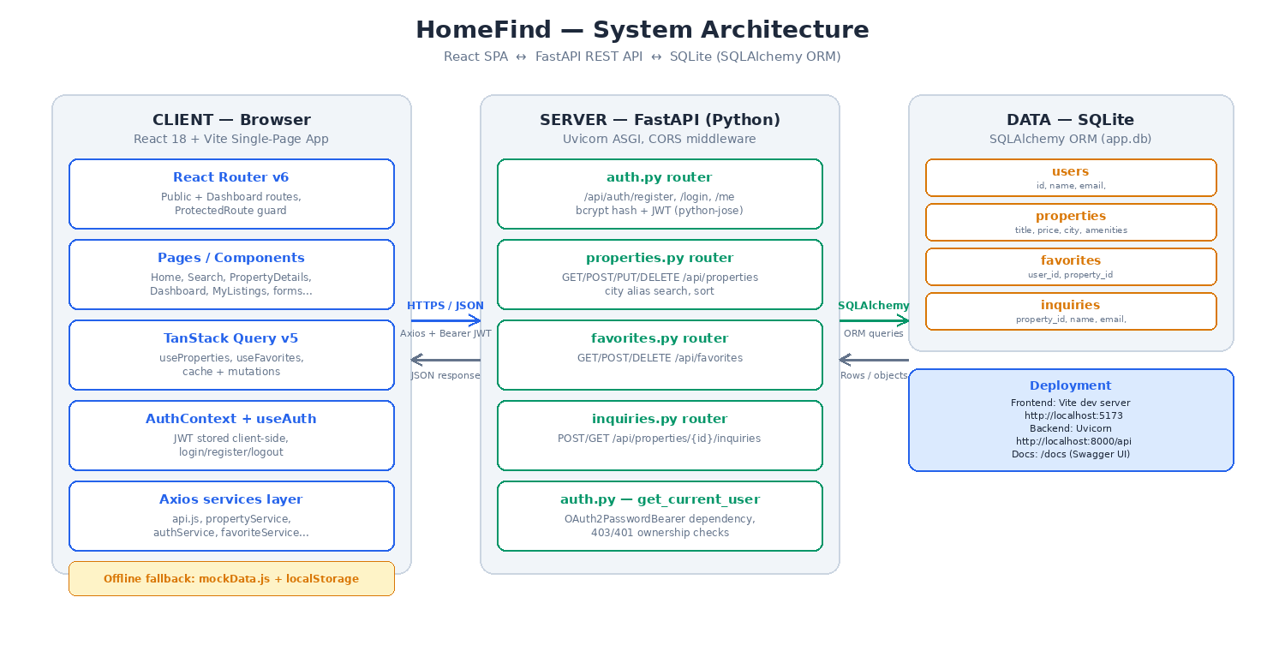
Figure 9.1 — HomeFind system architecture

9.2 Key Code Snippets
1. Password Hashing & JWT Authentication (backend/app/auth.py)
This snippet shows how HomeFind hashes passwords with bcrypt and issues/validates JSON Web Tokens for protected endpoints:
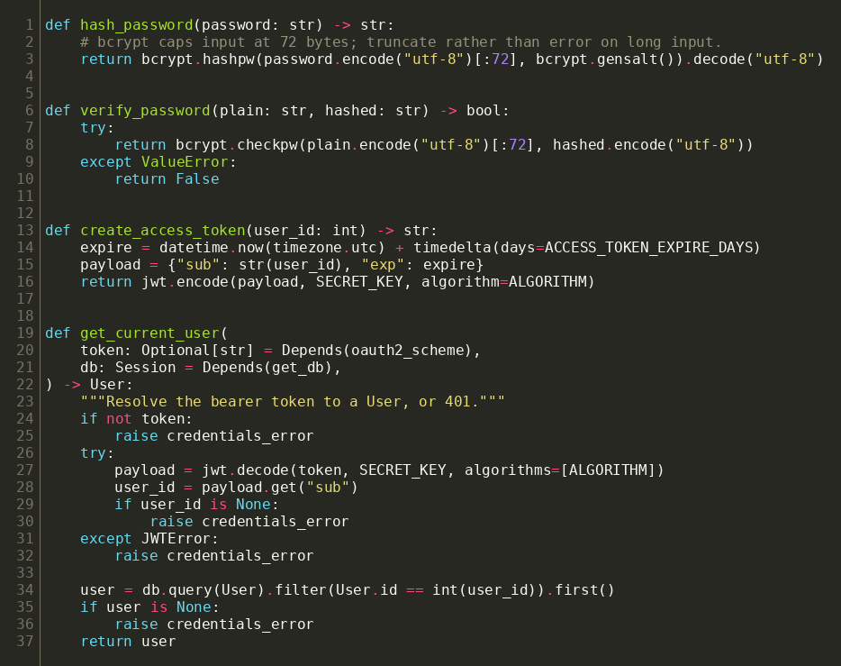
2. Property Data Model (backend/app/models.py)
This snippet shows the SQLAlchemy ORM model for a property listing, including the JSON-typed amenities/images columns and the ownership relationship used to enforce access control:
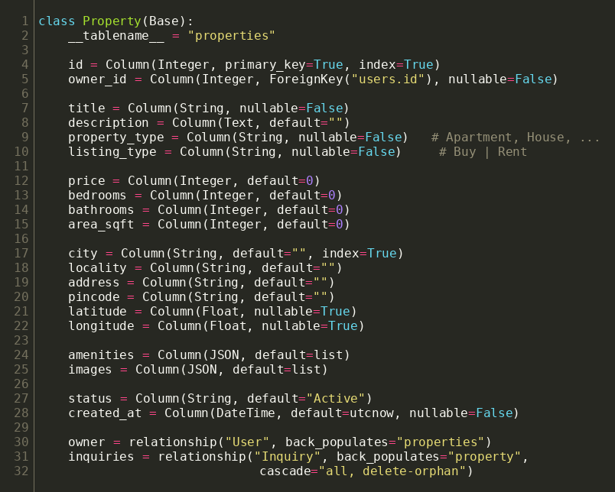
3. Property Search Endpoint (backend/app/routers/properties.py)
This snippet shows the /api/properties endpoint combining SQL-level filters with the Python-side city-alias match and configurable sort:
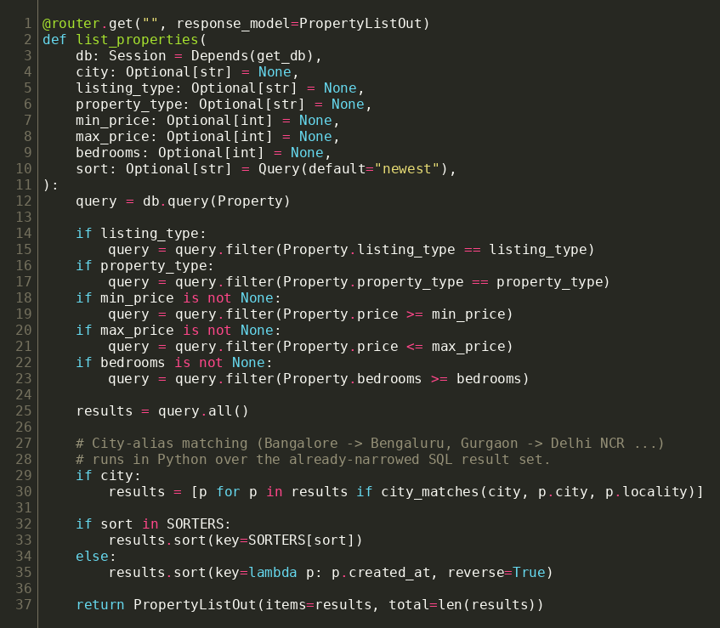
4. TanStack Query Hooks (frontend/src/hooks/useProperties.js)
This snippet shows the React hooks that wrap the property/favorite services in TanStack Query, giving pages automatic caching, loading states, and cache invalidation after mutations:
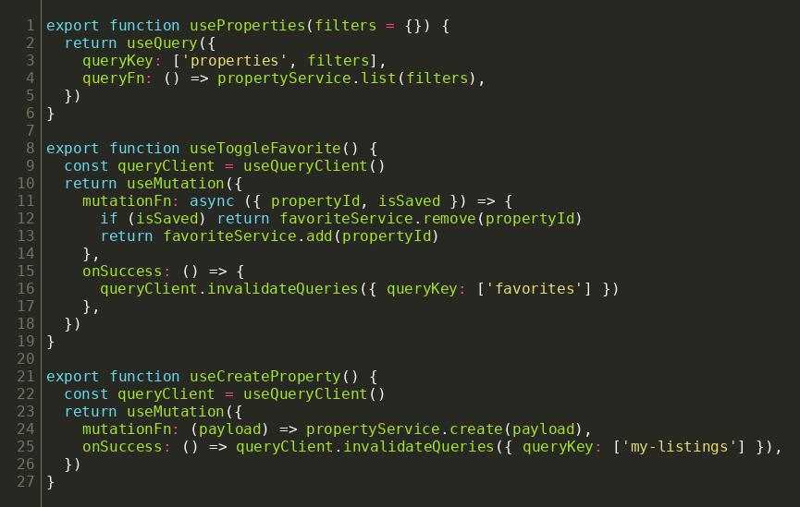

9.3 Application Screenshots (Live Demo)
The screenshots below were captured from the actual running application — the FastAPI backend served live from app.db (seeded with 32 demo listings across 4 users) and the React frontend served by Vite — rather than mock-ups, to demonstrate that every flow described in this report is implemented and working end-to-end.
Home page — hero search and featured listings
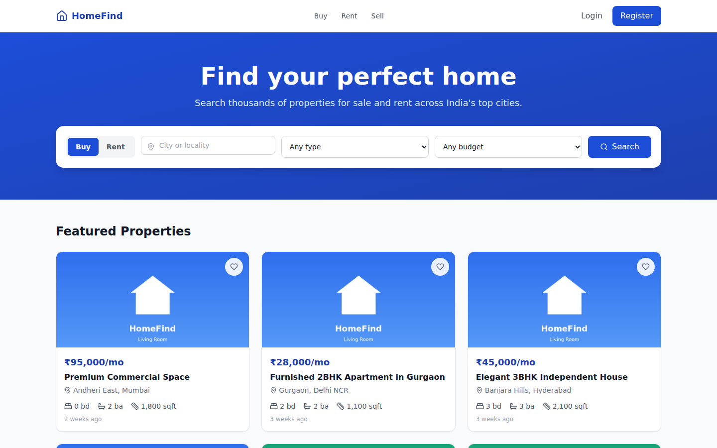
Figure 9.3.1 — Home page
Search page — filters, sort, and result grid
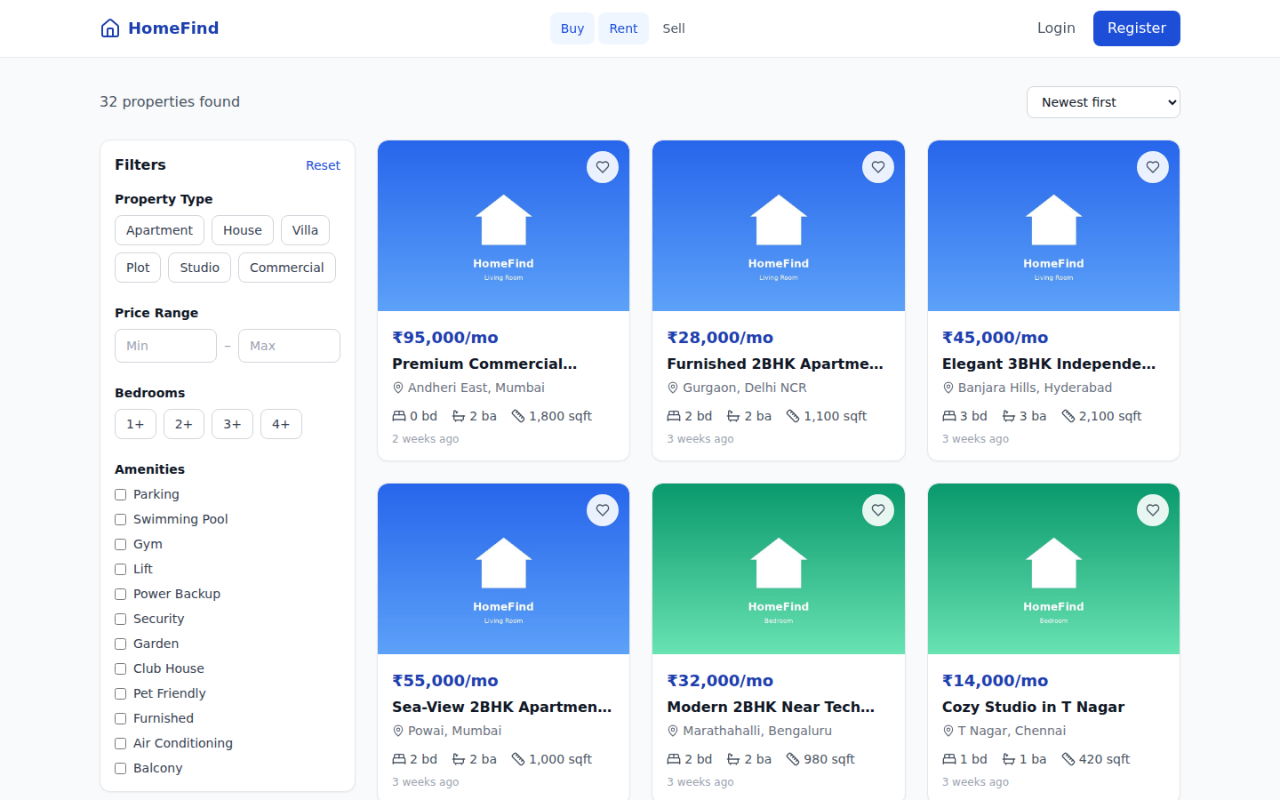
Figure 9.3.2 — Search with filters
Property Details — gallery, specs, and contact-seller inquiry
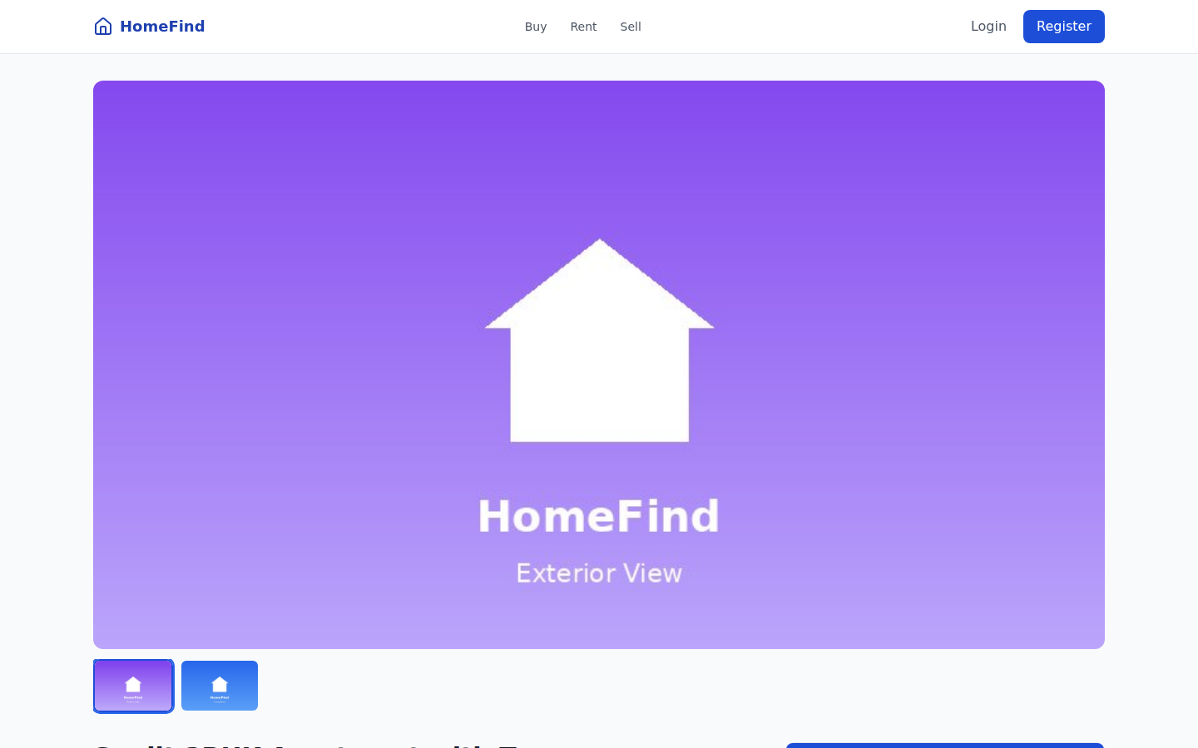
Figure 9.3.3 — Property details page
Login page
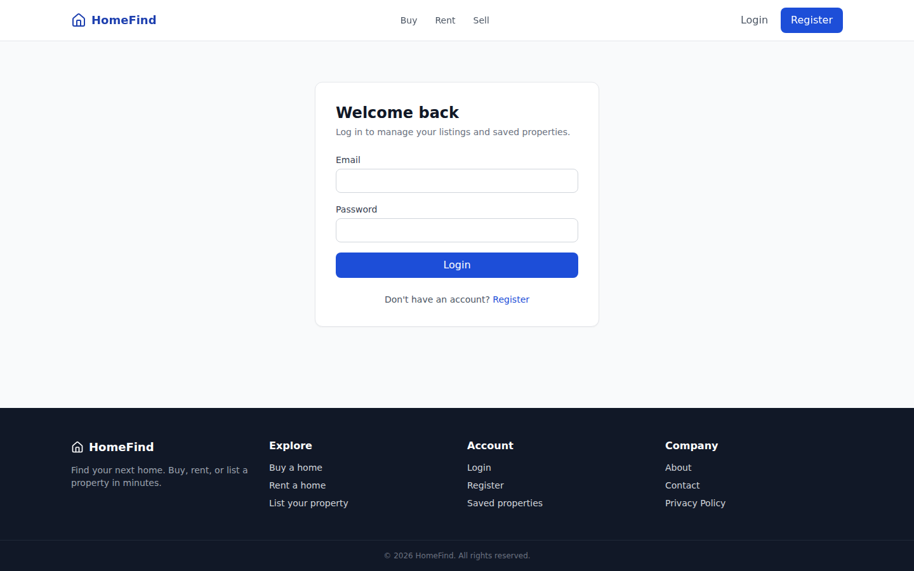
Figure 9.3.4 — Login
Seller Dashboard — summary cards and recent listings
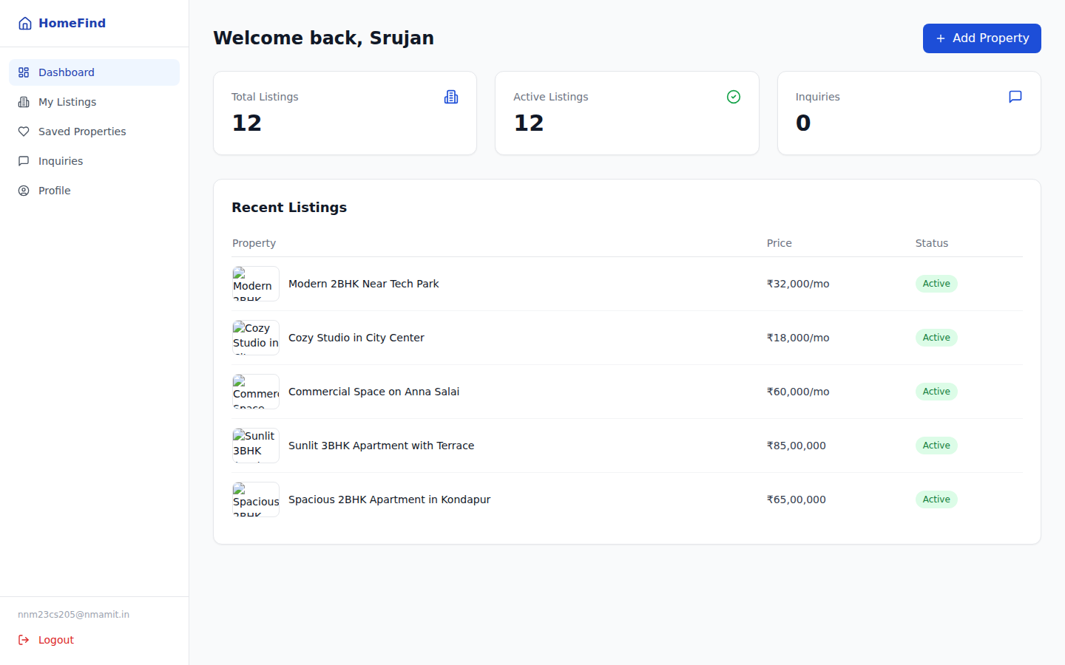
Figure 9.3.5 — Dashboard (logged in as seller)
My Listings — edit/hide/delete a seller's own properties
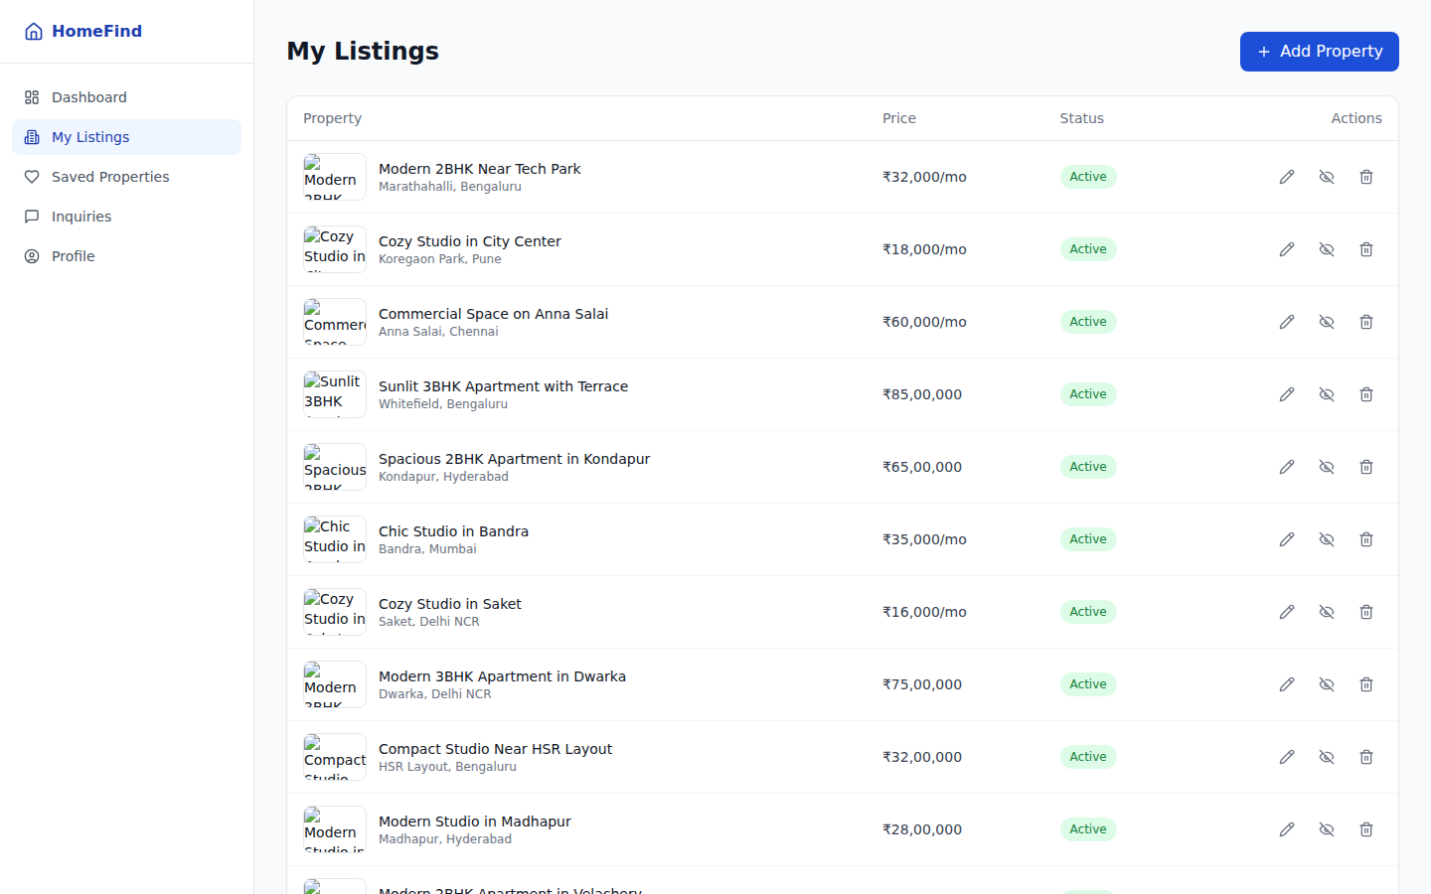
Figure 9.3.6 — My Listings
Create Listing — step 1 of the 4-step form
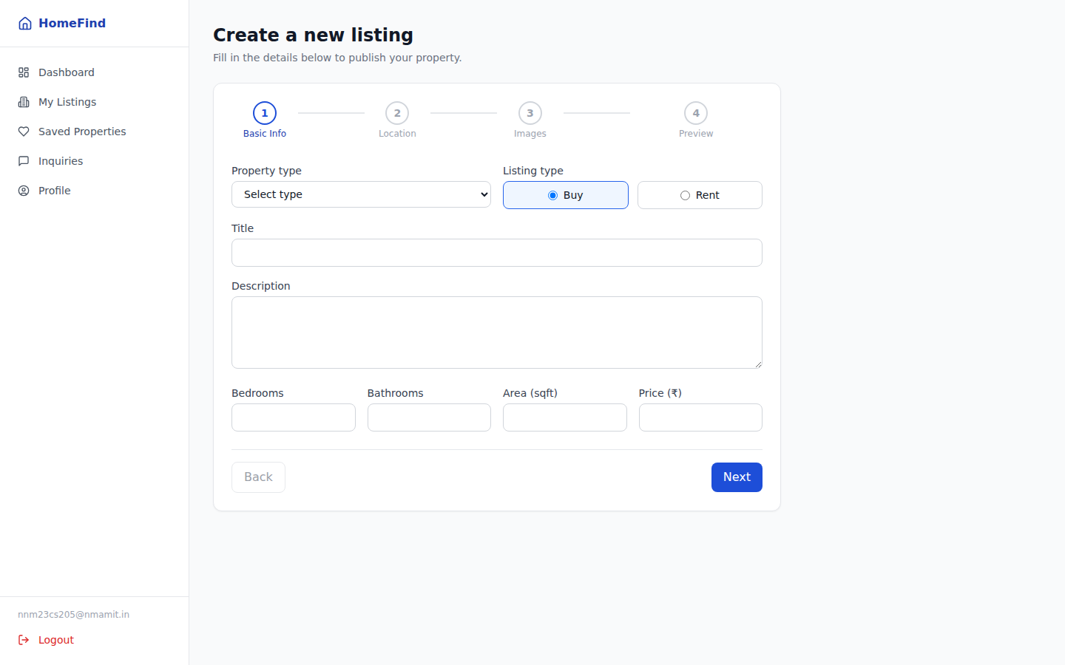
Figure 9.3.7 — Create Listing (Basic Info step)
Inquiries — a real buyer inquiry submitted through the public form and received by the owning seller
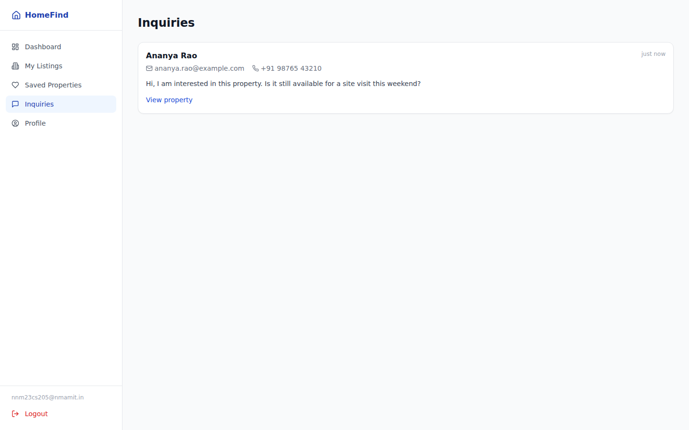
Figure 9.3.8 — Inquiries inbox

10. Results
The development of project HomeFind successfully delivered a fully functional real estate listing platform covering the complete buyer/seller journey from search to inquiry. Key outcomes and functional results achieved include:
- Role-Based Listing Management: Sellers can create, edit, and delete their own listings through a validated 4-step form; ownership is enforced server-side (403 on any attempt to modify another user's property), not just hidden in the UI.
- Forgiving Location Search: The city-alias engine correctly resolves colloquial and alternate city names (Bangalore/Bengaluru, Gurgaon/Noida/Delhi NCR) alongside listing type, property type, price range, and bedroom filters, with sort by newest, price, or area.
- Buyer Tools: Authenticated users can save and unsave properties through an idempotent favorites API and send inquiries to a seller without needing an account; sellers see only inquiries addressed to their own listings.
- Resilient Frontend: Every data-access hook falls back to bundled mock data and localStorage when the backend is unreachable, so the full UI — browsing, search, auth, saving, listing CRUD — stays demonstrable without the FastAPI server running; verified to build cleanly with Vite (1727 modules, no errors).
Overall, the project met its functional goals, demonstrating that a FastAPI + SQLAlchemy backend paired with a React + TanStack Query frontend is a practical, extensible foundation for a listings marketplace.

11. Applications
The HomeFind platform has several practical, real-world applications across property marketplaces, seller tooling, and web software architecture:
- Residential & Commercial Listings: The core buy/rent search and listing-management flow generalizes directly to apartments, houses, plots, and commercial spaces.
- Seller Self-Service Portal: The dashboard, My Listings page, and inquiries inbox give an individual agent or small brokerage a lightweight CMS for their own inventory without needing a shared admin panel.
- Lead-Generation Channel: The structured, owner-scoped inquiry system gives sellers a persistent, searchable record of buyer interest instead of relying on an exposed phone number.
- Template for Other Marketplaces: The same architecture (React SPA + FastAPI ownership-enforced backend + SQL persistence) can be adapted to classifieds, vehicle listings, or rental-equipment marketplaces with minimal structural change.

12. Literature Survey

12.1 Survey of Existing Systems
Many lightweight property-listing implementations either hardcode data on the client with no backend at all, or expose a database directly to the frontend with little to no server-side ownership enforcement — meaning any authenticated (or even unauthenticated) request can, in principle, modify another user's data. Location search in such systems is typically an exact string match, which fails whenever a user types a colloquial or alternate city name.

12.2 Comparative Analysis Table
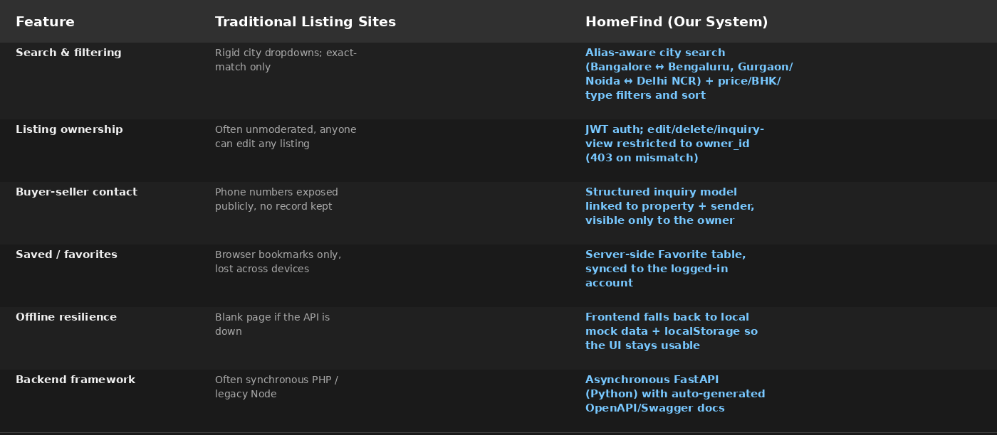
Table 12.2 — Traditional listing sites vs. HomeFind

12.3 Summary of Surveyed Technologies
The literature survey concluded that a React Single Page Application for the presentation layer, combined with an ownership-enforcing FastAPI (Python) REST backend and a relational database accessed exclusively through an ORM, provides a secure and maintainable foundation for a listings platform — while a client-side offline fallback (mock data + localStorage) keeps the UI demonstrable independent of backend availability, which is valuable during iterative development.

13. Training Experience
During the Python Full Stack Internship at DLithe Consultancy Services, the training experience focused on applying core web technologies — HTML, CSS, JavaScript, React, Python, SQL, and GitHub — to build a practical web application named HomeFind. Through hands-on development, I learned to design a REST API in FastAPI with routers separated by resource (auth, properties, favorites, inquiries), implement password hashing and JWT-based authentication from scratch using bcrypt and python-jose, and model ownership relationships in SQLAlchemy so that access control is enforced at the database-query level rather than trusted from the client. On the frontend, I gained practical experience with React 18, Tailwind CSS, TanStack Query for server-state caching, and React Hook Form with Zod for multi-step form validation, while building a services layer that keeps all API access out of components. This training provided realistic insight into end-to-end full-stack development, API design, and version-control workflows using Git and GitHub.

14. Key Learnings
Developing HomeFind provided valuable technical insight into full-stack engineering and secure API design. Key learnings included implementing JWT-based authentication end-to-end — issuing tokens on login/register, resolving them via a get_current_user dependency, and distinguishing 401 (not authenticated) from 403 (authenticated but not the owner); designing a normalized relational schema (User, Property, Favorite, Inquiry) with foreign keys and a unique constraint to keep favorites idempotent; building a search feature that has to reconcile real-world naming inconsistencies (city aliases) rather than assuming clean input; and structuring a React frontend around a dedicated services/hooks layer (TanStack Query) so that caching, loading states, and cache invalidation after mutations are handled consistently across every page instead of being reimplemented per component.

15. Challenges
Developing HomeFind involved overcoming several practical engineering hurdles. Enforcing ownership correctly required care — every mutating endpoint (edit, delete, view-inquiries) had to independently re-check owner_id against the token's user rather than trusting a client-supplied ID, since relying on the frontend alone would have made the restriction cosmetic. Reconciling the frontend's original offline mock data with the new backend schema required porting the exact city-alias map from the JavaScript constants file into Python so search behavior stayed identical whether or not the backend was running. Keeping the frontend usable when the API is unreachable meant every service function needed an explicit fallback path to mock data and localStorage rather than letting requests fail silently. Finally, validating the multi-step listing-creation form (basic info → location → images → preview) with React Hook Form and Zod required carefully scoping validation per step, so users were not blocked by errors on fields they had not reached yet.

