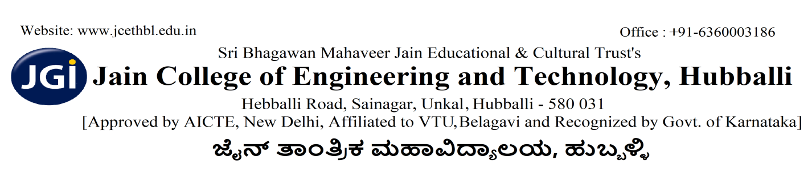
VAIBHAV 2K26
CIRCUITMANIA

- The event is open to students from all engineering branches and can be participated in teams of four.
- Participants must identify and rectify the faults in the given electronic circuit within the allotted time.
- The time limit for the debugging round will be strictly enforced, and no extra time will be provided.
- All required components, tools, and power supply will be provided by the department; use of personal materials is not permitted.
- Participants must not use mobile phones, smart devices, or seek external assistance during the event.
- Proper handling of equipment is mandatory; any intentional damage will lead to disqualification.
- Evaluation will be based on accuracy of fault identification, successful circuit operation, debugging approach, and time taken.
- The decision of the judges will be final and binding in all circumstances.

Faculty Co-ordinator:
Prof. Mahesh Hiremath
Prof. Sachin Shetty

Student Co-ordinator:
1) Shristi Dasannavar (VI sem ECE)
2) Meghana Bangari (VI sem ECE)
PRINCIPAL

