GEN-AI
🔥 Core LLM Fundamentals
- What is Generative AI?
- What is a Large Language Model (LLM)?
- What is the Transformer architecture?
- What is self-attention and why is it important?
- What are tokens and tokenization?
- What is temperature in LLMs?
- What is Top-p (nucleus sampling)?
- What is a context window?
- What is prompt engineering?
- What is hallucination in LLMs and how can it be reduced?
🔥 RAG & Embeddings (Very High Weight for You)
- What is Retrieval-Augmented Generation (RAG)?
- Why use RAG instead of fine-tuning?
- What are embeddings and why are they important?
- What is a vector database?
- What is FAISS and why is it used?
- What is chunking in RAG and why do we use overlap?
- How do you evaluate a RAG system?
🔥 Fine-Tuning & Practical Design
- What is fine-tuning?
- Difference between GPT and BERT?
- When should you use fine-tuning vs RAG?

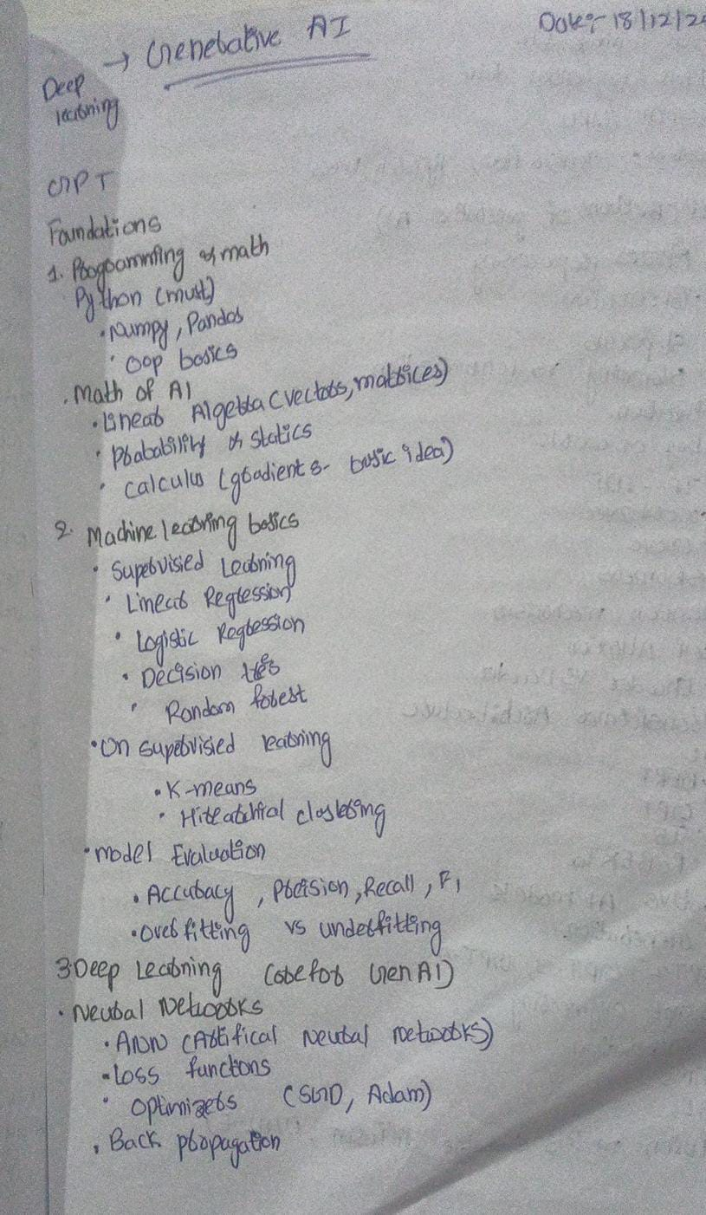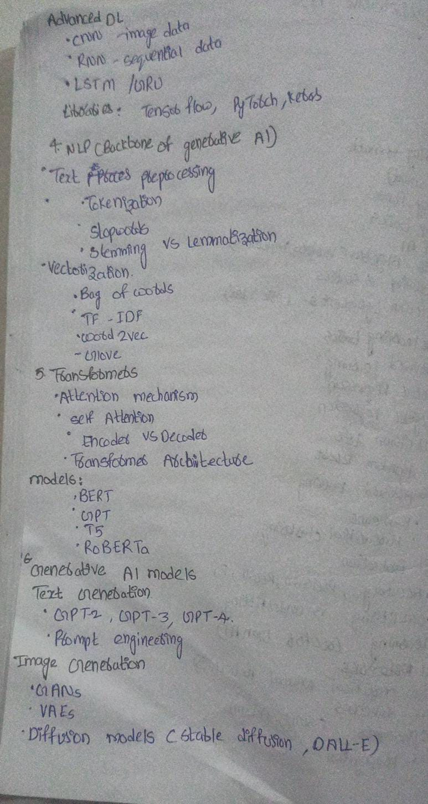
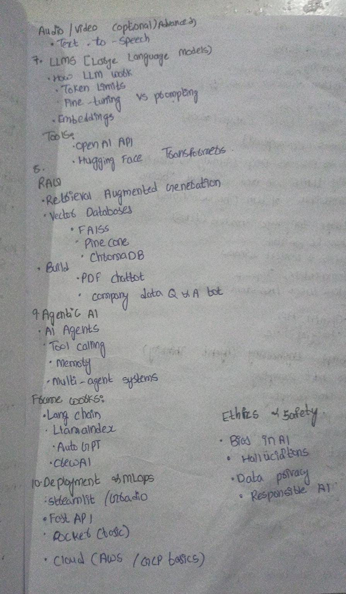
1.What is AI (Artificial Intelligence)?
Artificial Intelligence (AI) is a field of computer science that focuses on
creating machines or systems that can simulate human intelligence
2. What is Generative AI?
Generative AI is a type of Artificial Intelligence that can create new content such as text, images, audio, video, or code instead of only analyzing existing data.
3.What is Agentic AI?
Agentic AI is an artificial intelligence system that can autonomously plan, decide, and take actions to achieve a given goal by using tools, memory, and feedback, with minimal human intervention.
- Agentic AI is AI that can think, plan, and act on its own to complete tasks.
4. What are LLMs (Large Language Models)?
LLMs (Large Language Models) are advanced AI models trained on massive amounts of text data that can understand, generate, summarize, translate, and reason using human language.
- LLMs are the core technology behind chatbots, Generative AI, and Agentic AI systems.
5. What is a Transformer?
A Transformer is a deep learning model used in NLP and LLMs that understands text using self-attention, allowing it to see relationships between all words in a sentence at the same time.
6. What is Attention Mechanism?
Attention mechanism is a technique in deep learning that allows a model to focus on the most relevant parts of the input while making predictions.
Attention solves this by:
- Looking at all words
- Giving different importance (weights) to each word
🔹 Example:
Sentence:
"The animal didn’t cross the street because it was too tired."
To understand "it", model must focus on:
👉 animal
Attention assigns:
- High weight → "animal"
- Low weight → other words
7. What is Self-Attention?
Self-attention is a type of attention where a sequence attends to itself to understand relationships between words.
It is the core idea behind:
- Transformers
- BERT
- GPT
- LLMs
Example
Sentence:
"The bank of the river was full."
The word "bank" needs context.
Self-attention checks:
- river → high importance
- others → lower
So it understands:
👉 bank = river bank (not financial bank)
8. what is enoder vs decoders ?
Encoder
An encoder is a neural network component that reads the entire input sequence and converts it into meaningful contextual representations called embeddings. It understands relationships between words using self-attention.
If they ask what it does:
The encoder captures the meaning and context of the input data.
Decoder:
A decoder is a neural network component that generates the output sequence step-by-step by predicting one token at a time, using previously generated tokens and contextual information.
If they ask what it does:
The decoder is responsible for generating text or output sequences.
Task:
Translate English → French
Input:
"I love machine learning."
How Encoder–Decoder Works:
🔵 Encoder:
- Reads the full English sentence
- Understands meaning
- Creates contextual representation
🔴 Decoder:
- Uses that representation
- Generates French sentence word by word
Output:
"J'aime l'apprentissage automatique."
9.What is Transformer Architecture?
The Transformer architecture is the internal structure of a transformer model
Main components of Transformer Architecture
- Tokenization – splits text into tokens
- Embedding Layer – converts tokens into vectors
- Positional Encoding – adds word order information
- Self-Attention / Multi-Head Attention – finds word relationships
- Feed-Forward Neural Network – processes representations
- Residual Connections & Layer Normalization – stabilizes training
10.what is Embedding ?
Embedding is the process of converting words or tokens into dense numerical vectors that capture their meaning and context.
* Expanding the Embedding layer view, showing how the input prompt is converted to a vector representation. The process involves (1) Tokenization, (2) Token Embedding, (3) Positional Encoding, and (4) Final Embedding.
11.What is Tokenization?
Tokenization is the process of breaking text into smaller units called tokens (such as words, sub-words, or characters) so that a machine learning model can understand and process the text.
12.What is Positional Encoding?
Positional Encoding is a technique used in transformers to add information about the position (order) of words in a sentence, because transformers process all words in parallel and do not naturally understand word order.
13. What is Self-Attention?
Self-Attention is a mechanism in transformers that allows a model to focus on relevant words in a sentence by measuring how strongly each word is related to every other word.
Multi-Head Self-Attention
Step 1: Query, Key, and Value Matrices
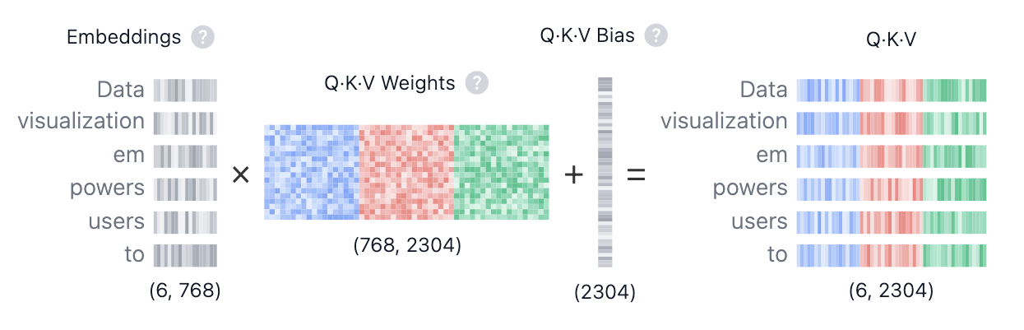
$$QKV_{ij}=(\sum_{d=1}^{768}{{\text{Embedding}}_{i,d}}⋅{\text{Weights}}_{d,j})+{\text{Bias}}_{j}$$
- Query (Q) is the search text you type in the search engine bar. This is the token you want to "find more information about".
- Key (K) is the title of each web page in the search result window. It represents the possible tokens the query can attend to.
- Value (V) is the actual content of web pages shown. Once we matched the appropriate search term (Query) with the relevant results (Key), we want to get the content (Value) of the most relevant pages.
By using these QKV values, the model can calculate attention scores.

Step 2: Multi-Head Splitting
Step 3: Masked Self-Attention
Dot Product
Scaling · Mask
Softmax · Dropout:
Step 4: Output and Concatenation
14. What is MLP (Multi-Layer Perceptron)?
MLP (Multi-Layer Perceptron) is a feed-forward neural network made up of multiple fully connected layers (input layer, one or more hidden layers, and an output layer) that learns complex, non-linear patterns in data.
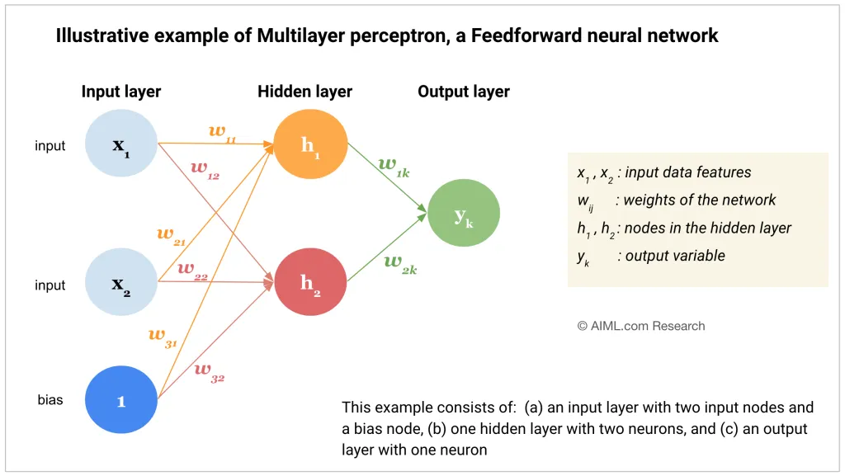
15. what is tempeature , sampling, top-K, top -p?
* Temperature controls how random or creative the model’s output is by adjusting the probability distribution.
- Low temperature (≈ 0–0.3) → more deterministic & safe
- High temperature (≈ 0.8–1.2) → more creative & random
- Sampling means the model randomly selects the next token based on output probabilities, instead of always choosing the highest-probability token.
Top-K limits the model to choose the next word only from the top K most probable tokens.
📌 Example:
If K = 5, the model selects from only the top 5 words.
- Small K → safer, less creative
- Large K → more diverse output
* Top-P selects the smallest set of words whose total probability ≥ P, and samples from them.
📌 Example:
If P = 0.9, choose tokens until their combined probability reaches 90%.

16.What are Output Probabilities?
Output probabilities are the likelihood values assigned to each possible output (such as the next word in a sentence), indicating how likely each option is
17.What is Layer Normalization?
Layer Normalization is a technique used in neural networks (especially transformers) to normalize the activations within a single layer for each data sample, which helps make training stable and faster.
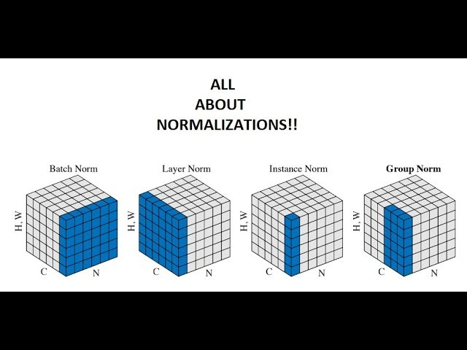
How transformer works
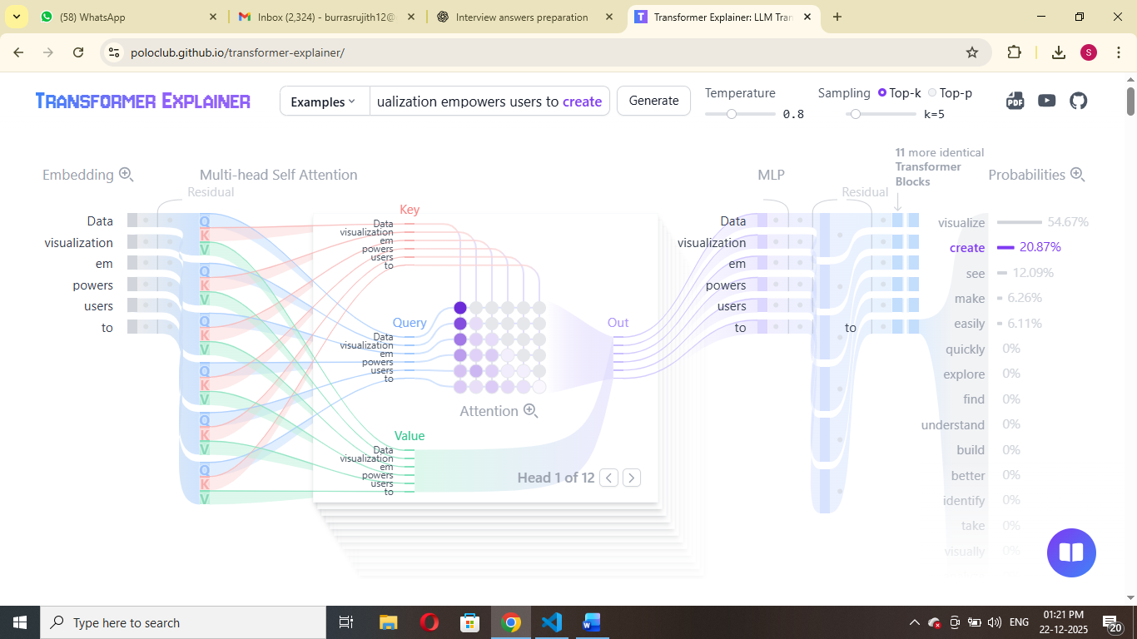

** LLMS does not give same responds everytime.

18.what are the types of response ?
There are two types of response
1.What is streaming response ?
A steam response sends the output incrementally in small chunks as it is generated, allowing, real time consumption.
2.what is completion response ?
A completion response means the system generates the entire output first and returns it in a single response only after processing in full completed.
19. How does streaming work in a real-time LLM API ?
In a real-time LLM API, when streaming is enabled, the model generates tokens one by one and sends each token immediately to the client through a persistent connection such as WebSockets or Server-Sent Events (SSE).
20. What is meant by “Model”?
A model is a trained neural network that learns patterns from data and makes predictions.
1️⃣ BERT
Full Form: Bidirectional Encoder Representations from Transformers
Developed by: Google
BERT is an encoder-based model that understands context by looking at words in both directions.
Key Features
- Bidirectional (reads left and right context)
- Uses self-attention
- Strong for text understanding tasks
🔹 Used For
- Sentiment analysis
- Question answering
- Text classification

2️⃣ GPT
Full Form: Generative Pre-trained Transformer
Developed by: OpenAI
GPT is a decoder-only Transformer model designed for text generation.
🔹 Key Features
- Autoregressive (predicts next word)
- Uses masked self-attention
- Generates text word-by-word
🔹 Used For
- Chatbots
- Content generation
- Code generation

3️⃣ T5
Full Form: Text-To-Text Transfer Transformer
Developed by: Google
T5 is an encoder-decoder Transformer model that treats every NLP task as a text-to-text problem.
🔹 Example
- Translation → input: "Translate English to French: I love AI"
- Output: "J’aime l’IA"
🔹 Used For
- Translation
- Summarization
- Question answering

4️⃣ RoBERTa
Full Form: Robustly Optimized BERT Approach
Developed by: Meta AI
What is RoBERTa?
RoBERTa is an improved version of BERT trained with better optimization and more data.
🔹 Improvements Over BERT
- Trained longer
- More data
- Removed next sentence prediction
🔹 Used For
- Text classification
- NLP understanding tasks
21.What is Generative AI models?
What is a Text Generator?
A text generator is a generative AI model that produces human-like text by predicting the next word in a sequence.
GPT Models
GPT = Generative Pre-trained Transformer
Developed by OpenAI
GPT models are decoder-only Transformer models designed for text generation.
🟢 GPT-2 (2019)
- 1.5B parameters
- First major public generative model
- Could generate coherent paragraphs
Interview Line:
GPT-2 demonstrated that large-scale language models can generate human-like text.
🔵 GPT-3 (2020)
- 175B parameters
- Strong few-shot learning
- Used in early ChatGPT versions
Interview Line:
GPT-3 showed powerful few-shot learning capabilities without task-specific training.
🟣 GPT-4 (2023)
- More accurate
- Better reasoning
- Multimodal (text + image)
Interview Line:
GPT-4 improved reasoning, safety, and multimodal capabilities compared to GPT-3.
🔵 What is Prompt Engineering?
Prompt engineering is the practice of designing effective input prompts to guide AI models to produce better outputs.
22. What is Image Generation?
Image generation is the process of creating new images using deep learning models trained on large datasets of images.
1️⃣ GANs (Generative Adversarial Networks)
Proposed by: Ian Goodfellow
🔹 What is GAN?
GAN is a generative model that uses two neural networks — a Generator and a Discriminator — trained in competition with each other.
2️⃣ VAEs (Variational Autoencoders)
VAE is a probabilistic generative model that encodes images into a latent space and then decodes them back to generate new images.
🔹 How It Works
- Encoder → Converts image to latent vector
- Latent space → Compressed representation
- Decoder → Reconstructs image
3️⃣ Diffusion Models
Currently the most powerful image generation models.
What is Diffusion Model?
Diffusion models generate images by gradually removing noise from random noise through a learned denoising process.
Stable Diffusion
Developed by: Stability AI
What is Stable Diffusion?
Stable Diffusion is a text-to-image diffusion model that generates high-quality images from text prompts.
Key Features:
- Open-source
- Uses latent diffusion
- Faster than traditional diffusion models

🎨 DALL·E
Developed by: OpenAI
What is DALL·E?
DALL·E is a text-to-image generative model that creates images from natural language descriptions.
23. What are LLMs?
LLMs (Large Language Models) are deep learning models trained on massive amounts of text data to understand and generate human-like language.
2️⃣ How do LLMs Work?
Step-by-step (Simple Explanation)
- Text → converted into tokens
- Tokens → converted into embeddings (vectors)
- Passed through Transformer layers
- Model predicts next token
5.Generates text one token at a time
3️⃣ Token Limits
What is Token Limit?
Token limit is the maximum number of tokens a model can process in one request (input + output).
If model limit = 8K tokens:
- Input + Response must be ≤ 8K
Tokens are:
- Words
- Parts of words
- Characters
Example:
"ChatGPT is amazing"
May become:
- "Chat"
- "G"
- "PT"
- " is"
- " amazing"

4️⃣ Fine-Tuning vs Prompting

🔹 Prompting
Giving clear instructions in the input to guide model output.
Example:
"Explain AI like I am 10 years old."
🔹 Fine-Tuning
Retraining the model on domain-specific data to improve performance.
Example:
- Legal data
- Medical data
- Company internal documents.
5️⃣ What are Embeddings?
Embeddings are numerical vector representations of text that capture semantic meaning.
Example
"King" → [0.23, -0.91, 0.45, …]
Similar words have similar vectors:
- King ≈ Queen
- Dog ≈ Puppy
6️⃣ Tools
OpenAI API
Developed by OpenAI
What It Is
A cloud API that allows developers to access GPT models for text generation, embeddings, and other AI tasks.
Used For
- Chatbots
- RAG systems
- Text generation
- Embeddings

🔹 Hugging Face Transformers
Developed by Hugging Face
What It Is
An open-source library providing pre-trained Transformer models like BERT, GPT, T5, and more.
Used For
- Local model training
- Fine-tuning
- Research
- Deployment
24.What is RAG?
RAG (Retrieval-Augmented Generation) is a technique where a language model first retrieves relevant information from external data sources and then uses that information to generate accurate and context-aware answers.
Very Short (1-Line Option)
RAG helps an AI model answer questions by searching relevant documents first and then generating the response.
This is useful if we want to ask question about specific documents (e.g., our PDFs, a set of videos, etc).
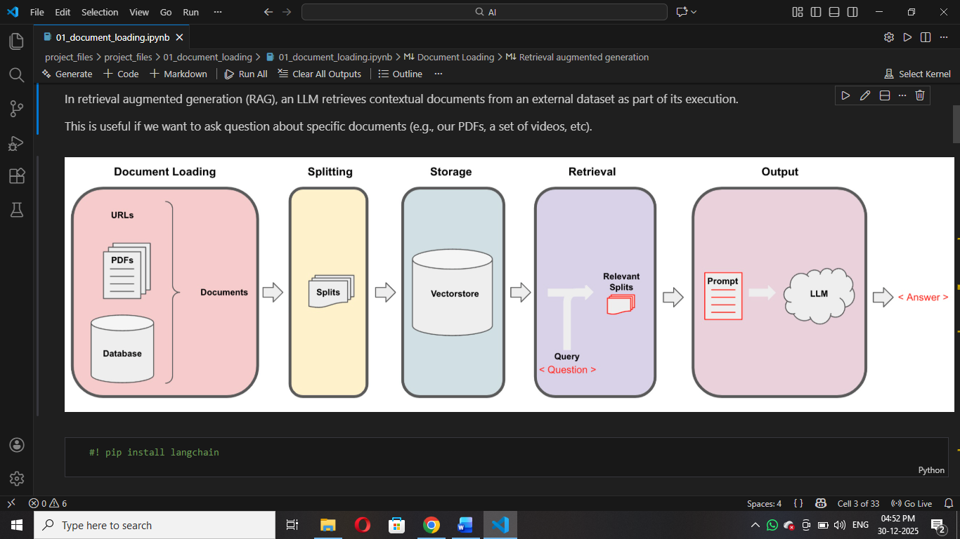
One-Line Summary (Interview Ready)
RAG works by loading documents, splitting them, storing embeddings in a vector database, retrieving relevant content for a query, and then generating an answer using an LLM.
25. What is a Vector Store?
A vector store is a system that stores text as numerical vectors (embeddings) and allows similarity search to find the most relevant information.
In simple words:
- Text → converted into numbers (vectors)
- These vectors are stored
- We search them using meaning, not keywords
26.What is a Vector Database?
A vector database is a specialized database designed to store, manage, and efficiently search large volumes of vector embeddings.
In simple words:
- It is a full-featured database
- Built for fast similarity search
- Handles millions of vectors
27. What are Embeddings?
Embeddings are numerical representations (vectors) of text that capture its meaning, so machines can understand and compare language mathematically.
Simple Explanation
- Text → converted into numbers
- These numbers represent the meaning of the text
- Similar meanings → vectors are closer together
📌 In short:
Embeddings = Meaning in number form
Vector Data bases :
1️⃣ FAISS
Developed by: Meta AI
FAISS (Facebook AI Similarity Search) is a library for efficient similarity search and clustering of high-dimensional vectors.
What It Does
- Stores embeddings (vectors)
- Finds nearest neighbors quickly
- Works very fast even for millions of vectors
Where It Is Used
- RAG systems
- Semantic search
- Recommendation systems
- Image similarity search

2️⃣ Pinecone
Type: Managed Vector Database
Company: Pinecone Systems
Pinecone is a fully managed cloud-based vector database used to store and search embeddings at scale.
Example
Company chatbot:
- Store company documents embeddings in Pinecone
- User asks question
- Pinecone retrieves relevant chunks
- LLM generates response
Where It Is Used
- Enterprise RAG systems
- Production chatbots
- Large-scale AI search systems

3️⃣ Chroma DB
Company: Chroma
Chroma DB is an open-source vector database designed specifically for LLM applications and RAG pipelines.
What It Does
- Stores embeddings
- Provides similarity search
- Easy integration with LangChain
Example
In your RAG project:
from langchain.vectorstores import Chroma
- Store PDF embeddings
- Retrieve relevant context
- Send to LLM
28. What is Agentic AI?
Agentic AI refers to AI systems that can autonomously plan, decide, and take actions to achieve a goal.
2️⃣ What are AI Agents?
An AI agent is a system that perceives input, makes decisions, and takes actions to achieve a specific objective.
Key Components of an AI Agent
- LLM (Brain)
- Memory
- Tools
- Planner / Reasoner
Example
Customer support agent:
- Reads user query
- Searches knowledge base
- Calls API if needed
- Responds

3️⃣ Tool Calling
Tool calling is the ability of an LLM to invoke external tools, APIs, or functions to perform real-world actions.
Example
User:
“What is the weather in Hyderabad?”
Agent:
- Calls weather API
- Gets real-time data
- Responds
Other Examples
- Database query
- Python calculator
- Web search
- Email sending

4️⃣ Multi-Agent Systems
A multi-agent system consists of multiple AI agents collaborating or competing to solve complex tasks.

Why Use Multi-Agents?
- Divide complex problems
- Specialized agents
- Parallel execution
🔹 Example
Building a report:
Agent 1 → Research
Agent 2 → Data analysis
Agent 3 → Write summary
Agent 4 → Review content
All collaborate.
Frame works
29. What is LangChain?
LangChain is a framework that helps developers build applications using large language models by connecting LLMs with external data, tools, and workflows.
In Very Simple Words:
LangChain makes it easy to connect an LLM to documents, databases, APIs, and tools instead of using the model alone.
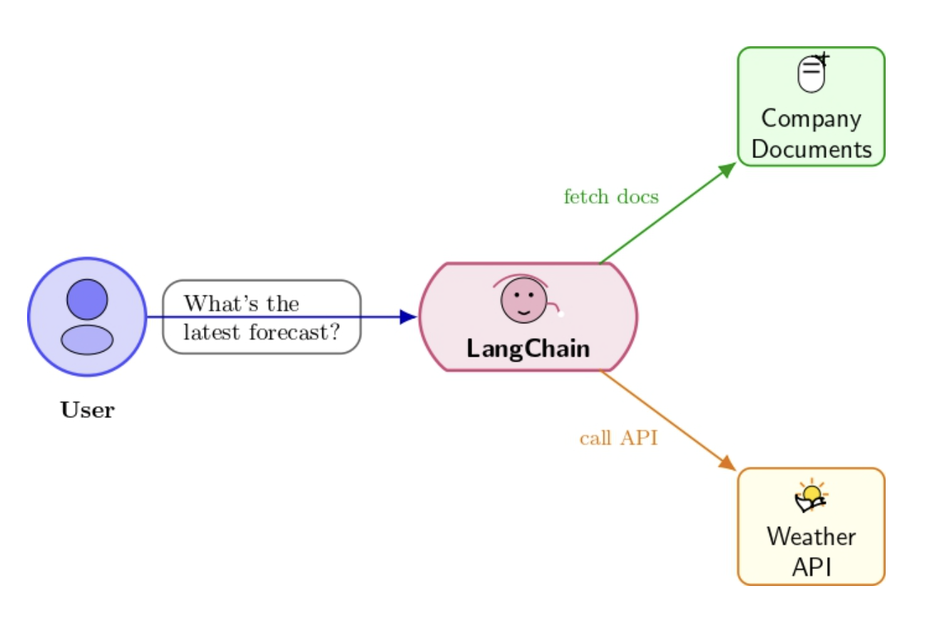

30.What is LlamaIndex?
LlamaIndex is a data framework that connects large language models with external data sources like PDFs, databases, and APIs for building RAG applications.
Example
You build a chatbot for company documents:
- Upload PDFs
- LlamaIndex indexes them
- User asks question
- Relevant chunks retrieved
- LLM generates answer
31. What is Auto-GPT ?
Auto-GPT is an autonomous AI agent framework that uses GPT models to break down goals into tasks and execute them automatically.
What It Does
You give a goal:
“Create a business plan for an AI startup.”
Auto-GPT will:
- Plan tasks
- Search web
- Generate content
- Save files
- Iterate
Where Used
- Autonomous research
- Task automation
- AI experimentation
32. What is CrewAI ?
CrewAI is a multi-agent framework where multiple AI agents collaborate to complete complex tasks.
🔹 What It Does
You define roles:
- Researcher
- Analyst
- Writer
- Reviewer
They work together like a team (crew).
Example
Task:
“Write a market research report.”
Research Agent → Collects data
Analysis Agent → Analyzes data
Writer Agent → Writes report
Editor Agent → Reviews
Where Used
- Multi-agent workflows
- AI automation systems
- Enterprise AI solutions

33. 🔹 What is Token Splitting?
Token splitting is the process of breaking text into smaller units called tokens, which are the basic pieces a language model understands.
34. 🔹 What is Context-Aware Splitting?
Context-aware splitting is a method of dividing text into chunks while preserving the meaning and relationships between sentences or sections, instead of cutting text blindly by size.
Instead of splitting text randomly by characters or tokens, context-aware splitting tries to:
- Keep related sentences together
- Avoid breaking ideas, paragraphs, or sections
- Preserve semantic meaning
👉 This is especially important for RAG systems
35. What is OpenAI API?
OpenAI API is used to access powerful AI models like GPT for tasks such as text generation, chatbots, summarization, and embeddings through REST APIs.
OpenAI API allows developers to use AI models (like GPT) through code.
It is used for:
- Chatbots
- Text generation
- Image generation
- Embeddings
- AI automation
36. 🔹 What is Hugging Face?
Hugging Face is an open-source AI platform that provides pre-trained models and tools, especially for NLP tasks like text classification, embeddings, and transformers.”
Hugging Face is a platform for open-source AI models
It provides:
- Pre-trained ML / NLP models
- Transformers library
- Datasets
- Model hosting
37. What are FAISS, ChromaDB, Pinecone?
All three are Vector Databases
👉 Used to store embeddings and search similar data
What is FAISS?
🔹 Meaning
- FAISS = Facebook AI Similarity Search
- Developed by Meta AI
- Used for fast similarity search on vectors
Key Points (Interview Ready)
- Open-source
- Runs locally
- Very fast
- No UI
- No persistence by default
- 🔹 Simple Interview Answer
- “FAISS is an open-source library by Meta AI used for efficient similarity search on high-dimensional vector embeddings.”
- 🔹 When to use
- Research
- Local experiments
- High-speed similarity search
What is Chroma (ChromaDB)?
🔹 Meaning
- Open-source vector database
- Designed specifically for LLM & RAG applications
🔹 Key Points
- Stores embeddings + metadata
- Easy integration with LangChain
- Persistent storage
- Runs locally
🔹 Simple Interview Answer
“ChromaDB is an open-source vector database commonly used in RAG pipelines to store embeddings and perform similarity search.”
When to use
- Local RAG projects
- Student projects
- Small to medium applications
What is Pinecone?
🔹 Meaning
- Fully managed cloud-based vector database
- Production-ready
🔹 Key Points
- No infrastructure management
- Scalable
- Fast
- Paid service
🔹 Simple Interview Answer
“Pinecone is a managed cloud vector database used in production systems for scalable and fast similarity search on embeddings.”
When to use
- Production apps
- Large-scale AI systems
- Enterprise use cases
One-line Interview Gold
“FAISS is best for fast local similarity search, ChromaDB is ideal for local RAG pipelines, and Pinecone is used for scalable production-ready vector search.”

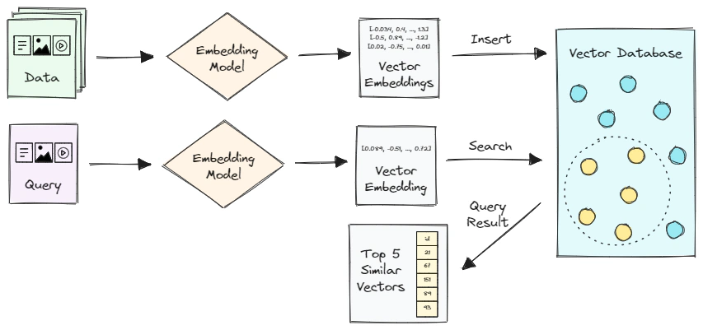

Missing Important Generative AI Interview Questions

1️⃣ What is Hallucination in LLMs?
Definition:
Hallucination is when an LLM generates incorrect or fabricated information that appears confident but is not factually true.
Follow-up they may ask:
- How to reduce hallucination?
  - RAG
  - Better prompts
  - Fine-tuning
  - Lower temperature
  - Grounded generation

2️⃣ What is Context Window?
Context window is the maximum number of tokens an LLM can consider at once.
Example:
- 8K tokens
- 32K tokens
- 128K tokens
Very commonly asked.

3️⃣ What is Few-shot, Zero-shot, and One-shot Learning?
- Zero-shot → No examples given
- One-shot → One example
- Few-shot → Few examples
Interviewers LOVE this question.

4️⃣ What is ReAct Framework?
ReAct = Reasoning + Acting
A prompting strategy where the model reasons step-by-step and calls tools.
Very important in Agentic AI interviews.

5️⃣ What is Memory in LLM Agents?
Types:
- Short-term memory (conversation history)
- Long-term memory (vector DB storage)
Very important for agent systems.

6️⃣ What is Model Quantization?
Reducing model size (e.g., 16-bit → 8-bit → 4-bit) to run efficiently.
Used for:
- Running LLM locally
- Reducing GPU usage

7️⃣ What is LoRA?
LoRA = Low-Rank Adaptation
A parameter-efficient fine-tuning technique that updates small parts of a model instead of full retraining.
Important for LLM fine-tuning roles.

8️⃣ What is Instruction Tuning?
Fine-tuning a model on instruction-following datasets to improve response quality.

9️⃣ What is RLHF?
RLHF = Reinforcement Learning from Human Feedback
A training method that improves LLM responses using human preference feedback.
Very frequently asked.

🔟 What is Function Calling?
You covered tool calling — but add:
Function calling is when LLM outputs structured JSON to trigger specific backend functions.
Important for API design interviews.

1️⃣1️⃣ What is Model Alignment?
Ensuring AI models behave safely, ethically, and according to human values.

1️⃣2️⃣ What is Multimodal AI?
Models that handle multiple input types like text, images, audio.
Example:
- GPT-4
- Vision-language models

1️⃣3️⃣ What is Latent Space?
A compressed numerical representation where similar concepts are located close together.
Important for diffusion & VAEs.

1️⃣4️⃣ What is Cosine Similarity?
Used in:
- Embedding search
- Vector databases
Formula-based questions sometimes asked.

1️⃣5️⃣ What is Indexing in Vector Databases?
Example:
- IVF
- HNSW
For FAISS interviews.

