Generative AI, Agentic AI, LLMs, Prompt Engineering
1.What is AI (Artificial Intelligence)?
Artificial Intelligence (AI) is a field of computer science that focuses on
creating machines or systems that can simulate human intelligence
2. What is Generative AI?
Generative AI is a type of Artificial Intelligence that can create new content such as text, images, audio, video, or code instead of only analyzing existing data.
3.What is Agentic AI?
Agentic AI is an artificial intelligence system that can autonomously plan, decide, and take actions to achieve a given goal by using tools, memory, and feedback, with minimal human intervention.
- Agentic AI is AI that can think, plan, and act on its own to complete tasks.
4. What are LLMs (Large Language Models)?
LLMs (Large Language Models) are advanced AI models trained on massive amounts of text data that can understand, generate, summarize, translate, and reason using human language.
- LLMs are the core technology behind chatbots, Generative AI, and Agentic AI systems.
5. What is a Transformer?
A Transformer is a deep learning model used in NLP and LLMs that understands text using self-attention, allowing it to see relationships between all words in a sentence at the same time.
6.What is Transformer Architecture?
The Transformer architecture is the internal structure of a transformer model
Main components of Transformer Architecture
- Tokenization – splits text into tokens
- Embedding Layer – converts tokens into vectors
- Positional Encoding – adds word order information
- Self-Attention / Multi-Head Attention – finds word relationships
- Feed-Forward Neural Network – processes representations
- Residual Connections & Layer Normalization – stabilizes training
7.what is Embedding ?
Embedding is the process of converting words or tokens into dense numerical vectors that capture their meaning and context.
* Expanding the Embedding layer view, showing how the input prompt is converted to a vector representation. The process involves (1) Tokenization, (2) Token Embedding, (3) Positional Encoding, and (4) Final Embedding.
8.What is Tokenization?
Tokenization is the process of breaking text into smaller units called tokens (such as words, sub-words, or characters) so that a machine learning model can understand and process the text.
9.What is Positional Encoding?
Positional Encoding is a technique used in transformers to add information about the position (order) of words in a sentence, because transformers process all words in parallel and do not naturally understand word order.
10. What is Self-Attention?
Self-Attention is a mechanism in transformers that allows a model to focus on relevant words in a sentence by measuring how strongly each word is related to every other word.
Multi-Head Self-Attention
Step 1: Query, Key, and Value Matrices
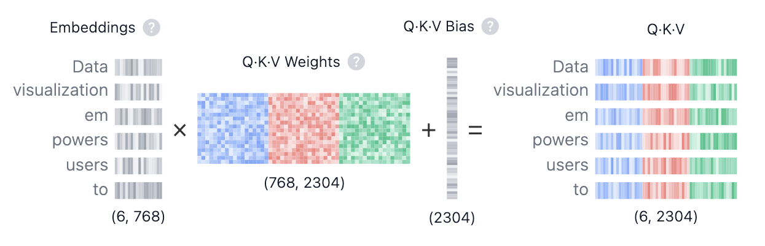
$$QKV_{ij}=(\sum_{d=1}^{768}{{\text{Embedding}}_{i,d}}⋅{\text{Weights}}_{d,j})+{\text{Bias}}_{j}$$
- Query (Q) is the search text you type in the search engine bar. This is the token you want to "find more information about".
- Key (K) is the title of each web page in the search result window. It represents the possible tokens the query can attend to.
- Value (V) is the actual content of web pages shown. Once we matched the appropriate search term (Query) with the relevant results (Key), we want to get the content (Value) of the most relevant pages.
By using these QKV values, the model can calculate attention scores.

Step 2: Multi-Head Splitting
Step 3: Masked Self-Attention
Dot Product
Scaling · Mask
Softmax · Dropout:
Step 4: Output and Concatenation
11. What is MLP (Multi-Layer Perceptron)?
MLP (Multi-Layer Perceptron) is a feed-forward neural network made up of multiple fully connected layers (input layer, one or more hidden layers, and an output layer) that learns complex, non-linear patterns in data.
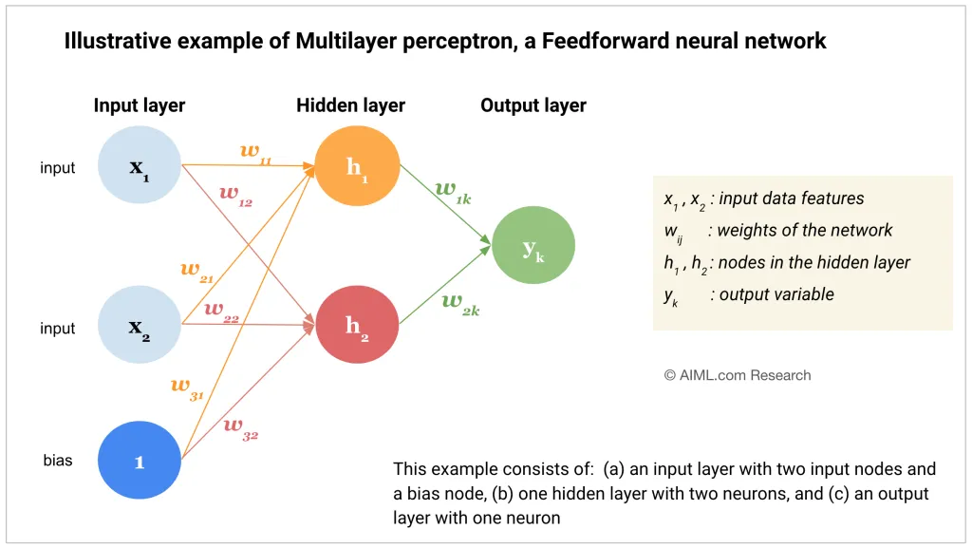
12. what is tempeature , sampling, top-K, top -p?
* Temperature controls how random or creative the model’s output is by adjusting the probability distribution.
- Low temperature (≈ 0–0.3) → more deterministic & safe
- High temperature (≈ 0.8–1.2) → more creative & random
- Sampling means the model randomly selects the next token based on output probabilities, instead of always choosing the highest-probability token.
Top-K limits the model to choose the next word only from the top K most probable tokens.
📌 Example:
If K = 5, the model selects from only the top 5 words.
- Small K → safer, less creative
- Large K → more diverse output
* Top-P selects the smallest set of words whose total probability ≥ P, and samples from them.
📌 Example:
If P = 0.9, choose tokens until their combined probability reaches 90%.

12.What are Output Probabilities?
Output probabilities are the likelihood values assigned to each possible output (such as the next word in a sentence), indicating how likely each option is
13.What is Layer Normalization?
Layer Normalization is a technique used in neural networks (especially transformers) to normalize the activations within a single layer for each data sample, which helps make training stable and faster.
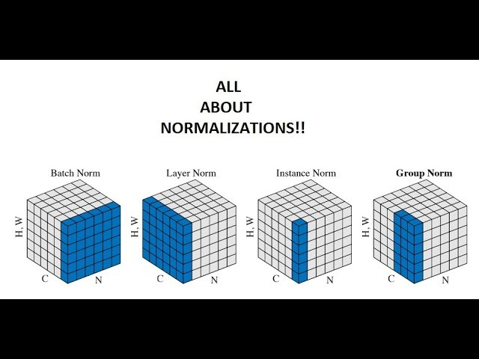
How transformer works
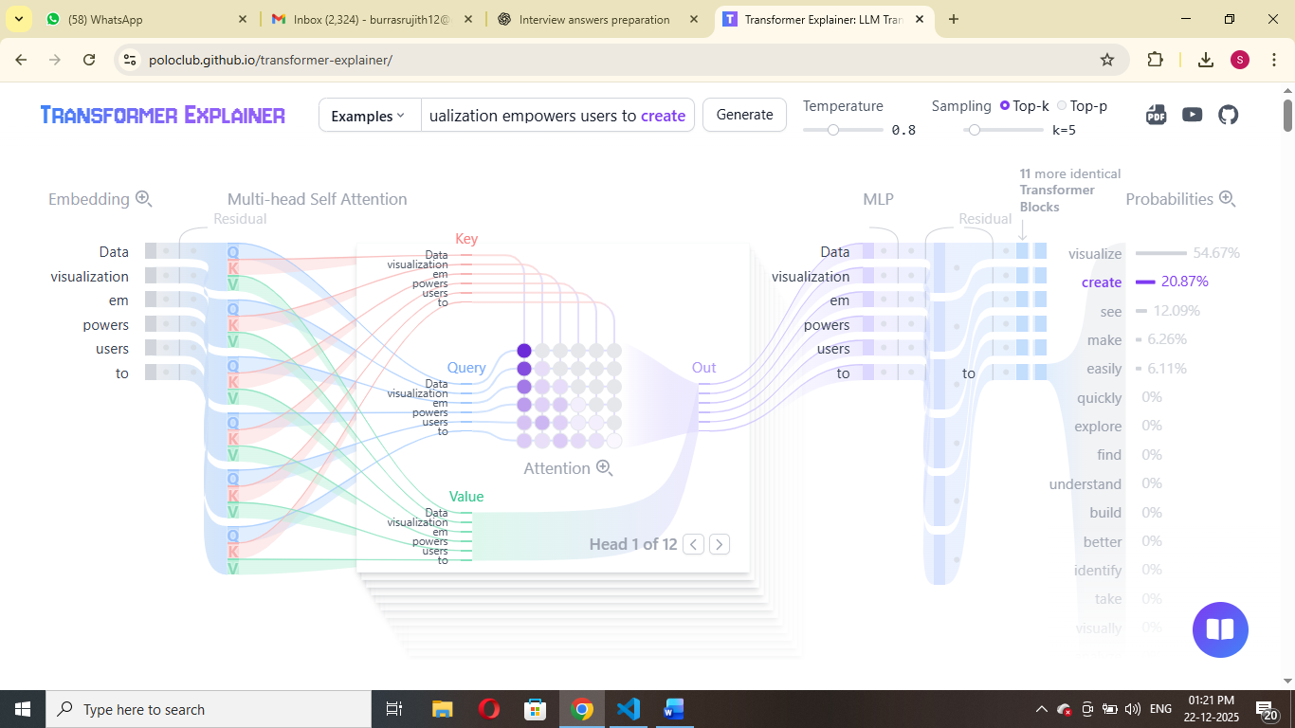

** LLMS does not give same responds everytime.

14.what are the types of response ?
There are two types of response
1.What is streaming response ?
A steam response sends the output incrementally in small chunks as it is generated, allowing, real time consumption.
2.what is completion response ?
A completion response means the system generates the entire output first and returns it in a single response only after processing in full completed.
15. How does streaming work in a real-time LLM API ?
In a real-time LLM API, when streaming is enabled, the model generates tokens one by one and sends each token immediately to the client through a persistent connection such as WebSockets or Server-Sent Events (SSE).
23.What is RAG?
RAG (Retrieval-Augmented Generation) is a technique where a language model first retrieves relevant information from external data sources and then uses that information to generate accurate and context-aware answers.
Very Short (1-Line Option)
RAG helps an AI model answer questions by searching relevant documents first and then generating the response.
This is useful if we want to ask question about specific documents (e.g., our PDFs, a set of videos, etc).
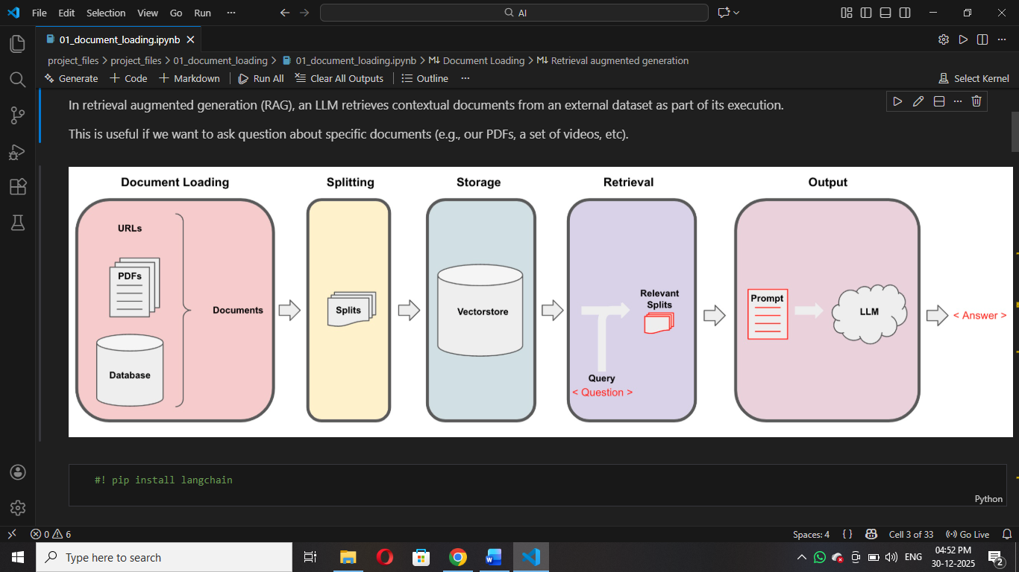
One-Line Summary (Interview Ready)
RAG works by loading documents, splitting them, storing embeddings in a vector database, retrieving relevant content for a query, and then generating an answer using an LLM.
24. What is a Vector Store?
A vector store is a system that stores text as numerical vectors (embeddings) and allows similarity search to find the most relevant information.
In simple words:
- Text → converted into numbers (vectors)
- These vectors are stored
- We search them using meaning, not keywords
25.What is a Vector Database?
A vector database is a specialized database designed to store, manage, and efficiently search large volumes of vector embeddings.
In simple words:
- It is a full-featured database
- Built for fast similarity search
- Handles millions of vectors
26.🔹 What are Embeddings?
Embeddings are numerical representations (vectors) of text that capture its meaning, so machines can understand and compare language mathematically.
Simple Explanation
- Text → converted into numbers
- These numbers represent the meaning of the text
- Similar meanings → vectors are closer together
📌 In short:
Embeddings = Meaning in number form

27. What is LangChain?
LangChain is a framework that helps developers build applications using large language models by connecting LLMs with external data, tools, and workflows.
In Very Simple Words:
LangChain makes it easy to connect an LLM to documents, databases, APIs, and tools instead of using the model alone.
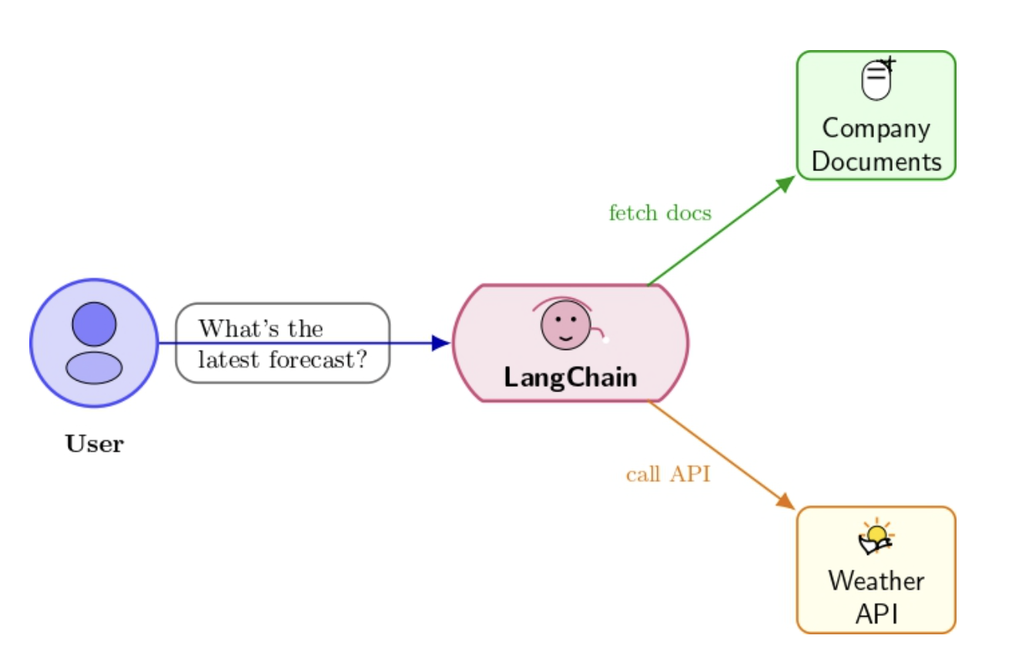

28. 🔹 What is Token Splitting?
Token splitting is the process of breaking text into smaller units called tokens, which are the basic pieces a language model understands.
29. 🔹 What is Context-Aware Splitting?
Context-aware splitting is a method of dividing text into chunks while preserving the meaning and relationships between sentences or sections, instead of cutting text blindly by size.
Instead of splitting text randomly by characters or tokens, context-aware splitting tries to:
- Keep related sentences together
- Avoid breaking ideas, paragraphs, or sections
- Preserve semantic meaning
👉 This is especially important for RAG systems
30. What is OpenAI API?
OpenAI API is used to access powerful AI models like GPT for tasks such as text generation, chatbots, summarization, and embeddings through REST APIs.
OpenAI API allows developers to use AI models (like GPT) through code.
It is used for:
- Chatbots
- Text generation
- Image generation
- Embeddings
- AI automation
31. 🔹 What is Hugging Face?
Hugging Face is an open-source AI platform that provides pre-trained models and tools, especially for NLP tasks like text classification, embeddings, and transformers.”
Hugging Face is a platform for open-source AI models
It provides:
- Pre-trained ML / NLP models
- Transformers library
- Datasets
- Model hosting
32. What are FAISS, ChromaDB, Pinecone?
All three are Vector Databases
👉 Used to store embeddings and search similar data
What is FAISS?
🔹 Meaning
- FAISS = Facebook AI Similarity Search
- Developed by Meta AI
- Used for fast similarity search on vectors
Key Points (Interview Ready)
- Open-source
- Runs locally
- Very fast
- No UI
- No persistence by default
- 🔹 Simple Interview Answer
- “FAISS is an open-source library by Meta AI used for efficient similarity search on high-dimensional vector embeddings.”
- 🔹 When to use
- Research
- Local experiments
- High-speed similarity search
What is Chroma (ChromaDB)?
🔹 Meaning
- Open-source vector database
- Designed specifically for LLM & RAG applications
🔹 Key Points
- Stores embeddings + metadata
- Easy integration with LangChain
- Persistent storage
- Runs locally
🔹 Simple Interview Answer
“ChromaDB is an open-source vector database commonly used in RAG pipelines to store embeddings and perform similarity search.”
When to use
- Local RAG projects
- Student projects
- Small to medium applications
What is Pinecone?
🔹 Meaning
- Fully managed cloud-based vector database
- Production-ready
🔹 Key Points
- No infrastructure management
- Scalable
- Fast
- Paid service
🔹 Simple Interview Answer
“Pinecone is a managed cloud vector database used in production systems for scalable and fast similarity search on embeddings.”
When to use
- Production apps
- Large-scale AI systems
- Enterprise use cases
One-line Interview Gold
“FAISS is best for fast local similarity search, ChromaDB is ideal for local RAG pipelines, and Pinecone is used for scalable production-ready vector search.”

