AI & ML Interview Questions
What are the most repeated question for Interview?
Top 30 ML Interview Questions (Most Asked)
- What is Machine Learning?
- Difference between AI, ML, and Deep Learning?
- What are the types of Machine Learning?
- What is supervised learning?
- What is unsupervised learning?
- What is regression?
- Difference between regression and classification?
- What is classification?
- What is overfitting?
- What is underfitting?
- What is bias–variance tradeoff?
- What is data preprocessing?
- How do you handle missing values?
- What are outliers and how do you handle them?
- What is feature engineering?
- What is feature scaling?
- Difference between normalization and standardization?
- What is train-test split?
- What is cross-validation?
- What is regularization?
- Difference between L1 and L2 regularization?
- What is a decision tree?
- What is Random Forest?
- What are ensemble methods?
- Difference between bagging and boosting?
- What is Gradient Boosting?
- What is XGBoost?
- What is dimensionality reduction?
- What is PCA?
- Explain your ML project end-to-end.

Machine Learning Pipeline (Step-by-Step Explained)
A Machine Learning (ML) pipeline is a structured sequence of steps used to build, train, evaluate, and deploy an ML model efficiently and reproducibly.
11 Steps of Machine Learning Pipeline
1️⃣ Problem Definition
2️⃣ Data Collection
3️⃣ Data Understanding (EDA)
4️⃣ Data Preprocessing
5️⃣ Feature Engineering
6️⃣ Feature Selection
7️⃣ Model Selection
8️⃣ Model Training
9️⃣ Model Evaluation
🔟 Model Deployment
1️⃣1️⃣ Monitoring & Maintenance
:

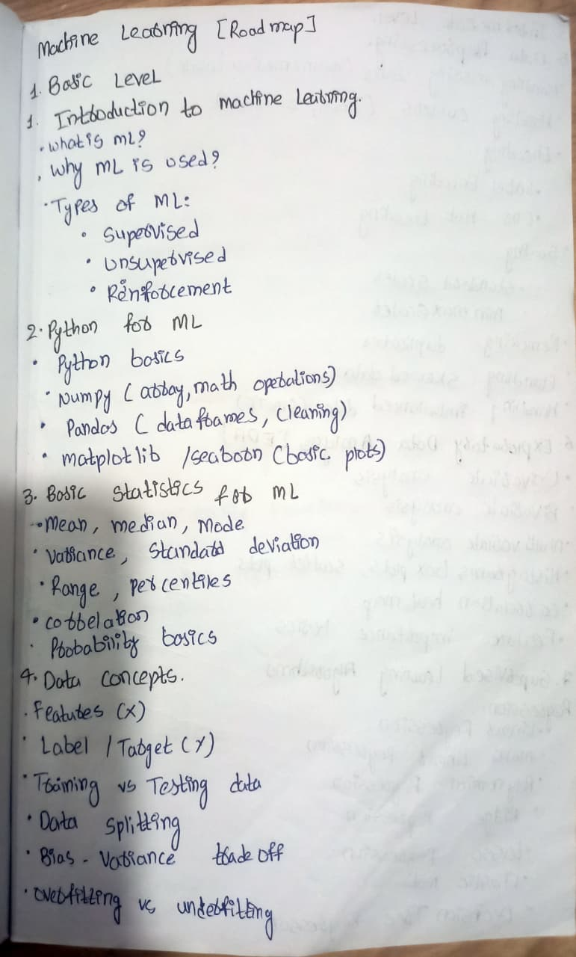
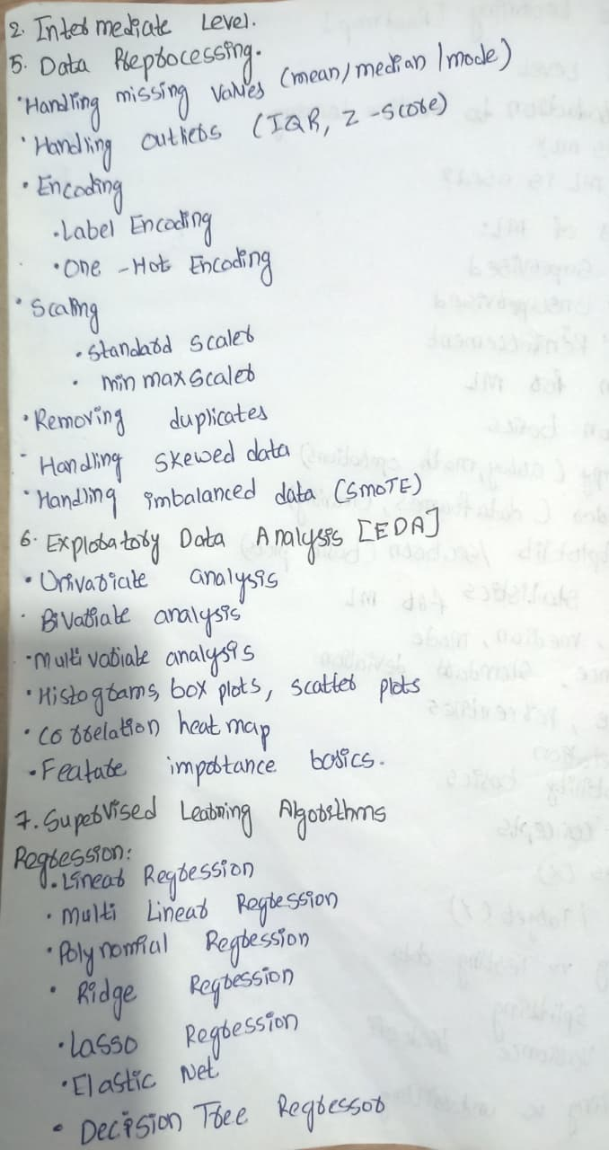
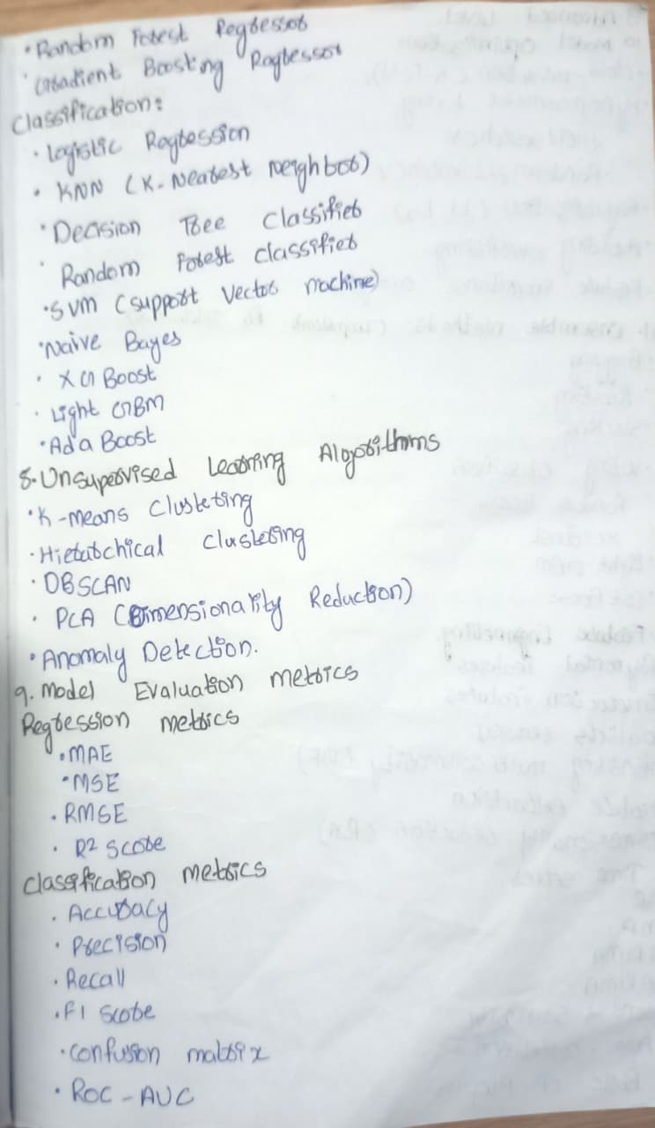
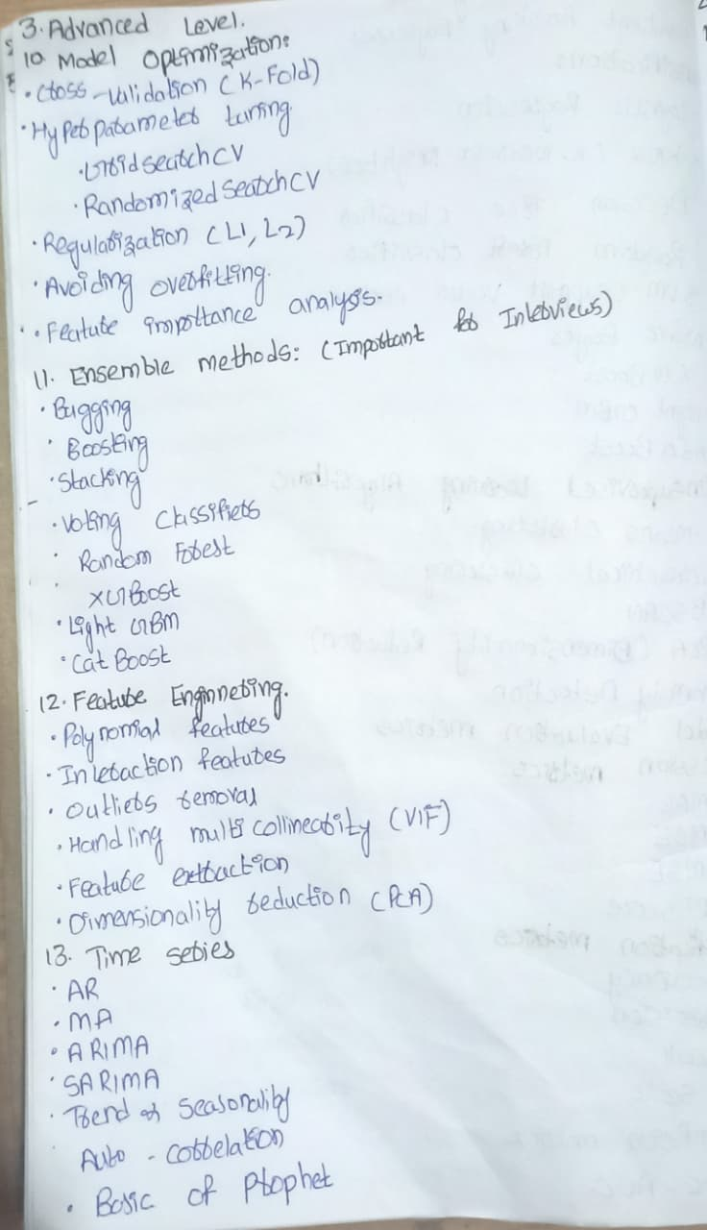
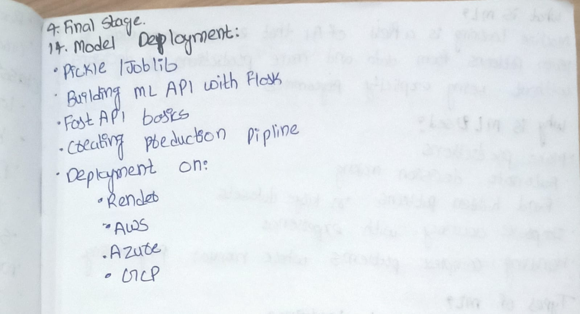
1.Who is the father of Artificial Intelligence?
A: John McCarthy — coined the term AI in 1956.
2. Who is the father of Machine Learning?
A: Arthur Samuel — introduced ML in 1959.
3. What is Artificial Intelligence (AI)?
Artificial Intelligence (AI) is a branch of computer science that enables machines to simulate human-like intelligence.
AI systems can think, learn, reason, make decisions, and solve problems similar to humans.
In simple words:
AI makes machines smart enough to perform tasks like humans.
. Applications: Chatbots, self-driving cars, facial recognition, recommendation systems, etc.
4.What is Machine Learning (ML)?
Machine Learning (ML) is a subset of AI that allows machines to learn from data without being explicitly programmed.
In simple words:
ML finds patterns in data and uses them to make predictions or decisions.
. Applications: Spam detection, fraud detection, churn prediction, recommendation systems, etc.
5.Why ML is Used?
Machine Learning is used to automatically learn patterns from data and make accurate predictions or decisions without being explicitly programmed.
Key Points: Why Machine Learning is Used?
- To find patterns in data
- To make accurate predictions
- To automate decision-making
- To handle large and complex datasets
- To improve performance over time (learns automatically)
- To reduce manual work and human errors
- To solve problems that rule-based programming cannot solve
- To support data-driven decisions
- To personalize user experience (recommendations)
- To detect anomalies like fraud or defects
6. What is an Algorithm?
An algorithm is a step-by-step procedure or set of instructions used to solve a problem or perform a task.
7.What is a pattern in Machine Learning?
A pattern is a relationship, trend, or structure in the data that the ML algorithm learns to make predictions.
8.What is a model in Machine Learning?
A model is the output of a machine learning algorithm after it has learned patterns from data. It is used to make predictions or decisions.
9.What are features in Machine Learning?
Features are the input variables used by a machine learning model to make predictions. They describe the properties of the data.
. Features (also called attributes, predictors, or independent variables) are the input variables used to make predictions.
10.What is a Label or Target Variable?
A label, or target variable, is the output that the model is trying to predict.
It is the dependent variable in supervised learning.
11.What are the types of Machine Learning ? Expain them?
There are three main types of Machine Learning:
- Supervised Learning
- Unsupervised Learning
- Reinforcement Learning
1️⃣ .Supervised Learning:
✔ The model learns from labeled data (input + correct output).
✔ Goal: Predict outcomes for new data.
✔ Algorithms learn the relationship between features and the target.
Examples:
- Predicting house prices
- Spam vs non-spam classification
- Loan default prediction
Algorithms: Linear Regression, Logistic Regression, Decision Trees, Random Forest, SVM.
2️⃣ Unsupervised Learning:
✔ The model learns from unlabeled data (only input).
✔ Goal: Find hidden patterns or groups.
✔ No correct output is provided.
Examples:
- Customer segmentation
- Market basket analysis
- Anomaly detection
Algorithms: K-Means, Hierarchical Clustering, PCA, Apriori.
3️⃣ Reinforcement Learning:
✔ The model learns by interacting with an environment.
✔ Makes decisions based on reward and penalty.
✔ Learns through trial and error.
Examples:
- Game-playing AI (Chess, Go)
- Self-driving cars
- Robotics
Algorithms: Q-Learning, Deep Q-Networks.
12. What is Regression? What are the types of Regression Algorithms in Supervised Learning?
Regression is a supervised learning technique used to predict continuous numerical values.
It identifies the relationship between input features (X) and a continuous target variable (Y).
Examples:
- Predicting house prices
- Predicting salary
- Predicting temperature
- Predicting sales
Below are the main types of regression used in Machine Learning:
1.Linear Regression
2.Multiple Linear Regression
3.Polynomial Regression
4.Ridge Regression
5.Lasso Regression
6.Elastic Net Regression
7.Decision Tree Regression
8. Random Forest Regression
9. Gradient Boosting Regression

1️⃣ Linear Regression:
- Predicts output using a straight-line relationship.
- Used when the relation between X and Y is linear.
Example: Predicting house prices.
2️⃣ Multiple Linear Regression:
- Extension of Linear Regression with multiple input features.
- Used when multiple factors affect the output.
Example: Price prediction based on size, location, rooms, age.
3️⃣ Polynomial Regression:
- Models non-linear relationships by adding polynomial terms.
- Adds polynomial terms (x², x³…)
Example: Growth curves, non-linear trends.
4️⃣ Ridge Regression:
- Regularization technique to avoid overfitting.
- Adds L2 penalty to the model.
5️⃣ Lasso Regression:
- Similar to Ridge but uses L1 penalty.
- Can reduce coefficients to zero (feature selection).
6️⃣ Elastic Net Regression:
- Combination of Ridge and Lasso penalties.
7. Decision Tree Regression:
- Uses tree-like structure to make decisions.
- Splits data into nodes and predicts values at leaf nodes.
Example: Predicting house price using decision rules.
Strength: Handles non-linear data very well.
8. Random Forest Regression:
- Combination of many decision trees (ensemble).
- Final prediction = average of multiple tree predictions.
Strength:
- Very accurate
- Reduces overfitting
9. Gradient Boosting Regression:
- Builds models sequentially.
- Each new tree corrects the errors of the previous tree.
- More powerful than random forest for many tasks.
Examples:
- XGBoost
- LightGBM
- CatBoost
11. What is Classification? What are the types of Classification Methods in Supervised Learning?
Classification is a supervised learning technique used to predict categories or classes.
The output is discrete, not continuous.
The model learns from labeled data and classifies new data into predefined groups.
Examples:
- Spam or Not Spam
- Loan Approved or Not Approved
- Disease: Positive or Negative
- Image: Cat or Dog
One-line answer:
👉 “Classification predicts categories based on labeled data.”
Types of Classification in Supervised Learning:
Below are the main types of classification Methods:
1️⃣ Binary Classification:
- Predicts two classes only.
- Output: Yes/No, True/False, 0/1.
Examples:
- Spam vs Not Spam
- Fraud vs Not Fraud
- Disease: Positive vs Negative
2️⃣ Multi-Class Classification:
- Predicts more than two classes.
- One input can belong to only one class.
Examples:
- Classifying fruits: Apple / Banana / Orange
- Handwritten digit recognition (0–9)
3️⃣ Multi-Label Classification:
- Each input can belong to multiple classes at the same time.
Examples:
- A single photo can contain: Cat + Dog + Person
- Movie can have: Action + Comedy + Drama
4️⃣ Imbalanced Classification:
- When one class has much more data than other classes.
- Common in fraud detection, medical diagnosis.
Example:
- 99% normal transactions, 1% fraud.
5️⃣ Ordinal Classification:
- Classes have a natural order or ranking.
Examples:
- Rating: Low / Medium / High
- Education level: Primary / Secondary / Graduate
12.What are Classification Algorithms? Where it is used ? in supervised learning?
Classification algorithms are supervised learning techniques used to predict categories or classes.
They learn from labeled data and classify new data into predefined groups such as Yes/No, Spam/Not Spam, Fraud/Not Fraud, Disease/No Disease, etc.

Algorithms used under the Classification Method:
1. Logistic Regression
2.KNN (K-Nearest Neighbors)
3.Decision Tree Classifier
4.Random Forest Classifier
5.SVM (Support Vector Machine)
6.Naive Bayes
7.XGBoost Classifier
8.LightGBM Classifier
9.AdaBoost Classifier
10.CatBoost Classifier

1. Logistic Regression:
What is it?
A simple and powerful classification algorithm that predicts probabilities using the logistic function.
Where is it used?
- Spam detection
- Fraud detection
- Loan approval
- Disease prediction
🔹 2. KNN (K-Nearest Neighbors):
What is it?
A distance-based classifier that predicts the class based on the closest neighbors.
Where is it used?
- Recommendation systems
- Pattern recognition
- Image classification
🔹 3. Decision Tree Classifier:
What is it?
A tree-like structure where decisions are made based on conditions.
Where is it used?
- Loan decision systems
- Customer segmentation
- Medical diagnosis
🔹 4. Random Forest Classifier:
What is it?
An ensemble of multiple decision trees.
Final prediction = majority vote.
Where is it used?
- Fraud detection
- Risk assessment
- Feature importance ranking
- Any classification with high accuracy needs
🔹 5. SVM (Support Vector Machine):
What is it?
A powerful classifier that finds the best boundary (hyperplane) between classes.
Where is it used?
- Face recognition
- Text classification
- Image classification
- Bioinformatics
🔹 6. Naive Bayes:
What is it?
A probabilistic classifier based on Bayes’ theorem.
Assumes independence between features.
Where is it used?
- Email spam detection
- Sentiment analysis
- Document/text classification
🔹 7. XGBoost (Extreme Gradient Boosting):
What is it?
A very powerful boosting algorithm used for structured/tabular data.
Fast and highly accurate.
Where is it used?
- Kaggle competitions
- Fraud detection
- Churn prediction
- Credit scoring
🔹 8. LightGBM:
What is it?
A faster, optimized version of gradient boosting created by Microsoft.
Best for large datasets.
Where is it used?
- Large-scale prediction tasks
- Ranking in search engines
- Real-time predictions
🔹 9. AdaBoost (Adaptive Boosting):
What is it?
Boosting algorithm that combines multiple weak learners to create one strong learner.
Where is it used?
- Face detection
- Classification with noisy data
- High-bias problems
🔹10. CatBoost (Categorical Boosting):
What is it?
CatBoost is a supervised gradient boosting algorithm designed to handle categorical features automatically.
It reduces preprocessing steps, prevents overfitting, and works well even with small datasets.
Where is it used?
• Datasets with many categorical features
• Customer churn prediction
• Credit risk scoring
• Fraud detection
• Recommendation systems
• Any classification task needing high accuracy with minimal preprocessing
13. “What is the Machine Learning workflow?”
🔹 “Explain the end-to-end ML pipeline.”
🔹 “What steps do you follow in an ML project?”
🔹 “What is your approach when building an ML model?
✅ 1. Problem Understanding
“First, I clearly understand the business problem and define what needs to be predicted (target variable).”
✅ 2. Data Collection
“I gather data from available sources like CSVs, databases, APIs, or web scraping.”
✅ 3. Data Cleaning
“I handle missing values, remove duplicates, fix inconsistent formats, and correct outliers.”
✅ 4. Exploratory Data Analysis (EDA)
“I analyze distributions, correlations, patterns, and visualize relationships to understand the data deeply.”
✅ 5. Feature Engineering & Preprocessing
“I create new features, scale numerical data, encode categorical data, and select the most important features.”
✅ 6. Model Selection & Training
“I choose suitable algorithms (like Linear Regression, Random Forest, SVM) and train models on the training data.”
✅ 7. Model Evaluation
“I evaluate using metrics like accuracy, F1-score, RMSE, R², precision, recall, and confusion matrix.”
✅ 8. Model Deployment & Monitoring
“I finally deploy the model using tools like Flask, FastAPI, or cloud platforms and monitor performance.”
⭐ One-line SUPER Answer (when time is short)
The ML flow includes: problem understanding → data collection → data cleaning → EDA → feature engineering → model training → evaluation → deployment.
14.Explain end-to-end ML with an example project you built.? Explain the Machine Learning workflow.?
1️⃣ Problem Definition
Understand the business problem and what exactly needs to be predicted.
2️⃣ Define Target & Features
Identify the target variable and understand what features describe the data.
3️⃣ Data Collection
Gather data from databases, CSVs, APIs, or other sources.
4️⃣ Data Cleaning
Handle missing values, remove duplicates, fix wrong formats, and treat outliers.
5️⃣ Data Transformation
Convert raw data into usable form (scaling, encoding, normalization).
6️⃣ Exploratory Data Analysis (EDA)
Analyze patterns, check correlations, visualize distributions, and understand feature importance.
7️⃣ Feature Engineering
Create new features, select important ones, and reduce dimensionality if needed.
8️⃣ Train-Test Split
Split data into training and testing sets to evaluate performance properly.
9️⃣ Model Selection & Training
Choose suitable algorithms (LR, Decision Tree, Random Forest, SVM, etc.) and train them.
🔟 Model Evaluation
Evaluate using metrics such as accuracy, F1-score, precision, recall, RMSE, R², and confusion matrix.
1️⃣1️⃣ Model Deployment & Monitoring
Deploy using Flask, FastAPI, or cloud services and monitor performance over time.
⭐ One-Line Summary (Use for HR or quick answer)
“ML flow includes: problem → target/features → data collection → cleaning → transformation → EDA → feature engineering → train-test split → model training → evaluation → deployment.”
15. What is a Training Set?
“The training set is the portion of the data used to teach the model.
The model learns patterns, relationships, and parameters from this data so that it can make predictions.”
Key points to add if needed:
- Largest part of the dataset
- Used during the learning phase
- No evaluation happens here
16. What is a Validation Set?
“The validation set is used to tune hyperparameters, evaluate different model versions, and prevent overfitting.
It helps us decide which model configuration performs best before we test it.
Key points:
- Used for model selection
- Helps adjust learning rate, depth, C, gamma, etc.
- Not used for training
17. What is a Test Set?
The test set is a completely unseen dataset used to evaluate the final performance of the trained model.
It tells how well the model will generalize on real-world data.
Key points:
- Used only once after training + validation
- Final accuracy/metrics are calculated here
- Must not be used during model building
Short:
- Training set: Used to train the model.
- Validation set: Used to tune hyperparameters and choose the best model.
- Test set: Used to evaluate the final performance on unseen data.
18.what is Bias , what is Variance , what is bais-varinace Tradeoff?
Bias is the error due to wrong assumptions in the model.
High bias → model is too simple, underfits, and cannot learn patterns well.
Variance is the error due to the model being too sensitive to training data.
High variance → model is too complex, overfits, and performs poorly on new data.
The Bias–Variance Tradeoff means we must find a balance between the two so the model neither underfits nor overfits.
19.What is overfitting?
Overfitting happens when a model learns the training data too well, including noise and unnecessary patterns.
Because of this, training accuracy is high but test accuracy is poor.
The model fails to generalize to new data.”
Examples to say:
- Deep decision tree overfits
- kNN with k=1 overfits
20.What is underfitting?
Underfitting happens when a model is too simple and cannot learn the underlying patterns in the data.
Both training and test accuracy are low.
Examples to say:
- Using Linear Regression on non-linear data
- Very shallow decision tree
21.What is data preprocessing ?
Data preprocessing is the process of cleaning, transforming, and preparing raw data so that a machine learning model can understand it.
It involves steps like handling missing values, removing noise, encoding categorical data, scaling features, and splitting data.
22. What are Missing Values? What are the Types of Missing Values?
Missing values are data points that are not recorded or unavailable in a dataset.
Models cannot learn properly if missing values are not handled, so we clean or impute them during preprocessing.
1. MCAR — Missing Completely At Random
- The missingness is not related to any feature or the target.
- Example: A passenger accidentally skipped entering Age.
- Safest case — deletion/imputation introduces minimal bias.
2. MAR — Missing At Random
- Missingness depends on observed data, not the missing values themselves.
- Example: Older passengers may be more likely to omit Age.
- Handled with more thoughtful imputation (e.g., grouped median).
3. MNAR — Missing Not At Random
- Missingness depends on the value that is missing (unobserved data).
- Example: Higher ticket fares intentionally withheld; people hide their income.
- Most difficult to handle — often requires domain knowledge.
23. What is Imputation?
Imputation is the process of filling or replacing missing values in a dataset so that the model can learn properly.
It prevents data loss and helps maintain consistency.

Types of Imputation Techniques :
Method : Mean / Median / Mode Imputation
Mean, Median, and Mode Imputation are some of the most widely used methods to handle missing values.
Instead of removing data (as in deletion), we fill missing values with a central tendency measure.
These methods are simple, fast, and effective when used correctly.

Why Use Mean/Median/Mode Imputation?
- Prevents loss of valuable data
- Preserves dataset size
- Easy to implement
- Works well when missingness is small or moderate
- Helps maintain overall distribution shape (when chosen correctly)

When to Use Each Method
🎯 1. Mean Imputation
Use only when:
- Data is numerical
- Data is normally distributed
- Outliers are minimal or controlled
Drawback: Sensitive to outliers
Example: A single very high Fare value can distort the mean.

🎯 2. Median Imputation (Recommended for Titanic Age)
Use when:
- Data is numerical
- Distribution is skewed
- Outliers are present
Why?
The median is robust and not affected by extreme values.
Since Age in the Titanic dataset is skewed, median is the best choice.

🎯 3. Mode Imputation
Use when:
- Data is categorical
- You want to fill missing class labels
Example: Filling missing Embarked values with the most common port (“S”).

4️⃣ Constant Imputation
Fill with a fixed value (0, “Unknown”).
Used when missing values have meaning.

Advanced Imputation Techniques
5️⃣ KNN Imputation
Uses nearest neighbors to fill missing values.
More accurate but computationally heavy.
6️⃣ Regression Imputation
Predict missing values using a regression model with other features.
7️⃣ Multiple Imputation (MICE)
Generates several possible values and averages them.
Used when data is missing in complex patterns.
8️⃣ Interpolation
Used in time series (linear, spline, polynomial).
24. What is an Outlier ? How do you detect outliers? How to Handle Outliers ?
Outliers are data points that are unusually high or low compared to the rest. Outliers are extreme values in a dataset.
Outliers can be detected using statistical methods like the IQR method or Z-score, or visually using boxplots and scatter plots. Advanced techniques like Isolation Forest and LOF can also be used for complex datasets.”
1. IQR Method (Interquartile Range)
Most commonly expected answer.
Steps:
- Calculate Q1 (25th percentile) and Q3 (75th percentile)
- IQR = Q3 – Q1
- Lower bound = Q1 – 1.5 × IQR
- Upper bound = Q3 + 1.5 × IQR
Any value outside these bounds is an outlier.

✔ 2. Z-Score Method
Used for normally distributed data.
- Z = (value – mean) / standard deviation
- If |Z| > 3 → outlier

✔ 3. Boxplot Visualization
Outliers appear as points outside the whiskers of a boxplot.

✔ 4. Scatter Plot / Histogram
Visually show extreme values.

✔ 5. Advanced Methods (Say these to impress)
- Isolation Forest
- DBSCAN Clustering
- Local Outlier Factor (LOF)

We handle outliers by removing them, capping them using Winsorization, or transforming the data using log or square-root methods. If they hold important information, we keep them but use robust models like Random Forest.”
1. Remove Outliers
If they are clearly errors or impossible values.
✔ 2. Cap or Floor (Winsorization)
Replace extreme values with upper/lower limits.
Example:
Values > 95th percentile → set to 95th percentile.
✔ 3. Transform the Data
Reduce the impact of outliers using:
- Log transform
- Square root
- Box-Cox transform
✔ 4. Impute Outliers
Replace with mean/median (for small number of outliers).
✔ 5. Use Robust Models
Models less sensitive to outliers:
- Random Forest
- Tree-based models
- Median-based models
25. What is Feature Scaling?
Feature scaling is the process of transforming numerical features so they all have a similar range.
It helps machine learning algorithms work better and faster, especially those based on distance or gradient descent.”
. Different features may have different ranges (e.g., age 1–100, salary 10k–10L)
Most Important Feature Scaling Techniques (Interview-Focused)
Normalization scales values between 0 and 1 using Min–Max scaling, and is useful for algorithms that depend on distance.
Standardization converts values to mean 0 and standard deviation 1 using Z-score, and is preferred when data follows or is assumed to follow a normal distribution.
Normalization is range-based, while standardization is distribution-based.
1️⃣ Normalization (Min–Max Scaling)
Formula:
$$x^{'}=\frac{x-min⁡(x)}{max⁡(x)-min⁡(x)}$$
Range becomes 0 to 1.
Use when the distribution is not normal or bounded is needed.
Used in: Neural Networks, KNN, K-Means.

2️⃣ Standardization (Z-score Scaling)
Formula:
$$x^{'}=\frac{x-μ}{σ}$$
Result has mean = 0 and standard deviation = 1.
Use when the distribution is normal or unknown.
Used in: Logistic Regression, SVM, Linear Regression.

3️⃣ Robust Scaler
Uses median and IQR, not mean → good for outliers.
Formula:
$$x^{'}=\frac{x-\text{median}}{IQR}$$
4. Interpretation
- (z=0) → exactly at the mean
- (z>0) → above the mean
- (z<0) → below the mean
- (|z|) = distance in standard deviations
- Ages 10 and 18 are (1.41\sigma) from the mean (lowest/highest)
5. Log Transformation
When to Use:
- Right-skewed (positively skewed) distributions
- Data spans several orders of magnitude
- To reduce impact of outliers
Applies logarithmic transformation to reduce skewness.
26. What is Encoding? What are the types of encoding techniques?”
Encoding is the process of converting categorical data into numerical values so machine learning models can understand and process them.
BASIC ENCODING TECHNIQUES
1. Label Encoding : Label Encoding assigns each category an integer and is useful for ordered data.
- Converts categories into integer values (A → 0, B → 1...)
- Best for ordinal data (order matters).
- Issue: Adds fake order for nominal data.

2. One-Hot Encoding: One-Hot Encoding creates separate binary columns for each category and is used when categories have no order.
- Creates separate binary columns for each category.
- Best for nominal data (no order).
- Drawback: High dimensionality.

3. Ordinal Encoding
- Assigns numbers based on defined order.
- Example: Small=1, Medium=2, Large=3.
Used when categories have natural hierarchy.

🔷 B) ADVANCED ENCODING TECHNIQUES
4. Target Encoding
Definition: Replaces category with mean of target variable for that category
When to Use:
- High cardinality variables
- Strong relationship between category and target
- Tree-based models and competitions
Warning: High risk of overfitting. Use with cross-validation!
Pros: Reduces dimensionality, captures target relationship
Cons: Risk of overfitting, requires careful CV

- Frequency Encoding
Definition: Replaces category with its frequency count or percentage
When to Use:
- When frequency itself is informative
- High cardinality variables
Pros: Simple, reduces dimensionality
Cons: Multiple categories may have same frequency
- Replace each category with how many times it appears.
Example: Category A appears 50 times → encode as 50.

6. Count Encoding
- Similar to frequency, but stores count instead of proportion.

7. Binary Encoding
- Converts categories into binary digits.
- Useful when many categories exist (reduces dimensionality).

8. Hash Encoding (Hashing Trick)
- Uses a hash function to map categories to a fixed number of columns.
- Used in large data / NLP.

9. Target-Guided Ordinal Encoding
- Orders categories based on target mean before encoding.
Advanced techniques include Target Encoding, Frequency/Count Encoding, Binary Encoding, and Hash Encoding.
The choice depends on whether the data is ordinal, nominal, or high-cardinality.”
27. What is feature engineering?
Definition: Creating new features from existing ones to improve model performance
Why Engineer Features?
- Expose hidden patterns
- Capture domain knowledge
- Improve model performance
- Reduce complexity
28. What are Model Evaluation Metrics?
Model evaluation metrics are measurements used to assess how well a machine learning model performs on unseen data.
important Regression Evaluation Metrics
1️⃣ Mean Absolute Error (MAE)
Measures the average absolute difference between actual and predicted values.
$$MAE=\frac{1}{n}\sum_{i=1}^{n}{∣}y_{i}-{\hat{y}}_{i}∣$$

⭐ 2️⃣ Mean Squared Error (MSE)
Penalizes larger errors more heavily.
$$MSE=\frac{1}{n}\sum_{i=1}^{n}{(}y_{i}-{\hat{y}}_{i})^{2}$$

⭐ 3️⃣ Root Mean Squared Error (RMSE)
Square root of MSE — same unit as target variable.
$$RMSE=\sqrt{\frac{1}{n}\sum_{i=1}^{n}{(}y_{i}-{\hat{y}}_{i})^{2}}$$

⭐ 4️⃣ R² Score (Coefficient of Determination)
Shows how much variance the model explains.
$$R^{2}=1-\frac{\sum_{i=1}^{n}{(}y_{i}-{\hat{y}}_{i})^{2}}{\sum_{i=1}^{n}{(}y_{i}-\overset{ˉ}{y})^{2}}$$
Where:
- $y_{i}$= actual values
- ${\hat{y}}_{i}$= predicted values
- $\overset{ˉ}{y}$= mean of actual values

⭐ 5️⃣ Adjusted R² Score
Used when multiple features are present.
$$Adjusted R^{2}=1-\left(\frac{1-R^{2}}{n-p-1}\right)(n-1)$$
Where:
- $n$= number of observations
- $p$= number of predictors

⭐ 6️⃣ Mean Absolute Percentage Error (MAPE)
Measures percentage error.
$$MAPE=\frac{100}{n}\sum_{i=1}^{n}{∣\frac{y_{i}-{\hat{y}}_{i}}{y_{i}}∣}$$Metrics for Classification Problems
In machine learning, classification metrics quantify how well a model assigns the correct label (e.g., spam vs. not spam).
1. Confusion Matrix (Foundation of All Metrics)
A confusion matrix compares predicted values vs actual values.
 | Predicted Negative | Predicted Positive
Actual Negative | TN (correctly predicted negative) | FP (wrongly predicted positive)
Actual Positive | FN (wrongly predicted negative) | TP (correctly predicted positive)
Meaning of Each Term
- TP (True Positive): Model predicts positive and it is actually positive
- TN (True Negative): Model predicts negative and it is actually negative
- FP (False Positive): Model predicts positive but it is actually negative
- FN (False Negative): Model predicts negative but it is actually positive

2. Core Metrics (Accuracy, Precision, Recall, F1)
Example confusion matrix:
- TP = 40
- FP = 10
- FN = 20
- TN = 30
- Total = 100

1. Accuracy
Formula
Accuracy = (TP + TN) / (TP + TN + FP + FN)
Explanation
- Measures the overall correctness of the model.
- Works well when classes are balanced.
Example
Accuracy = (40 + 30) / 100 = 0.70
Limitation
Can be misleading for imbalanced data (e.g., fraud detection with 1% fraud → even a dumb model can get 99% accuracy).

2. Precision
Formula
Precision = TP / (TP + FP)
Explanation
- Out of all predicted positives, how many were correct.
- Helps reduce false positives.
Example
Precision = 40 / (40 + 10) = 0.80
When Important
- When predicting positive wrongly is expensive:
  - Spam detection
  - Hiring models
  - Quality inspection
Intuition: “When you say something is positive, be sure.”

3. Recall (Sensitivity)
Formula
Recall = TP / (TP + FN)
Explanation
- Out of all actual positives, how many were caught correctly.
- Helps reduce false negatives.
Example
Recall = 40 / (40 + 20) = 0.6667
When Important
- When missing a positive is dangerous:
  - Cancer detection
  - Fraud detection
  - Alarm systems
Intuition: “Don’t miss positives.”

4. F1-Score
Formula
F1 = 2 × (Precision × Recall) / (Precision + Recall)
Explanation
- Combines Precision and Recall into one score.
- Uses harmonic mean, which penalizes imbalance.
- Very useful for imbalanced datasets.
Example
F1 = 2 × (0.80 × 0.6667) / (0.80 + 0.6667) F1 ≈ 0.727
Why Harmonic Mean?
- If Precision is high but Recall is low → F1 stays low.
- Forces a balanced performance.

Summary Table
Metric | Measures | Best For | Weak When
Accuracy | How often the model is correct | Balanced classes | Imbalanced data
Precision | How many predicted positives are correct | FP is costly | FN is costly
Recall | How many actual positives are found | FN is costly | FP is costly
F1-Score | Balance of Precision & Recall | Imbalanced classes | When individual metrics are needed

Real-World Examples
Spam Detection
- Focus: Precision
- Avoid marking a real email as spam (false positive).
Cancer Detection
- Focus: Recall
- Must catch all actual positive cases; missing one is dangerous.
Fraud Detection
- Focus: F1-Score
- Need to balance catching fraud and not annoying customers with false alarms.

5. Confusion Matrix
Shows TP, TN, FP, FN.
Helps understand model errors.

6. ROC–AUC Score
Measures the ability of the model to distinguish between classes.
Higher AUC = better performance.

7. Log Loss
Measures probability errors in classification models.
28. What Is Imbalanced Data?
Imbalanced data means one class has many more samples than the other.
Because of this, the model becomes biased and performs poorly on the minority class.”
Example:
- Fraud (1%) vs Not Fraud (99%)
- Disease detection (5%) vs Healthy (95%)
Resampling Techniques (imblearn)
We will use the imbalanced-learn library.
1. Random Oversampling
Simply duplicates examples from the minority class.
- Pros: Simple.
- Cons: Can lead to overfitting (model memorizes duplicates).
2. Random Undersampling
Removes examples from the majority class.
- Pros: Faster training.
- Cons: Loss of information.
3. SMOTE (Synthetic Minority Over-sampling Technique)
Creates new synthetic examples by interpolating between existing minority samples.
- Select a minority sample A.
- Find its k-nearest neighbors.
- Select a neighbor B.
- Create a point on the line connecting A and B.
4. ADASYN (Adaptive Synthetic)
Similar to SMOTE, but focuses on generating samples next to the decision boundary (hard-to-learn examples).
5. Class Weights (No Resampling)
Instead of changing the data, we change the Cost Function. We assign a higher penalty for misclassifying the minority class.
In sklearn: class_weight='balanced'
29. What is a Decision Tree ?
A Decision Tree is a supervised machine learning algorithm used for classification and regression problems.
It works by splitting the data into branches based on feature conditions, starting from a root node, and ending at leaf nodes that give the final prediction.
The model makes decisions in a tree-like structure, similar to how humans make decisions using if–else rules.
In a Decision Tree, Gini Index, Entropy, and Information Gain are metrics used to decide the best feature to split the data at each node.
They measure how pure or impure a dataset is after a split.
Impurity Measures
To decide the best split at each node, Decision Trees use impurity measures.

1. Gini Impurity (Default in sklearn)
Gini Index measures how mixed or impure the classes are in a node.
A lower Gini value means the node is more pure, so it is a better split.
$$\text{Gini}=1-\sum_{i=1}^{C}{p_{i}^{2}}$$
Where:
- $p_{i}$= probability of class $i$in the node
- $C$= number of classes
Key Points:
- Gini = 0 → Perfectly pure (all samples belong to one class)
- Gini = 0.5 → Maximum impurity (for binary classification)
- Lower Gini value indicates a better split
- Used by the CART algorithm

2. Entropy (Information Theory)
Entropy measures the amount of uncertainty or randomness in the data.
Lower entropy means the data is more organized and pure.
$\text{Entropy}=-\sum_{i=1}^{C}{p_{i}}{log⁡}_{2}(p_{i})$
Key Points:
- Entropy = 0 → Perfectly pure node
- Entropy = 1 → Maximum impurity (for binary classification)
- Higher entropy means more uncertainty
- Used in ID3 and C4.5 algorithms

Information Gain
Information Gain measures how much uncertainty is reduced after splitting the data using a feature.
The feature with highest Information Gain is chosen for the split.$$\text{I}\text{nformation Gain}=\text{Impurity(Parent)}-∑\left(\frac{N_{\text{child}}}{N_{\text{parent}}} × \text{Impurity(Child)}\right)$$Where:
- $N_{\text{child}}$= number of samples in the child node
- $N_{\text{parent}}$= number of samples in the parent node
Key Points:
- Higher Information Gain → better feature
- Decision Tree selects the split with maximum Information Gain
- Based on Entropy

30. Why Overfitting Happens in Trees ?
Decision Trees keep splitting until all data is classified, so deep trees easily overfit.
31.What is Pruning?
Pruning reduces unnecessary branches so the model becomes simpler and generalizes better.
32. Hyperparameters Used to Control Overfitting?
✅ max_depth
Limits how deep the tree can grow.
Smaller depth → less overfitting.
✅ min_samples_split
Minimum number of samples required to split a node.
Higher value → fewer splits → better generalization.
✅ min_samples_leaf
Minimum number of samples allowed in a leaf node.
Prevents very small, noisy leaf nodes.
33.What are Ensemble Methods?
Ensemble Methods are machine learning techniques that combine multiple models to make a stronger and more accurate prediction than any single model.
The idea is that many weak learners together perform better than one model.
Types of Ensemble Methods (Very Important)
✅ Bagging (Bootstrap Aggregating)
Trains models on different random samples and averages the results.
Example: Random Forest
✅ Boosting
Trains models sequentially, focusing more where each new model fixes the errors of the previous one.
Examples: AdaBoost, Gradient Boosting, XGBoost
✅ Stacking
Combines predictions from multiple models using a meta-model.
34. what is the Step-by-Step Mechanics(working ) Bagging (Bootstrap Aggregating)?
Step 1: Bootstrap Sampling
- Create multiple datasets by sampling with replacement
- Some data points repeat, some are missing
- Missing data becomes Out-Of-Bag (OOB) data
🔹 Step 2: Parallel Training
- Train a separate Decision Tree on each bootstrap sample
- These trees are usually grown deep (unpruned). Individual deep trees overfit (high variance), but that's okay!
🔹 Step 3: Aggregation
- Classification → Majority Voting (The class predicted by the most trees wins).
- Regression → Average of predictions (The mean of all tree predictions).
35. What is Random Forest?
Random Forest is an ensemble learning algorithm that builds multiple Decision Trees using bagging and feature randomness, and then combines their predictions to produce a more accurate and stable model.
Explain Step by Step (If Interviewer Asks More)
🔹 Step 1: Random Forest is Based on Bagging
Random Forest IS a Bagging algorithm, but with one crucial upgrade to solve the Correlation Problem.

🔹 Step 2: The Problem with Normal Bagging (Correlation)
In standard bagging, if one feature is very strong, all trees choose the same feature, so trees become similar and error reduction is limited.

🔹 Step 3: The Key Upgrade – Feature Randomness
Random Forest solves this by selecting a random subset of features at every split.
This makes trees different (decorrelated) and improves performance.

🔹 Step 4: Final Prediction
- Classification → Majority Voting
- Regression → Average of predictions
36. What is Boosting?
Boosting is an ensemble technique that builds models sequentially, where each new model focuses on correcting the errors made by previous models, turning weak learners into a strong learner.
37. What is AdaBoost? Why is it called Adaptive Boosting?
AdaBoost (Adaptive Boosting) is a boosting algorithm that builds models sequentially and increases the importance of misclassified data points, so that each new model focuses more on the previous mistakes.
The "Grandfather" of boosting
- Mechanism: Updates weights
- Process: Increases the weight of misclassified data points. The next tree is forced to focus on these “heavy” points
- Base Model: Decision stumps (trees with depth = 1)
- Best For: Simple classification tasks
38. Why do we use Gradient Boosting?
Gradient Boosting Machine (GBM) is a boosting algorithm that builds models sequentially, where each new model is trained to predict the errors (residuals) of the previous model and minimize a chosen loss function.
- Mechanism: Fits residuals (errors)
- Process: Does not touch weights. If Tree 1 predicts 80 and the target is 100, Tree 2 tries to predict the error (+20)
- Loss Function: Can optimize any differentiable loss function (MSE, Log Loss, etc.)
- Downside: Slow because it cannot be easily parallelized due to its sequential nature
39. What is XGBoost?
XGBoost (Extreme Gradient Boosting) is an optimized and regularized version of Gradient Boosting that provides high performance, better accuracy, and faster training, making it an industry standard and widely used in Kaggle competitions.
- Mechanism: Optimized GBM with Regularization.
- Key Upgrades over GBM:
  - Regularization: Adds L1/L2 penalties to the trees to prevent overfitting.
  - Speed: Uses hardware optimization and block structure for faster tree building.
  - Missing Values: Automatically learns the best direction for missing data.
  - Tree Pruning: Uses "max_depth" but grows trees backwards (pruning) for better structure.
40. What is LightGBM?
LightGBM (Light Gradient Boosting Machine) is a fast and efficient gradient boosting algorithm developed by Microsoft. It uses leaf-wise tree growth and histogram-based binning, making it highly suitable for large datasets.
Mechanism: Leaf-wise tree growth (vs Level-wise).
  - Level-wise (XGBoost/GBM): Grows the tree level by level. Balanced but slower.
  - Leaf-wise (LightGBM): Splits the single leaf that reduces loss the most. This creates deeper, unbalanced trees but is much faster and often more accurate.
- Best For: Massive datasets (100k+ rows). It uses histogram-based binning to speed up calculation.
41.What is CatBoost?
CatBoost (Categorical Boosting) is a gradient boosting algorithm developed by Yandex that is specially designed to handle categorical features efficiently. It uses ordered boosting and symmetric trees to reduce overfitting and provide fast predictions.
- Mechanism: Ordered Boosting & Symmetric Trees.
- Key Upgrades:
  - Categorical Features: You don't need One-Hot Encoding. You just tell it "Column A is categorical," and it handles it mathematically perfectly.
  - Symmetric Trees: It builds balanced trees, which makes prediction extremely fast.
- Best For: Datasets with many category columns (High Cardinality) and mixed data types.

✅ When to Use Which Algorithm? (Cheat Sheet)
✅ Option 1: Table Format (Clean & Interview-Ready)
Algorithm | Key Feature | Best Use Case
AdaBoost | Reweights misclassified samples | Simple classification problems
GBM | Fits residuals (errors) | Good baseline, but slower than XGBoost
XGBoost | Regularization + Speed | Structured / Tabular data (Gold Standard)
LightGBM | Leaf-wise growth + Histograms | Massive datasets (Speed is priority)
CatBoost | Native categorical handling | Data with many categories (Strings / Factors)
Final Recommendation
1. Start with **Random Forest** for baseline.
2. Switch to **XGBoost** for performance tuning.
3. Use **LightGBM** if XGBoost is too slow.
4. Use **CatBoost** if you have messy categorical data.
42. What is Dimensionality Reduction?
Dimensionality reduction is the process of reducing the number of random variables under consideration. It is useful for visualization, noise reduction, and improving model performance (avoiding the Curse of Dimensionality).

1. **PCA (Principal Component Analysis)**: Unsupervised, linear.
2. **t-SNE (t-Distributed Stochastic Neighbor Embedding)**: Unsupervised, non-linear (manifold learning).
3. **LDA (Linear Discriminant Analysis)**: Supervised, linear.
43. What is PCA?
PCA is an unsupervised dimensionality reduction technique that converts original features into new uncorrelated variables (principal components) which capture maximum variance in the data.
Key Points to Say
- Unsupervised (does not use target label)
- Uses variance
- Reduces features while keeping most information
- Used for noise reduction, speed, visualization
44. What is t-SNE used for?
t-SNE is an unsupervised non-linear dimensionality reduction technique mainly used for visualizing high-dimensional data in 2D or 3D.
Key Points to Say
- Best for visualization
- Preserves local structure (neighbors)
- Computationally slow
- Not suitable for model training
45. What is LDA (Linear Discriminant Analysis)
LDA is a supervised dimensionality reduction technique that reduces dimensions by maximizing class separability using label information.
🧠 Key Points to Say
- Supervised (uses target labels)
- Maximizes between-class variance
- Used for classification problems
46.What is SVR?
SVR (Support Vector Regression) is a regression algorithm based on Support Vector Machines that tries to fit a function within a margin of tolerance (ε) while keeping the model as simple and smooth as possible.
- Points inside the tube cost 0.
- Points outside the tube contribute to the loss (linear penalty).
47. What is SVM?
SVM (Support Vector Machine) is a supervised machine learning algorithm used for classification and regression.
It works by finding the optimal hyperplane that best separates different classes by maximizing the margin between them.
Important Concepts (Very Common Follow-ups)
1.What is a hyperplane?
A hyperplane is a line (2D) or plane (3D) that separates classes.
2. What are support vectors?
Support vectors are the data points closest to the hyperplane that influence its position.
3. What is margin?
Margin is the distance between the hyperplane and the nearest data points from each class.
Soft Margin (C Parameter)
- Large C: Strict penalty for misclassification (Hard Margin). Risk of overfitting.
- Small C: Allows some misclassification (Soft Margin). Better generalization.
4. What is the kernel trick in SVM?
The kernel trick allows SVM to handle non-linear data by transforming it into a higher-dimensional space where it becomes linearly separable.
- Linear: No mapping.
- Polynomial: Maps to polynomial features.
- RBF (Radial Basis Function): Maps to infinite dimensions (Gaussian).
Missing questions?
1️⃣ What is Cross-Validation?
Q: What is Cross-Validation?
A:
Cross-validation is a technique used to evaluate model performance more reliably by splitting data into multiple train-test folds.
Most common: K-Fold Cross Validation
- Data is split into K parts
- Train on K−1 folds, test on 1 fold
- Repeat K times and average the score
👉 Used to avoid overfitting and biased evaluation.

2️⃣ What is K-Fold Cross Validation?
Q: What is K-Fold Cross Validation?
A:
K-Fold Cross Validation divides the dataset into K equal parts.
Each fold is used once as a test set while the remaining folds are used for training.
Why important:
- Better performance estimation
- Uses full data efficiently

3️⃣ What is Regularization? Why is it used?
Q: What is Regularization?
A:
Regularization is a technique used to prevent overfitting by adding a penalty to the loss function.
Types:
- L1 (Lasso): Feature selection
- L2 (Ridge): Shrinks coefficients
- Elastic Net: L1 + L2
👉 Controls model complexity.

4️⃣ What is the Curse of Dimensionality?
Q: What is the Curse of Dimensionality?
A:
As the number of features increases, data becomes sparse and models perform poorly.
Problems:
- Overfitting
- High computation
- Poor distance calculations
👉 Solved using Dimensionality Reduction (PCA) or Feature Selection.

5️⃣ What is Hyperparameter Tuning?
Q: What is Hyperparameter Tuning?
A:
Hyperparameter tuning is the process of finding the best values for model parameters like depth, learning rate, C, gamma, etc.
Common methods:
- GridSearchCV
- RandomizedSearchCV

6️⃣ What is Learning Rate?
Q: What is Learning Rate?
A:
Learning rate controls how much the model updates weights in each step.
- High LR → fast but unstable
- Low LR → slow but stable
👉 Very important in Gradient Boosting & Neural Networks.

7️⃣ What is Feature Importance?
Q: What is Feature Importance?
A:
Feature importance tells how much each feature contributes to the model’s prediction.
Common in:
- Decision Trees
- Random Forest
- XGBoost

8️⃣ What is the Difference Between Parametric and Non-Parametric Models?
Q: Parametric vs Non-Parametric models?
A:
Parametric | Non-Parametric
Fixed number of parameters | No fixed parameters
Faster | Slower
Example: Linear Regression | Example: KNN, Decision Trees

9️⃣ What is the Difference Between Generative and Discriminative Models?
Q: Generative vs Discriminative models?
A:
Generative | Discriminative
Models P(X, Y) | Models P(Y
Example: Naive Bayes | Example: Logistic Regression, SVM

🔟 What is Data Leakage?
Q: What is Data Leakage?
A:
Data leakage happens when future or test data information leaks into training, leading to unrealistically high accuracy.
👉 Very serious mistake in ML projects.

1️⃣1️⃣ What is Explainable AI (XAI)?
Q: What is Explainable AI?
A:
Explainable AI focuses on making ML model decisions understandable to humans.
Tools:
- SHAP
- LIME
Important for finance, healthcare.

1️⃣2️⃣ What is Online vs Batch Learning?
Q: Online vs Batch Learning?
A:
- Batch Learning: Train once on full dataset
- Online Learning: Model updates continuously with new data
Used in real-time systems.

1️⃣3️⃣ Difference Between Accuracy and F1-Score?
Q: Accuracy vs F1-Score?
A:
Accuracy works well for balanced data,
F1-Score is better for imbalanced data.

1️⃣4️⃣ What is ROC Curve?
Q: What is ROC Curve?
A:
ROC curve shows trade-off between True Positive Rate and False Positive Rate.
AUC:
- Closer to 1 → better model
What are the most repeated question for Interview?
Top 30 ML Interview Questions (Most Asked)
- What is Machine Learning?
- Difference between AI, ML, and Deep Learning?
- What are the types of Machine Learning?
- What is supervised learning?
- What is unsupervised learning?
- What is regression?
- Difference between regression and classification?
- What is classification?
- What is overfitting?
- What is underfitting?
- What is bias–variance tradeoff?
- What is data preprocessing?
- How do you handle missing values?
- What are outliers and how do you handle them?
- What is feature engineering?
- What is feature scaling?
- Difference between normalization and standardization?
- What is train-test split?
- What is cross-validation?
- What is regularization?
- Difference between L1 and L2 regularization?
- What is a decision tree?
- What is Random Forest?
- What are ensemble methods?
- Difference between bagging and boosting?
- What is Gradient Boosting?
- What is XGBoost?
- What is dimensionality reduction?
- What is PCA?
- Explain your ML project end-to-end.

