PROMPT ENGINEERING

PROMPT ENGINEERING ROADMAP (BEGINNER → ADVANCED)
1. FOUNDATIONS
- What is Prompt Engineering
- What are LLMs (Large Language Models)
- Tokens, context window, temperature, top-p
- Why prompts fail (ambiguity, lack of context)
- Difference between prompt vs fine-tuning
2. BASIC PROMPT STRUCTURE
Golden Formula:
Role + Task + Context + Constraints + Output Format
Example:
"You are a Data Analyst.
Task: Write SQL queries.
Context: Customer purchase dataset.
Constraints: Use MySQL only.
Output: Query + short explanation."
3. TYPES OF PROMPTS
- Instruction prompts
- Question-based prompts
- Role-based prompts
- Contextual prompts
- Output-format controlled prompts (table, bullets, JSON)
4. CORE PROMPT ENGINEERING TECHNIQUES
- Zero-shot prompting
- Few-shot prompting
- Chain-of-Thought prompting
- ReAct (Reason + Action)
- Self-consistency
- Prompt refinement and iteration
5. PROMPT ENGINEERING FOR DATA / ML
Use prompts for:
- SQL query generation & optimization
- Exploratory Data Analysis (EDA)
- Feature engineering ideas
- Model comparison & selection
- Debugging Python / ML code
- Power BI / Tableau insights explanation
Example:"Act as a senior data analyst and extract business insights from this dataset."
6. ADVANCED PROMPT ENGINEERING
- System vs User vs Assistant prompts
- Prompt chaining
- Memory and context management
- Guardrails and safety prompts
- Reducing hallucinations
- Prompt testing and versioning
7. TOOLS & PLATFORMS
- ChatGPT / OpenAI API
- LangChain
- Hugging Face
- Prompt testing tools (PromptLayer, OpenPrompt)
8. PROJECT IDEAS (FOR RESUME)
- AI Resume Reviewer using prompts
- SQL Query Generator with LLM prompts
- Data Analysis Chatbot
- Prompt-based EDA Assistant
- Interview Question Generator for Data / ML roles
Each project should include:
- Problem statement
- Prompt design
- Iterations & improvements
- Final output

9. INTERVIEW PREPARATION
Common questions:
- What is Prompt Engineering?
- Zero-shot vs Few-shot prompting
- How to reduce hallucinations?
- Prompt Engineering vs Fine-tuning
- How do you design accurate prompts?
10. CERTIFICATIONS (OPTIONAL)
- Prompt Engineering by DeepLearning.AI
- Google Generative AI courses
- OpenAI documentation & cookbooks

FINAL NOTE:
Prompt Engineering is not about magic words.
It is about clear thinking, structured instructions, and continuous improvement.
1. What is a Prompt?
A prompt is the input or instruction given to an AI model to tell it what task to perform and how to respond.
In simple words:
A prompt is how we communicate our request to AI.
2. What is Prompt Engineering?
Prompt Engineering is the practice of designing, structuring, and optimizing inputs (prompts) given to Large Language Models (LLMs) so that they produce accurate, relevant, and reliable outputs.
In simple words:
Prompt engineering is how we talk to AI in a smart, structured way to get the best results.
Example : What is ML ? (normal Prompt)
Explain Machine Learning in simple terms with a real-world examples, in 5 bullet points for a beginner? (Engineering prompt)
3. Why is Prompt Engineering Important?
- Improves accuracy of AI responses
- Reduces wrong or irrelevant answers (hallucinations)
- Helps control output format and depth
- Allows non-developers to use AI effectively
- Avoids costly model retraining or fine-tuning
4. Prompt Engineering in Real-World Applications?
- Chatbots & virtual assistants
- SQL query generation
- Resume screening systems
- Customer sentiment analysis
- Code debugging & documentation
- Data analysis & business insights
5.Prompt Engineering Formula (Interview Gold ⭐)
ROLE + TASK + CONTEXT + CONSTRAINTS + OUTPUT FORMAT
DEFINITION:
Role + Task + Context + Constraints + Output Format is a structured prompt engineering framework
used to guide AI models to produce accurate, relevant, and well-formatted responses.
ROLE:
Defines who the AI should act as.
Example:
"You are a Data Analyst."
TASK:
Specifies what the AI should do.
Example:
"Write a SQL query to find top 5 customers by total purchase amount."
CONTEXT:
Provides background information to help the AI understand the situation.
Example:
"The table 'orders' contains customer_id, order_amount, and order_date."

CONSTRAINTS:
Sets rules, limits, or conditions for the response.
Example:
"Use MySQL syntax only and keep the explanation simple."
OUTPUT FORMAT:
Defines how the response should be presented.
Example:
"Provide the output as SQL query followed by a brief explanation."
COMPLETE PROMPT EXAMPLES
EXAMPLE 1: DATA ANALYST (SQL)
Role: You are a Data Analyst.
Task: Write a SQL query to find the top 5 customers by total purchase amount.
Context: The table 'orders' contains customer_id, order_amount, and order_date.
Constraints: Use MySQL syntax only.
Output Format: Provide the SQL query and a short explanation.
--------------------------------------------------
EXAMPLE 2: MACHINE LEARNING
Role: You are a Machine Learning Engineer.
Task: Suggest suitable models for customer churn prediction.
Context: The dataset includes customer demographics and usage data.
Constraints: Explain in simple language suitable for freshers.
Output Format: Provide the answer in bullet points.
6. What are Prompt Engineering Techniques?
Prompt Engineering Techniques are methods used to structure prompts so that AI models generate accurate, relevant, and reliable outputs.
1.Zero – shot Prompting
2.Few – shot Prompting
3.Role – base prompting
4.Chain – of – thought prompting
5.Constraint – based Prompting
1. What is zero-shot prompting ?
Zero-shot prompting means asking the AI to perform a task without giving any examples.
2. Explain few-shot prompting with an example ?
Few-shot prompting provides a small number of examples to guide the AI before asking it to perform the task.
Example
Prompt:
Positive: I love this phone
Negative: This phone is bad
Classify: This phone is amazing
3. What is role-based prompting ?
Role-based prompting assigns a specific role or personal to the AI to control the tone, style, and expertise of the response.
Example
Prompt:
“Act as a data scientist and explain customer churn.”
4. Explain chain-of-thought prompting ?
Chain-of-thought prompting encourages the AI to explain its reasoning step by step instead of giving only the final answer.
Example
Prompt:
“Solve this problem step by step and explain your reasoning.”
5.What is constraint-based prompting ?
Constraint-based prompting sets rules or limits on how the AI should respond, such as length, format, or tone.
Example
Prompt:
“Explain AI in 100 words, using bullet points only.”
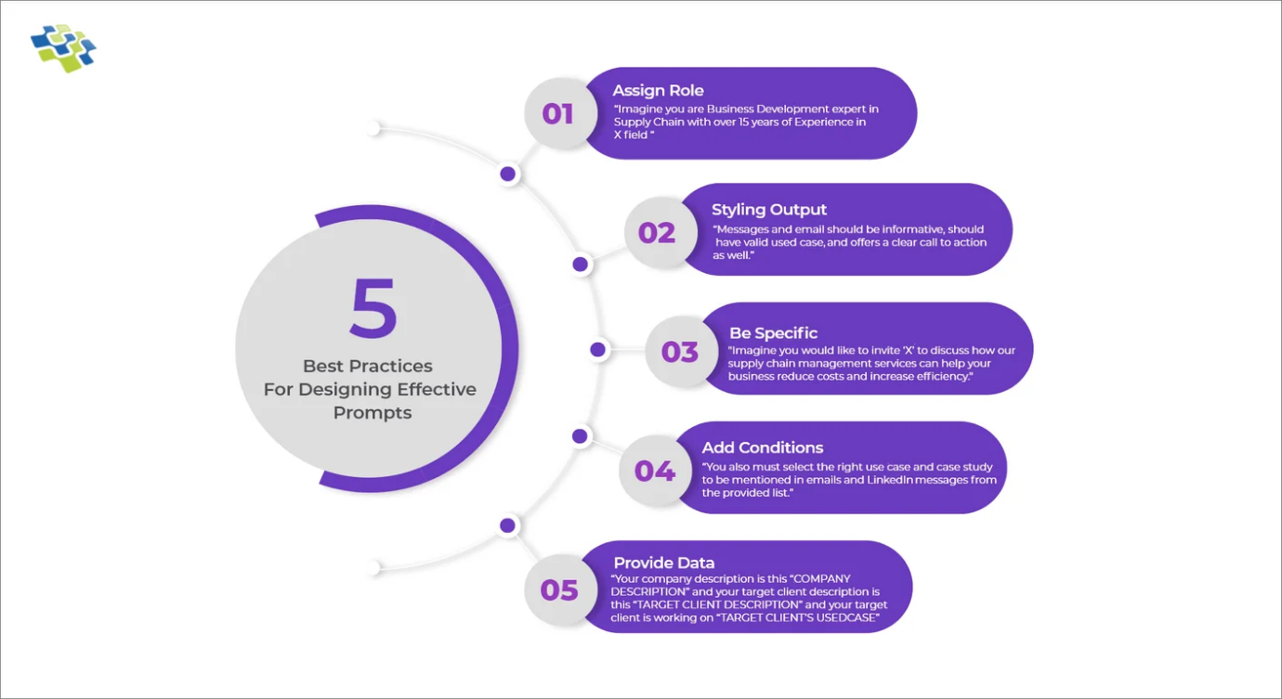
19. What are Prompting Principles ?
1. Principle 1: Write clear and specific instructions.
2. Principle 2: Give the Model time to think.
Example
❌ Unclear prompt:
“Explain AI”
✅ Clear & specific prompt:
“Explain AI in simple terms with one real-world example in 5 bullet points.”
Example
❌ Direct prompt:
“Solve this math problem.”
✅ Better prompt:
“Solve this problem step by step and explain your reasoning.”
20. What are Tactics (in Prompting / Prompt Engineering) ?
Tactics are practical techniques or methods used to apply prompting principles (like clarity and step-by-step thinking) to get better, more accurate responses from an AI model.
21. Explain tactics for Principle 1 & Principle 2 ?
🛠️ 🔹 Principle 1: Write Clear and Specific Instructions
1️⃣ Use Delimiters
- Separate instructions and input clearly using symbols like , ###, or quotes.
2️⃣ Be Specific About the Task
- Avoid vague prompts.
Example:
❌ “Explain AI”
✅ “Explain AI in simple terms with one example.”
3️⃣ Specify the Output Format
- Tell the model how the answer should look.
Example:
“Give the answer in bullet points.”
4️⃣ Set Constraints
- Control length, tone, or style.
Example:
“Explain AI in 100 words using simple language.”
5️⃣ Ask for Structured Output
- Request tables, lists, or headings.
Example:
“Compare AI and ML in a table.”
🛠️ 🔹 Principle 2: Give the Model Time to Think
1️⃣ Ask for Step-by-Step Reasoning
- Encourages logical thinking.
Example:
“Solve the problem step by step and explain your reasoning.”
2️⃣ Break the Task into Steps
- Divide complex instructions into smaller parts.
Example:
“First analyze the data, then summarize the insights.”
3️⃣ Use Chain-of-Thought Prompting
- Explicitly request reasoning.
Example:
“Explain how you arrived at the answer.”
4️⃣ Ask the Model to Verify Its Answer
- Improves correctness.
Example:
“Recheck the answer and correct any mistakes.”
5️⃣ Let the Model Think Before Answering
- Ask it to reason internally before final output.
Example:
“Think carefully before giving the final answer.”
22. What is Model Limitation: Hallucinations ?
Hallucinations are a limitation of AI models where the model generates information that sounds confident and fluent but is incorrect, misleading, or completely false.
How to reduce hallucinations
- Write clear and specific prompts
- Use constraints (e.g., “answer only from given data”)
- Ask for citations or sources
- Use retrieval-augmented generation (RAG)
- Human verification

IMPORTANT PROMPT ENGINEERING QUESTIONS & ANSWERS (INTERVIEW READY)

1. What makes a prompt effective?
An effective prompt is clear, specific, provides enough context, sets constraints, and defines the expected output format.

2. What are the characteristics of a good prompt?
A good prompt is clear, unambiguous, context-aware, goal-oriented, and output-controlled.

3. What are common mistakes in prompt engineering?
Using vague instructions, missing context, not defining output format, overloading the prompt, and not setting constraints.

4. How do you improve a bad prompt?
By adding role, task clarity, context, constraints, and refining the prompt iteratively based on output.

5. What is the difference between a system prompt and a user prompt?
A system prompt defines the AI’s behavior and role, while a user prompt contains the actual task or question.

6. How does temperature affect prompt responses?
Higher temperature makes responses more creative and random, while lower temperature makes them more deterministic and accurate.

7. What is top-p and when do you use it?
Top-p controls the probability mass of tokens used; it is used to balance creativity and accuracy in outputs.

8. What is token limit and why is it important?
Token limit is the maximum input and output length the model can handle; exceeding it can truncate responses or lose context.

9. What is prompt chaining and why is it used?
Prompt chaining breaks a complex task into multiple smaller prompts to improve accuracy and reasoning.

10. What is ReAct prompting?
ReAct prompting combines reasoning and action, allowing the model to think step by step and perform actions like tool usage.

11. What is meta-prompting?
Meta-prompting is prompting the model to generate, improve, or evaluate other prompts.

12. What is self-reflection or self-critique prompting?
It asks the model to review and correct its own output to improve accuracy.

13. How do you evaluate the quality of a prompt?
By checking output accuracy, relevance, consistency, and whether it meets the task requirements.

14. How do you test and validate prompts?
By running multiple test cases, edge cases, and comparing outputs for consistency and correctness.

15. What are the limitations of prompt engineering?
Prompt engineering cannot fully eliminate hallucinations and depends on model capabilities and context limits.

16. When should prompt engineering NOT be used?
When strict accuracy is required or when the task needs domain-specific training or fine-tuning.

17. How do you handle incorrect or hallucinated outputs?
By refining prompts, adding constraints, using RAG, and validating outputs manually.

18. What is grounding in prompt engineering?
Grounding restricts responses to verified or provided data sources to improve reliability.

19. How does RAG help prompt engineering?
RAG retrieves external data and provides it as context, reducing hallucinations and improving accuracy.

20. What are guardrails in prompt engineering?
Guardrails are rules and constraints that control AI behavior and prevent unsafe or undesired outputs.

21. How do you design prompts for structured output?
By explicitly specifying the required format such as JSON, tables, or bullet points.

22. How do you design prompts for SQL generation?
By specifying the role, database type, schema details, constraints, and expected query format.

23. How do you design prompts for data analysis?
By defining the business context, dataset details, analysis goals, and output format.

24. How do you reduce ambiguity in prompts?
By being specific, adding examples, defining constraints, and clearly stating the task.

25. How do you control tone, length, and style in prompts?
By explicitly mentioning tone, word limits, and style requirements in the prompt.

26. What is over-prompting?
Over-prompting is adding unnecessary instructions that confuse the model and reduce output quality.

27. What is prompt leakage?
Prompt leakage occurs when system or hidden prompts are unintentionally revealed in outputs.

28. What are ethical considerations in prompt engineering?
Avoiding biased, harmful, or misleading outputs and ensuring responsible AI usage.

29. How is prompt engineering used in real-world applications?
In chatbots, data analysis, SQL generation, resume screening, and code assistance.

30. Design a prompt for a real business problem.
Example:
Role: You are a data analyst.
Task: Identify key revenue trends.
Context: E-commerce sales data for the last 6 months.
Constraints: Focus on revenue metrics only.
Output Format: Bullet points.

