I used data from UC IRVINE DATABASE for Machine Learning, DATASET NAME: Wine Quality Testing

The dataset has 12 features to predict the quality of the wine on the scale of 0-10

**Input variables (based on physicochemical tests):**  
1 - fixed acidity   
2 - volatile acidity   
3 - citric acid   
4 - residual sugar   
5 - chlorides   
6 - free sulfur dioxide   
7 - total sulfur dioxide   
8 - density   
9 - pH   
10 - sulphates   
11 - alcohol   
**Output variable (based on sensory data):**   
12 - quality (score between 0 and 10)

Number of instances considered for classifying are 149

**Classifying using J48:**

Correctly Classified Instances 92

Accuracy :61.745 %

Incorrectly Classified Instances 57

Error rate: 38.255 %

Confusion Matrix:

a b c d e f g h i j <-- classified as ROC curve for Quality 5

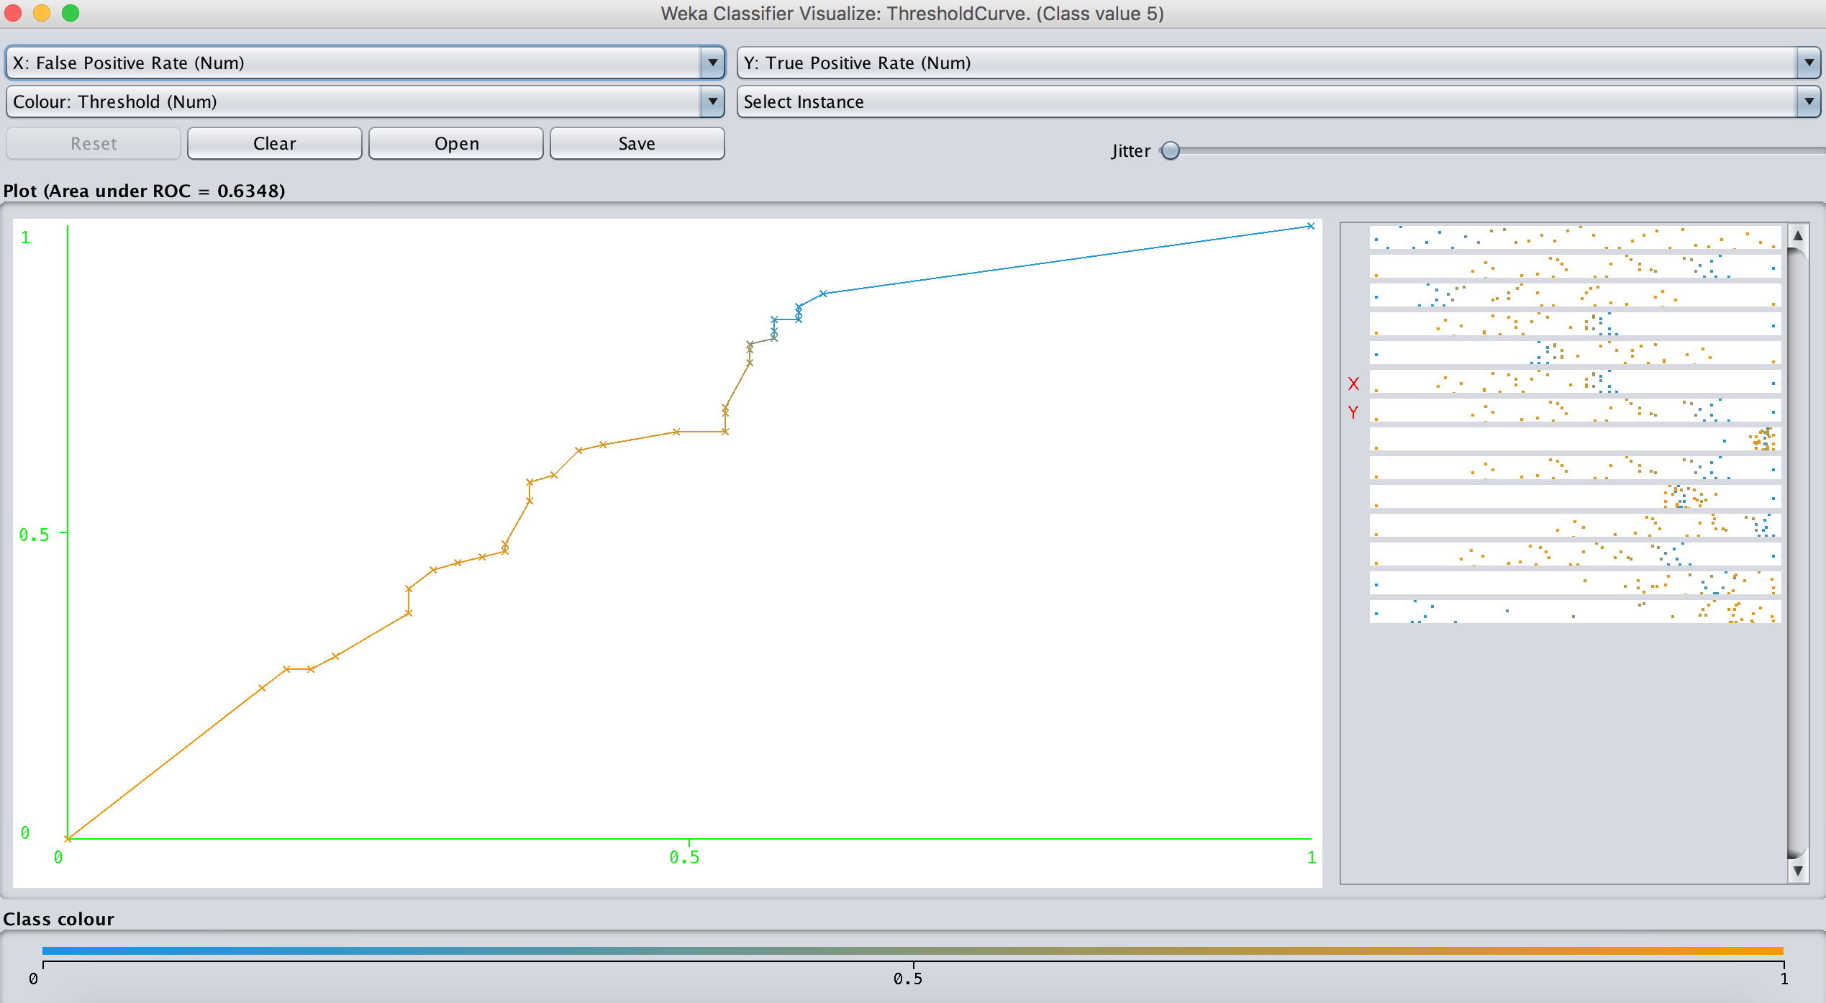 0 0 0 0 0 0 0 0 0 0 | a = 0

0 0 0 0 0 0 0 0 0 0 | b = 1

0 0 0 0 0 0 0 0 0 0 | c = 2

0 0 0 0 0 0 0 0 0 0 | d = 3

0 0 0 0 1 3 3 0 0 0 | e = 4

0 0 0 0 4 78 14 2 0 0 | f = 5

0 0 0 0 2 22 13 1 0 0 | g = 6

0 0 0 0 0 3 3 0 0 0 | h = 7

0 0 0 0 0 0 0 0 0 0 | i = 8

0 0 0 0 0 0 0 0 0 0 | j = 9

**Classifying using 1- NN**

Correctly Classified Instances 95

Accuracy: 63.7584 %

Incorrectly Classified Instances 54

Error Rate: 36.2416 %

Confusion Matrix:

a b c d e f g h i j <-- classified as ROC curve for Quality 5

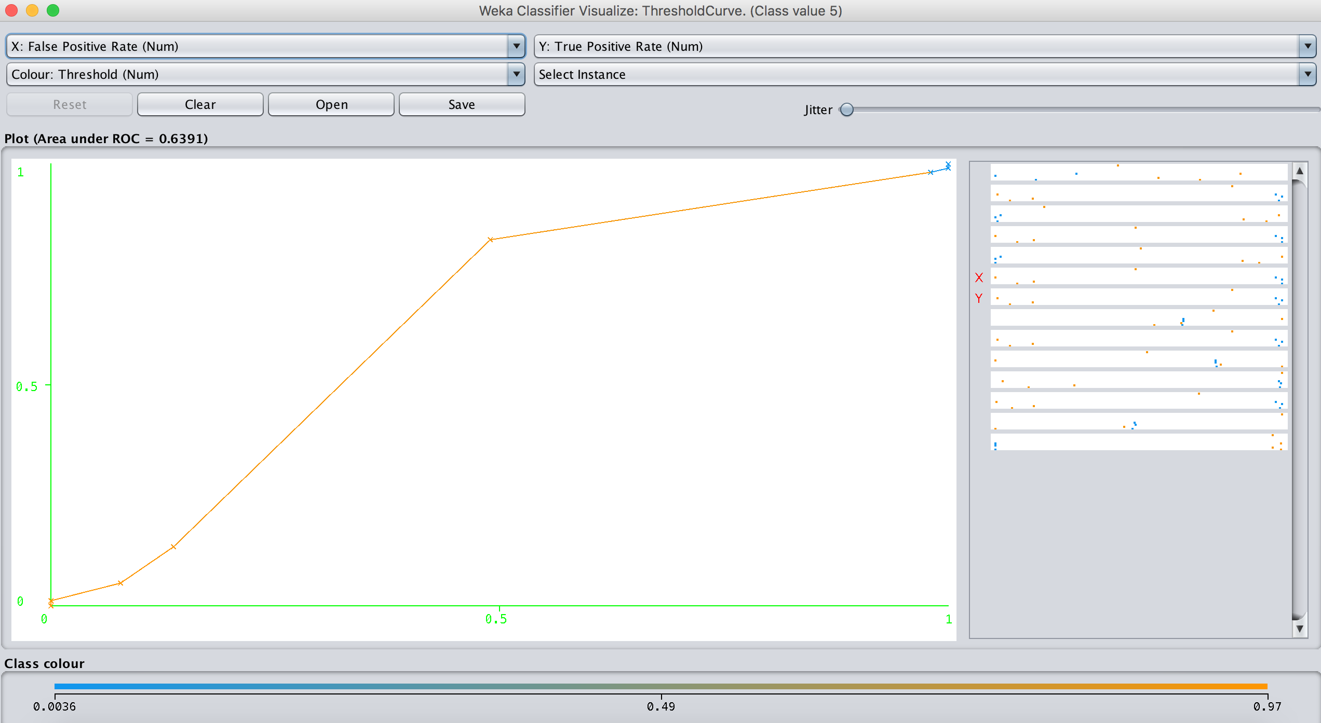 0 0 0 0 0 0 0 0 0 0 | a = 0

0 0 0 0 0 0 0 0 0 0 | b = 1

0 0 0 0 0 0 0 0 0 0 | c = 2

0 0 0 0 0 0 0 0 0 0 | d = 3

0 0 0 0 2 3 2 0 0 0 | e = 4

0 0 0 0 2 81 13 2 0 0 | f = 5

0 0 0 0 1 19 12 6 0 0 | g = 6

0 0 0 0 0 3 3 0 0 0 | h = 7

0 0 0 0 0 0 0 0 0 0 | i = 8

0 0 0 0 0 0 0 0 0 0 | j = 9