## SMARTINTERNZ

### Credit Card Approval Prediction Using Machine Learning

### Project Report

### introduction

**1.1 overview**

Credit risk as the board in banks basically centers around deciding the probability of a customer's default or credit decay and how expensive it will end up being assuming it happens. It is important to consider major factors and predict beforehand the probability of consumers defaulting given their conditions. Which is where a machine learning model comes in handy and allows the banks and major financial institutions to predict whether the customer, they are giving the loan to, will default or not. This project builds a machine learning model with the best accuracy possible using python. First we load and view the dataset. The dataset has a combination of both mathematical and non-mathematical elements, that it contains values from various reaches, in addition to that it contains a few missing passages. We preprocess the dataset to guarantee the AI model we pick can make great expectations. After the information is looking great, some exploratory information examination is done to assemble our instincts. Finally, we will build a machine learning model that can predict if an individual's application for a credit card will be accepted. Using various tools and techniques we then try to improve the accuracy of the model. This project uses Jupyter notebook for python programming to build the machine learning model. Using Data Analysis and Machine Learning, we attempted to determine the most essential parameters for obtaining credit card acceptance in this project.

**1.2 Purpose :**  
 It uses personal information and data submitted by credit card applicants to predict the probability of future defaults and credit card borrowings. The bank is able to decide whether to issue a credit card to the applicant. Credit scores can objectively quantify the magnitude of risk.

**2 LITERATURE SURVEY**

**2.1 Existing problem :**

This is a classification problem in which we need to classify whether the loan will be approved or not. classification refers to a predictive modeling problem where a class label is predicted for a given example of input data.

**2.2 Proposed solution** :

The company wants to automate the loan eligibility process (real-time) based on customer detail provided while filling out online application forms. These details are Gender, Marital Status, Education, number of Dependents, Income, Loan Amount, Credit History, and others.

To automate this process, they have provided a dataset to identify the customer segments that are eligible for loan amounts so that they can specifically target these customers.

3.THEORITICAL ANALYSIS

**3.1** **Block Diagram :**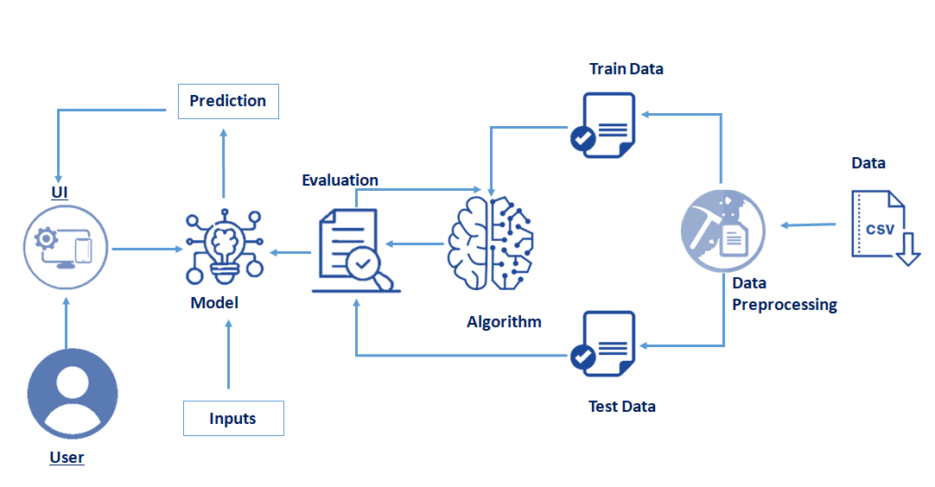

**3.2 Software Requirements :**

* **ANACONDA NAVIGATOR**

**USED PYTHON PACKAGES :**

* PANDAS
* NUMPY
* SCIKIT-LEARN
* MATPLOTLIB
* PICKLE-MIXIN
* SEABORN
* FLASK

#### 4. Project Flow

* Data Collection.
* Data Visualization
* Data Pre-processing
* Model Building
* Application Building

#### 5.RESULT

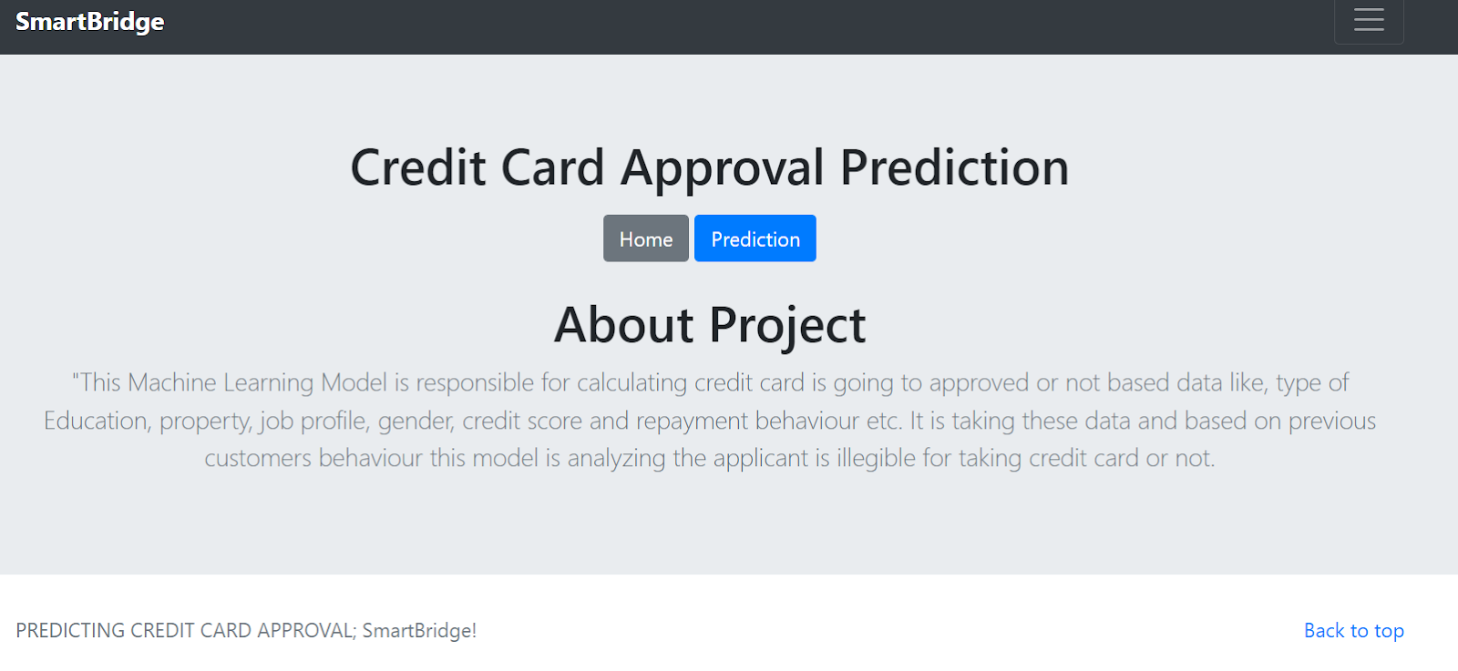

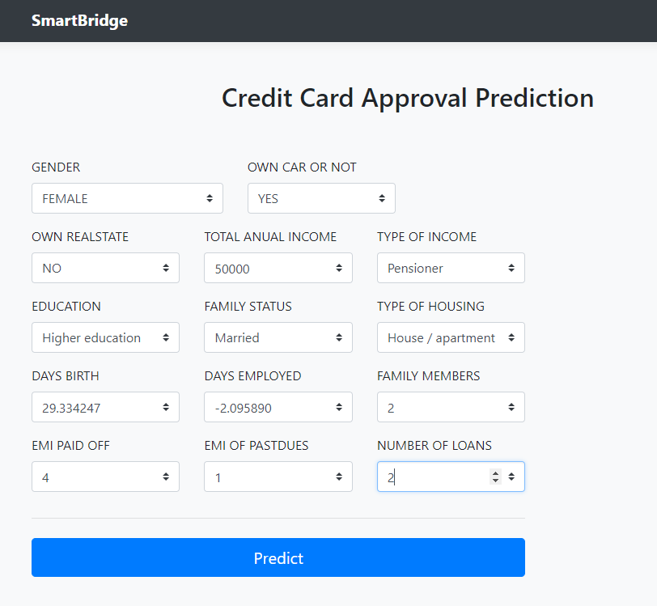



6 . ADAVANTAGES AND DISADAVANTAGES :

6.1 ADAVANTAGES

* Opportunity to build credit
* Earn rewards such as cash back or miles points
* Protection against credit card fraud
* Free credit score information
* No foreign transaction fees

6.2 DISADAVANTAGES

* Minimum due trap
* Hidden costs
* Ease of overuse
* High intrest rate

**7. CONCLUSION :**

Currently, factors considered are regular details related to gender, age of the consumer, his/hercredit reports and worthiness, yearly income, and the number of years he/she has been working.Further, to improve this work, various other factors or conditions can be considered like theirhistory related to any offense and their assets which can be both physical and liquid cash. Thesefeatures can improve the model to be more effective and can help the institutes to make betterdecisions so that they can avoid experiencing frauds and loss. Various classification algorithmscan be used to build a model and compare the rates or levels of accuracy to improve the model for better use.

**7. FUTURE SCOPE :**

machine learning needs you to know computer programming, statistics and data evaluation, the future scope of your machine learning career can also be in **leadership roles in automation or analytics environments**

**8.REFERENCE :**

K. Chaudhary, J. Yadav, and B. Mallick, “A review of fraud detection techniques: Credit card,” International Journal of Computer Applications

**9.APPENDIX**

**9.1 source code**

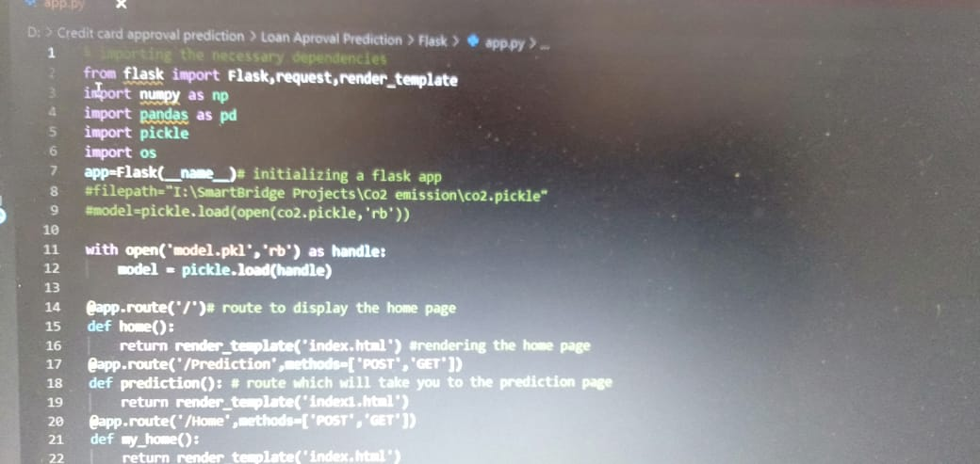

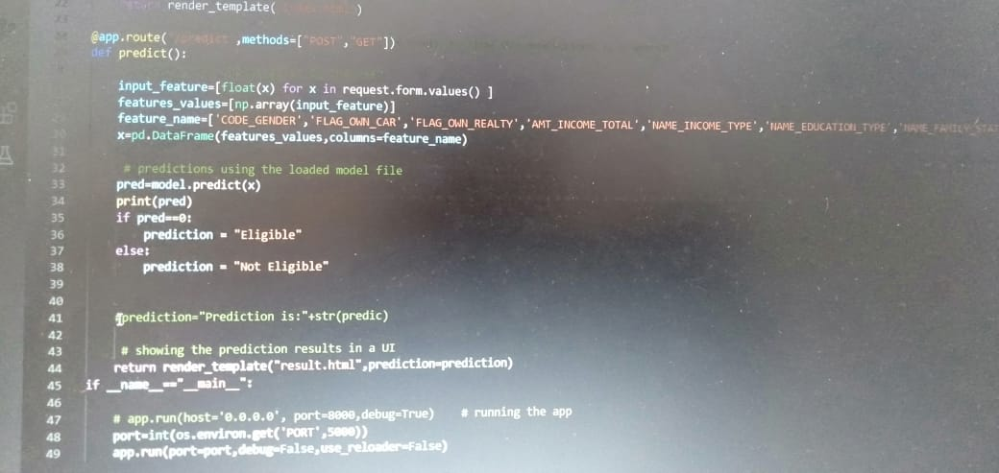

output :



###### 



###### 

THANK YOU

###### 

###### 