N Queens Backtracking
package nqueens;
import java.util.Scanner;
public class Backtracking {
int N;
void printSolution(int board[][])
{
for (int i = 0; i < N; i++)
{
for (int j = 0; j < N; j++)
System.out.print(" " + board[i][j]
+ " ");
System.out.println();
}
}
boolean isSafe(int board[][], int row, int col)
{
int i, j;
for (i = 0; i < col; i++)
if (board[row][i] == 1)
return false;
for (i=row, j=col; i>=0 && j>=0; i--, j--)
if (board[i][j] == 1)
return false;
for (i=row, j=col; j>=0 && i<N; i++, j--)
if (board[i][j] == 1)
return false;
return true;
}
boolean solveNQUtil(int board[][], int col)
{
if (col >= N)
return true;
for (int i = 0; i < N; i++)
{
if (isSafe(board, i, col))
{
board[i][col] = 1;
if (solveNQUtil(board, col + 1) == true)
return true;
board[i][col] = 0; // BACKTRACK
}
}
return false;
}

boolean solveNQ(int N)
{
int[][] board = new int[N][N];
for(int i=0;i<N;i++)
{
for(int j=0;j<N;j++)
board[i][j]=0;
}
if (solveNQUtil(board, 0) == false)
{
System.out.print("Solution does not exist");
return false;
}
printSolution(board);
return true;
}

void setN(int n)
{
this.N=n;
}
public static void main(String[] args) {
Backtracking q = new Backtracking();
Scanner sc = new Scanner(System.in);
System.out.println("Enter value of N");
int N = sc.nextInt();
q.setN(N);
q.solveNQ(N);
}
}

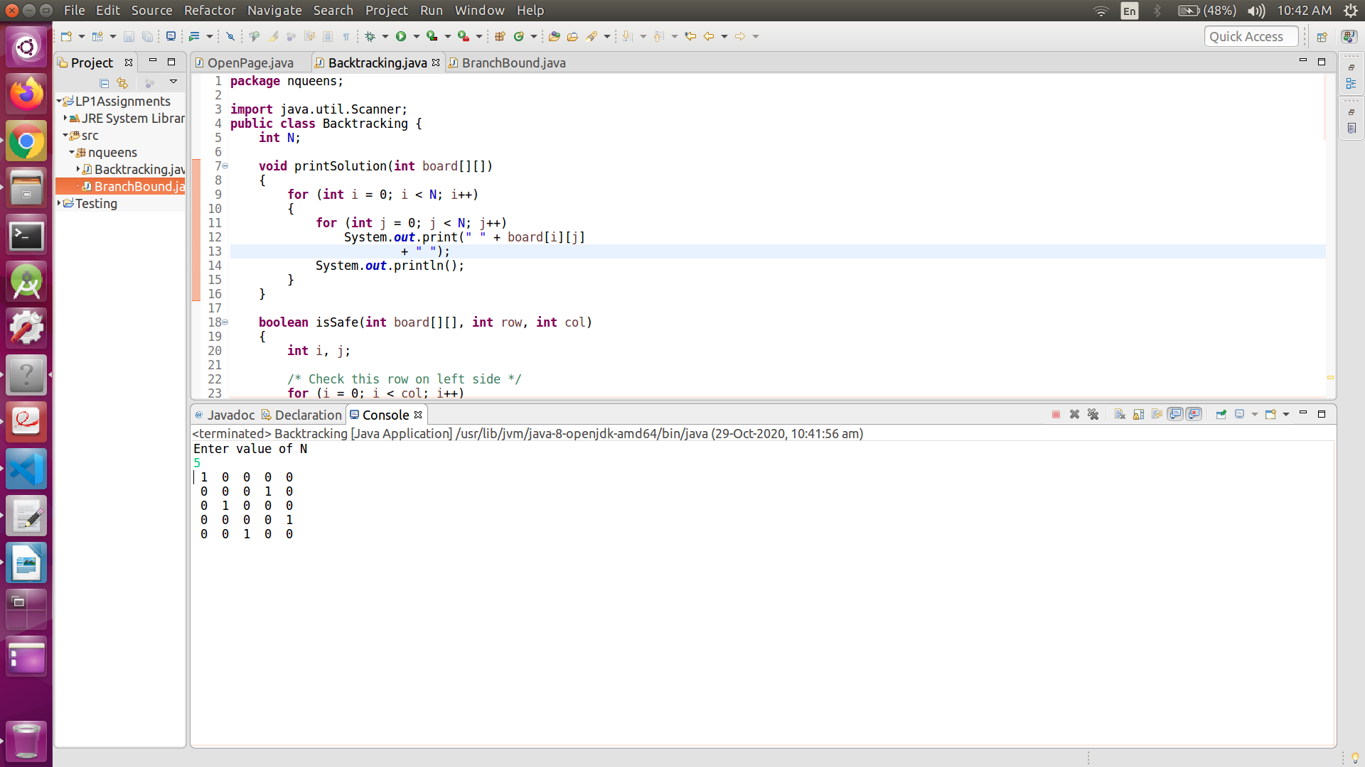

N Queens Branch and Bound
package nqueens;
import java.util.*;
public class BranchBound {
int N;

void printSolution(int board[][])
{
for (int i = 0; i < N; i++)
{
for (int j = 0; j < N; j++)
System.out.print(board[i][j]+"\t");
System.out.println();
}
}

boolean isSafe(int row, int col, int slashCode[][],
int backslashCode[][], boolean rowLookup[],
boolean slashCodeLookup[], boolean backslashCodeLookup[] )
{
if (slashCodeLookup[slashCode[row][col]] ||
backslashCodeLookup[backslashCode[row][col]] ||
rowLookup[row])
return false;

return true;
}

boolean solveNQueensUtil(int board[][], int col,
int slashCode[][], int backslashCode[][], boolean rowLookup[],
boolean slashCodeLookup[], boolean backslashCodeLookup[] )
{
if (col >= N)
return true;

for (int i = 0; i < N; i++)
{
if ( isSafe(i, col, slashCode, backslashCode, rowLookup,
slashCodeLookup, backslashCodeLookup) )
{
board[i][col] = 1;
rowLookup[i] = true;
slashCodeLookup[slashCode[i][col]] = true;
backslashCodeLookup[backslashCode[i][col]] = true;

if ( solveNQueensUtil(board, col + 1, slashCode, backslashCode,
rowLookup, slashCodeLookup, backslashCodeLookup) )
return true;
board[i][col] = 0;
rowLookup[i] = false;
slashCodeLookup[slashCode[i][col]] = false;
backslashCodeLookup[backslashCode[i][col]] = false;
}
}
return false;
}

boolean solveNQueens()
{
int board[][] = new int[N][N];
for(int i=0;i<N;i++)
{
for(int j=0;j<N;j++)
board[i][j]=0;
}
int slashCode[][] = new int[N][N];
int backslashCode[][] = new int[N][N];
boolean rowLookup[] = new boolean[N];
for(int i=0;i<N;i++)
rowLookup[i]=false;
boolean slashCodeLookup[] = new boolean[2*N - 1];
for(int i=0;i<2*N-1;i++)
slashCodeLookup[i]=false;
boolean backslashCodeLookup[] = new boolean[2*N - 1];
for(int i=0;i<2*N-1;i++)
backslashCodeLookup[i]=false;
for (int r = 0; r < N; r++) {
for (int c = 0; c < N; c++) {
slashCode[r][c] = r + c;
backslashCode[r][c] = r - c + N-1;
}
}
if (solveNQueensUtil(board, 0, slashCode, backslashCode,
rowLookup, slashCodeLookup, backslashCodeLookup) == false )
{
System.out.println("solution does not exist");
return false;
}
printSolution(board);

return true;
}
void setN(int n)
{
this.N=n;
}
public static void main(String[] args) {
BranchBound q = new BranchBound();
Scanner sc = new Scanner(System.in);
System.out.println("Enter value of N");
int N = sc.nextInt();
q.setN(N);
q.solveNQueens();

}
}
