Assignment 1:

Code:
#include<iostream>
#include<math.h>

#define n 10000

using namespace std;

__global__ void minimum(int *input) {
int tid = threadIdx.x;
int step_size = 1;
int number_of_threads = blockDim.x;
while(number_of_threads>0) {
if(tid < number_of_threads) {
int first = tid*step_size*2;
int second = first + step_size;
if(input[second] < input[first])
input[first] = input[second];
}
step_size <<= 1;
number_of_threads >>= 1;
}
}

__global__ void maximum(int *input) {
int tid = threadIdx.x;
int step_size = 1;
int number_of_threads = blockDim.x;
while(number_of_threads>0) {
if(tid < number_of_threads) {
int first = tid*step_size*2;
int second = first + step_size;
if(input[second] > input[first])
input[first] = input[second];
}
step_size <<= 1;
number_of_threads >>= 1;
}
}

__global__ void sum(int *input) {
const int tid = threadIdx.x;
int step_size = 1;
int number_of_threads = blockDim.x;
while(number_of_threads > 0) {
if(tid < number_of_threads) {
int first = tid * step_size * 2;
int second = first + step_size;
input[first] += input[second];
}
step_size <<= 1;
number_of_threads >>= 1;
}
}

__global__ void mean_diff_sq(float *input, float mean) {
input[threadIdx.x] -= mean;
input[threadIdx.x] *= input[threadIdx.x];
}

__global__ void sum_floats(float *input) {
int tid = threadIdx.x;
int step_size = 1;
int number_of_threads = blockDim.x;
while(number_of_threads > 0) {
if(tid < number_of_threads) {
int first = tid * step_size * 2;
int second = first + step_size;
input[first] += input[second];
}
step_size <<= 1;
number_of_threads >>= 1;
}
}

void copy_int_to_float(float *dest, int *src, int size){
for(int i=0; i<size; i++)
dest[i] = float(src[i]);
}

void random_ints(int *input, int size) {
for(int i=0; i<size; i++) {
input[i] = rand()%10000;
}
}

int main() {
int size = n*sizeof(int);
cudaEvent_t start, stop;
cudaEventCreate(&start);
cudaEventCreate(&stop);
int *arr;
int *arr_d, result;
arr = (int *)malloc(size);

random_ints(arr, n);
float milliseconds = 0;
cout<<"Size of array is: "<<n<<endl;
cout<<"The array is: ";
for(int i=0;i<n;i++){
cout<<arr[i]<<" ";
}
cout<<endl;
cudaMalloc((void **)&arr_d, size);
//MIN

int min = arr[0];

cudaEventRecord(start);
for(int i=1;i<n;i++){
if(min>arr[i])
min=arr[i];
}
cudaEventRecord(stop);
cout<<endl<<"-------------MINIMUM-------------"<<endl;
cout<<"The minimum element is: "<<min<<endl;
cudaEventSynchronize(stop);

cudaEventElapsedTime(&milliseconds, start, stop);

cout<<endl<<"Time taken sequentially is: "<<milliseconds<<" milliseconds"<<endl;

cudaMemcpy(arr_d, arr, size, cudaMemcpyHostToDevice);
cudaEventRecord(start);
minimum<<<1,n/2>>>(arr_d);
cudaEventRecord(stop);

cudaMemcpy(&result, arr_d, sizeof(int), cudaMemcpyDeviceToHost);
cudaEventSynchronize(stop);
milliseconds = 0;
cudaEventElapsedTime(&milliseconds, start, stop);
cout<<"Time taken parallelly is: "<<milliseconds<<" milliseconds"<<endl<<endl<<endl;
//MAX

cout<<endl<<"-------------MAXIMUM-------------"<<endl;
int max = arr[0];

cudaEventRecord(start);
for(int i=1;i<n;i++){
if(max<arr[i])
max=arr[i];
}
cudaEventRecord(stop);

cout<<"The maximum element is: "<<max<<endl;
cudaEventSynchronize(stop);

cudaEventElapsedTime(&milliseconds, start, stop);

cout<<endl<<"Time taken sequentially is: "<<milliseconds<<" milliseconds"<<endl;

cudaMemcpy(arr_d, arr, size, cudaMemcpyHostToDevice);
cudaEventRecord(start);
maximum<<<1,n/2>>>(arr_d);
cudaEventRecord(stop);
cudaMemcpy(&result, arr_d, sizeof(int), cudaMemcpyDeviceToHost);
cudaEventSynchronize(stop);
milliseconds = 0;
cudaEventElapsedTime(&milliseconds, start, stop);
cout<<"Time taken parallelly is: "<<milliseconds<<" milliseconds"<<endl<<endl<<endl;
//SUM
cudaMemcpy(arr_d, arr, size, cudaMemcpyHostToDevice);
sum<<<1,n/2>>>(arr_d);
cudaMemcpy(&result, arr_d, sizeof(int), cudaMemcpyDeviceToHost);
cout<<"The sum is "<<result<<endl<<endl;
//AVERAGE
float mean = float(result)/n;
cout<<"The mean is "<<mean<<endl<<endl;
//STANDARD DEVIATION
float *arr_float;
float *arr_std, stdValue;
arr_float = (float *)malloc(n*sizeof(float));
cudaMalloc((void **)&arr_std, n*sizeof(float));
copy_int_to_float(arr_float, arr, n);
cudaMemcpy(arr_std, arr_float, n*sizeof(float), cudaMemcpyHostToDevice);
float variance = 0, stdDeviation = 0;
cudaEventRecord(start);
for(int i = 0; i < n; ++i)
variance += pow(arr[i] - mean, 2);
variance=variance/n;
stdDeviation = sqrt(variance);
cudaEventRecord(stop);

cout<<endl<<"-------------STD DEVIATION AND VARIANCE-------------"<<endl;
cout<<"The variance is "<<variance<<endl;
cout<<"The standard deviation is "<<stdDeviation<<endl;
cudaEventSynchronize(stop);
milliseconds = 0;
cudaEventElapsedTime(&milliseconds, start, stop);
cout<<endl<<"Time taken sequentially is: "<<milliseconds<<" milliseconds"<<endl;

cudaEventRecord(start);
mean_diff_sq <<<1,n>>>(arr_std, mean);
sum_floats<<<1,n/2>>>(arr_std);
cudaMemcpy(&stdValue, arr_std, sizeof(float), cudaMemcpyDeviceToHost);

float Variance = stdValue / n;
stdValue = sqrt(Variance);
cudaEventRecord(stop);
cudaEventSynchronize(stop);
milliseconds = 0;
cudaEventElapsedTime(&milliseconds, start, stop);
cout<<"Time taken parallelly is: "<<milliseconds<<" milliseconds"<<endl;

cudaFree(arr_d);
return 0;
}

Output:
For 10 elements: (Sequential takes less time)
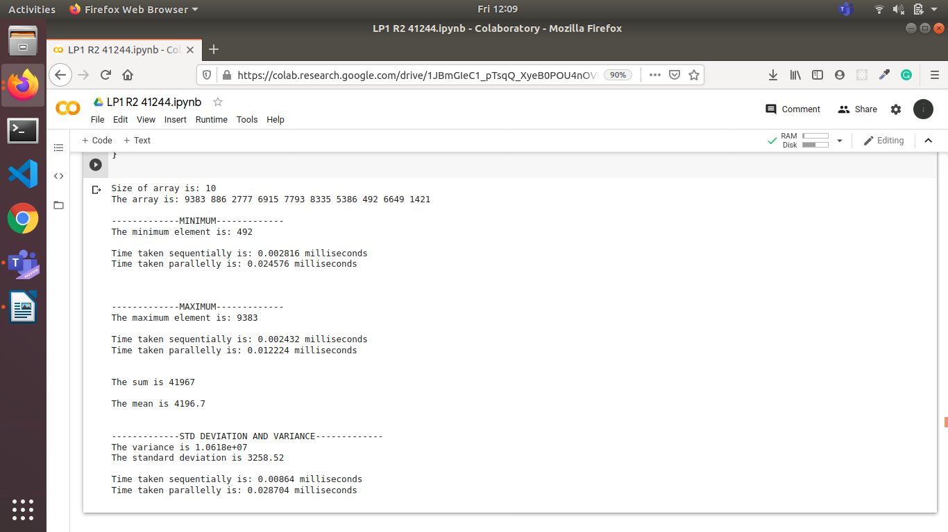
For 10000 elements: (Parallel takes less time)
